**Frequently Asked Questions**

1. **How should I prepare and store samples to be sent for analysis by ICP?**

To prepare and store samples for analysis by ICP, it is advisable to refer to the literature in your field of work for specific sample preservation and storage conditions. However, the following general guidelines can be followed:

* Soil samples should be air-dried and ground to a particle size of less than 2 mm.
* Composts and sewage sludges should also be air-dried and ground to the smallest possible size.
* Plant material should be dried at 65-70 °C and ground to a fine powder.
* Water samples should be stored at +4 °C and typically acidified with nitric acid to achieve a pH of less than 2 as soon as possible.
* Biological samples should be stored at temperatures ranging from -20 °C to -80 °C.

Note that if you have a special interest in analyzing Hg (mercury), a separate water sampling and storage procedure should be followed. For Hg analysis, take your water samples in glass vials (avoid plastic) and acidify them with HCl instead of HNO3. It is important to note that these specific treatments are not suitable for most other elements.

When sampling and storing liquids or solids for ICP analysis, it is important to avoid metal containers, including aluminum foil, to prevent sample contamination. Additionally, please note that liquid samples stored in glass vessels can potentially become contaminated by elements such as B and Si, as well as other elements at low pH. Therefore, it is recommended to use plastic containers whenever possible.

2. **How much sample is needed for sample preparation and analysis by ICP?**

In a typical measurement, approximately 5 - 10 mL of the tested solution is consumed by the ICP. Water samples and dilute aqueous solutions are usually analyzed as received without further dilutions. However, we recommend providing 10-25 mL volumes of such samples to allow for repetitions and dilutions.

For most other solid or liquid samples, digestion is required as part of the preparation for analysis. The typical protocol involves digesting the sample in strong mineral acids using a microwave-assisted system. The table below provides the minimum amounts required for different sample types. The resultant solution is typically made up to a final volume of 25-50 mL with water.

|  |  |
| --- | --- |
| **Sample Type** | **Minimal Amount** |
| Water and clear dilute aqueous solutions | 10 - 25 ml |
| Aqueous solutions with high salt or organic matter content | 5 - 10 ml |
| Metals and alloys | 0.1 - 1 g |
| Oils and non-aqueous liquids | About 20 g |
| Plant material, Composts, Sludges | 500 mg (dry weight) |
| Biological tissue, blood, feces | >1 g (fresh weight) |

3. **Which sample types are difficult to prepare for analysis by ICP?**

To ensure suitability for analysis by ICP, samples must undergo complete mineralization and solubilization. While a mixture of nitric acid, hydrochloric acid, and hydrogen peroxide is generally effective for digesting most samples, certain matrices can pose challenges.

In the case of milk and milk-based drinks containing casein, a special Kjeldahl-type digestion method using H2SO4 may be required if the microwave-assisted closed acid digestion is unavailable. It's important to note that hydrofluoric acid (HF) can dissolve stubborn siliceous matrices such as soil and rocks. However, it cannot be used in our ICP system due to the potential damage it can cause to the quartz spray chamber and torch. Additionally, HF can lead to contamination from elements like B, K, and Si that leach from the glassware of the instrument.

Mineral and vegetable oils also present difficulties in digestion. For low sample weights (approximately 100-200 mg), microwave-assisted digestion can be employed. In some cases, the organic phase with a low boiling point can be evaporated, and the residue can be dissolved in acid using hot-block digestion. It's important to avoid aspirating organic solvents such as methanol or acetone into the ICP instrument and not subjecting them to closed microwave-assisted digestion.

Please be aware that the special methods mentioned above may result in increased matrix effects and background levels for many of the analyzed elements.

4. **How may I submit my samples samples for analysis by ICP?**

Please follow these steps to submit your samples for analysis:

* Download and fill out the **"Samples Submission Form"** from our website.
* Bring or send both the completed form and the samples to our offices.

For sending the samples, please take note of the following information:

**Contact person:** Mrs. Shoshanna Shalom, administrative officer, 08-948-91-52

**Sample delivery time:** 8 am - 4 pm, Sunday to Thursday.

**Postal address**: Herzl Street, 229, Rehovot.

**Address for letters:** ZBM Lab, P.O. Box 12, Rehovot 76100, Israel.

Please be aware that there is no building numbered 229 on Herzl Street. Our laboratory is located on the campus. To find us using a navigation app, enter "Faculty of Agriculture, Rehovot." This will bring you to the main gate of the campus called "Herzl." Upon entering the gate, turn left and then take a right. The second building on your right will be the Ariowitch Laboratories. Mrs. Shoshanna Shalom's office is on the ground floor, on the right-hand side.

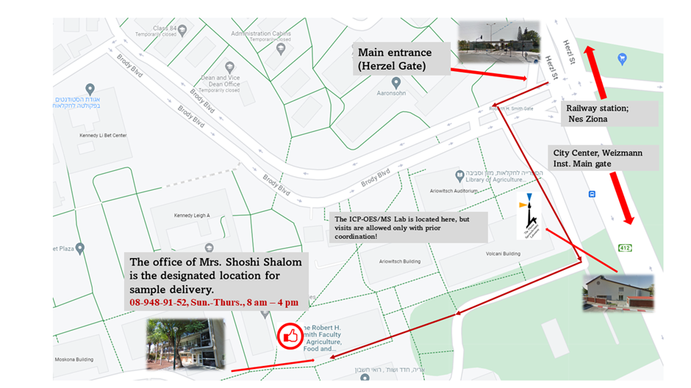

If you have any further questions or need assistance, please don't hesitate to contact us (vasiliyr@savion.huji.ac.il).