Danny Pineau

March 6th, 2020

Homework 6

1. For the city of Portsmouth, create a boxplot of campaign donations that Bernie Sanders, Donald Trump and Pete Buttigieg received; find the minimum, maximum, mean, and number of total donations. Were the results to be expected? Anything surprising?

**For Pete Buttigieg:**

Boxplot:

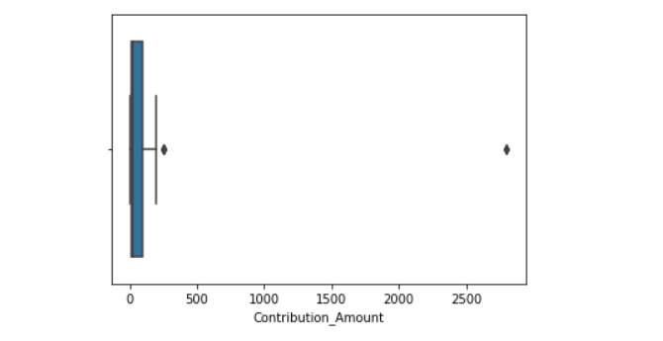

Min = 3, Max = 2800, Mean = 263.49, Total Donations = 28

**For Bernie Sanders:**

Boxplot:

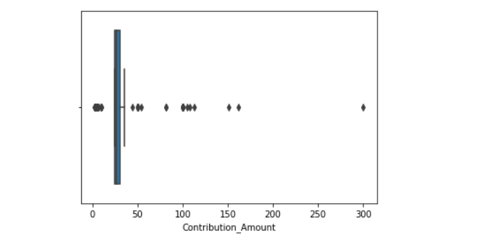

Min = 2, Max = 300, Mean = 36.85, Total Donations = 144

**For Donald Trump:**

Boxplot:

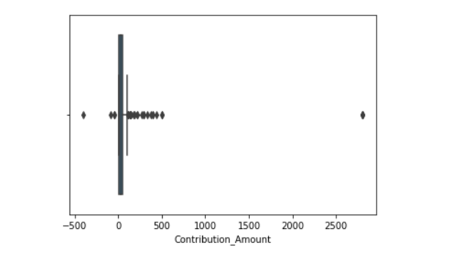

Min = -400(means there was a refund), Max = 2800, Mean = 86.81, Total Donations = 257

I would say the results here are mostly what I expected but there are few interesting things of note that I found surprising. I find it interesting how Trump’s campaign was the only one where people requested a refund while Buttigieg and Bernie did not have any such instances of that occurring. I was also surprised at the differences of the averages of the contribution amounts between Sanders, Buttigieg and Trump. I did not expect Buttigieg’s to be so high compared to Sanders’ and Trump’s. I also did not expect Buttigieg’s total donations to be so low compared to Sanders’ and Trump’s.

1. What were the cities that contained at least $20,000 in campaign contributions? Were the results to be expected? Anything surprising?

**Tableau Picture:**

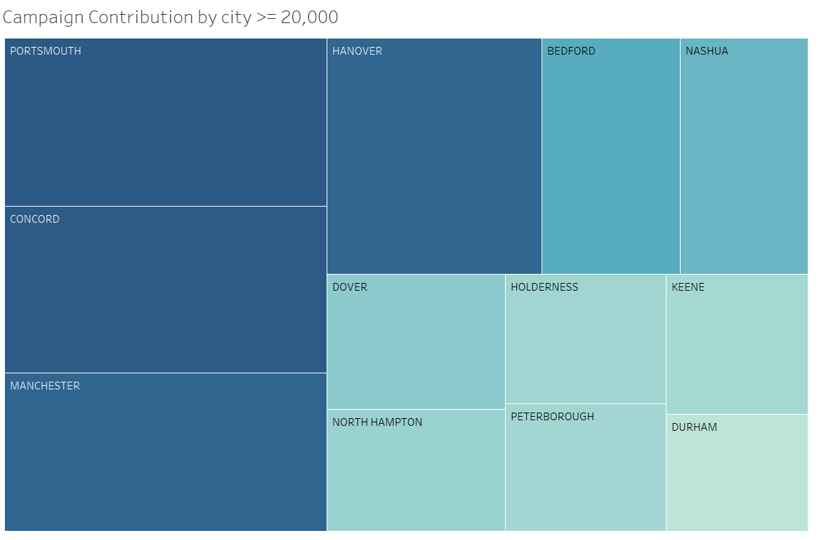

I would say the results here were mostly to be expected. Portsmouth, Concord, and Manchester were given because they are the biggest cities in New Hampshire. Durham and Keene are college towns so it isn’t too much of a surprise that many people in those towns would be avid followers of politics and contribute towards campaigns. Bedford and Holderness were the towns I was surprised to see on this list considering I’ve heard so little about them before.

1. What employers/occupations donated at least $2500 to Joe Biden, Donald Trump, and Bernie Sanders’s campaigns? Where the results to be expected? Anything surprising?

**Donald Trump Contributors:**

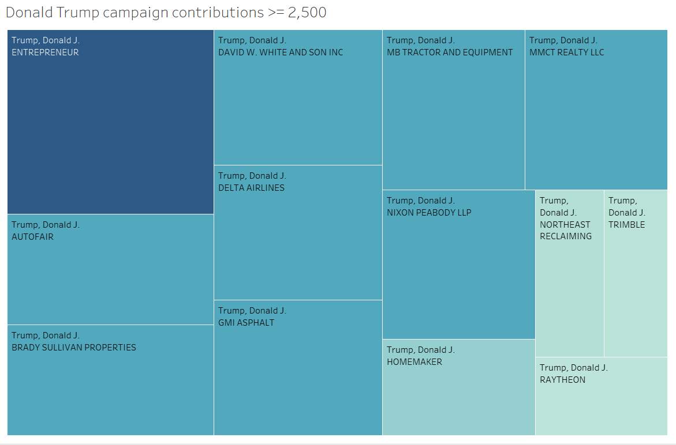

**Bernie Sanders Contributors:**

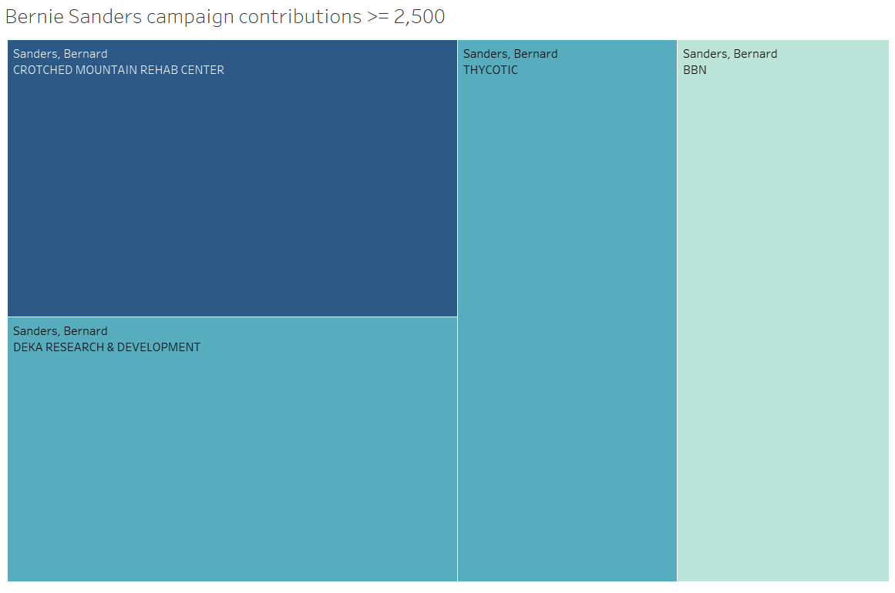

**Joe Biden Contributors:**

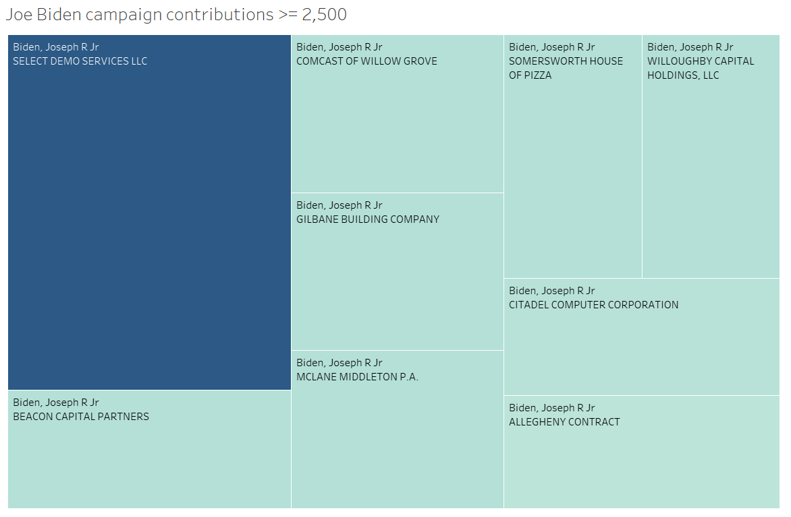

The results here were pretty much exactly what I expected. The companies that poured money into Trump’s campaign were mostly industrial, with entrepreneurs being the largest source of money Trump got from donations. Entrepreneurs tend to prefer less government involvement in the economy which Trump and the Republican party promote. There was more diversity in the companies that gave Joe Biden money to his campaign. Somersworth House of Pizza giving him over $2500 is not what I’d expect but it’s very interesting that they did do that. Meanwhile with Bernie Sanders I did not expect many companies to donating $2500 or over towards his campaign but the fact the Crotched Mountain Rehab Center was the top group that donated to his campaign would make sense considering Bernie’s stances on healthcare.