

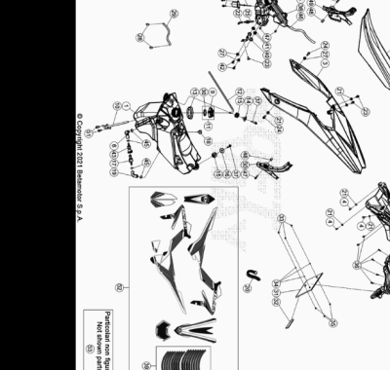

Ref. | Part Number | Description | Part
1 | 036.43.034.00.59 | DEPOSITO GASOLINA | 1
2 | 036.43.048.00.00 | ASIENTO XTRAINER 2T MY 20 | 1
3 | 036.43.003.10.51 | GUARDABARROS POSTERIOR | 1
4 | 11.47015.000 | TORNILLO 6.12 REV3-04 - RR-4T | 5
5 | 036.43.010.00.00 | TAPON DEPOSITO ACEITE | 1
6 | 036.43.012.00.00 | TUBO GASOLINA | 1
7 | 036.43.006.10.59 | PORTAMATRICULAS RR 2T/4T | 1
8 | 020.43.034.10.59 | PORTAMATRICULA RR4T MY10 HOMLOLOGADO NEGRO | 1
9 | 036.43.041.80.00 | TAPON DEPOSITO GASOLINA | 1
10 | 036.43.039.00.00 | GRIFO GASOLINA | 1
11 | 036.43.041.82.00 | TAPON GASOLINA COMPLETO | 1
12 | 020.43.003.00.00 | TUBO TAPON-VALVULA PURGA AIRE | 1
13 | 026.43.029.00.00 | GOMA | 1
14 | 020.43.002.00.00 | DISTANCIADOR DEPOSITO GASOLINA | 1
15 | 032.37.013.00.00 | SILENT-BLOCK | 2
16 | 031.43.002.00.00 | DISTANCIADOR DEPOSITO GASOLINA | 1
17 | 036.43.013.00.00 | CONECTOR | 1
18 | 31.89010.000 | TORNILLO BLOQUEO SILLÍN RR-4T / RR 125 | 1
19 | 036.43.011.00.00 | TUBO GASOLINA | 1
20 | 15.14264.000 | ABRAZ.PA 6 NY.DENT.NAT.ABNY-B 3,6 X 200 | 1
21 | 13.54820.000 | DISTANCIADOR RR-4T | 6
22 | 036.43.022.00.00 | TUBO ACEITE | 1
23 | 31.95510.000 | TORNILLO DIN 7380+ARANDELA M-06 X 012 ZN | 3
24 | 11.48025.000 | TORNILLO HEX/C.ARO 6x16 ( RS-T.8 ) | 2
25 | 036.43.017.00.00 | RACORD | 1
26 | 026.40.019.00.00 | SENSOR NIVEL | 1
27 | 13.62000.000 | DISTANCIADOR DISCO TR ( 6x14x7.5 ) | 3
28 | C07.08.008.00.00 | BRIDA CE 12 | 2
29 | 026.43.005.00.00 | TUBO GASOLINA DEP/CARBURAT. RR 2T | 1
30 | 031.43.116.00.00 | JUNTA TAPON GASOLINA | 1
31 | 018.43.010.10.59 | SOPORTE MATRICULA | 1
32 | 12.33086.000 | REFLECTOR POSTERIOR RR.4T 7 RR 125 | 1
33 | 13.11010.000 | TUERCA M5 AUTOBLOC. | 3
34 | 27.36000.000 | ARANDELA PLANA 5.11 | 3
35 | 31.29860.000 | TORNILLO TTLIC 5.16 CABEZA 10 | 3
36 | 31.79960.000 | TORNILLO AUTOROSCANTE M6x15 | 6
37 | 11.50300.000 | TORNILLO 6,30 RS CH 8 RR-4T / RR 125 | 2
38 | 026.43.007.10.51 | DEPOSITO ACEITE MIX | 1
39 | 036.43.054.82.00 | SERIE ADHESIVOS LLANTA XTRAINER MY 21 | 1
40 | 036.43.021.22.00 | BRIDA BOMBA ACEITE | 1
41 | 16.34906.000 | GOMA PORTACARGA | 2
42 | 31.30470.000 | TORNILLO TBCE 6.6 | 2
43 | 031.40.027.00.00 | CONECTOR TUBO GASOLINA | 1
45 | C07.16.002.00.00 | GRAPA NORMA 13/8 W4 | 4
46 | 036.43.028.14.00 | TUBO | 1
47 | 11.49070.000 | TORNILLO 6X20 RS CH8 | 4
48 | 27.33740.000 | REMACHE M. 6 | 2
49 | 036.43.027.10.59 | #036.43.029.00.59# | 1
50 | 036.43.026.10.59 | #036.43.029.00.59# | 1
51 | 11.46251.000 | TORNILLO 5.12 RS CH8 | 2
52 | 036.43.056.82.00 | SERIE ADHESIVOS XTRAINER MY 22 | 1
53 | 041.43.008.82.00 | CONTENEDOR FILTRO KIT 2T | 1

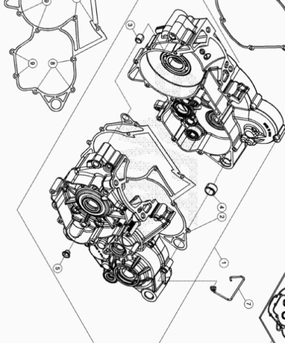

Ref. | Part Number | Description | Part
1 | 026.01.046.80.00 | CARTER MOTOR RR 2T 300 | 1
2 | 026.01.003.00.00 | JUNTA CARTER | 1
3 | 16.41500.000 | CASQUILLO CENTRADOR 13.13 | 1
4 | 006.01.012.00.00 | CASQUILLO CENTRADOR 17 X 21.12 | 1
5 | C03.02.001.00.00 | CASQUILLO 8x10x8 | 1
6 | 026.01.005.00.00 | JUNTA TAPA INTERIOR EMBRAGUE | 1
7 | 006.01.023.00.00 | PASACABLES | 1
8 | 11.50360.000 | TORNILLO 6X40 | 3
9 | 11.05535.000 | TORNILLO 6,50 RS CH 8 RR-4T | 10
10 | 036.01.010.82.00 | JUEGO JUNTAS / RETENES XTRAINER | 1

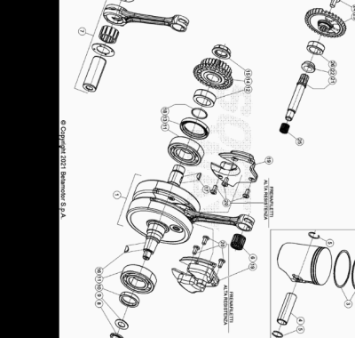

Ref. | Part Number | Description | Part
1 | 026.02.056.80.00 | CIGUEÑAL MOTOR RR 2T 300 | 1
2 | 026.02.060.80.0A | PISTON MOTOR D.73-A RR 2T 300 | 1
2 | 026.02.060.80.0B | PISTON D.73-B RR 2T 300 | 1
2 | 026.02.060.80.0C | PISTON D.73-C RR 2T 300 | 1
3 | 026.02.061.00.00 | SEGMENTO D.73 | 2
4 | 026.02.023.00.00 | BULON PISTON | 1
5 | 10.42600.000 | ANILLO CIERRE BULON 18 | 2
6 | 16.16710.000 | GABIA BIELA EVO 250/290 CC 18.22.20 | 1
7 | 026.02.059.80.00 | BIELA RR 2T | 1
8 | 13.25010.000 | TUERCA ESP.VOLANTE MAGNETICO MORIC GR65/85 RR-4T | 1
9 | 27.74810.000 | ARANDELA GOMA | 1
10 | C02.01.041.00.00 | RETEN 25X35X7 | 1
11 | C06.01.035.00.00 | COJINETE 3 TM 6206 CJR 2CM40 | 2
12 | 026.02.009.00.00 | DISTANCIADOR CIGUEÑAL | 1
13 | C02.01.042.00.00 | RETEN 38 X 52 X 7 FPM | 1
14 | 026.03.005.80.00 | PIÑON TRANSMISION PRIMARIA Z 27 | 1
15 | 006.03.023.00.00 | TUERCA M. 20 X 1 X 5 LH | 1
16 | 12.46020.000 | CHAVETA 3.5 | 1
17 | 12.46151.000 | CHAVETA CIGUEÑAL 4X5 UNI 6606 | 1
18 | 10.66620.000 | JUNTA TORICA 25,12.1,78 | 1
19 | 026.02.048.00.00 | SOPORTE CIGUEÑAL | 2
20 | C24.91.002.00.00 | TORNILLO 6.12 TORX | 6
21 | 026.02.040.00.00 | EJE BALANCIN | 1
22 | 026.02.042.00.00 | DISTANCIADOR | 1
23 | 026.02.007.00.00 | ENGRANAJE EJE | 1
24 | C24.31.044.00.00 | TORNILLO M 8 X 16 DIN 6921 | 1
25 | 11.22200.000 | COJINETE AGUJAS 12.18.12 | 1
26 | 12.98000.000 | COJINETE 20.42.12 | 1

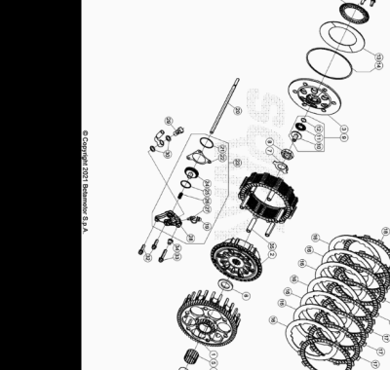

Ref. | Part Number | Description | Part
1 | 037.03.000.00.00 | PRIMARIA Z-72 | 1
2 | 029.03.141.00.00 | TAMBOR EMBRAGUE | 1
3 | 037.03.002.00.00 | PLATILLO EMBRAGUE | 1
4 | 026.03.061.00.00 | CASQUILLO CORONA TRANSMISION PRIMARIA | 1
5 | 006.03.063.00.00 | JAULA RODILLOS 26 X 30.22 | 1
6 | 006.03.062.00.00 | ARANDELA 21,7 X 38.3 | 1
7 | 037.03.006.48.00 | ARANDELA | 1
8 | 006.03.065.00.00 | TUERCA M 18x1,5 H9 | 1
9 | 029.03.071.80.00 | ACOPLE VARILLA CUERPO EMBRAGUE | 1
10 | 029.03.071.00.00 |  | 1
11 | 16.11370.000 | GABIA 15.28.2 | 1
12 | 28.23105.000 | SEEGER RB 14 DIN 7993 | 1
13 | 037.03.003.00.00 | MUELLE | 1
14 | 037.03.004.00.00 | TORICA 112.5 X 117.5 X 1.2 | 1
15 | 037.03.007.00.00 | TORNILLO ESPECIAL M. 6 X 16 | 6
16 | 037.03.008.00.00 | DISCO SEPARADOR EMBRAGUE | 7
17 | 029.03.053.00.00 | DISCO EMBRAGUE | 6
18 | 029.03.054.00.00 | DISCO EMBRAGUE | 2
19 | 16.33788.000 | TAPON | 1
20 | 026.03.070.00.00 | VARILLA EMBRAGUE | 1
21 | 10.66840.000 | TORICA OR 33 X 1.5 | 1
22 | 006.03.085.00.00 | JUNTA BOMBIN EMBRAGUE | 1
23 | 029.03.001.80.00 | BOMBIN EMBRAGUE RR | 1
24 | 006.03.281.80.00 | PISTON EMBRAGUE | 1
25 | 10.66520.000 | JUNTA TORICA 23,52.1,78.EPDM (OR2-021) | 1
26 | 006.03.083.00.00 | MUELLE BOMBIN EMBRAGUE | 1
27 | 28.91050.000 | RESPIRADOR AIRE PINZA POST. TR-89 | 1
28 | 029.03.001.00.00 | TAPA BOMBIN EMBRAGUE | 1
29 | 11.65040.000 | TORNILLO ESP. TALAD.10.1 PARA TUBO FRENO | 1
30 | 16.50510.000 | JUNTA 10.15.1 (COBRE) | 2
32 | 11.49070.000 | TORNILLO 6X20 RS CH8 | 2
33 | 11.50355.000 | TORNILLO ANCLAJE M6X35 RS CH 8 | 1
34 | 13.49190.000 | DISTANCIADOR RR-4T / RR 125 | 1
35 | 037.03.009.00.00 | GUIA DISCO | 6
36 | 037.03.005.00.00 | ANILLO | 1

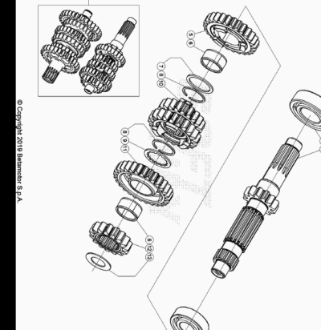

Ref. | Part Number | Description | Part
1 | 026.04.000.80.00 | CAMBIO COMPLETO | 1
2 | 026.04.010.00.00 | EJE PRIMARIO | 1
3 | 12.95610.000 | COJINETE 6205 C3 | 1
4 | 12.95605.000 | COJINETE ( 6203 ) JR2 C3 | 1
5 | 006.04.015.00.00 | ENGRANAJE 5ª EJE PRIMARIO | 1
6 | 11.22855.000 | JAULA RODILLOS 22 X 26 X 13 | 2
7 | 006.04.031.00.00 | ARANDELA DISTANCIADORA EJE PRIMARIO | 1
8 | 28.25520.000 | SEEGER SW25 | 2
9 | 006.04.030.00.00 | ARANDELA DISTANCIADORA | 1
10 | 006.04.013.00.00 | ENGRANAJE 3ª/4ª EJE PRIMARIO | 1
11 | 006.04.016.00.00 | ENGRANAJE 6ª EJE PRIMARIO | 1
12 | 006.04.012.00.00 | ENGRANAJE 2ª EJE PRIMARIO | 1
13 | 006.04.032.00.00 | ARANDELA DISTANCIADORA 17 X 30 X 1 | 1

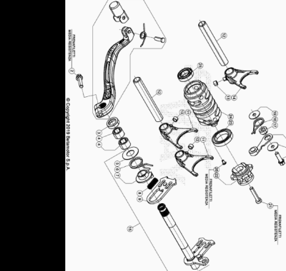

Ref. | Part Number | Description | Part
1 | 026.05.002.80.00 | PALANCA CAMBIO | 1
2 | 11.50010.000 | TORNILLO 6,25 RS CH 8 | 1
3 | 10.52012.000 | RETEN 14 X 24 X 6 | 1
4 | 11.22320.000 | JAULA RODILLOS | 2
5 | 27.63020.000 | ARANDELA 14 X 30 X 1 | 1
6 | 006.05.017.00.00 | MUELLE RETORNO PALANCA CAMBIO | 1
7 | 16.92911.000 | GUIA MUELLE CAMBIO | 1
8 | 006.05.016.00.00 | MUELLE 0.8 MM | 1
9 | 006.05.014.80.00 | HORQUILLA MOVIL CAMBIO | 1
11 | 006.05.020.00.00 | HORQUILLA 1/4 | 2
12 | 026.05.025.00.00 | EJE HORQUILLA CAMBIO | 2
13 | 006.05.027.00.00 | CASQUILLO 6 X 8 X 5,2 | 3
14 | 006.05.021.00.00 | HORQUILLA 5/6 | 1
15 | 026.05.010.80.00 | EJE CAMBIO COMPLETO RR 2T | 1
16 | 22.39591.000 | MUELLE PALANCA CAMBIO | 1
17 | 029.05.054.00.00 | DISTANCIADOR | 1
18 | 026.05.050.80.00 | PALANCA ARRASTRE | 1
19 | 27.42000.100 | ARANDELA 6 X 20 X 1,0 | 2
20 | 11.49070.000 | TORNILLO 6X20 RS CH8 | 1
21 | 31.45000.000 | TORNILLO ALLEN TCCE 6.30 | 1
22 | 029.05.001.80.00 | LEVA ARRESTO | 1
23 | 12.93405.000 | COJINETE 61805-2RS1 | 1
24 | 026.05.030.00.00 | SELECTOR CAMBIO | 1
25 | 12.93840.000 | COJINETE 15 X 28 X 7 C3 | 1
26 | 31.30084.000 | TORNILLO *TORX 25* 5 X 8 | 1

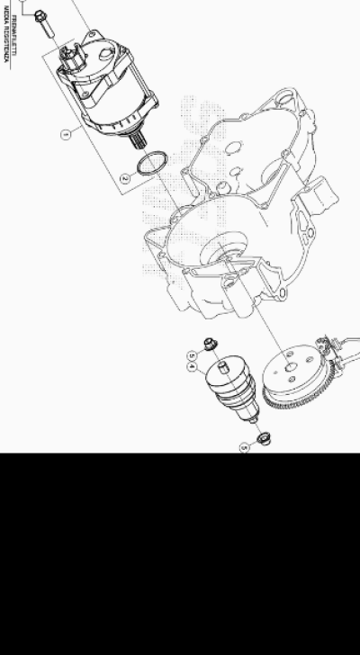

Ref. | Part Number | Description | Part
1 | 026.07.011.80.00 | MOTOR ARRANQUE | 1
2 | 36.25056.000 | OR 25,00X3,00 NBR 70 RR-4T | 1
3 | 11.50010.000 | TORNILLO 6,25 RS CH 8 | 2
4 | 026.07.010.00.00 | BENDIX ARRANQUE | 1
5 | C03.02.001.00.00 | CASQUILLO 8x10x8 | 2

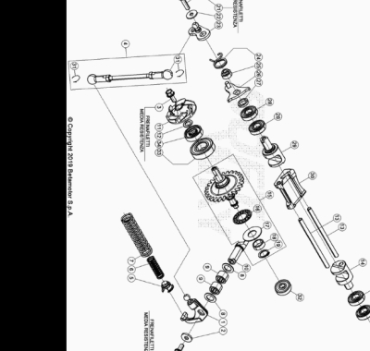

Ref. | Part Number | Description | Part
1 | 026.09.013.80.00 | BALANCIN COMPLETO | 1
2 | C16.02.001.00.00 | ARANDELA 5.15.2 DIN 7349 | 1
3 | 11.46251.000 | TORNILLO 5.12 RS CH8 | 2
4 | 026.09.015.80.00 | VARILLA MANDO VALVULA | 1
5 | 026.09.017.00.00 | GUIA MUELLE VALVULA | 1
6 | 026.09.018.00.00 | MUELLE AUXILIAR | 1
7 | 026.09.022.00.00 | MUELLE REGULACION | 1
8 | C19.04.001.00.00 | ARANDELA SPESS. 10.16.1 DIN988 | 2
9 | 11.22100.000 | COJINETE AGUJAS 10.14.10 | 2
10 | 026.09.011.00.00 | EJE CONTROL | 1
11 | 006.09.000.00.00 | ASPAS BOMBA AGUA | 1
12 | 006.09.012.00.00 | ARANDELA | 1
13 | 026.09.031.00.00 | EJE VALVULA ESCAPE | 2
14 | 026.09.040.00.00 | VALVULA BOOSTER SX | 1
15 | 026.09.005.80.00 | UNIDAD CENTRIFUGA | 1
16 | 16.11512.000 | JAULA AGUJAS COJINETE | 1
17 | 27.56400.000 | DISTANCIADOR AS1226 | 1
18 | 026.09.003.00.00 | DISTANCIADOR | 1
19 | 28.22760.000 | SEEGER A12 DIN 471 | 1
21 | 31.30015.000 | TORNILLO ALLEN 5 X 20 | 1
22 | 27.36500.000 | ARANDELA PLANA 5.15 | 1
23 | 026.09.042.85.00 | EJE MANDO | 1
24 | 026.09.046.00.00 | MUELLE COMPENSACION | 1
25 | 026.09.044.00.00 | DISTANCIADOR | 1
26 | 026.09.043.85.00 | PALANCA FINAL CARRERA | 1
27 | 026.09.047.00.00 | DISTANCIADOR | 1
28 | 12.93410.000 | COJINETE 10.22.6 2RS1 | 4
29 | 026.09.041.00.00 | VALVULA BOOSTER DX | 1
30 | 026.09.051.00.00 | VALVULA ESCAPE | 1
31 | C21.31.001.00.00 | MUELLE SEGURIDAD | 2
32 | 12.93387.000 | COJINETE 6 X 19 X 6 | 1
33 | C06.01.001.00.00 | COJINETE 15 X 32 X 9 6002-2RSH C3 | 1
34 | 10.43720.000 | RETEN ACEITE 8 X 24 X 7 | 1

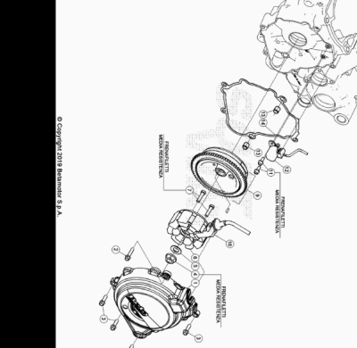

Ref. | Part Number | Description | Part
1 | 026.01.051.80.52 | TAPA VOLANTE | 1
2 | 11.50010.000 | TORNILLO 6,25 RS CH 8 | 2
3 | 11.49070.000 | TORNILLO 6X20 RS CH8 | 3
4 | 13.25010.000 | TUERCA ESP.VOLANTE MAGNETICO MORIC GR65/85 RR-4T | 1
5 | 27.74810.000 | ARANDELA GOMA | 1
6 | 026.10.005.00.00 | STATOR | 1
7 | 31.48507.000 | TORNILLO ESP 6X25 | 2
9 | 026.10.001.85.00 | ROTOR VOLANTE | 1
10 | 006.01.054.00.00 | PLACA SUJECCION INSTALACION | 1
11 | 11.46251.000 | TORNILLO 5.12 RS CH8 | 2
12 | 026.10.006.00.00 | PICK UP | 1
13 | 16.36500.000 | CASQUILLO CENTRADOR 9.10 | 2
14 | 026.01.053.00.00 | JUNTA TAPA VOLANTE | 1

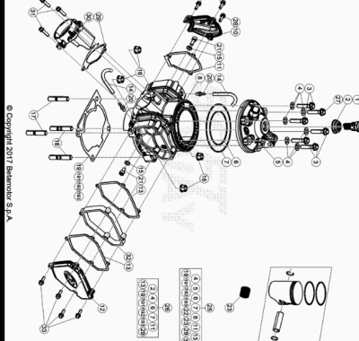

Ref. | Part Number | Description | Part
1 | 036.11.001.00.00 | BUJIA IRIDIO T40352G ( NGK IR - GR7CI 8 ) | 1
2 | 026.10.012.00.00 | JUNTA BUJIA | 1
3 | 026.11.011.00.00 | TORNILLO M8 X 35 | 5
4 | 026.11.010.00.00 | ARANDELA 8 X 16 X 1 | 6
5 | 036.11.013.80.52 | CULATA D.73 NEGRA XTRAINER 2T 300 | 1
6 | 10.66973.000 | TORICA OR 78.2 VITON | 1
7 | 10.66978.000 | TORICA OR 105.2 VITON | 1
8 | 026.11.051.00.0A | CILINDRO D.73 A RR 2T 300 | 1
8 | 026.11.051.00.0B | CILINDRO D.73 B RR 2T 300 | 1
9 | 11.46360.000 | TORNILLO 5X16 LLAVE 8rs RR-4T | 2
10 | 026.11.052.00.00 | TAPA | 1
11 | 026.11.053.00.00 | JUNTA TAPA | 1
12 | 026.11.004.00.52 | TAPA VALVULA SX | 1
13 | 026.11.005.00.00 | JUNTA TAPA VALVULA SX | 2
14 | 026.11.012.00.00 | TUBO DE VENTILACION | 2
15 | 27.40500.000 | ARANDELA PLANA 6.12.1,6 DIN125 | 2
16 | 13.20210.000 | TUERCA ESPECIAL M10X1.25 CH13 | 4
17 | C24.76.003.00.00 | PRISIONERO M10 X 28 X 1.25 | 2
18 | C24.76.004.00.00 | PRISIONERO M.10 X 33 X 1.25 | 2
19 | 026.11.025.00.00 | JUNTA BASE CILINDRO SPESS. 0,30MM | 1
20 | 29.00280.000 | TAPON TOMA AIRE DEP. | 2
21 | 31.31050.000 | TORNILLO ALLEN TCCE 6.15 | 2
22 | 026.02.060.80.0A | PISTON MOTOR D.73-A RR 2T 300 | 1
22 | 026.02.060.80.0B | PISTON D.73-B RR 2T 300 | 1
22 | 026.02.060.80.0C | PISTON D.73-C RR 2T 300 | 1
23 | 16.16710.000 | GABIA BIELA EVO 250/290 CC 18.22.20 | 1
25 | 036.11.015.82.0A | CILINDRO D.73 LETRA A- KIT | 1
25 | 036.11.015.82.0B | CILINDRO D.73 LETRA B- KIT | 1
26 | 026.11.040.82.00 | KIT JUNTAS GRUPO TERMICO | 1
27 | 026.11.037.00.00 | TORNILLO DE SEGURIDAD | 1
28 | 026.11.036.00.00 | TORNILLO DE SEGURIDAD | 1
29 | 026.11.038.00.00 | JUNTA BRIDA | 1
30 | 026.11.032.00.00 | BRIDA ESCAPE | 1
31 | 11.49070.000 | TORNILLO 6X20 RS CH8 | 3
32 | 036.11.007.20.00 | DISTANCIADOR | 1
33 | C24.31.042.00.00 | TORNILLO 5 X 25 RS CH 8 | 4
191 | 026.11.026.00.00 | JUNTA BASE CILINDRO SPESS. 0,40 MM | 1
192 | 026.11.027.00.00 | JUNTA BASE CILINDRO SPESS. 0,50MM | 1
193 | 026.11.028.00.00 | JUNTA BASE CILINDRO SPESS 0.60MM | 1

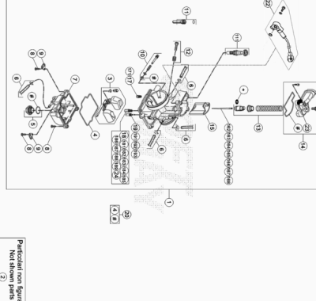

Ref. | Part Number | Description | Part
1 | 036.12.014.80.00 | CARBURADOR ASSY XTRAINER 2T 300 | 1
2 | 036.12.015.80.00 | CARBURADOR COMPLETO XTRAINER 2T 300 EU | 1
3 | 026.12.009.80.00 | FLOTADOR CARBURADOR COMPL. | 1
4 | 026.12.011.00.00 | JUNTA CUBETA CARBURADOR | 1
5 | 026.12.012.80.00 | TAPON COMPLETO | 1
6 | 026.12.045.00.00 | KIT TUBO SOBRANTE CARBURADOR | 1
7 | 026.12.107.00.00 | CUBETA COMPLETA | 1
8 | 026.12.016.00.00 | TORNILLO M4 X 16 | 3
9 | 026.12.024.00.00 | PLACA FLOTADOR | 2
10 | 026.12.028.80.00 | TORNILLO DE REGULACION COMPLETO | 1
11 | 026.12.006.80.00 | DISTANCIADOR LIMITAC. VALVULA CARB. COMPL. | 1
12 | 026.12.032.80.00 | TONILLO REGULACION M.5 COMPL. | 1
13 | 026.12.037.80.00 | MUELLE COMPLETO | 1
14 | 036.12.001.80.00 | TAPA CARBURADOR COMPLETA | 1
15 | 036.12.002.00.00 | VALVULA CARBURADOR | 1
17 | 026.12.046.00.00 | SURTIDOR STARTER 85 PARA CARBURADOR KEIHIN | 1
18 | 16.42304.000 | GETTO MAXIMO 118 | 1
19 | 16.42357.000 | GETTO MINIMO 35 | 1
20 | 026.12.044.00.00 | KIT JUNTAS | 1
22 | 036.12.004.00.00 | SENSOR VALVULA | 1
23 | 25.57912.000 | PLACA FIJACION MUELLE COLECTOR REV4T | 1
24 | 16.42311.000 | GETTO MAXIMO 130 | 1
111 | 026.12.008.00.00 | PISTON STARTER CMPL. | 1
162 | 036.12.003.00.00 | AGUJA CARBURADOR KEIHIN NIEJ | 1
163 | 026.12.017.00.00 | AGUJA KEIHIN N84K- HOMOL- | 1
164 | 026.12.023.00.00 | AGUJA KEIHIN NOZJ | 1
165 | 036.12.005.00.00 | AGUJA N1EI | 1
166 | 036.12.006.00.00 | AGUJA N1EK | 1
167 | 026.12.022.00.00 | AGUJA KEIHIN NOZK | 1
168 | 036.12.018.00.00 | AGUJA N84H | 1
171 | 026.12.005.00.00 | GETTO STARTER 50 PARA CARBURADOR KEIHIN | 1
181 | 36.25104.000 | DIFUSOR MÁXIMO 155 KEIHIN RR-4T | 1
182 | 36.25105.000 | DIFUSOR MÁXIMO 158 KEIHIN RR-4T | 1
183 | 36.25106.000 | DIFUSOR MÁXIMO 160 KEIHIN | 1
184 | 36.25107.000 | DIFUSOR MÁXIMO 162 KEIHIN RR-4T | 1
185 | 36.25108.000 | DIFUSOR MÁXIMO 165 KEIHIN RR-4T | 1
186 | 36.25109.000 | DIFUSOR MÁXIMO 168 KEIHIN RR-4T | 1
187 | 36.25110.000 | DIFUSOR MÁXIMO 170 KEIHIN RR-4T | 1
188 | 36.25111.000 | DIFUSOR MÁXIMO 172 KEIHIN RR-4T | 1
189 | 36.25112.000 | DIFUSOR MÁXIMO 175 KEIHIN RR-4T | 1
191 | 16.42355.000 | GETTO MINIMO 38 | 1
192 | 026.12.007.00.00 | #36.25101.000# | 1
193 | 16.42347.000 | CHICLE MIN.42 CARBURADOR KEIHIN | 1

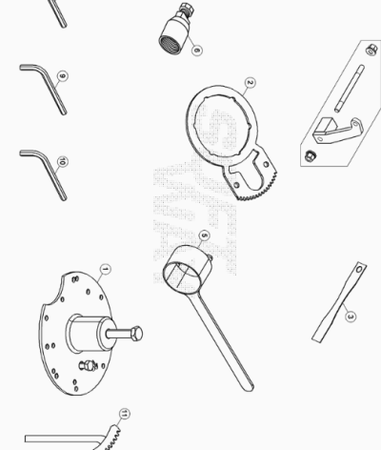

Ref. | Part Number | Description | Part
1 | 007.14.010.80.00 | DESACOPLADOR DEL CARTER | 1
2 | 037.14.002.50.00 | LLAVE ESPECIAL | 1
3 | 026.14.017.00.00 | INSTRUMENTO MEDIDA SQUISH | 1
4 | 026.14.003.00.00 | BRIDA SOPORTE MOTOR | 1
5 | 026.14.005.50.00 | UTILAJE PARA BLOQUEAR EL VOLANTE | 1
6 | 36.25173.000 | EXTRACTOR VOLANTE MAGNETICO RR2T/ RR-4T | 1
8 | 026.44.029.00.00 | LLAVE ESPECIAL | 1
9 | 026.44.028.00.00 | LLAVE ESPECIAL | 1
10 | 007.44.035.00.00 | LLAVE ESPECIAL | 1
11 | 026.14.012.50.00 | LLAVE ESPECIAL | 1

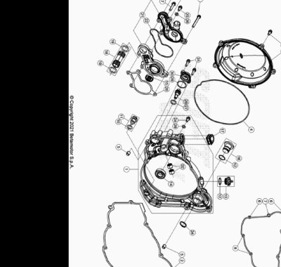

Ref. | Part Number | Description | Part
1 | 026.01.029.80.52 | TAPA EMBRAGUE | 1
2 | 026.01.005.00.00 | JUNTA TAPA INTERIOR EMBRAGUE | 1
3 | 026.01.018.80.52 | TAPA EXTERIOR EMBRAGUE | 1
4 | 026.01.041.00.00 | JUNTA TORICA TAPA EXTERIOR EMBRAGUE | 1
5 | 16.36500.000 | CASQUILLO CENTRADOR 9.10 | 2
6 | 11.49070.000 | TORNILLO 6X20 RS CH8 | 4
7 | 11.50300.000 | TORNILLO 6,30 RS CH 8 RR-4T / RR 125 | 4
8 | 11.05535.000 | TORNILLO 6,50 RS CH 8 RR-4T | 3
9 | 11.05485.000 | TORNILLO 6.60 RS CH 8 RR-4T | 2
10 | 10.66164.000 | TORICA OR 11.2,5 NBR 70SH | 1
11 | 006.08.152.80.00 | TAPON PARA EL ESCAPE DE ACEITE | 1
12 | 10.66321.000 | TORICA OR 17.17X1.78 | 2
13 | 026.01.019.80.59 | TAPON LLENADO ACEITE | 1
14 | C06.01.001.00.00 | COJINETE 15 X 32 X 9 6002-2RSH C3 | 1
15 | 10.43720.000 | RETEN ACEITE 8 X 24 X 7 | 1
16 | 037.01.017.80.59 | TAPON | 1
17 | 026.01.031.80.00 | JUNTA VALVULA | 1
18 | 026.01.037.80.00 | TUBO AGUA | 1
19 | C02.06.052.00.00 | TORICA OR 17,96 X 2,62 | 2
20 | 026.01.036.00.00 | JUNTA CUERPO BOMBA AGUA | 1
21 | 026.01.056.82.00 |  | 1
22 | 026.01.035.00.00 | JUNTA BOMBA AGUA | 1
24 | 11.46501.000 | TORNILLO ENCAJE M6.10 RSCH8 | 1
25 | 11.47015.000 | TORNILLO 6.12 REV3-04 - RR-4T | 1
26 | 27.40495.000 | ARANDELA COBRE 6.11 | 2
27 | 10.66296.000 | TORICA OR 12,37.2,62 NBR70 | 1
28 | 026.09.023.42.00 | GUIA REGULACION MUELLE | 1
29 | 10.66540.000 | TORICA OR 24.2 NBR70 | 1
30 | 026.09.025.00.00 | TAPA REGULADOR | 1
31 | 11.46401.000 | TORNILLO 5X20 LLAVE 8rs RR-4T | 2
32 | 11.22100.000 | COJINETE AGUJAS 10.14.10 | 2
34 | 33.00070.000 | SEEGER PARA EJE D.19 | 1

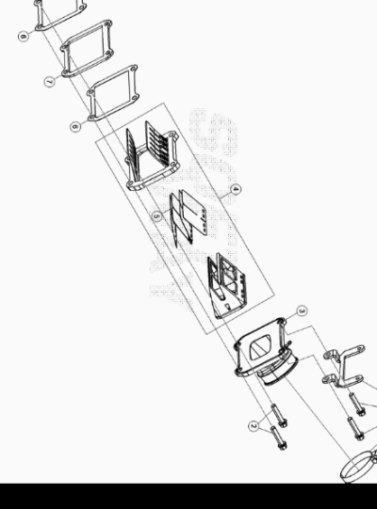

Ref. | Part Number | Description | Part
1 | 15.14275.000 | ABRAZADERA 52/12 | 1
2 | 11.50300.000 | TORNILLO 6,30 RS CH 8 RR-4T / RR 125 | 3
3 | 036.01.005.80.00 | TOBERA CARBURADOR | 1
4 | 026.01.007.80.00 | CAJA LAMINAS COMPL. | 1
5 | 026.01.009.00.00 | KIT LAMINAS | 1
6 | 026.01.010.00.00 | JUNTA VALVULA ASPIRACION | 2
7 | 026.01.008.42.52 | DISTANCIADOR | 1
8 | 036.01.009.32.00 | SOPORTE BOBINA | 1
9 | 026.11.034.00.00 | TORNILLO SEGURIDAD | 1

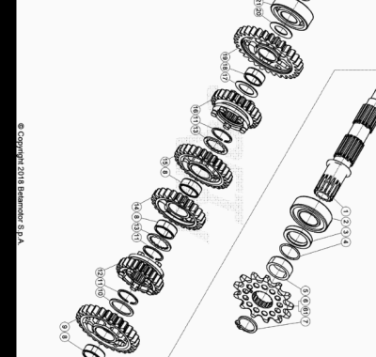

Ref. | Part Number | Description | Part
1 | 026.04.020.00.00 | EJE SECUNDARIO | 1
2 | 12.99710.000 | COJINETE NJ 205 | 1
3 | 10.66020.000 | RETEN 32 X 45 X 6 X 5 | 1
4 | 10.66620.000 | JUNTA TORICA 25,12.1,78 | 1
5 | 006.04.040.00.00 | DISTANCIADOR | 1
6 | 006.04.051.00.00 | PIÑON Z=14 | 1
7 | 28.25530.000 | ANILLO SEEGER 25 X 2 | 1
8 | 11.22845.000 | JAULA RODILLOS 22 X 26 X 10 | 3
9 | 006.04.022.00.00 | ENGRANAJE 2ª EJE SECUNDARIO | 1
10 | 006.04.031.00.00 | ARANDELA DISTANCIADORA EJE PRIMARIO | 1
11 | 28.25520.000 | SEEGER SW25 | 3
12 | 006.04.026.00.00 | ENGRANAJE 6ª EJE SECUNDARIO | 1
13 | 006.04.030.00.00 | ARANDELA DISTANCIADORA | 2
14 | 006.04.024.00.00 | ENGRANAJE 4ª EJE SECUNDARIO | 1
15 | 006.04.023.00.00 | ENGRANAJE 3ª EJE SECUNDARIO | 1
16 | 006.04.025.00.00 | ENGRANAJE 5ª EJE SECUNDARIO | 1
17 | 006.04.033.00.00 | ARANDELA DISTANCIADORA 20 X 30 X 1 | 1
18 | 11.22835.000 | JAULA RODILLOS 20 X 24 X 10 | 1
19 | 006.04.021.00.00 | ENGRANAJE 1ª EJE SECUNDARIO | 1
20 | 006.04.032.00.00 | ARANDELA DISTANCIADORA 17 X 30 X 1 | 1
21 | 12.95605.000 | COJINETE ( 6203 ) JR2 C3 | 1
24 | C01.23.001.00.00 | SEEGER 17 X 1 DIN 471 A | 1
61 | 006.04.052.00.00 | PIÑON SALIDA Z15 | 1

Ref. | Part Number | Description | Part
1 | 026.04.020.00.00 | EJE SECUNDARIO | 1
2 | 12.99710.000 | COJINETE NJ 205 | 1
3 | 10.66020.000 | RETEN 32 X 45 X 6 X 5 | 1
4 | 10.66620.000 | JUNTA TORICA 25,12.1,78 | 1
5 | 006.04.040.00.00 | DISTANCIADOR | 1
6 | 006.04.051.00.00 | PIÑON Z=14 | 1
7 | 28.25530.000 | ANILLO SEEGER 25 X 2 | 1
8 | 11.22845.000 | JAULA RODILLOS 22 X 26 X 10 | 3
9 | 006.04.022.00.00 | ENGRANAJE 2ª EJE SECUNDARIO | 1
10 | 006.04.031.00.00 | ARANDELA DISTANCIADORA EJE PRIMARIO | 1
11 | 28.25520.000 | SEEGER SW25 | 3
12 | 006.04.026.00.00 | ENGRANAJE 6ª EJE SECUNDARIO | 1
13 | 006.04.030.00.00 | ARANDELA DISTANCIADORA | 2
14 | 006.04.024.00.00 | ENGRANAJE 4ª EJE SECUNDARIO | 1
15 | 006.04.023.00.00 | ENGRANAJE 3ª EJE SECUNDARIO | 1
16 | 006.04.025.00.00 | ENGRANAJE 5ª EJE SECUNDARIO | 1
17 | 006.04.033.00.00 | ARANDELA DISTANCIADORA 20 X 30 X 1 | 1
18 | 11.22835.000 | JAULA RODILLOS 20 X 24 X 10 | 1
19 | 006.04.021.00.00 | ENGRANAJE 1ª EJE SECUNDARIO | 1
20 | 006.04.032.00.00 | ARANDELA DISTANCIADORA 17 X 30 X 1 | 1
21 | 12.95605.000 | COJINETE ( 6203 ) JR2 C3 | 1
24 | C01.23.001.00.00 | SEEGER 17 X 1 DIN 471 A | 1
61 | 006.04.052.00.00 | PIÑON SALIDA Z15 | 1

