

ENDURO_RR-S_500_4T_MY19_USA
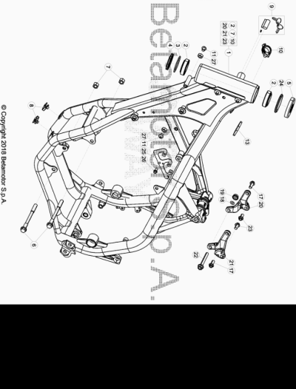

ENDURO_RR-S_500_4T_MY19_USA
Ref. | Part Number | Description | Part
1 | 031.31.010.80.50 | CHASIS | 1
2 | 12.99510.000 | COJINETE CÓNICO 29X50X15 RR-4T | 2
3 | 10.66935.000 | JUNTA TÓRICA RR-4T | 1
4 | 020.31.039.00.00 | GUARDAPOLVO DIRECCION | 1
5 | 031.31.016.22.00 | PROTECCION COJINETE | 1
6 | 11.64607.000 | TORNILLO ESPECIAL RR-4T | 2
7 | 13.21060.000 | TUERCA AMBRIDADA M10 X 1,25 | 2
8 | 25.60311.000 | GRAPA TORNILLO M6 ALP 4.0 2008 | 2
9 | 28.85861.000 | CLAUSOR CERRADURA (Q20.30) RR. | 1
10 | 25.24441.000 | PASACABLES | 1
11 | 31.64060.000 | TORNILLO TBIB 8.16 | 2
13 | 031.31.035.00.00 | SLENT BLOCK DEPOSITO | 1
17 | 11.54521.000 | TORNILLO 8.16 RS C/ARANDELA CH.10 | 2
18 | 27.49500.000 | ARANDELA PLANA 8.18 | 1
19 | 13.17120.000 | TUERCA M8 BASE CILINDRO | 1
20 | 020.31.144.00.00 | BRIDA FIJACION CULATA DX | 1
21 | 020.31.145.00.00 | BRIDA FIJACION CULATA SX | 1
22 | 11.55970.000 | TORNILLO 8.65 PF CH 13 RS | 1
23 | 11.54521.000 | TORNILLO 8.16 RS C/ARANDELA CH.10 | 2
24 | 031.32.007.00.00 | ANILLO DE SELLADO | 1
25 | 031.40.126.22.00 | SOPORTE | 1
26 | 11.47015.000 | TORNILLO 6.12 REV3-04 - RR-4T | 1
27 | 13.16000.000 | TUERCA 8.6 CH13 | 2

ENDURO_RR-S_500_4T_MY19_USA
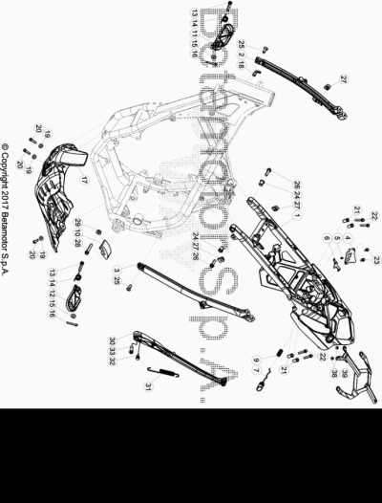

ENDURO_RR-S_500_4T_MY19_USA
Ref. | Part Number | Description | Part
1 | 031.32.008.37.51 |  | 1
2 | 020.32.100.00.59 | BRAZO CHASIS POSTERIOR DX | 1
3 | 020.32.027.42.59 | SOPORTE CHASIS POSTERIOR SX | 1
4 | 020.32.010.00.05 | CHAPA FIJ. CERRADURA | 1
5 | 020.32.112.00.00 | EJE CERRADURA | 1
6 | 020.32.011.00.05 | PLACA CERRADURA | 1
7 | 020.32.013.80.51 | BOTON CERRADURA FIJACION SILLIN | 1
9 | 020.32.016.00.00 | MUELLE | 1
10 | 25.25601.000 | PATIN TENSOR RR 4T 2008 | 1
11 | 25.32521.000 | ESTRIBERA DX ENDURO RR 4T | 1
12 | 25.32531.000 | ESTRIBERA SX ENDURO RR 4T | 1
13 | 25.54465.000 | EJE ESTRIBERA RR-4T | 2
14 | 016.32.020.00.00 | MUELLE ESTRIBERA | 2
15 | 031.32.001.00.00 | ARANDELA 10 X 21 X 2 | 2
16 | 12.81993.000 | PASADOR EJE ESTRIBERA | 2
17 | 031.32.005.00.59 | CUBRECARTER RR 4T | 1
18 | 27.23470.000 | RACORD MOTOR RK6-50/ TUBO GASOLINA RR-T/ART - RR-4T- RR 125 | 1
19 | 27.42000.000 | ARANDELA PLANA 6.18 | 3
20 | 11.49070.000 | TORNILLO 6X20 RS CH8 | 3
21 | 020.32.004.00.00 | CASQUILLO SUPERIOR | 4
22 | 11.50355.000 | TORNILLO ANCLAJE M6X35 RS CH 8 | 4
23 | 31.29810.000 | TORNILLO TBCE 5.12 | 2
24 | 020.32.003.00.00 | CASQUILLO DELANTERO | 2
25 | 007.32.032.00.00 | TORNILLO ESP. TSBEI CH6 M8X20 10.9 ZINC | 2
26 | 31.64070.000 | TORNILLO ESPECIAL 8X25 CH10 | 2
27 | 25.60311.000 | GRAPA TORNILLO M6 ALP 4.0 2008 | 3
28 | 11.55480.000 | TORNILLO 8.40 PF C/ARANDELA | 1
29 | 13.17020.000 | TUERCA M8 AUTOBLOC. BASSO | 1
30 | 031.32.070.00.00 | #037.32.010.82.00# | 1
31 | 020.32.026.00.00 | MUELLE CABALLETE | 1
32 | 11.66615.000 | TORNILLO ESP. CAVALLETE RR 4T 2008 | 1
33 | 11.66614.000 | TORNILLO ESPECIAL CABALLETE RR 4T 2008 | 1
38 | 13.12610.000 | TUERCA AUTOBLOCANTE GUIACADENA ENDURO 4T PS-M6-3 | 2
39 | 031.32.078.40.59 |  | 1

ENDURO_RR-S_500_4T_MY19_USA
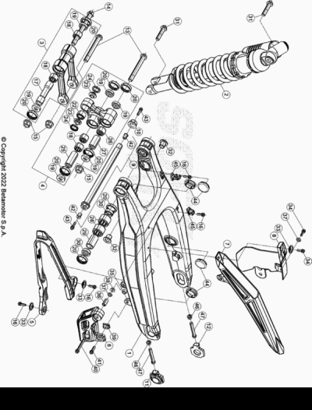

ENDURO_RR-S_500_4T_MY19_USA
Ref. | Part Number | Description | Part
1 | 031.33.019.00.59 | BASCULANTE ENDURO RR | 1
2 | 031.33.025.80.00 | AMORTIGUADOR | 1
3 | 020.33.030.80.00 | BIELETA COMPLETA | 1
4 | 020.33.020.80.00 | TRAPEZIO COMPLETO | 1
5 | 020.33.015.00.00 | PROTECTOR CADENA SUP. | 1
6 | 29.10071.000 | PROTECTOR CADENA INFERIOR RR-4T/08 | 1
7 | 12.88591.159 | #12.88591.000# | 1
8 | 12.88594.159 | CUBRECADENA INF RR 4 T | 1
9 | 031.33.142.80.00 | EJE BASCULANTE | 1
10 | 13.27121.000 | #037.33.008.50.00# | 1
11 | 29.11866.100 | TENSOR CADENA IZQUIERDO RR-4T | 1
12 | 29.11865.100 | TENSOR CADENA DERECHO RR-4T | 1
13 | 11.63992.000 | TORNILLO 12.1,25.96 BIELETA RR-4T | 2
14 | 020.33.032.00.00 | TORNILLO ESPECIAL M 12 | 1
15 | 13.21130.000 | TUERCA 12 RR-4T | 3
16 | 11.46251.000 | TORNILLO 5.12 RS CH8 | 4
17 | 020.33.031.00.00 | DISTANCIADOR | 1
18 | 11.22055.000 | COJINETE 20X26X16 RR-4T | 4
19 | 28.14083.000 | SOPERO BIELETAS RR-4T | 6
20 | 10.64481.000 | JUNTA ACEITE 25X32X7 RR-4T | 10
22 | 16.17310.000 | GABIA 12.24.13 | 1
23 | 11.21920.000 | CASQUILLO TRAPECIO RR-4T | 2
24 | 10.56020.000 | RETEN 16.24.4 | 2
25 | 13.62813.000 | DISTANCIADOR 12X20X50 RR-4T | 1
26 | 11.22061.000 | COJINETE 20x26x30 | 1
27 | 13.62812.000 | DISTANCIADOR 12X20X40 RR-4T | 1
28 | 11.22056.000 | COJINETE 22X28X12 RR-4T | 4
29 | 13.49183.000 | DISTANCIADOR BASCULANTE RR-4T | 2
30 | 28.14081.000 | SOPERO BASCULANTE RR-4T | 4
31 | 11.62050.000 | TORNILLO 10.45 RR-4T | 2
32 | 020.33.001.00.00 | DISTANCIADOR BASCULANTE RR 4T 2010 | 2
33 | 27.74786.000 | ARANDELA RR-4T | 3
34 | 11.46360.000 | TORNILLO 5X16 LLAVE 8rs RR-4T | 2
35 | 13.12610.000 | TUERCA AUTOBLOCANTE GUIACADENA ENDURO 4T PS-M6-3 | 1
36 | 13.49191.000 | DISTANCIADOR RR-4T | 1
37 | 13.54820.000 | DISTANCIADOR RR-4T | 2
38 | 13.13020.000 | TUERCA M6 AUTOBLOC. BASSO | 1
39 | 13.48868.000 | DISTANCIADOR RR 4T 2008 | 1
40 | 11.05535.000 | TORNILLO 6,50 RS CH 8 RR-4T | 1
41 | 11.49070.000 | TORNILLO 6X20 RS CH8 | 1
42 | 27.33740.000 | REMACHE M. 6 | 2
43 | 11.46401.000 | TORNILLO 5X20 LLAVE 8rs RR-4T | 2
44 | 29.10596.136 | TAPON BASCULANTE DIÁMETRO 30 RR-4T | 4
45 | 15.14605.000 | BRIDA FIJACIÓN TUBO FRENO RR-4T | 2
46 | 13.17122.000 | TUERCA M8 ENDURO RR 125 | 2
47 | 11.55909.000 | TORNILLO 8X55 IF CH 10 ZB | 2

ENDURO_RR-S_500_4T_MY19_USA
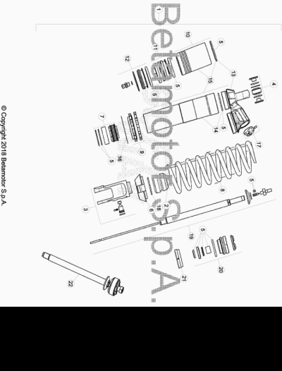

ENDURO_RR-S_500_4T_MY19_USA
Ref. | Part Number | Description | Part
1 | 031.33.025.80.00 | AMORTIGUADOR | 1
2 | 020.33.141.00.00 | TAPON AMORTIGUADOR RR 4T MY 10 | 1
3 | 026.33.023.00.00 | HORQUILLA AMORTIGUADOR | 1
4 | 13.86078.800 | KIT DISTANCIADOR AMORTIGUADOR RRT-4T-GR | 1
5 | 026.33.015.82.00 | KIT JUNTAS | 1
6 | 15.39110.000 | PROTECTOR AMORTIGUADOR RR-4T/06 | 1
7 | 026.33.020.00.00 | PISTON | 1
8 | 031.33.026.00.00 | MUELLE K 5,4 N/mm | 1
9 | 026.33.019.00.00 | TUERCAS AMORTIGUADOR | 1
10 | 026.33.012.00.00 | DEPOSITO AMORTIGUADOR | 1
11 | 026.33.013.00.00 | MEMBRANA | 1
12 | 026.33.014.00.00 | TAPON | 1
13 | 026.33.016.00.00 | TAPON | 1
14 | 026.33.017.00.00 | CUERPO AMORTIGUADOR | 1
15 | 026.33.018.00.00 | CUERPO AMORTIGUADOR | 1
16 | 031.33.012.00.00 | ARANDELA | 1
17 | 026.33.021.00.00 | TAPON REGISTRO | 1
18 | 031.33.014.00.00 | ARANDELA | 1
19 | 026.33.024.00.00 | VARILLA | 1
20 | 026.33.025.00.00 | GUIA | 1
21 | 026.33.026.00.00 | TAPON | 1
22 | 026.33.027.80.00 | VARILLA COMPLETA | 1

ENDURO_RR-S_500_4T_MY19_USA
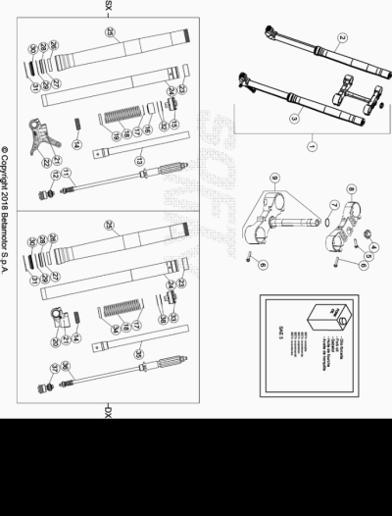

ENDURO_RR-S_500_4T_MY19_USA
Ref. | Part Number | Description | Part
1 | 031.34.065.82.00 | HORQUILLA COMPLETA RR 4T MY19 | 1
2 | 031.34.066.80.00 | BRAZO HORQUILLA DX | 1
3 | 031.34.067.80.00 | BRAZO HORQUILLA SX | 1
4 | 020.34.004.00.00 | TUERCA M 20 X 1,5 HORQUILLA RR 4T MY 10 | 1
5 | 11.55440.000 | TORNILLO C/HEX. 10 M8x30 DIN 933 8.8 | 1
6 | 11.55510.000 | TORNILLO 8.40 ALP 200/08 | 8
7 | 10.66420.000 | ANILLO OR 22-3,53 NBR | 1
8 | 031.34.051.42.04 | PLETINA SUPERIOR HORQUILLA | 1
9 | 031.34.041.82.04 | PLETINA INFERIOR HORQUILLA | 1
11 | 031.34.078.00.00 | GRUPO EXTENSION | 1
12 | 026.34.052.00.00 | GRUPO COMPRESION | 1
13 | 026.34.017.00.00 | TUBO INTERNO | 1
14 | 020.34.313.00.00 | ANILLO DE APOYO VARILLA+ O.RING | 2
15 | 026.34.053.00.00 | TAPON | 1
16 | 026.34.358.00.00 | DISTANCIADOR | 1
17 | 031.34.323.00.00 | ARANDELA | 2
18 | 031.34.025.00.00 | MUELLE K=4,8 N/MM | 2
19 | 031.34.026.00.00 | ANILLO DE CENTRAJE | 1
20 | 026.34.054.00.00 | PATA HORQUILLA | 1
21 | 020.34.308.00.00 | CLAVIJA | 2
22 | 026.34.055.00.00 | PATA HORQUILLA | 1
23 | 020.34.320.00.00 | CASQUILLO 049/47 L 20 | 2
24 | 031.34.021.00.00 | BARRA HORQ,. RR 2T/4T | 2
25 | 026.34.363.00.00 | BOTELLA | 2
26 | 031.34.020.00.00 | DISTANCIADOR D.52/48 L12 | 2
27 | 020.34.318.00.00 | DISTANCIADOR | 2
28 | 020.34.317.00.00 | RETEN HORQUILLA 48X58X9/11,5 | 2
29 | 020.34.316.00.00 | SEEGER 58,45 | 2
30 | 020.34.315.00.00 | GUARDAPOLVO HORQUILLA | 2
31 | 026.34.364.00.00 | ANILLO BLOQUEO | 2
32 | 031.34.023.00.00 | ANTIFRICCION MUELLE | 1
33 | 026.34.056.00.00 |  | 1
34 | 026.34.057.00.00 | CASQUILLO | 1
35 | 026.34.058.00.00 | TUBO | 1
36 | 031.34.079.00.00 | GRUPO EXTENSION | 1
37 | 031.34.080.00.00 | GRUPO COMPRESION | 1
38 | 031.34.323.00.00 | ARANDELA | 1

ENDURO_RR-S_500_4T_MY19_USA
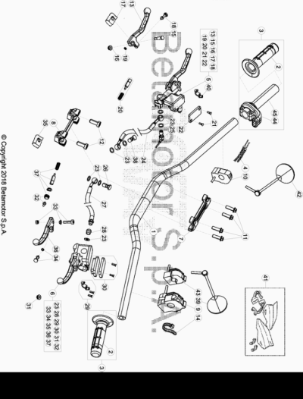

ENDURO_RR-S_500_4T_MY19_USA
Ref. | Part Number | Description | Part
1 | 026.35.000.00.59 | MANILLAR REIKON HL2716002 | 1
2 | 036.35.005.00.00 | JUEGO DE PUÑOS ENDURO | 1
3 | 031.35.012.80.00 | MANDO GAS | 1
4 | 031.35.007.82.00 | CABLE TRANSMISION GAS | 1
5 | 21.02057.059 | BOMBA FRENO DELANTERA RR4T RACING | 1
6 | 020.35.120.82.00 | #020.35.020.00.00# | 1
7 | 12.08253.000 | ABRAZADERA SUPERIOR HORQUILLA RR-4T | 1
8 | 12.08263.000 | ABRAZADERA INF HORQUILLA RR4T 1508050 | 1
9 | 016.35.010.00.00 | MANDO LUCES CON INTERMITENTES ENDURO 2017 | 1
10 | 026.40.047.00.00 | DISPOSITIVO ON/OFF | 1
11 | 31.64070.000 | TORNILLO ESPECIAL 8X25 CH10 | 4
12 | 31.65626.000 | TORNILLO 10X25 RR-4T | 2
13 | 21.27104.000 | MANETA FRENO ANT. FORJADA RR 4T | 1
14 | 15.14264.000 | ABRAZ.PA 6 NY.DENT.NAT.ABNY-B 3,6 X 200 | 1
15 | 31.96832.000 | PASADOR MANETA FRENO | 1
16 | 13.30911.000 | TUERCA PASADOR MANETA FRENO | 1
17 | 16.33841.000 | GOMA RR 4T 2008 | 1
18 | 31.88604.000 | TORINILLO REG | 1
19 | 22.38704.000 | MUELLE REG. BOMBA FRENO | 1
20 | 20.08258.000 | JUEGO PISTON COMPL. BOMBA FRENO ANT. RR-4T | 1
21 | 31.23410.052 | TORNILLO TAPA DEP. LIQUIDO FRENOS | 2
22 | 031.36.003.82.00 | KIT TAPA BOMBA FRENO ANT. RR2T | 1
23 | 16.50510.000 | JUNTA 10.15.1 (COBRE) | 8
24 | 031.36.004.00.00 |  | 1
25 | 18.89621.000 | INTERRUPTOR STOP RR-4T | 1
26 | 11.65040.000 | TORNILLO ESP. TALAD.10.1 PARA TUBO FRENO | 1
27 | 020.35.021.00.00 | #031.35.010.00.00# | 1
28 | 020.35.032.00.00 | RACORD BOMBA EMBRAGUE | 1
29 | 020.35.122.00.00 |  | 1
30 | 020.35.023.00.00 | TAPA DEPOSITO BOMBA EMBRAGUE | 1
31 | 020.35.028.00.00 | ANTIEMULSION | 1
32 | 020.35.029.00.00 | VARILLA DE PRESION | 1
33 | 020.35.024.00.00 | EJE PALANCA | 1
34 | 020.35.030.00.00 | GUIA RESORTE | 1
35 | 020.35.027.00.00 | GOMA PROTECCION PALANCA | 1
36 | 020.35.022.00.00 | MANETA EMBRAGUE RR4T 2012 | 1
37 | 020.35.026.00.00 | KIT PISTON BOMBA | 1
38 | 11.65053.000 | TORNILLO ESPECIAL TALAD.10..1,25 RR-4T | 1
39 | 28.92925.000 | ESPEJO RETROVISOR IZQ. ALP 4T. / RR 125 | 1
40 | 12.30100.000 | SOPORTE MANETA FRENO ANT (ESPEJO) | 1
41 | 026.46.005.82.51 | KIT PARAMANOS RR 2T/4T BLANCOS | 1
42 | 28.92927.000 | #28.92927.800# | 1
43 | 031.40.003.00.00 | CONMUTADOR CURVAS RR2T/4T 2013 | 1
44 | 031.35.013.00.00 | PROTECCION | 1
45 | 031.35.011.00.00 |  | 1

ENDURO_RR-S_500_4T_MY19_USA
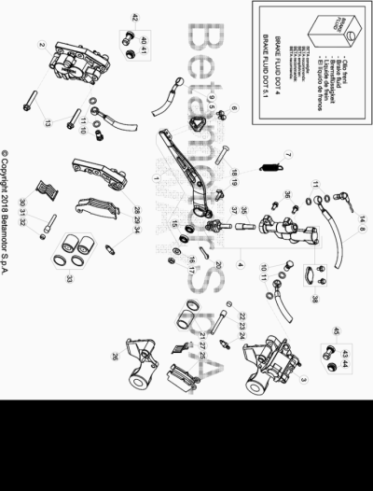

ENDURO_RR-S_500_4T_MY19_USA
Ref. | Part Number | Description | Part
1 | 020.36.001.80.00 | PALANCA FRENO ENDURO RR 4T | 1
2 | 25.03056.000 | PINZA FRENO ANTERIOR RR-4T | 1
3 | 25.03066.000 | PINZA FRENO POSTERIOR RR-4T | 1
4 | 25.91178.000 | BOMBA FRENO POSTERIOR ENDURO RR 4T /07 | 1
5 | 22.90053.000 | PUNTERA PEDAL FRENO RR-4T | 1
6 | 11.46251.000 | TORNILLO 5.12 RS CH8 | 2
7 | 026.36.000.00.00 | MUELLE RETORNO PALANA FRENO RR 2T | 1
8 | 29.09428.000 | TUBO FRENO POSTERIOR ENDURO RR 4T /07 | 1
9 | 031.36.004.00.00 |  | 1
10 | 11.65053.000 | TORNILLO ESPECIAL TALAD.10..1,25 RR-4T | 2
11 | 16.50510.000 | JUNTA 10.15.1 (COBRE) | 6
13 | 11.55510.000 | TORNILLO 8.40 ALP 200/08 | 2
14 | 18.89621.000 | INTERRUPTOR STOP RR-4T | 1
15 | 12.93388.000 | COJINETE 8X22X7 RR-4T | 2
16 | 27.49500.000 | ARANDELA PLANA 8.18 | 1
17 | 13.17020.000 | TUERCA M8 AUTOBLOC. BASSO | 1
18 | 31.63985.000 | TORNILLO M 8 X50 | 1
19 | 25.41830.000 | EJE BOMBA POST.RR-4T/07 | 1
20 | 12.81995.000 | PASADOR 2.15 INOX REV 3 | 1
21 | 20.02717.000 | JUEGO PISTON Y GUARNICIÓN PINZA RR-4T | 1
22 | 31.96821.000 | TORNILLO ESP. PASTILLAS PINZAS RR-4T/06 | 1
23 | 25.41860.000 | VARILLA ESP. PASTILLAS PINZAS RR-4T/06 | 1
24 | 28.91002.000 | AIREADOR PINZAS FRENO RR-4T | 1
25 | 25.25362.000 | JUG. PASTILLAS PINZA FRENO POSTERIOR RR-4T | 1
26 | 020.36.011.00.00 | BRIDA SOPORTE PINZA | 1
27 | 22.32208.000 | MUELLE PASTILLAS PINZA RR-4T | 1
28 | 020.36.012.00.00 | BRIDA SOPORTE PINZA ANT. 25.03056. 0.00 | 1
29 | 25.25361.000 | #25.25365.000# | 1
30 | 22.32207.000 | MUELLE PASTILLAS PINZA RR-4T | 1
31 | 25.41859.000 | VARILLA ESP. PASTILLAS PINZAS RR-4T/06 | 1
32 | 31.96821.000 | TORNILLO ESP. PASTILLAS PINZAS RR-4T/06 | 1
33 | 20.02716.000 | JUEGO PISTON Y GUARNICIÓN PINZA RR-4T | 1
34 | 28.91001.000 | AIREADOR PASTILLAS PINZA RR-4T | 1
35 | 20.08276.000 | JUEGO PISTON BOMBA FRENO RR 4T 2008 | 1
36 | 31.30750.000 | TORNILLO TBIB 6.16 | 2
37 | 20.08277.000 | KIT LEVA BOMBA FRENO | 2
38 | 20.08275.000 | KIT DEPOSITO BOMBA RR 4T 2008 | 1
40 | 036.36.002.00.00 | PROTECCION | 1
41 | 036.36.003.00.00 | PROTECCION | 1
42 | 036.36.006.82.00 | PROTECCION ANTERIOR | 1
43 | 036.36.004.00.00 | PROTECCION | 1
44 | 036.36.005.00.00 | PROTECCION | 1
45 | 036.36.007.82.00 | PROTECCION POSTERIOR | 1

ENDURO_RR-S_500_4T_MY19_USA
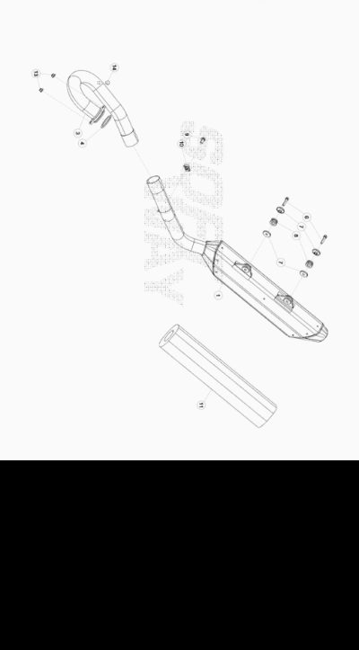

ENDURO_RR-S_500_4T_MY19_USA
Ref. | Part Number | Description | Part
1 | 031.37.034.80.00 |  | 1
3 | 031.37.009.00.00 | COLECTOR ESCAPE RR 4T 430/480 | 1
4 | 020.37.004.00.00 | JUNTA COLECTOR ESCAPE | 1
6 | 11.50300.000 | TORNILLO 6,30 RS CH 8 RR-4T / RR 125 | 2
7 | 13.49187.000 | DISTANCIADOR RR-4T | 4
8 | 28.91946.000 | #032.37.013.00.00# | 2
9 | 11.48025.000 | TORNILLO HEX/C.ARO 6x16 ( RS-T.8 ) | 1
10 | 25.60311.000 | GRAPA TORNILLO M6 ALP 4.0 2008 | 1
11 | 020.37.099.80.00 | KIT REVISION SILENCIADOR | 1
13 | 13.17121.000 | TUERCA M8 BASE CILINDRO CH.10 | 2
14 | 031.37.030.00.00 | TAPON SENSOR OXIGENO | 1

ENDURO_RR-S_500_4T_MY19_USA
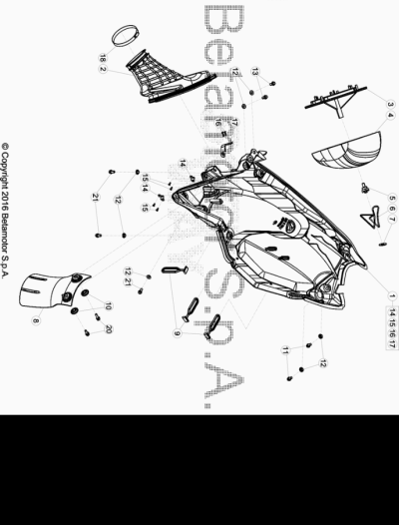

ENDURO_RR-S_500_4T_MY19_USA
Ref. | Part Number | Description | Part
1 | 031.38.009.82.59 |  | 1
2 | 031.38.003.00.00 | TOBERA CAJA FILTRO RR4T EFI 350 | 1
3 | 031.38.002.00.00 | JAULA FILTRO AIRE RR 4T | 1
4 | 031.38.001.00.00 | FILTRO AIRE RR 2T/4T | 1
5 | 25.57197.000 | EJE FILTRO RR-4T - RR 125 | 1
6 | 020.38.021.00.00 | MUELLE FILTRO | 1
7 | 27.74800.000 | ARANDELA 9 RR-4T - RR 125 | 1
8 | 026.38.007.10.59 | PROTECTOR AMORTIGUADOR | 1
9 | 16.34907.000 | GOMA CABALLETE RR-4T | 3
10 | 27.74786.000 | ARANDELA RR-4T | 2
11 | 31.79960.000 | TORNILLO AUTOROSCANTE M6x15 | 2
12 | 13.54820.000 | DISTANCIADOR RR-4T | 7
13 | 11.47015.000 | TORNILLO 6.12 REV3-04 - RR-4T | 2
14 | 026.38.004.00.00 | GRAPA CAJA FILTRO | 2
15 | C18.19.009.00.00 | REMACHE 2,5 X 8 | 4
16 | 27.33803.000 | REMACHE 3x12 | 2
17 | 020.38.002.00.00 | SOPORTE MUELLE CAJA FILTRO | 1
18 | 15.14606.000 | BRIDA CARBURADOR RR-4T | 1
20 | 31.30815.000 | TORNILLO AUTOROSC. 6 X 20 | 2
21 | 11.48025.000 | TORNILLO HEX/C.ARO 6x16 ( RS-T.8 ) | 3

ENDURO_RR-S_500_4T_MY19_USA
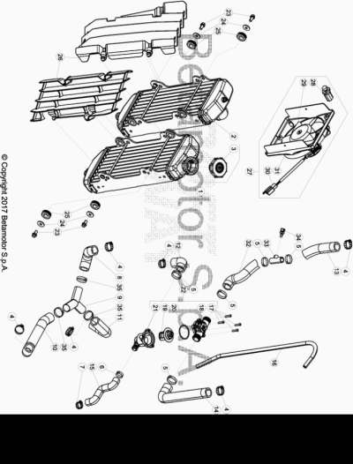

ENDURO_RR-S_500_4T_MY19_USA
Ref. | Part Number | Description | Part
1 | 020.39.110.00.00 | RADIADOR SX | 1
2 | 020.39.021.82.00 |  | 1
3 | 020.39.111.00.00 | TAPON RADIADOR RR4T | 1
4 | 15.15240.000 | BRIDA 17/29 VELOXBLOC 3B | 6
5 | 020.39.008.00.00 | ABRAZADERA 24 | 5
6 | 020.39.009.00.00 | ABRAZADERA 17 | 1
7 | 15.15220.000 | BRIDA 12/20 APA SX9-C-W1 | 1
8 | 031.39.005.00.00 | TUBO RADIADOR | 1
9 | 020.39.020.00.00 | RACORD A "Y" | 1
10 | 031.39.023.00.00 | TUBO RADIADOR | 1
11 | 031.39.007.00.00 | TUBO BOMBA AGUA | 1
12 | 020.39.001.00.00 | TUBO TERMOSTATO | 1
13 | 031.39.025.82.00 |  | 1
14 | 020.39.003.00.00 | TUBO RADIADOR SX TERMOSTATO | 1
15 | 020.39.002.00.00 | TUBO INFERIOR TERMOSTATO | 1
16 | 020.39.015.00.00 | TUBO SOBRE- PRESION | 1
17 | 031.39.017.50.00 | TORNILLO ESPECIAL M 3, 5X18 | 4
18 | 031.39.016.00.00 | TAPA TERMOSTATO | 1
19 | 020.39.013.00.00 | TERMOSTATO | 1
20 | 10.66830.000 | TORICA OR 32X2 REV4T | 1
21 | 031.39.015.00.00 | CONTENEDOR TERMOSTATO | 1
22 | 031.39.014.80.00 | TERMOSTATO | 1
23 | 11.47015.000 | TORNILLO 6.12 REV3-04 - RR-4T | 4
24 | 27.43250.000 | ARANDELA PLANA 6.24 | 4
25 | 16.34911.000 | GOMA RADIADOR RR-4T | 4
26 | 031.39.003.00.51 | JUEGO REJILLAS RADIADOR RR 2T | 1
27 | 031.46.024.82.00 | KIT ELECTROVENTILA. RR 4T 350 EFI 15/19 | 1
28 | 020.40.007.00.00 | TERMOCANTACTO ELECTROVENT. 100/95 RR 4T | 1
29 | 14.01040.000 | ELECTROVENTILADOR REV 50/80 | 1
30 | 18.01596.000 | INSTALACION ELECTROVENTILADOR | 1
31 | 031.39.013.15.00 | SOPORTE ELECTROVENTILADOR | 2
32 | 031.39.026.82.00 |  | 1
33 | 031.39.020.00.00 |  | 1
34 | 031.40.032.00.00 |  | 1
35 | C07.16.005.00.00 | ABRAZADERA D.25 | 3

ENDURO_RR-S_500_4T_MY19_USA
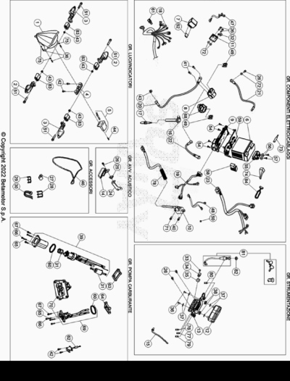

ENDURO_RR-S_500_4T_MY19_USA
Ref. | Part Number | Description | Part
1 | 16.46210.800 |  | 1
2 | 18.12691.000 | INDICADOR DIRECCION ASX-PDX ALP 4.0 | 2
3 | 18.12681.000 | INDICADOR DIRECCION ADX-PSX ALP 4.0 | 2
4 | 15.01769.800 | PILOTO POST. A LED / RR 4T | 1
5 | 020.40.020.00.00 | LUZ MATRICULA | 1
6 | 031.40.124.00.00 | BATERIA RR4T MY18 | 1
7 | 18.84946.000 | INTERMITENCIA CRUISER/ALP4T/RR-4T/ RR 125 | 1
8 | 27.28471.000 | RELE ARRANQUE RR 2T/ 4T | 1
9 | 031.40.015.10.00 | CENTRALITA CDI- PARA MAPEAR | 1
10 | 031.40.021.37.00 | BOBINA | 1
11 | 031.40.025.37.00 | REGULADOR DE TENSION | 1
12 | 031.40.030.00.00 |  | 1
13 | 031.40.059.22.00 |  | 1
14 | 007.40.050.00.00 | AVISADOR ACUSTICO SCOOTER | 1
15 | 28.79013.000 | #031.40.166.00.00# | 1
16 | 006.10.055.00.00 | PIPA BUJIA | 1
17 | 006.10.050.00.00 | BUJIA M 12 X 1,25 NGK -LKAR8A-9 | 1
18 | 031.40.163.00.00 |  | 1
19 | 031.40.162.80.00 |  | 1
20 | 031.40.038.00.00 | INSTALACION RELE | 1
21 | 036.40.011.00.00 | CABLE DE MASA | 1
22 | 020.40.003.00.00 | CABLE BATERIA-RELE | 1
23 | 031.40.042.00.00 | INTALACIÓN POSTERIOR ENDURO | 1
24 | 28.97255.000 | SOPORTE CLAXON RR-4T | 1
25 | 25.60311.000 | GRAPA TORNILLO M6 ALP 4.0 2008 | 1
26 | 11.47015.000 | TORNILLO 6.12 REV3-04 - RR-4T | 6
27 | 15.14654.000 | BRIDA PASACABLE 14 ALP 4.0 | 1
28 | 25.24442.000 | GUIA CABLE 6/8 RR-4T / RR 125 / RR-T | 1
29 | 25.24443.000 | GUIA CABLE 6/6 RR-4T / RR 125 / RR-T | 3
30 | 15.14264.000 | ABRAZ.PA 6 NY.DENT.NAT.ABNY-B 3,6 X 200 | 1
31 | 031.40.043.82.00 | KIT FILTRO BOMBA GASOLINA EFI | 1
32 | 25.25180.000 | GUIA TUBO FRENO ANT. TECHNO/96 | 1
33 | 31.23530.000 | TORNILLO ROSCA CHAPA 4,2.16 TMTIC | 1
34 | 25.25182.000 | ABRAZADERA | 1
35 | 25.58090.000 | GRAPA PARA TORNILLO AUTOF.4,2 | 1
36 | 31.26190.000 | TORNILLO M. 4 X 12 TCIC | 5
37 | 020.40.812.00.00 | DISTANCIADOR SOPORTE K/M | 4
38 | 031.40.013.00.00 | GOMA SOPORTE K/M | 2
39 | 031.40.024.00.00 |  | 1
40 | 11.49070.000 | TORNILLO 6X20 RS CH8 | 1
41 | 31.30190.000 | TORNILLO ALLEN TCCE 6.8 | 2
42 | 11.46251.000 | TORNILLO 5.12 RS CH8 | 4
43 | 13.12550.000 | TUERCA M6.5 FLAN. | 5
44 | 31.23565.000 | TORNILLO 4,5 X 15 TCCCR ALP 200/08 | 1
46 | 14.40020.000 | GOMA SUJETA BATERIA | 1
47 | 031.40.129.00.00 | INSTALACION REGULADOR | 1
48 | 031.40.078.00.00 | INSTALACION ELECTRICA DIAGNOSTICO | 1
49 | 020.40.006.00.00 | FUSIBLE 10 A | 6
50 | 031.40.074.00.00 | TAPON | 1
51 | 11.05540.000 | TORNILLO ANCLAJE M6X25 RS CH 8 | 4
52 | 031.40.002.22.00 | BRIDA SOPORTE INTERMITENCIA | 1
54 | 31.23370.000 | TORNILLO 4.11 TTLC AUTOFIL. | 4
55 | 031.40.017.00.00 | SENSOR | 1
56 | 27.34800.000 | ARANDELA TRANCIATA 4.16 | 2
57 | 31.23560.000 | TORNILLO ROSCA CHAPA 4,2.25 TMTIC | 2
58 | 031.40.039.00.00 | RELE | 1
59 | 031.40.016.10.00 | SOPORTE CENTRALITA | 1
60 | 031.40.044.82.00 | KIT JUNTAS | 1
61 | 029.13.004.00.00 | SENSOR TEMPERATURA | 1
62 | 031.40.014.00.00 | SONDA SEÑALIZACION RESERVA GASOLINA RR 4T EFI | 1
63 | 031.43.087.00.00 | PLACA DE CAUCHO VULCANIZADO | 1
64 | 031.43.090.00.00 | SOPORTE | 1
65 | C24.75.002.00.00 | ESPARRAGO M5 L22 | 4
66 | C24.07.013.00.00 | TUERCA SEGURIDAD | 4
67 | 11.46401.000 | TORNILLO 5X20 LLAVE 8rs RR-4T | 4
68 | 031.40.018.10.00 | ELASTICO | 1
69 | 031.40.045.00.00 |  | 1
70 | 031.40.049.82.00 | KIT RACORD CARBURANTE | 1
71 | 11.50010.000 | TORNILLO 6,25 RS CH 8 | 1
72 | 27.40500.000 | ARANDELA PLANA 6.12.1,6 DIN125 | 3
73 | 031.40.051.00.00 | CONDENSADOR | 1
74 | 031.40.052.00.00 | DIODO | 1
75 | 27.34650.000 | ARANDELA PLANA 4x9 DIN 125/A | 3
76 | 28.92897.000 |  | 1
77 | 28.92895.000 |  | 1
78 | 031.40.033.00.00 |  | 1
79 | 031.40.056.00.00 |  | 1
80 | 031.40.057.00.00 |  | 1
81 | 12.55291.000 | CONMUTADOR C/LLAVES ENDURO RR 125 | 1
82 | 16.20640.000 | TUERCA CONMUTADOR ENDURO RR 125 | 1
83 | 031.40.128.00.59 |  | 4
84 | 16.34907.000 | GOMA CABALLETE RR-4T | 1

ENDURO_RR-S_500_4T_MY19_USA
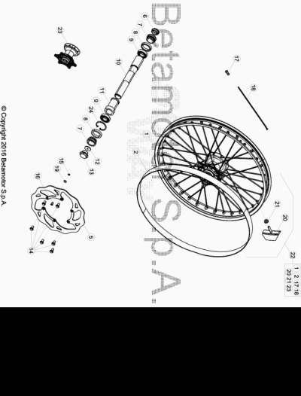

ENDURO_RR-S_500_4T_MY19_USA
Ref. | Part Number | Description | Part
1 | 031.41.046.00.59 | LLANTA ANTERIOR | 1
2 | 15.38200.000 | SALVACAMARA 750x25-21" RR-4T / RR 125 | 1
5 | 031.41.030.00.00 | #031.41.030.82.00# | 1
6 | 020.41.007.00.00 | TAPON EJE RUEDA ANTERIOR | 1
7 | 031.41.004.00.00 | DISTANCIADOR BUJE DEL. | 2
8 | 10.66000.000 | RETEN 35X47X7 RR-4T | 2
9 | 020.41.003.00.00 | #12.99520.000# | 2
10 | 020.41.005.00.00 | EJE RUEDA DELANTERA | 1
11 | 031.41.015.00.00 | DISTANCIADOR INTERIOR BUJE DELANTERO | 1
12 | 020.41.110.00.00 | TAPON INTERNO RUEDA ANT.RR4TMY11 | 1
13 | 020.41.006.00.00 | TAPON EJE | 1
14 | 031.41.016.00.00 | #031.41.043.00.00# | 6
15 | 28.22660.000 | SEEGER 9E | 1
16 | 021.41.005.00.00 | MAGNETO DIAM. 9 PER SENSORE HALL | 1
17 | 031.41.050.00.00 | TUERCA RADIO ANT. | 36
18 | 031.41.049.00.52 | RADIO ANTERIOR | 36
19 | 27.58080.000 | ARANDELA 9 X 13 X 0.4 ENDURO RR 125 | 1
20 | 036.41.010.00.00 | AGARRE CUBIERTA | 1
21 | 13.17120.000 | TUERCA M8 BASE CILINDRO | 1
22 | 026.41.001.00.59 | RUEDA ANTERIOR | 1
23 | 031.41.014.80.00 | BUJE ANT. C/COJI. Y DIST.INTERNO RR 4T | 1
24 | C01.26.001.00.00 | SEEGER D: 47 X 1,75 | 1

ENDURO_RR-S_500_4T_MY19_USA
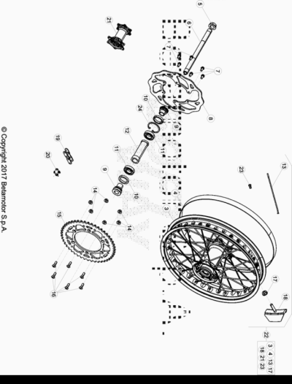

ENDURO_RR-S_500_4T_MY19_USA
Ref. | Part Number | Description | Part
3 | 031.42.034.00.59 | LLANTA POSTERIOR | 1
4 | 15.36000.000 | SALVACAMARA 575x25-18 | 1
5 | 13.27120.000 | TUERCA ESPECIAL RUEDA POSTERIOR RR-4T | 1
6 | 25.55812.000 | EJE RUEDA POSTERIOR RR-4T | 1
7 | 031.41.016.00.00 | #031.41.043.00.00# | 6
8 | 031.42.030.00.00 | #031.42.030.82.00# | 1
9 | 031.42.002.00.00 | DISTANCIADOR BUJE POST. RR 4T | 2
10 | 10.66000.000 | RETEN 35X47X7 RR-4T | 2
11 | 020.42.004.00.00 | #12.99280.000# | 2
12 | 031.42.005.00.00 | DIST.INTERNO RUEDA POST. RR4T | 1
13 | 031.42.037.00.52 | RADIO POST. | 36
14 | 13.17123.000 | TUERCAS M8 | 6
15 | 031.42.038.00.00 | CORONA Z 48 | 1
16 | 31.96827.000 | TORNILLO TGS M8X26 10.9 DACR | 6
17 | 13.17120.000 | TUERCA M8 BASE CILINDRO | 1
18 | 036.42.009.00.00 | AGARRE CUBIERTA | 1
19 | 031.42.003.00.00 | CADENA 520 VF ( DID CON RETENES )CADENA P. 114 RR4T/2T | 1
20 | 031.42.008.00.00 | ENGANCHE CADENA 5/8X1/4 | 1
21 | 031.42.014.80.00 | BUJE POSTERIOR C/ COJINETES | 1
22 | 026.42.008.00.59 | RUEDA POSTERIOR | 1
23 | 031.42.051.00.00 | CABECILLA POST. | 36
24 | C01.26.001.00.00 | SEEGER D: 47 X 1,75 | 1

ENDURO_RR-S_500_4T_MY19_USA
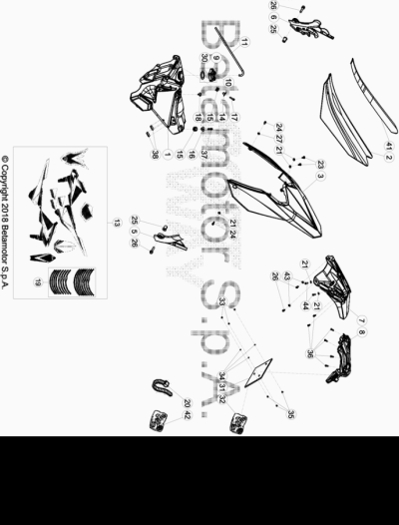

ENDURO_RR-S_500_4T_MY19_USA
Ref. | Part Number | Description | Part
1 | 031.43.139.00.51 | DEPOSITO GASOLINA RR 4T MY 18 | 1
2 | 031.43.065.00.00 |  | 1
3 | 031.43.030.10.51 | GUARDABARROS POST. RR 4T MY 13 | 1
5 | 020.43.060.10.59 | PROTECCION CHASIS SX | 1
6 | 020.43.061.10.59 | PROTECCION CHASIS DX | 1
7 | 036.43.006.82.59 |  | 1
8 | 020.43.034.10.59 | PORTAMATRICULA RR4T MY10 HOMLOLOGADO NEGRO | 1
9 | 036.43.041.80.00 | TAPON DEPOSITO GASOLINA | 1
10 | 036.43.041.82.00 | TAPON GASOLINA COMPLETO | 1
11 | 021.43.006.00.00 | TUBO DEPOSITO-VALVULA | 1
13 | 031.43.165.82.00 |  | 1
14 | 020.43.002.00.00 | DISTANCIADOR DEPOSITO GASOLINA | 1
15 | 28.91946.000 | #032.37.013.00.00# | 2
16 | 031.43.002.00.00 | DISTANCIADOR DEPOSITO GASOLINA | 1
17 | 11.50010.000 | TORNILLO 6,25 RS CH 8 | 1
18 | 31.89010.000 | TORNILLO BLOQUEO SILLÍN RR-4T / RR 125 | 1
19 | 031.43.163.00.00 |  | 1
20 | 15.14264.000 | ABRAZ.PA 6 NY.DENT.NAT.ABNY-B 3,6 X 200 | 1
21 | 13.54820.000 | DISTANCIADOR RR-4T | 6
23 | 31.95510.000 | TORNILLO DIN 7380+ARANDELA M-06 X 012 ZN | 2
24 | 11.48025.000 | TORNILLO HEX/C.ARO 6x16 ( RS-T.8 ) | 5
25 | 27.33740.000 | REMACHE M. 6 | 2
26 | 11.49070.000 | TORNILLO 6X20 RS CH8 | 2
27 | 13.62000.000 | DISTANCIADOR DISCO TR ( 6x14x7.5 ) | 1
30 | 031.43.116.00.00 | JUNTA TAPON GASOLINA | 1
31 | 018.43.010.10.59 | SOPORTE MATRICULA | 1
32 | 031.43.103.82.00 |  | 1
33 | 13.11010.000 | TUERCA M5 AUTOBLOC. | 3
34 | 27.36000.000 | ARANDELA PLANA 5.11 | 3
35 | 31.29860.000 | TORNILLO TTLIC 5.16 CABEZA 10 | 3
36 | 31.79960.000 | TORNILLO AUTOROSCANTE M6x15 | 6
37 | 11.50300.000 | TORNILLO 6,30 RS CH 8 RR-4T / RR 125 | 1
38 | 031.43.004.82.00 | PROTECCION DEPOSITO GASOLINA RR 4T | 2
41 | 031.43.025.00.00 |  | 1
42 | 031.45.107.82.00 |  | 1
43 | 13.62000.000 | DISTANCIADOR DISCO TR ( 6x14x7.5 ) | 2
44 | 11.48025.000 | TORNILLO HEX/C.ARO 6x16 ( RS-T.8 ) | 2

ENDURO_RR-S_500_4T_MY19_USA
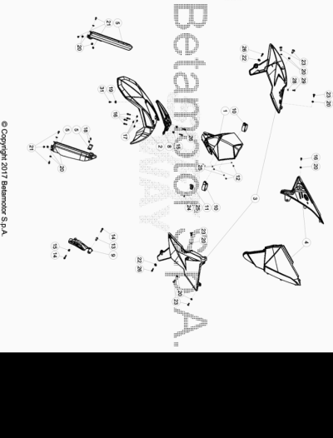

ENDURO_RR-S_500_4T_MY19_USA
Ref. | Part Number | Description | Part
1 | 020.43.015.00.51 | #020.43.017.87.51# | 1
2 | 031.43.034.10.51 | GUARDABARROS ANTERIOR XTRAINER | 1
3 | 031.43.140.00.51 | JUEGO PLACAS RADIADOR RRMY18 | 1
4 | 026.43.021.00.51 | JUEGO TAPAS FILTRO XTRAINER | 1
5 | 026.45.113.82.51 | #040.43.006.82.51# | 1
8 | 020.43.141.10.59 | SOPORTE GUARDABARROS ANT.RR4T MY12 | 1
9 | 020.43.062.10.59 | TAPA PIÑON | 1
10 | 14.40081.000 | GOMA FIJACION FARO RR-4T/ART | 2
11 | 25.24464.000 | BRIDA RR 4T 2008 | 1
12 | 31.26190.000 | TORNILLO M. 4 X 12 TCIC | 3
13 | 13.49189.000 | DISTANCIADOR RR-4T/06 | 1
14 | 11.50300.000 | TORNILLO 6,30 RS CH 8 RR-4T / RR 125 | 2
15 | 13.49190.000 | DISTANCIADOR RR-4T / RR 125 | 3
16 | 11.48025.000 | TORNILLO HEX/C.ARO 6x16 ( RS-T.8 ) | 5
17 | 13.54841.000 | DISTANCIADOR GUARD. ANT. RR-4T | 4
18 | 31.79960.000 | TORNILLO AUTOROSCANTE M6x15 | 2
19 | 27.74786.000 | ARANDELA RR-4T | 1
20 | 13.54820.000 | DISTANCIADOR RR-4T | 13
21 | 11.47015.000 | TORNILLO 6.12 REV3-04 - RR-4T | 6
22 | 020.43.012.00.00 | DISTANCIADOR PLACA RADIADOR | 2
23 | 31.95510.000 | TORNILLO DIN 7380+ARANDELA M-06 X 012 ZN | 6
24 | 31.23360.000 | TORNILLO AUTOFREN. 4.10 (CEV) | 1
25 | 27.34650.000 | ARANDELA PLANA 4x9 DIN 125/A | 4
26 | 11.49070.000 | TORNILLO 6X20 RS CH8 | 4
28 | 13.62000.000 | DISTANCIADOR DISCO TR ( 6x14x7.5 ) | 1
29 | 31.30035.000 | TORNILLO M6x16 TBCEI URBAN /08 | 1
31 | 11.46501.000 | TORNILLO ENCAJE M6.10 RSCH8 | 1

ENDURO_RR-S_500_4T_MY19_USA
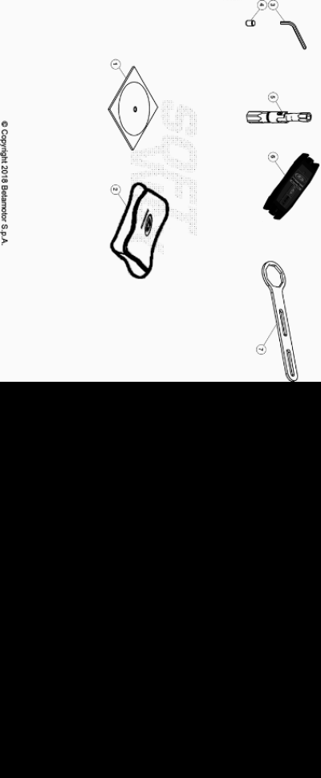

ENDURO_RR-S_500_4T_MY19_USA
Ref. | Part Number | Description | Part
1 | 031.44.055.00.00 |  | 1
2 | 020.44.202.80.00 | BOLSA HERRAMIENTAS | 1
3 | 020.44.003.00.00 | LLAVE ESPECIAL ALLEN 6 MM | 1
4 | 020.44.004.00.00 | LLAVE ALLEN 8 MM | 1
5 | 020.44.010.00.00 | LLAVE BUJIA | 1
6 | 031.44.016.82.00 | KIT DE DIAGNOSIS INYECCION ENDURO 4T | 1
7 | 031.44.034.00.00 | UTILAJE TAPON HORQ. | 1

ENDURO_RR-S_500_4T_MY19_USA
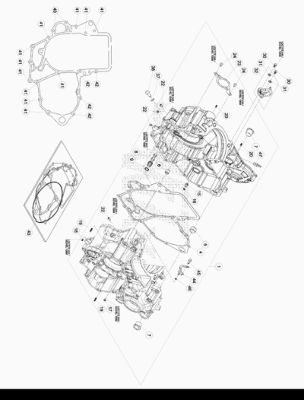

ENDURO_RR-S_500_4T_MY19_USA
Ref. | Part Number | Description | Part
1 | 029.01.000.80.00 | CARTER MOTOR RR 4T 430/480 | 1
4 | 029.01.003.00.00 | JUNTA CARTER MOTOR RR4T | 1
5 | 006.01.012.00.00 | CASQUILLO CENTRADOR 17 X 21.12 | 1
6 | 16.41500.000 | CASQUILLO CENTRADOR 13.13 | 1
7 | 006.01.011.00.00 | CASQUILLO 17 X 21 X 19 | 2
8 | 006.08.053.80.00 | FILTRO ACEITE | 1
9 | 10.50010.000 | TORICA OR 8 X 1.5 | 1
15 | 029.01.024.80.00 | SURTIDOR ACEITE COMPLETO | 1
16 | 10.66139.000 | TORICA OR 6 X 1.5 | 1
17 | 16.42903.000 | CHICLE LUBRICACION 100 | 1
18 | 16.42904.000 | CHICLE LUBRICACION CARTER 100 | 1
19 | 12.93384.000 | RODILLO 4 X 15.8 | 2
20 | 36.25021.000 | RODILLO 4,0X9.8 RR-4T | 2
22 | 006.01.021.00.00 | TAPON ACEITE EXPANSION 7 X 9 | 4
23 | 006.01.018.00.09 | PLACA FIJACION RETEN DX EJE MOTOR | 1
24 | 31.30085.000 | TORNILLO M. 5 X 10 | 2
30 | C24.24.045.00.00 | TORNILLO TCCE 5.10 (EN AW 7075) | 2
31 | 006.08.081.00.00 | TUERCA | 2
32 | 022.08.080.80.00 | DIFUSOR ACEITE | 1
37 | 029.01.026.00.00 | ARANDELA TORNILLO CENTRAJE 8.14.5 | 1
38 | 029.01.025.00.00 | TORNILLO ESP. PMS | 1
40 | 11.50300.000 | TORNILLO 6,30 RS CH 8 RR-4T / RR 125 | 2
41 | 11.05485.000 | TORNILLO 6.60 RS CH 8 RR-4T | 11
42 | C24.31.041.00.00 | TORNILLO 6.70 RS CH 8 | 4
43 | 029.01.005.82.00 | #029.01.041.82.00# | 1
44 | 029.01.021.00.00 | SURTIDOR ACEITE ENFRIAMIENTO | 1
45 | 31.26790.000 | TORNILLO 4.10 CABALLETE ALP 200/08 | 1
46 | C02.06.054.00.00 | TORICA OR 3,5 X 1,5 | 1
47 | 29.00280.000 | TAPON TOMA AIRE DEP. | 1

ENDURO_RR-S_500_4T_MY19_USA
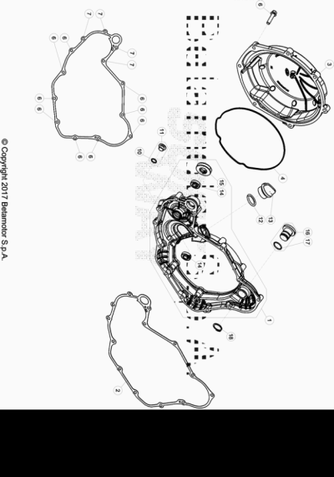

ENDURO_RR-S_500_4T_MY19_USA
Ref. | Part Number | Description | Part
1 | 029.01.030.80.00 | TAPA DE EMBRAGUE INTERNA COMPLETA | 1
2 | 029.01.031.00.00 | JUNTA EMBRAGUE RR4T FACTORY 350 c.c. | 1
3 | 029.01.007.80.52 | TAPA EXTERIOR EMBRAGUE | 1
4 | 006.01.041.00.00 | JUNTA TORICA TAPA EXT. EMBRAGUE | 1
6 | 11.50010.000 | TORNILLO 6,25 RS CH 8 | 16
7 | 11.50360.000 | TORNILLO 6X40 | 4
10 | 10.50010.000 | TORICA OR 8 X 1.5 | 1
11 | 006.11.045.80.00 | TAPON CIGUEÑAL EMBRAGUE | 1
12 | 10.66340.000 | JUNTA TORICA 16.3 | 1
13 | 29.09601.000 | TAPON ACEITE CR/EXC. RR-4T | 1
14 | 12.93400.000 | COJINETE 10.19.5 (61800-2RS1) | 2
15 | 10.48030.000 | RETEN ACEITE 12 X 30.7 | 1
16 | 036.01.006.80.59 | TAPON COMPLETO | 1
17 | 10.66321.000 | TORICA OR 17.17X1.78 | 1
18 | 33.00070.000 | SEEGER PARA EJE D.19 | 1

ENDURO_RR-S_500_4T_MY19_USA
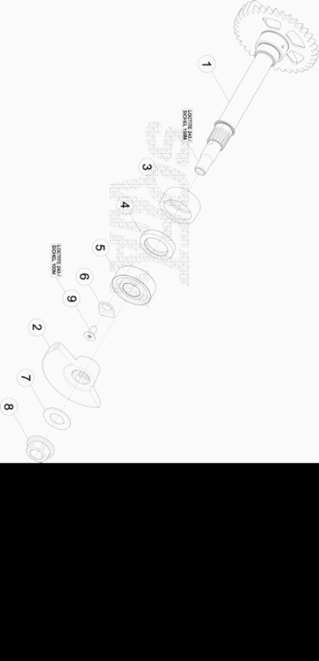

ENDURO_RR-S_500_4T_MY19_USA
Ref. | Part Number | Description | Part
1 | 029.02.020.00.00 | EJE DE EQUILIBRADO | 1
2 | 029.02.021.00.00 | CONTRAPESO EJE BALANCIN | 1
3 | C06.14.019.00.00 | RODAMIENTO 25.33.15 ( HMK 2515C ) | 1
4 | 10.64490.000 | RETEN ACEITE 20 X 30.5/6 | 1
5 | C06.01.034.00.00 | COJINETE 15.32.9 NTN 6002 LLUC3/5K | 1
6 | 006.01.016.00.00 | PLACA FIJACION COJINETE CIGUEÑAL | 1
7 | 27.74810.000 | ARANDELA GOMA | 1
8 | 13.25010.000 | TUERCA ESP.VOLANTE MAGNETICO MORIC GR65/85 RR-4T | 1
9 | C24.90.002.00.00 | TORNILLO TSP TORX M6X12 - 10.9/12.9 | 1

ENDURO_RR-S_500_4T_MY19_USA
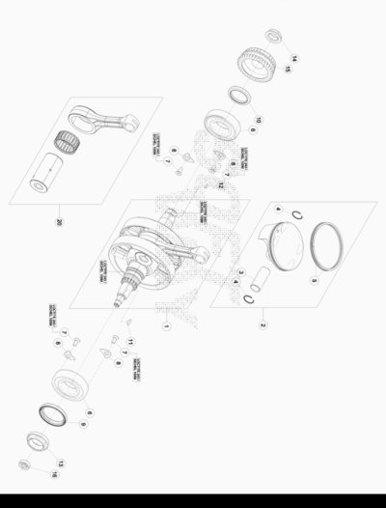

ENDURO_RR-S_500_4T_MY19_USA
Ref. | Part Number | Description | Part
1 | 029.02.000.80.00 | CIGUEÑAL COMPLETO 430/480CC | 1
2 | 030.02.050.80.01 | PISTON COMPLETO 480 CC MEDIDA 1 | 1
2 | 030.02.050.80.02 | PISTON COMPLETO 480 CC MEDIDA 2 | 1
3 | 029.02.051.00.00 | BULON | 1
4 | 029.02.052.00.00 | CLIP PISTON RR 4T | 2
5 | 006.02.153.80.00 | SERIE SEGMENTO PISTON D. 100 MM ( 498/510cc ) | 1
6 | 12.99700.000 | COJINETE CIGUEÑAL 35 X 72 ENDURO 4T 2010 | 2
7 | C24.90.002.00.00 | TORNILLO TSP TORX M6X12 - 10.9/12.9 | 4
8 | 006.01.016.00.00 | PLACA FIJACION COJINETE CIGUEÑAL | 4
9 | 10.66085.000 | RETEN 45x58,7 | 1
10 | 10.65900.000 | RETEN CIGUEÑAL 35 X 47.6 | 1
11 | 12.46020.000 | CHAVETA 3.5 | 1
12 | 12.46000.000 | CHAVETA 3.3,7.9,7 | 1
13 | 022.02.011.00.00 | TUERCA M 32 X 1 | 1
14 | 006.03.023.00.00 | TUERCA M. 20 X 1 X 5 LH | 1
15 | 006.03.121.80.00 | PIÑON ENGRANAJE TRANSMISION PRIMARIA | 1
16 | 10.44690.000 | RETEN 10 X 22.6 | 1
20 | 029.02.008.80.00 | BIELA COMPLETA | 1

ENDURO_RR-S_500_4T_MY19_USA
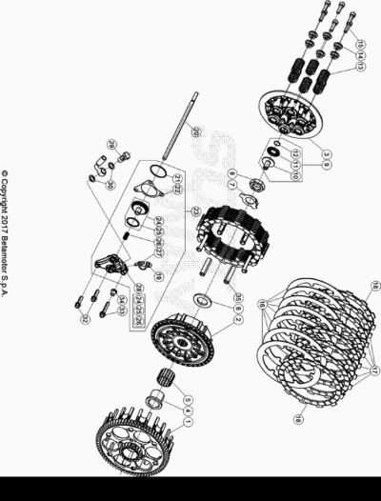

ENDURO_RR-S_500_4T_MY19_USA
Ref. | Part Number | Description | Part
1 | 029.03.011.00.00 | CAMPANA EMBRAGUE | 1
2 | 029.03.141.00.00 | TAMBOR EMBRAGUE | 1
3 | 029.03.031.00.00 | PLATILLO EMBRAGUE | 1
4 | 006.03.061.00.00 | CASQUILLO | 1
5 | 006.03.063.00.00 | JAULA RODILLOS 26 X 30.22 | 1
6 | 006.03.062.00.00 | ARANDELA 21,7 X 38.3 | 1
7 | 029.03.000.48.00 | ARANDELA | 1
8 | 006.03.065.00.00 | TUERCA M 18x1,5 H9 | 1
9 | 029.03.071.80.00 | ACOPLE VARILLA CUERPO EMBRAGUE | 1
10 | 029.03.071.00.00 |  | 1
11 | 16.11370.000 | GABIA 15.28.2 | 1
12 | 28.23105.000 | SEEGER RB 14 DIN 7993 | 1
13 | 029.03.055.00.00 | MUELLE EMBRAGUE | 6
14 | 029.03.056.00.00 | CASQUILLO AMORTIGUADOR EMBRAGUE | 6
15 | 31.34510.000 | TORNILLO ALLEN TCCE 6.20 | 6
16 | 029.03.150.00.00 | DISCO SEPARADOR EMBRAGUE | 7
17 | 029.03.053.00.00 | DISCO EMBRAGUE | 6
18 | 029.03.054.00.00 | DISCO EMBRAGUE | 2
19 | 16.33788.000 | TAPON | 1
20 | 006.03.070.00.00 | VARILLA EMPUJADOR EMBRAGUE | 1
21 | 10.66840.000 | TORICA OR 33 X 1.5 | 1
22 | 006.03.085.00.00 | JUNTA BOMBIN EMBRAGUE | 1
23 | 029.03.001.80.00 | BOMBIN EMBRAGUE RR | 1
24 | 006.03.281.80.00 | PISTON EMBRAGUE | 1
25 | 10.66520.000 | JUNTA TORICA 23,52.1,78.EPDM (OR2-021) | 1
26 | 006.03.083.00.00 | MUELLE BOMBIN EMBRAGUE | 1
27 | 28.91050.000 | RESPIRADOR AIRE PINZA POST. TR-89 | 1
28 | 029.03.001.00.00 | TAPA BOMBIN EMBRAGUE | 1
29 | 11.65040.000 | TORNILLO ESP. TALAD.10.1 PARA TUBO FRENO | 1
30 | 16.50510.000 | JUNTA 10.15.1 (COBRE) | 2
32 | 11.49070.000 | TORNILLO 6X20 RS CH8 | 2
33 | 11.50355.000 | TORNILLO ANCLAJE M6X35 RS CH 8 | 1
34 | 13.49190.000 | DISTANCIADOR RR-4T / RR 125 | 1
35 | 029.03.107.00.00 | GUIA DISCO | 6

ENDURO_RR-S_500_4T_MY19_USA
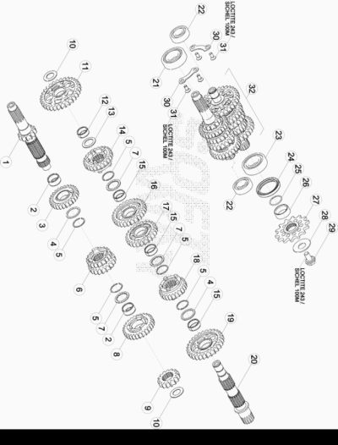

ENDURO_RR-S_500_4T_MY19_USA
Ref. | Part Number | Description | Part
1 | 006.04.010.00.00 | EJE PRIMARIO | 1
2 | 11.22855.000 | JAULA RODILLOS 22 X 26 X 13 | 2
3 | 006.04.015.00.00 | ENGRANAJE 5ª EJE PRIMARIO | 1
4 | 006.04.031.00.00 | ARANDELA DISTANCIADORA EJE PRIMARIO | 2
5 | 28.25520.000 | SEEGER SW25 | 5
6 | 006.04.013.00.00 | ENGRANAJE 3ª/4ª EJE PRIMARIO | 1
7 | 006.04.030.00.00 | ARANDELA DISTANCIADORA | 3
8 | 006.04.016.00.00 | ENGRANAJE 6ª EJE PRIMARIO | 1
9 | 006.04.012.00.00 | ENGRANAJE 2ª EJE PRIMARIO | 1
10 | 006.04.032.00.00 | ARANDELA DISTANCIADORA 17 X 30 X 1 | 2
11 | 006.04.021.00.00 | ENGRANAJE 1ª EJE SECUNDARIO | 1
12 | 11.22835.000 | JAULA RODILLOS 20 X 24 X 10 | 1
13 | 006.04.033.00.00 | ARANDELA DISTANCIADORA 20 X 30 X 1 | 1
14 | 006.04.025.00.00 | ENGRANAJE 5ª EJE SECUNDARIO | 1
15 | 11.22845.000 | JAULA RODILLOS 22 X 26 X 10 | 3
16 | 006.04.023.00.00 | ENGRANAJE 3ª EJE SECUNDARIO | 1
17 | 006.04.024.00.00 | ENGRANAJE 4ª EJE SECUNDARIO | 1
18 | 006.04.026.00.00 | ENGRANAJE 6ª EJE SECUNDARIO | 1
19 | 006.04.022.00.00 | ENGRANAJE 2ª EJE SECUNDARIO | 1
20 | 006.04.020.00.00 | EJE SECUNDARIO | 1
21 | 12.95610.000 | COJINETE 6205 C3 | 1
22 | 12.95605.000 | COJINETE ( 6203 ) JR2 C3 | 2
23 | 12.99710.000 | COJINETE NJ 205 | 1
24 | 10.66020.000 | RETEN 32 X 45 X 6 X 5 | 1
25 | 10.66620.000 | JUNTA TORICA 25,12.1,78 | 1
26 | 006.04.040.00.00 | DISTANCIADOR | 1
27 | 006.04.050.00.00 | PIÑON SALIDA Z13 | 1
27 | 006.04.052.00.00 | PIÑON SALIDA Z15 | 1
28 | 006.04.041.00.00 | ARANDELA PIÑON SALIDA . | 1
29 | 006.04.042.00.00 | TORNILLO PIÑON SALIDA M10 X 18 | 1
30 | 006.01.016.00.00 | PLACA FIJACION COJINETE CIGUEÑAL | 2
31 | C24.90.002.00.00 | TORNILLO TSP TORX M6X12 - 10.9/12.9 | 2
32 | 006.04.000.80.00 | CAMBIO COMPLETO | 1

ENDURO_RR-S_500_4T_MY19_USA
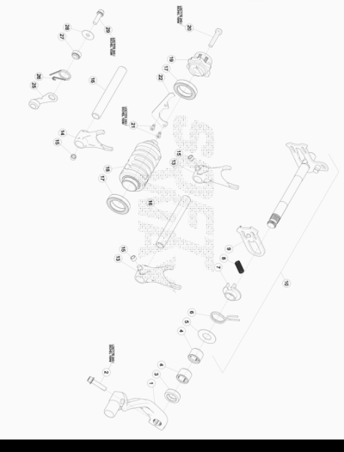

ENDURO_RR-S_500_4T_MY19_USA
Ref. | Part Number | Description | Part
1 | 006.05.000.80.00 | PALANCA CAMBIO | 1
2 | 11.50010.000 | TORNILLO 6,25 RS CH 8 | 1
3 | 10.52012.000 | RETEN 14 X 24 X 6 | 1
4 | 11.22320.000 | JAULA RODILLOS | 2
5 | 27.63020.000 | ARANDELA 14 X 30 X 1 | 1
6 | 006.05.017.00.00 | MUELLE RETORNO PALANCA CAMBIO | 1
7 | 16.92911.000 | GUIA MUELLE CAMBIO | 1
8 | 006.05.016.00.00 | MUELLE 0.8 MM | 1
9 | 006.05.014.80.00 | HORQUILLA MOVIL CAMBIO | 1
10 | 006.05.010.80.00 | EJE CAMBIO COMPLETO | 1
13 | 006.05.020.00.00 | HORQUILLA 1/4 | 2
14 | 006.05.021.00.00 | HORQUILLA 5/6 | 1
15 | 006.05.027.00.00 | CASQUILLO 6 X 8 X 5,2 | 3
16 | 026.05.025.00.00 | EJE HORQUILLA CAMBIO | 2
17 | 12.93405.000 | COJINETE 61805-2RS1 | 2
18 | 006.05.030.00.00 | SELECTOR CAMBIO | 1
19 | 029.05.001.80.00 | LEVA ARRESTO | 1
20 | 31.45115.000 | TORNILLO M.6 X 30 | 1
21 | C24.24.045.00.00 | TORNILLO TCCE 5.10 (EN AW 7075) | 2
22 | 029.05.031.00.00 | PLACA FIJACION COJINETE | 1
25 | 029.05.050.80.00 | MUELLE ARRASTRE VEL. | 1
26 | 22.39591.000 | MUELLE PALANCA CAMBIO | 1
27 | 029.05.054.00.00 | DISTANCIADOR | 1
28 | 27.42000.100 | ARANDELA 6 X 20 X 1,0 | 1
29 | 31.30780.000 | TORNILLO TBIB 6.20 | 1

ENDURO_RR-S_500_4T_MY19_USA
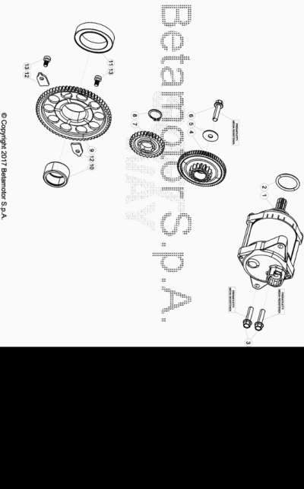

ENDURO_RR-S_500_4T_MY19_USA
Ref. | Part Number | Description | Part
1 | 029.07.000.80.00 | MOTOR ARRANQUE 0,45KW | 1
2 | 36.25056.000 | OR 25,00X3,00 NBR 70 RR-4T | 1
3 | 11.50010.000 | TORNILLO 6,25 RS CH 8 | 2
4 | 029.07.010.80.00 | LIMITADOR DE FUERZA REENVIO MOTOR ARRANQUE | 1
5 | 27.42000.100 | ARANDELA 6 X 20 X 1,0 | 1
6 | 11.50010.000 | TORNILLO 6,25 RS CH 8 | 1
7 | 029.07.020.00.00 | ENGRANAJE | 1
8 | 28.24460.000 | SEEGER 16 X 1 | 1
9 | 029.07.030.00.00 | ENGRANAJE PUESTA EN MARCHA | 1
10 | 006.07.031.00.00 | JAULA RODILLOS HK 2516 | 1
11 | 006.07.040.00.00 | COJINETE FWD 331608-BLS | 1
12 | 029.07.025.00.00 | SOPORTE ENGRANAJE P. EN MARCHA | 2
13 | C24.24.045.00.00 | TORNILLO TCCE 5.10 (EN AW 7075) | 2

ENDURO_RR-S_500_4T_MY19_USA
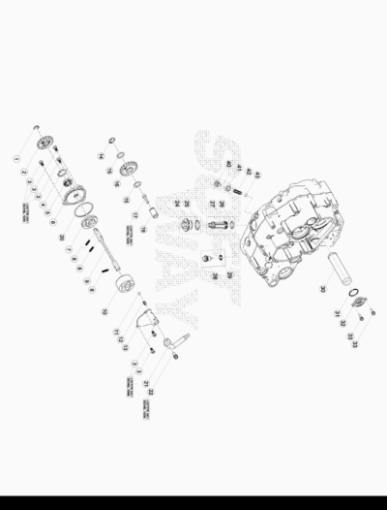

ENDURO_RR-S_500_4T_MY19_USA
Ref. | Part Number | Description | Part
1 | 28.22645.000 | SEEGER RA 7 | 1
2 | 006.08.022.00.00 | ENGRANAJE BOMBA ACEITE | 1
3 | C24.24.045.00.00 | TORNILLO TCCE 5.10 (EN AW 7075) | 5
4 | 28.25502.000 | SEEGER JS 24 | 1
5 | 10.44695.000 | RETEN 10 X 22 X 6 | 1
6 | 029.08.011.00.00 | TAPA BOMBA ACEITE | 1
7 | 006.08.010.80.00 | BOMBA ACEITE D=40,56 B=5 | 1
8 | 12.93384.000 | RODILLO 4 X 15.8 | 3
9 | 006.08.120.00.00 | EJE BOMBA ACEITE | 1
10 | 006.08.000.80.00 | BOMBA ACEITE D=40,56 B=19 | 1
11 | 28.90220.000 | BOLA D.5,5 | 1
12 | 006.08.041.00.00 | MUELLE | 1
13 | 029.08.010.00.00 | TAPA BOMBA ACEITE ASPIRACION | 1
14 | 28.22810.000 | SEEGER A13 | 1
15 | 27.61395.050 | ARANDELA DISTANCIADORA 13 X 19 X 0,50 | 2
16 | 029.08.030.00.00 | REENVIO ENGRANAJE BOMBA ACEITE | 1
17 | 31.30015.000 | TORNILLO ALLEN 5 X 20 | 1
19 | 006.08.032.00.00 | EJE REENVIO BOMBA ACEITE | 1
20 | 10.66934.000 | TORICA OR 45 X 2 | 1
21 | 029.08.002.80.00 | RACORD TUBO ACEITE | 1
22 | 11.46251.000 | TORNILLO 5.12 RS CH8 | 1
24 | 029.08.050.80.00 | TAPON ACEITE COMPLETO | 1
25 | 10.66321.000 | TORICA OR 17.17X1.78 | 1
26 | 10.66168.000 | TORICA OR. 12 X 2 | 1
27 | 029.08.051.80.00 | FILTRO ACEITE | 1
28 | 006.08.152.80.00 | TAPON PARA EL ESCAPE DE ACEITE | 1
29 | 10.66164.000 | TORICA OR 11.2,5 NBR 70SH | 1
30 | 006.08.070.00.00 | FILTRO ACEITE | 1
31 | 10.66685.000 | TORICA OR 28 X 1,5 | 1
32 | 029.08.060.00.00 | TAPON FILTRO ACEITE | 1
33 | 11.48025.000 | TORNILLO HEX/C.ARO 6x16 ( RS-T.8 ) | 2
40 | 36.25062.000 | TAPON M12X1,5 RR-4T | 2
41 | 27.60265.000 | ARANDELA EMPUJADOR 12X18X1.5 | 1
42 | 029.08.040.00.00 | MUELLE | 1
43 | 28.90225.000 | BOLA D. 9 | 1

ENDURO_RR-S_500_4T_MY19_USA
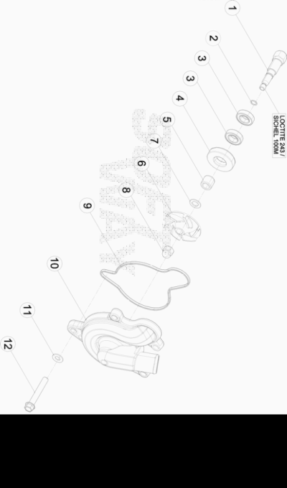

ENDURO_RR-S_500_4T_MY19_USA
Ref. | Part Number | Description | Part
1 | 006.09.010.00.00 | EJE BOMBA AGUA | 1
2 | 10.66136.000 | ANILLO OR 5,5X 1 | 1
3 | 12.93400.000 | COJINETE 10.19.5 (61800-2RS1) | 2
4 | 10.48030.000 | RETEN ACEITE 12 X 30.7 | 1
5 | 006.09.011.00.00 | CASQUILLO 8 X 12,10 | 1
6 | 006.09.000.00.00 | ASPAS BOMBA AGUA | 1
7 | 006.09.012.00.00 | ARANDELA | 1
8 | 13.11520.000 | TUERCA M 6 X 1 | 1
9 | 006.09.021.00.00 | JUNTA BOMBA AGUA | 1
10 | 006.09.020.00.00 | TAPA BOMBA AGUA | 1
11 | 27.40490.000 | ARANDELA PLANA 6x10 | 1
12 | 11.50360.000 | TORNILLO 6X40 | 4

ENDURO_RR-S_500_4T_MY19_USA
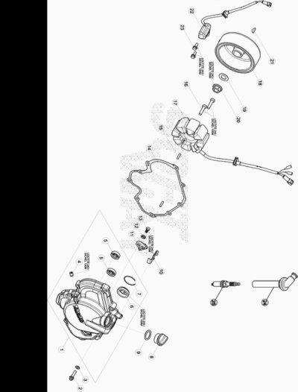

ENDURO_RR-S_500_4T_MY19_USA
Ref. | Part Number | Description | Part
1 | 027.01.050.80.00 | TAPA VOLANTE COMPLETA RR4T | 1
2 | 11.50010.000 | TORNILLO 6,25 RS CH 8 | 9
3 | 27.58000.000 | ARANDELA DE EMPUJE COBRE 6X12X1 | 1
4 | 006.01.021.00.00 | TAPON ACEITE EXPANSION 7 X 9 | 1
5 | 10.44690.000 | RETEN 10 X 22.6 | 2
6 | 006.01.056.00.00 | TAPON NIVEL ACEITE | 1
7 | 28.25680.000 | SEEGER 30 X 1 | 1
8 | 29.09601.000 | TAPON ACEITE CR/EXC. RR-4T | 1
9 | 10.66340.000 | JUNTA TORICA 16.3 | 1
10 | 006.01.054.00.00 | PLACA SUJECCION INSTALACION | 1
11 | 006.11.070.00.00 | GUIA CADENA TAPA VOLANTE | 1
12 | 029.08.081.00.00 | CASQUILLO | 1
13 | C24.24.045.00.00 | TORNILLO TCCE 5.10 (EN AW 7075) | 1
14 | 006.01.051.00.00 | JUNTA TAPA VOLANTE | 1
15 | 12.93384.000 | RODILLO 4 X 15.8 | 2
16 | C24.24.039.00.00 | TORNILLO TCCE 5.30 CMPL FIL | 3
17 | 006.10.120.00.00 | STATOR RR4 EFI | 1
18 | 006.10.110.00.00 | ROTOR | 1
19 | 27.74810.000 | ARANDELA GOMA | 1
20 | 13.25010.000 | TUERCA ESP.VOLANTE MAGNETICO MORIC GR65/85 RR-4T | 1
21 | 12.46020.000 | CHAVETA 3.5 | 1
22 | 006.10.030.00.00 | PICK-UP | 1
23 | 11.46251.000 | TORNILLO 5.12 RS CH8 | 2
24 | 006.10.055.00.00 | PIPA BUJIA | 1
25 | 006.10.050.00.00 | BUJIA M 12 X 1,25 NGK -LKAR8A-9 | 1

ENDURO_RR-S_500_4T_MY19_USA
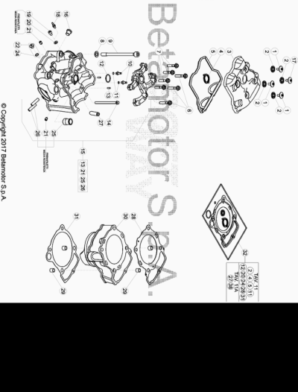

ENDURO_RR-S_500_4T_MY19_USA
Ref. | Part Number | Description | Part
1 | 006.11.025.00.00 | TORNILLO TAPA CULATA | 3
2 | 006.11.026.00.00 | JUNTA TORNILLO TAPA CULATA | 4
3 | 006.11.020.00.52 | TAPA CULATA | 1
4 | 006.11.022.00.00 | JUNTA BUJIA | 1
5 | 029.11.021.00.00 | JUNTA TAPA CULATA ENDURO | 1
6 | 11.52427.000 | TORNILLO ESPECIAL 7 X 38 | 3
7 | 11.52425.000 | TORNILLO ESPECIAL 7.33 | 4
8 | 006.11.012.00.00 | DISTANCIADOR 10,5 X 18,5 X 2,5 | 4
9 | 022.11.013.00.00 | TORNILLO M 10 X 1,25 L=127,5 350cc | 4
10 | 006.11.009.00.00 | CHICLE | 2
11 | 10.66136.000 | ANILLO OR 5,5X 1 | 2
12 | 10.66495.000 | TORICA OR 22 X 2 | 1
13 | 36.25021.000 | RODILLO 4,0X9.8 RR-4T | 2
14 | 11.05445.000 | TORNILLO 6 X 80 | 1
15 | 029.11.100.80.00 | #037.11.012.82.00# | 1
16 | 029.13.004.00.00 | SENSOR TEMPERATURA | 1
17 | 006.11.035.00.00 | TORNILLO SEGURIDAD | 1
18 | 29.00280.000 | TAPON TOMA AIRE DEP. | 1
19 | C24.24.044.00.00 | TORNILLO TCCE 6.8 (EN AW 7075) | 1
20 | 27.58000.000 | ARANDELA DE EMPUJE COBRE 6X12X1 | 1
21 | 006.01.021.00.00 | TAPON ACEITE EXPANSION 7 X 9 | 2
22 | 006.11.045.80.00 | TAPON CIGUEÑAL EMBRAGUE | 1
24 | 10.50010.000 | TORICA OR 8 X 1.5 | 1
25 | 006.11.108.00.00 | RACORD SALIDA AGUA M 20 X 1,25 | 1
26 | 006.11.019.00.00 | ESPARRAGO M 8 X 30 | 2
27 | 006.11.005.00.00 | GUIA VALVULA PARA RECTIFICAR | 4
28 | 030.02.063.00.00 | JUNTA CULATA | 1
29 | 006.02.070.00.00 | CASQUILLO 10,5 X 12 X 11 | 4
30 | 030.02.060.00.01 | CILINDRO DIAMETRO=100 MEDIDA=1 | 1
30 | 030.02.060.00.02 | CILINDRO DIAMETRO=100 MEDIDA=2 | 1
31 | 029.02.162.00.00 | JUNTA BASE CILINDRO 0,3 MM | 2
32 | 030.11.000.82.00 | KIT JUNTAS | 1

ENDURO_RR-S_500_4T_MY19_USA
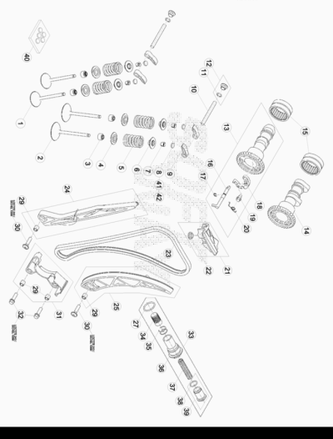

ENDURO_RR-S_500_4T_MY19_USA
Ref. | Part Number | Description | Part
1 | 029.11.033.00.00 | #029.11.033.82.00# | 2
2 | 029.15.032.00.00 | VALVULA ASPIRACION | 2
3 | 006.11.139.00.00 | RETEN BRAZO VALVULAS | 4
4 | 027.11.037.00.00 | PLATILLO INFERIOR MUELLE VALVULA | 4
5 | 027.11.034.00.00 | MUELLE VALVULA | 4
6 | 027.11.036.00.00 | PLATILLO SUPERIOR MUELLE VALVULA | 4
7 | 006.11.038.00.00 | SEMICONO | 8
8 | 006.11.040.20.00 | ARANDELA SUPLEMENTO 2,00 | 1
8 | 006.11.040.20.05 | ARANDELA SUPLEMENTO 2,050 | 1
8 | 006.11.040.20.10 | ARANDELA SUPLEMENTO , 2,100 | 1
8 | 006.11.040.20.15 | ARANDELA SUPLEMENTO, 2,150 | 1
8 | 006.11.040.20.20 | ARANDELA SUPLEMENTO, 2,200 | 1
8 | 006.11.040.20.25 | ARANDELA SUPLEMENTO, 2,250 | 1
8 | 006.11.040.20.30 | ARANDELA SUPLEMENTO, 2.300 | 1
8 | 006.11.040.20.32 | ARANDELA SUPLEMENTO, 2,325 | 1
8 | 006.11.040.20.35 | ARANDELA SUPLEMENTO, 2,350 | 1
8 | 006.11.040.20.37 | ARANDELA SUPLEMENTO, 2,375 | 1
8 | 006.11.040.20.40 | ARANDELA SUPLEMENTO, 2,400 | 1
8 | 006.11.040.20.42 | ARANDELA SUPLEMENTO, 2,425 | 1
8 | 006.11.040.20.45 | ARANDELA SUPLEMENTO, 2,450 | 1
8 | 006.11.040.20.47 | ARANDELA SUPLEMENTO, 2,475 | 1
8 | 006.11.040.20.50 | ARANDELA SUPLEMENTO, 2,500 | 1
9 | 006.11.030.00.00 | BALANCIN VALVULAS | 4
10 | 006.11.031.00.00 | EJE BALANCIN | 2
11 | 10.50010.000 | TORICA OR 8 X 1.5 | 3
12 | 006.11.045.80.00 | TAPON CIGUEÑAL EMBRAGUE | 2
13 | 029.11.051.80.00 | EJE DISTRIBUCION COMPLETO 430 | 1
14 | 006.11.150.00.00 | EJE DISTRIBUCION ASPIRACION 520 CC | 1
15 | 006.11.053.00.00 | JAULA RODILLOS | 2
16 | 006.11.156.00.00 | CIGUEÑAL DESCOMPRESION | 1
17 | 28.22635.000 | SEEGER H7 | 1
18 | 006.11.155.00.00 | MASA DE DESCOMPRESION | 1
19 | 006.11.057.00.00 | EJE DESCOMPRESION | 1
20 | 029.11.058.00.00 | MUELLE DESCOMPRESION | 1
21 | 006.11.063.80.00 | PATIN FIJO | 1
22 | 006.11.066.00.00 | CASQUILLO PATIN FIJO | 1
23 | 022.11.060.00.00 | CADENA DISTRIBUCION Z=124 350cc | 1
24 | 006.11.061.80.00 | PATIN FIJO | 1
25 | 022.11.062.80.00 | ZAPATA MOVIL COMPLETO | 1
27 | 10.66466.000 | TORICA OR 20 X 2 | 1
29 | 006.11.065.00.00 | CASQUILLO 6,2 X 9 X 9 | 4
30 | 31.30792.000 | TORNILLO TBCE 6 X 25 | 2
31 | 022.11.064.80.00 | PROTECCION CADENA COMPLETA | 1
32 | 11.49070.000 | TORNILLO 6X20 RS CH8 | 2
33 | 006.11.167.80.00 | TENSOR CADENA COMPLETO 350cc | 1
34 | 006.11.167.20.00 | PISTON TENSOR CADENA 350cc | 1
35 | 28.23105.000 | SEEGER RB 14 DIN 7993 | 2
36 | 006.11.167.10.00 | TORNILLO TENSOR CADENA DIST.350cc | 1
37 | 006.11.267.30.00 | MUELLE TENSOR CADENA RR 4T MY* 13 | 1
38 | 10.66175.000 | TORICA OR 13 X 1,5 350cc | 1
39 | 006.11.168.80.00 | TAPON COMPLETO 350cc | 1
40 | 006.45.001.80.00 | KIT ELEMENTOS DE VALVULAS | 1
41 | 006.11.040.20.52 | ARANDELA SUPLEMENTO, 2,525 | 1
41 | 006.11.040.20.55 | ARANDELA SUPLEMENTO, 2,550 | 1
41 | 006.11.040.20.57 | ARANDELA SUPLEMENTO, 2,575 | 1
41 | 006.11.040.20.60 | ARANDELA SUPLEMENTO 2,600 | 1
41 | 006.11.040.20.62 | ARANDELA SUPLEMENTO, 2,625 | 1
41 | 006.11.040.20.65 | ARANDELA SUPLEMENTO, 2,650 | 1
41 | 006.11.040.20.67 | ARANDELA SUPLEMENTO, 2,675 | 1
41 | 006.11.040.20.70 | ARANDELA SUPLEMENTO, 2,700 | 1
41 | 006.11.040.20.72 | ARANDELA SUPLEMENTO, 2,725 | 1
41 | 006.11.040.20.75 | ARANDELA SUPLEMENTO, 2,750 | 1
41 | 006.11.040.20.77 | ARANDELA SUPLEMENTO, 2,775 | 1
41 | 006.11.040.20.80 | ARANDELA SUPLEMENTO, 2,800 | 1
41 | 006.11.040.20.82 | ARANDELA SUPLEMENTO, 2,825 | 1
41 | 006.11.040.20.85 | ARANDELA SUPLEMENTO, 2,850 | 1
41 | 006.11.040.20.87 | ARANDELA SUPLEMENTO, 2,875 | 1
42 | 006.11.040.20.90 | ARANDELA SUPLEMENTO, 2,900 | 1
42 | 006.11.040.20.92 | ARANDELA SUPLEMENTO, 2,925 | 1
42 | 006.11.040.20.95 | ARANDELA SUPLEMENTO, 2,950 | 1
42 | 006.11.040.20.97 | ARANDELA SUPLEMENTO, 2,975 | 1
42 | 006.11.040.30.00 | ARANDELA SUPLEMENTO, 3,00 | 1
42 | 006.11.040.30.05 | ARANDELA SUPLEMENTO, 3,050 | 1
42 | 006.11.040.30.10 | ARANDELA SUPLEMENTO, 3,100 | 1
42 | 006.11.040.30.15 | ARANDELA SUPLEMENTO, 3,150 | 1
42 | 006.11.040.30.20 | ARANDELA SUPLEMENTO, 3,200 | 1

ENDURO_RR-S_500_4T_MY19_USA
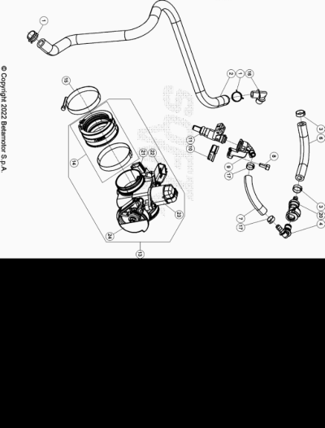

ENDURO_RR-S_500_4T_MY19_USA
Ref. | Part Number | Description | Part
1 | 10.67470.000 | ARANDELA CAJA FILTRO | 2
2 | 029.13.002.00.00 | TUBO VENTILACION | 1
3 | C07.16.002.00.00 | GRAPA NORMA 13/8 W4 | 2
4 | 029.13.008.00.00 | CONECTOR TUBO GASOLINA | 1
6 | 029.13.025.00.00 |  | 1
7 | 029.13.026.00.00 |  | 1
8 | 31.29910.000 | TORNILLO ALLEN 5.12 | 1
9 | 029.13.028.00.00 |  | 1
10 | 029.13.009.15.00 | SOPORTE FIJACION | 1
11 | 029.13.005.00.00 | INYECTOR EFI | 1
13 | 029.13.013.80.00 | CUERPO INYECCIÓN ENDURO RR 4T | 1
14 | 029.13.000.82.00 | COLECTOR ASPIRACION | 1
15 | 15.14607.800 | ABRAZADERA | 1
16 | 27.11020.000 | RACORD 90º ALP 200cc E-2 | 1
17 | C07.16.003.00.00 | ABRAZADERA | 2
20 | 031.40.125.00.00 | CONECTOR TUBO GASOLINA | 1
21 | 029.13.029.00.00 | SENSOR POSICION VALVULA | 1
22 | 029.13.030.00.00 | SENSOR TEMPERATURA | 1
23 | 029.13.031.00.00 | MOTOR PASSO-PASSO | 1
24 | 029.13.032.00.00 | TAPA | 1

ENDURO_RR-S_500_4T_MY19_USA
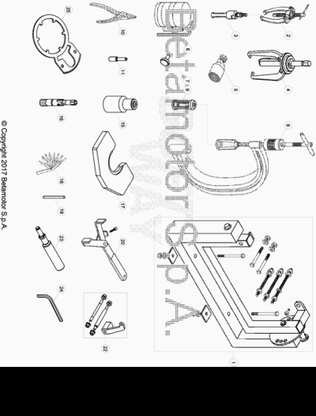

ENDURO_RR-S_500_4T_MY19_USA
Ref. | Part Number | Description | Part
1 | 36.25132.000 | HERRAMIENTAS UNIVERSALES MONTAJE MOTOR RR-4T | 1
2 | 36.25081.000 | EXTRACTOR GOMA RR-4T | 1
3 | 006.14.016.00.00 | EXTRACTOR COJINETES INT.20-30 MM | 1
4 | 006.14.015.00.00 | EXTRACTOR ENGRANAJES | 1
5 | 36.25173.000 | EXTRACTOR VOLANTE MAGNETICO RR2T/ RR-4T | 1
6 | 006.14.017.00.00 | ANILLO COMPRESION PISTON | 1
7 | 006.14.005.00.00 | UTIL TENSOR CADENA | 1
8 | 01.00043.000 | HERRAMIENTA MONTAJE MUELLE VALVULAS | 1
9 | 006.14.003.00.00 | UTIL MONTAJE MUELLE VALVULA | 1
10 | 36.25097.000 | PINZA ESPECIAL ANILLOS RR-4T | 1
11 | 006.14.011.00.00 | HERRAMIENTA PARA BLOQUEO CIGUEÑAL AL PMS | 1
15 | 006.14.002.00.00 | LLAVE DE ENCHUFE 36 MM | 1
16 | 020.44.010.00.00 | LLAVE BUJIA | 1
17 | 029.14.007.50.00 | UTIL DESMONTAJE BIELA | 1
18 | 006.14.021.00.00 | CALIBRE PARA JUEGO VALVULAS | 1
19 | 006.14.018.00.00 | CALIBRE PARA GUIA VALVULA | 1
20 | 006.14.004.00.00 | LLAVE BLOQUEADORA TUBO FRICCION | 1
22 | 006.14.014.00.00 | FIJACIONES MOTOR | 1
23 | 022.14.020.00.00 | UTILAJE ANILLO ELASTICO BLOQUEO-CLAVIJA 350cc | 1
24 | 006.44.000.00.00 | LLAVE ESPECIAL | 1
25 | 029.14.002.50.00 | LLAVE ESPECIAL | 1

