

ENDURO_RR_125_2T_MY22
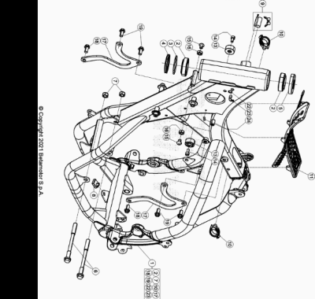

ENDURO_RR_125_2T_MY22
Ref. | Part Number | Description | Part
1 | 041.31.017.80.50 | CHASIS RR 2T | 1
2 | 12.99510.000 | COJINETE CÓNICO 29X50X15 RR-4T | 2
3 | 10.66935.000 | JUNTA TÓRICA RR-4T | 1
4 | 020.31.039.00.00 | GUARDAPOLVO DIRECCION | 1
5 | 031.31.016.22.00 | PROTECCION COJINETE | 1
6 | 11.64607.000 | TORNILLO ESPECIAL RR-4T | 2
7 | 13.21060.000 | TUERCA AMBRIDADA M10 X 1,25 | 2
8 | 25.60311.000 | GRAPA TORNILLO M6 ALP 4.0 2008 | 1
9 | 037.31.024.00.00 | CERRADURA BLOCAJE | 1
10 | 25.24441.000 | PASACABLES | 2
11 | 037.31.071.00.59 | GOMA PROTECTOR DEPOSITO | 1
13 | 29.10310.000 | TOPE GOMA DEPOSITO TR-34/RR-4T | 2
14 | 31.31050.000 | TORNILLO ALLEN TCCE 6.15 | 2
15 | 31.64020.000 | #31.63890.000# | 2
16 | 13.16000.000 | TUERCA 8.6 CH13 | 2
17 | 041.32.000.50.00 | SOPORTE MOTOR RR 2T 125 | 2
18 | 11.54492.000 | TORNILLO CH 8.20 X 10 ENDURO RR 125 | 2
19 | 11.54521.000 | TORNILLO 8.16 RS C/ARANDELA CH.10 | 4
22 | 27.33741.000 | REMACHE | 1
23 | 27.23470.000 | RACORD MOTOR RK6-50/ TUBO GASOLINA RR-T/ART - RR-4T- RR 125 | 1
24 | 25.24443.000 | GUIA CABLE 6/6 RR-4T / RR 125 / RR-T | 1

ENDURO_RR_125_2T_MY22
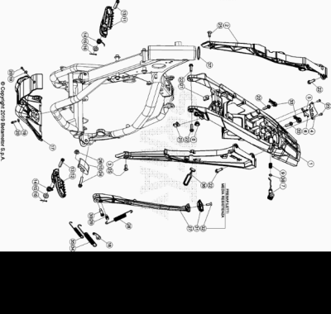

ENDURO_RR_125_2T_MY22
Ref. | Part Number | Description | Part
1 | 040.32.035.80.59 | CHASIS POSTERIOR | 1
2 | 037.32.033.87.59 | SOPORTE SUBCHASIS | 1
3 | 037.32.034.87.59 | SOPORTE COLA TRASERA | 1
4 | 020.32.010.00.05 | CHAPA FIJ. CERRADURA | 1
5 | 020.32.112.00.00 | EJE CERRADURA | 1
6 | 037.32.013.50.00 | SOPORTE | 1
7 | 037.32.014.87.59 | PULSANTE ASIENTO | 1
8 | 037.38.003.00.00 | SOPORTE | 1
9 | 020.32.016.00.00 | MUELLE | 1
10 | 25.25601.000 | PATIN TENSOR RR 4T 2008 | 1
11 | 037.32.009.00.00 | ESTRIBERA DX | 1
12 | 037.32.008.00.00 | ESTRIBERA SX | 1
13 | 25.54465.000 | EJE ESTRIBERA RR-4T | 2
14 | 037.32.019.00.00 | MUELLE | 2
15 | 031.32.001.00.00 | ARANDELA 10 X 21 X 2 | 2
16 | 12.81993.000 | PASADOR EJE ESTRIBERA | 2
17 | 041.32.004.00.59 | PROTECCION MOTOR RR 2T | 1
18 | 037.32.031.50.00 | SOPORTE MUELLE CABALLETE | 1
19 | 27.42000.000 | ARANDELA PLANA 6.18 | 2
20 | 11.49070.000 | TORNILLO 6X20 RS CH8 | 2
21 | 25.60311.000 | GRAPA TORNILLO M6 ALP 4.0 2008 | 2
22 | 31.64070.000 | TORNILLO ESPECIAL 8X25 CH10 | 6
23 | 31.29810.000 | TORNILLO TBCE 5.12 | 2
24 | 11.55480.000 | TORNILLO 8.40 PF C/ARANDELA | 1
25 | 007.32.032.00.00 | TORNILLO ESP. TSBEI CH6 M8X20 10.9 ZINC | 2
26 | 13.17120.000 | TUERCA M8 BASE CILINDRO | 1
27 | 037.32.010.82.00 | KIT CABALLETE | 1
28 | 037.32.030.00.00 | MUELLE | 1
29 | 11.66615.000 | TORNILLO ESP. CAVALLETE RR 4T 2008 | 1
30 | 11.66614.000 | TORNILLO ESPECIAL CABALLETE RR 4T 2008 | 1
31 | 037.32.017.00.00 | SOPORTE | 1
32 | 31.34400.000 | TORNILLO 6 X 20 | 1
33 | 037.32.027.00.00 | KIT TAPON | 1
34 | 037.32.029.00.00 | MUELLE | 1
35 | 037.32.028.00.00 | MUELLE | 1
36 | 16.34907.000 | GOMA CABALLETE RR-4T | 1
37 | 031.32.007.00.00 | ANILLO DE SELLADO | 1
38 | C02.06.066.00.00 | RETEN 9.52 X 1.78 | 1

ENDURO_RR_125_2T_MY22
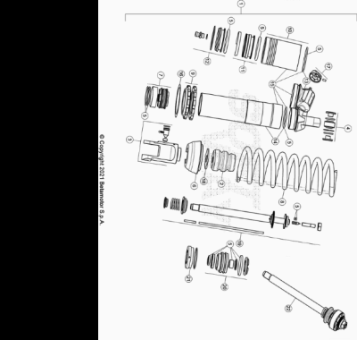

ENDURO_RR_125_2T_MY22
Ref. | Part Number | Description | Part
1 | 041.33.005.80.00 | AMORTIGUADOR RR 2T | 1
2 | 037.33.009.00.00 | TAPON AMORTIGUADOR | 1
3 | 037.33.010.00.00 | HORQUILLA AMORTIGUADOR | 1
4 | 13.86078.800 | KIT DISTANCIADOR AMORTIGUADOR RRT-4T-GR | 1
5 | 037.33.011.82.00 | KIT JUNTAS | 1
6 | 037.33.012.00.00 | TAPON AMORTIGUADOR | 1
7 | 026.33.020.00.00 | PISTON | 1
8 | 041.33.009.00.00 | MUELLE AMORTIGUADOR | 1
9 | 026.33.019.00.00 | TUERCAS AMORTIGUADOR | 1
10 | 026.33.012.00.00 | DEPOSITO AMORTIGUADOR | 1
11 | 026.33.013.00.00 | MEMBRANA | 1
12 | 026.33.014.00.00 | TAPON | 1
13 | 037.33.013.00.00 | TAPON | 1
14 | 037.33.014.00.00 | CUERPO AMORTIGUADOR | 1
15 | 037.33.015.00.00 | CUERPO AMORTIGUADOR | 1
16 | 031.33.012.00.00 | ARANDELA | 1
17 | 026.33.021.00.00 | TAPON REGISTRO | 1
18 | 031.33.014.00.00 | ARANDELA | 1
19 | 037.33.016.00.00 | VARILLA | 1
20 | 037.33.017.00.00 | GUIA | 1
21 | 026.33.026.00.00 | TAPON | 1
22 | 041.33.010.80.00 | VARILLA COMPLETA | 1

ENDURO_RR_125_2T_MY22
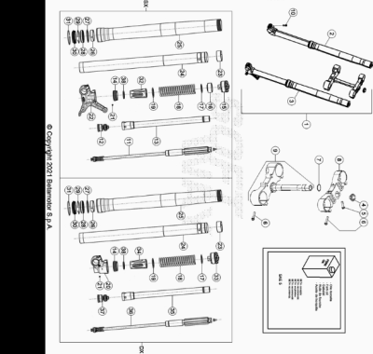

ENDURO_RR_125_2T_MY22
Ref. | Part Number | Description | Part
1 | 041.34.033.80.00 | HORQUILLA COMPLETA | 1
2 | 041.34.027.80.00 | BRAZO DERECHO | 1
3 | 041.34.028.80.00 | BRAZO IZQUIERDO | 1
4 | 020.34.004.00.00 | TUERCA M 20 X 1,5 HORQUILLA RR 4T MY 10 | 1
5 | 11.55440.000 | TORNILLO C/HEX. 10 M8x30 DIN 933 8.8 | 1
6 | 11.55510.000 | TORNILLO 8.40 ALP 200/08 | 8
7 | 10.66420.000 | ANILLO OR 22-3,53 NBR | 1
8 | 031.34.051.42.59 | PLETINA INF | 1
9 | 031.34.041.82.59 |  | 1
10 | 031.34.072.00.00 | TORNILLO M 8.25 8.8 | 4
11 | 041.34.031.00.00 | GRUPO EXTENSION | 1
12 | 040.34.047.00.00 | GRUPO COMPRESION | 1
13 | 037.34.015.00.00 | TUBO | 1
14 | 020.34.313.00.00 | ANILLO DE APOYO VARILLA+ O.RING | 2
15 | 040.34.050.00.00 | TAPON HORQUILLA | 1
16 | 040.34.008.00.00 | DISTANCIADOR | 1
17 | 031.34.323.00.00 | ARANDELA | 2
18 | 035.34.015.00.00 | MUELLE | 2
19 | 040.34.041.00.00 | ARANDELA | 2
20 | 037.34.014.00.00 | PIE HORQUILLA | 1
21 | 020.34.308.00.00 | CLAVIJA | 2
22 | 037.34.013.00.00 | PIE HORQUILLA | 1
23 | 020.34.320.00.00 | CASQUILLO 049/47 L 20 | 2
24 | 031.34.021.00.00 | BARRA HORQ,. RR 2T/4T | 2
25 | 040.34.040.00.00 | BOTELLA HORQUILLA RR 2T | 2
26 | 031.34.020.00.00 | DISTANCIADOR D.52/48 L12 | 2
27 | 020.34.318.00.00 | DISTANCIADOR | 2
28 | 020.34.317.00.00 | RETEN HORQUILLA 48X58X9/11,5 | 2
29 | 020.34.316.00.00 | SEEGER 58,45 | 2
30 | 020.34.315.00.00 | GUARDAPOLVO HORQUILLA | 2
31 | 026.34.364.00.00 | ANILLO BLOQUEO | 2
32 | 040.34.042.00.00 | GUIA MUELLE | 1
33 | 040.34.051.00.00 | TAPON HORQUILLA | 1
34 | 040.34.043.00.00 | GUIA MUELLE | 1
35 | 037.34.016.00.00 | TUBO | 1
36 | 041.34.032.00.00 | GRUPO EXTENSION | 1
37 | 040.34.048.00.00 | GRUPO COMPRESION | 1
38 | 040.34.044.00.00 | ARANDELA | 2

ENDURO_RR_125_2T_MY22
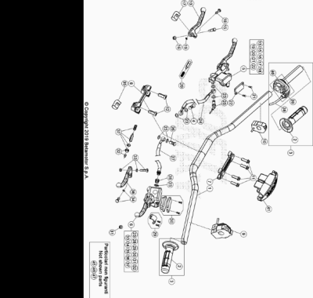

ENDURO_RR_125_2T_MY22
Ref. | Part Number | Description | Part
1 | 037.35.000.00.59 | MANILLAR | 1
2 | 036.35.005.00.00 | JUEGO DE PUÑOS ENDURO | 1
3 | 026.35.002.80.00 |  | 1
4 | 11.65053.000 | TORNILLO ESPECIAL TALAD.10..1,25 RR-4T | 1
5 | 21.02057.059 | BOMBA FRENO DELANTERA RR4T RACING | 1
6 | 020.35.020.00.00 | BOMBA EMBRAGUE ENDURO RR 4T 2012 | 1
7 | 12.08253.000 | ABRAZADERA SUPERIOR HORQUILLA RR-4T | 1
8 | 12.08263.000 | ABRAZADERA INF HORQUILLA RR4T 1508050 | 1
9 | 016.35.010.00.00 | MANDO LUCES CON INTERMITENTES ENDURO 2017 | 1
10 | 035.35.003.00.00 | DISPOSITIVO ON-OFF | 1
11 | 31.64070.000 | TORNILLO ESPECIAL 8X25 CH10 | 4
12 | 31.65626.000 | TORNILLO 10X25 RR-4T | 2
13 | 21.27104.000 | MANETA FRENO ANT. FORJADA RR 4T | 1
15 | 31.96832.000 | PASADOR MANETA FRENO | 1
16 | 13.30911.000 | TUERCA PASADOR MANETA FRENO | 1
17 | 16.33841.000 | GOMA RR 4T 2008 | 1
18 | 31.88604.000 | TORINILLO REG | 1
19 | 22.38704.000 | MUELLE REG. BOMBA FRENO | 1
20 | 20.08258.000 | JUEGO PISTON COMPL. BOMBA FRENO ANT. RR-4T | 1
21 | 31.23410.052 | TORNILLO TAPA DEP. LIQUIDO FRENOS | 2
22 | 031.36.003.82.00 | KIT TAPA BOMBA FRENO ANT. RR2T | 1
23 | 16.50510.000 | JUNTA 10.15.1 (COBRE) | 7
24 | 037.36.002.00.00 | TUBO FRENO | 1
25 | 18.89621.000 | INTERRUPTOR STOP RR-4T | 1
26 | 11.65040.000 | TORNILLO ESP. TALAD.10.1 PARA TUBO FRENO | 1
27 | 035.35.002.00.00 | TUBO EMBRAGUE | 1
28 | 020.35.032.00.00 | RACORD BOMBA EMBRAGUE | 1
29 | 020.35.025.00.00 | BRIDA | 1
30 | 020.35.023.00.00 | TAPA DEPOSITO BOMBA EMBRAGUE | 1
31 | 020.35.028.00.00 | ANTIEMULSION | 1
32 | 020.35.029.00.00 | VARILLA DE PRESION | 1
33 | 020.35.024.00.00 | EJE PALANCA | 1
34 | 020.35.030.00.00 | GUIA RESORTE | 1
35 | 020.35.027.00.00 | GOMA PROTECCION PALANCA | 1
36 | 020.35.022.00.00 | MANETA EMBRAGUE RR4T 2012 | 1
37 | 020.35.026.00.00 | KIT PISTON BOMBA | 1
38 | 026.35.011.82.00 | CABLE MANDO GAS | 1
39 | 026.35.010.00.00 | #12.55098.000# | 1
40 | 031.35.013.00.00 | PROTECCION | 1
41 | 037.43.016.00.59 | PROTECCION MANILLAR | 1
45 | 12.30100.000 | SOPORTE MANETA FRENO ANT (ESPEJO) | 1
46 | 28.92927.000 | #28.92927.800# | 1
47 | 031.35.008.00.00 | RETROVISOR SX | 1

ENDURO_RR_125_2T_MY22
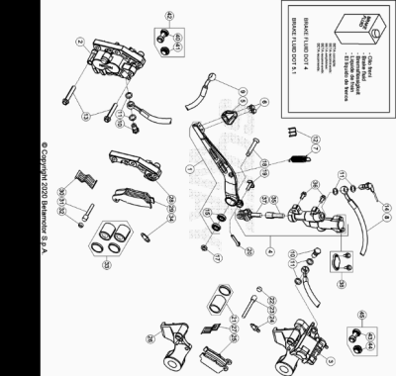

ENDURO_RR_125_2T_MY22
Ref. | Part Number | Description | Part
1 | 037.36.004.80.00 | PEDAL FRENO | 1
2 | 25.03056.000 | PINZA FRENO ANTERIOR RR-4T | 1
3 | 25.03066.000 | PINZA FRENO POSTERIOR RR-4T | 1
4 | 25.91178.000 | BOMBA FRENO POSTERIOR ENDURO RR 4T /07 | 1
5 | 22.90053.000 | PUNTERA PEDAL FRENO RR-4T | 1
6 | 11.46251.000 | TORNILLO 5.12 RS CH8 | 2
7 | 026.36.000.00.00 | MUELLE RETORNO PALANA FRENO RR 2T | 1
8 | 29.09428.000 | TUBO FRENO POSTERIOR ENDURO RR 4T /07 | 1
9 | 037.36.002.00.00 | TUBO FRENO | 1
10 | 11.65053.000 | TORNILLO ESPECIAL TALAD.10..1,25 RR-4T | 2
11 | 16.50510.000 | JUNTA 10.15.1 (COBRE) | 6
12 | 25.24442.000 | GUIA CABLE 6/8 RR-4T / RR 125 / RR-T | 1
13 | 11.55510.000 | TORNILLO 8.40 ALP 200/08 | 2
14 | 18.89621.000 | INTERRUPTOR STOP RR-4T | 1
15 | C06.01.047.00.00 |  | 2
17 | 13.21060.000 | TUERCA AMBRIDADA M10 X 1,25 | 1
18 | 037.36.001.00.00 | TORNILLO ESPECIAL M. 10 X 1,25 X 35 | 1
19 | 25.41830.000 | EJE BOMBA POST.RR-4T/07 | 1
20 | 12.81995.000 | PASADOR 2.15 INOX REV 3 | 1
21 | 20.02717.000 | JUEGO PISTON Y GUARNICIÓN PINZA RR-4T | 1
22 | 31.96821.000 | TORNILLO ESP. PASTILLAS PINZAS RR-4T/06 | 1
23 | 25.41860.000 | VARILLA ESP. PASTILLAS PINZAS RR-4T/06 | 1
24 | 28.91002.000 | AIREADOR PINZAS FRENO RR-4T | 1
25 | 25.25362.000 | JUG. PASTILLAS PINZA FRENO POSTERIOR RR-4T | 1
26 | 020.36.011.00.00 | BRIDA SOPORTE PINZA | 1
27 | 22.32208.000 | MUELLE PASTILLAS PINZA RR-4T | 1
28 | 020.36.012.00.00 | BRIDA SOPORTE PINZA ANT. 25.03056. 0.00 | 1
29 | 25.25361.000 | #25.25365.000# | 1
30 | 22.32207.000 | MUELLE PASTILLAS PINZA RR-4T | 1
31 | 25.41859.000 | VARILLA ESP. PASTILLAS PINZAS RR-4T/06 | 1
32 | 31.96821.000 | TORNILLO ESP. PASTILLAS PINZAS RR-4T/06 | 1
33 | 20.02716.000 | JUEGO PISTON Y GUARNICIÓN PINZA RR-4T | 1
34 | 28.91001.000 | AIREADOR PASTILLAS PINZA RR-4T | 1
35 | 20.08276.000 | JUEGO PISTON BOMBA FRENO RR 4T 2008 | 1
36 | 31.30750.000 | TORNILLO TBIB 6.16 | 2
37 | 20.08277.000 | KIT LEVA BOMBA FRENO | 1
38 | 20.08275.000 | KIT DEPOSITO BOMBA RR 4T 2008 | 1
40 | 036.36.002.00.00 | PROTECCION | 1
41 | 036.36.003.00.00 | PROTECCION | 1
42 | 036.36.006.82.00 | PROTECCION ANTERIOR | 1
43 | 036.36.004.00.00 | PROTECCION | 1
44 | 036.36.005.00.00 | PROTECCION | 1
45 | 036.36.007.82.00 | PROTECCION POSTERIOR | 1

ENDURO_RR_125_2T_MY22
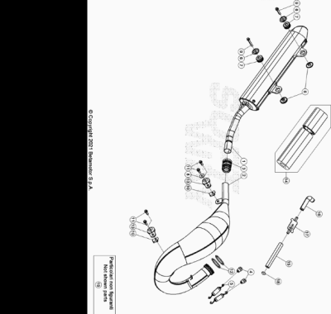

ENDURO_RR_125_2T_MY22
Ref. | Part Number | Description | Part
1 | 041.37.000.80.00 | #041.37.000.82.00# | 1
2 | 041.37.003.80.00 | ESCAPE | 1
3 | 035.37.002.00.00 | JUNTA SILENCIOSO | 1
4 | 25.57912.000 | PLACA FIJACION MUELLE COLECTOR REV4T | 2
5 | 026.37.005.00.00 | MUELLE ESCAPE | 2
6 | 026.37.006.00.00 | DISTANCIADOR ESCAPE | 4
7 | 032.37.013.00.00 | SILENT-BLOCK | 2
8 | 27.42000.000 | ARANDELA PLANA 6.18 | 1
9 | 11.50300.000 | TORNILLO 6,30 RS CH 8 RR-4T / RR 125 | 2
10 | 25.60311.000 | GRAPA TORNILLO M6 ALP 4.0 2008 | 2
11 | 11.48025.000 | TORNILLO HEX/C.ARO 6x16 ( RS-T.8 ) | 4
12 | 10.66930.000 | TORICA OR 43.3 VYTON (OR M 0430-30) | 2
13 | 28.91943.000 | SILENT-BLOCK ESCAPE KIT RR GARA FE | 2
14 | 036.37.110.82.00 | #026.37.007.82.00# | 1
15 | 29.15858.000 | TUBO | 1
16 | 29.15852.000 | TUBO VALVULA/FILTRO AL 4.0 2008 | 1
17 | 31.15070.000 | VALVULA AIRE RR4T EURO3 | 1
18 | 10.67470.000 | ARANDELA CAJA FILTRO | 1
19 | 035.37.026.80.00 | ESCAPE RR 125 2T RACING *EU* | 1

ENDURO_RR_125_2T_MY22
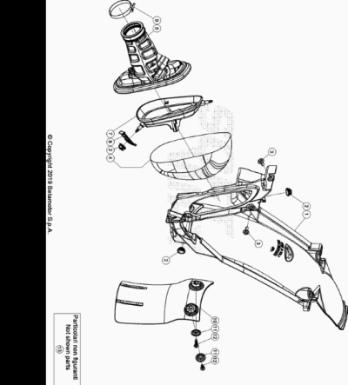

ENDURO_RR_125_2T_MY22
Ref. | Part Number | Description | Part
1 | 037.38.000.87.59 | CAJA FILTRO | 1
2 | 037.38.003.00.00 | SOPORTE | 3
3 | 037.43.029.00.00 | TORNILLO ESP. M 6 X 12 | 2
4 | 037.38.002.82.00 | FILTRO AIRE RR 2T/4T 2020/21 | 1
6 | 037.38.006.00.59 | SOPORTE CAJE FILTRO | 1
7 | 037.38.001.00.00 | GABIA FILTRO | 1
8 | 041.38.000.00.00 | MANGUITO CAJA FILTRO | 1
9 | 15.14272.000 | BRIDA FIJACIÓN RR-4T | 1
10 | 026.38.007.10.59 | PROTECTOR AMORTIGUADOR | 1
11 | 27.74786.000 | ARANDELA RR-4T | 2
12 | 31.30815.000 | TORNILLO AUTOROSC. 6 X 20 | 2
13 | 040.38.002.82.00 | FILTRO | 1

ENDURO_RR_125_2T_MY22
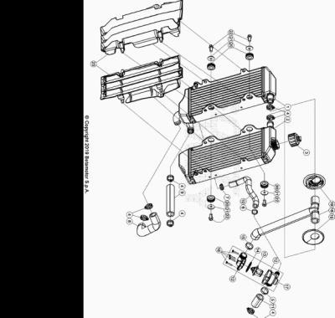

ENDURO_RR_125_2T_MY22
Ref. | Part Number | Description | Part
1 | 040.39.018.00.00 | RADIADOR RR 2T | 1
2 | 040.39.019.00.00 | RADIADOR RR 2T | 1
3 | 036.39.008.00.00 | TAPON RADIADOR | 1
4 | 15.15240.000 | BRIDA 17/29 VELOXBLOC 3B | 7
5 | C07.16.005.00.00 | ABRAZADERA D.25 | 1
6 | 020.39.009.00.00 | ABRAZADERA 17 | 1
7 | 15.15220.000 | BRIDA 12/20 APA SX9-C-W1 | 1
8 | 041.39.003.00.00 | TUBO BOMBA AGUA | 1
9 | 040.39.007.00.00 | TUBO AGUA RR 2T | 1
10 | 040.39.008.00.00 | TUBO AGUA RR 2T | 1
11 | 041.39.001.00.00 | TUBO AGUA | 1
12 | 037.39.006.00.00 | CONTENEDOR TERMOSTATO | 1
13 | 026.39.013.00.00 | TERMOSTATO RR 2T | 1
14 | 10.66830.000 | TORICA OR 32X2 REV4T | 1
15 | C07.16.007.00.00 | ABRAZADERA D. 26 | 1
16 | 031.39.017.50.00 | TORNILLO ESPECIAL M 3, 5X18 | 4
17 | 040.39.003.80.00 |  | 1
18 | 041.39.000.00.00 | TUBO AGUA | 1
19 | 037.39.015.00.00 | TAPON | 2
20 | 035.39.006.00.00 | SILENT BLOCK | 4
21 | 27.43250.000 | ARANDELA PLANA 6.24 | 4
22 | 11.47015.000 | TORNILLO 6.12 REV3-04 - RR-4T | 4
23 | 037.39.003.00.51 | REJILLAS RADIADOR *JUEGO* | 1

ENDURO_RR_125_2T_MY22
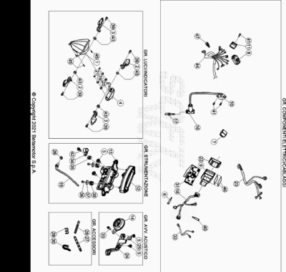

ENDURO_RR_125_2T_MY22
Ref. | Part Number | Description | Part
1 | 031.40.006.00.00 | GRUPO OPTICO | 1
2 | 020.40.061.00.00 | INTERMITENTE ANT SX - POST.DX | 2
3 | 020.40.060.00.00 | INTERMITENTE ANT DX - POST SX | 2
4 | 037.40.063.00.00 | GRUPO OPTICO POSTERIOR | 1
5 | 037.43.028.00.00 | TORNILLO ESPECIAL M6X8 | 4
6 | 026.40.039.00.00 | CONECTOR | 1
7 | 18.84948.000 | INTERMITENCIA ALP 200/08 | 1
8 | 007.40.088.00.00 | DISPOSITIVO SWITCH MAPA | 1
9 | 041.40.001.82.00 | CENTRALITA RR 2T 125 MY20 | 1
10 | 007.40.044.00.00 | BOBINA EVO 2017 | 1
11 | 27.28101.000 | REGULADOR RR-4T | 1
12 | 040.40.004.00.00 | INSTRUMENTO DIGITAL RR 2T | 1
13 | 037.40.001.00.00 | SOPORTE INSTRUMENTO DIGITAL | 1
14 | 007.40.050.00.00 | AVISADOR ACUSTICO SCOOTER | 1
15 | 031.40.166.00.00 | SENSOR RED | 1
16 | 27.13514.000 | PIPA BUJIA | 1
17 | 12.25126.000 | BUJIA NGK BR9 ECMVX | 1
18 | 041.40.000.00.00 | INSTALACION ELECTRICA PRINCIPAL | 1
19 | 043.40.015.00.00 | ESPACIADOR | 2
20 | 16.34903.000 | GOMA INSTRUMENTOS ALP 200/08 | 2
21 | 13.10910.000 | TUERCA M4 AUTOBLOC. | 2
22 | 007.40.081.00.00 | GOMA SOPORTE CENTRALITA | 1
23 | 040.40.006.00.00 | INSTALACION ELECTRICA SERVICIO RR 2T | 1
24 | 037.40.023.00.59 | SOPORTE AVISADOR ACUSTICO | 1
25 | 25.60311.000 | GRAPA TORNILLO M6 ALP 4.0 2008 | 1
26 | 13.17121.000 | TUERCA M8 BASE CILINDRO CH.10 | 1
27 | 037.40.026.00.00 | ABRAZADERA | 6
28 | 032.35.049.00.00 | GOMA | 1
29 | 25.24443.000 | GUIA CABLE 6/6 RR-4T / RR 125 / RR-T | 4
30 | 15.14264.000 | ABRAZ.PA 6 NY.DENT.NAT.ABNY-B 3,6 X 200 | 6
31 | 040.40.001.00.00 | SOPORTE CENTRALITA RR 2T | 1
32 | 026.40.057.00.00 | INSTALACION ELECTRICA DIAGNOSIS | 1
33 | 11.46501.000 | TORNILLO ENCAJE M6.10 RSCH8 | 1
34 | 25.25182.000 | ABRAZADERA | 1
35 | 037.40.030.00.00 | PIEZA 35 DAR ALTA BETA MOTOR | 1
36 | 31.73000.000 | TORNILLO SPEC. 4.8 TC 8 VOLANTE | 2
37 | 27.34800.000 | ARANDELA TRANCIATA 4.16 | 2
38 | 024.40.039.00.00 | SILENT BLOCK | 2
39 | 11.48025.000 | TORNILLO HEX/C.ARO 6x16 ( RS-T.8 ) | 4
40 | 037.40.022.00.00 | CONDENSADOR | 1
41 | 11.49070.000 | TORNILLO 6X20 RS CH8 | 3
42 | 11.46251.000 | TORNILLO 5.12 RS CH8 | 1
43 | 13.12550.000 | TUERCA M6.5 FLAN. | 4
44 | 040.40.019.00.00 | INSTALACION SERVICIO ANTERIOR | 1
45 | 31.26190.000 | TORNILLO M. 4 X 12 TCIC | 3
46 | 29.10317.000 | PROTECTOR GOMA | 2
47 | 037.40.115.00.00 |  | 1

ENDURO_RR_125_2T_MY22
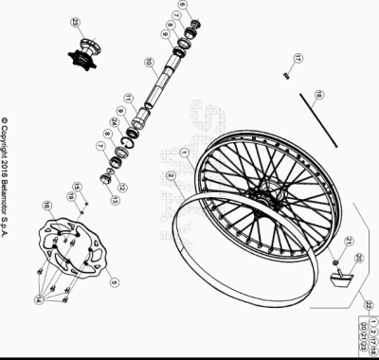

ENDURO_RR_125_2T_MY22
Ref. | Part Number | Description | Part
1 | 036.41.007.00.59 | LLANTA ANTERIOR | 1
2 | 15.38200.000 | SALVACAMARA 750x25-21" RR-4T / RR 125 | 1
5 | 031.41.030.00.00 | #031.41.030.82.00# | 1
6 | 020.41.007.00.00 | TAPON EJE RUEDA ANTERIOR | 1
7 | 031.41.004.00.00 | DISTANCIADOR BUJE DEL. | 2
8 | 10.66000.000 | RETEN 35X47X7 RR-4T | 2
9 | 020.41.003.00.00 | #12.99520.000# | 2
10 | 020.41.005.00.00 | EJE RUEDA DELANTERA | 1
11 | 031.41.015.00.00 | DISTANCIADOR INTERIOR BUJE DELANTERO | 1
12 | 020.41.110.00.00 | TAPON INTERNO RUEDA ANT.RR4TMY11 | 1
13 | 020.41.006.00.00 | TAPON EJE | 1
14 | 031.41.043.00.00 | TORNILLO ESP. M 6X14 | 6
15 | 28.22660.000 | SEEGER 9E | 1
16 | 021.41.005.00.00 | MAGNETO DIAM. 9 PER SENSORE HALL | 1
17 | 031.41.050.00.00 | TUERCA RADIO ANT. | 36
18 | 031.41.049.00.52 | RADIO ANTERIOR | 36
19 | 27.58080.000 | ARANDELA 9 X 13 X 0.4 ENDURO RR 125 | 1
20 | 036.41.010.00.00 | AGARRE CUBIERTA | 1
21 | 13.17120.000 | TUERCA M8 BASE CILINDRO | 1
22 | 041.41.001.00.59 | RUEDA DELANTERA | 1
23 | 031.41.014.80.00 | BUJE ANT. C/COJI. Y DIST.INTERNO RR 4T | 1
24 | C01.26.001.00.00 | SEEGER D: 47 X 1,75 | 1

ENDURO_RR_125_2T_MY22
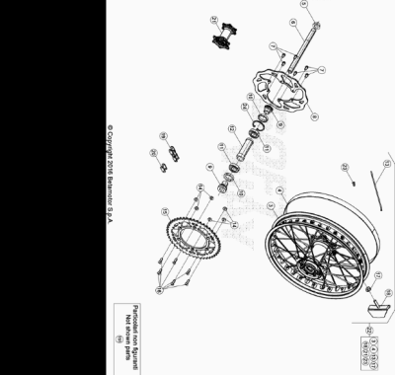

ENDURO_RR_125_2T_MY22
Ref. | Part Number | Description | Part
3 | 036.42.007.00.59 | LLANTA RUEDA TRASERA 18.1,85-36 | 1
4 | 15.36000.000 | SALVACAMARA 575x25-18 | 1
5 | 13.27120.000 | TUERCA ESPECIAL RUEDA POSTERIOR RR-4T | 1
6 | 25.55812.000 | EJE RUEDA POSTERIOR RR-4T | 1
7 | 031.41.016.00.00 | #031.41.043.00.00# | 6
8 | 031.42.030.00.00 | #031.42.030.82.00# | 1
9 | 031.42.002.00.00 | DISTANCIADOR BUJE POST. RR 4T | 2
10 | 10.66000.000 | RETEN 35X47X7 RR-4T | 2
11 | 020.42.004.00.00 | #12.99280.000# | 2
12 | 031.42.005.00.00 | DIST.INTERNO RUEDA POST. RR4T | 1
13 | 031.42.037.00.52 | RADIO POST. | 36
14 | 13.17123.000 | TUERCAS M8 | 6
15 | 031.42.039.00.00 | CORONA Z 50 | 1
16 | 31.96827.000 | TORNILLO TGS M8X26 10.9 DACR | 6
17 | 13.17120.000 | TUERCA M8 BASE CILINDRO | 1
18 | 15.17550.000 | #15.17541.000# | 1
19 | 035.42.002.00.00 | CADENA | 1
20 | 035.42.005.00.00 | ENGANCHE CADENA | 1
21 | 031.42.014.80.00 | BUJE POSTERIOR C/ COJINETES | 1
22 | 041.42.003.00.59 | RUEDA TRASERA | 1
23 | 031.42.051.00.00 | CABECILLA POST. | 36
24 | C01.26.001.00.00 | SEEGER D: 47 X 1,75 | 1
151 | 031.42.028.00.00 | CORONA Z 45 | 1

ENDURO_RR_125_2T_MY22
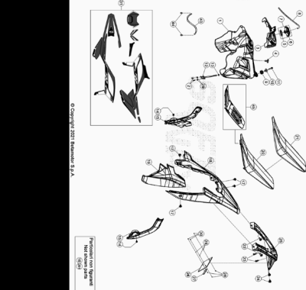

ENDURO_RR_125_2T_MY22
Ref. | Part Number | Description | Part
1 | 040.43.000.00.51 | DEPOSITO GASOLINA BLANCO RR 2T | 1
2 | 31.29810.000 | TORNILLO TBCE 5.12 | 2
3 | 041.43.000.00.97 | TAPA DEPOSITO | 1
4 | 31.89010.000 | TORNILLO BLOQUEO SILLÍN RR-4T / RR 125 | 1
5 | 031.43.116.00.00 | JUNTA TAPON GASOLINA | 1
6 | 036.43.041.80.00 | TAPON DEPOSITO GASOLINA | 1
7 | 036.43.041.82.00 | TAPON GASOLINA COMPLETO | 1
8 | 020.43.003.00.00 | TUBO TAPON-VALVULA PURGA AIRE | 1
9 | 032.37.013.00.00 | SILENT-BLOCK | 1
10 | 020.43.002.00.00 | DISTANCIADOR DEPOSITO GASOLINA | 1
11 | 11.50300.000 | TORNILLO 6,30 RS CH 8 RR-4T / RR 125 | 1
12 | 020.43.007.00.00 | GRIFO GASOLINA | 1
13 | 026.43.034.00.00 | TORICA | 1
14 | C24.31.046.00.00 | TORNILLO M 5 X 8 8.8 DIN 6921 | 2
15 | 037.43.078.00.59 | PROTECTOR CHASIS | 1
16 | 041.43.008.82.00 | CONTENEDOR FILTRO KIT 2T | 1
17 | 037.43.028.00.00 | TORNILLO ESPECIAL M6X8 | 4
18 | 037.43.007.87.97 | GUARDABARROS POSTERIOR RR | 1
19 | 037.43.005.87.97 | PLACA FILTRO | 1
20 | 037.43.106.00.00 | ASIENTO | 1
21 | 037.43.107.00.00 | FUNDA SILLIN | 1
22 | 037.43.030.00.00 | TORNILLO ESPECIAL M 6 X 16 | 2
23 | 31.79960.000 | TORNILLO AUTOROSCANTE M6x15 | 2
24 | 037.43.029.00.00 | TORNILLO ESP. M 6 X 12 | 2
25 | 037.43.112.00.59 | PORTAMATRICULAS | 1
26 | 018.43.010.10.59 | SOPORTE MATRICULA | 1
27 | 12.33086.000 | REFLECTOR POSTERIOR RR.4T 7 RR 125 | 1
28 | 31.29860.000 | TORNILLO TTLIC 5.16 CABEZA 10 | 3
29 | 27.36000.000 | ARANDELA PLANA 5.11 | 5
30 | 13.11010.000 | TUERCA M5 AUTOBLOC. | 3
31 | 037.43.108.82.00 | SERIE ADHESIVOS ENDURO RR2T/4T 2022 | 1
43 | 026.43.005.00.00 | TUBO GASOLINA DEP/CARBURAT. RR 2T | 1
44 | C07.08.008.00.00 | BRIDA CE 12 | 2
45 | 037.43.084.80.00 | SOPORTE SILLIN | 1
251 | 037.43.113.80.59 | PORTAMATRICULAS HO | 1

ENDURO_RR_125_2T_MY22
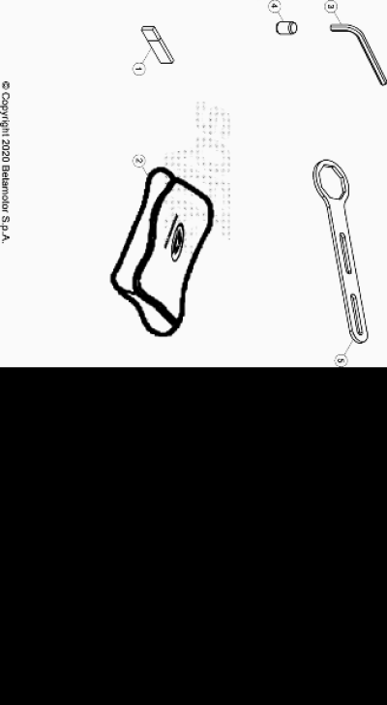

ENDURO_RR_125_2T_MY22
Ref. | Part Number | Description | Part
1 | 040.44.021.83.00 | PEN DRIVE MANUAL USUARIO | 1
2 | 020.44.202.80.00 | BOLSA HERRAMIENTAS | 1
3 | 020.44.003.00.00 | LLAVE ESPECIAL ALLEN 6 MM | 1
4 | 020.44.004.00.00 | LLAVE ALLEN 8 MM | 1
5 | 031.44.034.00.00 | UTILAJE TAPON HORQ. | 1

ENDURO_RR_125_2T_MY22
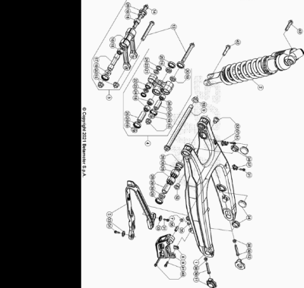

ENDURO_RR_125_2T_MY22
Ref. | Part Number | Description | Part
1 | 037.33.003.00.59 | BASCULANTE RR 2T MY 20 | 1
2 | 041.33.005.80.00 | AMORTIGUADOR RR 2T | 1
3 | 020.33.030.80.00 | BIELETA COMPLETA | 1
4 | 020.33.020.80.00 | TRAPEZIO COMPLETO | 1
5 | 037.33.006.00.00 | PATIN CADENA | 1
6 | 037.33.004.00.00 | GUIACADENA | 1
7 | 13.13020.000 | TUERCA M6 AUTOBLOC. BASSO | 1
8 | 13.48868.000 | DISTANCIADOR RR 4T 2008 | 1
9 | 037.33.005.50.00 | EJE BASCULANTE | 1
10 | 037.33.008.50.00 | TUERCA | 1
11 | 29.11866.100 | TENSOR CADENA IZQUIERDO RR-4T | 1
12 | 29.11865.100 | TENSOR CADENA DERECHO RR-4T | 1
13 | 11.63992.000 | TORNILLO 12.1,25.96 BIELETA RR-4T | 2
14 | 020.33.032.00.00 | TORNILLO ESPECIAL M 12 | 1
15 | 13.21130.000 | TUERCA 12 RR-4T | 3
16 | 020.33.030.00.00 | BIELETA | 1
17 | 020.33.031.00.00 | DISTANCIADOR | 1
18 | 11.22055.000 | COJINETE 20X26X16 RR-4T | 4
19 | 28.14083.000 | SOPERO BIELETAS RR-4T | 6
20 | 10.64481.000 | JUNTA ACEITE 25X32X7 RR-4T | 10
21 | 020.33.020.00.00 | TRAPECIO RR4T2010 | 1
22 | 16.17310.000 | GABIA 12.24.13 | 1
23 | 11.21920.000 | CASQUILLO TRAPECIO RR-4T | 2
24 | 10.56020.000 | RETEN 16.24.4 | 2
25 | 13.62813.000 | DISTANCIADOR 12X20X50 RR-4T | 1
26 | 11.22061.000 | COJINETE 20x26x30 | 1
27 | 13.62812.000 | DISTANCIADOR 12X20X40 RR-4T | 1
28 | 11.22056.000 | COJINETE 22X28X12 RR-4T | 4
29 | 13.49183.000 | DISTANCIADOR BASCULANTE RR-4T | 2
30 | 28.14081.000 | SOPERO BASCULANTE RR-4T | 4
31 | 11.46251.000 | TORNILLO 5.12 RS CH8 | 4
32 | 020.33.001.00.00 | DISTANCIADOR BASCULANTE RR 4T 2010 | 2
33 | 27.74786.000 | ARANDELA RR-4T | 2
34 | 29.10596.136 | TAPON BASCULANTE DIÁMETRO 30 RR-4T | 4
35 | 13.12610.000 | TUERCA AUTOBLOCANTE GUIACADENA ENDURO 4T PS-M6-3 | 1
36 | 13.49191.000 | DISTANCIADOR RR-4T | 1
37 | 15.14605.000 | BRIDA FIJACIÓN TUBO FRENO RR-4T | 2
38 | 13.17122.000 | TUERCA M8 ENDURO RR 125 | 2
39 | 11.55909.000 | TORNILLO 8X55 IF CH 10 ZB | 2
40 | 11.50535.000 | TORNILLO M 6X45 RS CH 8 | 1
41 | 11.49070.000 | TORNILLO 6X20 RS CH8 | 1
42 | 11.62050.000 | TORNILLO 10.45 RR-4T | 2

ENDURO_RR_125_2T_MY22
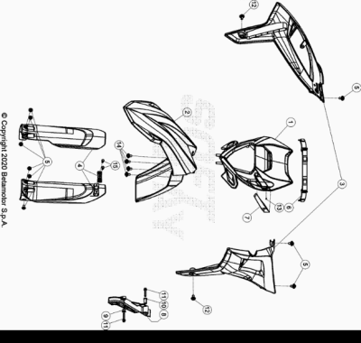

ENDURO_RR_125_2T_MY22
Ref. | Part Number | Description | Part
1 | 037.43.008.00.97 | PORTAFARO | 1
2 | 037.43.009.00.97 | GUARDABARROS ANTERIOR | 1
3 | 037.43.001.00.97 | JUEGO PLACAS RADIADOR | 1
4 | 040.43.006.82.97 | KIT PROTECTORES HORQUILLA | 1
5 | 037.43.028.00.00 | TORNILLO ESPECIAL M6X8 | 9
6 | 037.43.020.00.59 | GOMA PORTAFARO | 2
7 | 037.43.017.00.97 | PASACABLES | 1
8 | 040.43.005.00.59 | PROTECCION PIÑON | 1
9 | 13.49190.000 | DISTANCIADOR RR-4T / RR 125 | 1
10 | 13.49189.000 | DISTANCIADOR RR-4T/06 | 1
11 | 11.50300.000 | TORNILLO 6,30 RS CH 8 RR-4T / RR 125 | 2
12 | 037.43.030.00.00 | TORNILLO ESPECIAL M 6 X 16 | 2
13 | 31.23580.000 | TORNILLO 4,8X13_x000D_ | 1
14 | 037.43.029.00.00 | TORNILLO ESP. M 6 X 12 | 4
15 | 31.79960.000 | TORNILLO AUTOROSCANTE M6x15 | 2

ENDURO_RR_125_2T_MY22
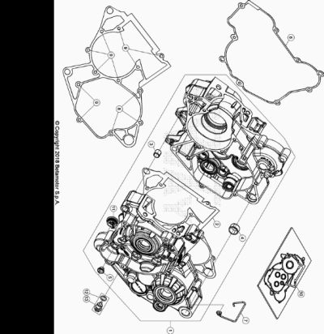

ENDURO_RR_125_2T_MY22
Ref. | Part Number | Description | Part
1 | 035.01.000.80.00 | CARTER MOTOR COMPLETO | 1
2 | 035.01.003.00.00 | JUNTA CARTER | 1
3 | 16.41500.000 | CASQUILLO CENTRADOR 13.13 | 1
4 | 006.01.012.00.00 | CASQUILLO CENTRADOR 17 X 21.12 | 1
5 | C03.02.001.00.00 | CASQUILLO 8x10x8 | 1
6 | 035.01.009.00.00 | JUNTA CARTER | 1
7 | 006.01.023.00.00 | PASACABLES | 1
8 | 11.50360.000 | TORNILLO 6X40 | 3
9 | 11.05535.000 | TORNILLO 6,50 RS CH 8 RR-4T | 9
10 | 035.01.005.82.00 | KIT JUNTAS RR 2T 125 2018 | 1
11 | 035.01.006.00.59 | TAPON | 1
12 | 10.66164.000 | TORICA OR 11.2,5 NBR 70SH | 1
13 | 006.08.152.80.00 | TAPON PARA EL ESCAPE DE ACEITE | 1

ENDURO_RR_125_2T_MY22
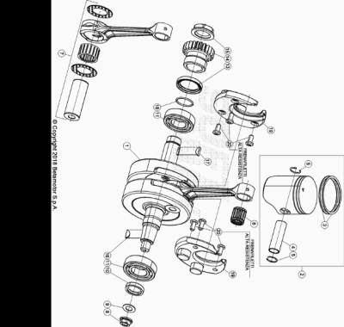

ENDURO_RR_125_2T_MY22
Ref. | Part Number | Description | Part
1 | 035.02.000.80.00 | CIGUEÑAL | 1
2 | 035.02.019.80.0A | PISTON LETRA *A* RR2T 125 | 3
2 | 035.02.019.80.0B | PISTON LETRA *B* RR2T 125 | 3
2 | 035.02.019.80.0C | PISTON LETRA *C* RR2T 125 | 3
3 | 007.02.041.00.00 | SEGMENTO PISTON 125cc | 2
4 | 007.02.042.00.00 | BULON PISTON 125 cc | 1
5 | 007.02.044.00.00 | ANILLO SEEGER 125 cc | 2
6 | C06.22.030.00.00 | COJINETE KBK 15 X 1 9 X 19,8 | 1
7 | 035.02.004.80.00 | BIELA | 1
8 | 13.25010.000 | TUERCA ESP.VOLANTE MAGNETICO MORIC GR65/85 RR-4T | 1
9 | 27.74810.000 | ARANDELA GOMA | 1
10 | C02.01.041.00.00 | RETEN 25X35X7 | 1
11 | C06.01.043.00.00 | COJINETE 25 X 57 X 16 | 2
13 | 10.66020.000 | RETEN 32 X 45 X 6 X 5 | 1
14 | 035.03.001.00.00 | PIÑON TRANSMISION PRIMARIA | 1
15 | 006.03.023.00.00 | TUERCA M. 20 X 1 X 5 LH | 1
16 | 12.46020.000 | CHAVETA 3.5 | 1
17 | 12.46151.000 | CHAVETA CIGUEÑAL 4X5 UNI 6606 | 1
18 | 10.66490.000 | JUNTA TORICA 21,95.25,51.1,78 | 1
19 | 035.02.003.00.00 | ENCAJE CIGUEÑAL | 2
20 | C24.91.002.00.00 | TORNILLO 6.12 TORX | 6

ENDURO_RR_125_2T_MY22
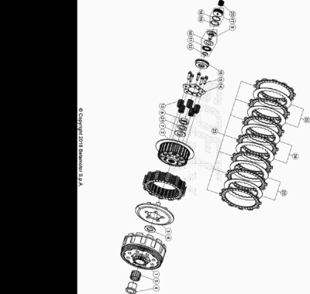

ENDURO_RR_125_2T_MY22
Ref. | Part Number | Description | Part
1 | 035.03.027.80.00 | CAMPANA EMBRAGUE | 1
2 | 035.03.013.00.00 | TAMBOR EMBRAGUE | 1
3 | 035.03.014.00.00 | PLATILLO EMBRAGUE | 1
4 | 035.03.016.00.00 | CASQUILLO 20 X 26 X 25,9 | 1
5 | 006.03.063.00.00 | JAULA RODILLOS 26 X 30.22 | 1
6 | 035.03.018.00.00 | ARANDELA 20 X 35 X 3 | 1
7 | 27.65891.000 | ARANDELA | 1
8 | 006.03.065.00.00 | TUERCA M 18x1,5 H9 | 1
9 | 035.03.020.80.00 | ACOPLE EMBRAGUE | 1
10 | C06.61.002.00.00 | ARANDELA | 1
11 | C06.39.004.82.00 | COJINETE | 1
12 | 28.24470.000 | SEEGER RB 16.1,6 DIN 7993 | 1
13 | 035.03.011.00.00 | MUELLE EMBRAGUE | 5
14 | 035.03.015.00.00 | PLATILLO MUELLE | 1
15 | 11.49070.000 | TORNILLO 6X20 RS CH8 | 5
16 | 035.03.019.00.00 | PLATILLO ACPLE EMBRAGUE | 1
17 | 035.03.021.80.00 | PISTON ACTUADOR COMPLETO | 1
18 | 10.66520.000 | JUNTA TORICA 23,52.1,78.EPDM (OR2-021) | 1
19 | 10.66510.000 | JUNTA TORICA 21,89.2,62 | 1
20 | 035.03.022.00.00 | MUELLE | 1
21 | C19.42.004.00.00 | ARANDELA 19 X 27 X 1,4 | 1
22 | 035.03.009.00.00 | DISCO SEPARADOR EMBRAGUE | 4
23 | 035.03.010.00.00 | DISCO EMBRAGUE | 7
24 | 035.03.008.00.00 | DISCO SEPARADOR EMBRAGUE RR 125 2T | 2

ENDURO_RR_125_2T_MY22
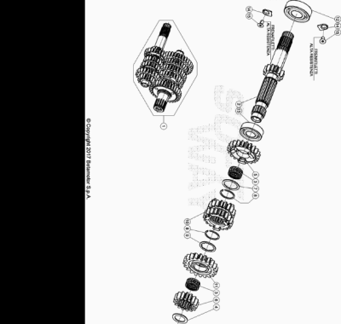

ENDURO_RR_125_2T_MY22
Ref. | Part Number | Description | Part
1 | 035.04.025.80.00 | CAMBIO | 1
2 | 035.04.026.00.00 | EJE PRIMARIO | 1
3 | 16.16580.000 | GABIA 18 X 22 X 10 | 2
4 | 035.04.016.00.00 | ARANDELA 17.25.1 | 1
5 | 035.04.002.00.00 | ENGRANAJE 5ª PRIMARIO | 1
6 | 035.04.023.00.00 | ENGRANAJE 2ª PRIMARIO | 1
7 | C19.04.004.00.00 | ARANDELA 22.28.1 | 1
8 | C01.31.005.00.00 | ANILLO BLOQUEO SW 22.1,2 | 2
9 | 035.04.022.00.00 | ARANDELA | 1
10 | 035.04.004.00.00 | ENGRANAJE 3ª A 4ª DEL PRIMARIO | 1
11 | 035.04.006.00.00 | ENGRANAJE 6ª DEL PRIMARIO | 1
12 | 12.98001.000 | COJINETE 20.4212 NTN | 1
13 | C06.01.036.00.00 | COJINETE 17 X 35 X 10 | 1
14 | 006.01.019.00.09 | PLACA FIJACION COJINETE EJE BALANCIN | 2
15 | 31.30085.000 | TORNILLO M. 5 X 10 | 2

ENDURO_RR_125_2T_MY22
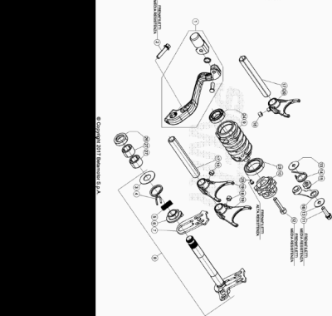

ENDURO_RR_125_2T_MY22
Ref. | Part Number | Description | Part
1 | 006.05.000.80.00 | PALANCA CAMBIO | 1
2 | 11.50010.000 | TORNILLO 6,25 RS CH 8 | 1
3 | 27.63020.000 | ARANDELA 14 X 30 X 1 | 1
4 | 006.05.017.00.00 | MUELLE RETORNO PALANCA CAMBIO | 1
5 | 16.92911.000 | GUIA MUELLE CAMBIO | 1
6 | 006.05.016.00.00 | MUELLE 0.8 MM | 1
7 | 006.05.014.80.00 | HORQUILLA MOVIL CAMBIO | 1
8 | 035.05.000.80.00 | EJE MANDO CAMBIO COMPLETO | 1
9 | 035.05.006.00.00 | SELECTOR CAMBIO | 1
10 | 029.05.001.80.00 | LEVA ARRESTO | 1
11 | 11.49070.000 | TORNILLO 6X20 RS CH8 | 1
12 | 31.45000.000 | TORNILLO ALLEN TCCE 6.30 | 1
13 | 27.42000.100 | ARANDELA 6 X 20 X 1,0 | 2
14 | 035.05.007.00.00 | MUELLE | 1
15 | 029.05.054.00.00 | DISTANCIADOR | 1
16 | 029.05.050.80.00 | MUELLE ARRASTRE VEL. | 1
17 | 026.05.025.00.00 | EJE HORQUILLA CAMBIO | 2
18 | 006.05.027.00.00 | CASQUILLO 6 X 8 X 5,2 | 3
19 | 035.05.004.00.00 | HORQUILLA CAMBIO | 2
20 | 035.05.005.00.00 | HORQUILLA CAMBIO | 1
23 | 12.93405.000 | COJINETE 61805-2RS1 | 1
24 | 12.93840.000 | COJINETE 15 X 28 X 7 C3 | 1
25 | 31.30084.000 | TORNILLO *TORX 25* 5 X 8 | 1
26 | 10.52012.000 | RETEN 14 X 24 X 6 | 1
27 | 11.22320.000 | JAULA RODILLOS | 2

ENDURO_RR_125_2T_MY22
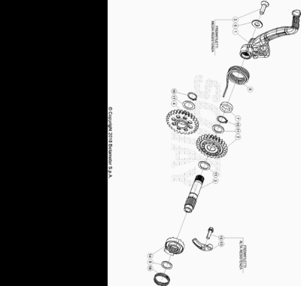

ENDURO_RR_125_2T_MY22
Ref. | Part Number | Description | Part
1 | 035.06.015.80.00 | PALANCA ARRANQUE | 1
2 | 035.06.002.00.00 | ENGRANAJE PUESTA EN MARCHA | 1
3 | 035.06.014.00.00 | EJE PALANCA | 1
4 | 035.06.006.80.00 | ENGRANAJE REENVIO ARRANQUE | 1
5 | 31.96827.000 | TORNILLO TGS M8X26 10.9 DACR | 1
6 | 006.06.008.00.00 | ARANDELA | 1
7 | 035.06.003.00.00 | DISTANCIADOR | 1
8 | 006.06.013.00.00 | MUELLE RETORNO EJE PUESTA EN MARCHA | 1
9 | C19.04.002.00.00 | ARANDELA 16 X 22 X 1 DIN 988 | 1
10 | C01.23.001.00.00 | SEEGER 17 X 1 DIN 471 A | 2
11 | C19.04.003.00.00 | ARANDELA 17 X 24 X 1 DIN988 | 2
13 | 006.06.016.00.00 | PLACA EJE ARRANQUE | 1
14 | 035.06.004.00.00 | TRINQUETE ARRANQUE | 1
15 | 11.49070.000 | TORNILLO 6X20 RS CH8 | 1
16 | 006.06.015.00.00 | MUELLE | 1
17 | 27.71220.000 | ARANDELA SPEC. 17,25 | 1

ENDURO_RR_125_2T_MY22
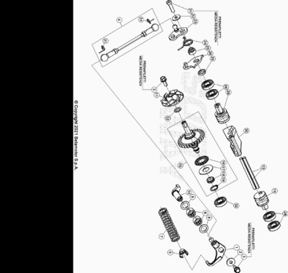

ENDURO_RR_125_2T_MY22
Ref. | Part Number | Description | Part
1 | 035.09.022.80.00 | BALANCIN | 1
2 | C16.02.001.00.00 | ARANDELA 5.15.2 DIN 7349 | 1
3 | 11.46251.000 | TORNILLO 5.12 RS CH8 | 2
4 | 026.09.015.80.00 | VARILLA MANDO VALVULA | 1
5 | 026.09.017.00.00 | GUIA MUELLE VALVULA | 1
7 | 026.09.019.00.00 | MUELLE REGULACION 300 CC | 1
8 | 27.58400.000 | ARANDELA SPESS. 10.16.1 DIN 988 | 2
9 | 11.22100.000 | COJINETE AGUJAS 10.14.10 | 2
10 | 026.09.011.00.00 | EJE CONTROL | 1
11 | 006.09.000.00.00 | ASPAS BOMBA AGUA | 1
12 | 006.09.012.00.00 | ARANDELA | 1
13 | 035.09.004.00.00 | EJE | 2
14 | 035.09.011.00.00 | VALVULA BOOSTER | 1
15 | 035.09.015.80.00 | CENTRIFUGA | 1
16 | 16.11512.000 | JAULA AGUJAS COJINETE | 1
17 | 27.56400.000 | DISTANCIADOR AS1226 | 1
18 | 035.09.017.00.00 | DISTANCIADOR | 1
19 | 28.22760.000 | SEEGER A12 DIN 471 | 1
21 | 31.30015.000 | TORNILLO ALLEN 5 X 20 | 1
22 | 27.36500.000 | ARANDELA PLANA 5.15 | 1
23 | 035.09.020.85.00 | PALANCA | 1
24 | 035.09.025.00.00 | MUELLE | 1
25 | 026.09.044.00.00 | DISTANCIADOR | 1
26 | 035.09.019.85.00 | PALANCA FINAL CARRERA | 1
28 | 12.93410.000 | COJINETE 10.22.6 2RS1 | 4
29 | 035.09.012.00.00 | VALVULA BOOSTER | 1
30 | 035.09.013.00.00 | VALVULA DESCARGA | 1
31 | C21.31.001.00.00 | MUELLE SEGURIDAD | 2
32 | 12.93387.000 | COJINETE 6 X 19 X 6 | 1
33 | 026.09.047.00.00 | DISTANCIADOR | 1

ENDURO_RR_125_2T_MY22
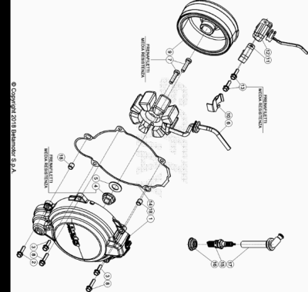

ENDURO_RR_125_2T_MY22
Ref. | Part Number | Description | Part
1 | 035.01.014.80.59 | TAPA VOLANTE | 1
2 | 11.50010.000 | TORNILLO 6,25 RS CH 8 | 1
3 | 11.49070.000 | TORNILLO 6X20 RS CH8 | 2
4 | 13.25010.000 | TUERCA ESP.VOLANTE MAGNETICO MORIC GR65/85 RR-4T | 1
5 | 27.74810.000 | ARANDELA GOMA | 1
6 | 026.10.005.00.00 | STATOR | 1
7 | 31.48507.000 | TORNILLO ESP 6X25 | 2
8 | 11.50355.000 | TORNILLO ANCLAJE M6X35 RS CH 8 | 2
9 | 006.10.010.00.00 | ROTOR | 1
10 | 006.01.054.00.00 | PLACA SUJECCION INSTALACION | 1
11 | 035.10.004.00.00 | PLACA RETENCION | 1
12 | 026.10.003.00.00 | PICK UP | 1
13 | 11.46360.000 | TORNILLO 5X16 LLAVE 8rs RR-4T | 2
14 | 035.01.015.00.00 | JUNTA TAPA VOLANTE | 1
15 | 12.25126.000 | BUJIA NGK BR9 ECMVX | 1
16 | 026.10.012.00.00 | JUNTA BUJIA | 1
17 | 27.13514.000 | PIPA BUJIA | 1
18 | 16.36500.000 | CASQUILLO CENTRADOR 9.10 | 2

ENDURO_RR_125_2T_MY22
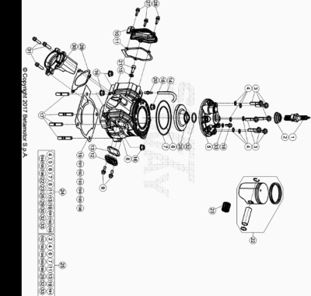

ENDURO_RR_125_2T_MY22
Ref. | Part Number | Description | Part
1 | 12.25126.000 | BUJIA NGK BR9 ECMVX | 1
2 | 026.10.012.00.00 | JUNTA BUJIA | 1
3 | 11.52429.000 | TORNILLO ESPECIAL 7 X 31 (12.9) | 6
4 | 27.45100.000 | ARANDELA PLANA COBRE 7.12.0,2 | 6
5 | 035.11.007.00.59 | TAPA CULATA | 1
6 | C02.06.060.00.00 | TORICA CULATA 60 X 2 | 1
7 | C02.06.061.00.00 | TORICA CULATA 92 X 2 | 1
8 | 035.11.027.00.0A | CILINDRO SEL. A RACING | 2
8 | 035.11.027.00.0B | CILINDRO SEL. B RACING | 2
9 | 11.48025.000 | TORNILLO HEX/C.ARO 6x16 ( RS-T.8 ) | 2
10 | 035.11.032.40.59 | TAPA RACING | 1
11 | 035.11.033.00.00 | JUNTA | 1
12 | 035.11.013.00.59 | TAPA | 1
13 | 035.11.018.00.00 | JUNTA | 1
14 | 026.11.012.00.00 | TUBO DE VENTILACION | 1
15 | 27.40500.000 | ARANDELA PLANA 6.12.1,6 DIN125 | 1
16 | 035.11.019.00.00 | TUERCA M8 X 1,25 | 4
17 | 25.98050.000 | ESPARRAGO 8.41 | 4
18 | 11.47018.000 | TORNILLO ESPECIAL 6.12 RS CH 8 | 1
19 | 035.11.010.00.00 | JUNTA CILINDRO 0,3 mm | 1
20 | 29.00280.000 | TAPON TOMA AIRE DEP. | 1
21 | 31.31050.000 | TORNILLO ALLEN TCCE 6.15 | 1
22 | 035.02.019.80.0A | PISTON LETRA *A* RR2T 125 | 3
22 | 035.02.019.80.0B | PISTON LETRA *B* RR2T 125 | 3
22 | 035.02.019.80.0C | PISTON LETRA *C* RR2T 125 | 3
23 | C06.22.030.00.00 | COJINETE KBK 15 X 1 9 X 19,8 | 1
24 | 035.11.006.82.0A | KIT GRUPO TERMICO D.54 RR 2T125- LETRA A | 2
24 | 035.11.006.82.0B | KIT GRUPO TERMICO D. 54 RR 125 2T LETRA B | 2
25 | 035.11.037.82.00 | KIT JUNTAS PARTE ALTA RR2T 125/200 | 1
26 | 035.11.042.00.00 | CAMARA DE COMBUSTION | 1
27 | 11.46360.000 | TORNILLO 5X16 LLAVE 8rs RR-4T | 2
28 | 026.11.036.00.00 | TORNILLO DE SEGURIDAD | 1
29 | 035.11.034.00.00 | JUNTA | 1
30 | 035.11.030.00.00 | BRIDA ESCAPE | 1
31 | 11.49070.000 | TORNILLO 6X20 RS CH8 | 3
32 | 10.66505.000 | TORICA OR 22.27.2,5 VYTON | 1
33 | 27.40495.000 | ARANDELA COBRE 6.11 | 1
191 | 035.11.011.00.00 | JUNTA CILINDRO 0,4 mm | 1
192 | 035.11.012.00.00 | JUNTA CILINDRO 0,5 mm | 1
193 | 035.11.022.00.00 | JUNTA CILINDRO 0,125 mm | 1
194 | 035.11.023.00.00 | JUNTA CILINDRO 0,2 mm | 1
195 | 035.11.024.00.00 | JUNTA CILINDRO 0,25 mm | 1
196 | 035.11.025.00.00 | JUNTA CILINDRO 0.6 mm | 1

ENDURO_RR_125_2T_MY22
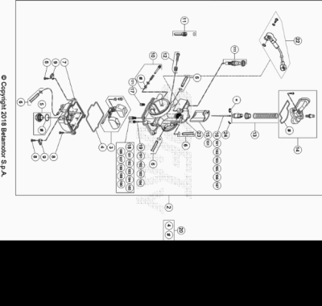

ENDURO_RR_125_2T_MY22
Ref. | Part Number | Description | Part
2 | 035.12.000.00.00 | CARBURADOR | 1
3 | 026.12.009.80.00 | FLOTADOR CARBURADOR COMPL. | 1
4 | 026.12.011.00.00 | JUNTA CUBETA CARBURADOR | 1
5 | 026.12.106.80.00 | TAPON COMPLETO | 1
6 | 026.12.045.00.00 | KIT TUBO SOBRANTE CARBURADOR | 1
7 | 026.12.107.00.00 | CUBETA COMPLETA | 1
8 | 026.12.016.00.00 | TORNILLO M4 X 16 | 3
9 | 026.12.024.00.00 | PLACA FLOTADOR | 2
10 | 026.12.028.80.00 | TORNILLO DE REGULACION COMPLETO | 1
11 | 026.12.006.80.00 | DISTANCIADOR LIMITAC. VALVULA CARB. COMPL. | 1
12 | 026.12.032.80.00 | TONILLO REGULACION M.5 COMPL. | 1
13 | 026.12.037.80.00 | MUELLE COMPLETO | 1
14 | 026.12.060.00.00 | TAPA CARBURADOR | 1
15 | 026.12.105.00.00 | VALVULA CARBURADOR | 1
16 | 035.12.001.00.00 | AGUJA NOZH | 1
17 | 026.12.005.00.00 | GETTO STARTER 50 PARA CARBURADOR KEIHIN | 1
18 | 035.12.006.00.00 | SURTIDOR MAXIMO 92 | 1
19 | 16.42357.000 | GETTO MINIMO 35 | 1
20 | 026.12.044.00.00 | KIT JUNTAS | 1
22 | 036.12.004.00.00 | SENSOR VALVULA | 1
23 | 25.57912.000 | PLACA FIJACION MUELLE COLECTOR REV4T | 1
24 | 12.54242.000 | CLIP | 1
111 | 026.12.008.00.00 | PISTON STARTER CMPL. | 1
151 | 036.12.002.00.00 | VALVULA CARBURADOR | 1
161 | 035.12.003.00.00 | AGUJA NOZG | 1
162 | 035.12.004.00.00 | AGUJA NOZF | 1
163 | 035.12.005.00.00 | AGUJA N841 | 1
165 | 026.12.022.00.00 | AGUJA KEIHIN NOZK | 1
166 | 026.12.023.00.00 | AGUJA KEIHIN NOZJ | 1
167 | 026.12.050.00.00 | AGUJA NOZI | 1
171 | 026.12.046.00.00 | SURTIDOR STARTER 85 PARA CARBURADOR KEIHIN | 1
181 | 36.25113.000 | DIFUSOR MÁXIMO 178 KEIHIN RR-4T | 1
182 | 36.25114.000 | DIFUSOR MÁXIMO 180 KEIHIN RR-4T | 1
183 | 36.25115.000 | DIFUSOR MÁXIMO 182 KEIHIN RR-4T | 1
184 | 36.25116.000 | DIFUSOR MÁXIMO 185 KEIHIN RR-4T | 1
185 | 36.25108.000 | DIFUSOR MÁXIMO 165 KEIHIN RR-4T | 1
186 | 36.25109.000 | DIFUSOR MÁXIMO 168 KEIHIN RR-4T | 1
187 | 36.25110.000 | DIFUSOR MÁXIMO 170 KEIHIN RR-4T | 1
188 | 36.25111.000 | DIFUSOR MÁXIMO 172 KEIHIN RR-4T | 1
189 | 36.25112.000 | DIFUSOR MÁXIMO 175 KEIHIN RR-4T | 1
190 | 36.25118.000 | DIFUSOR MÁXIMO 190 KEIHIN RR-4T | 1
191 | 16.42348.000 | CHICLE MIN. 48 CARBURADOR KEIHIN | 1
192 | 16.42344.000 | GETTO MINIMO 50 | 1
193 | 16.42358.000 | GETTO MINIMO 52 | 1
194 | 16.42359.000 | CHICLE MINIMO 55 | 1

ENDURO_RR_125_2T_MY22
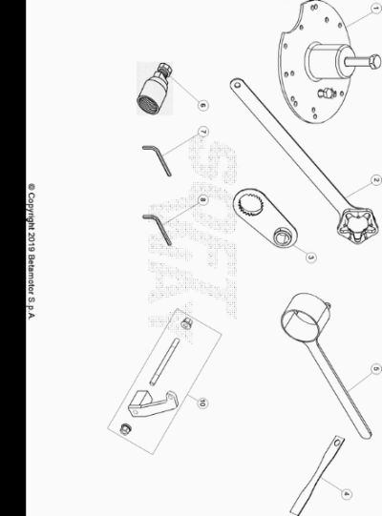

ENDURO_RR_125_2T_MY22
Ref. | Part Number | Description | Part
1 | 007.14.010.80.00 | DESACOPLADOR DEL CARTER | 1
2 | 035.14.000.80.00 | UTILAJE | 1
3 | 035.14.006.50.00 | UTILAJE | 1
4 | 007.44.010.00.00 | HERRAMIENTA PARA MEDIR EL SQUISH | 1
5 | 026.14.005.50.00 | UTILAJE PARA BLOQUEAR EL VOLANTE | 1
6 | 36.25173.000 | EXTRACTOR VOLANTE MAGNETICO RR2T/ RR-4T | 1
7 | 026.44.029.00.00 | LLAVE ESPECIAL | 1
8 | 007.44.035.00.00 | LLAVE ESPECIAL | 1
10 | 035.14.008.80.00 | SOPORTE MOTOR | 1

ENDURO_RR_125_2T_MY22
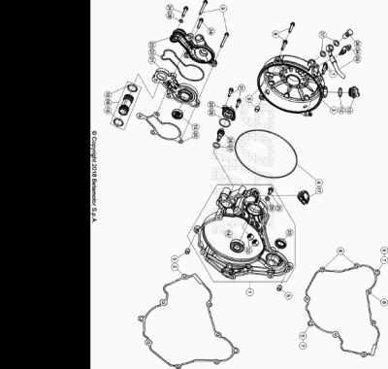

ENDURO_RR_125_2T_MY22
Ref. | Part Number | Description | Part
1 | 035.01.011.80.59 | TAPA INTERIOR EMBRAGUE RR 2T 125 | 1
2 | 035.01.009.00.00 | JUNTA CARTER | 1
3 | 035.01.030.80.59 | TAPA EXTERIOR EMBRAGUE RR 2T RACING MY19 | 1
4 | 035.01.008.00.59 | TORICA TAPA EMBRAGUE | 1
5 | 16.36500.000 | CASQUILLO CENTRADOR 9.10 | 6
6 | 11.49070.000 | TORNILLO 6X20 RS CH8 | 3
7 | 11.50010.000 | TORNILLO 6,25 RS CH 8 | 4
8 | 11.05535.000 | TORNILLO 6,50 RS CH 8 RR-4T | 2
9 | 11.05485.000 | TORNILLO 6.60 RS CH 8 RR-4T | 2
12 | 10.66321.000 | TORICA OR 17.17X1.78 | 1
13 | 026.01.019.80.59 | TAPON LLENADO ACEITE | 1
14 | C06.01.001.00.00 | COJINETE 15 X 32 X 9 6002-2RSH C3 | 1
15 | 10.43720.000 | RETEN ACEITE 8 X 24 X 7 | 1
17 | 026.01.031.80.00 | JUNTA VALVULA | 1
18 | 026.01.037.80.00 | TUBO AGUA | 1
19 | C02.06.052.00.00 | TORICA OR 17,96 X 2,62 | 2
20 | 035.01.024.00.00 | JUNTA | 1
21 | 035.01.021.00.00 | CUERPO BOMBA AGUA | 1
22 | 035.01.023.00.00 | TORICA BOMBA AGUA | 1
23 | 035.01.020.00.00 | TAPA BOMBA AGUA | 1
24 | 11.50300.000 | TORNILLO 6,30 RS CH 8 RR-4T / RR 125 | 2
25 | 11.47015.000 | TORNILLO 6.12 REV3-04 - RR-4T | 1
26 | 27.40495.000 | ARANDELA COBRE 6.11 | 2
27 | 10.66296.000 | TORICA OR 12,37.2,62 NBR70 | 1
28 | 026.09.020.00.00 | GUIA MUELLE REGULABLE | 1
29 | 10.66540.000 | TORICA OR 24.2 NBR70 | 1
30 | 026.09.025.00.00 | TAPA REGULADOR | 1
31 | 11.46401.000 | TORNILLO 5X20 LLAVE 8rs RR-4T | 2
32 | 11.22100.000 | COJINETE AGUJAS 10.14.10 | 2
33 | C02.01.039.00.00 | RETEN 17 X 26 X 6 | 1
34 | 28.91050.800 | RESPIRADERO BOMBIN EMBRAGUE | 1
35 | 035.35.002.00.00 | TUBO EMBRAGUE | 1
36 | 11.65040.000 | TORNILLO ESP. TALAD.10.1 PARA TUBO FRENO | 1
37 | 16.50510.000 | JUNTA 10.15.1 (COBRE) | 2

ENDURO_RR_125_2T_MY22
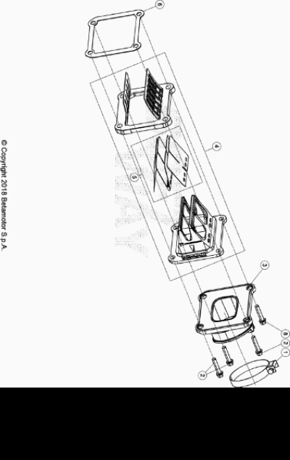

ENDURO_RR_125_2T_MY22
Ref. | Part Number | Description | Part
1 | 15.14275.000 | ABRAZADERA 52/12 | 1
2 | 11.50010.000 | TORNILLO 6,25 RS CH 8 | 3
3 | 035.01.010.82.00 |  | 1
4 | 035.01.016.80.00 | VALVULA LAMINAS | 1
5 | 035.01.007.82.00 | KIT LAMINAS RR 2T 125 2018 | 1
6 | 035.01.019.00.00 | JUNTA VALVULA ASPIRACION | 1
8 | 026.11.035.00.00 | TORNILLO M 6X25 | 1

ENDURO_RR_125_2T_MY22
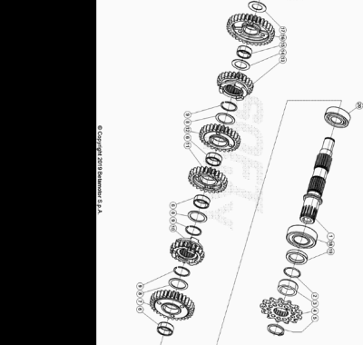

ENDURO_RR_125_2T_MY22
Ref. | Part Number | Description | Part
1 | 035.04.020.80.00 | EJE SECUNDARIO | 1
2 | 10.66620.000 | JUNTA TORICA 25,12.1,78 | 1
3 | 006.04.040.00.00 | DISTANCIADOR | 1
4 | 006.04.050.00.00 | PIÑON SALIDA Z13 | 1
5 | 28.25530.000 | ANILLO SEEGER 25 X 2 | 1
6 | 11.22845.000 | JAULA RODILLOS 22 X 26 X 10 | 3
7 | 035.04.024.00.00 | ENGRANAJE 2ª SECUNDARIO | 1
8 | 035.04.003.00.00 | ARANDELA | 3
9 | C01.31.008.00.00 | ANILLO BLOQUEO SW24 | 3
10 | 035.04.019.00.00 | ENGRANAJE 6ª SECUNDARIO | 1
11 | 035.04.012.00.00 | ENGRANAJE 4ª DEL SECUNDARIO | 1
12 | 035.04.011.00.00 | ENGRANAJE 3ª DEL SECUNDARIO | 1
13 | 035.04.018.00.00 | ENGRANAJE 5ª DEL SECUNDARIO | 1
14 | 27.73635.000 | ARANDELA SPEC. 72 20.30.1 | 1
15 | 11.22835.000 | JAULA RODILLOS 20 X 24 X 10 | 1
16 | 035.04.014.00.00 | ENGRANAJE 1ª DEL SECUNDARIO | 1
17 | 006.04.032.00.00 | ARANDELA DISTANCIADORA 17 X 30 X 1 | 1
18 | 12.95610.000 | COJINETE 6205 C3 | 1
19 | 10.66020.000 | RETEN 32 X 45 X 6 X 5 | 1
20 | C06.01.036.00.00 | COJINETE 17 X 35 X 10 | 1

