Volunteer Call Statistics

# Total number of calls answered:

21.0

# Total number of calls answered broken down by volunteer:

Suey (Ella):5.0

Caroline (Rebecca):4.0

David (Daniel):3.0

Helen (Geena):4.0

Jenna (Dorothy):5.0

# Total number of calls with Female callers:

9.0

# Number of calls with Female callers broken down by volunteer:

Suey (Ella): 2.0

Caroline (Rebecca): 2.0

David (Daniel): 0.0

Helen (Geena): 3.0

Jenna (Dorothy): 2.0

# Total number of calls with Male callers:

11.0

# Number of calls with Male callers broken down by volunteer:

Suey (Ella): 3.0

Caroline (Rebecca): 2.0

David (Daniel): 3.0

Helen (Geena): 1.0

Jenna (Dorothy): 2.0

# Total number of Hang ups calls:

8.0

# Number of Hang ups calls broken down by volunteer:

Suey (Ella): 2.0

Caroline (Rebecca): 2.0

David (Daniel): 1.0

Helen (Geena): 1.0

Jenna (Dorothy): 2.0

# Total number of Immediate Risk (IR) calls:

2.0

# Which volunteer(s) had IR calls:

Suey (Ella): 1.0 07952237318 - Ryder. AM. Has borderline personality disorder. Ex girlfriend has accused him of rape. Began to overdose on the call. Took 20 tramadol whilst on the call. He was asked to phone 999 himself but he became unresponsive. SC called 999. Ref 3010 ED

Helen (Geena): 1.0 02830478345 Candice AF Has had a miscarriage. Feeling very alone and suicidal. Had a rope around her neck and started cutting herself. Could not guarantee she would keep herself safe. SC called 999 Ref 0211 WD

# Total number of Minor calls:

2

# Which volunteer(s) had Minor calls:

Suey (Ella): 07878512783- Laine - 17 years old. Sister recent committed suicide very upset about it and just wanted to chat. Asked if her parents were aware and she confirmed yes. Asked her if her GP was aware and confirmed yes. No risk. Told her to call us back if she needed to speak to anyone again.

Helen (Geena): 01325348702 Sarah 15 years old. Serious bullying at school and has been self harming. Parents were not aware and she felt like she could not talk to them. Asked me would I speak with them for her to make them aware of the situation and self harming

# Total number of Abusive calls:

1.0

# Which volunteer had Abusive calls:

Jenna (Dorothy): Anon Phil Called up to say he was feeling very alone. Became weird as he asked me what I was wearing and told me be could tell from my voice how kind I was and that he was going to masturbate. I asked him to stop or I would hang up the call. He refused so I hung up

# Were there any Nimvelo issues?

Suey (Ella): Call was crackling and had issues hearing callers at times

David (Daniel): It was showing me as red and not as logged in

# Volunteer performance:

Suey (Ella): Submitted in time (2 days)

Caroline (Rebecca): Late Submission (4 days)

David (Daniel): Late Submission (4 days)

Helen (Geena): Submitted in time (2 days)

Jenna (Dorothy): Submitted in time (2 days)

# The welfare of our volunteers:

Suey (Ella): It is affecting my sleep;It is making me sad and/or upset;

Caroline (Rebecca): Volunteering is not having any negative impact on me, I feel fine and able to cope;

David (Daniel): It is making me sad and/or upset;

Helen (Geena): Volunteering is not having any negative impact on me, I feel fine and able to cope;

Jenna (Dorothy): It is affecting my sleep;It's affecting my ability to focus;It is making me sad and/or upset;It is affecting my appetite;I am finding it difficult to forget some of calls I have taken and keep thinking about them;

# Visualization: Calls Answered by Volunteer

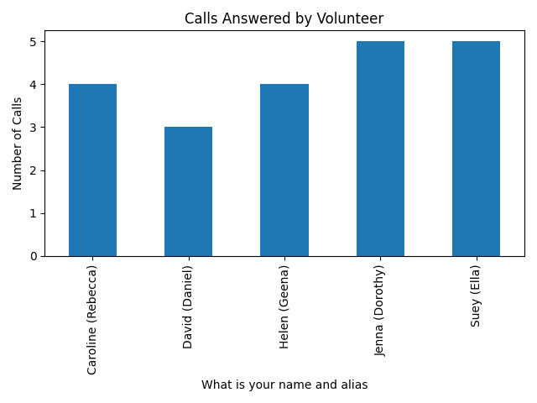

# Visualization: Gender Distribution of Callers

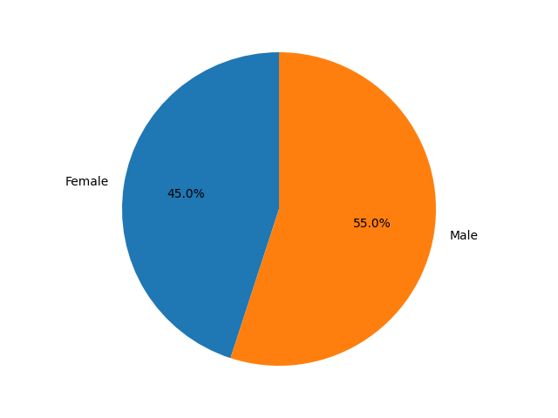

# Visualization: Hang-up Calls by Volunteer

