FITNESS APP (REACT.JS)

**PROJECT REPORT**

**SUBMITTED TO THE NAAN MUDHALVAN IN THE PARTIAL**

**FULFILLMENT OF THE REQUIREMENT FOR THE**

**DEGREE OF BACHELOR OF COMPUTER SCIENCE**

**BY**

**TEAM LEADER: DANIEL.V**

**TEAM MEMBER 1: PRAVEEN RAJ.A**

**TEAM MEMBER 2: MOHAMMED FAROOK.S**

**TEAM MEMBER 3: SATHISH.G**



**DEPARTMENT OF COMPUTER SCIENCE**

**PROF.DHANAPALAN COLLEGE SCIENCE AND MANAGEMENT**

**KELAMBAKKAM**

**MARCH-2025**

**Introduction:**

**Fitness app is a revolutionary fitness app designed to transform your workout experience. Itoffers an intuitive interface, dynamic search, and a vast library of exercises for all fitness levels. Join fitness app to embark on a personalized fitness journey and achieve your wellnessgoals.**

**Description:**

**🏋♂️ Welcome to the forefront of fitness exploration with fitness app! Our innovative fitness app is meticulously designed to revolutionize the way you engage with exercise routines, catering to the diverse interests of both fitness enthusiasts and seasoned workout professionals. With a focus on an intuitive user interface and a comprehensive feature set,**

**Fitness app is set to redefine the entire fitness discovery and exercise experience.**

**💪 Crafted with a commitment to user-friendly aesthetics, Fitness app immerses users in an unparalleled fitness journey. Effortlessly navigate through a wide array of exercise categories with features like dynamic search, bringing you the latest and most effective workouts from the fitness world.**

**🌐 From those embarking on their fitness journey to seasoned workout aficionados, Fitness app embraces a diverse audience, fostering a dynamic community united by a shared passion for L a healthy lifestyle. Our vision is to reshape how users interact with fitness, presenting a platform that not only provides effective exercise routines but also encourages collaboration and sharing within the vibrant fitness community.**

**🔥 Embark on this fitness adventure with us, where innovation seamlessly intertwines with established exercise principles. Every tap within Fitness app propels you closer to a realm of diverse workouts and wellness perspectives. Join us and experience the evolution of fitness engagement, where each feature is meticulously crafted to offer a glimpse into the future of a healthier you.**

**🏋♀️ Elevate your fitness exploration with Fitness app, where every exercise becomes a gateway to a world of wellness waiting to be discovered and embraced. Trust Fitness app to be your reliable companion on the journey to staying connected with a fit and active lifestyle. 🏋♂️**

**Scenario based Intro:**

**You lace up your sneakers, determined to get serious about your fitness. But where do you start? Suddenly, you remember Fitness app,the innovative app that promised to revolutionize your workouts. With a tap, you open the app. Vibrant visuals flood the screen – personalized workout plans, diverse exercise categories, and a supportive community. This isn't your typical fitness app. Fitness app feels...different. Intrigued, you select a workout and get ready to experience the future of fitness.**

**Project Goals and Objectives:**

**The overarching aim of Fitness app is to offer an accessible platform tailored for individuals passionate about fitness, exercise, and holistic well-being.**

**Our key objectives are as follows:**

**✔ User-Friendly Experience: Develop an intuitive interface that facilitates easy**

**navigation, enabling users to effortlessly discover, save, and share their preferred**

**workout routines.**

**✔ Comprehensive Exercise Management: Provide robust features for organizing and**

**managing exercise routines, incorporating advanced search options for a**

**personalized fitness experience.**

**✔ Technology Stack: Harness contemporary web development technologies, with a**

**focus on React.js, to ensure an efficient and enjoyable user experience.**

**Features of Fitness app:**

**✔ Exercises from Fitness API: Access a diverse array of exercises from reputable fitness APIs, covering a broad spectrum of workout categories and catering to various fitness goals.**

**✔ Visual Exercise Exploration: Engage with workout routines through curated image**

**galleries, allowing users to explore different exercise categories and discover new**

**fitness challenges visually.**

**✔ Intuitive and User-Friendly Design: Navigate the app seamlessly with a clean,**

**modern interface designed for optimal user experience and clear exercise selection.**

**✔ Advanced Search Feature: Easily find specific exercises or workout plans through a powerful search feature, enhancing the app's usability for users with varied fitness**

**preferences.**

**Technical Architecture:**

**Fitness app prioritizes a user-centric approach from the ground up. The engaging user interface (UI), likely built with a framework like React Native, keeps interaction smooth and intuitive. An API client specifically designed for FitFlex communicates with the backend, but with a twist: it leverages Rapid API. This platform grants access to various external APIs, allowing Fitness app to potentially integrate features like fitness trackers, nutrition data, or workout tracking functionalities without building everything from scratch. This approach ensures a feature-rich experience while focusing development efforts on the core Fitness app functionalities.**

**PRE-REQUISITES:**

**Here are the key prerequisites for developing a frontend application using React.js:**

**✔ Node.js and npm:**

**Node.js is a powerful JavaScript runtime environment that allows you to run**

**JavaScript code on the local environment. It provides a scalable and efficient**

**platform for building network applications.**

**Install Node.js and npm on your development machine, as they are required to run**

**JavaScript on the server-side.**

**● Download: https://nodejs.org/en/download/**

**● Installation instructions: https://nodejs.org/en/download/package-manager/**

**✔ React.js:**

**React.js is a popular JavaScript library for building user interfaces. It enables**

**developers to create interactive and reusable UI components, making it easier to**

**build dynamic and responsive web applications.**

**Install React.js, a JavaScript library for building user interfaces.**

**● Create a new React app:**

**npx create-react-app my-react-app**

**Replace my-react-app with your preferred project name.**

**● Navigate to the project directory:**

**cd my-react-app**

**● Running the React App:**

**With the React app created, you can now start the development server and**

**see your React application in action.**

**● Start the development server:**

**npm start**

**This command launches the development server, and you can access**

**your React app at http://localhost:3000 in your web browser.**

**✔ HTML, CSS, and JavaScript: Basic knowledge of HTML for creating the structure of**

**your app, CSS for styling, and JavaScript for client-side interactivity is essential.**

**✔Version Control: Use Git for version control, enabling collaboration and tracking**

**changes throughout the development process. Platforms like GitHub or Bitbucket can**

**host your repository.**

**SOURCE CODE:**

**<!DOCTYPE html>**

**<html lang="en">**

**<head>**

**<meta charset="utf-8" />**

**<link rel="icon" href="%PUBLIC_URL%/favicon.ico" />**

**<meta name="viewport" content="width=device-width, initial-scale=1" />**

**<meta name="theme-color" content="#000000" />**

**<meta**

**name="description"**

**content="Web site created using create-react-app"**

**/>**

**<link rel="apple-touch-icon" href="%PUBLIC_URL%/logo192.png" />**

**<!--**

**manifest.json provides metadata used when your web app is installed on a**

**user's mobile device or desktop. See https://developers.google.com/web/fundamentals/web-app-manifest/**

**-->**

**<link rel="manifest" href="%PUBLIC_URL%/manifest.json" />**

**<!--**

**Notice the use of %PUBLIC_URL% in the tags above.**

**It will be replaced with the URL of the `public` folder during the build.**

**Only files inside the `public` folder can be referenced from the HTML.**

**Unlike "/favicon.ico" or "favicon.ico", "%PUBLIC_URL%/favicon.ico" will**

**work correctly both with client-side routing and a non-root public URL.**

**Learn how to configure a non-root public URL by running `npm run build`.**

**-->**

**<title>React App</title>**

**</head>**

**<body>**

**<noscript>You need to enable JavaScript to run this app.</noscript>**

**<div id="root"></div>**

**<!--**

**This HTML file is a template.**

**If you open it directly in the browser, you will see an empty page.**

**You can add webfonts, meta tags, or analytics to this file.**

**The build step will place the bundled scripts into the <body> tag.**

**To begin the development, run `npm start` or `yarn start`.**

**To create a production bundle, use `npm run build` or `yarn build`.**

**--> </body></html>**

**SCREENSHOT AND DEMO:**

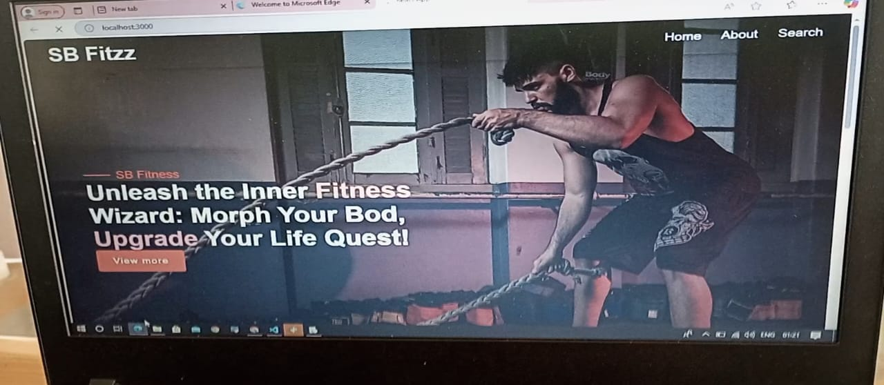

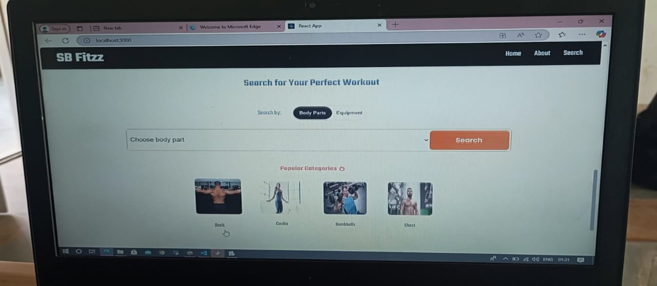

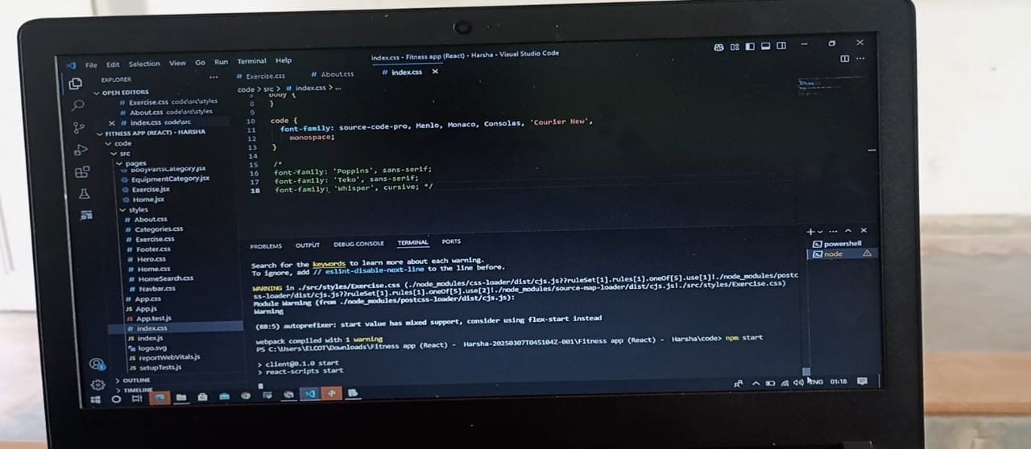

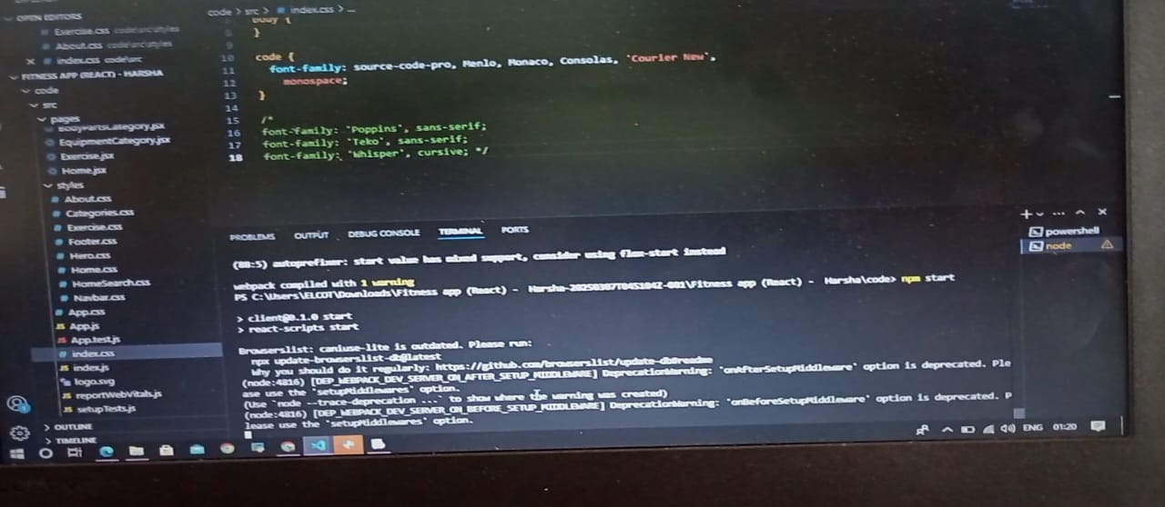

**FUTURE ENHANCEMENT:**

Future enhancements for your React.js fitness app can include AI-powered workout recommendations, a chatbot for fitness queries, and adaptive workout plans to personalize user experiences. Gamification elements like badges, achievements, leaderboards, and social sharing can boost engagement. Advanced tracking features such as real-time progress tracking with wearables, AI-powered form analysis using computer vision, and nutrition tracking can provide deeper insights. Expanding workout options with live & on-demand classes, AR-guided workouts, and offline mode can enhance accessibility. Monetization strategies like premium memberships, in-app purchases, and affiliate programs can generate revenue. Cross-platform compatibility through PWA, a React Native version, and smartwatch integration can widen your app's reach. Let me know if you'd like help implementing any of these features!

**CONCLUSION:**

Incorporating these enhancements will make your React.js fitness app more engaging, intelligent, and accessible. By leveraging AI, gamification, advanced tracking, and cross-platform compatibility, you can provide a highly personalized experience that keeps users motivated. Additionally, integrating monetization strategies will ensure long-term sustainability. With these improvements, your app can stand out in the competitive fitness tech market and deliver real value to users.