

**UltraStar Deluxe**

**v.1.10**

**User Manual**

**UK English**

**10.10.2010**

Table of Contents

1 Introduction 6

1.1 What is UltraStar Deluxe? 6

1.2 System Requirements 6

2 Installation 7

2.1 Windows 7

2.2 Windows Vista & Windows 7 considerations. 12

2.2.1 Program location 12

2.2.2 File ownership 12

3 Playing the game 13

3.1 Singing Solo – 1 player 13

3.2 The song selection screen – keyboard shortcuts 13

3.3 Multiple players 13

3.3.1 2 players - using the Singstar Microphones 13

4 Basic Configuration 16

4.1 Game menu 16

4.1.1 Players 16

4.1.2 Difficulty 16

4.1.3 Language 16

4.1.4 Tabs 16

4.1.5 Sorting 16

4.1.6 Debug 16

4.2 Graphics sub menu 16

4.2.1 Resolution 16

4.2.2 Full screen 16

4.2.3 Depth 16

4.2.4 Oscilloscope 17

4.2.5 Movie size 17

4.3 Sound sub menu 17

4.3.1 Microphone Playback 17

4.3.2 Background Music 17

4.3.3 Mic boost 17

4.3.4 Click assist 17

4.3.5 Beat click 17

4.3.6 Threshold 17

4.3.7 Preview Volume 17

4.3.8 Preview Fading 18

4.4 Lyrics 18

4.4.1 Font 18

4.4.2 Effect: 18

4.4.3 Staves 18

4.5 Themes 18

4.5.1 Theme 18

4.5.2 Skin 18

4.5.3 Colour 18

4.6 Record 19

4.6.1 Sound card 19

4.6.2 Input 19

4.7 Advanced 19

4.7.1 Screen Fading: 19

4.7.2 Sing Effects: 19

4.7.3 Line Bonus 19

4.7.4 After Song Select 19

4.7.5 Safety Questions 19

4.7.6 Auto Party Menu 19

5 Statistics 20

5.1 General 20

5.1.1 Reset Highscore 20

5.1.2 Editing individual or team scores 20

6 Importing New Songs 21

6.1 Downloading song .txt files 21

6.2 Creating blank .txt lyric files 21

6.3 Removing a song 21

6.4 Adding a song background & song cover graphic files. 21

6.5 Using music videos 22

6.5.1 Removing a music video 22

7 .txt lyric file 23

7.1 Overview 23

7.2 Field definitions 23

7.3 UTF8 Support 23

7.4 Lyrics and pitch definition 23

7.4.1 Position 1 – Type of note 24

7.4.2 Position 2 – Beat number 24

7.4.3 Position 3 – Period before next syllable 24

7.4.4 Position 4 - Pitch 24

7.4.5 Position 5 – Syllable to be sung 24

7.4.6 Line breaks 24

7.4.7 Example of a .txt lyric file 24

8 Creating new songs using .kar files 25

8.1 The midi .kar import screen 25

8.2 Creating a .txt lyric file from a midi kar file 25

8.3 Test the .txt lyric file 26

8.4 Setting the correct BPM 26

9 Viewing and editing a song 27

9.1 Keys used 27

9.2 Setting the #GAP value 27

9.3 Setting the #BPM value 27

9.4 Setting pitch 27

9.5 Splitting and merging sentences 28

9.6 Setting Notes 28

9.7 Line Breaks 28

10 Advanced Customisation 29

10.1 Language.ini file settings. 29

10.1.1 Rating a singer 29

10.1.2 Line Bonus 29

10.2 Config.ini settings 29

12 Appendix 35

11.2.1 Syllables incorrectly appear in italics 31

11.2.2 Lyrics are all joined together 32

11.2.3 Lyrics are in time, but start at the wrong time 32

11.2.4 Lyrics are not in time with the song 32

11.2.5 The next lyric line begins too early / too late 33

11.2.6 A particular song will not load or causes to crash 33

11.3 Vocal issues 33

11.3.1 The vocals are too quiet 33

11.3.2 The vocals dont always register 33

11.3.3 The pitch is incorrect 33

12 Appendix 34

12.1 Legal 34

12.1.1 Disclaimer 34

12.1.2 Acknowledgements 34

12.1.3 Usage 34

12.2 Versions 34

13 Index 35

# 1 Introduction

## 1.1 What is UltraStar Deluxe?

UltraStar Deluxe is a free open -source karaoke software that was inspired by the Sony Playstation game SingStar. UltraStar Deluxe will run on Ms Windows, Apple Mac OSX or Linux. The GUI is intuitive and easy to handle and the gameplay offers the same feeling as SingStar does.

The biggest advantage of UltraStar Deluxe is that of song management: Additional songs can be added as required.

Sing along to your favourite songs alone or with up to five friends. Points are awarded when notes are hit correctly.

Try as hard as you can to become an *UltraStar.*

## 1.2 System Requirements

**Operating System**: Microsoft® Windows® Vista/XP/ME/2000/98 or Linux or Mac OS X (10.4 or 10.5) **CPU**: 800MHz Intel® Pentium® ||| or AMD Athlon™ 1GHz or higher - PowerPC G4 .

**Graphics Card**: Newer than 5 years with drivers that support 3D rendering or Open GL **RAM**: 256 MB or higher

**Hard disk**: 50MB - keep in mind that your collection of songs will grow, 50 songs will take up approximately300MB (without videos)

**Sound card**: with 3.5mm microphone input.

**Control**: keyboard, game controller / gamepad / joypad, Wii-Mote , infra-red remote control

**Extra Hardware**: At least one microphone (headset, hand-held microphone, SingStar™ USB microphones)

# 2 Installation

## 2.1 Windows

* Open an Internet Browser
* In the address bar, type **http://ultrastardx.sourceforge.net/usdx-downloads/usdx/**
* Once the UltraStar Deluxe downloads page appears
* Click on **Installer – exe**.

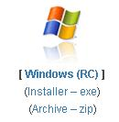

◦ For older versions click on the windows icon and choose the version to be downloaded

* Choose a folder where the installer file will be downloaded to. (e.g. My Downloads)
* Once the file has downloaded, double click on the installer icon

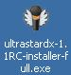

* If the following screen appears, click on the **Run** button

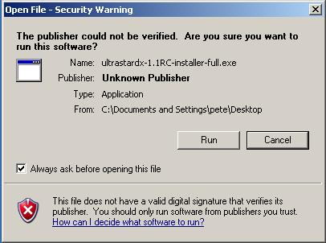

* Choose the installation language as **English** and click **OK.**

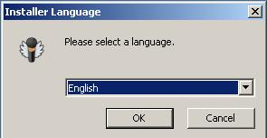

* At the first UltraStar installation screen, some background music will play, showing that the sound card is in operation. Click **Next**.

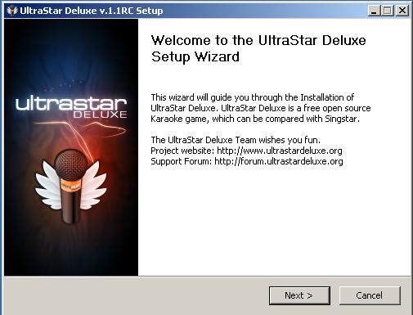

* At the Licence screen, but sure to read the terms and, if in agreement, select the '**I accept**' button and then click **Next**.

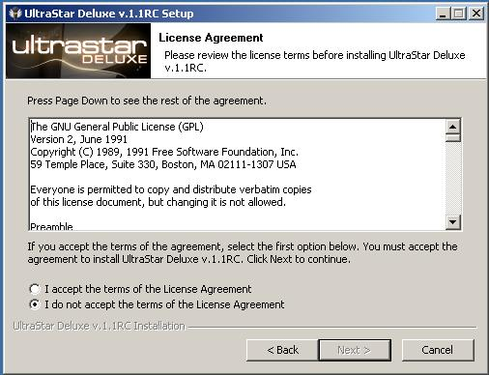

* As the 'main components' section has already been ticked, Expand the 'Songs' section and select which demonstration songs to install (No songs are installed by default.). Then click **Next**.

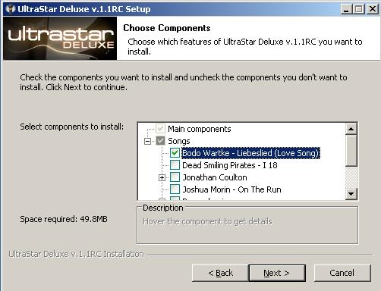

* Unless required, accept the default installation location and click **Next**.

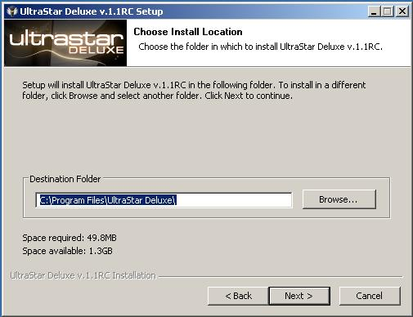

* Unless required, accept the default menu folder and click **Install**.

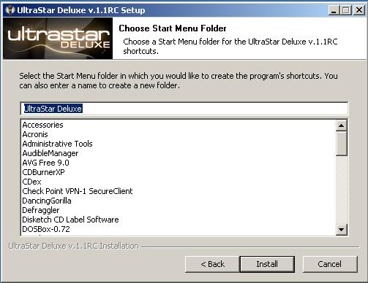

* The installation will then proceed and, at the end, download the requested songs. Click **Next** to complete the installation and display the configuration setup screen.

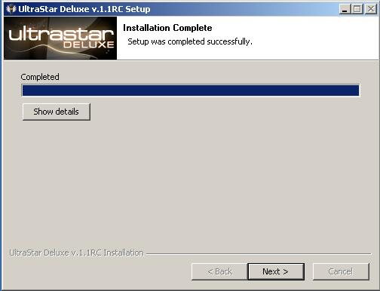

At the configuration screen accept the defaults, unless you choose otherwise, and press **Next.** However, unless the PC is to be used purely for UltraStar, it is recommended that the **Fullscreen** option should be set to **Off**.

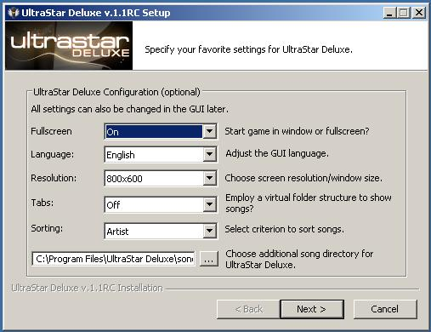

* Finally, click **Finish**.
* The installation is now complete and UltraStar can be run from **Start** – **Programs – Ultrastar** **Deluxe**, or the UltraStar Deluxe icon on the desktop.

## 2.2 Windows Vista & Windows 7 considerations.

### 2.2.1 Program location

Whilst Windows XP will installs completely to c:\program files or any folder you select, Vista and Windows 7 might put some files to C:\Users\%USERNAME%\AppData\ultrastardx\ when you choose to install under C:\program files.

### 2.2.2 File ownership

Under Vista and Windows 7, it is recommended that the user should 'take ownership' of the USDX directory and all files and subfolders below it.

# 3 Playing the game

## 3.1 Singing Solo – 1 player

* Plug a microphone plug into the 3,5 mm microphone input socket (often coloured pink) on the sound card of the PC.
* Double click on the UltraStar Deluxe icon to start the game.
* At the first screen, select '**Sing**' and press '**Enter**'.
* Enter the players name and press '**Enter**'.
* By using the left and right cursor keys, choose the difficulty level and press '**Enter**'
  + The difficulty rating is as follows:
  + 'Easy' allows five semitones difference between the original note and yours.
  + 'Medium' allows three semitones.
  + 'Hard' only allows one semitone, but keep in mind that the software recognition of your vocals might not be perfect or the pitch might be set wrong in the lyric.txt file, see section .

7

* The list of songs will now be displayed in order of the artist name.
* By using the left and right cursor keys, choose the required song and press '**Enter**'
* Sing along to the song, reading the words at the bottom of the screen. Points are given for accuracy of the notes.

## 3.2 The song selection screen – keyboard shortcuts

There are several keyboard shortcuts available in the song selection screen.

* Press **P** to use a playlist
* Press **R** to choose a song at random
* **ALT** + [***Letter***] Jump to an artist begining with the first letter of [***Letter***]
* **ALT** + **SHIFT** + [***Letter***] Jump to an song title begining with the first letter of [***Letter***]

## 3.3 Multiple players

To play with more than one person, further configuration must be applied.

### 3.3.1 2 players - using the Singstar Microphones

The Singstar Adapter takes two microphone audio channels (the left one is the blue player and the right one is the red player) and outputs the signals via a USB interface.

* Insert the Singstar USB plug into the USB socket on the PC
* Under windows XP and above, the microphones will be identified (as shown in the screen shots below) and the correct drivers will be installed.

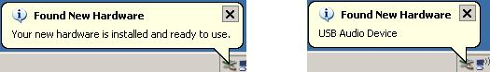

* Open **Control Panel** then and **Sounds and Audio Devices**.
* Click on the **Audio** tab and in under **Sound recording**, select **USB Mic** Serial#.
* Click on the **Volume** button, set it to the maximum and close the volume control window
* Click **OK** on the '**Sounds and Audio**' window to close it
* Close Control Panel
* Start UltraStar Deluxe
* From the main menu, choose the **Tools** menu, then **Option**s and then **Record**.
* Under the soundcard option, select the default sound card (if fitted) and set channel 1 to '**off**'
* Under the sound card option Choose **USB Mic Serial#**
* Set left **Channel1** to **1** and **Channel2** to **2**.
  + Note Channel1 represents player one and Channel2 player 2.
  + Ensure that the channel numbers are not allocated to another channel on another soundcard.
* Press **ESC** twice to return to the main screen.

**3.3.2 Playing with 4 or more players**

For more than 3 players a second screen will need to be installed, see section 10.4 10.4 for more information.

**3.4 Party-Mode**

The party mode is a new feature in UltraStar Deluxe. Here you can play with up to 8-12 Players in 2 or 3 teams.

* Select Party from the main menu.
* Select the required difficulty level from: **Easy**, **Medium** and **Hard**.
* The playlist mode defines which songs are played, choose from '**All Songs**','**Folder**' or ''**Playlist**'.
  + '**All Songs**' plays every song within default the song directory.
  + '**Folder**' plays every song within a subdirectory created underneath the song directory.
  + '**'Playlist**' plays every song within a previously created playlist.
* To define the teams, select playlist mode and press **Enter**.
* Set the number of teams to either 2 or 3.
* Set the number of players in each team, and type their name in each box and press **Enter.**
* Select the number of rounds to be played, between 2 and 7.
* Set the mode of each round.
  + '**Duel**' - Like the classic mode, players sing together and the player with the highest score at the end of the song wins the round.

* + '**Blind Mode**' – The same as duel mode, but without the pitch bars being displayed on the screen.
  + '**Until 5000**' - The same as duel mode, but the first player who gets 5000 points wins.
* Press **Enter** to start the game in Party Mode.

**3.4.1 The Joker card**

If one team does not want to sing the chosen song, they can use the joker card. Every team has 5 joker cards at the beginning of a party mode match. A joker can be taken by pressing the number of the team (1-3) or via a menu (M: opens party mode menu).

It is recommended that each team can only take one joker per round. If a team uses a joker, UltraStar Deluxe will choose a new random song. Due to the random generator a song can be chosen more than one time (e.g. someone uses a joker at song A, the song A might be chosen again).

# 4 Basic Configuration

On the main menu screen, choose the '**tools**' menu and then '**options**'.

## 4.1 Game menu

### 4.1.1 Players

Sets the number of players to play the game.

### 4.1.2 Difficulty

Sets the difficulty level of the game.

### 4.1.3 Language

Sets the language of the screen instructions.

### 4.1.4 Tabs

Displays the on screen tabs.

### 4.1.5 Sorting

Songs in UltraStar Deluxe can be sorted in the following ways: 'Edition / Genre / Language / Folder / Title / Artist depending on the tags that are set in the lyrics .txt file of the song.

The 'folder' option sorts the songs according to the subfolders in the 'Songs' directory. UltraStar Deluxe must be restarted for these changes to take effect.

### 4.1.6 Debug

Enables log data for troubleshooting purposes.

## 4.2 Graphics sub menu

### 4.2.1 Resolution

Choose a screen resolution between 320x200 and 1280x1024+.On lower powered systems, the higher the resolution, the slower the performance. So if UltraStar Deluxe does not run smoothly try to lower the resolution. The most popular screen resolutions are: 640x480, 800x600, 1024x768, 1280x1024.

### 4.2.2 Full screen

If the PC is primarily used for running UltraStar Deluxe, then set this to '**on**'. UltraStar Deluxe must be restarted for the changes on this option to take effect.

### 4.2.3 Depth

The depth option changes the number of colours that are used within UltraStar Deluxe. Allowed options are: 16 bit (65.536 colours) and 32 bit (4.294.967.296 colours). On lower powered systems, the higher the colour depth, the slower the performance. So if UltraStar Deluxe does not run smoothly change this to **16 bit**.

### 4.2.4 Oscilloscope

The Oscilloscope setting reacts to the microphone input and is useful for setting up new songs. Therefore leave this option set to '**off**' unless a new song is being set up. For more information on setting up new songs, see section 6 . 6 .

### 4.2.5 Movie size

UltraStar Deluxe is able to play music videos or movies whilst the song is being played.The option '**Full Vid +** **Bg'** displays the movie and the background picture completely (on the whole screen). The option '**Half'** reduces movie and background size to half and at the top/bottom are white borderlines. The third option '**Full** **Vid**' will display the movie completely but UltraStar Deluxe will reduce the background picture.

See 6.5 6.5 section for information using music videos.

## 4.3 Sound sub menu

### 4.3.1 Microphone Playback

Sound input can be disabled using this option.

### 4.3.2 Background Music

Background music, which plays during the menu and selection process, can be disabled using this option.

### 4.3.3 Mic boost

For UltraStar Deluxe to work correctly, the microphones levels may need to be adjusted. The mic boost option helps to increase the signals generated by the microphone.

There are four levels : Off, +6 db, +12 db and +18 db. Start at 'Off' and slowly work towards +18db. If the microphone level is still too low, adjust the microphone input level within the operating system itself.

See section 10.3 10.3 for more information on increasing the voume of a microphone..

### 4.3.4 Click assist

This function is an aid for making a song. When enabled there will be a 'click'-noise on every note to be sung. In order to assist synchronizing the song with the lyrics.

### 4.3.5 Beat click

This function is similar to a metronome, as an aid for creating a song. If enabled there will be a 'click'-noise on every beat in the rhythm depending on the beats-per-minute which are set in the .txt file of the song.

### 4.3.6 Threshold

This function is used to minimize background noise that could alter a singers score. It works by reducing the sensitivity of the input signals. Values are 5%, 10%, 15% and 20%. The higher the option, the higher the input signals are recognized as wanted signals. (Default is 15%)

### 4.3.7 Preview Volume

Choose the volume of the song preview in the song selection menu. The values can be off: Off, 10% and up to 100% in decimal steps.

**UltraStar Deluxe v1.1.0** **User Manual**

### 4.3.8 Preview Fading

These settings affect the fade in time of the song preview. You can turn fading-time 'Off' (0 seconds) or from 1 second up to 5 seconds.

## 4.4 Lyrics

### 4.4.1 Font

The font that is used to display the song lyrics can be enhanced by using this option.

* '**Plain**' displays the standard typeface without any enhancements.
* '**Oline1**'. Displays the lyrics appear with a standard outline style.
* '**OLine2**' Displays the lyrics appear with a different outline style.

### 4.4.2 Effect:

This option changes the visual cueing effect that is used on the lyrics to be sung.

* '**Simple**' - Colours the current syllable of lyrics.
* '**Zoom**' - The syllable to be sung changes colour and increases and decreases in size
* '**Slide**' - The syllable to be sung changes colour on each letter, similar to a karaoke style
* '**Ball**' **-** Bounces a small smiley ball over the syllable to be sung, colouring it at the same time.

### 4.4.3 Staves

Enables or disables the displays of Staves during play.

## 4.5 Themes

### 4.5.1 Theme

There are two pre-installed themes, but new ones can be designed and installed by the user.

* '**Deluxe**' - UltraStar Deluxe default (newer style).
* '**Classic**' – Similar to SingStar

### 4.5.2 Skin

The skin option changes the overall background. There are four settings to choose from: Autumn, Blue, Summer and Winter.

### 4.5.3 Colour

Colours available are: Blue, Green, Pink, Red, Violet, Orange, Yellow, Brown and Black.

## 4.6 Record

### 4.6.1 Sound card

UltraStar Deluxe will detect the first soundcard where the first microphone is plugged in to. If more than one soundcard is used, each one must be set up. The numbers 1-6 represent each player and each channel on each soundcard must have its own unique number or the be set to '**off**'.

### 4.6.2 Input

Choose the soundcard input channel for each microphone.

* Left Channel: Choose the player´s number (1-6) for the left input channel (e.g. Singstar Mics: Blue Mic would be 2).
* Right Channel: Choose the player´s number (1-6) for the right input channel (e.g. Singstar Mics: Red Mic would be 3).

## 4.7 Advanced

### 4.7.1 Screen Fading:

Controls the fade-in/out effect when entering or leaving a screen. Options are '**Off'** or '**On'**.

### 4.7.2 Sing Effects:

This option enables sing effects such as perfect line, note effects, golden note effects and golden note hit effects. If you experience graphic bugs, set this this option to '**off**''

### 4.7.3 Line Bonus

A pop-up bar that is displayed after each line of lyrics with a simple rating of 'Bad' or 'Good', informing the sing of how well they are doing. The description of the ratings can be changed, see section 10.1.1 . 10.1.1 .

### 4.7.4 After Song Select

Once the song has been selected, this option controls what happens next.

* '**Sing**' - Skips the 'Select Players' dialog.
* '**Select Players**' - Displays a player selection screen, asking which players wish to play.
* '**Open menu**' - Returns to the menu.

### 4.7.5 Safety Questions

Enables the 'Are you sure you wish to exit' warning before the program terminates.

### 4.7.6 Auto Party Menu

Primarily for use in Party Mode, if enabled, 'Joker Menu' will always be opened at the Song Selection screen.

# 5 Statistics

UltraStar Deluxe holds statistics about songs, singers and scores. This is accessed from the 'Tool's section of the main menu.

## 5.1 General

The first page displays the general settings such as:

* UltraStar Deluxe version number
* Last reset date
  + When the statistics were last reset
* Songs
  + The number of songs held in the song directory, how many have a video, how many different songs and players have played or haven´t been played since last reset, the most popular song/artist, the best player (calculated by an average score) and the highest score.

By selecting the **High Scores** and **Best singers** buttons, further information is displayed, e.g. Which Player got a highscore, what the song was and the difficulty level.

The **Reverse Order** button displays details about the lowest scores.

### 5.1.1 Reset Highscore

To reset the UltraStar Deluxe high score:

* Ensure that UltraStar Deluxe is not running
* Open the program directory where UltraStar Deluxe is installed

◦ under ms windows, this is usually 'c:\program files\ultrastar deluxe'

* Delete the file Ultrastar.db.

### 5.1.2 Editing individual or team scores

To delete or edit single scores the scores must be converted from the database ('Ultrastar.db') to *.sco files (e.g. by using the ScoreConverter utility) and save the .sco file in the subdirectory 'Songs'.

The players will be listed with the difficulty and their score, for example: [Easy1] can be changed to [Normal1] or [Hard1]

Name=Player1 Name=UltraStar Name=UltraStar Score=0 Score=10000 Score=10000

The highest score is 10000 with the rating UltraStar.

# 6 Importing New Songs

One of the big advantages of UltraStar Deluxe is the ability to add new songs. A song contains the music in an .mp3 file, the lyrics and other settings in a .txt file, known as a lyric file. For legal copyright reasons, the

.mp3 music file cannot be copied from person to person, but a new .txt file usually can, as long as the creator of the .txt gives permission, which most do.

## 6.1 Downloading song .txt files

New .txt lyrics files are available and can be downloaded from the UltraStar Deluxe Forums and are then matched to the .mp3 file that you already own.

* Ensure that UltraStar Deluxe is not running
* Under the 'Songs' folder, create a new folder with the name of the artist and song title. e.g. Abba – Dancing Queen (ABBA gold CD album track)
* Copy your .mp3 file into the new folder
* Visit the Forum site, download the .txt lyric file for the .mp3 audio file and save it in the new song folder with the .mp3 file
* In the new song folder, make sure that the .mp3 audio file and the .txt lyric file have the same name
* Using notepad (or another text editor) open the .txt lyric file
* Make sure that the **#TITLE**, **#ARTIST**, **#MP3**, **#BPM** and **#GAP** fields are all there and that the is an '**E**' at the very end of the file.
* Make sure that the **#MP3** value holds the exact filename of the .mp3 audio file.
* Save the .txt lyric file.
* Run UltraStar Deluxe and the new song will be displayed in the song selection screen.
* Sing along to the song and make sure it's correct, otherwise see section 11. 11.2 ◦ To add a new background or cover, see section 6.4 .  6.4 .

## 6.2 Creating blank .txt lyric files

.txt lyric files can be created from scratch using the import feature within UltraStar Deluxe, see section 8 . 8 .

## 6.3 Removing a song

A song can be removed by simply deleting the song subdirectory in the main 'Songs' directory.

## 6.4 Adding a song background & song cover graphic files.

Each song can have a picture, which is displayed during the song selection process, this is known as a 'cover'. and a background picture, which is displayed when the song is being sung.

The cover graphic file should be a resolution of 300 x 300 and in a .jpg format. The background graphic file should be a resolution of 600 x 800 and in a .jpg format.

* Copy the cover and background graphic files into the song folder to which the graphic files relate.
* Using notepad (or another text editor) open the .txt lyric file
* Edit the value of the **#COVER** variable (or add it, if it does not exist) to hold the cover graphic file name.

* + e.g. #COVER:abba – abba gold CD cover.jpg.
* Edit the value of the **#BACKGROUND** variable (or add it, if it does not exist) to hold the background graphic file name.
  + e.g. #BACKGROUND:abba – abba gold CD cover.jpg.
* Save the .txt lyric file.
* Start UltraStar Deluxe.

## 6.5 Using music videos

UltraStar Deluxe can play music videos (in a mpg or mpeg file format) instead of displaying a background graphic file.

However, it is important to remember that although the music video is playing, the lyrics and their timing are still defined in the .txt lyric file, so if the lyrics dont start on time or out of synch the .txt lyric file will need to be changed. See section 11.2See section  11.2 for details of synchronising .txt lyric files.

* Copy the music video .mpg file into the song folder to which the video file relates.
* Using notepad (or another text editor) open the .txt lyric file.
* Rename the existing cover graphics file defined in **#COVER** variable (if it exists) by adding '**.old**' to the end of the filename.
* Rename the existing background graphics file defined in **#BACKGROUND** variable (if it exists) by adding '**.old**' to the end of the filename.
* Edit the value of the **#VIDEO** variable (or add it, if it does not exist) to hold the music video file name.
* Edit the value of the **#VIDEOGAP** variable (or add it, if it does not exist) to hold the number of seconds between the start of the music video and the start of lyrics.
  + The value of **#VIDEOGAP** can be negative if the **#START** parameter has been set, but the gap define in **#START** will skip the seconds set in the .txt file.
* Restart UltraStar Deluxe

### 6.5.1 Removing a music video

A music video can be prevented from playing by simply deleting it. As long as the .mp3 audio file and .txt lyric file still exist the song will play. The tags do not need to be removed from the .txt lyric file.

# 7 .txt lyric file

## 7.1 Overview

The .txt lyric file is used to hold the lyrics of the song as well as information about the song and must be in a standard text format. There are several required fields: #TITLE, #ARTIST, #MP3, #BPM and #GAP. The field name needs to be in capital letters, prefixed by a '#' and suffixed by a colon :

See section 9 9 for information on how to view and edit the song using the song editor.

## 7.2 Field definitions

* #TITLE: Text value. Defines the title of the song which is displayed in UltraStar Deluxe.
* #ARTIST: Text value. Defines the name of the artist name which is displayed in UltraStar Deluxe.
* #MP3: Text value. Defines the .mp3 audio filename of the the song. It should be in the format *filename.mp3*.
* #BPM: Integer value. These are the emphasized beats per minute. Changing this value will affect the speed of the song, the high the value, the faster the song.
* #GAP: Integer value. The pause in milliseconds between the start of the song to the first note of the lyrics.
* #START: Integer value. This is the new start of the song in seconds. Amount of time will be skipped from the mp3 and the lyrics.
* #RELATIVE: Boolean (yes – no). Defines how the txt-file is written. If this tag is set to 'yes', the start of the notes is counted from zero in every line. If this tag is not available or set to 'no', the start of the notes is counted continuous from the beginning to the end of the txt-file.
* #EDITION: Text value. Defines the edition the song belongs to. Primarily used for sorting the songs.
* #GENRE: Text value. The genre of song (e.g. Pop, Rock).
* #LANGUAGE: Text value. The language of the songs lyrics (e.g. German, English).
* #VIDEO, #VIDEOGAP: See section 21 21 for more information.
* #COVER, #BACKGROUND: See section 6.4 6.4 for more information.
* #ENCODING: For supporting languages that adhere to the UTF8 format.
* #DATE: Not officially used or supported, but can hold the date that the file was created.
* #AUTHOR: Not officially used or supported, but can hold the author of the file.

## 7.3 UTF8 Support

UltraStar Deluxe supports many languages and different character sets. If a non English character set is to be used in the .txt lyric file, the #ENCODE value should be set to UTF8.

## 7.4 Lyrics and pitch definition

The lyrics and the pitch are defined in a format represented by the table below.

### 7.4.1 Position 1 – Type of note

Possible values are :

* **\*** = Beginning of a 'Golden note'.
* **:** = Beginning of a Standard note
* **F =** Freestyle note.
* **-** = Line break, next lyric line is displayed.
* **E** = The end of the lyric file.

### 7.4.2 Position 2 – Beat number

A numeric value defining the beat in the song; i.e. when the syllable defined in Position 4 is displayed on the screen. This should always equal the sum of values in position 2 and position 4 of the previous line plus 1. See section 23See section  23 for an example of a .txt lyric file.

### 7.4.3 Position 3 – Period before next syllable

A numeric value defining how many beats the syllable in position 4 is displayed.

### 7.4.4 Position 4 - Pitch

A numeric value defining the pitch of the note to be sung.

### 7.4.5 Position 5 – Syllable to be sung

A text value defining the syllable to be displayed.

### 7.4.6 Line breaks

A line break is when there are no lyrics at that point in the song, but are more to come before the end of the song. e.g. An instrumental break.

A line break is defined as a '-' in position 1, followed an integer in position 2 that defines the duration of the break in beats number of beats. The correct line break value can be calculated from adding the values of position 2 and 3 in the previous row and then incrementing the result by 1.

Sometimes, .txt lyric files have incorrect line breaks and the pace of the lyrics appear to drift out of time. This can be fixed, see section 11.2.4 . 11.2.4 .

### 7.4.7 Example of a .txt lyric file

Here is an example lyric file for the song 'Twinkle Twinkle'.

**#TITLE:Twinkle Twinkle Little Star**

**#ARTIST:Nursery Rhyme**

**#MP3:Nursery Rhyme - Twinkle Twinkle.mp3 #BPM:105**

**#GAP:12500**

**: 0 3 66 Twin**

**: 4 3 66 kle : 8 3 68 Twin : 12 7 68 kle : 32 3 69 Lit**

**: 36 3 69 tle : 40 3 68 star E**

# 8 Creating new songs using .kar files

The song editor allows the importing of MIDI .kar files and the creation of blank .txt lyric files enabling the production of new songs. It is important to remember that this relies on the accuracy of the pitch, bpm and timings of the .kar file when compared to the .mp3 audio file to be used. An inaccurate .kar file is likely to result in a .txt lyric file which doesn’t display the lyrics at the right time.

It is highly advantageous to obtain a .kar file rather than a plain midi file as the words to the music are already included in the .kar file and this saves time, when trying to calculate the timing of the individual syllables to be sung.

## 8.1 The midi .kar import screen

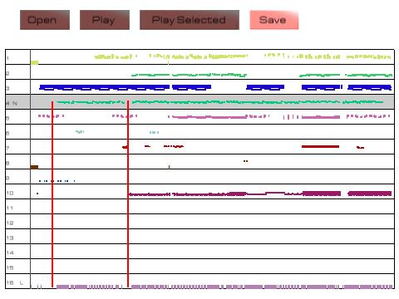

## 8.2 Creating a .txt lyric file from a midi kar file

* Start UltraStar Deluxe and from the main menu, choose '**Tools**' then '**editor**', (on later versions, this is likely to be named as 'import'.)
* Select the '**import**' option and press enter.
* Type in the name of the .kar file to be converted then select '**OK**'
* The .midi file will then be displayed on the screen.
  + It is very important that the midi file has separate tracks, most importantly a lyrics and a note track, identified, by a 'L' and an 'N' in the leftmost column. If these track type are not displayed, the song editor process is unlikely to work correctly.
* Cursor down to the track that is labelled as '**Lyrics**' , '**Words**' or '**Vocal**'.
* Press the space bar twice to select the track and and '**L**' will appear in the left column.

* Cursor down to the track that is labelled as '**Note**' or '**Melody**'.
* Press the space bar once to select the track and and '**N**' will appear in the left column.
* Using the cursor keys, select '**Save**'.
* A .txt lyric file will now be saved to the same location as the .midi file.

## 8.3 Test the .txt lyric file

If the midi file was a .kar type, it may work without further configuration, but to be sure:

* Using notepad (or another text editor) open the .txt lyric file
* Ensure that the required fields: #TITLE, #ARTIST, #MP3, have the correct values, according to the

.mp3 audio file.

* Ensure that the required fields: #BPM and #GAP have integer values
* Save the .txt lyric file.
* Start UltraStar Deluxe and try the song, if the lyrics appear are not synchronised, see section 11.2 .  11.2 .

## 8.4 Setting the correct BPM

The BPM of the song needs to be correct for the lyrics to appear in time with the song. The BPM can be calculated manually or by using an open-source BPM analyser, such as MixMeister.

* Using notepad (or another text editor) open the .txt lyric file
* Set the #BPM to the correct values, according to the BPM analyser.
* Save the .txt lyric file.
* Start UltraStar Deluxe and try the song, if the lyrics appear drift out of time, see section 11.2 .  11.2 .

# 9 Viewing and editing a song

Various aspects of the songs .txt lyric file can be edited from within Ultrastar Deluxe

* From the Main Menu choose '**sing**'.
* Cursor through the song selection screen until the required song apepars foremost
* Press '**E**' and the song editor screen will appear

## 9.1 Keys used

* '**P**' - Plays current page with metronome in the background.
* **'Space'** - Plays current note.
* '**S**' - Saves changes to the .txt lyric file.
* '**ESC**' – Return to the song selection screen.
* **Cursor Keys** 
  + **Left** and **Right** cursor keys to navigate between the notes in the current sentence.
  + **Up** and **Down** key to browse through the pages (sentences) of the song.

## 9.2 Setting the #GAP value

The #GAP value can be changed so that the lyrics start at the correct time. The keys used are at the top of the keyboard

|  |  |  |
| --- | --- | --- |
| • | **'9'** | Decrease the #GAP value by 100 milliseconds |
| • | **'0'** | Increase the #GAP value by 100 milliseconds |

* **'SHIFT + 9'** Decrease the #GAP value by 1 second
* **'SHIFT + 0'** Increase the #GAP value by 1 second

## 9.3 Setting the #BPM value

To change the #BPM value use the following keys.

|  |  |  |
| --- | --- | --- |
| • | **'-'** | Decrease the #BPM by 0.05 |
| • | **'='** | Increase the #BPM by 0.05 |

* **'SHIFT + M'** Multiplies BPM by 2 (note timings will also be multiplied by 2).
* **'SHIFT + D'**“ Divides BPM by 2 (note timings will also be divided by 2).

## 9.4 Setting pitch

The keys below refer to those on the numeric pad to the right of the keyboard.

|  |  |  |
| --- | --- | --- |
| • | **'-'** | Decreases the pitch of every note by 1. |
| • | **'+'** | Increase the pitch of every note by 1. |

* **'SHIFT + -'** Decreases the pitch of every note by 12.
* **'SHIFT + +'** Increases the pitch of every note by 12.
* **'CTRL + Down Arrow'** Decreases the pitch of the selected note by 1.

* **'CTRL + Up Arrow'** Increases the pitch of the selected note by 1.

## 9.5 Splitting and merging sentences

|  |  |  |
| --- | --- | --- |
| • | **'/'** | Divide current sentence. |
| • | **'SHIFT + /'** | Current sentence and next sentence will be combined. |

## 9.6 Setting Notes

* **'SHIFT + Left Arrow'** Moves selected note to the left.
* **'SHIFT + Right Arrow'** Moves selected note to the right.
* **'CTRL + Left Arrow'** Decreases the beginning of the note (note begins earlier).
* **'CTRL + Right Arrow'** Increases the beginning of the note (note begins later).
* **'ALT + Left Arrow'** Decreases the end of the note (note ends earlier).
* **'ATL + Right Arrow'** Increases the end of the note (note ends later).
* **SHIFT + CTRL + ALT+ Left Arrow'** Moves all notes, starting after the selected note, to the left.
* **SHIFT + CTRL + ALT+ Right Arrow'** Moves all notes, starting after the selected note, to the right.

|  |  |  |
| --- | --- | --- |
| • | **CTRL + /'** | The new note will become the lyric: “-“. |
| • | **CTRL + DEL** | Deletes selected note. |

## 9.7 Line Breaks

* **'B'** Moves the lyrics of the sentence to the right. The current (selected) note will become thelyrics: '-'.
* To remove a line break, the lyric.txt file will need to be edited manually. See section 7 . See section  7 .

# 10 Advanced Customisation

This section assumes that the user has a fair degree of technical knowledge: e.g. understands how to backup a configuration file before editing it and also the concepts of a .ini file, its fields, variables and values .

Under the UltraStar Deluxe program directory, is a '**languages'** directory. Within this directory, there are .ini files correlating to specific languages. Each .ini file holds variables that are used by UltraStar Deluxe.

The format of the variables in the .ini file is as follows:

VARIABLE_NAME=*value*

Where VARIABLE_NAME can never be changed, but *value* can be text, real or integer number, depending in the variable type.

***It is highly recommended that the original .ini file is backed up before any editing commences.***

## Language.ini file settings.

### Rating a singer

In the language.ini file, there are eight values that represent how well a singer sung. The defaults may be changed by simply editing the value. The default values, from worst singer to best singer, are:

* SING_SCORE_TONE_DEAF=Tone Deaf
* SING_SCORE_AMATEUR=Amateur
* SING_SCORE_WANNABE=Wannabe
* SING_SCORE_HOPEFUL=Hopeful
* SING_SCORE_RISING_STAR=Rising Star
* SING_SCORE_LEAD_SINGER=Lead Singer
* SING_SCORE_SUPERSTAR=Superstar
* SING_SCORE_ULTRASTAR=Ultrastar

### Line Bonus

A line bonus can be given when a line is sung accurately, the two main settings are:

* LINEBONUS_WORST=text_variable
* LINEBONUS_PERFECT=text_variable

## Config.ini settings

The config.ini file resides in the main program directory and holds most of the program settings. Incorrectly

changing values in this .ini file can cause UltraStar Deluxe to stop running. The config.ini file is usually held within the installation direcgtory, but can soemtimes reside the users profile e.g.: %LOCALAPPDATA%\VirtualStore\Program Files\UltraStar Deluxe

1. **Saving a recording**

This feature is not supported and is only mentioned here for developers interest. The vocals that have been sung can be saved as a .RAW file by setting the **SavePlayback** value to '**On'**. This will save a raw .wav file which will need to be imported into an audio editor, such as Audacity, to be correctly heard.

1. **Using a joystick style controller.**

To use a joystick, go to the the [Controller] section, and set '**Joypad=On**'.

1. **Setting the location of covers to another drive and directory**

To change the location of the covers directory, the following lines should be added to config.ini

[Path] covers=*full_pathname*

where *full_pathname* is the directory where the covers reside. e.g. C:\UltraStar Deluxe\Covers.

1. **Setting the location of songs to another drive and directory**

To change the location of the songs directory, the following lines should be added to config.ini

[Path] Songs=*full_pathname*

However, multiple song directories can be created by adding

[Directories]

SongDir1= *full_pathname* SongDir2= *full_pathname* SongDir3= *full_pathname*

where *full_pathname* is the directory where the songs reside. e.g. C:\UltraStar Deluxe\Songs.

1. **Adjusting the OS microphone levels**

* Start UltraStar Deluxe
* Open **Control Panel** then and **Sounds and Audio Devices**.
* Click on the **Advanced** button which displays the **Volume Control** window ◦ Or for XP users, run sndvol32.exe – Vista users, run sndvol.exe
* From the **Options** menu, choose **Properties**
* Set the mixer device to '**Input**', select '**Recording**' and click '**OK**'
* In the 'Recording control' window, select the required input device (.e.g. Singstar microphones are referred to as USBMic Serial#) and adjust the level accordingly.
* In UltraStar Deluxe, test the loudness of the microphone and singer again, repeat the previous step until the level is correct.
* Close the 'Recording control' window
* Click **OK** on the '**Sounds and Audio**' window to close it

* Close Control Panel

1. **Playing with more than 3 people**

UltraStar Deluxe can be played with up to 5 people, but for 4 or more players a additional screen is required. This section assumes that the user has a fair degree of technical knowledge: i.e. understands how to configure graphic card drivers, scan rates and horizontal resolution rates, if in doubt please consult your local IT service engineer.

* Open config.ini
* Under the **[graphics]** section, set “**Screens=2**” and '**FullScreen=Off**'
* Set the resolution value to the same as in Windows display device.
* Save and close config.ini
* In Windows Screen device driver settings expand the horizontal resolution to encompass two screens.

**11** **Troubleshooting**

1. **Graphics issues**

Over 90% of the issues with graphics are to do with the drivers for the graphics card. Please ensure that the PC is running the latest drivers for the card, rather than the ones shipped with the Operating System.

For example, as of October 2010, US & UK English graphics drivers can be downloaded from:

|  |  |  |
| --- | --- | --- |
| • | ATI (AMD) drivers | [http://support.amd.com/us/gpudownload/Pages/index.asp](http://support.amd.com/us/gpudownload/Pages/index.aspx)x |
| • | Nvidia | [http://www.nvidia.com/Download/index.aspx?lang=en-u](http://www.nvidia.com/Download/index.aspx?lang=en-us)s |
| • | Intel | [http://www.intel.com/support/detect.htm?iid=dc_spotlight_home](http://www.intel.com/support/detect.htm?iid=dc_spotlight_home1)1 |

1. **Slow Graphics**

If the screen display appears jerky :

* From the Main Menu, select **Tools** then **Options**
* Select **Advanced** – set **sing effects** to **Off**

1. **Windows 7 & Vista**

To overcome Windows 7 and Vista font display problems:

* Make sure Ultrastar Deluxe is not running
* Right click on the **UltraStar Deluxe** desktop icon
* Click **properties** then the **compatibility** tab
* Click on the checkbox '**Disable display scaling on high DPI settings'**.
* Restart Ultrastar Deluxe

1. **Error message “*Failed Loading Open GL 1.2 ...*”**

Update the graphics drivers. See section 11.1See section  11.1

1. **On-Screen lyrics and song issues**

Music files can come from various sources and also be different mixes: A radio edit of a song may be different to a CD version, which could be different to a iTunes download, which could also be different to the album version of a song and all of these could differ from country to country.

Therefore it is worth remembering that the creation of the lyrics and pitch in some .txt lyric files may not be accurate due to the version of the song being different. Therefore, it is recommended that the .mp3 and .txt filenames correctly identify the source and mix of the song. e.g.

* Abba – Dancing Queen (ABBA gold CD album track)
* Madonna – Holiday (US vinyl single mix)
* Michael Jackson – Thriller (UK iTunes download)

1. **Syllables incorrectly appear in italics**

Syllables will appear in italics when the note to be sung is a 'freestyle' note. However there are some occasions when lyrics have been imported from a midi .kar file when the syllable is incorrectly marked as a freestyle note.

This can be changed by opening the .txt lyric file using a text editor and replacing the '**F**' in column 1 with a '**:**' of the appropriate syllable.

1. **Lyrics are all joined together**

The lyrics can appear to be all joined together if there are formatting errors in the .txt lyric file, often caused from a faulty MIDI .KAR files.

To correctly format the lyrics, open the .txt lyric file using a text editor and edit the spaces as defined in the following paragraph.

The first syllable in a line should have one space after the pitch number. A new word in the lyrics will need two spaces following the pitch number. Words that are broken up over two notes will need two spaces at the start of the first syllable and one space in the following syllables.

1. **Lyrics are in time, but start at the wrong time**

If the lyrics just start at the wrong time, but keep in time for the duration of the song, this can be corrected by editing the #GAP value in the .txt lyric file, this can be done using the editor:

* Start UltraStar Deluxe as normal.
* At the first screen, select '**Sing**' and press '**Enter**'.
* Enter a players name (or accept the default) and press '**Enter**'.
* Accept the default difficulty level and press '**Enter**'
* Using the cursor keys, display the song that is incorrect and press '**E**' to start the editor
* If the words start too late, press the '**9**' key to reduce the #GAP value, if they start too early press the '**0**' key to increase the #GAP value
* Press the space bar to hear the first syllable again.
* Repeat the previous two steps until the start of the first syllable of the first word is correctly heard.
* Press '**S**' to save the changes made.
* Finally, press '**ESC**' to return to the song selection menu.

See section 7 7 for more information about editing the lyric.txt file manually or section 9 9 to use the song editor.

1. **Lyrics are not in time with the song**

First, make sure that the lyriscs start at the right time, be following section 11.2.3 . 11.2.3 . Once this has be established then check that the lyrics keep time. If they suddenly become out of synch at a particular point, the problem is likely to be a line break problem and this can be fixed in section 11.2.5 . 11.2.5 .

Least likely is when the lyrics start correctly, but slowly slowly drift out of time over the course of the song. This often occurs when the speed of the .mp3 file was recorded at a different bpm to the .txt lyric.

This can be corrected by editing the #BPMvalue in the .txt lyric file. If the lyrics finish before the song does, lower the #BPM value, if the song finishes before the lyrics raise the #BPM value.

See section 7 7 for more information about editing the lyric.txt file or section 9 9 to use the song editor.

1. **The next lyric line begins too early / too late**

Lyrics that start on time, but suddenly go out of time at a particular point in the song, usually show an error in the line break spacing of the .txt lyric file. This can be fixed by editing the .txt lyric file and modifying the line break values.

Before editing this section of the the .txt lyric file, it is important to fully understand how the beats, syllables and line breaks work - see section 7 7 for more information about editing the .txt lyric file.

A line break is defined as a '-' in position 1, followed an integer in position 2 that defines the duration of the break in beats number of beats. The correct line break value can be calculated from adding the values in position 2 and 3 and then incrementing the result by 1 and then choose a value in the middle to have a good line break, so that the notes will not be cut.

1. **A particular song will not load or causes to crash.**

There are several reasons why a particular song may not work with UltraStar Deluxe.

• Check that the header section of the .txt lyric file is correct. See section  7 for more information about editing the lyric.txt file for more information about editing the lyric.txt file.

* Check that the .mp3 file is named correctly in the .txt lyric file. See section 7 7 for more information about editing the lyric.txt file.
* Check that the structure of the .txt lyric file is correct, such as an 'E' at the end and if line breaks are

set between the notes. See section 7 7 for more information about editing the lyric.txt file.

* The .mp3 song file may have a variable bitrate. UltraStar Deluxe fully does not support variable bitrate .mp3 files.

1. **Vocal issues**

Vocal problems can spoil the enjoyment of the game, here are quick fixes for some common problems.

1. **The vocals are too quiet**

If the vocals are too quiet, the microphone audio settings will need to be adjusted. See section 10.3 .See section  10.3 .

1. **The vocals dont always register**

If the vocals dont always register correctly, the background noise and toerlance rates may need to be changed. See section 4.3.6 4.3.6 for dealing with background noise.

1. **The pitch is incorrect**

The pitch of a song can be changed by using the Editor, see section 9 9 , or manually, by editing the lyric.txt file syllable by syllable. See section 7 .See section  7 .

# 12 Appendix

1. **Legal**
2. **Disclaimer**

The information in this document is provided as is and there is no warrant to its completeness or accuracy;

The developers of UltraStar Deluxe or any associated personnel shall not be responsible for any errors, omissions, loss or damage whether indirect, special, incidental or consequential resulting from the use of the information that contained herein.

1. **Acknowledgements**

All trademarks are acknowledged.

1. **Usage**

This document is licensed for use under the GNU Free Documentation License 1.3.3. http://www.gnu.org/copyleft/fdl.html

1. **Versions**



|  |  |  |
| --- | --- | --- |
| **Date** | **Description** | **Author** |
|  |  |  |
| 24.09.10 | Creation of initial version | P A Harsent |
|  |  |  |
| 02.10.10 | Tidied ambiguity over channel numbers in two player sound set up | P A Harsent |
|  | Added further solutions to common graphic card problems |  |
|  | Added further solutions for common lyric problems |  |
|  |  |  |
| 09.10.10 | Added main index | P A Harsent |
|  | Added further solutions to common graphic card problems |  |
|  | Added #GAP section when importing new songs |  |
|  | Added further solutions for common lyric problems |  |
|  | Added section on support for UTF8 layouts |  |
|  | Added .RAW section |  |
|  | Added further Windows 7 & Vista considerations |  |
|  | Added multiple song directories section |  |
|  | Added alternate cover location section |  |
|  |  |  |
| 10.10.10 | Corrections in layout and updated information to fit changes in 1.1 final | canni |
|  |  |  |

**13** **Index**

All songs 13

Artist **12,** 15, **19, 20, 22**

Audacity **29**

Audio editor **29**

Background music **7,** 16

Background noise **16, 33**

Beat click **16**

Beat number 23

Blind Mode **14**

Bpm **16, 24**

BPM **20, 22, 23, 25, 26**

Channel **12, 13, 18, 34**

Channel1 **13**

Channel2 **13**

Click assist **16**

Config.ini **28, 29, 30**

Control Panel **13, 29, 30**

Debug **15**

Difficulty **12, 13, 15, 19, 32**

Directory **29**

Duel **13, 14**

Edition 15, **22**

Editor **20, 21, 22, 24, 25, 26, 32, 33**

File ownership **11**

Folder **6, 9, 13, 15, 20, 21**

Font **17**

Freestyle note **23, 32**

Full screen **15**

Genre 15, **22**

Golden note **18, 23**

High scores **19**

Import **20, 21, 24, 31, 34**

Joker **14, 18**

Joystick **29**

Language **7, 15, 22, 28**

Language.ini **28**

|  |  |  |
| --- | --- | --- |
| Legal Usage................................................... |  | **34** |
| Line bonus................................................ |  | **18, 28** |
| Line break........................................... |  | **23, 27, 33** |
| Lyrics..**15, 16, 17, 18, 20, 21, 22, 23, 24, 25, 26,** | | |
| **27, 31, 32, 33** |  |  |
| Metronome............................................... |  | **16, 26** |
| Mic boost........................................................ |  | **16** |
| Microphone............................... |  | **5, 12, 16, 18, 29** |
| Midi..................................................... |  | **24, 25, 31** |
| MIDI................................................................ |  | **24** |
| MixMeister...................................................... |  | **25** |
| Movies............................................................ |  | **16** |
| Multiple players............................................... | | **12** |
| Multiple song directories........................... | | **29, 34** |
| Music videos............................................. |  | **16, 21** |
| Oline............................................................... |  | **17** |
| Options menu......................... |  | **13, 15, 18, 29, 31** |
| Oscilloscope................................................... |  | **16** |
| Party................................................... |  | **13, 14, 18** |
| Party mode..................................................... |  | **13** |
| Party mode .................................................... |  | **13** |
| Pitch................ | **12, 14, 22, 23, 24, 26, 27, 31, 32** | |
| Players........................ | **12, 13, 15, 18, 19, 30, 32** | |
| Playlist...................................................... |  | **12, 13** |
| Preview fading................................................ |  | **17** |
| Preview volume.............................................. | | **16** |
| Program location............................................. | | **11** |
| Random.................................................... |  | **12, 14** |
| Random generator.......................................... | | **14** |
| Rounds........................................................... |  | **13** |
| Screen fading................................................. |  | **18** |
| Screen resolution ........................................... | | **15** |
| Semitone........................................................ |  | **12** |
| Sensitivity....................................................... |  | **16** |
| Sing effects............................................... |  | **18, 31** |
| Singstar..................................... |  | **5, 12, 17, 18, 29** |
| Singstar microphones............................... | | 12, **29** |

Skin **17, 18**

Song background **20**

Song directory **13, 19**

Song selection menu **16**

Songs directory **29**

Soundcard **13, 18**

Sounds and Audio **13, 29**

Standard note **23**

Statistics **19**

Staves **17**

Subfolders 15

Syllable **17, 23, 24, 31, 32, 33**

Synchronizing **16**

System Requirements **5**

Teams **13**

Threshold **16**

Title **12, 20, 22**

Tools menu **15**

Ultrastar.db **19**

Until 5000 **14**

USB **5, 12, 13, 29**

UTF8 **22**

Variable bitrate **33**

Version number **19**

|  |  |  |
| --- | --- | --- |
|  |  | |
| .kar file................................................ | **24, 31,** | **32** |
| .mp3 file...................... | **20, 21, 22, 24, 25, 31,** | **33** |
| .RAW file......................................................... |  | **29** |

.txt lyric file **20, 21, 22, 23, 24, 25, 26, 31, 32, 33**

|  |  |
| --- | --- |
| .wav file........................................................... | **29** |
| #..................................................................... | **22** |
| #ARTIST....................................... | **20, 22, 23, 25** |
| #AUTHOR...................................................... | **22** |
| #BACKGROUND...................................... | **21, 22** |
| #BPM................................ | **20, 22, 23, 25, 26, 32** |
| #COVER............................................. | **20, 21, 22** |
| #DATE............................................................ | **22** |
| #EDITION....................................................... | 22 |
| #ENCODE...................................................... | **22** |
| #ENCODING.................................................. | **22** |
| #GAP................................ | **20, 22, 23, 25, 26, 32** |
| #LANGUAGE.................................................. | **22** |
| #MP3............................................ | **20, 22, 23, 25** |
| #RELATIVE.................................................... | **22** |
| #START.................................................... | **21, 22** |
| #TITLE.......................................... | **20,** 22, **23, 25** |
| #VIDEO.................................................... | **21, 22** |
| #VIDEOGAP............................................. | **21, 22** |