Dylan NA

DZ

2023-07-10

## A-priori power analysis

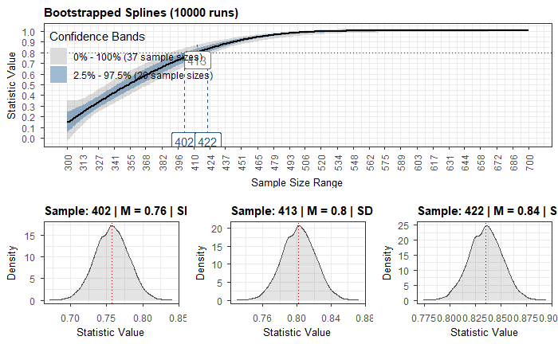

## Estimate network

##   
## === Estimated network ===  
## Number of nodes: 43   
## Number of non-zero edges: 251 / 903   
## Mean weight: 0.01896901   
## Network stored in x$graph   
##   
## Default set used: EBICglasso   
##   
## Use plot(x) to plot estimated network   
## Use bootnet(x) to bootstrap edge weights and centrality indices   
##   
## Relevant references:  
##   
## Friedman, J. H., Hastie, T., & Tibshirani, R. (2008). Sparse inverse covariance estimation with the graphical lasso. Biostatistics, 9 (3), 432-441.  
## Foygel, R., & Drton, M. (2010). Extended Bayesian information criteria for Gaussian graphical models.   
## Friedman, J. H., Hastie, T., & Tibshirani, R. (2014). glasso: Graphical lasso estimation of gaussian graphical models. Retrieved from https://CRAN.R-project.org/package=glasso  
## Epskamp, S., Cramer, A., Waldorp, L., Schmittmann, V. D., & Borsboom, D. (2012). qgraph: Network visualizations of relationships in psychometric data. Journal of Statistical Software, 48 (1), 1-18.  
## Epskamp, S., Borsboom, D., & Fried, E. I. (2016). Estimating psychological networks and their accuracy: a tutorial paper. arXiv preprint, arXiv:1604.08462

## Plot Network

## Correlation stability coefficient and plot

CS larger than 0.7 is excellent, 0.5 < CS < 0.7 is acceptable, CS < 0.5 not acceptable

## === Correlation Stability Analysis ===   
##   
## Sampling levels tested:  
## nPerson Drop% n  
## 1 113 75.1 96  
## 2 148 67.3 97  
## 3 184 59.4 113  
## 4 219 51.7 102  
## 5 254 43.9 108  
## 6 289 36.2 98  
## 7 325 28.3 103  
## 8 360 20.5 97  
## 9 395 12.8 93  
## 10 430 5.1 93  
##   
## Maximum drop proportions to retain correlation of 0.7 in at least 95% of the samples:  
##   
## betweenness: 0.051   
## - For more accuracy, run bootnet(..., caseMin = 0, caseMax = 0.051)   
##   
## closeness: 0.205   
## - For more accuracy, run bootnet(..., caseMin = 0.128, caseMax = 0.283)   
##   
## expectedInfluence: 0.517   
## - For more accuracy, run bootnet(..., caseMin = 0.362, caseMax = 0.517)   
##   
## strength: 0.517   
## - For more accuracy, run bootnet(..., caseMin = 0.439, caseMax = 0.594)   
##   
## Accuracy can also be increased by increasing both 'nBoots' and 'caseN'.



## Network accuracy

We plot Bootstrapped edge CI’s - here we focus on large discrepancies between the red (observed values) and black (bootstrapped mean) lines. We can also look at the size of CI’s with larger grey areas showing less confidence A graph of a graph

## Plot centrality indices and centrality table

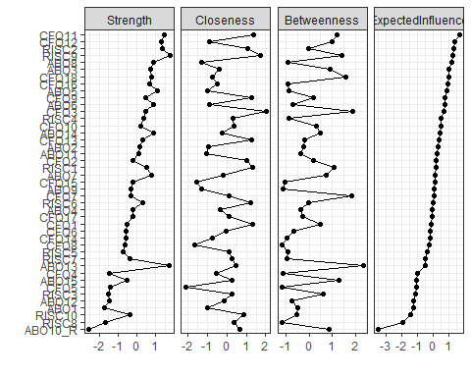



## Plot bridge symptoms



