**Danqi Chen**  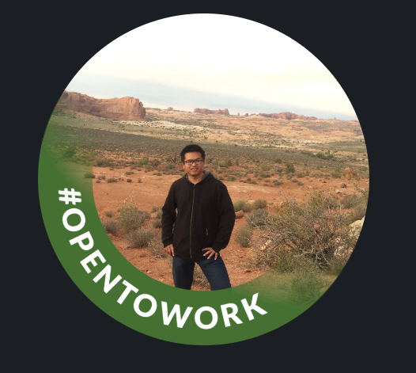

Contact: 657-217-0623 | daniel3832@gmail.com

**About me:**  
Focused and quick-learning Software Engineer (Full Stack Developer) with extensive experience in

all phases of the Software Development Life Cycle (SDLC). Adept at Requirement Analysis, Design,

Implementation, and Maintenance. Practiced in Scrum and Agile methodologies.

**Technologies:**

Golang, Java, JavaScript, Cassandra, Angular, Node.js, React, Python, C++, MySQL, Git, Chrome Developer Tools.

**Project:**

Deep Learning vs. Machine Learning Comparison Project  
This project compares deep learning and machine learning using two real examples: Lifeifei’s CNN-based image recognition system and a housing price prediction model. The image recognition system uses deep learning to analyze pictures and classify them accurately. The housing price model uses machine learning to predict home values based on factors like location and size. A challenge in this project was making sure both models were tested fairly, even though they used different types of data. To solve this, we used clear performance tests and looked at how each model made decisions. This project helps show when deep learning is needed and when regular machine learning is a better choice, based on the problem, data, and computing power available.