DBD 281 Project

07 April 2023

Daniël Jacobus Robbertse

577320

1. The business I contacted is Robbert Busdiens, they are a somewhat small family run business based in Gauteng. The business was established in 1978 and they have been providing bus transportation ever since. The business has a fleet of 23 busses ranging from 19-seater busses to 100-seater busses. Although the company provides bus transportation to anyone who can pay for their services, they mainly specialise in providing transportation for primary and high schools in Gauteng and North-West. The problem that this business had was that their database was rather basic and ineffective and that they wanted some information to be displayed in a specific manner and wanted easier ways to insert data into the database. The procedures will make it easier for the business to insert any information into the data base. The different views that I wrote will help the business see which of the clients the service the most and can help them to see who their most loyal customers are and which drivers they use the most.
2. ERD:

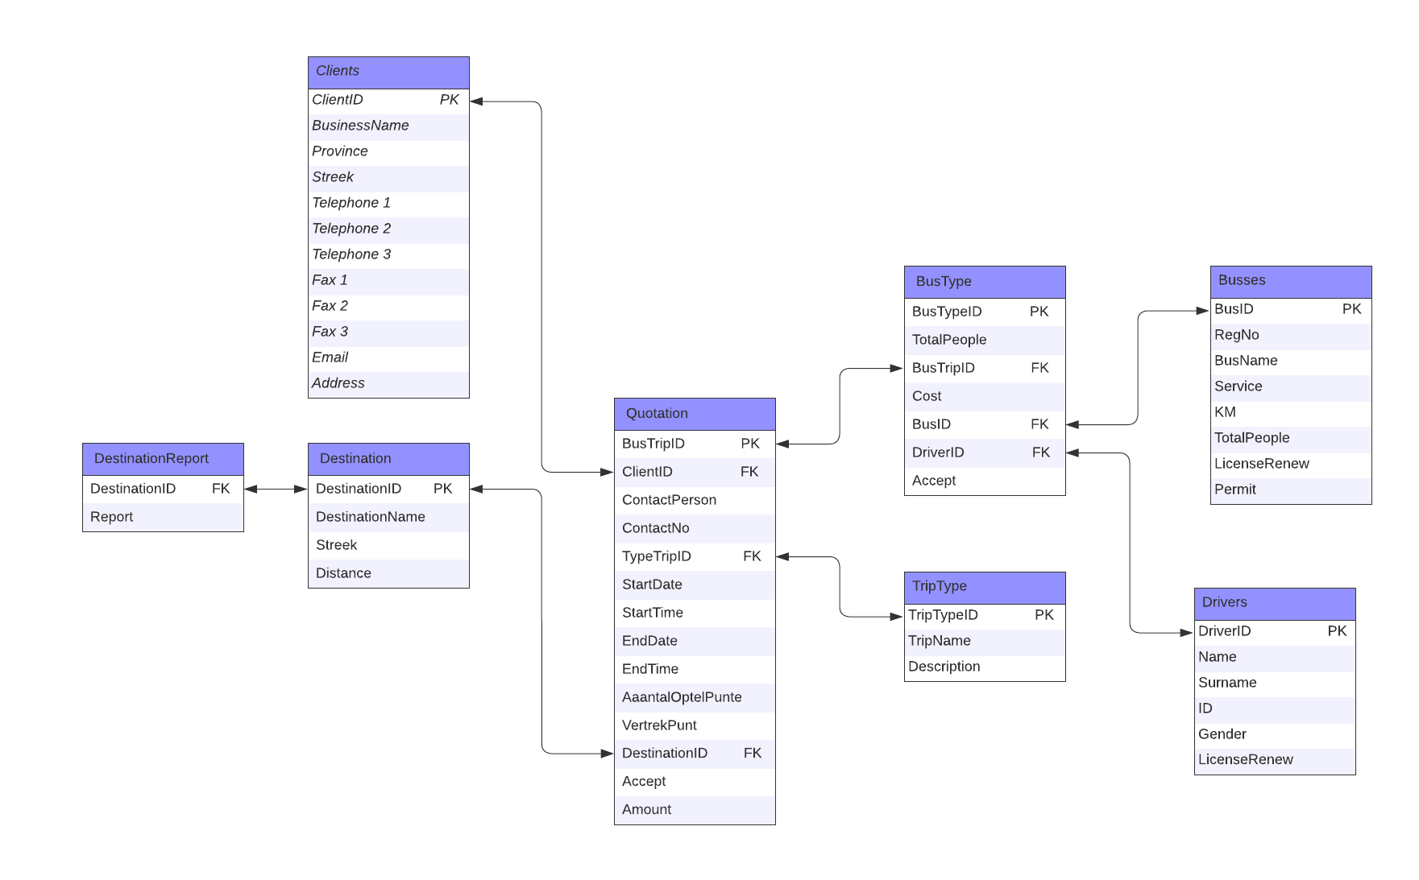

1. The above ERD is in third normal form and I will justify and prove it. For an ERD to be in 3rd normal form it must be in 2nd normal form and all the attributes are functionally independent on solely the primary key (it doesn’t contain any transitive partial dependencies). To make that statement more palatable, it means that any non-prime attribute (it isn’t part of the candidate’s key) is dependable on another non-prime attribute and this is what 3rd normal forms eliminates. In my database there isn’t any transitive partial dependencies because all the attributes aren’t dependant on other non-prime attributes but rather on the candidate or the primary key. If a database is in 3rd normal form, it means that it has significantly reduced any data duplication and, in my ERD, there is hardly any data duplication.
2. List
   1. Tables
      1. Clients: This table stores all the data related to the clients of the business such as where they are located and their contact information.
      2. Trip Type: This contains the name of the trip that would be given to the drivers and a description of the trip which will also tell the driver any useful information such as what they clients will be doing at the destination.
      3. Destination: This contains the name of the destination of the trip which general area it is in like Pretoria (the area would be more specific for provinces that the business transports people to more frequently) and how far away it is.
      4. Quotation: The quotation table contains a lot of the information about the trip and some information about the clients as well. This contains the name and contact information of the person the business interacts with on the client’s side e.g., a receptionist. It also has the dates/times of the trip, and they amount the clients will pay.
      5. Busses: This contains the information pertaining to the bus, it doesn’t just include the basic information like bus name and number of seats but also information such as when the bus was last serviced.
      6. Drivers: This just contains rather basic information of the drivers such as their name, ID and when last they had their license renewed.
      7. Destination Report: This just contains any useful information pertaining to the trip such as which road to use/avoid.
      8. Bus Type: This table mostly just exists to link the quotation to the drivers and busses table.
   2. Stored procedures
      1. procGetCustomer: This allows the user to see a list of all the customers and their information by using the client id.
      2. procTripDetails: This stored procedure(sp) allows the user to see all the trip information about a specific client.
      3. procAddClients: This sp allows the user to add new clients to the database.
      4. procAddQuotation: This sp allows the user to add a new quotation to the database.
      5. procAddBus: This sp allows the user to add a new bus/busses to the database.
   3. Views
      1. TotalDistancePerClient: This view will let the business see how far they have transported each client in total.
      2. DriverTotalBus: This view will show the business how far a driver has driven each bus.
      3. TotalCustomer: This view shows how many times each client has made use of the business.
      4. BusDriver: This view shows a driver and each bus that they have driven more than twice.
   4. Queries
      1. The first query shows information about each trip where the client has not yet accepted the quotation, this will help the business to decide if their quotation is too high or not.
      2. The second query shows information about each trip where the client has accepted the quotation.