Programme-Driven Demand Shocks in Food Supply Chains: A System Dynamics and Machine-Learning Scenario Discovery Analysis of Indonesia's Free Nutritious Meals Programme and the Egg and Broiler Supply Chain
[Your full name]
[Affiliation], Yogyakarta, Indonesia
Corresponding author: [email]
PRELIMINARY - 7 inputs pending verification against primary sources
GUIDE: Everything in this document is a DRAFT. Rewrite all prose in your own words, verify every citation against the original source, fill every yellow placeholder from your own final run, and delete all red guidance before submission. Disclose AI assistance in the Declarations.

Abstract
GUIDE: Write the Findings sentence last, from your Results. 200–250 words in total.
Purpose: Indonesia's Free Nutritious Meals programme (MBG) creates a large, fast and price-inelastic public demand for eggs and broiler meat. This study examines when such a programme-driven demand shock destabilises food prices and which procurement and roll-out policies keep prices stable.
Design/methodology/approach: A system dynamics model of the egg and broiler supply chains, including kitchen roll-out, biological production delays, farmer investment and price formation, was calibrated to public data. [N] scenarios were simulated with and without the programme, and machine-learning scenario discovery (classification trees, random forests, SHAP and PRIM) was used to identify the conditions under which programme-attributable price spikes occur.
Findings: [Your 2–3 main findings, with numbers from your final run]
Research limitations/implications: [e.g. national aggregation; parameter uncertainty in farmer behaviour]
Practical implications: [Concrete recommendations that follow from your results]
Originality/value: [Only after your literature check confirms it] To the author's knowledge, this is the first quantitative dynamic analysis of how a national school-meals programme transmits demand shocks to food prices, and the first application of scenario discovery to this problem.
Keywords: system dynamics; scenario discovery; machine learning; food supply chain; demand shock; school meals programme; Indonesia

1. Introduction
GUIDE: Draft wording built from sources found by web search on 7 Nov 2026. Replace news citations with primary sources (BPS releases, BGN statements) wherever possible, and check every figure.
Large public food programmes do more than feed their beneficiaries; they also change the markets they buy from. Indonesia's Free Nutritious Meals programme (Makan Bergizi Gratis, MBG), launched in January 2025, is one of the largest public food procurement programmes in the world. By the end of 2025 the National Nutrition Agency (Badan Gizi Nasional, BGN) reported 19,188 operational meal-preparation units (Satuan Pelayanan Pemenuhan Gizi, SPPG), and it targeted 82.9 million beneficiaries by mid-2026 [cite BGN / Investortrust, 2025–2026]. The programme budget was reported to rise from Rp 171 trillion in 2025 to Rp 335 trillion in 2026 [cite primary budget source].
Eggs and broiler meat are core protein items on MBG menus. Unlike household demand, programme demand is set by menus and roll-out targets rather than by price, and it grows as fast as new kitchens open. Supply, in contrast, adjusts slowly: laying hens take roughly [18–20] weeks to reach point of lay, and farmers expand flocks on the basis of expected prices and margins [cite poultry source]. A fast, price-inelastic increase in demand meeting a slow, biologically delayed supply response is a classic setting for price overshoot and commodity cycles (Meadows, 1970; Sterman, 2000).
Early evidence suggests that this tension is already visible but its cause is disputed. Statistics Indonesia (BPS) attributed part of the October 2025 inflation in eggs and broiler meat to demand from MBG kitchens [cite BPS release; Katadata/Kontan/Bisnis, Nov 2025], and national average egg prices were reported above the government reference price (HAP) from October 2025 [verify and cite]. The Ministry of Agriculture and the National Food Agency (Bapanas), however, described the movements as mainly seasonal and MBG demand as still too small to matter [cite Bisnis, Nov 2025; Republika, Dec 2025]. BGN has also stated that at least 1,500 additional layer farmers are needed in 2026 to keep egg supply stable [cite]. At the same time, the programme has faced operational strain, including reported food-safety incidents and the suspension of 1,256 SPPGs [cite primary source], and studies report that procurement often runs through intermediaries or single suppliers rather than local farmer groups [cite IPB study; Central Java study].
These observations raise questions that statistical analysis of short price series cannot settle on its own: how much of the price movement is caused by the programme rather than by seasonal or external shocks; under which conditions programme demand produces a severe price spike; and which policies — the speed of roll-out, the sourcing structure, advance contracting with farmers or flexible menus — reduce that risk. Answering them requires a model that captures feedback and delays across the supply chain, and an analysis that explores many plausible futures rather than a single forecast.
Existing research does not yet provide this. Studies of MBG to date are mainly qualitative or local [cite]; international work on school feeding shows that large programmes can move food prices (Handbury & Moshary, NBER w29384) and that local effects depend on procurement scale and market efficiency [cite Ghana HGSF evaluation], but does not model the supply-side dynamics. System dynamics studies of poultry supply chains explain endogenous price instability [cite Indonesian broiler SD study, 2024; Aboah & Enahoro, 2022] but do not consider programme-driven demand. Scenario discovery, which applies machine learning to large simulation ensembles to find decision-relevant conditions (Bryant & Lempert, 2010; Kwakkel, 2017), has rarely been applied to food supply chain policy in developing economies [confirm with your gap table].
This study addresses three research questions:
- RQ1: How does the MBG roll-out propagate through Indonesia's egg and broiler supply chains to market prices and household consumption over time?
- RQ2: Under which combinations of uncertain conditions does the programme cause severe programme-attributable price spikes?
- RQ3: Which roll-out and procurement policies reduce spike risk while maintaining programme coverage and cost?
To answer them, a system dynamics model was developed, calibrated to public data and validated, and then run as an exploratory ensemble in which every scenario is simulated both with and without the programme. Machine-learning classifiers, SHAP values and the Patient Rule Induction Method (PRIM) were applied to the results to identify spike conditions, derive early-warning indicators and compare policies.
The study makes three contributions. First, it provides [to the author's knowledge, the first] quantitative dynamic analysis of how a national school-meals programme transmits demand shocks to food prices, separating programme effects from exogenous shocks through a counterfactual design. Second, it demonstrates how system dynamics and machine-learning scenario discovery can be combined to produce interpretable spike conditions and early-warning rules. Third, it offers evidence-based recommendations for the design of large public food procurement programmes. Section 2 reviews related literature, Section 3 describes the model and analysis, Section 4 presents the results, Section 5 discusses them, and Section 6 concludes.

2. Literature Review
GUIDE: This section is an OUTLINE, not prose: a literature review must come from papers you have actually read. Read the sources in literature_reading_list.md, then write 2–4 paragraphs per subsection in your own words. End each subsection with what is missing, and close with the gap table.

2.1 Public food procurement and school meals programmes
- Purpose and scale of school feeding programmes (WFP, Brazil PNAE, India PM-POSHAN, home-grown school feeding).
- Market effects: Handbury & Moshary (US retail prices); Ghana HGSF evaluation (effects depend on procurement scale and market efficiency); HGSF supply-chain models paper.
- MBG studies so far: procurement via intermediaries (IPB study), closed vs open supplier systems (Central Java study), CELIOS policy note (May 2026).
- Gap: mostly descriptive or econometric; no dynamic supply-side model.
[Write this subsection after reading the sources]

2.2 Demand shocks, biological lags and commodity cycles
- Commodity production cycles and supply-line misperception (Meadows, 1970; Sterman, 2000).
- Biological lags and egg prices: Mitchell, Thompson & Malone (2024) on HPAI.
- Endogenous price fluctuation and price transmission in poultry (Pakistan studies).
- Gap: shocks studied are disease or seasonal, not programme-driven demand.
[Write this subsection after reading the sources]

2.3 System dynamics in poultry and food security
- Indonesian broiler SD study (2024): live-bird price instability arises from system structure — closest prior work; state clearly how yours differs (eggs + broilers, programme demand, policy levers, ML).
- Aboah & Enahoro (2022): Ghana backyard poultry SD model.
- Indonesian Vensim food-security models (mostly rice): Aprillya & Suryani; Suryani et al.; Widyawati et al.
- Gap: no SD model of programme demand; validation often limited; single-scenario analysis.
[Write this subsection after reading the sources]

2.4 Scenario discovery and machine learning on simulation models
- PRIM (Friedman & Fisher, 1999); scenario discovery (Bryant & Lempert, 2010); improvements (Kwakkel & Jaxa-Rozen, 2016); EMA Workbench (Kwakkel, 2017).
- Dynamic/behaviour-based scenario discovery (Steinmann et al., 2020); copper SD + PRIM (Kwakkel, Auping & Pruyt).
- Interpretable ML: SHAP (Lundberg & Lee, 2017); rule extraction (REDS).
- Gap: rarely applied to food supply chains or developing-economy public programmes.
[Write this subsection after reading the sources]

2.5 Research gap
Table 1. Positioning of this study relative to prior work
PRELIMINARY - 7 inputs pending verification against primary sources
Study | Context | Method | Programme demand | Dynamic feedback | Scenario discovery
[[Author, year]] | [[ ]] | [[ ]] | [[Y/N]] | [[Y/N]] | [[Y/N]]
[[Author, year]] | [[ ]] | [[ ]] | [[Y/N]] | [[Y/N]] | [[Y/N]]
This study | Indonesia, MBG, eggs & broilers | SD + ML scenario discovery | Y | Y | Y

3. Methodology
GUIDE: Draft wording that describes the model in paper/model/ as built. Update it to match every change you make.

3.1 Research design
The study combines system dynamics (SD) simulation with machine-learning scenario discovery (Figure 1). An SD model of the egg and broiler supply chains under MBG was developed in Vensim, calibrated to public data and validated with structural and behavioural tests. The model was then run as an exploratory ensemble over uncertain parameters and alternative policies using PySD (Houghton & Siegel, 2015). Classifiers, SHAP values (Lundberg & Lee, 2017) and PRIM (Friedman & Fisher, 1999; Bryant & Lempert, 2010), implemented with the EMA Workbench (Kwakkel, 2017), were used to identify the conditions under which the programme produces severe price increases, and policies were compared on a common set of scenarios with paired non-parametric tests.
[Figure 1. Research framework — draw it]

3.2 Model structure
The model has four interacting sectors simulated weekly from January 2024 to December 2029 (312 weeks; time step 0.125 weeks). Its causal structure is shown in Figure 2 and its stock-and-flow structure in Figure 3; all equations are listed in Appendix A.
Programme sector. Planned kitchens (SPPG) follow a logistic (S-shaped) roll-out whose final size, midpoint and steepness were fitted so that modelled operational kitchens reproduce BGN's reported counts (Section 3.4). Kitchens open after an opening delay and can be suspended. The weekly suspension fraction rises when the opening rate exceeds a sustainable opening capacity, representing strain on supervision, staff and suppliers during rapid scaling (reinforcing loop R1). Suspended kitchens reopen after a reinstatement time. Programme demand for eggs and chicken equals beneficiaries served multiplied by the menu quantity per beneficiary.
Egg (layer) sector. Pullets are placed and mature into laying hens through a third-order rearing delay. Hens leave the flock through culling and disease outbreaks. Farmers place pullets to replace expected losses and to close the gap between desired and actual flock size, with a partial correction for pullets already in rearing (supply-line weight; Sterman, 2000). Desired flock size responds to expected margin, formed by smoothing market price over an expectation delay (balancing loop B1 with delay). Placements are limited by hatchery capacity.
Broiler sector. Day-old chicks are placed and harvested after grow-out. Placements follow smoothed demand, inventory correction and expected margin, limited by day-old-chick supply.
Market and price formation. For each commodity, market inventory accumulates production and is depleted by sales and spoilage; programme kitchens are served before households when stock is short. Household demand responds to price through a constant own-price elasticity (balancing loop B2). Price adjusts toward an indicated price that rises when inventory coverage is below normal and is pulled toward unit cost plus a normal margin, bounded by a maximum relative price that represents imports, substitutes and market operations. Unit cost depends on feed price, which rises with total flock size (balancing loop B3) and with exogenous feed-price shocks.
[Figure 2. Causal loop diagram (draw in Vensim)]
[Figure 3. Stock-and-flow diagram (draw in Vensim)]

3.3 Policies
Table 2. Policy levers
PRELIMINARY - 7 inputs pending verification against primary sources
Policy | Implementation
P0 Baseline | Current roll-out; cooperative sourcing share 0.1; no forward contracts; fixed menu
P1 Phased roll-out | Roll-out steepness × 1.75, i.e. a more gradual S-curve [[justify from BGN plans]]
P2 Cooperative sourcing | Direct purchase share from farmer groups 0.6 (reduces intermediary mark-up)
P3 Forward contracts | 80% of future programme demand contracted 20 weeks ahead
P4 Menu flexibility | Up to 50% substitution when relative price > 1.15
P5 Combined | P2 + P3 + P4

3.4 Data and parameters
Prices. Monthly retail prices of chicken eggs and chicken meat were taken from the World Food Programme's Indonesia food price dataset on the Humanitarian Data Exchange (WFP, [access date]; CC BY-IGO), which covers about 200 markets. Because WFP publishes no recent national average and the set of reporting markets varies, each market's price was expressed relative to its own 2024 mean, and the national index for each month is the median of these relatives. Months with fewer than 100 reporting markets, and the incomplete latest month, were excluded, leaving 29 monthly observations (January 2024 to October 2026). Baseline prices were set to the 2024 mean of monthly national medians (Rp 28,140/kg for eggs; Rp 35,704/kg for chicken).
Programme roll-out. Reported numbers of operational SPPG and beneficiaries were compiled from BGN releases and press reports for August 2025 to September 2026 [cite each; replace secondary sources]. The roll-out parameters were estimated by least squares so that modelled operational kitchens match these counts. Beneficiaries per kitchen (about 2,850) were derived from the same reports. Menu quantities were set from planning figures reported by Bapanas, BGN and the Ministry of Agriculture (about 0.11–0.17 kg of egg and 0.08–0.26 kg of chicken per beneficiary per week) [cite], and are treated as uncertain. Kitchen-suspension parameters were fitted to BGN's report that 8,182 SPPG had been suspended at some point and 2,213 remained inactive by the end of May 2026 [cite]; the fitted weekly suspension hazard is about 0.4% and the mean reinstatement time about 15 weeks. Because suspensions in practice came largely in enforcement waves (for example, 1,256 SPPG in eastern Indonesia from 1 April 2026 for missing hygiene certificates), a constant hazard is an approximation.
Supply and demand parameters. Baseline production was derived from Bapanas' 2025 food balance projections (egg production 6.52 Mt, chicken meat 4.25 Mt, with stated growth rates over 2024) [cite; verify with BPS]. Household own-price elasticities were set from QUAIDS estimates on SUSENAS data (eggs about −0.7, poultry about −1.55; Khoiriyah et al., 2024, and the Bengkulu study) [verify]. Layer and broiler parameters (point of lay at about 18 weeks, laying period of about 65 weeks, hen-day production of about 84.5%, harvest at about five weeks, carcass yield about 1.37 kg per bird, grow-out mortality 5%) follow Indonesian farm studies and breed standards [cite]. Feed is 65–70% of production cost (Kementan) [cite]. Trader mark-ups follow BPS trade and transport margins for eggs (13–27%, 2017–2021), and day-old-chick capacity reflects documented oversupply (production about 1.2 times demand in 2020) [cite]. Two kitchen-operation parameters without public data (opening delay and sustainable opening capacity) are treated as uncertain. Appendix B lists every parameter with its value and source.

3.5 Validation
Following Barlas (1996) and Sterman (2000), the model was subjected to dimensional consistency checks; extreme-condition tests (no programme, ten-fold programme demand, loss of all laying hens, no hatchery expansion, doubled feed price, instantaneous roll-out); an integration-error test comparing time steps of 0.125 and 0.0625 weeks on the baseline run, and an ensemble robustness test repeating a random subset of ensemble scenarios at both time steps and comparing spike classification and peak prices; a parameter-recovery test applying the calibration procedure to synthetic data with known parameters; and behaviour reproduction against historical prices, assessed with MAPE, R² and Theil inequality statistics.
Because the model contains no seasonal demand, seasonality was removed from the price data before calibration. Using the WFP national series for 2007–2023 (pre-programme; March 2020 to December 2021 excluded), the log ratio of price to its centred 12-month moving average was regressed on calendar-month dummies and on the shares of the 30 days before and after Idul Fitri falling in each month, with HAC standard errors. The fitted seasonal factors were divided out of the 2024–2026 series. The remaining investment sensitivities of layer and broiler farmers were then estimated jointly on the seasonally adjusted egg and chicken series by minimising the sum of squared errors (Nelder–Mead, four starting points). Two further parameters, the price-expectation delay and the sensitivity of price to inventory coverage, were found not to be identifiable: the fit error changed little across wide ranges of either (Table 4e). They were therefore fixed (8 weeks and 1.0) [justify] and explored over wide ranges in the ensemble.

3.6 Exploratory ensemble and outcome indicators
[N] scenarios were drawn by Latin Hypercube sampling over 22 uncertain parameters (Table 3). Each policy was run on the same scenarios (common random numbers), giving a paired design, and each scenario was also run without the programme. Price effects were measured as the difference between the two runs, so that movements caused by exogenous shocks or seasonality are not attributed to the programme. Outcome indicators were the peak programme-attributable egg and chicken price rise, weeks above the threshold, mean household consumption loss, farmers' margin volatility, protein cost per portion and programme coverage in the final year. A run was labelled a spike if the programme-attributable price rise in either commodity exceeded 10 percentage points, because [justification].
Table 3. Uncertain parameters and ranges [[replace placeholder ranges with sourced ones]]
PRELIMINARY - 7 inputs pending verification against primary sources
Parameter | Low | High | Justification
Rollout midpoint | 86.000 | 100.000 | [[source/justification]]
Rollout steepness | 5.000 | 12.000 | [[source/justification]]
Target kitchens | 24,000.000 | 32,000.000 | [[source/justification]]
Beneficiaries per kitchen | 2,000.000 | 3,000.000 | [[source/justification]]
Egg per beneficiary | 0.100 | 0.180 | [[source/justification]]
Chicken per beneficiary | 0.080 | 0.260 | [[source/justification]]
Price expectation delay | 4.000 | 16.000 | [[source/justification]]
Investment sensitivity | 0.500 | 3.000 | [[source/justification]]
Supply line weight | 0.100 | 1.000 | [[source/justification]]
Hatchery capacity factor | 1.100 | 2.000 | [[source/justification]]
DOC capacity factor | 1.050 | 1.400 | [[source/justification]]
Household egg elasticity | -1.000 | -0.500 | [[source/justification]]
Household chicken elasticity | -1.800 | -1.200 | [[source/justification]]
Price sensitivity to coverage | 0.500 | 3.000 | [[source/justification]]
Feed shock magnitude | 0.000 | 0.500 | [[source/justification]]
Outbreak loss fraction | 0.000 | 0.300 | [[source/justification]]
Base suspension fraction | 0.002 | 0.008 | [[source/justification]]
Strain sensitivity | 0.000 | 5.000 | [[source/justification]]
Kitchen opening delay | 2.000 | 8.000 | [[source/justification]]
Sustainable opening capacity | 150.000 | 700.000 | [[source/justification]]
Intermediary margin | 0.100 | 0.300 | [[source/justification]]
Maximum relative price | 2.000 | 4.000 | [[source/justification]]

3.7 Scenario discovery and early warning
Using baseline-policy runs, four classifiers (logistic regression, a depth-3 decision tree, random forest and gradient boosting) were trained to predict spikes from the uncertain parameters and evaluated by stratified five-fold cross-validation. The decision tree provides readable rules; SHAP values on the random forest quantify each parameter's contribution and direction; PRIM identifies a region of the uncertainty space with high spike density (the box with the highest coverage at density ≥ 0.8, reporting dimensions restricted by at least 10% of their range). Results were compared with a one-at-a-time sensitivity analysis. An early-warning classifier was trained on indicators observable 13 weeks after programme start (relative prices, inventory coverage, growth in pullet placements, kitchen opening rate, share of suspended kitchens and feed price).

3.8 Policy comparison
For each policy, spike probability is reported with Wilson 95% confidence intervals, and the median and 10th/90th percentiles of each outcome are reported. Each policy is compared with P0 on the same scenarios with the Wilcoxon signed-rank test (Holm-corrected; matched-pairs rank-biserial correlation as effect size), spike occurrence with an exact McNemar test, and all policies jointly with the Friedman test.

4. Results
GUIDE: Tables and figures below are filled automatically from model/outputs. Under each one, describe what it shows (facts only); interpret in Section 5.

4.1 Validation
Table 4. Validation tests
PRELIMINARY - 7 inputs pending verification against primary sources
Test | Pass criterion | Observed | Pass
A1 No programme -> system stays in equilibrium | max |relative egg price - 1| < 1e-6 | 0.00e+00 | True
A2 10x programme demand -> price up, household consumption down | peak price > 1.2 and household ratio < 0.9; finite, no negative stocks | peak=2.43, hh_min=0.54 | True
A3 Outbreak kills 100% of hens -> production collapses, price spikes, no negatives | min hens < 10% of initial; 1.5 < peak price <= ceiling; no negative stocks | min hens=3,157,768, peak=3.00 | True
A4 No hatchery expansion possible -> higher prices than baseline | mean price (weeks 100-312) above baseline run | 1.154 vs 1.027 | True
A5 Feed price doubles -> egg price rises during shock | price at week 140 above baseline run | 1.044 vs 0.957 | True
A6 Near-instant roll-out (steepness 0.5 wk) -> more suspensions than baseline (loop R1) | peak suspended kitchens above baseline run | 5,375 vs 3,241 | True
B1 Integration error: TIME STEP 0.125 vs 0.0625 | max |difference| < 1% of each variable's range | 1.7409% | False
B2 Ensemble robustness: TIME STEP 0.125 vs 0.0625 (150 scenarios x 4 policies) | same spike classification in >= 98% of runs | 99.8% agree; median |peak diff| 0.0001 | True

Table 4b. Pre-programme seasonal regression (selected terms)
PRELIMINARY - 7 inputs pending verification against primary sources
series | term | coef | se | p
egg | eid_pre | 0.0362 | 0.0116 | 0.0018
egg | eid_post | 0.0221 | 0.0148 | 0.1355
egg | m12 | 0.0134 | 0.0087 | 0.1236
egg | R2 | 0.4253 | nan | nan
egg | n_obs | 168.0000 | nan | nan
chicken | eid_pre | 0.0578 | 0.0107 | 0.0000
chicken | eid_post | 0.0522 | 0.0125 | 0.0000
chicken | m12 | -0.0141 | 0.0105 | 0.1808
chicken | R2 | 0.4756 | nan | nan
chicken | n_obs | 168.0000 | nan | nan

Table 4c. Roll-out fit: reported vs modelled operational SPPG
PRELIMINARY - 7 inputs pending verification against primary sources
date | week | sppg_operational | model | rel_error
2025-08-05 | 83.143 | 3338 | 4,464.209 | 0.337
2025-08-13 | 84.286 | 5235 | 5,060.938 | -0.033
2025-08-18 | 85.000 | 5905 | 5,455.328 | -0.076
2025-09-29 | 91.000 | 10012 | 9,502.612 | -0.051
2025-12-15 | 102.000 | 17555 | 17,736.336 | 0.010
2025-12-31 | 104.286 | 19188 | 19,183.964 | -0.000
2026-01-19 | 107.000 | 21102 | 20,740.175 | -0.017
2026-02-12 | 110.429 | 21897 | 22,450.768 | 0.025
2026-09-30 | 143.286 | 27486 | 27,332.113 | -0.006

Table 4e. Identifiability profile: fit error (SSE) when one fixed parameter is varied
PRELIMINARY - 7 inputs pending verification against primary sources
parameter | value | SSE
Price sensitivity to coverage | 0.500000 | 0.004973
Price sensitivity to coverage | 1.000000 | 0.004761
Price sensitivity to coverage | 2.000000 | 0.004818
Price sensitivity to coverage | 3.000000 | 0.004892
Price sensitivity to coverage | 5.000000 | 0.004982
Price sensitivity to coverage | 10.000000 | 0.005071
Price expectation delay | 2.000000 | 0.004729
Price expectation delay | 4.000000 | 0.004721
Price expectation delay | 8.000000 | 0.004761
Price expectation delay | 16.000000 | 0.004959
Price expectation delay | 30.000000 | 0.005586

Table 4d. Calibrated parameters (best of four starts)
PRELIMINARY - 7 inputs pending verification against primary sources
index | estimate | lower_bound | upper_bound | at_bound | spread_across_starts
Investment sensitivity | 2.9582 | 0.2000 | 6 | False | 0.0000
Broiler investment sensitivity | 0.0252 | 0.0000 | 4 | True | 0.0000

Table 5. Behaviour reproduction (fit to historical prices)
PRELIMINARY - 7 inputs pending verification against primary sources
index | MAPE | R2 | MSE | Um | Us | Uc
egg (seasonally adjusted) | 0.0327 | 0.4216 | 0.0015 | 0.0120 | 0.1586 | 0.8294
chicken (seasonally adjusted) | 0.0458 | 0.4257 | 0.0033 | 0.0122 | 0.3102 | 0.6776
egg (raw, sim x seasonal factor) | 0.0327 | 0.3110 | 0.0015 | 0.0088 | 0.0008 | 0.9904
chicken (raw, sim x seasonal factor) | 0.0458 | 0.3014 | 0.0034 | 0.0144 | 0.1290 | 0.8565

Figure 4. Simulated vs observed (seasonally adjusted) prices
PRELIMINARY - 7 inputs pending verification against primary sources
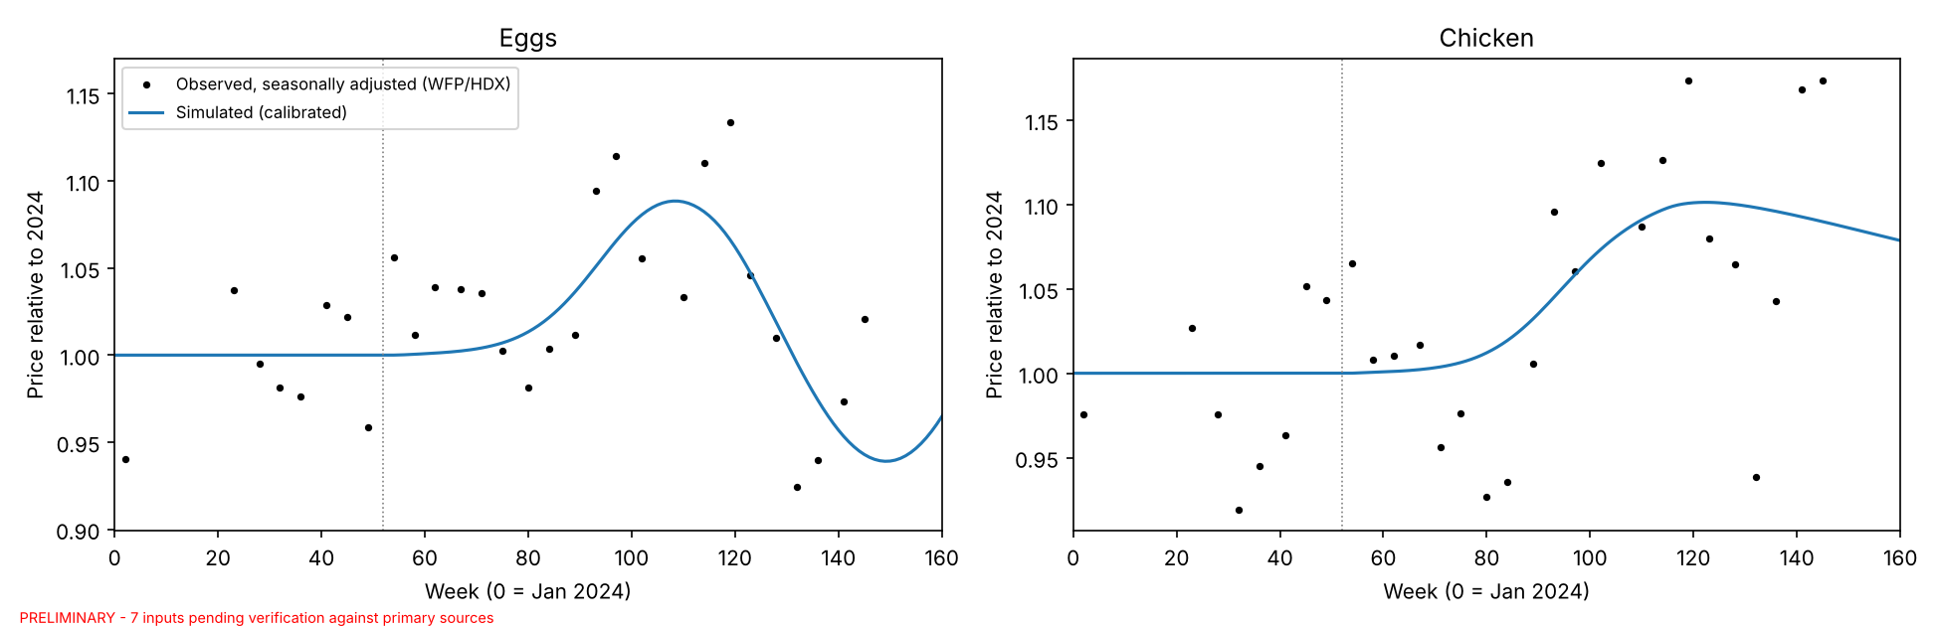
[Describe validation results]

4.2 Baseline dynamics
Figure 5. Baseline dynamics with and without the programme
PRELIMINARY - 7 inputs pending verification against primary sources
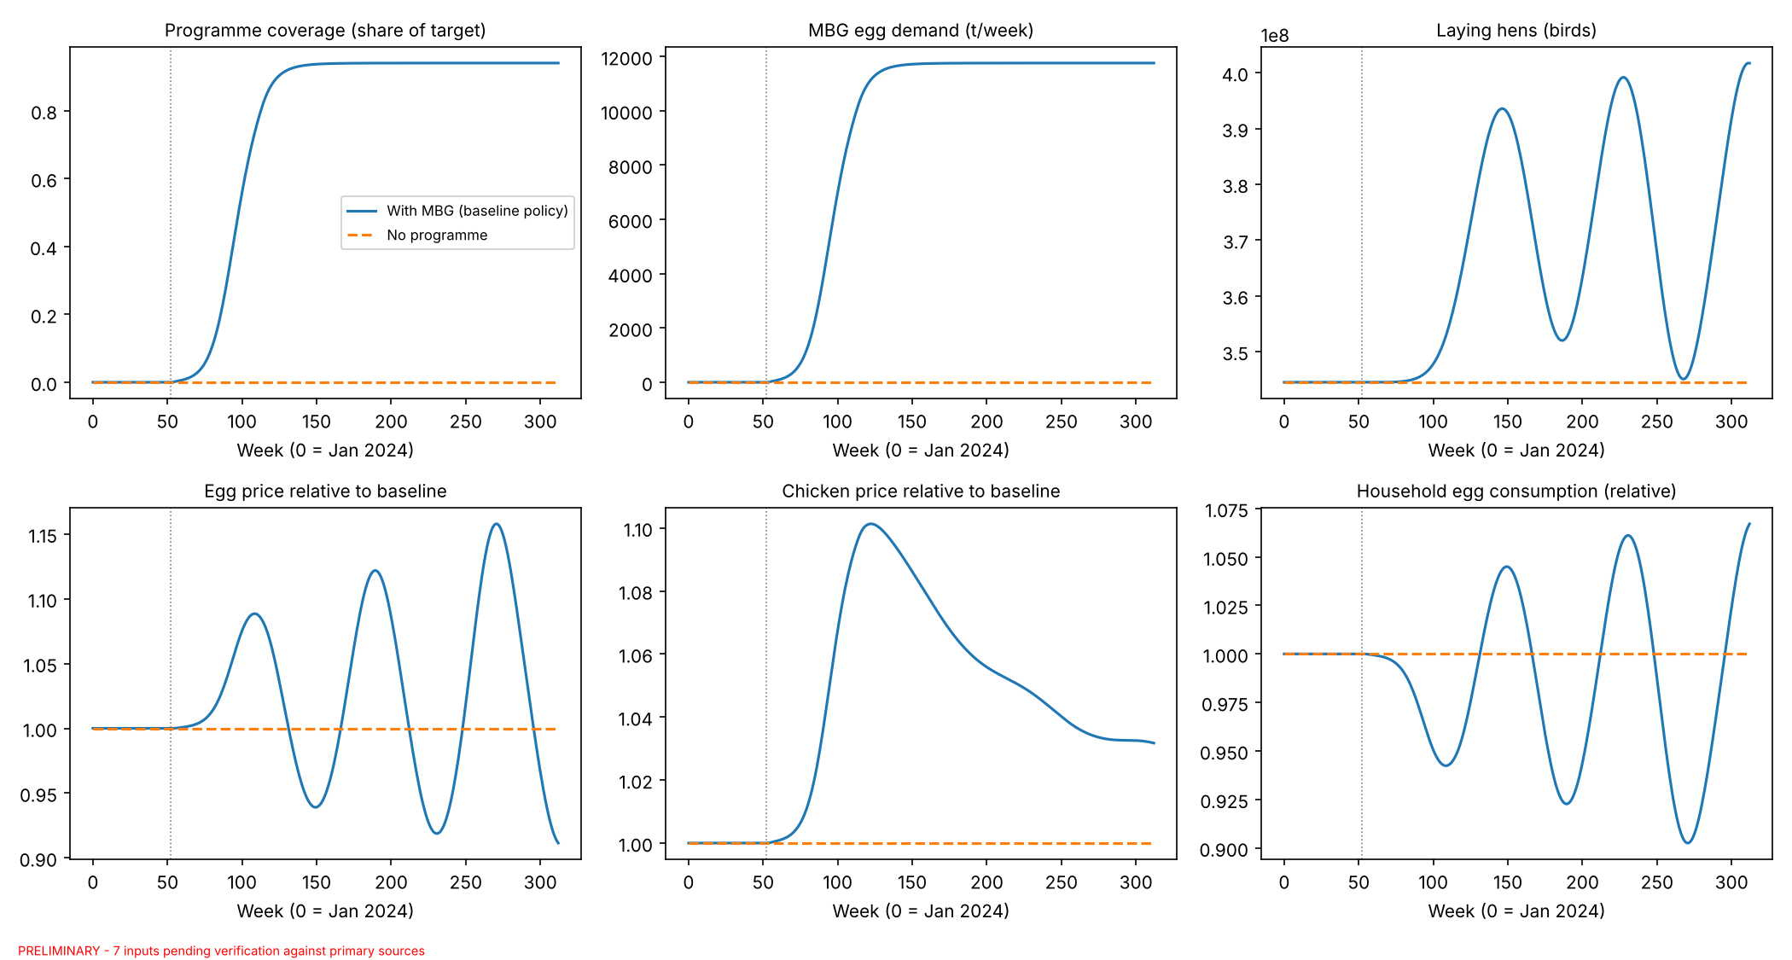
[Describe timing and size of the price response, overshoot/oscillation, household consumption]

4.3 When do programme-attributable spikes occur?
Table 6. Classifier performance (5-fold cross-validation)
PRELIMINARY - 7 inputs pending verification against primary sources
model | accuracy_mean | f1_mean | roc_auc_mean
Logistic regression | 0.828 | 0.838 | 0.913
CART (depth 3) | 0.731 | 0.731 | 0.806
Random forest | 0.868 | 0.877 | 0.950
Gradient boosting | 0.872 | 0.879 | 0.953

Figure 6. SHAP summary (random forest)
PRELIMINARY - 7 inputs pending verification against primary sources
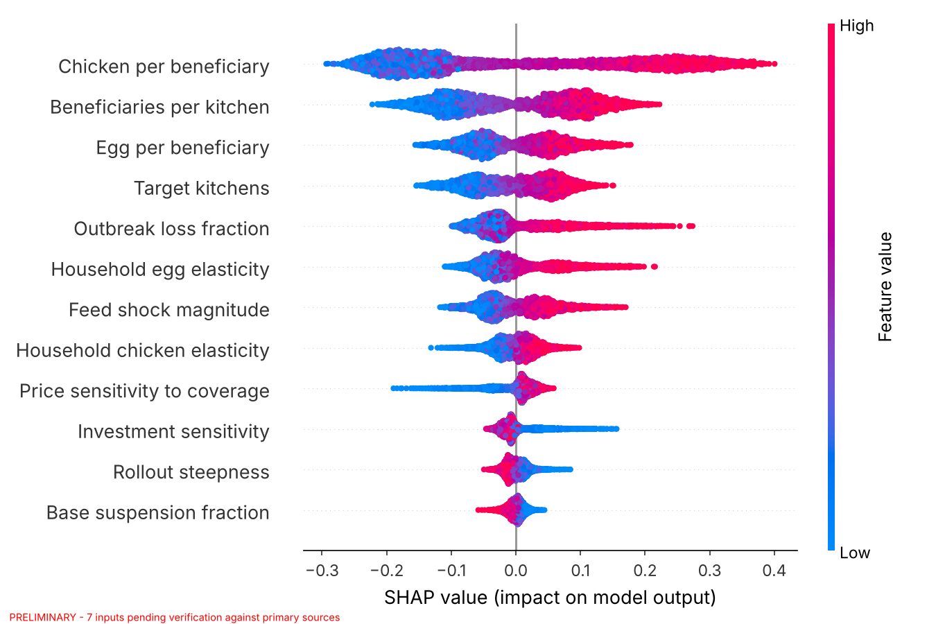
Table 7. PRIM box: conditions with high spike density
PRELIMINARY - 7 inputs pending verification against primary sources
index | lower | upper | full_range_low | full_range_high | share_of_range_removed | meaningful
Chicken per beneficiary | 0.167 | 0.260 | 0.080 | 0.260 | 0.486 | True
Beneficiaries per kitchen | 2,149.641 | 2,999.936 | 2,000.000 | 3,000.000 | 0.150 | True
Price sensitivity to coverage | 0.636 | 3.000 | 0.500 | 3.000 | 0.054 | False
Target kitchens | 24,415.084 | 31,999.052 | 24,000.000 | 32,000.000 | 0.052 | False

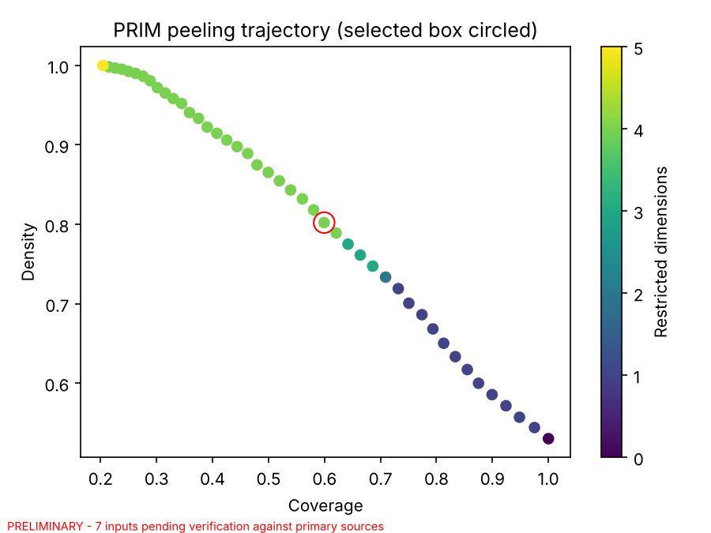
Box 1. Decision-tree rules
PRELIMINARY - 7 inputs pending verification against primary sources
|--- Chicken per beneficiary <= 0.19
| |--- Egg per beneficiary <= 0.14
| | |--- Outbreak loss fraction <= 0.25
| | | |--- weights: [1064.00, 220.00] class: 0
| | |--- Outbreak loss fraction > 0.25
| | | |--- weights: [112.00, 116.00] class: 1
| |--- Egg per beneficiary > 0.14
| | |--- Beneficiaries per kitchen <= 2466.77
| | | |--- weights: [449.00, 214.00] class: 0
| | |--- Beneficiaries per kitchen > 2466.77
| | | |--- weights: [296.00, 487.00] class: 1
|--- Chicken per beneficiary > 0.19
| |--- Beneficiaries per kitchen <= 2495.97
| | |--- Target kitchens <= 27351.13
| | | |--- weights: [231.00, 220.00] class: 0
| | |--- Target kitchens > 27351.13
| | | |--- weights: [118.00, 446.00] class: 1
| |--- Beneficiaries per kitchen > 2495.97
| | |--- Price sensitivity to coverage <= 0.77
| | | |--- weights: [35.00, 68.00] class: 1
| | |--- Price sensitivity to coverage > 0.77
| | | |--- weights: [44.00, 880.00] class: 1
Figure 7. One-at-a-time sensitivity (for comparison)
PRELIMINARY - 7 inputs pending verification against primary sources
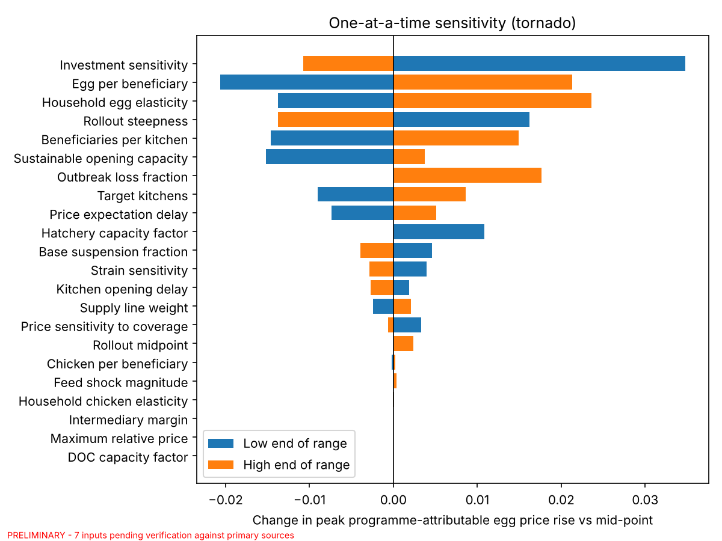
[Describe which conditions drive spikes, the PRIM box (coverage/density), and what OAT misses]

4.4 Early-warning indicators
Table 8. Early-warning classifier (indicators at week 13 of the programme)
PRELIMINARY - 7 inputs pending verification against primary sources
model | accuracy_mean | f1_mean | roc_auc_mean
CART (depth 2) | 0.571 | 0.698 | 0.585
Random forest | 0.736 | 0.751 | 0.812

|--- obs_rel_chicken_price <= 1.01
| |--- obs_opening_rate <= 145.47
| | |--- weights: [1866.00, 2147.00] class: 1
| |--- obs_opening_rate > 145.47
| | |--- weights: [433.00, 217.00] class: 0
|--- obs_rel_chicken_price > 1.01
| |--- obs_chicken_coverage <= 0.99
| | |--- weights: [21.00, 23.00] class: 1
| |--- obs_chicken_coverage > 0.99
| | |--- weights: [29.00, 264.00] class: 1
[Translate the rules into monitoring thresholds]

4.5 Policy comparison
Table 9. Policy outcomes across scenarios
PRELIMINARY - 7 inputs pending verification against primary sources
policy | spike_prob | spike_ci_low | spike_ci_high | peak_egg_price_median | peak_egg_price_p90 | peak_chicken_price_median | hh_egg_loss_median | mean_cost_per_portion_median | mean_coverage_last52_median
P0 Baseline | 0.530 | 0.516 | 0.544 | 0.082 | 0.144 | 0.085 | 0.017 | 2,541.277 | 0.930
P1 Phased roll-out | 0.486 | 0.473 | 0.500 | 0.077 | 0.158 | 0.079 | 0.018 | 2,539.076 | 0.930
P2 Cooperative sourcing | 0.530 | 0.516 | 0.544 | 0.082 | 0.144 | 0.085 | 0.017 | 2,328.204 | 0.930
P3 Forward contracts | 0.293 | 0.280 | 0.305 | 0.072 | 0.148 | -0.002 | 0.017 | 2,423.580 | 0.930
P4 Menu flexibility | 0.451 | 0.437 | 0.465 | 0.074 | 0.113 | 0.085 | 0.015 | 2,459.702 | 0.930
P5 Combined (P2+P3+P4) | 0.099 | 0.091 | 0.107 | 0.060 | 0.094 | -0.002 | 0.014 | 2,142.714 | 0.930

Table 10. Paired comparison with P0 (Wilcoxon signed-rank, Holm-corrected)
PRELIMINARY - 7 inputs pending verification against primary sources
outcome | policy | median_diff | rank_biserial | p_holm
peak_egg_price | P1 Phased roll-out | -0.0027 | -0.1202 | 0.0000
peak_egg_price | P2 Cooperative sourcing | 0.0000 | 0.0000 | 1.0000
peak_egg_price | P3 Forward contracts | -0.0065 | -0.2438 | 0.0000
peak_egg_price | P4 Menu flexibility | 0.0000 | -0.9555 | 0.0000
peak_egg_price | P5 Combined (P2+P3+P4) | -0.0204 | -0.9432 | 0.0000
peak_chicken_price | P1 Phased roll-out | -0.0058 | -1.0000 | 0.0000
peak_chicken_price | P2 Cooperative sourcing | 0.0000 | 0.0000 | 1.0000
peak_chicken_price | P3 Forward contracts | -0.0746 | -1.0000 | 0.0000
peak_chicken_price | P4 Menu flexibility | 0.0000 | -0.9940 | 0.0000
peak_chicken_price | P5 Combined (P2+P3+P4) | -0.0747 | -1.0000 | 0.0000
hh_egg_loss | P1 Phased roll-out | 0.0002 | 0.6005 | 0.0000
hh_egg_loss | P2 Cooperative sourcing | 0.0000 | 0.0000 | 1.0000
hh_egg_loss | P3 Forward contracts | -0.0001 | -0.1447 | 0.0000
hh_egg_loss | P4 Menu flexibility | -0.0019 | -0.7971 | 0.0000
hh_egg_loss | P5 Combined (P2+P3+P4) | -0.0031 | -0.8603 | 0.0000
mean_cost_per_portion | P1 Phased roll-out | -2.1098 | -0.5473 | 0.0000
mean_cost_per_portion | P2 Cooperative sourcing | -207.5220 | -1.0000 | 0.0000
mean_cost_per_portion | P3 Forward contracts | -91.2386 | -1.0000 | 0.0000
mean_cost_per_portion | P4 Menu flexibility | -70.3771 | -1.0000 | 0.0000
mean_cost_per_portion | P5 Combined (P2+P3+P4) | -379.0310 | -1.0000 | 0.0000

Table 11. Change in spike occurrence vs P0 (exact McNemar)
PRELIMINARY - 7 inputs pending verification against primary sources
policy | spike_removed (P0=1,P=0) | spike_added (P0=0,P=1) | p_exact
P1 Phased roll-out | 433 | 214 | 0.0000
P2 Cooperative sourcing | 0 | 0 | 1.0000
P3 Forward contracts | 1365 | 177 | 0.0000
P4 Menu flexibility | 397 | 1 | 0.0000
P5 Combined (P2+P3+P4) | 2166 | 8 | 0.0000

Figure 8. Policy comparison
PRELIMINARY - 7 inputs pending verification against primary sources
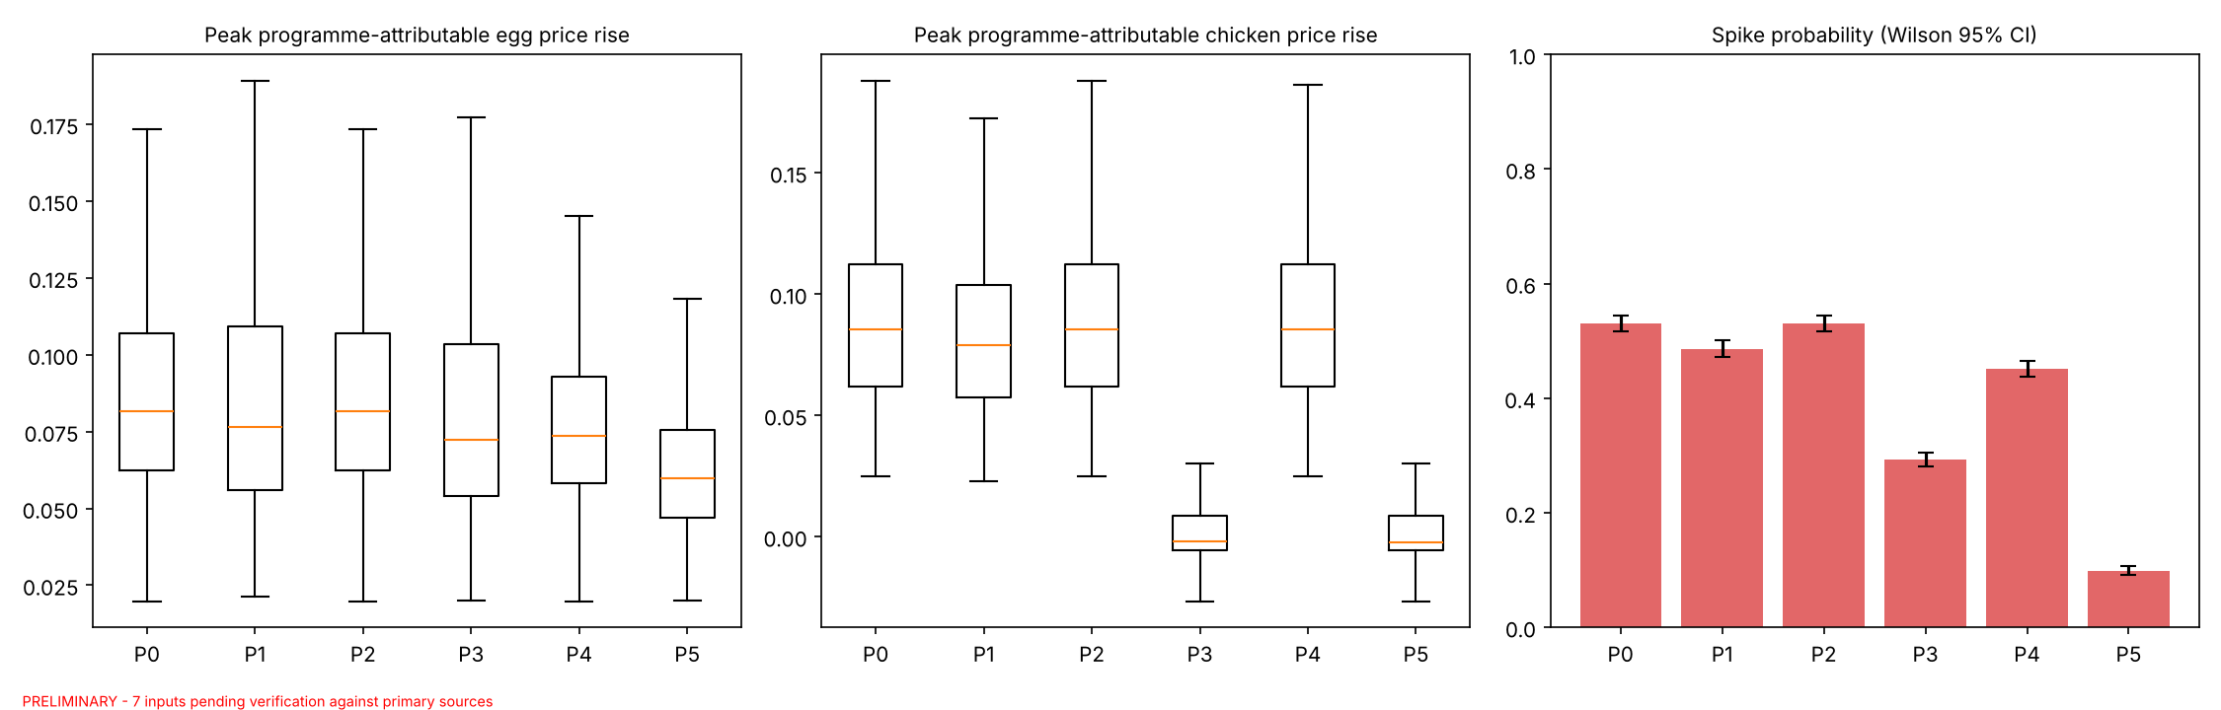
Figure 9. Cost vs spike-risk trade-off
PRELIMINARY - 7 inputs pending verification against primary sources
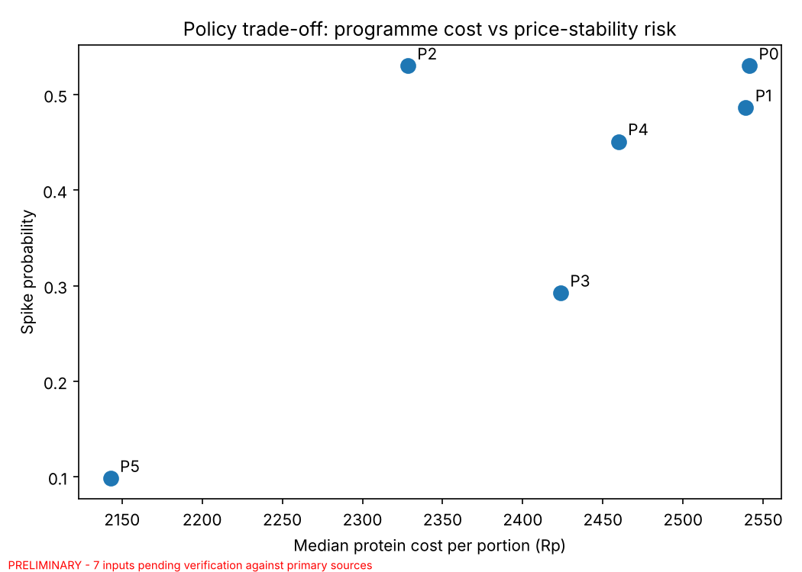
[Describe which policies reduce spike risk, by how much, and at what cost]

5. Discussion
GUIDE: Interpretation is the core intellectual contribution and must be yours.

5.1 Why the system behaves this way
[Link results to loops R1, B1–B3 and the delays]

5.2 Comparison with previous studies
[Agree/disagree with Section 2 sources; the BPS vs Bapanas debate]

5.3 Policy implications
[Specific, neutral, evidence-based recommendations for BGN, Bapanas, local governments, cooperatives]

5.4 Methodological contribution
[What the counterfactual design and scenario discovery revealed that OAT/single scenarios would not]

5.5 Limitations and future research
[National aggregation, parameter uncertainty, no regional or trade detail, other commodities]

6. Conclusion
[Answer RQ1–RQ3 directly in 300–400 words; restate contributions; one sentence on future work]

Declarations
Funding: This research received no external funding.
Competing interests: The author declares no competing interests.
Data and code availability: The model, code and data are available at [GitHub/Zenodo link].
Use of AI tools: [Describe honestly, following the journal's policy, how an AI assistant was used (e.g. model and code development, structuring and drafting text) and confirm that the author verified all content and takes full responsibility for it.]

References
GUIDE: Verify every entry against the original. Add the sources you actually read; remove any you do not cite.
Barlas, Y. (1996). Formal aspects of model validity and validation in system dynamics. System Dynamics Review, 12(3), 183–210.
Bryant, B. P., & Lempert, R. J. (2010). Thinking inside the box: A participatory, computer-assisted approach to scenario discovery. Technological Forecasting and Social Change, 77(1), 34–49.
Friedman, J. H., & Fisher, N. I. (1999). Bump hunting in high-dimensional data. Statistics and Computing, 9(2), 123–143.
Handbury, J., & Moshary, S. (2021). School food policy affects everyone: Retail responses to the National School Lunch Program. NBER Working Paper 29384.
Houghton, J., & Siegel, M. (2015). Advanced data analytics for system dynamics models using PySD. Proceedings of the 33rd International System Dynamics Conference.
Kwakkel, J. H. (2017). The Exploratory Modeling Workbench. Environmental Modelling & Software, 96, 239–250.
Kwakkel, J. H., & Jaxa-Rozen, M. (2016). Improving scenario discovery for handling heterogeneous uncertainties and multinomial classified outcomes. Environmental Modelling & Software, 79, 311–321.
Lundberg, S. M., & Lee, S.-I. (2017). A unified approach to interpreting model predictions. Advances in Neural Information Processing Systems, 30.
Meadows, D. L. (1970). Dynamics of Commodity Production Cycles. Wright-Allen Press.
Steinmann, P., Auping, W. L., & Kwakkel, J. H. (2020). Behavior-based scenario discovery using time series clustering. Technological Forecasting and Social Change, 156, 120052.
Sterman, J. D. (2000). Business Dynamics: Systems Thinking and Modeling for a Complex World. Irwin/McGraw-Hill.
[Mitchell, Thompson & Malone (2024) — complete after reading]
[Aboah & Enahoro (2022), Agricultural Systems — complete after reading]
[Indonesian broiler SD study (2024) — complete after reading]
[MBG studies, BPS, BGN, Bapanas and news sources — complete with access dates]

Appendix A. Model equations
Variable | Equation | Units
INITIAL TIME | 0 | Week
FINAL TIME | 312 | Week
TIME STEP | 0.125 | Week [0,?]
SAVEPER | 1 | Week [0,?]
Programme start time | 53 | Week
Target kitchens | 29256 | kitchen
Rollout midpoint | 91.66 | Week
Rollout steepness | 7.10 | Week
Rollout fraction | IF THEN ELSE(Time >= Programme start time, 1 / (1 + EXP(-(Time - Rollout midpoint) / Rollout steepness)), 0) | Dmnl
Planned kitchens | Target kitchens * Rollout fraction | kitchen
Operational kitchens | INTEG(Kitchen opening rate + Reinstatement rate - Suspension rate, 0) | kitchen
Suspended kitchens | INTEG(Suspension rate - Reinstatement rate, 0) | kitchen
Kitchen opening delay | 4 | Week
Kitchen opening rate | MAX(0, Planned kitchens - Operational kitchens - Suspended kitchens) / Kitchen opening delay | kitchen/Week
Reinstatement time | 15.05 | Week
Reinstatement rate | Suspended kitchens / Reinstatement time | kitchen/Week
Base suspension fraction | 0.00422 | 1/Week
Sustainable opening capacity | 300 | kitchen/Week
Scaling strain | Kitchen opening rate / Sustainable opening capacity | Dmnl
Strain sensitivity | 2 | Dmnl
Effect of scaling strain on suspension | 1 + Strain sensitivity * MAX(0, Scaling strain - 1) | Dmnl
Suspension rate | Operational kitchens * Base suspension fraction * Effect of scaling strain on suspension | kitchen/Week
Beneficiaries per kitchen | 2850 | person/kitchen
Beneficiaries served | Operational kitchens * Beneficiaries per kitchen | person
Programme coverage | ZIDZ(Beneficiaries served, Target kitchens * Beneficiaries per kitchen) | Dmnl
Portions per beneficiary | 5 | portion/(person*Week)
Egg per beneficiary | 0.15 | kg/(person*Week)
Chicken per beneficiary | 0.18 | kg/(person*Week)
Menu flexibility switch | 0 | Dmnl
Max menu substitution | 0.5 | Dmnl
Substitution price threshold | 1.15 | Dmnl
Egg menu multiplier | 1 - Menu flexibility switch * Max menu substitution * MIN(1, MAX(0, (Relative egg price - Substitution price threshold) / 0.2)) | Dmnl
Chicken menu multiplier | 1 - Menu flexibility switch * Max menu substitution * MIN(1, MAX(0, (Relative chicken price - Substitution price threshold) / 0.2)) | Dmnl
MBG egg demand | Beneficiaries served * Egg per beneficiary * Egg menu multiplier / 1000 | t/Week
MBG chicken demand | Beneficiaries served * Chicken per beneficiary * Chicken menu multiplier / 1000 | t/Week
Forward contract share | 0 | Dmnl
Contract lead time | 20 | Week
Anticipated rollout fraction | IF THEN ELSE(Time + Contract lead time >= Programme start time, 1 / (1 + EXP(-(Time + Contract lead time - Rollout midpoint) / Rollout steepness)), 0) | Dmnl
Anticipated MBG egg demand | Target kitchens * Anticipated rollout fraction * Beneficiaries per kitchen * Egg per beneficiary / 1000 | t/Week
Anticipated MBG chicken demand | Target kitchens * Anticipated rollout fraction * Beneficiaries per kitchen * Chicken per beneficiary / 1000 | t/Week
Cooperative sourcing share | 0.1 | Dmnl
Intermediary margin | 0.2 | Dmnl
Egg procurement price | Egg price * (1 + Intermediary margin * (1 - Cooperative sourcing share)) | Rp/kg
Chicken procurement price | Chicken price * (1 + Intermediary margin * (1 - Cooperative sourcing share)) | Rp/kg
Programme protein cost | (MBG egg sales * Egg procurement price + MBG chicken sales * Chicken procurement price) * 1000 | Rp/Week
Protein cost per portion | Programme protein cost / MAX(1, Beneficiaries served * Portions per beneficiary) | Rp/portion
Feed shock magnitude | 0 | Dmnl
Feed shock time | 120 | Week
Feed shock duration | 26 | Week
Exogenous feed price index | 1 + Feed shock magnitude * PULSE(Feed shock time, Feed shock duration) | Dmnl
Broiler feed weight | 0.5 | Dmnl
Total birds | Laying hens + Pullets + Broilers in growout * Broiler feed weight | bird
Initial total birds | INITIAL(Total birds) | bird
Feed price sensitivity to flock | 0.3 | Dmnl
Relative feed price | Exogenous feed price index * (Total birds / Initial total birds) ^ Feed price sensitivity to flock | Dmnl
Egg mass | 0.06 | kg/egg
Lay rate | 5.9 | egg/(bird*Week)
Production per hen | Lay rate * Egg mass / 1000 | t/(bird*Week)
Initial egg production | 121950 | t/Week
Initial laying hens | Initial egg production / Production per hen | bird
Productive life | 65 | Week
Rearing time | 18 | Week
Laying hens | INTEG(Maturation - Culling - Disease loss, Initial laying hens) | bird
Pullets | INTEG(Pullet placement - Maturation, Initial laying hens / Productive life * Rearing time) | bird
Maturation | DELAY3(Pullet placement, Rearing time) | bird/Week
Culling | Laying hens / Productive life | bird/Week
Outbreak loss fraction | 0 | Dmnl
Outbreak time | 150 | Week
Outbreak duration | 4 | Week
Disease loss | Laying hens * (-LN(1 - MIN(Outbreak loss fraction, 0.999))) * PULSE(Outbreak time, Outbreak duration) / Outbreak duration | bird/Week
Egg production | Laying hens * Production per hen | t/Week
Egg spoilage fraction | 0.01 | 1/Week
Normal egg coverage | 2 | Week
Reference household egg demand | Initial egg production / (1 + Egg spoilage fraction * Normal egg coverage) | t/Week
Egg inventory | INTEG(Egg production - Egg sales - Egg spoilage, Reference household egg demand * Normal egg coverage) | t
Egg spoilage | Egg inventory * Egg spoilage fraction | t/Week
Minimum delivery time | 0.5 | Week
Egg available | Egg inventory / Minimum delivery time | t/Week
Household egg elasticity | -0.7 | Dmnl
Household egg demand | Reference household egg demand * Relative egg price ^ Household egg elasticity | t/Week
MBG egg sales | MIN(MBG egg demand, Egg available) | t/Week
Household egg sales | MIN(Household egg demand, Egg available - MBG egg sales) | t/Week
Egg sales | MBG egg sales + Household egg sales | t/Week
Total egg demand | MBG egg demand + Household egg demand | t/Week
Relative egg coverage | (Egg inventory / MAX(1, Total egg demand)) / Normal egg coverage | Dmnl
Baseline egg price | 28140 | Rp/kg
Normal egg margin | 0.1 | Dmnl
Egg feed cost share | 0.7 | Dmnl
Base egg unit cost | Baseline egg price / (1 + Normal egg margin) | Rp/kg
Egg unit cost | Base egg unit cost * (Egg feed cost share * Relative feed price + 1 - Egg feed cost share) | Rp/kg
Price sensitivity to coverage | 1 | Dmnl
Cost pull weight | 0.3 | Dmnl
Maximum relative price | 3 | Dmnl
Price adjustment time | 2 | Week
Indicated egg price | MIN(Maximum relative price * Baseline egg price, Egg price * Relative egg coverage ^ (-Price sensitivity to coverage) * (Egg unit cost * (1 + Normal egg margin) / Egg price) ^ Cost pull weight) | Rp/kg
Change in egg price | (Indicated egg price - Egg price) / Price adjustment time | Rp/(kg*Week)
Egg price | INTEG(Change in egg price, Baseline egg price) | Rp/kg
Relative egg price | Egg price / Baseline egg price | Dmnl
Price expectation delay | 8 | Week
Expected egg price | SMOOTH(Egg price, Price expectation delay) | Rp/kg
Expected egg margin | (Expected egg price - Egg unit cost) / Egg unit cost | Dmnl
Egg farmer margin | (Egg price - Egg unit cost) / Egg unit cost | Dmnl
Investment sensitivity | 1.5 | Dmnl
Effect of margin on desired hens | MAX(0.5, 1 + Investment sensitivity * (Expected egg margin - Normal egg margin)) | Dmnl
Desired laying hens | Laying hens * Effect of margin on desired hens + Forward contract share * MAX(0, Anticipated MBG egg demand - MBG egg demand) / Production per hen | bird
Expected hen loss | SMOOTH(Culling + Disease loss, 4) | bird/Week
Desired pullets | Expected hen loss * Rearing time | bird
Capacity adjustment time | 26 | Week
Supply line weight | 0.5 | Dmnl
Hatchery capacity factor | 1.5 | Dmnl
Max pullet placement | Hatchery capacity factor * Initial laying hens / Productive life | bird/Week
Indicated pullet placement | Expected hen loss + (Desired laying hens - Laying hens) / Capacity adjustment time + Supply line weight * (Desired pullets - Pullets) / Capacity adjustment time | bird/Week
Pullet placement | MIN(Max pullet placement, MAX(0, Indicated pullet placement)) | bird/Week
Household egg consumption ratio | Household egg sales / Reference household egg demand | Dmnl
Initial chicken production | 73660 | t/Week
Meat per bird | 1.37 | kg/bird
Growout time | 5 | Week
Growout mortality | 0.05 | Dmnl
Initial DOC placement | Initial chicken production * 1000 / Meat per bird / (1 - Growout mortality) | bird/Week
Broilers in growout | INTEG(DOC placement - Broiler harvest - Growout mortality loss, Initial DOC placement * Growout time) | bird
Broiler harvest | Broilers in growout / Growout time * (1 - Growout mortality) | bird/Week
Growout mortality loss | Broilers in growout / Growout time * Growout mortality | bird/Week
Chicken production | Broiler harvest * Meat per bird / 1000 | t/Week
Chicken spoilage fraction | 0.02 | 1/Week
Normal chicken coverage | 1 | Week
Reference household chicken demand | Initial chicken production / (1 + Chicken spoilage fraction * Normal chicken coverage) | t/Week
Chicken inventory | INTEG(Chicken production - Chicken sales - Chicken spoilage, Reference household chicken demand * Normal chicken coverage) | t
Chicken spoilage | Chicken inventory * Chicken spoilage fraction | t/Week
Chicken available | Chicken inventory / Minimum delivery time | t/Week
Household chicken elasticity | -1.55 | Dmnl
Household chicken demand | Reference household chicken demand * Relative chicken price ^ Household chicken elasticity | t/Week
MBG chicken sales | MIN(MBG chicken demand, Chicken available) | t/Week
Household chicken sales | MIN(Household chicken demand, Chicken available - MBG chicken sales) | t/Week
Chicken sales | MBG chicken sales + Household chicken sales | t/Week
Total chicken demand | MBG chicken demand + Household chicken demand | t/Week
Relative chicken coverage | (Chicken inventory / MAX(1, Total chicken demand)) / Normal chicken coverage | Dmnl
Baseline chicken price | 35704 | Rp/kg
Normal chicken margin | 0.1 | Dmnl
Chicken feed cost share | 0.65 | Dmnl
Base chicken unit cost | Baseline chicken price / (1 + Normal chicken margin) | Rp/kg
Chicken unit cost | Base chicken unit cost * (Chicken feed cost share * Relative feed price + 1 - Chicken feed cost share) | Rp/kg
Indicated chicken price | MIN(Maximum relative price * Baseline chicken price, Chicken price * Relative chicken coverage ^ (-Price sensitivity to coverage) * (Chicken unit cost * (1 + Normal chicken margin) / Chicken price) ^ Cost pull weight) | Rp/kg
Change in chicken price | (Indicated chicken price - Chicken price) / Price adjustment time | Rp/(kg*Week)
Chicken price | INTEG(Change in chicken price, Baseline chicken price) | Rp/kg
Relative chicken price | Chicken price / Baseline chicken price | Dmnl
Expected chicken price | SMOOTH(Chicken price, Price expectation delay / 2) | Rp/kg
Expected chicken margin | (Expected chicken price - Chicken unit cost) / Chicken unit cost | Dmnl
Broiler investment sensitivity | 1 | Dmnl
Effect of margin on broiler placement | MAX(0.5, 1 + Broiler investment sensitivity * (Expected chicken margin - Normal chicken margin)) | Dmnl
Demand forecast time | 4 | Week
Expected chicken demand | SMOOTH(Total chicken demand, Demand forecast time) | t/Week
Inventory adjustment time | 2 | Week
Desired chicken production | (Expected chicken demand + Chicken spoilage) * Effect of margin on broiler placement + (Expected chicken demand * Normal chicken coverage - Chicken inventory) / Inventory adjustment time + Forward contract share * MAX(0, Anticipated MBG chicken demand - MBG chicken demand) | t/Week
DOC capacity factor | 1.2 | Dmnl
Max DOC placement | DOC capacity factor * Initial DOC placement | bird/Week
DOC placement | MIN(Max DOC placement, MAX(0, Desired chicken production * 1000 / Meat per bird / (1 - Growout mortality))) | bird/Week
Household chicken consumption ratio | Household chicken sales / Reference household chicken demand | Dmnl

Appendix B. Parameters and sources
parameter | model_value | units | tag | source
INITIAL TIME | 0.000 | Week |  | [to fill]
FINAL TIME | 312.000 | Week |  | [to fill]
TIME STEP | 0.125 | Week [0,?] |  | [to fill]
SAVEPER | 1.000 | Week [0,?] |  | [to fill]
Programme start time | 53.000 | Week |  | [to fill]
Target kitchens | 29,256.000 | kitchen |  | [to fill]
Rollout midpoint | 91.660 | Week |  | [to fill]
Rollout steepness | 7.100 | Week | POLICY | [to fill]
Kitchen opening delay | 4.000 | Week | UNCERTAINTY | [to fill]
Reinstatement time | 15.050 | Week |  | [to fill]
Base suspension fraction | 0.004 | 1/Week | UNCERTAINTY | [to fill]
Sustainable opening capacity | 300.000 | kitchen/Week | UNCERTAINTY | [to fill]
Strain sensitivity | 2.000 | Dmnl | UNCERTAINTY | [to fill]
Beneficiaries per kitchen | 2,850.000 | person/kitchen | UNCERTAINTY | [to fill]
Portions per beneficiary | 5.000 | portion/(person*Week) |  | [to fill]
Egg per beneficiary | 0.150 | kg/(person*Week) | UNCERTAINTY | [to fill]
Chicken per beneficiary | 0.180 | kg/(person*Week) | UNCERTAINTY | [to fill]
Menu flexibility switch | 0.000 | Dmnl | POLICY | [to fill]
Max menu substitution | 0.500 | Dmnl |  | [to fill]
Substitution price threshold | 1.150 | Dmnl |  | [to fill]
Forward contract share | 0.000 | Dmnl | POLICY | [to fill]
Contract lead time | 20.000 | Week |  | [to fill]
Cooperative sourcing share | 0.100 | Dmnl | POLICY | [to fill]
Intermediary margin | 0.200 | Dmnl |  | [to fill]
Feed shock magnitude | 0.000 | Dmnl | UNCERTAINTY | [to fill]
Feed shock time | 120.000 | Week |  | [to fill]
Feed shock duration | 26.000 | Week |  | [to fill]
Broiler feed weight | 0.500 | Dmnl |  | [to fill]
Feed price sensitivity to flock | 0.300 | Dmnl |  | [to fill]
Egg mass | 0.060 | kg/egg |  | [to fill]
Lay rate | 5.900 | egg/(bird*Week) |  | [to fill]
Initial egg production | 121,950 | t/Week |  | [to fill]
Productive life | 65.000 | Week |  | [to fill]
Rearing time | 18.000 | Week |  | [to fill]
Outbreak loss fraction | 0.000 | Dmnl |  | [to fill]
Outbreak time | 150.000 | Week |  | [to fill]
Outbreak duration | 4.000 | Week |  | [to fill]
Egg spoilage fraction | 0.010 | 1/Week |  | [to fill]
Normal egg coverage | 2.000 | Week |  | [to fill]
Minimum delivery time | 0.500 | Week |  | [to fill]
Household egg elasticity | -0.700 | Dmnl |  | [to fill]
Baseline egg price | 28,140.000 | Rp/kg |  | [to fill]
Normal egg margin | 0.100 | Dmnl |  | [to fill]
Egg feed cost share | 0.700 | Dmnl |  | [to fill]
Price sensitivity to coverage | 1.000 | Dmnl | UNCERTAINTY | [to fill]
Cost pull weight | 0.300 | Dmnl |  | [to fill]
Maximum relative price | 3.000 | Dmnl | UNCERTAINTY | [to fill]
Price adjustment time | 2.000 | Week |  | [to fill]
Price expectation delay | 8.000 | Week | UNCERTAINTY | [to fill]
Investment sensitivity | 1.500 | Dmnl | UNCERTAINTY | [to fill]
Capacity adjustment time | 26.000 | Week |  | [to fill]
Supply line weight | 0.500 | Dmnl | UNCERTAINTY | [to fill]
Hatchery capacity factor | 1.500 | Dmnl | UNCERTAINTY | [to fill]
Initial chicken production | 73,660.000 | t/Week |  | [to fill]
Meat per bird | 1.370 | kg/bird |  | [to fill]
Growout time | 5.000 | Week |  | [to fill]
Growout mortality | 0.050 | Dmnl |  | [to fill]
Chicken spoilage fraction | 0.020 | 1/Week |  | [to fill]
Normal chicken coverage | 1.000 | Week |  | [to fill]
Household chicken elasticity | -1.550 | Dmnl |  | [to fill]
Baseline chicken price | 35,704.000 | Rp/kg |  | [to fill]
Normal chicken margin | 0.100 | Dmnl |  | [to fill]
Chicken feed cost share | 0.650 | Dmnl |  | [to fill]
Broiler investment sensitivity | 1.000 | Dmnl | UNCERTAINTY | [to fill]
Demand forecast time | 4.000 | Week |  | [to fill]
Inventory adjustment time | 2.000 | Week |  | [to fill]
DOC capacity factor | 1.200 | Dmnl |  | [to fill]

