**SOLUTION OVERVIEW**



FINANCE SERVICES SOLUTION BRIEF

Finance IT Mandate – Reliable and Agile Branch Network

Finance Services market customers are embracing Software-defined WAN (SD-WAN) technology as a way to achieve bandwidth expansion, optimize connectivity to cloud resources and reduce branch device footprint. According to a survey conducted by Network Computing magazine, over 45% of the distributed Enterprises including many from Finance Services market plan to deploy SD-WAN by year 2017.

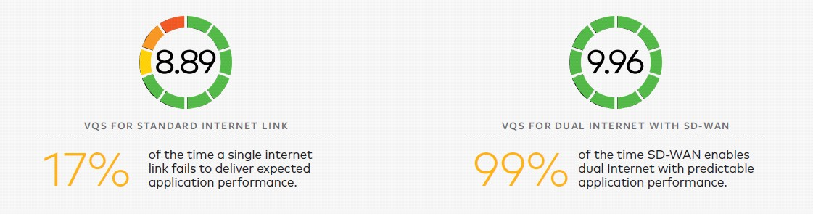

**Figure 1**

Assure Application Performance Over Internet

* Deploy Hybrid WAN comprising of MPLS and ordinary broadband to connect your retail and investment branches to access enterprise applications in the datacenter or in the public cloud

• Assure application performance SLA comparable to MPLS even for demanding applications like Voice and Video

* Dramatically improve user experience for any application by eliminating applications hair-pinning through datacenter, instead provide a direct path to the Cloud resources

Public or Private Cloud: The Choice is Yours

* Simplify your branch deployment with on-demand, distributed network of VMware NSX® SD-WAN by VeloCloud™ service gateways

• Provide optimized, direct access to cloud resources, SaaS instead of hair-pinning through your datacenter

* NSX SD-WAN Gateways operate in highly secure (Tier IV SSAE 16) datacenters.

• Provision firewall, web security, cloud VPN all from a single platform

* Establish secure IPsec connections to your private cloud, Enterprise datacenter



Enable Lean Branch Offices

* Fast provisioning of remote branches in minutes with zero IT touch and cloud activation
* Bring up your branch based on business-policies with centralized, cloud-based NSX SD-WAN
* Monitor and manage your WAN network across hundreds of branches with the centralized, cloud console
* Eliminate truck rolls, reduce remote IT with a suite of proactive troubleshooting tools

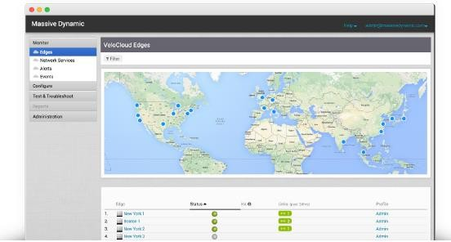

**Figure 2**



NSX SD-WAN Solution Components

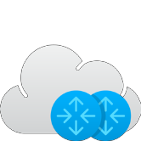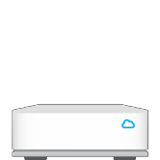

**NSX SD-WAN Gateways:** NSX SD- WAN incorporates a distributed network of service gateways deployed at top tier cloud datacenters around the world, providing scalability, redundancy, and on- demand flexibility. NSX SD-WAN Gateways provide optimized data paths to all applications, branches, and datacenters along with the ability to deliver network services from the cloud.

**VMware NSX® SD- WAN Edge by VeloCloud™:** The NSX SD-WAN Edges are zero-touch enterprise- class appliances that provide secure optimized connectivity to private, public and hybrid applications, compute and virtualized services. NSX SD-WAN Edges perform deep application recognition, application, and packet steering, performance metrics and end to end quality of service in addition to hosting virtual network function (VNF) services.

**NSX SD-WAN Orchestrator:** The NSX SD-WAN Orchestrator provides centralized enterprise-wide installation, configuration and real-time monitoring in addition to orchestrating the data flow through the cloud network. The NSX SD- WAN Orchestrator enables one-click provisioning of virtual services in the branch, the cloud, or the enterprise datacenter.

1 Footnote First Line U.S. and Worldwide Server Installed Base 2007–2011 Forecast, Doc #207044, May 2007;

2 Footnote Secondary Line Multicore Innovations Disrupt The Worldwide Server Market, Doc #206035, March 2007;

3 Source: VMware



**VMware, Inc. 3401 Hillview Avenue Palo Alto CA 94304 USA Tel 877-486-9273 Fax 650-427-5001** [**www.vmware.com**](http://www.vmware.com/)

Copyright © 2018 VMware, Inc. All rights reserved. This product is protected by U.S. and international copyright and intellectual property laws. VMware products are covered by one or more patents listed [at http://www.vmware.com/go/patents.](http://www.vmware.com/go/patents) VMware is a registered trademark or trademark of VMware, Inc. and its subsidiaries in the United States and other jurisdictions. All other marks and names mentioned herein may be trademarks of their respective companies.