**Technical Assessment: Business Data Understanding**

**Q.1**

**Company Customer**

1. Average Order Value(AOV)

**AOV = Total Sales Revenue / Total Number of Orders**

Total sales revenue= (2376214.71* 0.01) = 23762.1471

Total number of orders=11560

3247123.90/11560= 280.89307

Our average order value for **company** customer is 280.89

1. Frequency

F= Total Number of Orders / Total Number of Unique Customers

11560/268= 43.1343

1. Gross Margin (GM)

**GM** = Total Sales Revenue – Cost of Goods Sold (COGS) / Total Sales Revenue (express the result as a percentage).

(23762.1471- (268*500))/ 23762.1471= -463.92%

**Practice Customer**

1. Average Order Value(AOV)

**AOV = Total Sales Revenue / Total Number of Orders**

Total sales revenue= (13375* 0.01) = 133.75

Total number of orders=14

133.75/14= 9.5540

Our average order value for **company** customer is 9.5540

1. Frequency

**F**= Total Number of Orders / Total Number of Unique Customers

14/6= 2.3333

1. Gross Margin (GM)

**GM** = Total Sales Revenue – Cost of Goods Sold (COGS) / Total Sales Revenue (express the result as a percentage).

(133.75- (6*500))/ 133.75= -2142.99%

**Sole Proprietor Customer**

1. **Average Order Value(AOV)**

AOV = Total Sales Revenue / Total Number of Orders

Total sales revenue= (446610.01* 0.01) = 4466.1001

Total number of orders=1483

4466.1001/1483= 3.0115

Our **average order value** for **company** customer is 3.0115

1. Frequency

**F**= Total Number of Orders / Total Number of Unique Customers

1483/163= 9.0982

1. Gross Margin (GM)

**GM** = Total Sales Revenue – Cost of Goods Sold (COGS) / Total Sales Revenue (express the result as a percentage).

(4466.1001- (163*500))/ 4466.1001= -1724.86%

**Trust**

1. Average Order Value(AOV)

**AOV = Total Sales Revenue / Total Number of Orders**

Total sales revenue= (64490.5* 0.01) = 664.91

Total number of orders=78

664.91/78= 8.5245

Our **average order value** for **company** customer is **8.5245**

1. **Frequency**

**F**= Total Number of Orders / Total Number of Unique Customers

78/7= 11.1429

1. Gross Margin (GM)

**GM** = Total Sales Revenue – Cost of Goods Sold (COGS) / Total Sales Revenue (express the result as a percentage).

(664.91- (7*500))/ 664.91= -426.3870%

**Gross Margin**: We have made a low Gross margin with all of our clients. Reason being our customer acquisition cost is higher than what we’ve earned from them at the beginning which will be recovered in the long run and even make more profit.

**Total sales Revenue**: we made more sales revenue from customer **Company** followed by **sole proprietor** with customer **practice** performing poorly.

**Orders:** client **company** made most orders followed by **sole proprietor. They also performed** well in frequency.

**Recommendations:** We carry out this analysis to further segment our customers to be able to treat them based on their unique needs.

Sending a special offer or gift to your “VIP” customers will ensure more of them are retained. You can also focus on acquiring new customers with similar backgrounds using look-alike modeling.

You can start slowly upselling less valuable customers to increase their CLV. This segmentation will allow for a personalized experience; something many customers now expect.

N/B: At this point we leave out one important KPI known as Customer Lifetime Value, CLV. We shall capture it as we improve on our customer management techniques.

**Q.2**

1. **Mean processing time (on a weekly basis)**

Weekly mean processing time descending from the highest to the lowest. Week 51 has the highest average processing time. I would recommend investigation done to find out why week 51 recorded high transaction processing time. There is need to also establish whether there is any benefit from the long processing time.

Prepared by grouping data by week and aggregating the mean processing time against each week.

|  |  |  |
| --- | --- | --- |
|  | **week** | **Mean processing time** |
| 1 | 51 | 72.95238346 |
| 2 | 52 | 36.03185591 |
| 3 | 28 | 29.56943266 |
| 4 | 39 | 28.52538557 |
| 5 | 43 | 24.15895453 |
| 6 | 41 | 23.41019005 |
| 7 | 42 | 23.14861883 |
| 8 | 44 | 22.23706187 |
| 9 | 48 | 21.64151559 |
| 10 | 33 | 21.53563046 |

Below is a Visual representation of the average processing time for each calendar week for all the

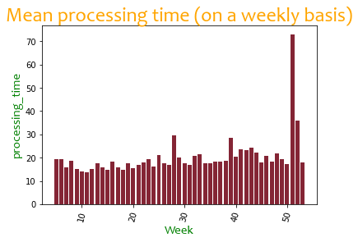

1. **Transaction Approval Rate**

The transaction approval rate is 79.7%. This was the highest transaction state. However, we still have errors appearing at the rate of 10.5%, and aborted transactions occurring at a rate of about 8%. There will be need for investigations to establish what causes such faults and why refunds recorded 72 transactions.

This is prepared by counting the number of transactions against each transaction state and computing the means of transactions by dividing the number of transactions column by the total number of transactions.

|  |  |  |  |
| --- | --- | --- | --- |
|  | **transaction state** | **Number of Transactions** | **percentage of total transactions** |
| 1 | approved | 12263 | 0.796764343 |
| 2 | error | 1620 | 0.105256319 |
| 3 | aborted | 1171 | 0.076083425 |
| 4 | declined | 263 | 0.017087909 |
| 5 | refunded | 72 | 0.004678059 |
| 6 | created | 1 | 6.4973E-05 |

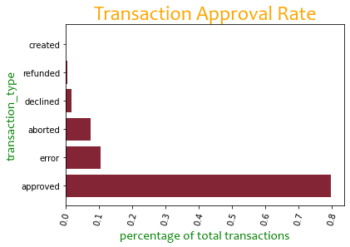 Below is a Visual representation of the average transaction rate for each transaction state

# Credit card Transaction Rate

# Credit card recorded the highest rate of transactions at a rate of 95% while refund has the lowest rate of about 1%. I would recommend we further investigate the reasons for refund and minimize them as much as possible.

# Aggregate number of transactions are calculated and grouped by the transaction type (Credit card, cash, and refund). The number of transactions per each transaction type are then divided by the total number of transactions.

# 

|  |  |  |  |
| --- | --- | --- | --- |
|  | **transaction type** | **Number of Transactions** | **Percentage of Transactions** |
| 1 | Credit card | 14607 | 0.949122807 |
| 2 | cash | 638 | 0.041455491 |
| 3 | refund | 145 | 0.009421702 |

# 

# C:\Users\Dan Masibo\Downloads\download (2).png

# Average Transactions per week

# The average weekly transactions is 290.3774. Week 51 recorded the highest number of transactions. The general performance is quite wanting. There is need to investigate the customer service whether there could be laxity on customer care. Further training may be recommended on staff who worked in those other weeks. This was computed by summing the number of transactions for all the 53 weeks and dividing by the total number of weeks, 53.

# The below table shows the weekly transactions performance in first 10 weeks of the year.

|  |  |  |  |
| --- | --- | --- | --- |
|  | **week** | **N0. of Transactions** | **No. of Transactions** |
| 1 | 51 | 959 | 959 |
| 2 | 48 | 844 | 844 |
| 3 | 49 | 835 | 835 |
| 4 | 50 | 801 | 801 |
| 5 | 52 | 684 | 684 |
| 6 | 47 | 662 | 662 |
| 7 | 45 | 647 | 647 |
| 8 | 44 | 594 | 594 |
| 9 | 46 | 588 | 588 |
| 10 | 43 | 561 | 561 |

Below is a Visual representation of the average weekly transactions for each week throughout the year.

