CASINO

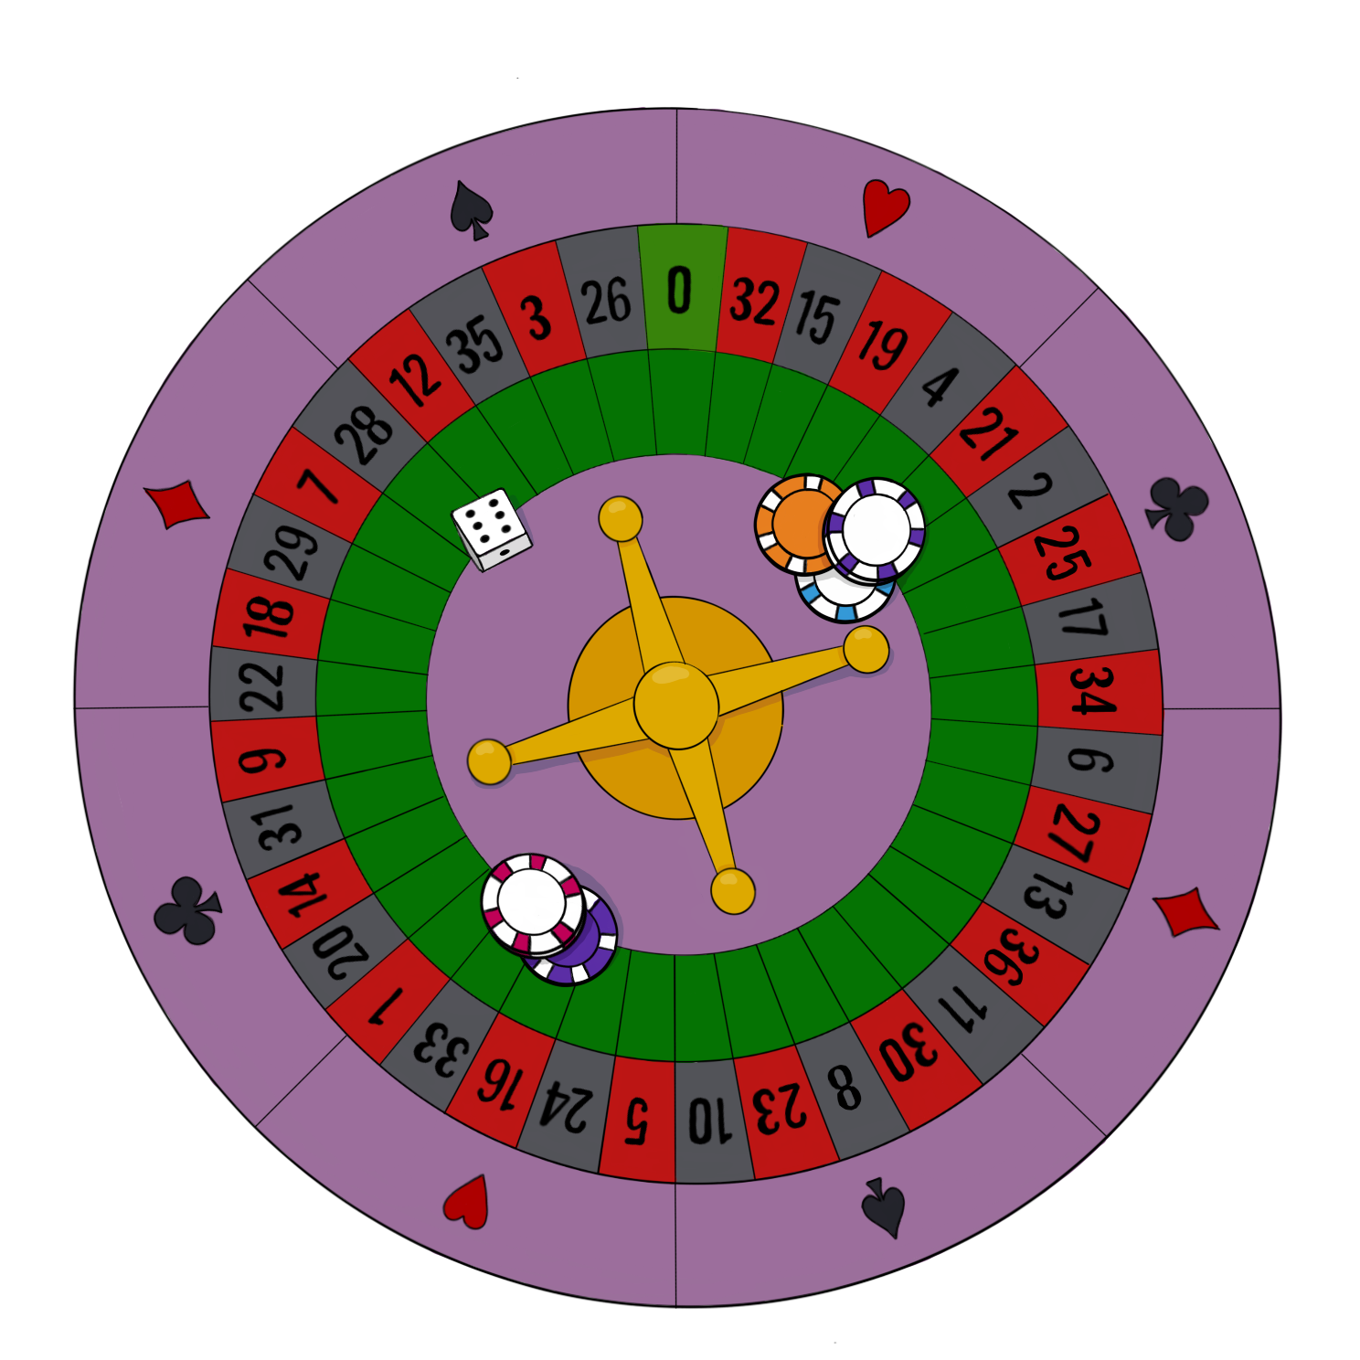

Daniel de las Heras
Índice
Abstract 3

Abstract

This project involves the development of a mini-casino application for Android devices, aimed at providing a simple, intuitive, and entertaining user experience through the implementation of classic casino games such as Blackjack, Roulette, and Slots. The main goal is to create an accessible, entertaining solution that serves both as amusement and as a practical demonstration of the knowledge gained during the training cycle.
For its development, Kotlin with Jetpack Compose was used for the user interface, Java with Jakarta EE 10 for building the REST API, and MySQL as the database management system, modeled using Workbench. The architecture follows a client-server pattern, allowing a clear separation between business logic and presentation.
The result is a functional, modular, and easily expandable application that allows users to play, manage their balance, and navigate through different games without complications. Throughout development, challenges related to navigation, interceptors, and JWT (to maintain the user session) were faced, and practical, efficient solutions were implemented.
In conclusion, the project has met its technical and educational objectives and is open to future improvements, such as the addition of more games, multiplatform support, and graphical enhancements. The experience has been highly enriching both professionally and academically.

