Gravitational Theory and Trajectory Design in astrophysics
(How do increasingly realistic models of gravitational dynamics affect spacecraft trajectory design?)

- Introduction
What is mass and what is weight?
Mass measures (in kg) the amount of matter in an object and it is constant everywhere in the universe.
Weight is the force of gravity acting on an object’s mass. It is calculated by W = m x g (Mass x Gravity). It is measured in Newtons (N) but daily scales convert it into kilograms or pounds. Weight is not constant and changes depending on strength of gravity applied to an object.

What is Gravity?
In the universe, every (almost) body has mass, and every object that has mass applies a force on other objects, drawing them towards its centre. This force is called Gravity. Objects with more mass have more gravity and gravity gets weaker with distance.
Gravity is the very force that keeps stellar objects in orbit around a body with a big enough mass.
Gravity can be described as a geometric property of space and time. The mathematical model of curved spacetime directly affects the energy, momentum of whichever is present, which includes matter.

How do orbits form and why don’t objects just fall towards each other?
An orbit is a continuous state of falling that misses. An object with low speed simply falls toward the centre of the greatest force of gravity applied on it. However, there exists a speed at which when reached, an object sustains its path and never falls to the ground. This is called an orbit.
An object in orbit is always in free fall, which means they are weightless.
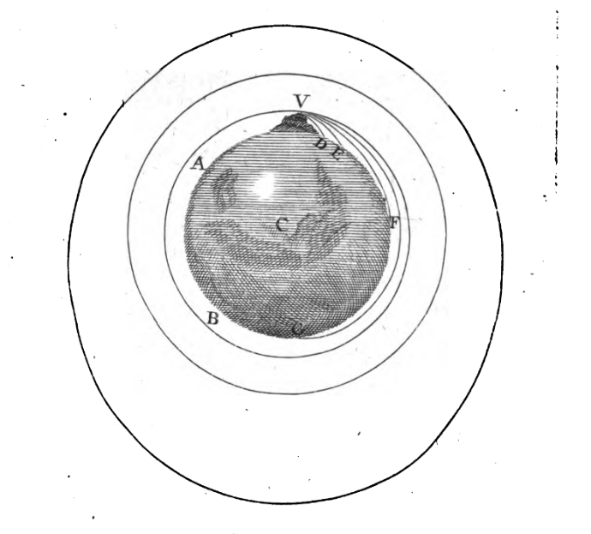

The original illustration of Newton’s explanation of the formation of an orbit.

What do we call Gravitational Theory and why?
In physics, the mechanisms and interaction governing the movements of bodies with mass is called Gravitational Theory. In humanity’s history, there have been numerous theories trying to explain this interaction.
The first sources discussing this are found in ancient Greek philosophy. This work was further developed through the Middle Ages by Indian, Islamic and European scientists culminating in the formulation of Newton’s law of gravity. This is later superseded by Einstein’s theory of relativity.

Difference between Newton’s laws and Einstein’s general relativity.
Newton’s laws of motion (including classical mechanics) almost perfectly explain how forces work in most of our daily lives, for bodies with low gravity (on nearly flat spacetime, see below). His classical mechanics describe the effect of macroscopic objects on the motion of lower mass bodies. This includes the motion of particles, satellites, asteroids etc.
Albert Einstein’s general relativity is the accepted description of macroscopic (big scale) gravitation in modern physics. It generalizes Galileo Galilei’s special relativity and expands upon Newton’s law of universal gravitation. It is best described and understood by the mathematical model of curved spacetime.

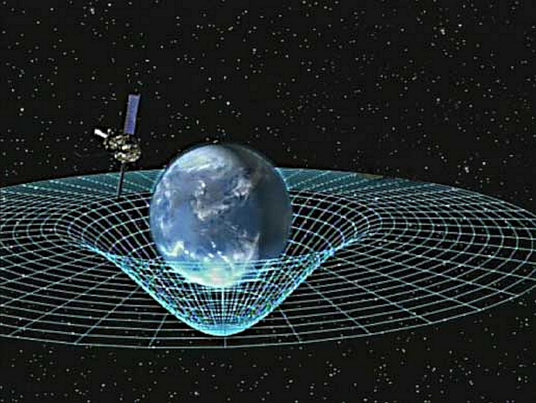

With that said, Newton’s laws are enough to calculate orbits and predict behaviour of satellite trajectories around larger mass bodies. General relativity is however more exact and is sometimes needed for greater accuracy or in high-gravity situations (orbits near the Sun).
The corrections of general relativity are negligible at solar-system scales except in specific precision cases.

  - How is this relevant today and why does it matter?

Spacecraft trajectory design
Every space mission is fundamentally a trajectory design problem governed by gravity. Trajectories are designed by making use of the fundamental laws of orbital mechanics and most importantly – Newton’s gravitational theory to calculate the path a spacecraft must follow, when to fire engines and how much fuel is needed. Because fuel is the largest constraint on what a mission can achieve, nearly all trajectory design is basically an optimization problem -more fuel means more mass, more cost, and less room for instruments.
In order to solve these problems, teams use propagation models that often simulate accurate gravity fields of multiple stellar objects, atmospheric drag and third body effects.

Gravity assists
A gravity assist lets a spacecraft borrow momentum from a planet’s motion to change its speed and direction without wasting fuel by entering and leaving the gravitational sphere of influence of a planet.
NASA’s Voyager missions used a rare planetary alignment to chain multiple gravity assists together essentially using a fraction of the fuel a direct trip would have required. Without gravity assists, many missions to the outer solar system wouldn’t be economically or physically possible.
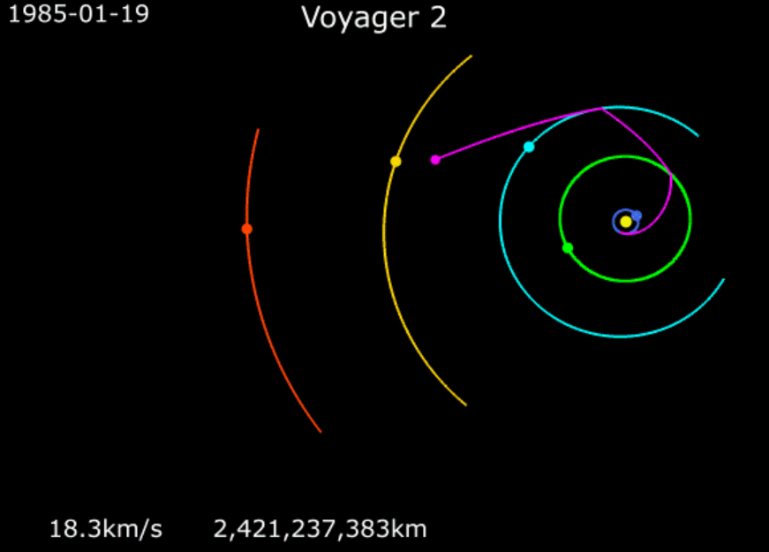

Lagrange points
Lagrange points are points of equilibrium (when the net force of each of an object’s individual parts is zero) for small-mass bodies under the gravitational influence of two massive orbiting bodies.
This makes them particularly useful for a spacecraft that needs to maintain a stable position.
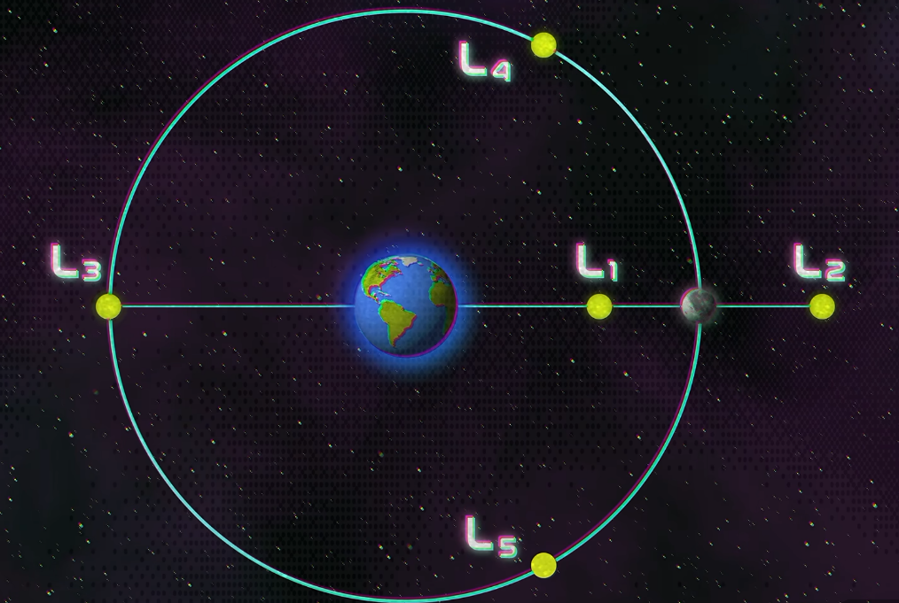

The three-body problem
The classis Three-Body problem has no general closed-form solution; it is mathematically chaotic.
This is the reason trajectory design is genuinely hard rather than a solved problem. Real missions are never isolated two-body systems – a spacecraft on route to Mars feels gravity from the Sun, Earth, Mars, Jupiter and this applies to everything else in the solar system simultaneously.
Because no general solution exists, every real trajectory is calculated through numerical simulation, and mission designers need to account for the chaotic sensitivity near unstable Lagrange Points (L1, L2).

  - Purpose of the research.
Gravitational theory isn’t just historical or abstract – it is the governing framework that makes every spacecraft trajectory, flyby, and stationary observatory possible. The gap between solvable idealizations such as two-body orbits, restricted three-body Lagrange points (see below) and reality – general three-body chaos, is genuinely hard to analyse and predict with current understanding of gravitational theory. Thus, the goal of this research is to simulate and explore this gap of human knowledge.

References:
https://www.youtube.com/watch?v=cQZ4GkqqvNo&list=PLRYW32aPvOdI&index=7
https://spaceplace.nasa.gov/what-is-gravity/en/
https://www.nasa.gov/ames-engineering/spaceflight-division/flight-dynamics/trajectory-design/
https://en.wikipedia.org/wiki/History_of_gravitational_theory
hsm.stackexchange.com/questions/18538/what-kind-of-perturbation-theory-did-lagrange-and-laplace-use
https://en.wikipedia.org/wiki/Gravitational_constant
https://en.wikipedia.org/wiki/Classical_mechanics
https://en.wikipedia.org/wiki/Newton%27s_law_of_universal_gravitation
https://pages.jh.edu/rrynasi1/dnl/Newton1731A_Treatise_of_the_System_of_the_World.pdf
https://en.wikipedia.org/wiki/Lagrange_point

