Amores Daniel Felix T.

2-ECE-C

Problem 1

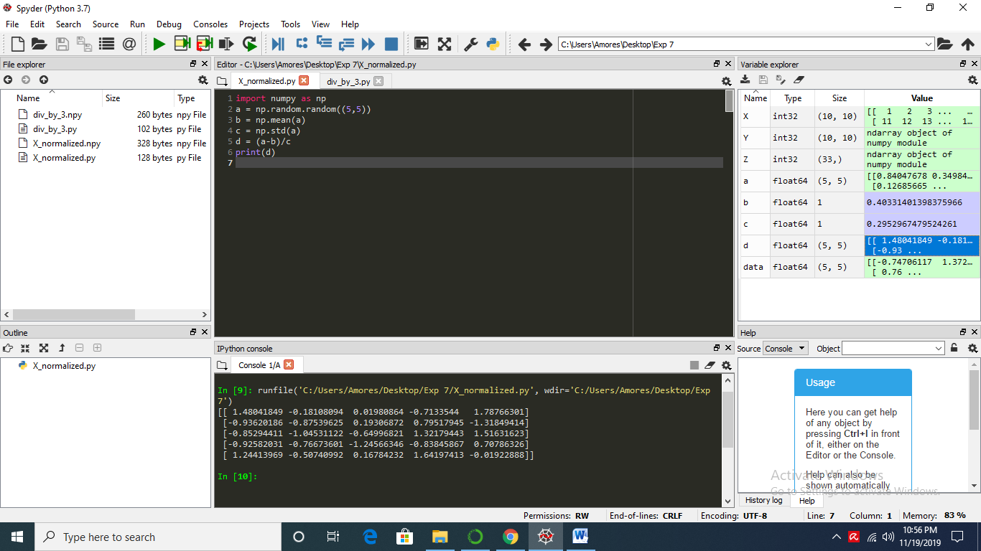

Problem 2

