ESG-451 Weekly Status Update
PhytoPi

Project Description
PhytoPi is an IoT-based controlled environment system for supporting a plant throughout its entire growth cycle with minimal human intervention. Utilizing embedded hardware and a machine learning system monitoring the plant using a camera, PhytoPi is designed to automatically care for more than 80% of a plant’s required maintenance over its lifespan.

Project Status Summary Percent Complete 7%
The PhytoPi project is on-track for completion on the projected timeline, currently the work items being focused on are completion of the first and second phases for Planning and Requirement Analysis and Requirement Finalization. The third phase System Design is projected to begin 10/12/25. The only remaining work item for the first epic is determining engineering standards that apply to the project and how they will be applied. The grooming of the project management structure in Jira is almost complete, a team meeting on 10/3/25 will serve to finalize the phases and user story structure. The second phase is most of the workload and the current focus is defining and finalizing all requirements.

Timeline Snapshot
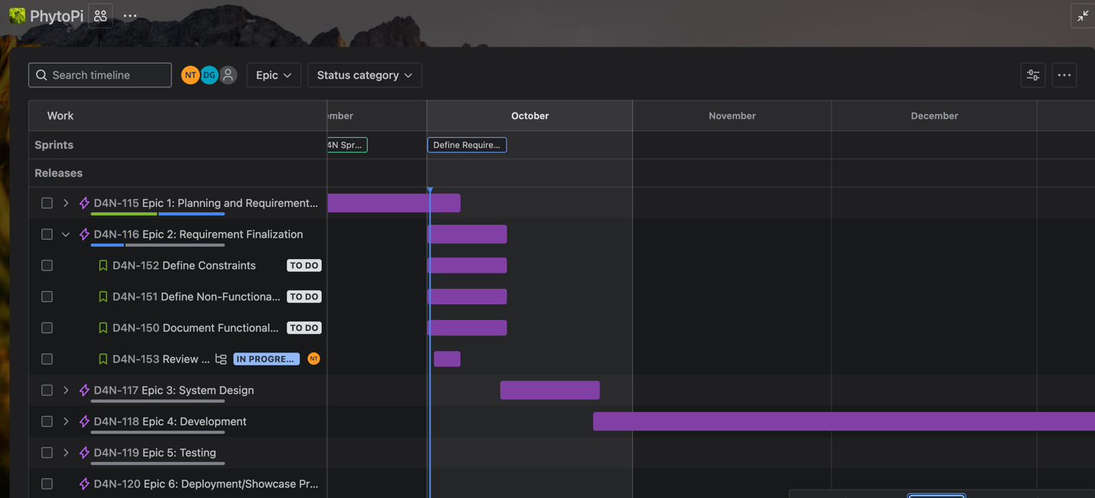

Current Concept
The current design concept (see Figure 1 & 2) includes an updated system block diagram and software architecture instead of a CAD model. This diagram highlights the Raspberry Pi at the center, connected to four IoT devices (sensors), and a data flow into the database and mobile/web app. Since last week, we refined the architecture by establishing our requirements for IoT devices and the tech stack being used in the software architecture.

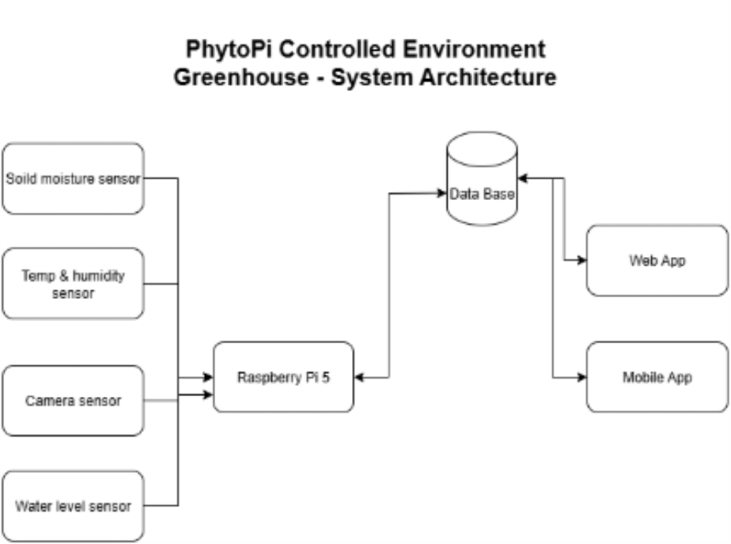
Figure 1. Current Design Concept - System Architecture Version 0.1

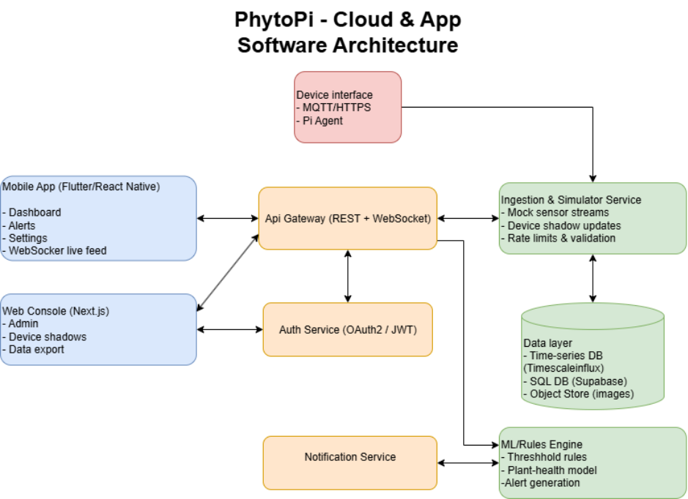
Figure 2. Current Design Concept – Software Architecture Version 0.1

Accomplishments and Learning
Planned from last week:
- Grooming Jira backlog – 60% complete
- Interview stakeholders to establish all user stories – 80% complete
- Finalize all project requirements – 50% complete

Unplanned:
- Begin system design phase/epic
- Create a finalized technical specification document
- Define and finalize all project requirements
- Prepare to present finalized system design presentation

Learning:
- Designing project management structure is crucial to the entire project.
- Conflict should be dealt with directly through meetings because good team collaboration is required to work efficiently.

Work Planned for Next Week

- Critical Path - Update and finalize all functional and nonfunctional requirements list using the latest customer feedback gathered.
- Apply IEEE engineering standards to organize project document collection
- Finalize timelines in Jira and cover scope of all functional requirements by filling the backlog with our user stories.
- Finish requirement finalization epic and begin designing the system.
- Refine design concept models, begin modeling physical casing for the system for future 3D printing.

Risks
- Initial Jira project management setup is causing a time delay of up to 1 week due to refactoring of user stories and reorganizing of timeline so that strict SDLC project management is enforced.
- Selecting a plant to test the system on may cause a time delay because if the wrong plant is selected, the difficulty of future milestones and overall development may increase significantly. We are consulting experienced stakeholders about plant species selection to mitigate this risk.

Deliverables and Milestones

Milestone | Planned | Forecasted | Actual | Status
Finalize Requirements | 10/12/25 | 10/11/25 | N/A | On Schedule
Begin System Design | 10/12/25 | 10/12/25 | N/A | On Schedule
Complete Planning Sprint | 10/5/25 | 10/07/25 | N/A | Behind Schedule
Deliverable | Planned | Forecasted | Actual | Status
Functional Requirement List | 10/12/25 | 10/12/25 | N/A | On Schedule
Complete Project Timeline Structure | 10/12/25 | 10/07/25 | N/A | On Schedule
Technical Specifications | 10/19/25 | 10/19/25 | N/A | On Schedule

Attachments
N/A

Approvals:

Team Role | Print Name | Signature | Date
Product Manager/Hardware + Integration Lead | Nolan Tuttle | Nolan Tuttle | 10/3/25
Software + Cloud Lead | Daniel Grijalva | Daniel Grijalva | 10/3/25
Faculty Mentor | Bill Hughes | Bill Hughes | 10/3/25

