ESG-451 Weekly Status Update
PhytoPi

Project Description
PhytoPi is an IoT-based controlled environment system for supporting a plant throughout its entire growth cycle with minimal human intervention. Utilizing embedded hardware and a machine learning system monitoring the plant using a camera, PhytoPi is designed to automatically care for more than 80% of a plant’s required maintenance over its lifespan.

Project Status Summary Percent Complete 10%
The PhytoPi project is on-track for completion on the projected timeline, currently, the Hardware/Integration Lead is completing documenting of functional and non-functional requirements as well as the electrical wiring diagram. The Software/Cloud Lead is defining all of the required materials for completion of the project in the Bill of Materials document, reporting the timeline and work breakdown structure of the project. The Software/Cloud Lead is also designing a virtual model of the physical enclosure for the system displayed below in Figure 1.

Timeline Snapshot

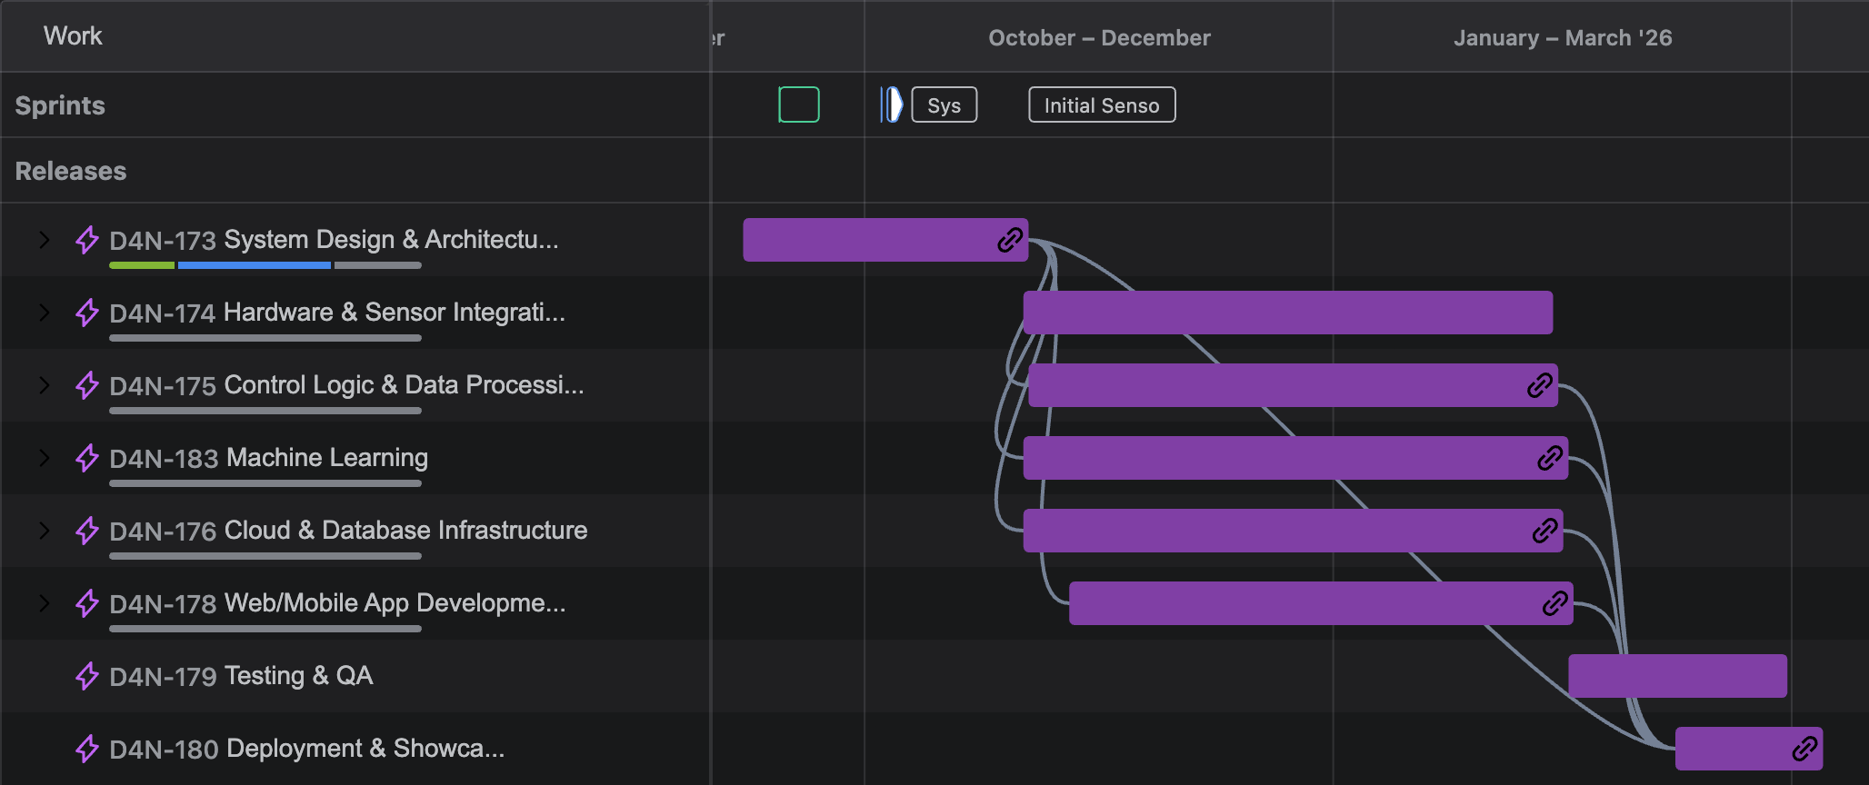

Current Concept
The current design concept (see Figure 1) includes an improved design from version 0.2 by enforcing N-layer architecture design by separating out the system into 4 different layers. This enhances data security by making sure the business logic layer alone handles database access for sensor control. In Figure 2 we created a prototype of our physical product architecture.

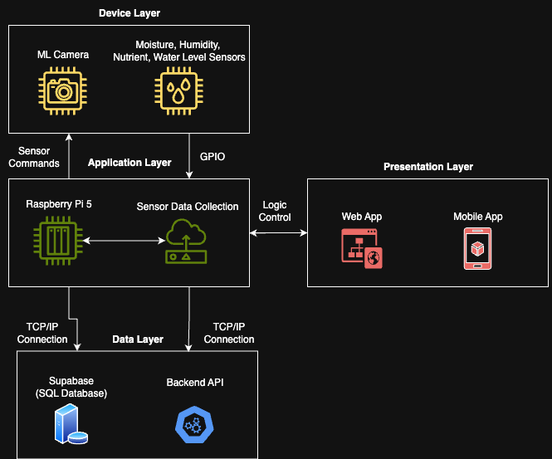

Figure 1. Current Design Concept - System Architecture Version 0.2

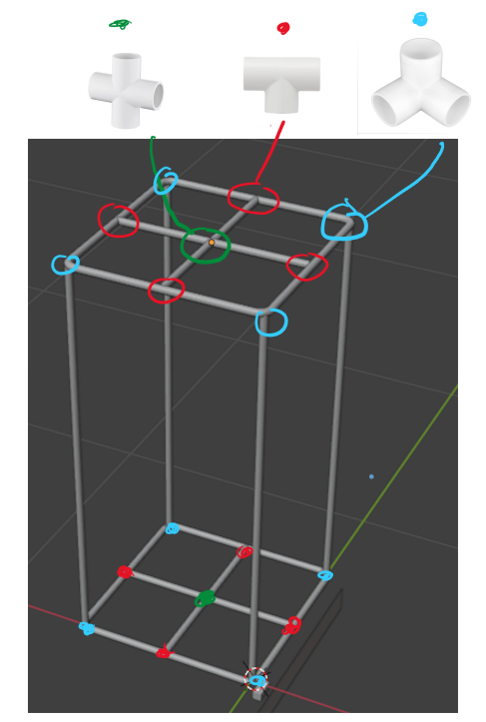 | 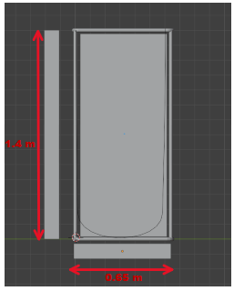

Figure 2. Current Design Concept – 3D Model of final product v0.1

Accomplishments and Learning
Planned from last week:
- Grooming Jira backlog – completed
- Interview stakeholders to establish all user stories – completed
- Finalize all project requirements – 80% complete
- Define all functional/nonfunctional requirements – 45% complete
- Finalize project timeline – 95% complete
- Blender system design – 50% complete
- Electrical design – 10% complete

Unplanned:
- Entity relationship diagram for database
- High-level database schema
- Privacy agreement write-up
- Figma UI design

Learning:
- Efficiency for completing tasks concurrently is greatly increased when team members communicate desire to work on specific tasks.
- CAD/Blender design is a critical task for visualizing project and completing future tasks such as sensor integration
- Coordinating team meetings is difficult outside of class time, best time for team meetings is typically immediately after class or over video call.

Work Planned for Next Week

- Critical Path – Finish the Blender design for the enclosure that will contain the plant, all sensors, and electrical components.
- Complete electrical wiring diagram.
- Research soil nutrient/pH collection/detection methods through a sensor connected to the Raspberry Pi’s GPIO.
- Test all sensors for accurate data collection/compatibility.
- Determine method for timestamping, recording, and moving useful data efficiently.
- Start Figma UI design for mobile app.
- Start database design such as schema and entity relationship diagram.

Risks
- Finishing Blender/CAD design for the project may result in a bill of materials that projects a cost higher than initial cost projections predicted, alternative options for hardware may be explored for further cost efficiency, delaying material ordering by up to 2 weeks.
- For the overall system design, to ensure data safety the N-layer design architecture will need to be adopted. However, when designing data flow for the system, it may be the case that Supabase’s method of data transfer to the UI may violate this architectural design, thus requiring a business logic layer to enforce strict separation of the data layer and the UI that users see to follow the N-layer architecture design pattern. This may cause a time delay in the upcoming database design tasks for up to 1 week.

Deliverables and Milestones

Milestone | Planned | Forecasted | Actual | Status
Finalize User Stories | 10/5/25 | 10/5/25 | 10/5/25 | On Schedule
Define All Requirements | 10/12/25 | 10/12/25 | N/A | On Schedule
Initial Sensor Testing | 11/30/25 | 11/30/25 | N/A | On Schedule
Deliverable | Planned | Forecasted | Actual | Status
Complete Figma UI Design | 10/22/25 | 10/22/25 | N/A | On Schedule
Fully Complete Materials Requirements | 10/12/25 | 10/12/25 | N/A | On Schedule
Technical Specifications | 10/19/25 | 10/19/25 | N/A | On Schedule

Attachments
N/A

Approvals:

Team Role | Print Name | Signature | Date
Product Manager/Hardware + Integration Lead | Nolan Tuttle | Nolan Tuttle | 10/10/25
Software + Cloud Lead | Daniel Grijalva | Daniel Grijalva | 10/10/25
Faculty Mentor | Bill Hughes | Bill Hughes | 10/10/25

