<COMPANY OR PROJECT LOGO>

<PhytoPi >

project charter

Version <1.0>

<09/28/2025>

Revision History

Date | Version | Description | Author
<MM/DD/YYYY> | <0.00> | <Type brief description here> | <First Initial & Last Name>

Notes to the Author

[The Project Charter is issued by the project initiator or sponsor. It formally authorizes the existence of a project, and provides the project manager with the authority to apply organizational resources to project activities.
Instructional text in this document is bracketed. Other text may be used in your actual plan. Please remove the instructions when the document is finalized.
The project initiator or sponsor create the charter or delegate the duty to the Project Manager. Typically the Project Sponsor, and Project Board/Steering Group authorize the Project Charter’s contents. The signed Project Charter authorizes the project.]

Contents
<PROPOSED PROJECT NAME> 1
project charter 1
Version <1.0> 1
<dd/mm/yyyy> 1
Revision History 2
Distribution list 2
Approvals 2
Purpose/Project Justification 6
Objectives and success criteria 6
Requirements 6
Project Assumptions and/Or Constraints 6
Preliminary Risk Statement 6
Summary Milestone Schedule 6
Summary Estimated Budget 7
Project Governance Requirements 7
Project Manager ReResponsibilities 7
Project OrganiZation 8
Project Organization Chart 8
Roles and Responsibilities 8
Appendices 9
DOWNLOAD MORE PROJECT TEMPLATES 9

Purpose/Project Justification
The purpose of PhytoPi is to create an automated system that enables plants to grow through their entire life cycle with minimal human intervention using embedded hardware and software solutions. This project requires data collection using sensors and a camera, which also serves our requirement that the product should analyze collected data for health trends of the plant. This project also must have a trigger system so that the plant can be watered, humidity adjusted, automatically to avoid human intervention. PhytoPi requires a mobile interface that can deliver alerts about plant status to users with a remote dashboard for precise control over the device. There is an increasing demand for urban agriculture and remote plant care, and we aim to create a product to compete in the market of plant growth monitors that offers ease-of-use for end users, detailed statistics about plant status, and utilizes efficient low-level hardware that can interface with readily available cheap components for customer appeal and low costs.
[Describe the purpose of the project and the requirements the project should to address. Describe the justification for conducting this project.]

Objectives and success criteria
[Briefly discuss the intended goals and expected outcomes of the project. If possible, relate these objectives strategic business plans, the table below may help. Describe each objective using measureable success criteria, such as anticipated productivity improvements, cost reduction, improvements in business processes, revenue enhancements, technical efficiencies, etc. The stated objectives will become the basis for the acceptance criteria.]

Business Strategy objective | Project objective
[Reference the goal or objective from the Strategic Business Plan. See Strategic Business Planning.] | [Describe the project objective using measureable success criteria if possible.]

Requirements
[Briefly describe the high level requirements. This might be a summary with the detail in an appendix.]

Project Assumptions and/Or Constraints
[Describe any constraints and assumptions that are currently known about the proposed project. These constraints and assumptions may include regulatory or legislative requirements, funding limitations, sunset dates, etc. Assumptions are statements taken for granted or accepted as true without proof. Assumptions are made in the absence of fact.]

Preliminary Risk Statement
[List and describe any risks that can be identified. Consider the project constraints and assumptions to help identify potential risks. Include known risk mitigation strategies. Risks and mitigations strategies may be in bulleted lists.]
- [Risk]
- [Risk]
[Get a risk register template.]

Summary Milestone Schedule
[List projected project milestones and their forecasted completion dates. This schedule is of preliminary nature only. Once the project has been approved to move forward a comprehensive Microsoft Project Plan will be developed.]
[The table below can be used or a high level Gantt Chart. Get an Excel Gantt Chart template.]
Project Milestone | Forecast Date | Owner
[Initiation]
[Concept Development]
[Planning]
[Requirements Analysis]
[Design]
[Development]

Summary Estimated Budget
[Detail the current estimated costs to conduct the project and identify the source of funding. Add any additional categories to the table below as needed. Please remember that the budget cannot exceed $4000.]
The forecasted budget for the <Project Name> project is $<amount>. It is to be funded through <funding source/budget>. This forecasted amount will be adjusted during the Concept Development, Planning, and Requirements Analysis Phases to derive a more precise budget.
Rough Order of Magnitude Item | ROM Estimate
[Software] | $
[Internal Resources] | $
[Contractor Resources] | $

Project OrganiZation

Project Organization Chart
[Provide an Organization chart of the project team. It will typically begin with the project sponsor (this could be GCU or an industry partner) and include the project team and other stakeholders. An example is below:]
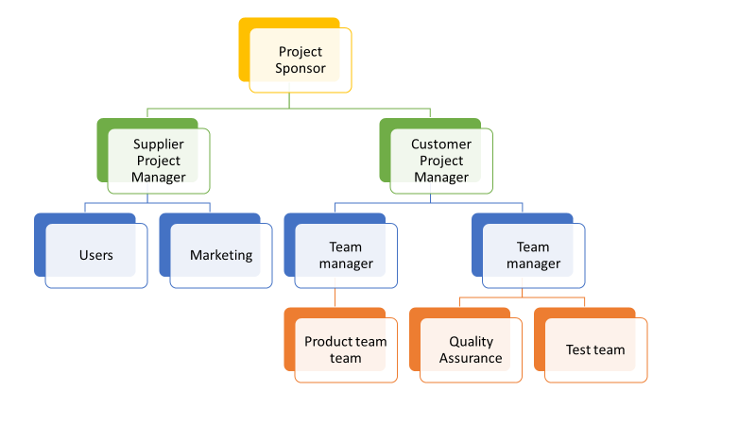

Roles and Responsibilities
[Describe the Roles and Responsibilities of the project team and include key stakeholders.]
[It can be useful to include a RACI chart in this section. An example is below:
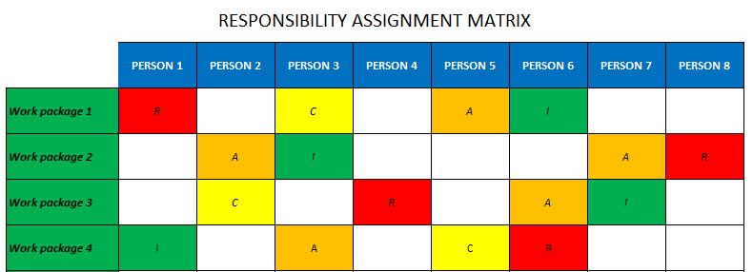
RACI Chart - a how to guide to using RACI

Appendices
[Use the appendices to include detailed documentation that has been summarized in the main body of the charter. For example, project schedules, estimates, project team job descriptions etc.]

DOWNLOAD MORE PROJECT TEMPLATES
Microsoft Project Plans – real world project plans in Microsoft Project.
Project Management Templates – FREE project management templates in Word and Excel
Stakeholder Management Templates
Flowcharts to download in Visio and PDF
Risk Register in Excel – download immediately
Work Breakdown Structure Excel template
Work Breakdown Structure (WBS) FREE examples to download immediately.

