Project Portfolio: PhytoPi
Nolan Tuttle, Daniel Grijalva
Grand Canyon University, College of Engineering and Technology
ESG-451: Capstone Project 1
Professor Hughes
November 2, 2025

PhytoPi
The PhytoPi project was created to address a common issue among gardening hobbyists, because traditional plant maintenance requires regular watering and diagnosis of health issues. PhytoPi was designed to reduce these burdens with an automated, IoT-based solution that minimizes need for human intervention and ensures optimal growth through a plant’s entire life cycle.
Objectives
The objectives of the PhytoPi project focus on creating an IoT-based controlled environment system that enables plants to grow through their entire life cycle with minimal human intervention. These objectives are derived from customer feedback, engineering standards, and research completed by the team. The main objectives include:
- Monitoring environmental variables such as temperature, humidity, soil moisture, and light.
- Using a Raspberry Pi 5 as the control hub to collect and process sensor data.
- Automating plant care, including watering and lighting adjustments, based on sensor readings.
- Delivering real-time monitoring and notifications via a mobile app and cloud dashboard.
- Ensuring ease of use for end users with minimal gardening experience while providing detailed insights for experienced users.

Customer feedback emphasized the need for automation and simplicity. For example, Cayla Dickens noted that plant care can be stressful and confusing, requesting automatic watering, clear visual indicators, and phone notifications for alerts. Similarly, Noelle Tuttle expressed a desire for grow light scheduling, watering reminders, and mobile notifications, while Mathew Hobson highlighted the importance of a responsive mobile dashboard, real-time sensor data, and environmental alerts. These inputs directly shaped the functional requirements of the project.
Table 1: Business Strategy and Project Objectives
Business Strategy objective | Project objective
To improve urban agriculture and promote sustainability. | To reduce manual plant care labor by at least 80%.
To compete for a share of the market in IoT solutions through affordable components. | To deliver a product with hardware costs under $250/unit, target costs for prototype production is $200.
To create a user interface that keeps customers extremely engaged through speed/ease of use. | To create a responsive mobile dashboard that has a refresh time of less than 2 seconds
To create a product that collects precise details about plant growth for data insights. | To collect and analyze at least 3 different plant health metrics over the life cycle of a plant including light levels, soil moisture, and projected growth vs. actual growth.

Functional Requirements
The functional requirements of PhytoPi translate the business objectives and customer feedback into measurable capabilities. Each requirement ensures the system meets the expectations of the target users and engineering standards.
Table 2: Functional Requirements
Functional Requirements | Relationship to Customer Feedback | Relationship to Engineering Standard(s) | How Will the Functional Requirement Be Measured?
The system shall provide a complete electrical wiring diagram for all hardware components. | Internal/system requirement; ensures hardware can be safely and reliably deployed. | IEEE 1220-2005: Ensures thorough system design documentation and proper lifecycle management for complex systems. | Completion and availability of a detailed electrical wiring diagram covering all hardware components.
The system shall highlight all important connections such as signal and power so that the diagram is properly organized. | Internal/system requirement; supports clarity and safety for maintenance and assembly. | IEEE 1220-2005: Applies to structured system documentation and clarity of hardware design. | Presence of highlighted signal and power connections in the wiring diagram.
The system shall indicate safety measures for components prone to damage or with high voltage. | Internal/system requirement; protects users and hardware from accidental damage. | IEEE 7009-2024: Ensures fail-safe design of autonomous systems to prevent damage or unsafe conditions. | Safety measures indicated and marked for all high-risk components in the diagram.
The system shall read temperature from temperature sensors at specified intervals. | User feedback: supports real-time environmental monitoring for plant care decisions. | IEEE 2700-2017: Provides standardized definitions for sensor performance and interval testing. | Temperature readings successfully collected at defined intervals and logged.
The system shall generate recommendations for adjustment based on analysis results. | User feedback: reduces confusion about plant care and provides actionable guidance. | IEEE 1012-2016: Supports validation of system software computations for accuracy and reliability. | Recommendations generated and accessible based on analysis results.
The system shall train a machine learning model using historical plant sensor and image data to predict growth and stress. | User feedback: helps users manage plant health and nutrient needs effectively. | IEEE 1012-2016: Ensures verification and validation processes are followed for ML model development. | Machine learning model trained and tested; performance metrics logged.
The system shall require authentication tokens for each data access requests. | Internal/system requirement; supports predictive analytics for automated alerts and recommendations. | IEEE 2413-2019: Standardizes IoT device security and proper access protocols. | Authentication tokens required for every data access attempt.
The system shall provide secure API endpoints for retrieving sensor data, alerts, or ML predictions. | Internal/system requirement; ensures secure access to sensitive data. | IEEE 2413-2019: Ensures secure communication and structured IoT API interactions. | Successful retrieval of sensor data, alerts, and ML predictions through secure API endpoints.
The system shall store all machine learning predictions in the cloud database. | Internal/system requirement; protects data integrity and security for system integration. | IEEE 2413-2019: Provides guidance on scalable IoT data storage and management. | ML predictions stored in the cloud database and retrievable for verification.
The system shall adjust artificial grow light to automatically maintain lighting target values. | User feedback: reduces manual effort and ensures plants receive proper light exposure. | IEEE 7009-2024: Applies fail-safe design principles to automation of lighting systems. | Automatic adjustment of grow lights achieves target lighting values.
The system shall compare received light sensor readings to target light levels. | Internal/system requirement; supports automated grow light scheduling and plant care accuracy. | IEEE 2700-2017: Defines sensor performance and validation metrics for light sensors. | Light sensor readings compared to target levels and adjustments logged.
The system shall record nutrient-related alerts/anomalies for trend analysis | Internal/system requirement; enables monitoring of plant health over time. | IEEE 1012-2016: Supports verification of logging and analytical software components. | Nutrient-related alerts/anomalies recorded and retrievable from the system.
The system shall compare optimal pH soil readings against detected pH levels. | Internal/system requirement; informs nutrient alerts for plant care. | IEEE 2700-2017: Ensures sensor readings meet defined performance standards. | Detected soil pH compared against optimal values with logged results.
The system shall trigger automatic watering when moisture is below threshold. | User feedback: reduces manual watering, ensures plants are watered correctly. | IEEE 7009-2024: Fail-safe design ensures watering occurs reliably without user intervention or unsafe behavior. | Automatic watering triggers recorded when moisture is below threshold.
The system shall compare soil moisture readings against defined thresholds. | Internal/system requirement; supports reliable automated watering. | IEEE 2700-2017: Sensor performance validation ensures accurate threshold comparison. | Soil moisture readings compared against thresholds and corresponding actions logged.
The system shall timestamp and include outcome for each log entry. | Internal/system requirement; supports traceability and analysis of system actions. | IEEE 1012-2016: Verification and validation of logging ensures accurate historical recordkeeping. | Log entries contain timestamps and recorded outcomes for all actions.
The system shall record every automated action executed by control logic. | Internal/system requirement; ensures full historical record for review and troubleshooting. | IEEE 1012-2016: Supports V&V of system action logs for analysis and traceability. | All automated actions executed by control logic are recorded with timestamps.
The system shall continuously compare sensor readings against expected readings. | Internal/system requirement; supports anomaly detection and alerting. | IEEE 2700-2017: Defines performance standards for continuous sensor evaluation. | Sensor readings continuously compared to expected values with discrepancy logs.
The system shall flag abnormal readings and generate alert messages. | User feedback: provides timely notifications about plant/environment issues. | IEEE 7009-2024: Fail-safe design ensures abnormal readings trigger safe responses. | Abnormal readings generate alerts, which are documented and verifiable.
The system shall log anomalies in storage for later review. | Internal/system requirement; enables historical review and analysis of unusual events. | IEEE 1012-2016: Verification ensures logging system reliably stores anomalies for analysis. | Anomalies logged in storage can be retrieved and audited.
The system shall verify calibration accuracy against known reference values. | Internal/system requirement; ensures sensor data is trustworthy and consistent. | IEEE 2700-2017: Sensor calibration standards ensure data accuracy and consistency. | Calibration accuracy verified against reference values and recorded.
The system shall provide a calibration routine for each sensor connected. | Internal/system requirement; supports accurate readings for all environmental monitoring. | IEEE 1451-99:2023: Ensures sensors are interfaced and calibrated consistently in IoT systems. | Calibration routine available and executable for each sensor.
The system shall display a clear privacy policy describing all data collected and what it is used for. | User feedback: supports transparency and trust in the system. | IEEE 2413-2019: Supports standardized IoT privacy and data management guidelines. | Privacy policy displayed clearly and completely on the interface.
The system shall require consent from the user before collecting any data. | User feedback: aligns with privacy expectations and legal compliance. | IEEE 2413-2019: Aligns with IoT architecture standards for secure and responsible data collection. | User consent is collected before data collection, logged and stored.
The system shall read soil moisture values from moisture sensors at specified intervals. | User feedback: supports real-time soil moisture monitoring for plant care decisions. | IEEE 2700-2017: Standardized sensor measurement intervals ensure data reliability. | Soil moisture values read at specified intervals and logged.
The system shall store and timestamp soil moisture readings in local storage for later use | Internal/system requirement; ensures data is retained for analytics and historical trends. | IEEE 2413-2019: Ensures IoT data storage meets architecture standards for accessibility and security. | Soil moisture readings stored with timestamps for later retrieval.
The system shall calibrate light sensors to ensure accuracy before readings are recorded. | Internal/system requirement; ensures lighting data is accurate for automated decisions. | IEEE 1451-99:2023: IoT sensor calibration ensures reliable measurements before processing. | Light sensors calibrated and verified before recording readings.
The system shall read light intensity from light sensors at specified intervals. | User feedback: supports monitoring of light exposure for plant health. | IEEE 2700-2017: Sensor performance standard ensures reliable data capture. | Light intensity readings collected at defined intervals and logged.
The system shall store and timestamp light readings in local storage for later use. | Internal/system requirement; enables historical trends and ML model training. | IEEE 2413-2019: IoT data storage and management guidance for accessibility and scalability. | Light readings stored with timestamps for verification.
The system shall collect soil pH readings at specified intervals. | User feedback: supports monitoring soil conditions for plant health. | IEEE 2700-2017: Sensor performance standard ensures accurate pH monitoring. | Soil pH readings collected at specified intervals and logged.
The system shall collect soil nutrient readings at specified intervals. | User feedback: enables timely recommendations for fertilization or interventions. | IEEE 2700-2017: Sensor performance standard ensures accurate nutrient monitoring. | Soil nutrient readings collected at specified intervals and logged.
The system shall store and timestamp soil nutrient and pH readings in local storage for later use. | Internal/system requirement; supports analysis, ML, and dashboard displays. | IEEE 2413-2019: IoT data storage and management guidance for accessibility and scalability. | Soil nutrient and pH readings stored with timestamps for verification.
The system shall store and timestamp temperature and humidity readings in local storage for later use. | Internal/system requirement; enables accurate historical tracking and ML predictions. | IEEE 2413-2019: IoT data storage standard ensures accessibility and reliability of environmental readings. | Temperature and humidity readings stored with timestamps for verification.
The system shall read humidity from humidity sensors at specified intervals. | User feedback: supports environmental monitoring for plant care. | IEEE 2700-2017: Sensor performance standard ensures accurate humidity measurements. | Humidity readings collected at specified intervals and logged.
The system shall display real-time data on the main dashboard. | User feedback: provides easy access to current plant and environmental status. | IEEE 2413-2019: IoT architecture guidance ensures timely, reliable dashboard data display. | Real-time data displayed correctly on the main dashboard and updated at specified intervals.
The system shall push notifications to the user‚Äôs device reading thresholds are exceeded | User feedback: provides timely alerts to reduce plant stress and care errors. | IEEE 7009-2024: Fail-safe design ensures notifications occur reliably and timely. | Push notifications delivered to user devices when thresholds are exceeded.
The system shall generate alerts when environmental readings exceed predefined thresholds. | User feedback: ensures user is informed of critical plant/environment conditions. | IEEE 7009-2024: Ensures automated alerts respond correctly to unexpected system states. | Alerts generated correctly for environmental readings and logged.
The system shall display color-coded alerts to indicate plant or environment status. | User feedback: simplifies plant care with clear visual indicators. | IEEE 2413-2019: IoT interface guidance for consistent and interpretable alert display. | Color-coded alerts displayed in response to environmental status changes.
The system shall generate and display graphical growth trends using plant data | User feedback: allows users to track progress and understand plant growth patterns. | IEEE 1012-2016: Verification ensures analytics and visualization modules operate correctly. | Graphical growth trends generated and displayed using collected plant data.
The system shall store and apply user's notification preferences across sessions. | User feedback: ensures personalization and avoids unnecessary alerts. | IEEE 2413-2019: IoT architecture standard ensures persistent and consistent user settings. | User notification preferences stored and persist across sessions.
The system shall allow users to enable and disable notifications for alerts from the system. | User feedback: gives users control over alerting, improving usability. | IEEE 2413-2019: Standard ensures secure, consistent handling of user preferences. | Users able to enable/disable notifications and settings are saved accurately.
The system shall allow users to navigate between all menus using the main navigation menu. | User feedback: improves user experience and efficiency in accessing system functions. | IEEE 2413-2019: Ensures UI navigation design aligns with consistent IoT interface standards. | Navigation between menus functional and occurs without errors.
The design prototype shall include all core UI components with navigation flow. | User feedback: ensures interface is intuitive and responsive for quick access. | IEEE 1220-2005: Supports structured system design and interface planning. | UI design prototype includes all core components and navigation flow.
The system shall transmit validated sensor readings to the Raspberry Pi every 10 seconds using a secure communication protocol | Internal/system requirement; supports timely and secure data transfer for processing. | IEEE 1451-99:2023: Standardized IoT transducer communication ensures reliable and consistent data transfer. | Validated sensor readings transmitted to Raspberry Pi every 10 seconds.
The system shall define minimum and maximum thresholds for each sensor type (e.g., soil moisture, pH) to ensure valid readings. | Internal/system requirement; prevents erroneous readings and system errors. | IEEE 2700-2017: Provides standardized validation methods for sensor thresholds. | Minimum and maximum thresholds defined for each sensor and enforced during data collection.
The schema must include attributes for sensor ID, and lighting values. | Internal/system requirement; supports database organization and data integrity. | IEEE 2413-2019: IoT data structure and schema guidance for consistent device communication. | Database schemas include attributes for sensor ID and lighting values.
The schema must include attributes for sensor ID, and pH values. | Internal/system requirement; supports database organization and data integrity. | IEEE 2413-2019: IoT data structure and schema guidance for consistent device communication. | Database schemas include attributes for sensor ID and pH values.
The schema must include attributes for sensor ID, and moisture percentages. | Internal/system requirement; supports database organization and data integrity. | IEEE 2413-2019: IoT data structure and schema guidance for consistent device communication. | Database schemas include attributes for sensor ID and moisture percentages.
The system must record all incoming sensor data along with their timestamps and sensor type. | Internal/system requirement; ensures complete data capture for dashboards and analysis. | IEEE 2413-2019: IoT standard ensures accurate data collection and timestamping for analytics. | Incoming sensor data recorded with timestamps and sensor type.
The system must organize control action data in a structured format for analytics or use in UI. | Internal/system requirement; allows efficient reporting, visualization, and analytics. | IEEE 1220-2005: Structured system design ensures control action data is usable for analytics and interface display. | Control action data organized and structured for analytics or UI display.
The system must store each automated or manual control action along with its timestamp, type, and description. | Internal/system requirement; ensures historical traceability of all system actions. | IEEE 1012-2016: Verification ensures accurate logging and traceability of actions. | Each automated or manual control action stored with timestamp, type, and description.
The system must flag or reject data points that are missing, or outside threshold values. | Internal/system requirement; ensures data quality for analysis and ML predictions. | IEEE 2700-2017: Standard ensures validation of sensor data against defined acceptable ranges. | Data points flagged or rejected if missing or outside acceptable ranges.
The system must check each section of incoming sensor data against defined acceptable ranges before storage. | Internal/system requirement; maintains data integrity and reliability. | IEEE 2700-2017: Standard ensures robust data validation for consistency and reliability. | Each section of incoming sensor data validated against defined ranges.
The model must export measurements and dimensions in standard engineering units for reference in material selection. | Internal/system requirement; supports engineers in hardware/material planning. | IEEE 1220-2005: Structured engineering documentation ensures accurate reference for design and materials. | Model exported in standard engineering units with measurements and dimensions verifiable.
The system must generate a to-scale model representing all hardware components and their arrangement. | Internal/system requirement; supports planning, assembly, and hardware validation. | IEEE 1220-2005: Standard for systems engineering ensures accurate hardware modeling for assembly and verification. | To-scale model generated representing all hardware components and arrangement.

Resources
The resources required for the PhytoPi project include personnel, specialized equipment, lab and workshop access, and materials for prototyping and construction.

Team Members
The project team consists of two students with clearly defined roles and responsibilities. Nolan Tuttle serves as the Hardware and Integration Lead, responsible for the enclosure design and build, wiring sensors, configuring the Raspberry Pi, and automating the pump, light, and fan systems. Daniel Grijalva serves as the Software and Cloud Lead, managing the backend API, database, and mobile application, developing the rules engine for alerts, and handling cloud deployment and user interface polish. Both team members share planning, testing, documentation, and presentation duties. These responsibilities are further detailed in the Responsibility Assignment Matrix included in Appendix B.

Facilities/Equipment
The project leverages the university’s capstone lab for prototyping the hardware enclosure and integrating the sensors. Specialized equipment includes the Raspberry Pi 5, ESP32 microcontroller, environmental sensors (soil moisture, temperature/humidity, light), pump, LED grow light, and camera module.

Materials
Materials required for construction include wiring, connectors, fasteners, and components necessary for integrating sensors and actuators into the enclosure. Based on the BOM, the projected cost for materials required to build the PhytoPi prototypes is approximately $944 USD. This includes sensors, Raspberry Pi components, pumps, wiring, and other mechanical and electrical components and is further detailed in the provided BOM in Appendix C.
Project Timeline
Table 3: Important Project Milestones
Phase / Milestone | Start Date | End Date | Status | Owner / Lead
System Design & Architecture | 9/7/25 | 11/1/25 | Done | Team
Define All Requirements | 10/3/25 | 10/12/25 | Done | Nolan & Daniel
System Design Modeling | 10/12/25 | 10/31/25 | Done | Nolan & Daniel
Hardware & Sensor Integration | 11/1/25 | 2/12/26 | In Progress | Nolan
Initial Sensor Testing | 11/2/25 | 11/30/25 | In Progress | Nolan & Daniel
Control Logic & Data Processing | 11/3/25 | 2/13/26 | In Progress | Nolan & Daniel
Machine Learning | 12/3/25 | 2/15/26 | To Do | Daniel
Cloud & Database Infrastructure | 11/2/25 | 2/14/26 | In Progress | Daniel
Database Preparation & Testing | 11/2/25 | 11/30/25 | In Progress | Daniel
Web/Mobile App Development | 11/10/25 | 2/16/26 | To Do | Daniel
Testing & QA | 2/16/26 | 3/30/26 | To Do | Team
Deployment & Showcase | 3/9/26 | 4/6/26 | To Do | Team

Risk Assessment
Table 4: Risk Assessment Table
Date raised | Risk description | Likelihood | Impact | Risk Rating | Mitigating action | Contingent action
9/26/25 | There is a risk that if the ML model or sensors misidentify plant health issues, there may be incorrect environmental adjustments. | Medium | High | High | Limit prototype to one plant species, combine sensor thresholds with ML outputs to ensure ML does not over adjust incorrectly. Use reliable, proven off-the-shelf sensors, calibrate sensors before deployment. | Send alert to user if ML confidence is low, user can adjust camera or lighting if needed. If sensor readings are unexpected, push alerts to user through mobile dashboard, ignore extreme outliers.
9/26/25 | There is a risk that the Raspberry Pi 5, ESP32, or pump motors fails and halts automated operation | Low | High | Medium | Test all hardware before integration, be ready with spare components and use a good power source. | Halt automated actions, notify user, replace failed hardware.
9/26/25 | There is a risk that there will be timeline delays, risking project incompletion before the term ends. | Medium | High | High | Break project into milestones weekly/biweekly, monitor tasks using project management software. | Reprioritize if a milestone is not accomplished in time, extend working hours, communicate delays through messaging software.
9/26/25 | There is a risk that the budget will overrun and potentially not meet our target cost of $200 or exceed our maximum of $300. | Low | Low | Low | Track costs when purchasing components, compare multiple suppliers and prioritize core functionality components. | Remove optional components, adjust specifications to remain within budget, 3D print parts such as the plant enclosure.
9/26/25 | There is a risk that users will damage components of the device with a water source or mishandling. | Low | High | Medium | Include clear instructions for users, design protective enclosure and waterproof sensitive electronics. | Replace affected component, provide troubleshooting steps for users.
9/26/25 | There is a risk that the plant species chosen for prototyping will not be able to survive in the PhytoPi’s controlled environment | Medium | Medium | Medium | Choose low-maintenance, hardy plant species, control environment carefully. | Replace with a new specimen, adjust environmental factors and retry with different factors.
9/26/25 | There is a risk that user Wi-Fi connectivity will drop, preventing remote control and monitoring. | Low | Low | Low | Test on typical network setups, implement manual local control, add reconnection logic. | If Wi-Fi is down, continue automated functions normally, alert user if connection reestablished.

Design
The design for PhytoPi consists of four parts: the high-level system architecture, the mechanical design, the electrical design, and the UI design. The system architecture provides a high-level overview of how the Raspberry Pi 5 communicates with sensors and the mobile application through the cloud, ensuring seamless data collection, processing, and notifications. The mechanical enclosure design was created to house the Raspberry Pi 5, sensors, pump, grow lights, and camera in a compact and safe setup suitable for a plant growth environment. The wiring diagram illustrates the interconnections between sensors, and the Raspberry Pi, providing clear guidance for assembly and integration. Finally, the UI design focuses on a responsive mobile dashboard that displays real-time environmental data, alerts, and plant health trends, emphasizing simplicity, ease of use, and quick access to critical information.

Initial Design
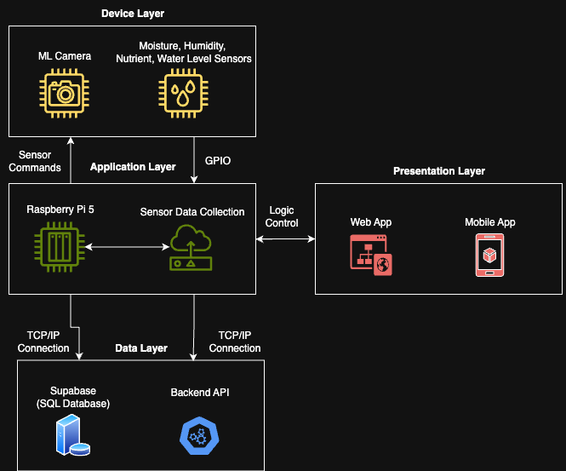
Figure 1. Current Design Concept - System Architecture Version 0.2

Mechanical Design
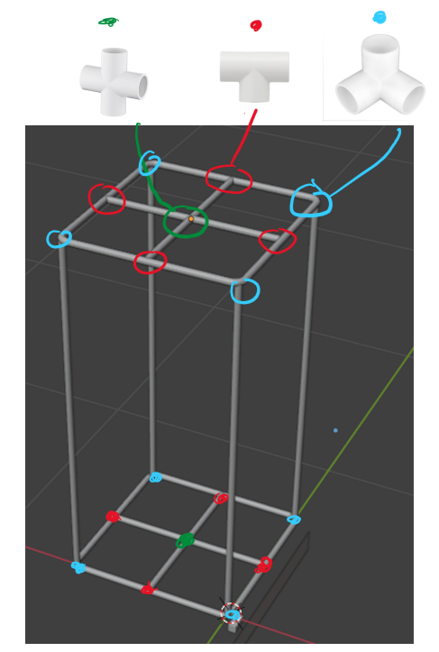 | 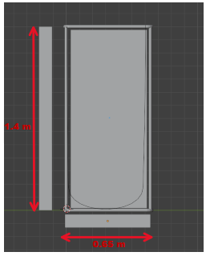
Figure 2. Current Design Concept – 3D Model of Final Product Version 0.1
Electrical Design
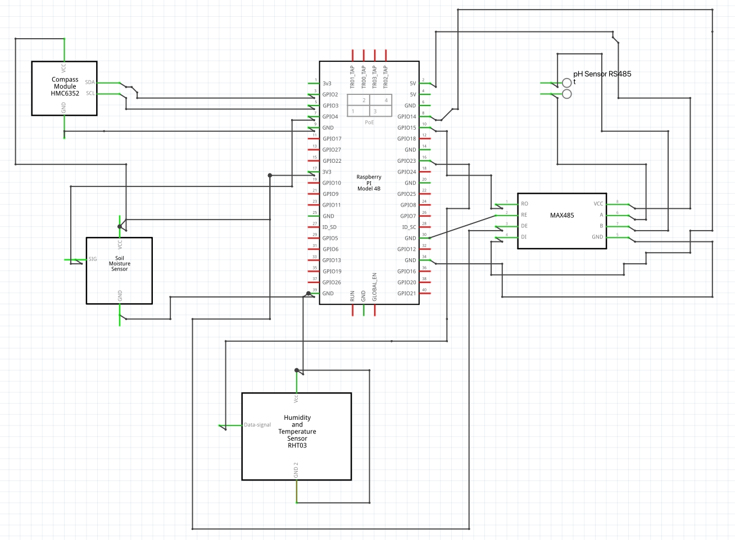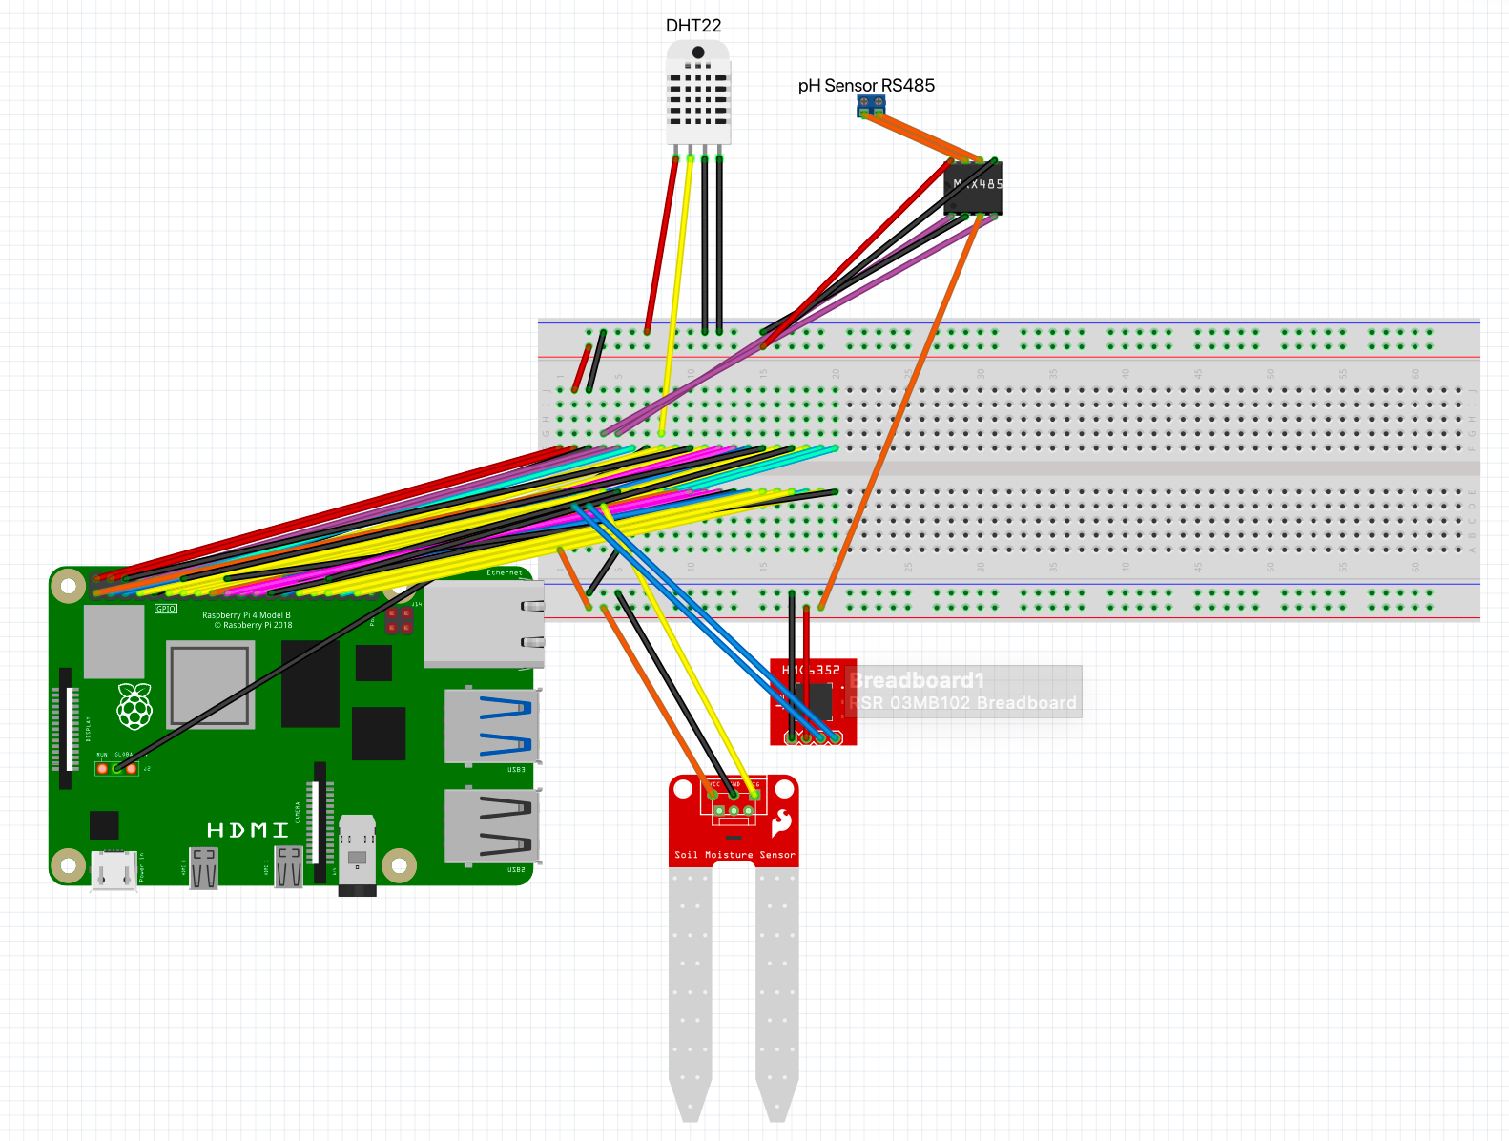
Figure 3. Current Design Concept – Wiring Diagram v0.3

User Interface Design
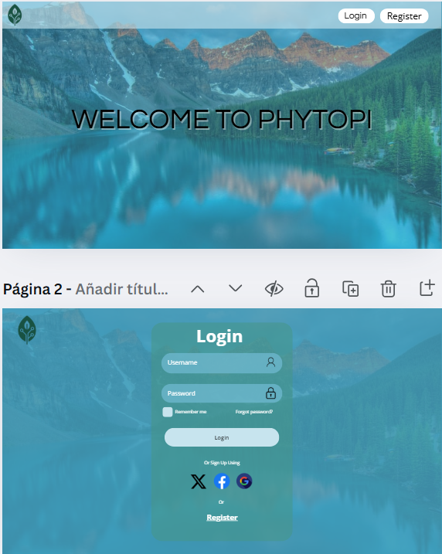   | 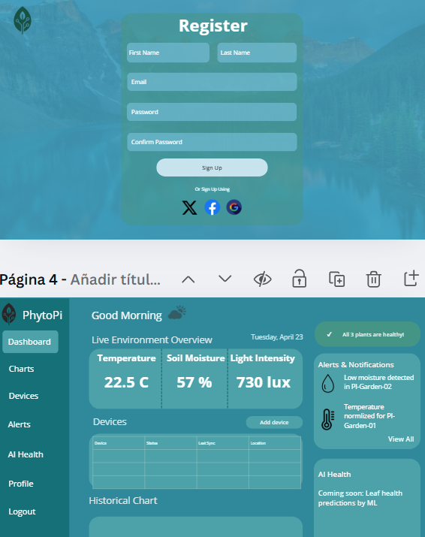  
Figure 4. Current Design Concept – User Interface Version 0.1

Conclusion
At the time of this portfolio’s submission, the PhytoPi project is on schedule for completion, with several key milestones already completed. The complete system design, electrical design, and Figma UI design have all been completed. The next steps focus on the critical path items: finishing the project portfolio, rapid prototyping of 3D-printed plant pot enclosures with integrated sensor slots, completing the database design and row-level rules, testing and calibrating all sensors, implementing timestamped data collection for UI integration, and completing the privacy agreement write-up. With these tasks, the project remains on track to achieve its full functional prototype and meet the planned final milestones.

References
Institute of Electrical and Electronics Engineers. (2024). IEEE standard for fail-safe design of autonomous and semi-autonomous systems (IEEE Std 7009-2024). IEEE. https://doi.org/10.1109/IEEESTD.2024.10582898
Institute of Electrical and Electronics Engineers. (2019). IEEE standard for an architectural framework for the Internet of Things (IoT) (IEEE Std 2413-2019). IEEE. Retrieved from https://standict.eu/standards-repository/ieee-2413-2019-ieee-standard-architectural-framework-internet-things-iot
Institute of Electrical and Electronics Engineers. (2017). IEEE standard for sensor performance parameter definitions (IEEE Std 2700-2017). IEEE. Retrieved from https://standict.eu/standards-repository/ieee-2700-2017-ieee-standard-sensor-performance-parameter-definitions
Institute of Electrical and Electronics Engineers. (2023). IEEE standard for smart transducer interface for sensors and actuators—IoT-enabled smart transducer interface and protocols (IEEE Std 1451-99:2023). IEEE. Retrieved from https://standict.eu/standards-repository/ieee-p1451-99-standard-harmonization-internet-things-iot-devices-and-systems-0
Institute of Electrical and Electronics Engineers. (2017). IEEE standard for system, software, and hardware verification and validation (IEEE Std 1012-2016). IEEE. Retrieved from https://standards.ieee.org/standard/1012-2016.html
Institute of Electrical and Electronics Engineers. (2005). IEEE standard for application and management of the systems engineering process (IEEE Std 1220-2005). IEEE. Retrieved from https://www.semanticscholar.org/paper/IEEE-Std-1220-2005-IEEE-Standard-for-Application-of/3e950074f556365e8cd3a9d8cab0f81402d69da4

Appendix A
Project Timeline

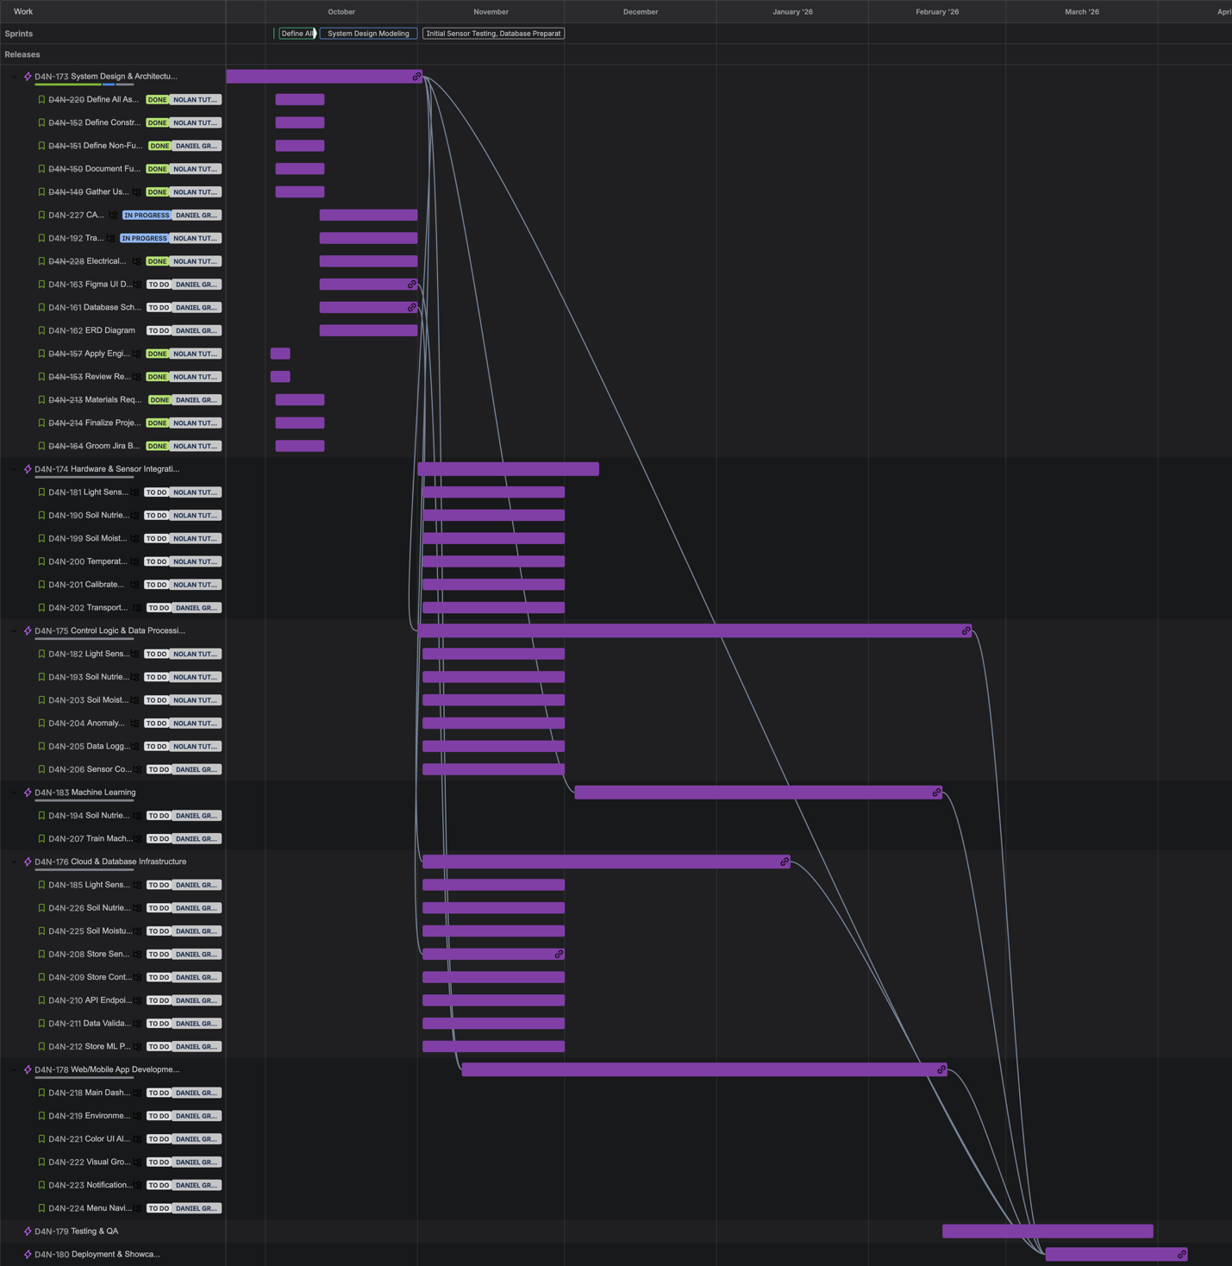
Figure 5: Project Timeline Gantt Chart

Appendix B
Work Breakdown Structure
Table 5: Responsibility Assignment Matrix
Table 6: Team Member Roles Table
Member Name | Email | Team Role
Daniel Grijalva | Dgrijalva3@my.gcu.edu | Software + Cloud Lead
Nolan Tuttle | NTuttle1@my.gcu.edu | Hardware + Integration Lead
Appendix C
Bill of Materials
Table 7: Bill of Materials
ID | Task Category | Item | Specification | Qty | Unit | Unit Price (USD) | Total (USD) | Notes
1 | Automatic Watering System | 12V DC Power Supply (for pump) | Wall adapter 12V 2A | 1 | pcs | 9.99 | 9.99 | Separate from Pi power
2 | Automatic Watering System | 4-Channel Relay Module 5V | Opto-isolated preferred | 1 | pcs | 8.49 | 8.49 | Switch pump and accessories
3 | Automatic Watering System | Adjustable Drip Emitters | 2-10 L/h; pack of 10 | 3 | pcs | 0.60 | 1.80 | One per pot (3 pcs used)
4 | Automatic Watering System | Check Valve (1/4") | Non-return valve | 1 | pcs | 5.99 | 5.99 | Prevents siphoning/backflow
5 | Automatic Watering System | Drip Manifold + 1/4" Barbed Tees | 3-way or 4-way splitter | 1 | set | 9.99 | 9.99 | Fan-out to each pot
6 | Automatic Watering System | Food-Grade Reservoir (1-2 gal) | HDPE container with lid | 1 | pcs | 14.99 | 14.99 | Can repurpose water jug
7 | Automatic Watering System | Inline Mesh Filter (1/4") | Debris filter for pump line | 1 | pcs | 6.99 | 6.99 | Protect emitters from clogging
8 | Automatic Watering System | Silicone/Vinyl Tubing, 1/4" ID | 10-20 ft roll | 1 | roll | 8.99 | 8.99 | Pump to drip lines
9 | Automatic Watering System | Submersible DC Pump (5-12V) | Mini pump 240-300 L/h range | 1 | pcs | 12.99 | 12.99 | Reservoir â†’ drip manifold
10 | Control | Smart Plug (WiFi) | On/Off scheduling via app | 1 | pcs | 6.00 | 6.00 | Optional; Pi can log/control via API
11 | DIY Tent Frame | 12-pack 3 Way PVC Fittings 3/4 Inch | PVC Pipe Connector Elbow | 1 | pcs | 13.25 | 13.25 | Top & bottom corners
12 | DIY Tent Frame | #8 x 3/4" Self-Tapping Truss Head Screws 100 Pcs | #8 x 3/4" Screws | 1 | pcs | 11.49 | 11.49 | Screws for corners
13 | DIY Tent Frame | PVC Pipe, 3/4" Schedule 40 (10 ft sticks) | Cut to length for 24"x24"x55" frame | 5 | stick (10 ft) | 4.86 | 24.30 | ~50 ft total; include ~10% waste
14 | DIY Tent Frame | PVC Tee, 3/4" | Slip x Slip x Slip | 8 | pcs | 0.73 | 5.84 | Mid braces / rigidity
15 | DIY Tent Frame | 12 Pack 3/4" Cross PVC Fitting Connector, 4-Way Cross Furniture Grade Elbow | 3/4" Cross PVC Fitting Connector | 1 | pcs | 13.44 | 13.44 | Middle braces for connection
16 | DIY Tent Frame | Rubber End Caps, 3/4" | Feet for floor protection | 1 | pcs | 6.79 | 6.79 | Vibration damping
17 | DIY Tent Skin | Blackout Fabric (outer) | 57" width; matte black | 4 | yd | 13.99 | 27.98 | Preferablly 110" width but couldn't find black mate color
18 | DIY Tent Skin | Heavy-Duty Coil Zipper #10 | Black; 9.2 m length | 10 | yd | 7.99 | 7.99 | Front door opening
19 | DIY Tent Skin | Hook & Loop (Velcro) Tape | 1 in x 4 in.; sew-on | 2 | m | 4.99 | 4.99 | Cable ports, light sealing
20 | DIY Tent Skin | Polyester Thread (heavy-duty) | UV-resistant, black | 1 | spool | 7.99 | 7.99 | Sewing panels & zipper
21 | DIY Tent Skin | Reflective Mylar (inner) | Emergency blanket, silver | 1 | roll | 31.99 | 31.99 | Highly Reflective Mylar Film Roll
22 | Development & Integration | I²C Level Shifter (3.3V-5V) | Bi-directional 4-ch | 1 | pcs | 6.49 | 6.49 | If any 5V modules are used
23 | Development & Integration | Jumper Wire Kit (M-F/M-M) | Dupont assorted pack | 1 | set | 7.99 | 7.99 | Prototyping & wiring
24 | Development & Integration | MicroSD Card 64GB (A2 U3) | High-endurance recommended | 1 | pcs | 12.99 | 12.99 | OS + logging
25 | Development & Integration | Multimeter (basic) | Auto-ranging preferred | 1 | pcs | 19.99 | 19.99 | Debug power & signal
26 | Development & Integration | Official Pi 5 Power Supply (27W) | USB-C 5V 5A | 1 | pcs | 14.99 | 14.99 | Stable power for Pi 5
27 | Development & Integration | PCA9548A I²C Multiplexer (optional) | 8-channel I²C mux | 1 | pcs | 7.99 | 7.99 | If address conflicts occur
28 | Development & Integration | Raspberry Pi 5 (4-8GB) | Main controller | 1 | pcs | 99.00 | 99.00 | If not already owned
29 | Development & Integration | Solderless Breadboard | 400-830 tie points | 1 | pcs | 6.49 | 6.49 | Sensor prototyping
30 | Development & Integration | USB to TTL Serial Adapter (FTDI/CP2102) | Debug console | 1 | pcs | 8.49 | 8.49 | Headless debug convenience
31 | Display & Showcase | 0.96" I²C OLED Display (SSD1306) | 128x64 px | 2 | pcs | 8.49 | 16.98 | Mini info boards (2x)
32 | Display & Showcase | 7" HDMI Touchscreen for Raspberry Pi | 1024x600 or 800x480 w/ driver board | 1 | pcs | 64.99 | 64.99 | Primary dashboard on tent top
33 | Display & Showcase | Acrylic/PLA Mounting Hardware | Standoffs, brackets, zip ties | 1 | set | 9.99 | 9.99 | Mount displays safely
34 | Display & Showcase | HDMI Cable (short right-angle) | Mini/standard as needed | 1 | pcs | 6.99 | 6.99 | For compact routing
35 | Display & Showcase | USB Cable for Touch (A->Micro/USB-C) | Match touchscreen controller | 1 | pcs | 6.49 | 6.49 | Touch panel signal
36 | Display & Showcase | WS2812B LED Strip (1m, USB/5V) | 30 LEDs/m | 1 | pcs | 9.99 | 9.99 | Ambient attract mode
37 | Integration | Aluminum Foil Tape | HVAC-grade | 1 | roll | 7.00 | 7.00 | Seal light leaks & seams
38 | Integration | Cable Grommet/Gland Assortment | Rubber pass-throughs | 1 | set | 6.00 | 6.00 | Sensor & power cable ports
39 | Integration | Zip Ties | 100-200 mm assorted | 1 | pack | 4.00 | 4.00 | Cable management
40 | Lighting | Rope Ratchet Hangers, 1/8" (pair) | Adjustable light mount | 1 | pair | 7.00 | 7.00 | For LED height control
41 | Lighting | TS600-class LED Grow Light (~100 W) | Mars Hydro TS600 or equivalent | 1 | pcs | 55.99 | 55.99 | Cheapest typical sale price
42 | ML / Imaging | Camera Ribbon Cable (long) | 30-50 cm | 1 | pcs | 6.49 | 6.49 | Route to suitable angle
43 | ML / Imaging | LED Ring Light (USB, dimmable) | 6-10 inch | 1 | pcs | 19.99 | 19.99 | Even illumination for photos
44 | ML / Imaging | Mini Tripod / Gooseneck Mount | Clamp or stand | 1 | pcs | 12.99 | 12.99 | Aim camera at canopy
45 | ML / Imaging | Raspberry Pi Camera Module 3 (Wide) | 12MP, autofocus | 1 | pcs | 34.99 | 34.99 | For plant health images
46 | Sensors & Electronics | ADS1115 16-bit ADC (4-ch) | I²C ADC module | 1 | pcs | 8.99 | 8.99 | Reads analog moisture sensors
47 | Sensors & Electronics | BH1750 Light Sensor | I²C lux sensor, 1-65535 lx | 1 | pcs | 7.99 | 7.99 | Place at canopy height
48 | Sensors & Electronics | BME280 (Temp/Humidity/Pressure) | I²C breakout, 3.3V compatible | 1 | pcs | 9.99 | 9.99 | Air T/RH/Pressure near canopy
49 | Sensors & Electronics | CO2 Sensor (SCD41 or MH-Z19C) | NDIR CO2 sensor (choose variant) | 1 | pcs | 59.00 | 59.00 | Optional but recommended for showcase
50 | Sensors & Electronics | Capacitive Soil Moisture Sensor v2 | Analog output, corrosion resistant | 3 | pcs | 6.49 | 19.47 | One per pot (3 pots max) via ADC
51 | Sensors & Electronics | DS18B20 Waterproof Temp Probe | Stainless steel encapsulated, 1-Wire | 1 | pcs | 8.49 | 8.49 | Soil or reservoir temperature
52 | Sensors & Electronics | Water Level Sensor (Ultrasonic HC-SR04 or Float) | Reservoir level detection | 1 | pcs | 7.99 | 7.99 | Prevent dry-run of pump
53 | Sensors & Electronics | RS485 Soil pH Level Sensor | Soil pH level detection | 1 | pcs | 59.20 | 59.20 | Ensure soil pH is correct for plant
54 | Sensors & Electronics | MAX485 Transceiver Module | Converting TTL UART Serial to RS485 | 1 | pcs | 8.99 | 8.99 | Allow communication with pH level sensor
55 | Ventilation | 120 mm Fan Grills (4-pack) | Protective grills | 1 | pack (4) | 5.99 | 5.99 | Safety & airflow
56 | Ventilation | 120 mm USB Fan (2-pack) | Case fans for intake/exhaust | 1 | pack (2) | 12.99 | 12.99 | Budget airflow solution
 | Internal Airflow | 6" Clip Fan (desk/clip) | Oscillating preferred | 1 | pcs | 37.99 | 37.99 | Circulates air within tent

Appendix D
Customer Feedback
Table 8: Customer Feedback Form
Customer Name: Cayla Dickens | Date: 10/5/25
Relevance: Interested user with little gardening experience, representing the target customer base.
Conversation Notes | Design Requirements
- Finds plant care stressful and confusing and unsure how much to water or how much light plants need.  - Wants reminders and simple visual indicators for plant health.  - Prefers phone notifications for quick, easy alerts.  - Thinks it would be convenient if the system could water automatically when needed. | - System must provide clear visual and textual indicators for plant health.  - Include automated watering based on soil moisture readings.  - Phone notifications for important alerts or reminders.  - Present plant data in an easy-to-understand format.
Customer Name: Noelle Tuttle | Date: 09/28/25
Relevance: Experienced home gardener; familiar with environment control for plants.
Conversation Notes | Design Requirements
- Often forgets to water on time, especially when managing multiple plants.  - Struggles to balance different light requirements across plant types.  - Wants automatic watering and grow light scheduling to reduce manual effort.  - Prefers phone notifications for reminders and lighting alerts. | - Implement reminder notifications for watering and fertilizing.  - Automated grow lights scheduling.  - Push notifications for light exposure needs.
Customer Name: Mathew Hobson | Date: 09/28/25
Relevance: Software Engineer experienced with mobile and IoT technologies
Conversation Notes | Design Requirements
- Interested in real-time monitoring of soil moisture, temperature, and light levels.  - Prefers receiving push notifications for significant environmental changes or alerts.  - Values a responsive, intuitive mobile interface for quick data access and control.  - Noted the importance of reliable data synchronization across devices. | - Develop a responsive mobile dashboard showing real-time sensor data.  - Implement push notifications for environmental alerts.  - Ensure dashboard supports multi-plant monitoring on one screen.

Summary
The customer feedback emphasized a need for automation, ease of use, and clear functionalities. Users with little gardening experience value intuitive visuals and automated care to reduce stress. More experienced gardeners are more focused on scheduling and reminders for watering and lighting. Technical users valued mobile access and live data.
Implementation Plan:
- Integrate automatic watering and grow light scheduling controlled using soil moisture and light sensors.
- Design a mobile dashboard with real-time sensor data, simple visuals, and clear color-coded plant health indicators.
- Implement customizable phone notifications for watering, fertilizing, and environmental alerts.
- Support for viewing and managing multiple plants within one dashboard.
- Use concise, easy-to-read text and visuals so users with varying experience levels can understand plant status at a glance.

