Technical Specifications

for

PhytoPi
Version 1.0 approved
Prepared by Nolan Tuttle, Daniel Grijalva
PhytoPi
11/2/25

Table of Contents
Table of Contents ii
Revision History ii
1. Introduction 1
1.1 Purpose 1
1.2 Standards & Document Conventions 1
1.3 Glossary 2
2. Technical Stack 4
I. Embedded 4
II. Frontend (mobile app) 4
III. Backend (API + database) 4
3. Front End Design 5
4. Basic Logic 9
5. Data Layer 11
6. Security Specifications 14
7. Performance and Scalability 15
8. Deployment and Infrastructure 15
9. Version Control & Development Workflow 17
10. Technical Specification List 18
11. References 42

Revision History
Name | Date | Reason For Changes | Version
Nolan Tuttle | 11/3/25 | Initial Document Creation | 1.0

Member Name | Email | Team Role
Daniel Grijalva | Dgrijalva3@my.gcu.edu | Software + Cloud Lead
Nolan Tuttle | NTuttle1@my.gcu.edu | Hardware + Integration Lead

Introduction

Purpose
PhytoPi is an IoT-based controlled environment system for supporting a plant throughout its entire growth cycle with minimal human intervention. Utilizing embedded hardware and a machine learning system monitoring the plant using a camera, PhytoPi is designed to automatically care for more than 80% of a plant’s required maintenance over its lifespan. The goal upon completion of a minimum viable product is to support at least one species of plant throughout its growth cycle from germination to harvest/maturity, or for at least for 70 days.

Standards & Document Conventions

Requirement Notation

Functional requirements: Prefixed with FR-XXX.

Non-functional requirements: Prefixed with NFR-XXX.

Technical specifications: Prefixed with TS-XXX.

User stories: Prefixed with USR-XXX.
- External references use APA 7th edition formatting.
- URLs included with access date when applicable.

Glossary
API (Application Programming Interface) – A set of endpoints and protocols allowing software components to communicate, such as between the Raspberry Pi and mobile app.
Actuator – A hardware component that performs actions in response to commands, e.g., water pump, fan, or light.
Calibration – The process of adjusting sensors to ensure that their readings match known reference values.
Control Logic – Software rules that automate system actions based on sensor inputs (e.g., turning on a water pump when soil moisture is low).
FR (Functional Requirement) – A requirement specifying a function or behavior that the system must implement.
I²C (Inter-Integrated Circuit) – A serial communication protocol used by microcontrollers and sensors to exchange data.
JWT (JSON Web Token) – A standard for securely transmitting information between parties for authentication and authorization.
Latency – The delay between an event occurring (sensor reading, data transmission) and the system response.
ML (Machine Learning) – Algorithms that analyze plant growth or environmental data to make predictions or decisions.
NFR (Non-Functional Requirement) – A requirement specifying system quality attributes like performance, security, or reliability.
Raspberry Pi 5 (RPi5) – A single-board computer used as the main embedded platform for PhytoPi.
REST (Representational State Transfer) – An architectural style for building networked APIs.
Sensor – A device that measures environmental parameters like temperature, humidity, soil moisture, pH, or light intensity.
Supabase – A cloud service platform providing database, authentication, and real-time features for the system.
Throughput – The amount of data the system can process within a given time frame.
UART (Universal Asynchronous Receiver/Transmitter) – A hardware communication protocol used to transmit data between devices asynchronously.
User Story – A description of a feature or requirement from an end-user perspective, often prefixed with USR-XXX.
Validation – The process of ensuring data conforms to expected ranges or formats before being stored or processed.
WebSocket – A protocol enabling real-time, two-way communication between client and server.
Wi-Fi – Wireless networking technology used for communication between the Raspberry Pi and cloud services.
Workflow – The sequence of steps for development, deployment, or data processing.

Technical Stack

Embedded
  - Platform: Raspberry Pi 5 (64-bit Linux-based OS), ESP32 Microcontroller
  - Programming Languages: C, Bash
  - Libraries/Tools: i2c-dev.h, fcntl.h, unistd.h, ioctl.h, i2cdetect, GNU Debugger
  - Interfaces: I²C, UART (RS-485), GPIO, ADC (ADS1115)
  - Purpose: Sensor data collection and actuation control

Frontend (mobile app)
  - Architecture: REST + WebSocket API Gateway
  - Authentication: OAuth2 / JWT
  - Database: PostgreSQL (hosted via Supabase)
  - File Storage / Realtime Sync: Supabase

Backend (API + database)
  - Mobile App: Flutter (Dart)
  - Web Console: Next.js (React-based)
  - Realtime Communication: WebSocket
  - Purpose: Monitoring, control, and user alerts
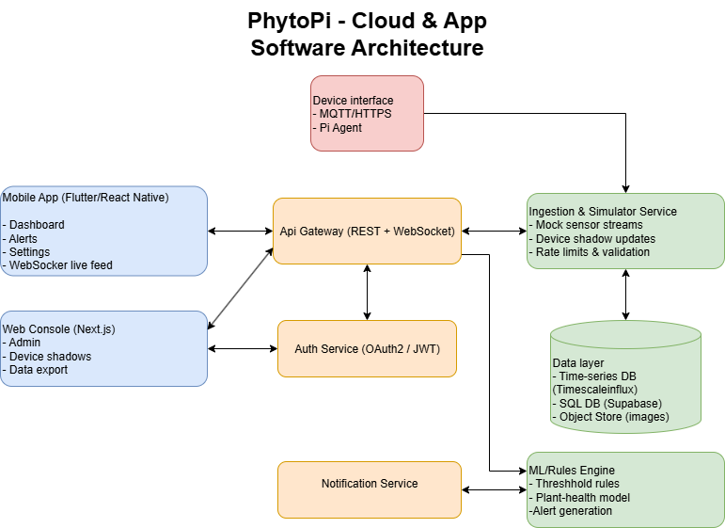
Figure 1: Technical Stack – Software Architecture Diagram

Front End Design

Overview
  - Mobile Application (Flutter): Used for real-time plant monitoring, manual control actions, and environment alerts.
  - Web Console (Next.js): Designed for administrator-level users to view detailed analytics, logs, and configure the system.
- UI/UX Design Principles
  - Simplicity: Focus on creating intuitive, simple menu navigation and essential functions such as viewing sensor data and receiving alerts.
  - Consistency: Reuse icons, colors, themes, and layouts between the web and mobile version as well as across menus.
  - Responsiveness: All components should adapt to screen size and interactive elements such as buttons should respond to users immediately.
- Navigation Structure
  - Dashboard: Displays temperature, humidity, soil moisture, pH, and light levels with color-coded indicators.
  - Control Panel: Manual override for pump, fan, or lighting.
  - Alerts Page: Shows notifications for errors, sensor failures, or critical environmental changes.
  - Settings: User account management, threshold customization, and data history export.

- Wireframes
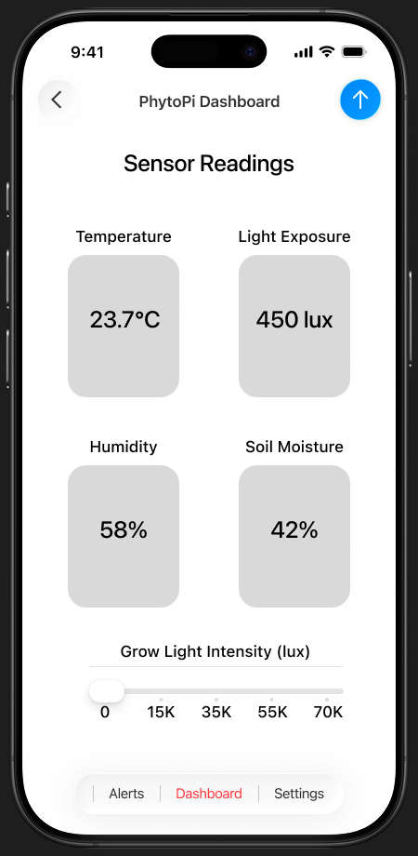
Figure 2: Front End Design – Mobile App Dashboard Wireframe
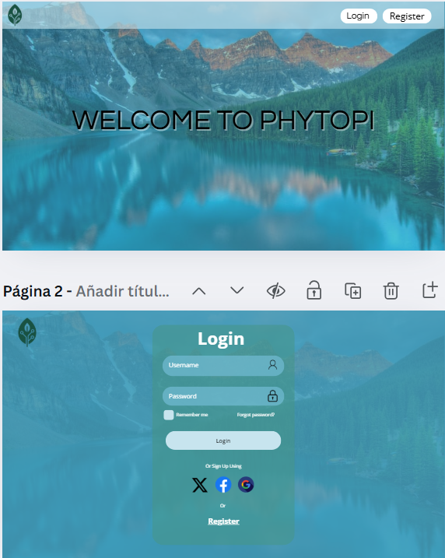
Figure 3: Front End Design – Web Console Login Page Wireframe
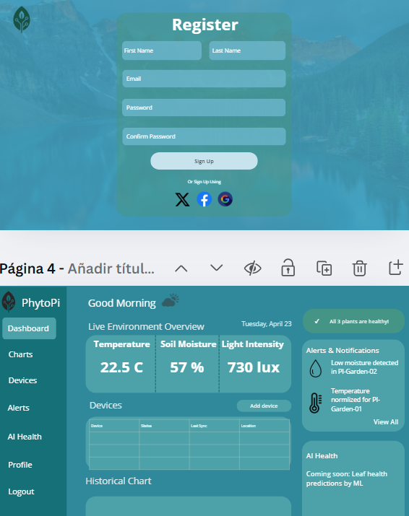
Figure 4: Front End Design – Web Console Registration Page Wireframe

Basic Logic
- UML/Flowcharts
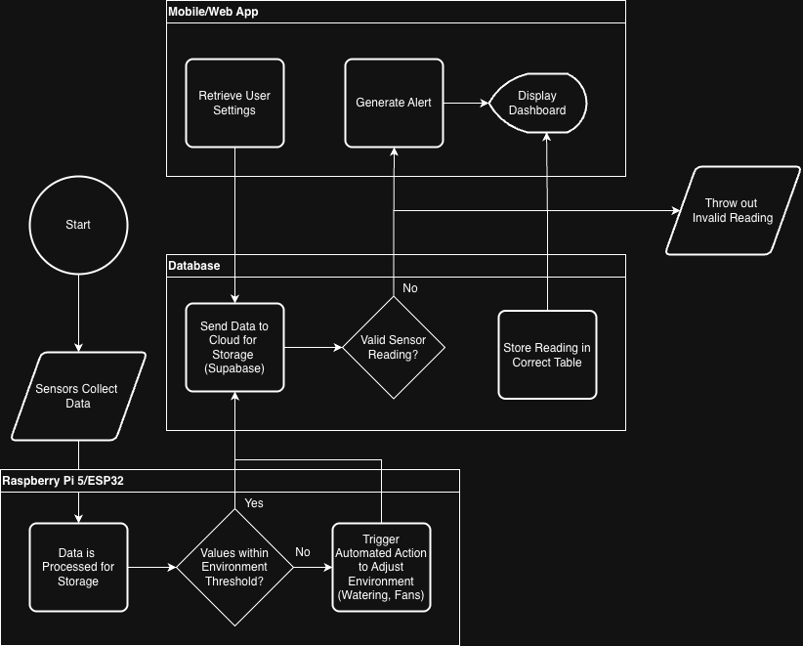
Figure 5: Basic Logic - High-Level Flowchart Logic
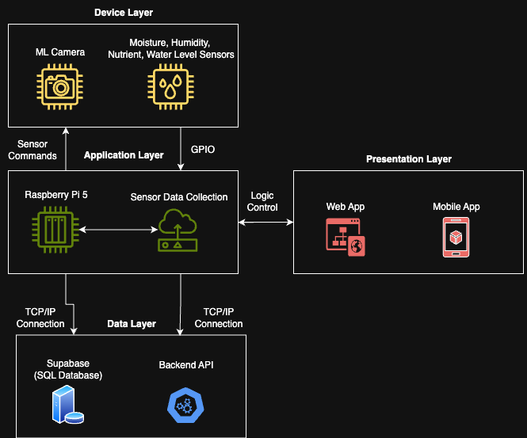
Figure 6: Basic Logic - System Architecture Diagram
- Error/Exception Handling
  - Sensor Errors
    - Detection: Software exceptions, out-of-range readings
    - Action: Log error locally on Raspberry Pi
    - Notification: Send alert to database for mobile app to read
    - Recovery: Continue normal monitoring state if possible
  - Actuator Errors (Water pump, fan)
    - Detection: Software exceptions, pump/fan fails to respond
    - Action: Log error locally on Raspberry Pi
    - Notification: Send alert to database for mobile app to read
    - Recovery: Pause control logic for actuator until issue is resolved
  - Database Failures
    - Detection: Failed write to database
    - Action: Retry write automatically, fallback to storing in a local data queue
    - Notification: Email alert if database remains inaccessible
    - Recovery: Sync queued data when database becomes available
  - Logging Mechanisms
    - Local storage on Raspberry Pi for hardware/actuator failures
    - Log database/API transactions in cloud storage
    - All logs (sensors, actuators, database) are timestamped for debugging purposes

Table 1: API Endpoints
Endpoint | Method | Request Format | Response Format | Description
/sensors/data | POST | {sensor_id, value, timestamp} | {status: “ok”} | Pi sends a new sensor reading
/alerts/new | GET | N/A | {alert_id, type, message, timestamp} | Mobile app fetch for current alerts
/control/pump | POST | {action, timestamp} | {status: “ok”} | Trigger for an environment warning

Authentication for mobile app HTTP requests to the API will be done using JWT tokens, different authorization levels will be available with admins having read/write access to all endpoints and the user-level having access to only read and control actions for their own device.

Data Layer
- Overview
  - The data layer supports persistent storage of sensor readings, actuator states, user preferences, and system logs. It provides the foundation for real-time monitoring, alerting, and control. See Figure 6 to see the separation of concerns between the data layer and the presentation layer, all data is handled by the application/data access layer and cannot be modified by the user directly, following the N-layer architectural principles.

- Data Flow
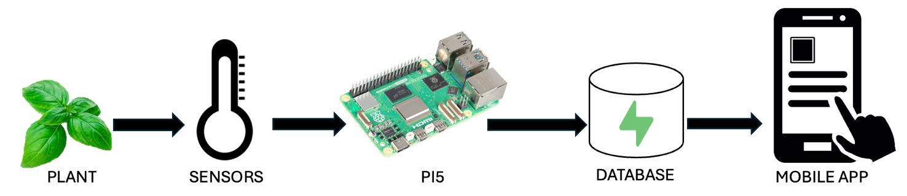
Figure 7: Data Layer – High-Level Data Flow Diagram

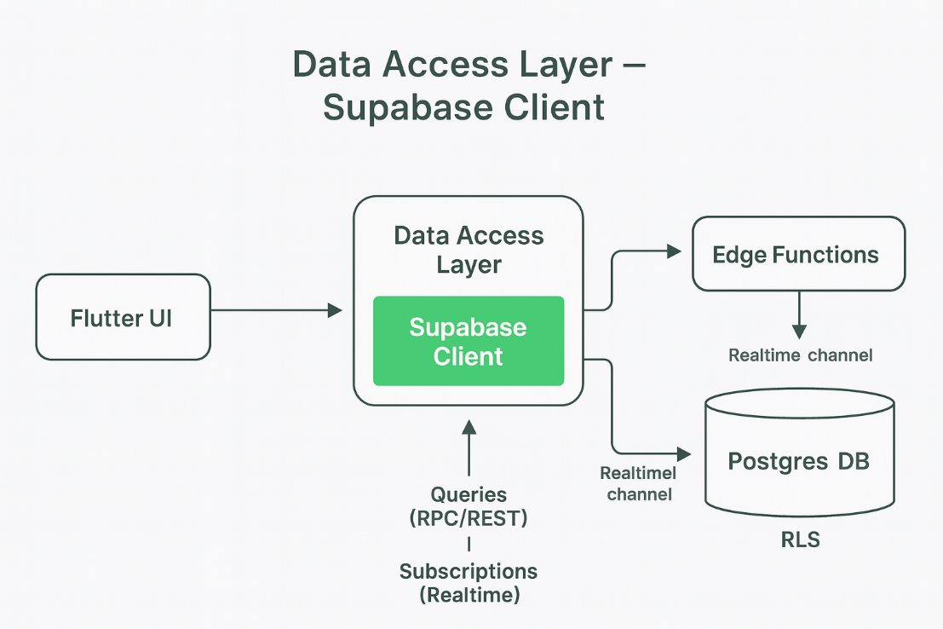
Figure 8: Data Layer – Supabase Client Data Flow Diagram
- Database Schemas
Table 2: Users Database Schema
Field | Type | Description
id | UUID (Pk) | User ID for authorization
email | varchar(50) | User email for signup
created_on | Date | Registration date

Table 3: Sensors Database Schema
Field | Type | Description
id | UUID (Pk) | Sensor record ID
device_id | UUID (Fk devices.id) | Source device
timestamp | Date | Timestamp
soil_moisture | Float | Moisture %
temperature | Float | Temperature in Celsius
humidity | Float | Humidity %
light | Integer | Light Lux Value

Table 4: Control Database Schema
Field | Type | Description
id | UUID (Pk) | Control ID
device_id | UUID (Fk devices.id) | Associated device
light_on | Boolean | Light state
pump_on | Boolean | Pump state
fan_on | Boolean | Fan state

Table 5: Alerts Database Schema
Field | Type | Description
id | UUID (Pk) | Alert ID
device_id | UUID (Fk devices.id) | Linked device
type | varchar(50) | Alert type (e.g. high temp, low moisture)
message | varchar(50) | Alert description
triggered_at | Date | Timestamp
resolved | Boolean | Whether alert has been acknowledged or not

Table 6: Devices Database Schema
Field | Type | Description
id | UUID (Pk) | Unique device ID
name | varchar(50) | Device name
owner_id | UUID (Fk users.id) | Owner of the device

- Validation Rules
  - temperature must be between 0 C and 60 C
  - humidity between 0% and 100%
  - soil_moisture must be between 0 % and 100 %
  - light_lux maximum at 200,000
  - device_id must exist in devices table
  - Foreign keys have cascaded deletion, meaning that when a device is deleted all foreign key related data is removed.

Security Specifications
Authentication: Mobile app users authenticate their sessions by logging in via username and password. On a successful login, a JWT is issued which is used in all future API requests to authenticate that user.

Authorization: The backend verifies the JWT each time a request is received to verify the user is allowed to perform the requested control action.

Storage: All API communications happen over HTTPS and sensitive data, such as user credentials and personal info, is stored encrypted securely in the database.

Compliance: To comply with best security standards, JWT tokens are used for stateless session handling and user passwords are never stored on the app. Open Web Application Security Project (OWASP) mobile app security guidelines are followed when conducting mobile app security tests (OWASP, n.d.).

Performance and Scalability
Sensors: System should capture temperature, humidity, soil moisture, and light data at a minimum interval of once per minute.

Data Logic: Automated control actions such as fan control and plant watering must execute within 2 seconds of receiving sensor data.

Mobile App: Refresh and display real-time data about plant health with <2 second latency when updating dashboard.

Database Storage: Sensor data and logs should be stored in the database without data loss, failed writes should be stored in a local queue and automatically retry, syncing the queue with existing data.

Scalability: When scaling for an increased load, Supabase’s database can be partitioned to handle multiple plants. The sensor network will have a modular design, allowing more sensors to be added without logic modification by utilizing automatic sensor detection. Dashboards and frequently accessed pages on the mobile/web app can be cached for faster load times, API calls can be limited to throttle request load.

Deployment and Infrastructure
- Environments
  - Development Environment
    - Runs locally on developer’s machine with a similar environment to the Pi.
    - Verifies software changes and new sensor integrations before pushes to staging branch.
    - Uses a separate local database instance to avoid modifying the production database.
  - Staging Environment
    - Same as the production setup except used for QA/testing.
    - Deployed on a cloud-hosted VM on Linode that mimics real conditions.
    - Mobile app connects to staging API endpoints to avoid modification of production database, used for validation before production release.
  - Production Environment
    - Live environment where the system interacts with a plant.
    - Raspberry Pi 5 in physical environment continuously runs the control software.
    - Connects to the production database, using it for data storage and authentication.
- Deployment
  - Business Logic
    - Source code managed using Git.
    - Developers will push updates to main branch, triggering automated deployment pipeline through Github Actions.
  - Mobile/Web App
    - Flutter mobile app built and released through Android Studio or Xcode to test device compatibility and mobile app functionality.
    - Next.js web console hosted via Linode cloud virtual machine.
- Infrastructure Requirements
  - Hardware
    - Raspberry Pi 5, sensors, actuators, power supply, network connectivity.
  - Cloud Services
    - Supabase (PostgreSQL, authentication, file storage, WebSocket API), Linode VM.
  - Network
    - Stable Wi-Fi connection for cloud communication.

Version Control & Development Workflow
- Version Control
  - Git Branch Structure
    - Main branch contains tested, deployed, and production-ready code
    - Staging branch contains completed features from development branches before production deployment for testing
    - Feature branches contain individual features/fixes with descriptive names
- Development Workflow
  - Developers code in isolated feature branches for individual features or fixes, with extensive comments and readability-focused style conventions
  - Each feature branch is unit tested locally on the development environment. Automated tests are run on the staging branch via GitHub Actions before merging
  - Pull requests must be submitted for review before merging into main. Reviews verify code quality, functionality, and adherence to project requirements.
  - Merges into main trigger the automated deployment pipeline through GitHub Actions. The pipeline handles building the mobile app, deploying backend code to the Linode VM, and syncing database changes as needed.
  - All changes, features, and bug fixes are documented in commit messages and the project’s Discord to maintain clarity across the team.

Technical Specification List
Technical Specification ID | Technical Specification | Functional Requirement | Functional/Non-functional Requirement ID | Related User Story | Related User Story ID
TS-001 | Create complete electrical wiring diagram for all hardware components. | The system shall provide a complete electrical wiring diagram for all hardware components. | FR-001 | As a developer I need to design an electrical wiring diagram so that I can ensure safety, organization, and proper function of hardware components. | USR-001
TS-002 | Highlight signal and power connections in wiring diagram for clarity. | The system shall highlight all important connections such as signal and power so that the diagram is properly organized. | FR-002
TS-003 | Add safety annotations for high-voltage or sensitive components. | The system shall indicate safety measures for components prone to damage or with high voltage. | FR-003
TS-004 | Ensure diagram output is legible and printable in A4 format. | Output must be legible and printable in A4 format. | FR-004
TS-005 | Generate to-scale 3D model of all hardware components and layout. | The system must generate a to-scale model representing all hardware components and their arrangement. | FR-005 | As a developer I need to design a to-scale model of the system so that I can know which materials will be needed and the dimensions of the system. | USR-002
TS-006 | Export model measurements in standard engineering units for material reference. | The model must export measurements and dimensions in standard engineering units for reference in material selection. | FR-006
TS-007 | Limit model file size to 100 MB for sharing purposes. | Model file size must not exceed 100 MB for sharing purposes. | FR-007
TS-008 | Create database schema for pH readings including sensor ID and pH value. | The schema must include attributes for sensor ID, and pH values. | FR-008 | As a system I need to create a database schema for soil nutrient readings so that the data is easily queryable. | USR-003
TS-009 | Create database schema for soil moisture readings including sensor ID and moisture percentage. | The schema must include attributes for sensor ID, and moisture percentages. | FR-009 | As a system I need to create a database schema for soil moisture readings so that the data is easily queryable. | USR-004
TS-010 | Implement main navigation menu for accessing all system menus. | The system shall allow users to navigate between all menus using the main navigation menu. | FR-010 | As a user, I want dashboards and charts to be responsive and intuitive to navigate so that I can access information quickly. | USR-005
TS-011 | Ensure page navigation occurs in under 1 second on stable internet connection. | Navigating between pages shall occur in under 1 second on a stable internet connection. | NFR-001
TS-012 | Provide toggle options for enabling/disabling alert notifications. | The system shall allow users to enable and disable notifications for alerts from the system. | FR-011 | As a user, I want to configure alert preferences so that I only get notifications that matter to me. | USR-006
TS-013 | Persist user notification preferences across sessions in database. | The system shall store and apply user's notification preferences across sessions. | FR-012
TS-014 | Maintain notification settings error rate below 1% during usability tests. | The notification settings shall have an error rate below 1% in usability testing. | NFR-002
TS-015 | Generate graphical growth trend charts from plant data. | The system shall generate and display graphical growth trends using plant data | FR-013 | As a user, I want to see historical growth data and trend analysis so that I can make informed care decisions. | USR-007
TS-016 | Render growth trend graphs in under 5 seconds after selecting time period. | Graphs shall render in under 5 seconds after time period selection | NFR-003
TS-017 | Display color-coded alerts for plant or environment status. | The system shall display color-coded alerts to indicate plant or environment status. | FR-014 | As a user, I want color-coded indicators of plant stress so that I can quickly see which plants need attention. | USR-008
TS-018 | Update color-coded alerts within 500 milliseconds of status change. | Color changes shall occur within 500 milliseconds of alert status update. | NFR-004
TS-019 | Trigger alerts when environmental readings exceed predefined thresholds. | The system shall generate alerts when environmental readings exceed predefined thresholds. | FR-015 | As a user, I want push notifications to alert me of unexpected environment conditions so that I can act promptly even when away. | USR-009
TS-020 | Deliver alerts to user devices within 2 seconds of detection. | Alerts shall be generated and delivered within 2 seconds of data detection. | NFR-005
TS-021 | Push notifications to user devices when thresholds are exceeded. | The system shall push notifications to the user’s device reading thresholds are exceeded | FR-016
TS-022 | Display real-time sensor data on the main dashboard. | The system shall display real-time data on the main dashboard. | FR-017 | As a user, I want a dashboard showing moisture, temperature, light, and nutrient levels so that I can check my plants remotely. | USR-010
TS-023 | Refresh dashboard data with less than 1 second delay from sensor input. | Dashboard data refresh rate shall not exceed 1 second delay from actual sensor input. | NFR-006
TS-026 | Store machine learning predictions in cloud database. | The system shall store all machine learning predictions in the cloud database. | FR-018 | As a system, I need to store ML predictions in the cloud database so that it can be accessed to display alerts or dashboard information. | USR-011
TS-027 | Ensure storing ML predictions takes no longer than 500 milliseconds. | Storing machine learning predictions in the cloud should not take longer than 500 ms. | NFR-007
TS-028 | Validate incoming sensor data against defined acceptable ranges before storage. | The system must check each section of incoming sensor data against defined acceptable ranges before storage. | FR-019 | As a system, I need to validate incoming data so that corrupt or out-of-range data is flagged or rejected. | USR-012
TS-029 | Flag or reject missing or out-of-range sensor data points. | The system must flag or reject data points that are missing, or outside threshold values. | FR-020
TS-030 | Complete data validation process in under 100 milliseconds per reading. | Data validation process must complete in under 100ms per reading. | NFR-008
TS-031 | Maintain data validation accuracy of at least 99%. | Data validation accuracy >= 99% | NFR-009
TS-032 | Provide secure API endpoints for retrieving sensor data, alerts, and ML predictions. | The system shall provide secure API endpoints for retrieving sensor data, alerts, or ML predictions. | FR-021 | As a system, I need to provide secure endpoints to retrieve sensor and ML data so that the business logic layer can access information safely. | USR-013
TS-033 | Require authentication tokens for all API data access requests. | The system shall require authentication tokens for each data access requests. | FR-022
TS-034 | Ensure API response times do not exceed 1 second for 95% of requests. | API response times shall not exceed 1 second for 95% of requests. | NFR-010
TS-035 | Enforce HTTPS and encrypt all data in transit for all endpoints. | All endpoints should use HTTPS and enforce encryption of data during transit. | FR-023
TS-036 | Store automated or manual control actions with timestamp, type, and description. | The system must store each automated or manual control action along with its timestamp, type, and description. | FR-024 | As a system, I need to store timestamps and logs of all control actions so that the system trends can be analyzed._ | USR-014
TS-037 | Organize control action data in structured format for analytics and UI usage. | The system must organize control action data in a structured format for analytics or use in UI. | FR-025
TS-038 | Ensure storing control logic actions occurs in under 500 milliseconds. | Storing a received control logic action must occur in <= 500ms | NFR-011
TS-039 | Retain stored control logic actions in database for at least 90 days. | Stored control logic actions must be retained in the database for >= 90 days | NFR-012
TS-040 | Record all incoming sensor data with timestamps and sensor type. | The system must record all incoming sensor data along with their timestamps and sensor type. | FR-026 | As a system, I need to store all sensor readings in a cloud database so that historical and real-time data are accessible to other systems._ | USR-015
TS-041 | Maintain database writing latency under 200 milliseconds. | Database writing latency must not exceed 200ms | NFR-013
TS-042 | Record all incoming sensor data with timestamps and sensor type. | The system must record all incoming sensor data along with their timestamps and sensor type. | FR-027 | As a system, I need to feed camera plant images into the ML model so that growth and stress can be detected automatically._ | USR-016
TS-043 | Ensure database writing latency does not exceed 200 milliseconds. | Database writing latency must not exceed 200ms | NFR-014
TS-044 | Define minimum and maximum thresholds for each sensor type to ensure valid readings. | The system shall define minimum and maximum thresholds for each sensor type (e.g., soil moisture, pH) to ensure valid readings. | FR-029 | As a system, I need to apply thresholds and rules to sensor readings so that automated interventions are accurate in the event of sensor failure or unexpected conditions._ | USR-017
TS-045 | Validate sensor thresholds in under 100 milliseconds per reading. | Sensor threshold validation shall occur in under 100 ms per reading. | NFR-015
TS-046 | Record every automated action executed by control logic. | The system shall record every automated action executed by control logic. | FR-030 | As a system, I need to log all automated actions taken by control logic so that historical trends are available for analysis._ | USR-018
TS-047 | Timestamp each control action and include outcome in log entry. | The system shall timestamp and include outcome for each log entry. | FR-031
TS-048 | Store action logs with capacity to retain at least 30 days of data. | The storage capacity for action logs should store >= 30 days | NFR-016
TS-049 | Retrieve logs of control logic actions within 2 seconds. | Retrieving logs of control logic actions should take <= 2 seconds. | NFR-017
TS-050 | Continuously compare sensor readings against expected ranges. | The system shall continuously compare sensor readings against expected readings. | FR-032 | As a system, I need to detect when readings from sensors are not within expected range so that notifications can be sent promptly. | USR-019
TS-051 | Flag abnormal readings and generate corresponding alert messages. | The system shall flag abnormal readings and generate alert messages. | FR-033
TS-052 | Log anomalies in storage for later review. | The system shall log anomalies in storage for later review. | FR-034
TS-053 | Detect anomalies with latency under 2 seconds. | The latency for anomaly detection is <= 2 seconds. | NFR-018
TS-054 | Maintain false positive rate of anomaly detection below 5%. | The false positive rate for anomaly detection is <= 5%. | NFR-019
TS-055 | Retain stored anomaly detection alerts for at least 30 days. | Stored anomaly detection alerts are retained >= 30 days. | NFR-020
TS-056 | Compare soil moisture readings against defined thresholds. | The system shall compare soil moisture readings against defined thresholds. | FR-035 | As a system, I need to evaluate soil moisture data so that the system can trigger watering alerts or automation. | USR-020
TS-057 | Trigger automatic watering when soil moisture is below threshold. | The system shall trigger automatic watering when moisture is below threshold. | FR-036
TS-058 | Evaluate soil moisture levels against thresholds in under 5 seconds. | The system shall evaluate soil moisture levels against threshold in < 5 seconds. | NFR-021
TS-059 | Ensure automatic watering system reliability is at least 99%. | The automatic watering system reliability should be >= 99% | NFR-022
TS-060 | Automatic watering system responds within 15 seconds of unexpected moisture levels. | The automatic watering system should respond within 15 seconds of unexpected soil moisture levels. | NFR-023
TS-061 | Transmit validated sensor readings to Raspberry Pi every 10 seconds using secure protocol. | The system shall transmit validated sensor readings to the Raspberry Pi every 10 seconds using a secure communication protocol | NFR-024 | As a system, I need to transport sensor readings to the Raspberry Pi so that downstream logic systems have accurate data for use._ | USR-021
TS-062 | Maintain minimum 99.5% successful transmission rate under stable network conditions. | The system shall maintain a minimum 99.5% successful transmission rate under stable network conditions. | NFR-025
TS-063 | Ensure data transmission latency does not exceed 300 milliseconds per packet. | Data transmission latency shall not exceed 300 ms per packet. | NFR-026
TS-064 | Provide calibration routine for each connected sensor. | The system shall provide a calibration routine for each sensor connected. | FR-037 | As a system, I need to calibrate all sensors so that readings are consistent and trustworthy._ | USR-022
TS-065 | Verify calibration accuracy against known reference values. | The system shall verify calibration accuracy against known reference values. | FR-038
TS-066 | Complete calibration routine within 5 seconds per sensor. | Calibration routine shall complete within 5 seconds per sensor. | NFR-027
TS-067 | Maintain system uptime above 99% during calibration. | The system uptime during calibration > 99% | NFR-028
TS-068 | Read temperature from sensors at specified intervals. | The system shall read temperature from temperature sensors at specified intervals. | FR-039 | As a system, I need to collect temperature and humidity readings so that environmental monitoring is complete._ | USR-023
TS-069 | Read humidity from sensors at specified intervals. | The system shall read humidity from humidity sensors at specified intervals. | FR-040
TS-070 | Store and timestamp temperature and humidity readings in local storage. | The system shall store and timestamp temperature and humidity readings in local storage for later use. | FR-041
TS-071 | Maintain sensor accuracy of ±1.0°C for temperature readings. | Sensor accuracy must be ±1.0°C for temperature readings. | NFR-029
TS-072 | Maintain sensor accuracy of ±5% for humidity readings. | Sensor accuracy must be ±5% for humidity readings. | NFR-030
TS-073 | Ensure system uptime above 99% when collecting readings. | System uptime when collecting readings is >99% | NFR-031
TS-074 | Read soil moisture values from moisture sensors at specified intervals. | The system shall read soil moisture values from moisture sensors at specified intervals. | FR-042 | As a system, I need to collect soil moisture readings so that control logic and ML have accurate input._ | USR-024
TS-075 | Store and timestamp soil moisture readings in local storage. | The system shall store and timestamp soil moisture readings in local storage for later use | FR-043
TS-076 | Ensure soil moisture sensor readings have latency under 1 second. | The sensor readings have a latency of < 1 second. | NFR-032
TS-077 | Maintain uptime above 99% for soil moisture monitoring. | The uptime for soil moisture monitoring is > 99% | NFR-033
TS-078 | Analyze historical pH data to detect imbalances. | The system shall analyze historical pH data to determine imbalances. | FR-044 | As a system I need to analyze historical soil nutrient and pH data so that I can predict when a plant will require replenishment. | USR-025
TS-079 | Generate recommendations for pH adjustment based on analysis. | The system shall generate recommendations for adjustment based on analysis results. | FR-045
TS-080 | Achieve analysis accuracy of at least 95% against known nutrient tests. | Analysis accuracy shall achieve at least 95% when validated against known nutrient test results. | NFR-034
TS-081 | Complete analysis computations within 3 seconds per plant dataset. | Analysis computations shall complete within 3 seconds per plant dataset. | NFR-035
TS-082 | Compare optimal soil pH readings against detected pH levels. | The system shall compare optimal pH soil readings against detected pH levels. | FR-046 | As a system I need to evaluate pH readings so that I can determine when a plant requires additional nutrients. | USR-026
TS-083 | Record nutrient-related alerts and anomalies for trend analysis. | The system shall record nutrient-related alerts/anomalies for trend analysis | FR-037
TS-084 | Maintain pH level detection accuracy of at least 90%. | The accuracy of pH level detection >= 90% | NFR-036
TS-085 | Retain alert logs for at least 30 days. | The alert log must be retained for >= 30 days. | NFR-037
TS-086 | Collect soil nutrient readings at specified intervals. | The system shall collect soil nutrient readings at specified intervals. | FR-038 | As a system, I need to collect soil nutrient and pH readings so that reliable data is available for nutrient alerts and ML._ | USR-027
TS-087 | Collect soil pH readings at specified intervals. | The system shall collect soil pH readings at specified intervals. | FR-049
TS-088 | Store and timestamp soil nutrient and pH readings in local storage. | The system shall store and timestamp soil nutrient and pH readings in local storage for later use. | NFR-038
TS-089 | Maintain soil nutrient sensor accuracy of ±5%. | The soil nutrient sensor has an accuracy of ±5% | NFR-039
TS-090 | Maintain pH sensor accuracy of ±0.2. | The pH sensor has an accuracy of ±0.2. | NFR-040
TS-091 | Ensure data integrity of sensor readings with no data loss over 24 hours. | The data integrity of sensor reading is ensured so that no data loss occurs over a 24 hour period | NFR-041

Jira Link: https://plantgrowthmanager.atlassian.net/jira/software/projects/D4N/summary

References
Open Web Application Security Project. (n.d.). OWASP Mobile Application Security (MAS) project. OWASP. Retrieved November 2, 2025, from https://owasp.org/www-project-mobile-app-security/

