ESG-451 Weekly Status Update
PhytoPi

Project Description
PhytoPi is an IoT-based controlled environment system for supporting a plant throughout its entire growth cycle with minimal human intervention. Utilizing embedded hardware and a machine learning system monitoring the plant using a camera, PhytoPi is designed to automatically care for more than 80% of a plant’s required maintenance over its lifespan.

Project Status Summary Percent Complete 15%
The PhytoPi project is on-track for completion on the projected timeline. Currently, the Hardware/Integration Lead is beginning development of temperature and humidity collection and timestamping software. The Software/Cloud Lead is working on populating the database with sample values and settings rules for the tables.

Timeline Snapshot

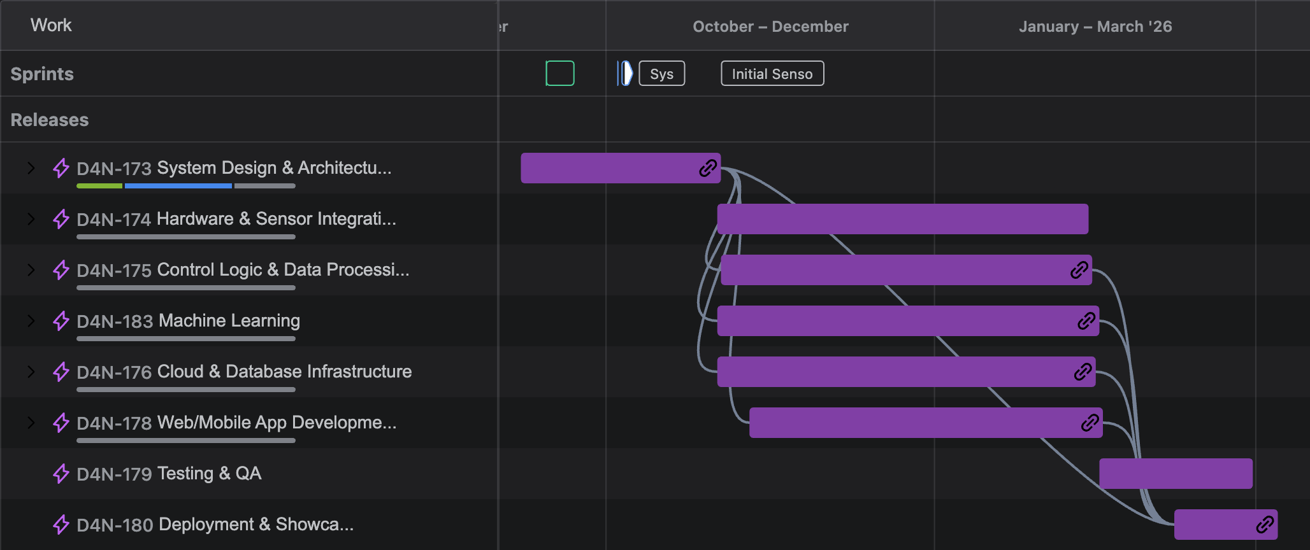

Current Concept
The current design concept featured in Figure 1 is an improvement over version 0.2 of the System Architecture by offering a basic logical flowchart of sensor data collection to cloud storage. In Figure 2 we created a prototype of our physical product architecture. Figure 3 features a new UI design , improved from version 0.1 by adding a mobile app layout for the dashboard. Figure 4 features an electrical schematic and physical layout of devices wired to the main controller.

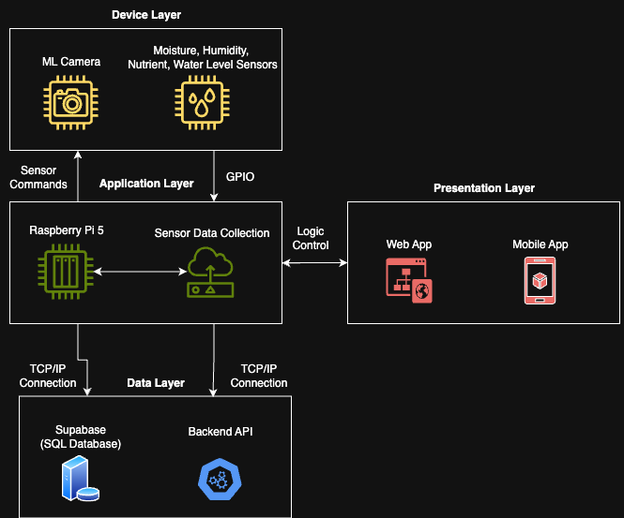
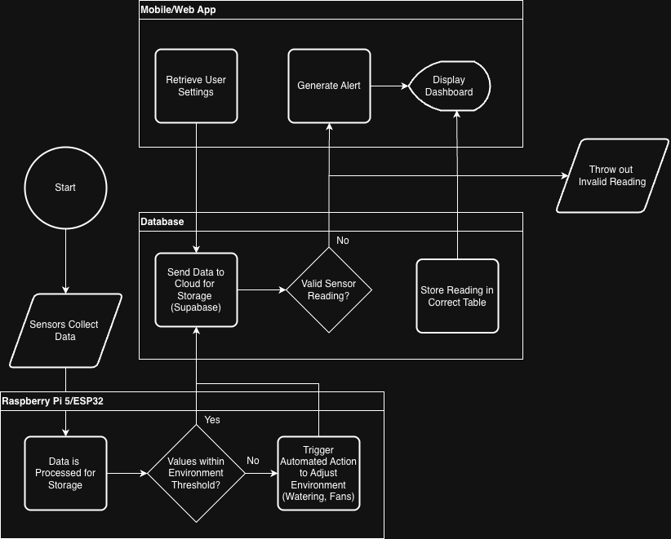
Figure 1. Current Design Concept - System Architecture Version 0.3

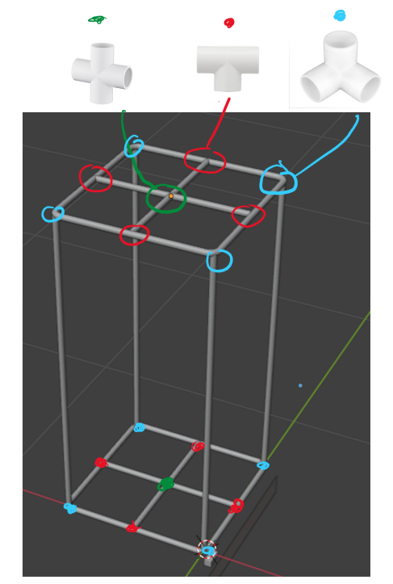 | 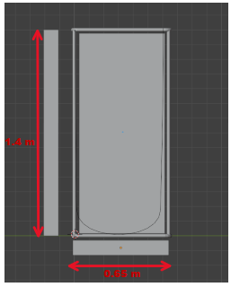
Figure 2. Current Design Concept – 3D Model of Final Product Version 0.1

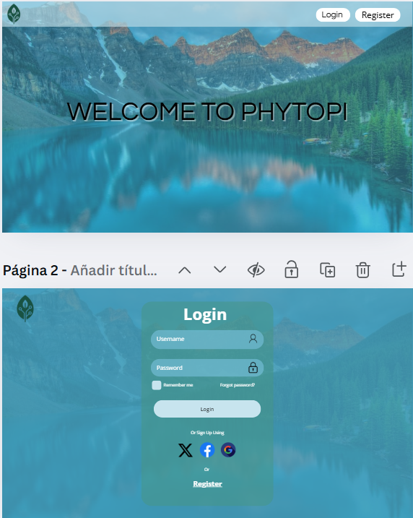  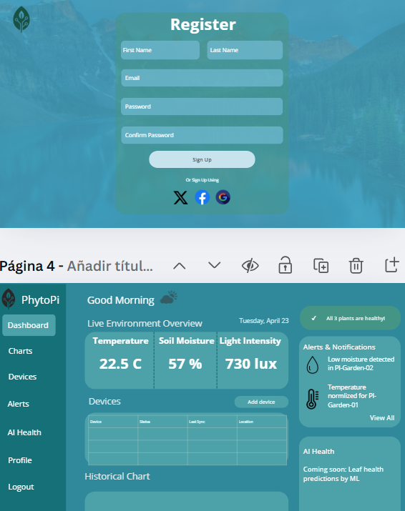 | 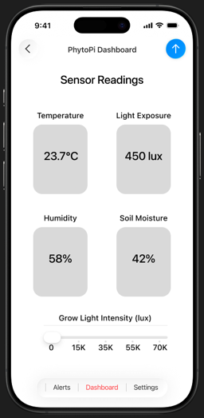
Figure 3. Current Design Concept – User Interface Version 0.2

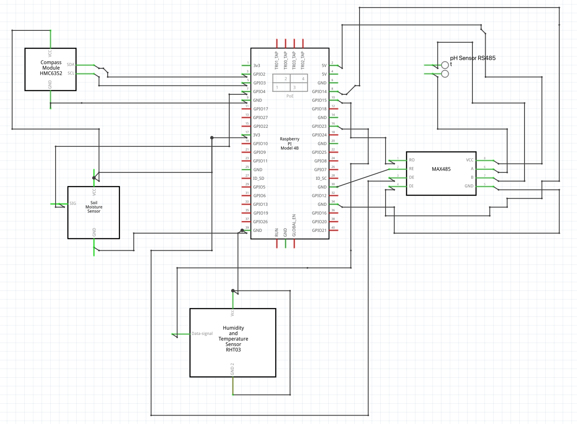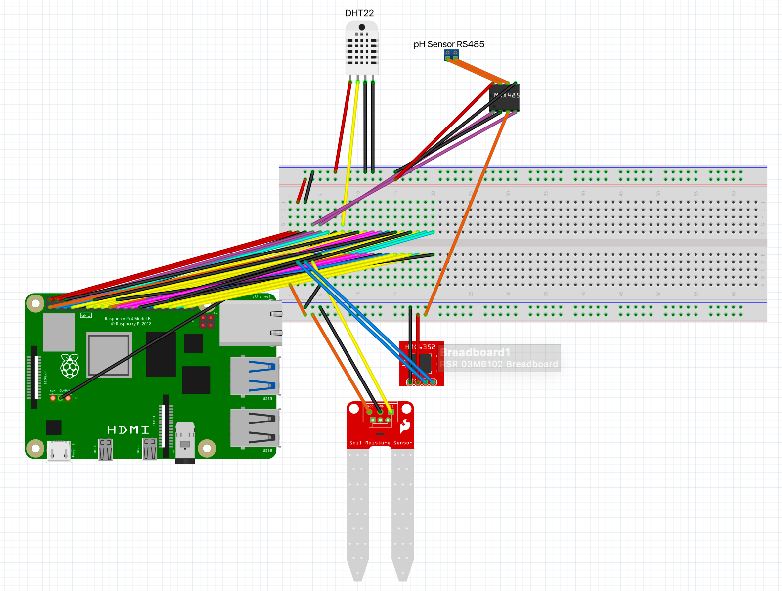
Figure 4. Current Design Concept – Wiring Diagram v0.3

Accomplishments and Learning
Planned from last week:
- Figma UI design – completed
- Finalize all project requirements – complete
- Database Schema – complete
- Entity Relationship Diagram – complete
- Project Portfolio –complete
- Technical Specifications – complete
- Soil Moisture Collection Logic – 5% completed
- Privacy agreement write-up – 10% completed
- Temperature/Humidity Collection Logic – 15% completed
- Further Jira Grooming/Improvement – 10% completed
- Test Plan Documents – 5% completed

Unplanned:
- Light Intensity Collection Logic
- Soil Moisture Collection Logic
- Plant Pot CAD Design
- Send Sample Readings to Database
Learning:
- Clear communication between team members is necessary for critical path items that require completion and distribute workload effectively.
- Document storage should be uncluttered and very clearly titled, with no duplicates or differing filetypes, and all documents should be kept locally as well as in cloud storage.

Work Planned for Next Week

- Critical Path – Test timestamping, recording, and moving collected sensor data efficiently in a format acceptable for moving to UI display.
- Finish test plan document according to IEEE standards
- Test and calibrate all available sensors for accurate data collection/compatibility.
- Set row-level rules for temperature and humidity values in database.
- Complete privacy agreement write-up.

Risks
- CAD design for plant pot might prove to be more difficult than expected with the lack of 3D modeling experience between both team members. This can be mitigated by making rapid prototyping for this a critical path for the project and emphasizing the importance of effort into this design.
- Without careful consideration of the entity relationships within the database, it may be the case that the database structure does not function as intended for data storage or does not follow the intended structure of our tables. This would require refactoring of the database structure, resulting in a time delay of up to one week.

Deliverables and Milestones

Milestone | Planned | Forecasted | Actual | Status
Database Infrastructure | 11/30/25 | 11/30/25 | N/A | On Schedule
Complete System Design | 10/31/25 | 11/1/25 | N/A | On Schedule
Complete Initial Sensor Testing | 11/30/25 | 11/30/25 | N/A | On Schedule
Deliverable | Planned | Forecasted | Actual | Status
Project Portfolio | 10/31/25 | 10/31/25 | 10/31/25 | Complete
Technical Specifications | 11/2/25 | 11/2/25 | 11/3/25 | Complete
Database Entity Relationship Diagram | 11/1/25 | 11/1/25 | 11/2/25 | Complete
Timestamped Sample Readings for Temperature | 11/12/25 | 11/12/25 | N/A | On Schedule

Attachments
N/A

Approvals:

Team Role | Print Name | Signature | Date
Product Manager/Hardware + Integration Lead | Nolan Tuttle | Nolan Tuttle | 11/7/25
Software + Cloud Lead | Daniel Grijalva | Daniel Grijalva | 11/7/25
Faculty Mentor | Bill Hughes | Bill Hughes | 11/7/25

