Supplementary Material S1. Event-marker timing calibration of the vMMR EEG set-up
Optical validation of Lab Streaming Layer (LSL) event markers recorded with a g.HIamp amplifier in Simulink, and the correction applied to all event latencies
Calibration data recorded 14–15 October 2026 (pilot 6–13 October 2026). Code and analysis: https://github.com/DanielAtad/vMMR_EEG_PsychoPy_experiment (branch photodiode-latency-calibration, commit [to be inserted at submission]).

Summary
Event markers in this study are sent by the stimulus computer over the Lab Streaming Layer (LSL) and recorded with the EEG on a separate computer. Because a photodiode cannot be used during experimental sessions, we calibrated the delay between each marker and the physical appearance of the stimulus on the screen in a dedicated database of 22 sessions recorded on 2 days (4,200 full-white flashes at the screen centre, detected with an optical sensor recorded by the EEG amplifier). Each marker was placed on the EEG time axis by its LSL send timestamp, converted to the recording computer's clock and then to amplifier sample time.
- Correction: the stimulus light reaches the screen centre 62.4 ms after the timestamp-placed marker (95 % CI 61.7–63.0 ms). Sessions differ by SD 1.4 ms; a new session is expected within 59.4–65.3 ms (95 % prediction interval).
- Per-event precision: after correction, single events deviate from the optical onset with SD 5.7 ms; 97.7% lie within ±10 ms and all within one display frame (max 13 ms; leave-one-session-out). This residual is set by the display and cannot be removed with markers alone.
- Stability: no drift over a 29-min session (-0.04 ms/min), no difference between short and long sessions, and a day difference of 1.3 ms (p = 0.07).
- Method matters: using the marker as recorded by the Simulink LSL block gives a between-session SD of 9.3 ms and single-event errors up to 26 ms; the timestamp-based placement is therefore required.
- Replication: the same procedure applied to 8 independent pilot sessions gave a between-session SD of 0.9 ms; with the sensor in the bottom-right corner the offset was 2.0 ms larger, as expected from top-to-bottom screen refresh.
- No session met any of the pre-defined exclusion criteria.

S1.1 Background
ERP latencies are measured relative to event markers, so any fixed or variable delay between a marker and the physical stimulus shifts or smears the averaged waveform (Luck, 2014). Reporting guidelines therefore ask for the timing accuracy of event codes to be verified and reported (Keil et al., 2014; Pernet et al., 2020), and timing errors in stimulus software and hardware are a known source of irreproducibility (Plant, 2016; Bridges et al., 2020). Display timing is usually validated with an optical sensor on the screen (Elze, 2010; Plant et al., 2004).
In this set-up the stimulus computer (PsychoPy; Peirce et al., 2019) sends integer markers as an LSL stream (Kothe et al., 2024) to a second computer that records EEG with a g.HIamp amplifier in Simulink. Three delays separate a marker from the light it labels: the display pipeline (from the PsychoPy flip to light emission), the network and LSL inlet, and the amplifier's block-wise data delivery to the recording model. During pilot testing, a one-off pause of the stimulus process while it opened its full-screen window (~0.8 s) left the recording model permanently behind the marker stream; the sender was changed so that the LSL stream is created only after the window is open (S1.8). All data reported here were recorded with the corrected sender. The optical sensor is used only for calibration and is removed for experimental sessions.

S1.2 Set-up
Table S1. Hardware and software
Component | Details
Stimulus computer (B) | AMD Ryzen 3 3200G, integrated Radeon Vega 8 graphics (driver 31.0.21916.2), Windows 11 Education 10.0.26200; Python 3.10.22, PsychoPy 2026.2.4, pylsl 1.18.5 (liblsl 1.18)
Display | Dell P2426H, 1920 × 1080, Windows refresh setting 59.94 Hz; measured 59.93–59.95 Hz in every session (PsychoPy getActualFrameRate); full-screen window, waitBlanking on
Recording computer (A) | g.tec g.HIamp ([model/channel count TBD]), 600 Hz, read by the g.HIamp Simulink block (frame length 8 samples = 13.3 ms); MATLAB/Simulink R2020a, g.HIsys [version TBD], liblsl-Matlab [version TBD]; Windows [version TBD]
Simulink model | Fixed-step discrete solver, step 1/600 s, single-tasking, no pacing; EEG, optical sensor and marker multiplexed and written to file at every step; recording stops on marker 255
Marker reception | (1) g.HIsys LSL Receive block, 600 Hz (marker value per step); (2) custom MATLAB System block LSLMarkerTimestamps (second inlet; per step: marker, rising-edge code, its LSL send timestamp, clock offset B→A from LSL time_correction refreshed every 1 s, and A's LSL clock at the step), saved to a separate file
LSL stream | One int32 channel, type Markers, nominal rate 600 Hz; the sender pushes a sample every 1/600 s (achieved 599.995–600.002 Hz), holding each code for the stimulus duration (calibration) or 100 ms; network: local Ethernet between A and B
Optical sensor | g.tec optical sensor (GTEC-0270) taped over a 45 × 45 px full-white square at the screen centre → g.TRIGbox (GTEC-0274W) → trigger adapter (GTEC-0274TR) → g.HIamp digital input, recorded as an EEG channel at 600 Hz

S1.3 Calibration procedure
The calibration script (run_photodiode_latency_v1_trig_after_framerate_measurement.py) uses the same window, frame-based timing and LSL sender as the experiment. Each session consisted of: start-up and refresh-rate check (the session stops if the measured rate deviates > 2 % from 59.94 Hz); creation of the LSL stream; sensor alignment; an experiment-start marker; 2 s black; a polarity calibration (3 s dark, 3 s white, 3 s dark); 2 s black; and the flash block.
- Flashes: the white square is shown for a whole number of frames and the flash marker (code 20) is pushed from a flip callback (win.callOnFlip), i.e. immediately after the buffer swap of the first frame of the flash. The flash duration increases by one frame per flash (6 to 105 frames, 100 ms to 1.75 s) and repeats every 100 flashes, so each optical pulse can be matched to its marker by its width. Inter-flash intervals were drawn at random from 21–39 frames (0.35–0.65 s) to prevent phase-locking with the 600 Hz LSL and amplifier cycles.
- Session types: short (100 flashes, ~3 min), long (400 flashes, ~10 min) and full experiment length (1200 flashes, ~29 min). Fresh starts of the recording model for every session sample the run-to-run variation that arises at each start.
- Fixed configuration: identical hardware, software versions and settings in all sessions; the sensor was not moved between sessions.
Table S2. Calibration database
Day | Short (100) | Long (400) | Full length (1200) | Flashes
14 Oct 2026 | 6 | 1 | 0 | 1000
15 Oct 2026 | 12 | 2 | 1 | 3200
Total | 18 | 3 | 1 | 4200

Exclusion criteria (defined before recording): sender resynchronisations (lsl_resyncs) > 0; a lasting backlog of the recording model > 5 ms; < 95 % of flashes paired with an optical pulse; dropped display frames > 1 %; incomplete session. None of the sessions met any criterion.

S1.4 Analysis
Optical onsets and pairing. Pulses were extracted from the optical channel and from the marker channel (gaps < 30 ms bridged, pulses < 30 ms ignored). The sensor polarity was taken from the polarity calibration and the width ramp. In every session the number of optical pulses equalled the number of flash markers and the pulse widths followed the marker widths (r > 0.99), so the n-th optical pulse was paired with flash n.
Placing a marker by its LSL timestamp. Three clocks are involved: B's LSL clock (send timestamp t_B), A's LSL clock (t_A, read at every model step) and the amplifier sample clock, which defines the EEG time axis (τ = sample index / 600 Hz). The offset between the two LSL clocks, Δ_BA, is estimated continuously by LSL. The relation between t_A and τ is observed at every model step as
lag(k) = t_A(k) − τ(k)
Because the amplifier delivers its data in frames of 8 samples, the model processes each frame in a burst after it arrives: within a frame, lag varies by up to one frame (13.3 ms), and in some sessions the model ran steadily about one frame behind instead (Fig. S2A). The first sample of a frame has waited the full frame; the upper envelope of lag therefore tracks the acquisition time in both modes. It also follows the slow drift between the amplifier and PC clocks. We used the 90th percentile of lag within ±10 s of each event:
B(τ) = P90{ lag(k) : |τ(k) − τ| ≤ 10 s }, τ_marker = t_B + Δ_BA − B(τ)
offset = τ_light − τ_marker
where τ_light is the first sample of the optical pulse. The previously used mapping, a single median of lag per session, is reported for comparison.
Statistics. Each session contributes its mean offset (sessions are the unit of replication). The correction is the mean over sessions, with a t-based 95 % CI and a 95 % prediction interval for a new session (mean ± t·SD·√(1 + 1/n)). Per-event accuracy was evaluated by leave-one-session-out cross-validation: the correction estimated from all other sessions was applied to every flash of the left-out session. Day and session-type effects were tested with Welch's t-test; drift is the slope of offset over time within a session. The percentile (90) was chosen from a sensitivity scan (Fig. S6A); results were then checked on 8 independent pilot sessions not used for that choice (sensor at the bottom-right corner, 13 October).

S1.5 Results
All 22 sessions passed the exclusion criteria; all 4,200 flashes were paired. Sender: 599.995–600.002 samples/s, no resynchronisations. Display: 14 dropped frames in 357,712 (0.004%). Recording model: 58 short stalls (> 100 ms, largest 196 ms) in 20 sessions, all caught up within seconds (no lasting backlog, Fig. S5).
Table S3. Offset between optical onset and marker (22 sessions, 4,200 flashes)
Quantity | Timestamp, upper envelope (adopted) | Timestamp, median mapping | Recorded marker
Mean offset (ms) | 62.4 | 53.2 | 46.5
95 % CI of the mean (ms) | 61.7–63.0 | 51.1–55.3 | 42.4–50.6
Between-session SD (ms) | 1.39 | 4.73 | 9.29
Range of session means (ms) | 60.3–65.4 | 48.5–63.7 | 31.3–62.0
95 % prediction interval, new session (ms) | 59.4–65.3 | 43.1–63.2 | 26.7–66.2
Within-session SD (ms) | 5.60 | — | 5.66
Per-event error, SD (ms)* | 5.68 | 7.66 | 11.55
Per-event error, 2.5–97.5 % (ms)* | -9.3 to 9.4 | -13.5 to 15.2 | -22.2 to 20.8
Events within ±10 ms / ±1 frame* | 97.7% / 100.0% | 77.3% / 98.0% | 52.4% / 81.9%
Maximum per-event error (ms)* | 13.0 | 21.0 | 25.9
Correlation of session mean with LSL transit | -0.32 | -0.74 | -0.96
Offset = optical onset − marker; positive values mean the light appears after the marker. *Leave-one-session-out: the correction from all other sessions applied to each flash.
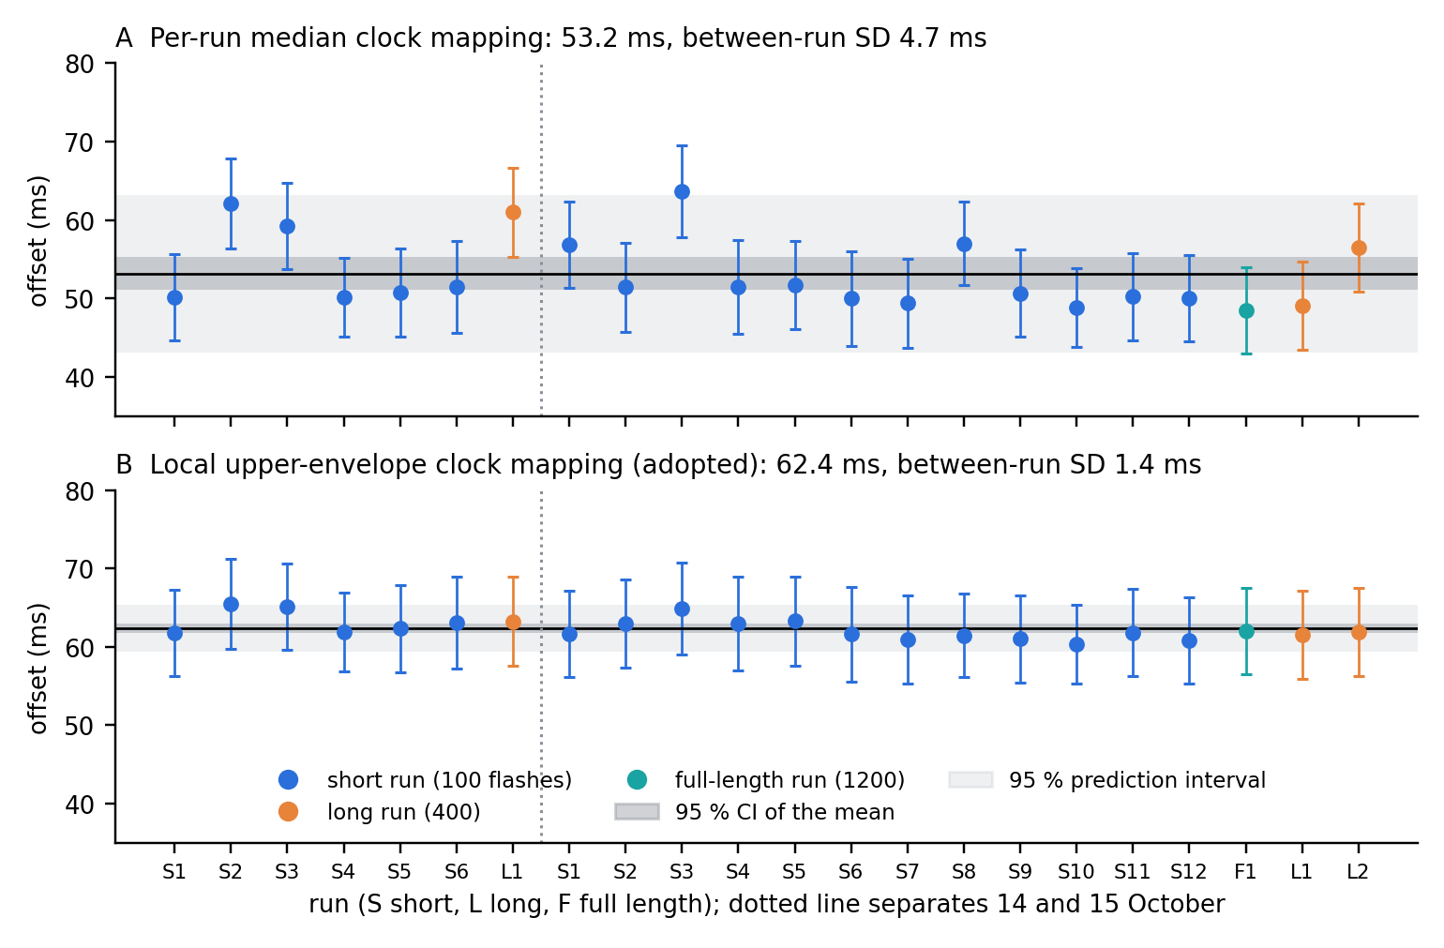
Figure S1. Offset per session (mean ± within-session SD). A: one median clock mapping per session. B: local upper-envelope mapping (adopted). Black line: mean over sessions; dark band: 95 % CI; light band: 95 % prediction interval for a new session.
Why the mapping matters. Sessions fell into two timing states of the recording model: a steady state (model about one amplifier frame behind, short LSL transit of ~1.5–2.6 ms) and a burst state (frame-wise processing, transit up to ~15 ms; Fig. S2A). The marker as recorded by the LSL Receive block, and the timestamp-placed marker with a median clock mapping, both shifted with this state (r = -0.96 and -0.74 with transit), producing bimodal session means. The upper-envelope mapping removed most of this dependence (r = -0.32; Fig. S2B) and reduced the between-session SD from 4.7 to 1.4 ms.
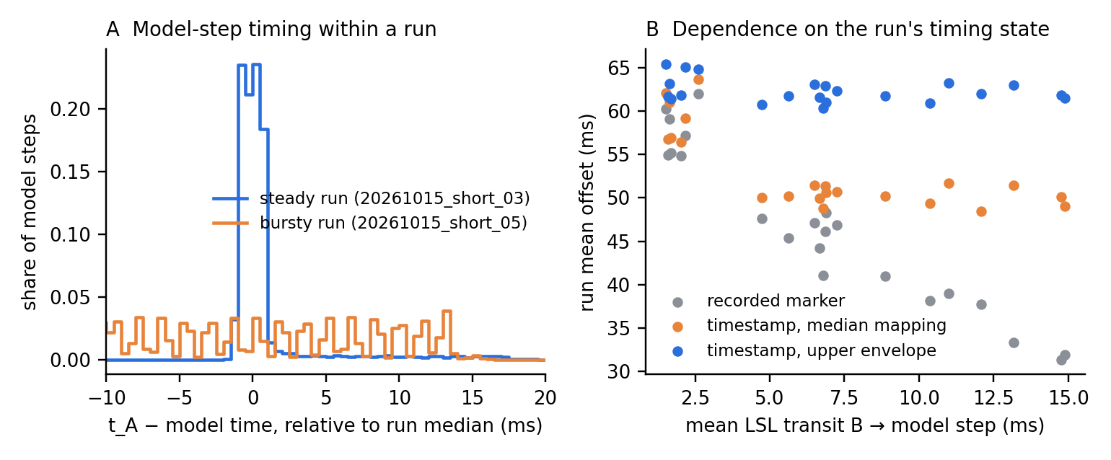
Figure S2. A: distribution of t_A − model time over all model steps in a steady and a burst-mode session. B: session mean offset against mean LSL transit for the recorded marker and the two timestamp mappings.
Per-event accuracy. With the correction from the other sessions, the optical onset of single flashes deviated from the corrected marker by SD 5.7 ms (Fig. S3A). This variability is the same in every session (within-session SD 5.6 ms after removing each session's trend; Fig. S3B), is unrelated to LSL transit, and is distributed approximately uniformly over one display frame (16.7 ms), i.e. it arises between the buffer swap reported to PsychoPy and the physical refresh.
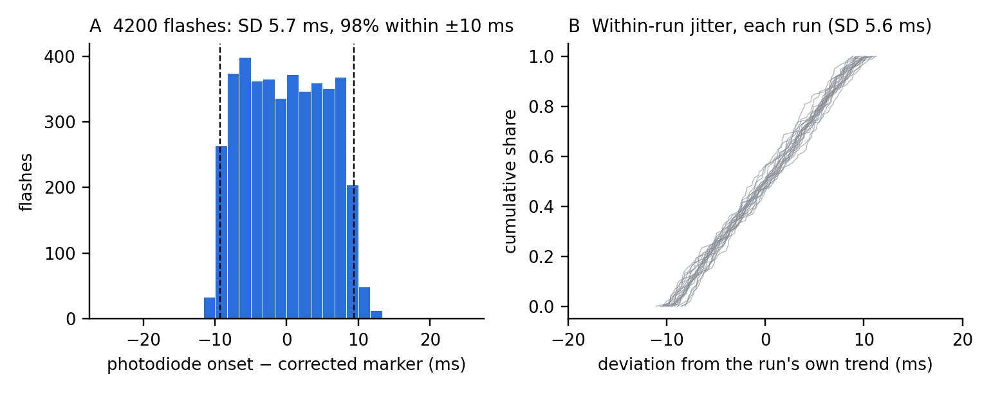
Figure S3. A: per-flash error after correction (leave-one-session-out), dashed lines 2.5th and 97.5th percentiles. B: cumulative distribution of within-session deviations, one line per session.
Stability over time. In the long and full-length sessions the corrected offset did not drift (Table S4, Fig. S4). The relation between A's clock and the amplifier clock changed slowly in all sessions (median 0.26 ms/min, ≈ 4 ppm; 0.33 ms/min in the 29-min session, Fig. S5). With a single mapping per session this drift accumulated to 11 ms over the full-length session; the local mapping follows it.
Table S4. Long and full-length sessions
Session | Duration (min) | Drift, adopted (ms/min) | Last − first 100 flashes (ms) | Drift, median mapping (ms/min)
20261014_long_01 | 10 | +0.018 | -0.0 | -0.227
20261015_full_01 | 29 | -0.040 | -1.0 | -0.373
20261015_long_01 | 10 | +0.220 | +1.5 | -0.085
20261015_long_02 | 10 | -0.023 | +0.1 | -0.295

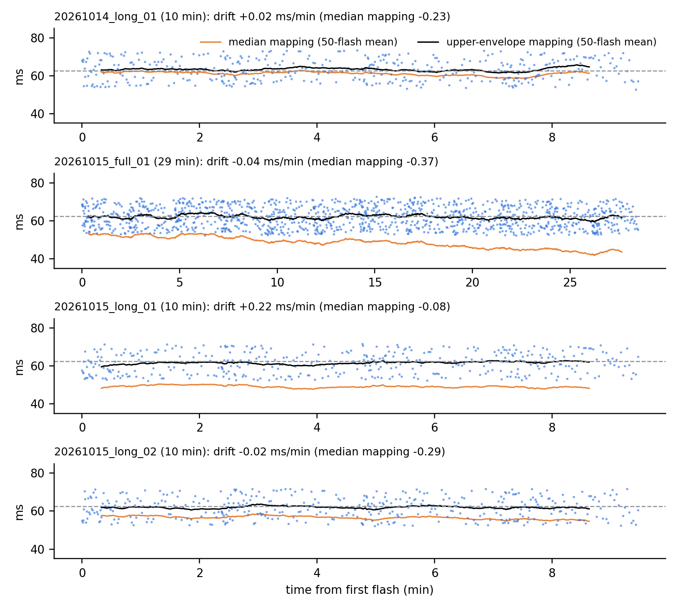
Figure S4. Offset of every flash (dots) and 50-flash running means over the long and full-length sessions; orange: median clock mapping; black: adopted mapping; dashed: correction.
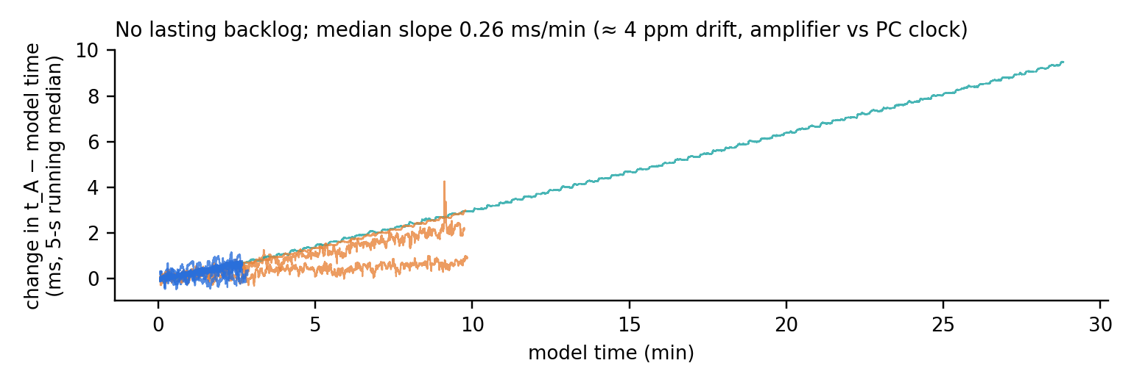
Figure S5. Change of t_A − model time over each session (5-s running median), relative to its first 10 s. Short stalls are caught up; the common slope reflects drift between the amplifier and PC clocks.
Other factors. Session type had no effect (short 62.4 ms, n = 18; long 62.2 ms, n = 3; full length 62.0 ms; Welch p = 0.64). Day 2 was 1.3 ms lower than day 1 (63.3 vs 61.9 ms; Welch t = 2.08, p = 0.07), within the prediction interval.
Sensitivity and replication. The between-session SD was lowest for percentiles 85–92 (Fig. S6A; 1.51–1.44 ms) and rose towards the median (4.54 ms) and the maximum. In 8 independent pilot sessions (sensor at the bottom-right corner; frame lengths 4 and 8) the adopted mapping gave 64.3 ms with a between-session SD of 0.90 ms (median mapping 4.79 ms), independent of frame length (64.3 vs 64.4 ms; Fig. S6B). The corner offset was 2.0 ms larger than at the centre (p < 0.001), consistent with top-to-bottom refresh of the display.
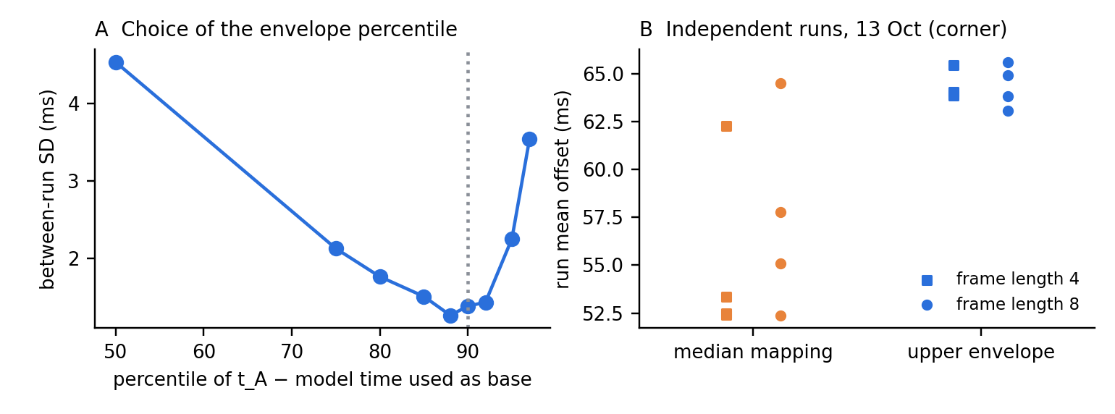
Figure S6. A: between-session SD of the offset as a function of the percentile of t_A − model time used for the clock mapping (dotted: adopted). B: independent pilot sessions (13 October, corner sensor), both mappings.

S1.6 Correction applied to the experimental data
For every event in an experimental session the onset on the EEG time axis is computed from the recorded timing file as
τ_event = t_B + Δ_BA − B(τ) + 62.4 ms
with B(τ) evaluated around the marker as in S1.4 (implemented in analysis/marker_timing.py, which shares its code with the calibration analysis; applied to the 22 calibration sessions it reproduces the optical onsets with a mean error of −0.2 ms). The constant is valid for stimuli at the screen centre. The expected session-level uncertainty is the prediction interval (59.4–65.3 ms); the per-event uncertainty (SD 5.7 ms, bounded by one frame) acts as a small temporal smoothing of the ERP and is identical across conditions. Each experimental session must (i) record the LSLMarkerTimestamps output, (ii) report lsl_resyncs = 0 on the stimulus computer and (iii) show no lasting backlog of the recording model; sessions failing these checks are flagged. Stimulus software, display settings and hardware were unchanged between calibration and data collection [to be confirmed per study; re-calibration with ≥ 3 sessions after any change].

S1.7 Limitations
- The calibration used a full-white square at the screen centre. Stimuli in the upper or lower part of the screen appear up to about half a frame earlier or later; at the bottom-right corner we measured +2.0 ms. Grey-scale stimuli may cross the sensor threshold at a slightly different point of the rise than full white.
- The database covers 2 days. The day difference (1.3 ms) was within the prediction interval, but longer-term stability should be checked with periodic re-calibration sessions.
- The 90th-percentile mapping was chosen on the database itself; the choice was confirmed on independent pilot sessions and results are insensitive between the 85th and 92nd percentiles.
- The clock mapping assumes no lasting backlog of the recording model. A pause of the stimulus process of the kind observed in pilot testing would add a lasting backlog that this mapping cannot separate from clock offset; such sessions are detected (lsl_resyncs, backlog) and excluded.
- Optical onsets are quantised to the 600 Hz sampling (1.67 ms).

S1.8 Development history
Initial recordings (6–8 October 2026) showed markers about 0.85–0.97 s earlier than the light in the EEG file. Simultaneous LSL timestamps located the cause in a single ~0.8 s pause of the stimulus process at its first full-screen frames, occurring after the LSL stream had been created; the recording model, which reads one LSL sample per step, never recovered from the resulting gap. Creating the LSL stream only after the window is open and the refresh rate measured removed the backlog (resynchronisations 1 → 0; delay ~870 ms → ~35–60 ms). On 13 October, 8 sessions compared Simulink frame lengths 4 and 8 (no difference) and introduced the experiment-start marker; these sessions form the independent replication set above. The calibration database was then recorded with the sensor at the screen centre, where the experimental stimuli appear.

Data and code availability
Repository: https://github.com/DanielAtad/vMMR_EEG_PsychoPy_experiment. Calibration script: run_photodiode_latency_v1_trig_after_framerate_measurement.py; LSL sender: lsl_trigger.py; recording model and timestamp block: matlab/on_eeg_computer/; analysis: analysis/calibration_database_analysis.py (produces every number, table and figure in this supplement from the raw recordings); correction of experimental data: analysis/marker_timing.py. Raw recordings (EEG .mat, timing .mat, PsychoPy logs) are available from the authors [or: repository/DOI].

Table S5. Per-session results
Session | Flashes | Offset, adopted (ms, mean ± SD) | Drift (ms/min) | Offset, median mapping (ms) | Recorded marker (ms) | LSL transit (ms) | Lag IQR (ms) | Stalls | Dropped frames
14.10 short 1 | 100 | 61.8 ± 5.5 | +0.34 | 50.2 | 40.9 | 8.9 | 13.8 | 1 | 0
14.10 short 2 | 100 | 65.4 ± 5.7 | -1.00 | 62.1 | 60.3 | 1.5 | 1.3 | 0 | 1
14.10 short 3 | 100 | 65.1 ± 5.5 | +0.38 | 59.2 | 57.2 | 2.2 | 2.0 | 2 | 0
14.10 short 4 | 100 | 61.8 ± 5.0 | +0.33 | 50.2 | 31.3 | 14.8 | 14.6 | 5 | 1
14.10 short 5 | 100 | 62.3 ± 5.6 | +0.56 | 50.7 | 46.9 | 7.2 | 9.2 | 4 | 2
14.10 short 6 | 100 | 63.1 ± 5.8 | -1.14 | 51.4 | 47.1 | 6.5 | 9.7 | 3 | 0
14.10 long 1 | 400 | 63.2 ± 5.7 | +0.02 | 61.0 | 59.1 | 1.6 | 1.6 | 0 | 2
15.10 short 1 | 100 | 61.7 ± 5.5 | +0.24 | 56.8 | 54.9 | 1.6 | 2.0 | 1 | 0
15.10 short 2 | 100 | 63.0 ± 5.7 | -1.14 | 51.4 | 46.2 | 6.9 | 10.3 | 3 | 0
15.10 short 3 | 100 | 64.9 ± 5.9 | -0.56 | 63.7 | 62.0 | 2.6 | 1.1 | 3 | 0
15.10 short 4 | 100 | 63.0 ± 6.0 | +0.17 | 51.4 | 33.3 | 13.2 | 14.6 | 2 | 1
15.10 short 5 | 100 | 63.3 ± 5.6 | -0.04 | 51.7 | 39.0 | 11.0 | 14.6 | 2 | 0
15.10 short 6 | 100 | 61.6 ± 6.1 | -1.17 | 50.0 | 44.2 | 6.7 | 10.9 | 3 | 1
15.10 short 7 | 100 | 60.9 ± 5.7 | -0.04 | 49.4 | 38.1 | 10.4 | 14.6 | 2 | 0
15.10 short 8 | 100 | 61.4 ± 5.3 | +0.39 | 57.0 | 55.2 | 1.7 | 1.4 | 2 | 0
15.10 short 9 | 100 | 61.0 ± 5.6 | +0.29 | 50.7 | 48.3 | 6.9 | 7.4 | 4 | 2
15.10 short 10 | 100 | 60.3 ± 5.0 | -0.49 | 48.8 | 41.1 | 6.8 | 12.5 | 3 | 1
15.10 short 11 | 100 | 61.8 ± 5.6 | -1.64 | 50.2 | 45.4 | 5.6 | 10.1 | 2 | 0
15.10 short 12 | 100 | 60.8 ± 5.5 | -0.17 | 50.0 | 47.6 | 4.7 | 7.7 | 3 | 0
15.10 full 1 | 1200 | 62.0 ± 5.5 | -0.04 | 48.5 | 37.7 | 12.1 | 14.6 | 1 | 3
15.10 long 1 | 400 | 61.5 ± 5.6 | +0.22 | 49.0 | 31.9 | 14.9 | 14.6 | 6 | 0
15.10 long 2 | 400 | 61.9 ± 5.6 | -0.02 | 56.5 | 54.8 | 2.0 | 1.8 | 6 | 0
Lag IQR: interquartile range of t_A − model time (≈ 1–2 ms steady state, ≈ 7–15 ms burst state).

References
Bridges, D., Pitiot, A., MacAskill, M. R., & Peirce, J. W. (2020). The timing mega-study: comparing a range of experiment generators, both lab-based and online. PeerJ, 8, e9414. https://doi.org/10.7717/peerj.9414
Elze, T. (2010). Achieving precise display timing in visual neuroscience experiments. Journal of Neuroscience Methods, 191(2), 171–179. https://doi.org/10.1016/j.jneumeth.2010.06.018
Keil, A., Debener, S., Gratton, G., Junghöfer, M., Kappenman, E. S., Luck, S. J., Luu, P., Miller, G. A., & Yee, C. M. (2014). Committee report: Publication guidelines and recommendations for studies using electroencephalography and magnetoencephalography. Psychophysiology, 51(1), 1–21. https://doi.org/10.1111/psyp.12147
Kothe, C., Shirazi, S. Y., Stenner, T., Medine, D., Boulay, C., Grivich, M. I., Mullen, T., Delorme, A., & Makeig, S. (2024). The Lab Streaming Layer for synchronized multimodal recording. bioRxiv. [verify final citation]
Luck, S. J. (2014). An introduction to the event-related potential technique (2nd ed.). MIT Press.
Peirce, J., Gray, J. R., Simpson, S., MacAskill, M., Höchenberger, R., Sogo, H., Kastman, E., & Lindeløv, J. K. (2019). PsychoPy2: Experiments in behavior made easy. Behavior Research Methods, 51(1), 195–203. https://doi.org/10.3758/s13428-018-01193-y
Pernet, C., Garrido, M. I., Gramfort, A., Maurits, N., Michel, C. M., Pang, E., Salmelin, R., Schoffelen, J. M., Valdes-Sosa, P. A., & Puce, A. (2020). Issues and recommendations from the OHBM COBIDAS MEEG committee for reproducible EEG and MEG research. Nature Neuroscience, 23(12), 1473–1483. https://doi.org/10.1038/s41593-020-00709-0
Plant, R. R. (2016). A reminder on millisecond timing accuracy and potential replication failure in computer-based psychology experiments: An open letter. Behavior Research Methods, 48(1), 408–411. https://doi.org/10.3758/s13428-015-0577-0
Plant, R. R., Hammond, N., & Turner, G. (2004). Self-validating presentation and response timing in cognitive paradigms: How and why? Behavior Research Methods, Instruments, & Computers, 36(2), 291–303. https://doi.org/10.3758/BF03195575

