Scene Recreation:

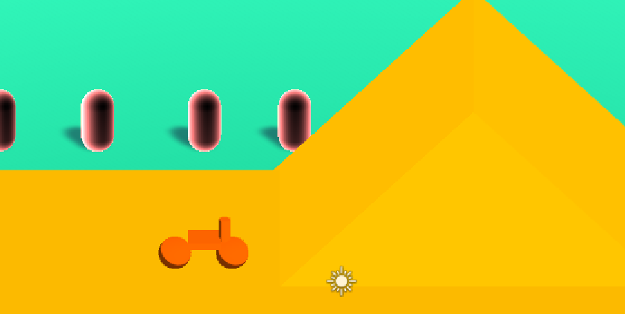

-It was made that way with an orthographic camera to achieve a similar angle

Toon Shader:

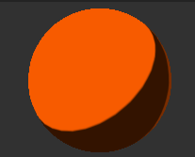

* Custom shading model with a standard lambert shading model
* Uses a custom colour ramp

Rim Shader:

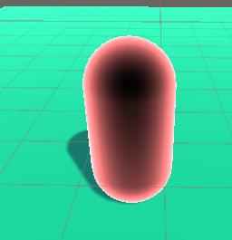

* It saturates the dot product of the normal and view direction
* There are two rim shaders one on top the other