MovieInsight

User Manual

1. Introduction

MovieInsight is a web-based movie analytics platform that allows users to explore movies, analyze trends, and discover recommendations using advanced database queries. It provides intelligent search, actor insights, profitability analysis, and related movie recommendations based on keywords and past data.

The platform leverages a structured MySQL backend to provide insights into movies, actors, and production companies.

2. Application Overview : Functionality

##### 2.1 Features

The application includes following features:

|  |  |  |  |
| --- | --- | --- | --- |
| Feature | Description | User Input | Backend Query |
| 🔍 Smart Movie Search | Users can search for movies by keywords in their description (overview). The results are ranked by relevance and popularity. Results limited to 10 by default. | search keywords, results limit (optional) | query_1 |
| 🎥 Movie Recommendations (Similar Movies) | Users can get personalized movie recommendations based on shared keywords with a given movie. Results ranked by the number of shared keywords (higher matches come first). Results limited to 10 by default. | movie title, results limit (optional) | query_6 |
| 🎭 Find Actor Dynasties | Users can search for actors based on last names (e.g., “Skarsgård”) to discover family connections in the film industry.  Actors are ranked by the number of movies they have appeared in. | actor’s last name | query_2 |
| ⭐ Top-Rated Actors in a Genre (“Top Actors” in the UI mockup) | Users can find top 10 actors who have most frequently appeared in highly-rated movies within a selected genre. | genre | query_4 |
| 🎬 Top 5 Most Profitable Movies in a Genre | Users can filter and explore the top 5 most profitable movies in a selected genre, along with average genre profitability. | genre | query_3 |
| 🏢 Top 5 Production Companies by Revenue | Users can see which movie production companies generate the highest revenue. The list only includes larger companies that produced more than 5 movies. | - | query_5 |

Backend Query refers to the main mysql queries designed in this project.

##### 2.2 Getting Started

To begin using MovieInsight, follow these simple steps:

1. Search for a Movie – Use the homepage search bar to find movies based on keywords from their descriptions.
2. Discovering Similar Movies – Navigate to the "Similar Movies" section, enter a movie title, and get personalized movie recommendations based on shared keywords.
3. Exploring Actor Lineages – Use the Actor Dynasties feature to find an actor by their last name and uncover their cinematic family history.
4. Discover Top Actors in a Genre – Access the "Top Actors" feature to view the top 10 actors who have appeared in highly-rated movies within a specific genre. Actors are ranked based on their involvement in movies with ratings above the genre's average.
5. Analyzing Movie Profitability – Visit "Production Insights: Top 5 Most Profitable Movies in a Genre" to explore the most financially successful movies by genre.
6. Reviewing Top Production Companies – In "Production Insights: Top 5 Production Companies by Revenue," find out which companies generate the highest revenue in the industry.

3. Web Application Use Cases

1. Movie Enthusiasts – search movies by descriptive words, find movies similar to their favorites and explore actor dynasties in film.
2. Film Students & Analysts – gain insights into movie trends, top actors in selected genres, and high-revenue studios.
3. Producers & Investors – understand profitable movies within genres to make investment decisions.
4. Casting Directors – find actors who frequently work in high-rated movies of a given genre.
5. General Public – simply search for movies using natural language descriptions.

4. UI Mockup

##### 4.1 MovieInsight UI Mockup Concept

Layout & Design Approach:

Single-page scrollable design with smooth anchor-based navigation.

Navigation menu at the top-right, with quick links:

🎥 Search Movies

🔍 Similar Movies

👨‍👩‍👦 Actor Dynasties

🌟 Top Actors by Genre

🏆 Production Insights (Dropdown with):

💰 Top 5 Most Profitable Movies by Genre

🏭 Top 5 Production Companies by Revenue

Each section has a full-width layout with ample padding & clear separation.

Modern, clean UI with a movie-centric theme (dark mode, cinematic gradients, high-quality imagery).

Search results will be presented in an aesthetic and easily comprehensible way.

Some numeric results may be presented as graphs (e.g. Production Insights as bar graphs).

Each section will include a brief description of the feature (see table features).

##### 4.2 MovieInsight UI Mockup

Strong Advisory;

Neither of the writers of this manual are, nor have ever been, graphic designers. The following principal design is intended solely to illustrate the integration of the developed MySQL backend functionality into a web app frontend.

Home + Search Movies (query_1)

Results for Search Movies (query_1)

Future versions may include a movie roll with posters as a background.

Find Similar Movies (query_6)

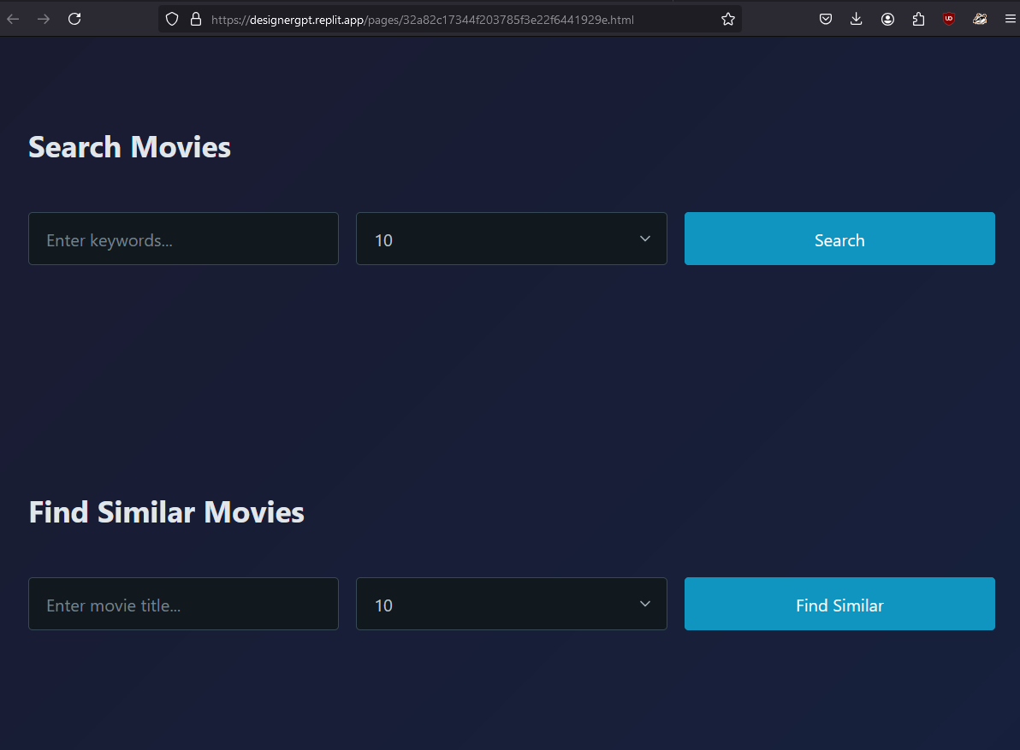

Results for Find Similar Movies (query_6)

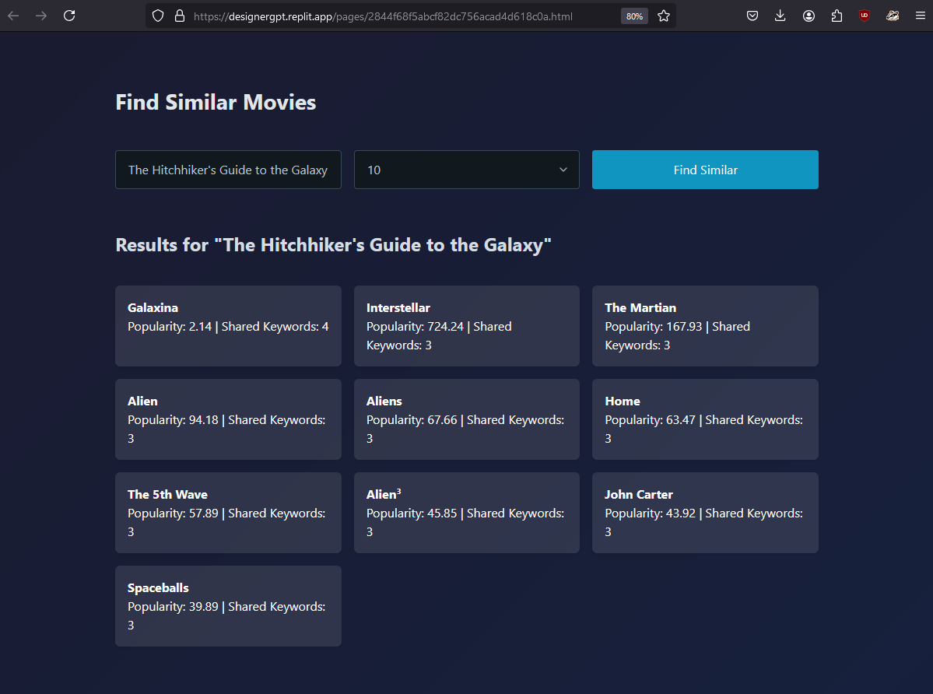

Future versions may include a movie roll with posters as a background.

Actor Dynasties (query_2)

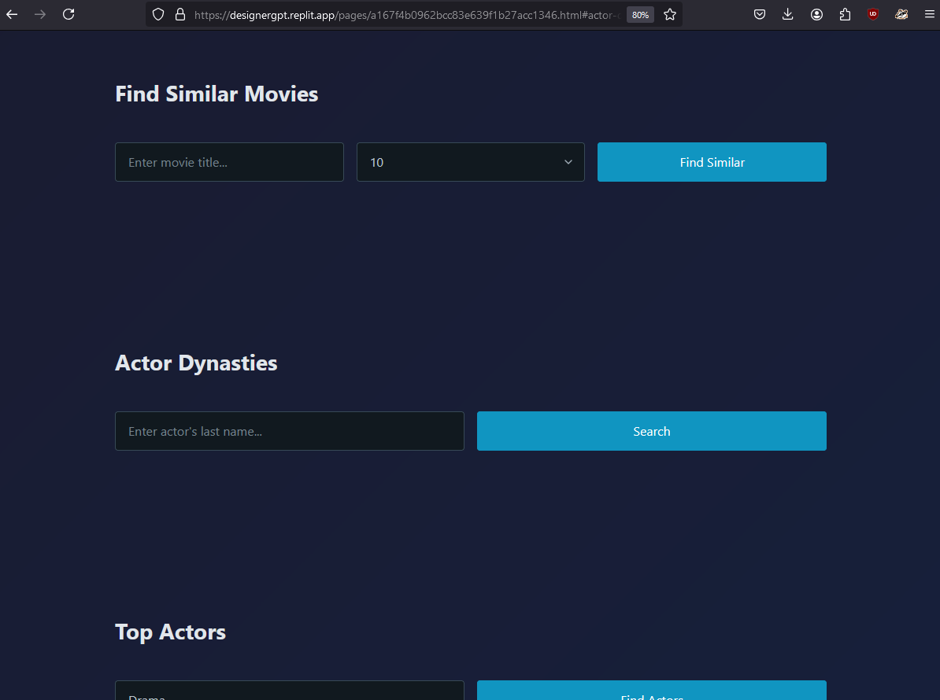

Results for Actor Dynasties (query_2)

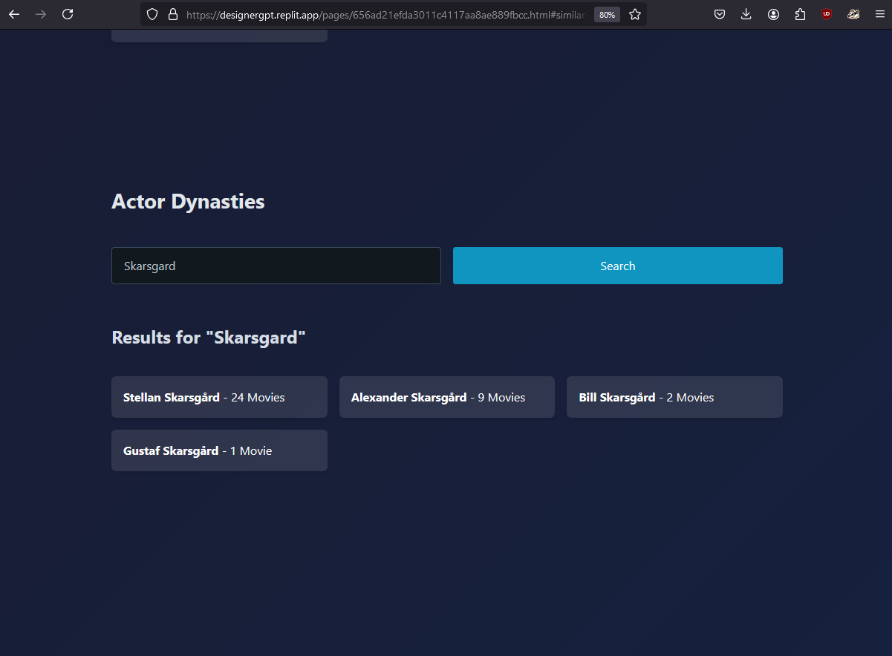

Top Actors (query_4)

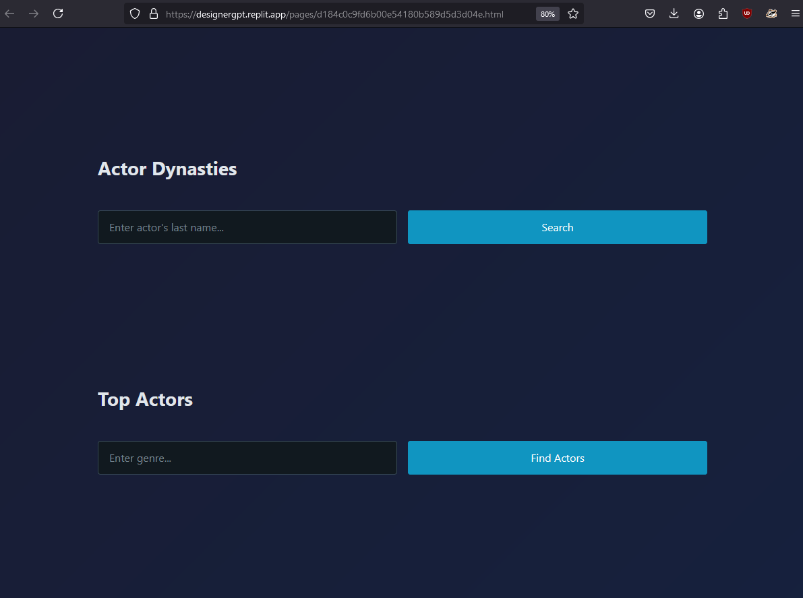

Future versions will rename to Top Actors by Genre and include explanation about the nature of this ranking. (see features table).

Results for Top Actors (query_4)

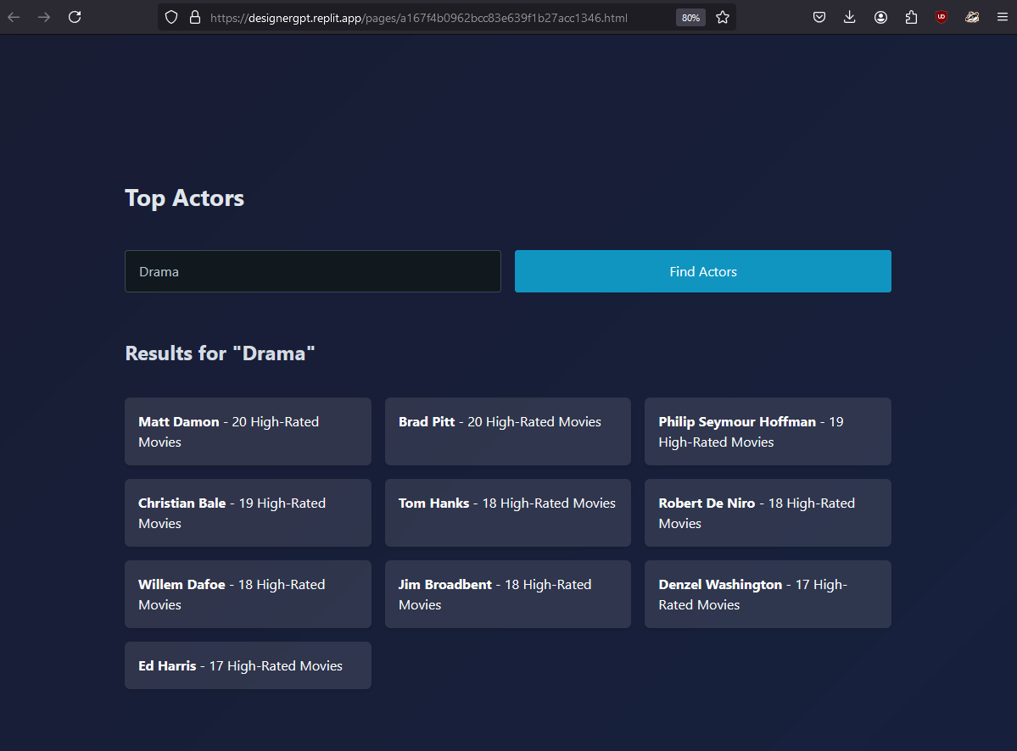

Production Insights : Top 5 Most Profitable Movies in a Genre(query_3)

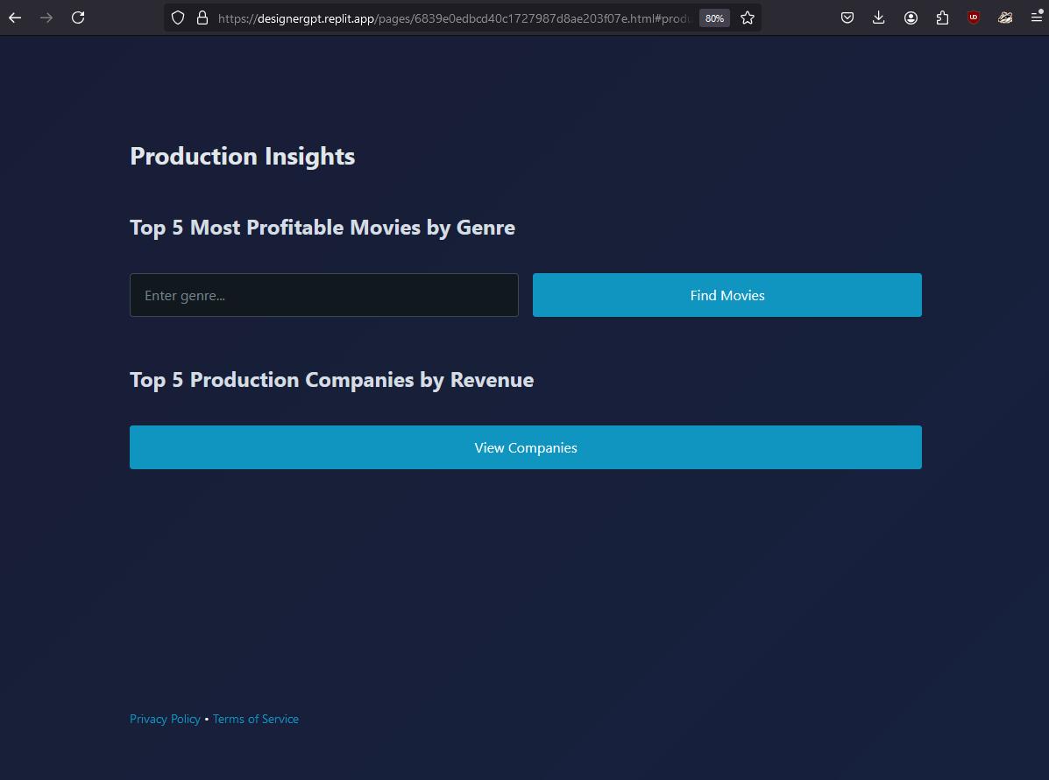

Production Insights : Results for Top 5 Most Profitable Movies in a Genre(query_3)

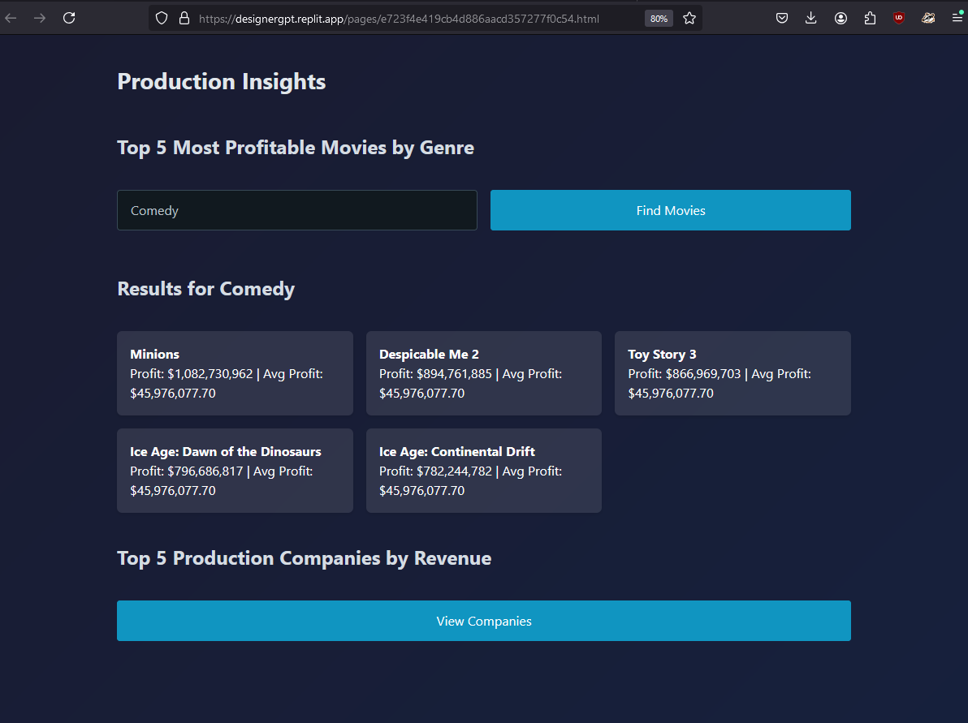

Future versions may include a bar chart for top results with comparison to the average.

Production Insights : Top 5 Production Companies by Revenue(query_5)

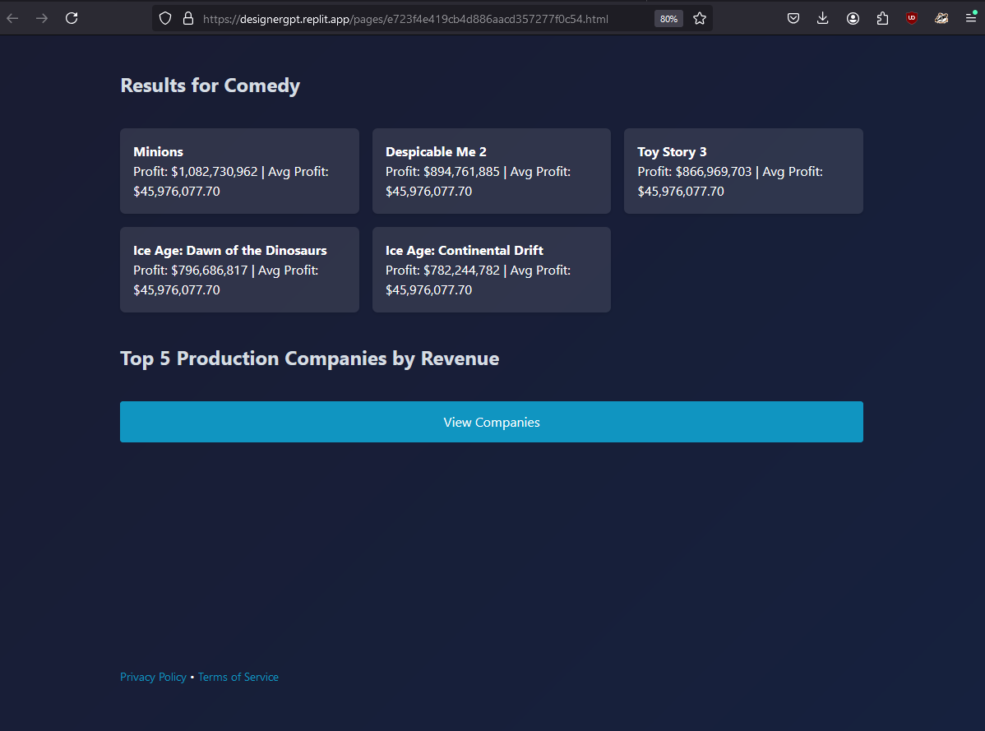

Production Insights : Results for Top 5 Production Companies by Revenue(query_5)

