Unzip the archive Cet235-Resources-Pack.zip into a known directory, this archive contains various file to prepare the IoT device.

Open a command prompt in the IoT VM and access the location where the unzipped files from the Cet235-Resources-Pack.zip are.

Connect one of the Huzzah32 boards to one of the PC usb port with a USB cable. The VM software will now ask you to which device to connect to, select the Virtual Machine.

Once the Huzzah32 is connected, you may see some LEDs flashing, open the app USBDeview in the IoT VM. This app shows all the devices connected to your PC. You should see a device with the Description “Silicon Labs…”, make sure to note the drive letter/port number, this is your Huzzah32 port connection.

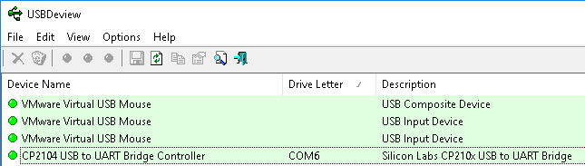

Go back to the command prompt in the IoT VM and make sure you are in the correct directory ***C:\Users\Ada\Desktop\Cet235-Resources-Pack>.***

Type in the following command and replace COM?? With the COM port your Huzzah32 is connected to and press enter.

***prep_esp32.bat COM6***

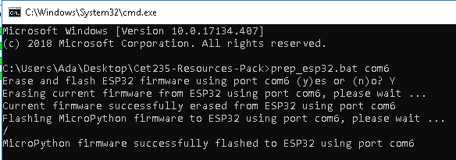

When completed you should see something like below:

If this fails, try reconnecting the USB cable or try another cable or board.

Now get the code

