PQA Developer's Guide

“This format shouldn't prevent us from using an automated unit test tool down the road to generate the report. We should be looking into that to ease the test/reporting burden.” -- Excel PQA.

Purpose of this Guide: This guide is used to define configurations of the PQA TSYS site.

Table of Contents
PQA Developer's Guide 1
What is a PQA? 2
Where is the template for the PQA Workbook? 2
PQA Sections 2
Home 2
Walkthrough 2
Unit Test Summary 2
Is it necessary to verify every unit test with every brand combination? 3
Code Review 3
Deployment 3
Performance 4
System Architecture 4
Technologies Used 4
Ruby on Rails 4
Database SQLite 3.0 4
Server Architecture 4
Logical Architecture 5
Security 5
Conventions 5

What is a PQA?
Stands for Pre-Quality and Assurance.

Where is the template for the PQA Workbook?
P:\Product Development and Delivery\Client Delivery

PQA Sections

Home
Contains the project life cycle, the project name, the project start date and the project ticket in Team Track.

Walkthrough
An Application walkthrough should be performed at approximately 90% dev completion. The walkthrough team includes developer, tech lead, business analyst, project manager and tester. The goal is for Business Analysts to "walk through" the product and verify that it is in line with expectations. Deviation from functional design should be documented here and resolved.

Each issue found during the walk through will be documented with the following information:
- Issue ID: Issue identifier inside Team Track, other tracking tool or just the PQA document.
- Description: Detail description of the issue.
- URL (If applicable): URL where the issue was found.
- Severity: Levels are => [Critical,High,Medium,Low]
- User: This is free information related to the user used when the issue arise. It could be Role, Username, Password and Security Answer.
- Owner: Developer owner of this issue, the one that will fix it.
- Resolved: Flag to tell if the issue was resolved or not.

Unit Test Summary
Maintain a unit test summary page for each feature in the project and developer. Developers are responsible for developing and execution unit test scripts. Tech leads and architects should review and advise the developer on the scripts prior to execution.

Each unit test will be documented with the following information:
- ID: Defined by the developer and it is just to keep each test identified.
- FSD Use Case ID:
- Module: Module being tested.
- Case Description: Description of the unit test steps.
- Desired Result: What the implementation guide expects the application to do after following the case steps.
- Brand X: Flags per brand that specifies if the unit test was done in those brands.
- Notes: Developer's notes about the test. Can include picture paths.

Is it necessary to verify every unit test with every brand combination?
Not always, we need to verify each unit test across multiple brands and make sure that all brands are represented as a whole. If a specific unit test's result is affected by a brand, then that brand must be verified.
For example if we have an email which is generated at the end of the test case and if that email is different then it is required to execute the unit test case for each of the brands and check the content of that email against the implementation guide/FSD.
But if there is no difference in the outcome across brands then that unit test case need not be executed across brands. One can always do extra testing but I do not think we have enough time for doing redundant testing.

Code Review
Code reviews are performed throughout the Dev and QA cycle by a tech lead or architect. Code reviews should aim to correct code formatting and naming problems, performance issues, unused resources, unclosed connections to external processes, and departures from standard architecture practices, among other things.
- ID: Defined by the tech lead or architect and it is just to keep each test identified.
- Module: Module reviewed.
- Line #: Line number of the issue in a file.
- Description of the Problem: Detailed description of why the file is bad coded.
- Submitted By: Tech lead or Architect name.
- Owner: Developer that will fix the bad code.
- Ticket # (Optional): If a ticket was opened to solve this issue.
- Resolved: Flag to tell if the issue was resolved or not.

Deployment
The developer will put in here the list of files created, deleted or modified to develop the project.
- ID: Defined by the developer and it is just to keep each file or group of files identified.
- File Name: VSS location of the created, deleted or modified file .
- File Type: The types are Config (XML), JSP, JAVA, Javascript, Image, Stylesheet, Velocity, PDF, etc.
- Existing/New: Flag that tells if the file is new or already existed.
- Environment Specific: If the file must be changed by the developer instead of the normal build due environment parameters inside the file.
- Deployment Location (Optional): ???
- Build Engineer: Engineer in charge of building the file.

Performance
Performance tests will not always be required. Check with Tech Leads and Architects before each project to determine components that will or will not require load testing. This form should be prepopulated by leads for those where performance tests are required.

- ID: Defined by the developer and it is just to keep each test identified.
- Test Description: Description of the unit test steps.
- URL/Component: URL or component to test.
- Tester: Person in charge to perform the test.
- Environment: Environment of the test.
- Pass/Fail: Flag the tells if the test pass or fail.
- Results/Comments: Tester notes about the test and its results. Can include picture paths.

System Architecture

Technologies Used

Ruby on Rails
Ruby on Rails is an open source web application framework for the Ruby programming language. It is often referred to as "Rails" or "RoR". It is intended to be used with an Agile development methodology, which is often utilized by web developers for its suitability for short, client-driven projects.

Further Information in:
http://en.wikipedia.org/wiki/Ruby_on_Rails
http://www.rubyonrails.com/

Database SQLite 3.0
SQLite is a software library that implements a self-contained, serverless, zero-configuration, transactional SQL database engine. SQLite is the most widely deployed SQL database engine in the world. The source code for SQLite is in the public domain.

Further Information in:
http://www.sqlite.org/

Server Architecture
I will leave this open to TSYS desires. But I can recommend a Mongrel + Apache server.

Logical Architecture
Rails follows the Model-View-Controller (MVC) architecture for application development, which allows for a logical separation of your application logic, business rules, and user views. By keeping these things segregated, it not only makes initial development easy, it also makes updates and maintenance to your system quicker.

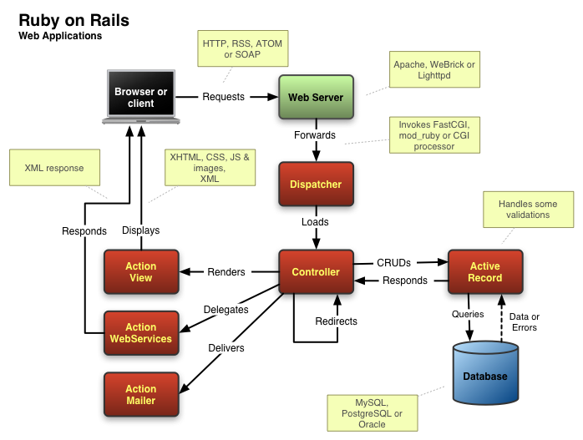

Security
There will be no security module at least in this first part of the project, perhaps if the project is accepted by TSYS they will add it.

Conventions
Ruby on Rails is the poster child for a principle of agile development frameworks: convention over configuration. What this means in practice is that, instead of having to write a bunch of configuration files and standard boilerplate code for every project you undertake, you can simply code to a set of assumptions and all that grunt work will be done for you.
With very few exceptions, the only time you need to write code in Rails is when your needs are different from the most common case.

For Ruby coding conventions search something in the web and stick to it.

