**Drama TEI Converter – User Instructions**

A Digital Humanities project by Daniel Braverman

The project was built in Eclipse environment in Java.

Installation steps:

1. Run Eclipse.
2. Choose: File > Import > General > Existing Projects into workspace.
3. Use "Select archive file". Click Browse and choose "TeiConverter.zip".
4. Click Finish.

Now you can run it freely using "Run as Java Application".

Please note that this converter takes a drama play written in HTML format and converts it into TEI Drama.

Please note that in order to run the converter correctly, you need to remove "NIKUD" from your HTML file. You can use this website: http://www.eshkol.net/Nikud/Default.aspx

**The main screen**

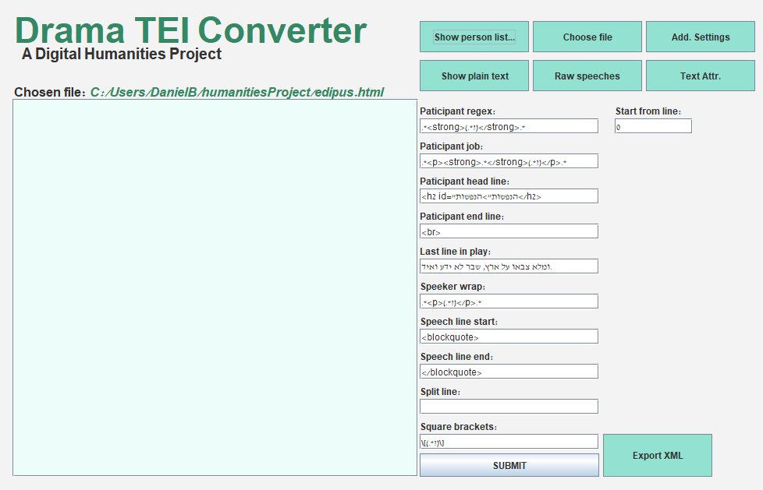

Participant regex: How the participant name wrapped in the participants list.

Participant job: How the participants job wrapped next to his name.

Participant head line: The line that appears as the head line of the participants list, for example, *"<strong><u>Participants</u></strong"*.

Participant end line: Where the participants list ends, usually a "<br>".

Last line in play: The last text line in the play.

Speaker Wrap: How the participant name wrapped in the text, in a speech that he performs.

Speech line start: How the participants speech content starts.

Speech line end: How the participants speech content ends.

Split line: The delimiter which the program will split the lines by, something that splits between the HTML lines. Usually it's a "\n".

Square brackets: Not necessarily square, but sometimes we encounter for example: "Speaker 1 [Speaks loudly]". The "Speaks loudly" is a stage directions, and it is in square brackets. With this regex the program knows how to recognize square brackets and take the contents withing those brackets.

Start from line: From which line to start converting the speeches.

**Buttons**

Show person list…: Shows the <listPerson> attribute.

Choose file: Choose a drama play HTML file to work on. Note that after choosing the file, you need to define all the required settings and press "SUBMIT".

Add. Settings: Additional settings. There you can add more participants (For example, when in the participants list, "Priest" appears, and in some speeches the speaker appears as "The Priest", The program won’t recognize the second one. In order to solve this problem, you will need to add "The Priest" to participants list. Dictionary helps to translate words and participants from for example Hebrew to English, which is crucial for the format. "Stage words" is very important, because in this way we can differ speakers/stage directions from actual parts like strophe/antistrophe.

Show plain text: Opens the HTML file of the current play.

Raw speeches: As is sounds, show raw speeches, without any TEI/HTML format.

Text attr.: Shows "<text>" attribute.

Export XML: Exports the converted TEI XML file. It will be exported to the same folder you imported your HTML file from.

* Please note that each time you change one or more of the settings, you need to press "SUBMIT" for the changes to take effect.

* Please note that for the default play, "edipus.html", you still need to add extra participants to "Additional Settings", which are: "הכוהן, הכהן, המקהלה". The correct format to add them will be:

$הכהן

$המקהלה

$הכוהן

* I gave 2 plays for examples. "itiel.html" and "hoy.html", with both files "HOY_PROPERTIES.txt" and "ITIEL_PROPERTIES.txt". In each property file, the settings are written in the order they appear in the main screen. Also, in each property file you will notice "additional:", which are the additional participants that you need to add.