**INTRO**

The NSD application works by taking CSV’s that have been filled out by an RA and automatically breaks it down and inserts it into a hosted database. The role of the RA will be to populate the CSV and insert them in the correct order and with the proper values. The following documentation will demonstrate the exact order of CSV’s that need to be filled out and what data needs to be in each. The data in each CSV will be in a tabular format where each row is one set of information and the column headers represent what data is required in each column of each row.

**Fac_Type.CSV**

This CSV will contain data that will represent organization and event facility types as well as activities that occur. The top of the CSV has the value titles that will go along with the data



In the future CSV you will be referencing the facility types so make sure they represent all the ones you need in this CSV for future ones to work.

Now as an example let’s say you want to input data about a soccer field that you can only play soccer and football on, the field is outside and the dimensions are 200 feet by 200 ft by 0 feet it would look like the following on the CSV.

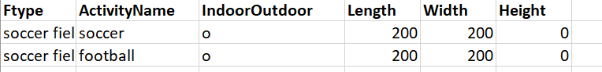

You can continue down each row filling in the required information. Please make sure to fill in all values and if you do not have the dimensions just put in a 0 as the value.

**Facility.CSV**

This CSV will be one of the larger ones and holds the data representing a facility alongside its facility type and the facility owner’s information. For example, if you wish to fill out the CSV with data about:

-the Hannah complex and its address

- Owner is named Bob who acts as an individual, not an organization, and his timeline of ownership

- With two facility types which are an ice rink and a basketball court with the timeline the facility had each of these for

The following images are one CSV row split into two images

You may leave the following fields blank if you wish

-Address information and timeline information for both the owner and facility type

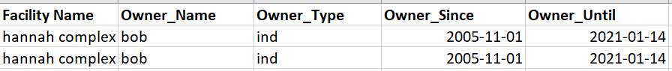



**Events.CSV**

This CSV will contain data about Events and what Facility they were held at. For example, if you wish to insert details about:

-The 2020 Olympics in Toronto

- Organizer is Tim with their details

- held at the Hannah complex

The following images are one CSV row split into two images

You may leave any fields blank if you wish other than event name and event organizer name





**Contains.CSV**

This CSV solely holds data to create the relationship between a division and an event. You can either just add a division name to create a new division or add a division name and event name to create the relationship between the two.

You can any field blank if you wish

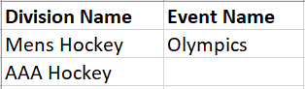

**Participants.CSV**

This CSV keeps track of participant data and if you wish the relationship between Participants and an Event. For example, you want to input data about a team of 5 participating in the Toronto Olympics.

You can leave the city and postal code blank if you wish

You can only fill in the Team size just to create a participant field without the relationship to an event



**Host_Hotels.CSV**

This CSV is responsible for input data about hotels and the relationship between hotels that are hosting events. You can either just add a hotel or a hotel and the corresponding event for example Hilton hosting the Olympics or just Sheraton.

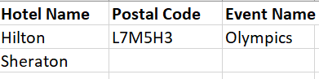

**Interface**

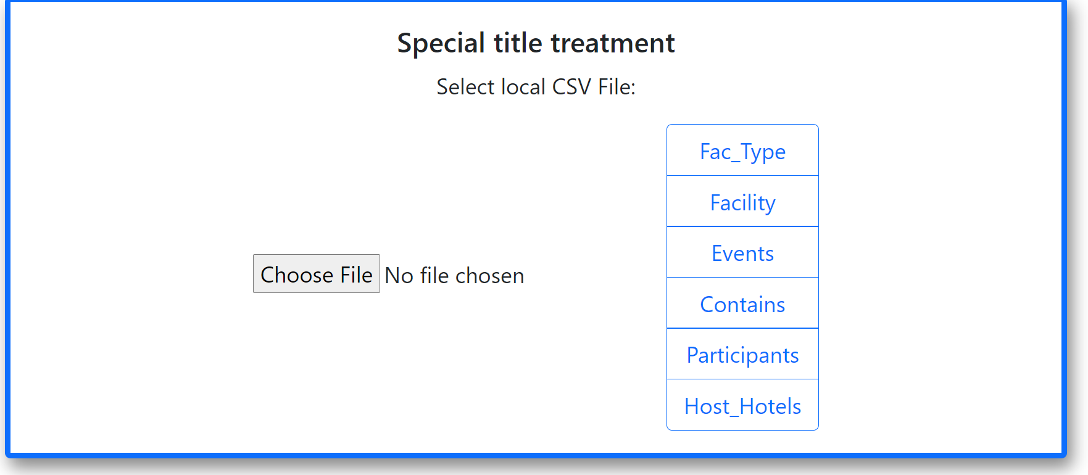

1. Click the choose file button and add the .csv file with the information of the table you wish to insert
2. On the right side click the button to run the parser you wish to be carried out on the currently added CSV
3. Repeat if needed

**Next Steps**

* If a new table is created it will require a new CSV or adaptations to current ones, then a new server function and parser in the Client.
* Update the Guide with any new CSV’s or changes to the CSV and their parsers