

**DIPLOMA KEMAHIRAN MALAYSIA**

**PROGRAMMING DEPARTMENT**

Ms. Gevita Chinnaiah

Ketua Bahagian Programming

*Department Head (Programming)*

Pensyarah / *Lecturer*

[gvta_25@yahoo.com.my](mailto:gvta_25@yahoo.com.my)

Mr. Lai Yen Ping

Pensyarah / *Lecturer*

lyping0526@gmail.com

Mr. Ho Kim Yit

Pensyarah / *Lecturer*

travisho02@gmail.com

Mr. Loke Hong Mun

Pensyarah / *Lecturer*

hongmun1997@gmail.com

Mr. Chen Shao Xi

Pensyarah / *Lecturer*

shaoxi9733@gmail.com

**KOLEJ SYNERGY**

NO 32 & 34 JALAN PERAI JAYA 4,

BANDAR PERAI JAYA,

13600 PULAU PINANG.

**FINAL YEAR PROJECT**

**(PROPOSAL)**

**Forum**

PREPARED BY:

1. Cheng Chia Chin 021217-07-0695
2. Yean Aik Zhe 971207-09-5257
3. Khoo Zhuong Xyu 000126-02-0913

SUPERVISOR: LAI YEN PING

**KOLEJ SYNERGY**

**PROGRAMMING DEPARTMENT**

**DIPLOMA KEMAHIRAN MALAYSIA**

**APPROVAL OF FINAL YEAR PROJECT PROPOSAL**

With this proposal recognized that this project has been approved for development.

Project Coordinator,

……………………………………

Name:Miss. Gevita Chinnaiah

Date :

Hereby acknowledged that the projects are the responsibility of the supervisor appointed.

Project Supervisor,

………………………………………..

Name: MR LAI YEN PING

Date :

# ORGANIZATION CHART

GROUP MEMBER

Yean Aik Zhe

Khoo Zhoung Xyu

COORDINATOR

Miss. Gevita Chinnaiah

SUPERVISOR

LAI YEN PING

GROUP LEADER

Cheng Chia Chin

# GROUP MEMBER



Cheng Chia Chin 021217-07-0695

B.PRO 0695.11/18



Yean Aik Zhe

971207-09-5257

B.PRO 5257.01/18



Khoo Zhoung Xyu

000126-02-0913

B.PRO 0913.05/18

# WORK SEPARATION

|  |  |  |
| --- | --- | --- |
| **MEMBER** | **POSITION** | **RESPONSIBILITY** |
| Cheng Chia Chin | Web development | Troubleshoot  Design interface  Prepare Presentation  Prepare Proposal  Program Code development  Create hosting server |
| Yean Aik Zhe | Web development | Troubleshoot  Design interface  Prepare Presentation  Prepare Proposal  Identify project  Prepare documentation |
| Khoo Zhoung Xyu | Web development | Troubleshoot  Design interface  Prepare Presentation  Prepare Proposal  Identify project  Testing function  Prepare documentation |

# CONTENT

ORGANIZATION CHART III

GROUP MEMBER IV

WORK SEPARATION V

CONTENT VI

ABSTRACT VII

CHAPTER 1 1

INTRODUCTION 1

1.1 INTRODUCTION 1

1.2 PROBLEM STATEMENT 2

1.3 PROBLEM SCOPE 3

1.4 OBJECTIVE 4

CHAPTER 2 5

FUNCTION & USABILITY 5

CHAPTER 3 6

SOFTWARE AND HARDWARE COSTING 6

CHAPTER 4 7

PROTOTYPE 7

CHAPTER 5 8

FLOW CHART 8

CHAPTER 6 9

GANTT CHART 9-10

CHAPTER 7 11

CONCLUSION 11

CHAPTER 8 12

REFERENCE 12

# ABSTRACT

In 21-century, human are highly intelligent creatures. Uncivilized from the previous era slowly into the high-tech era. There are got many kind of high technology gadget that uses to make our life easier. These technologies were built by the component that never gets expired in the time.Cleanliness will affect human life. Every day of the week will clean their homes, from this point, we intend to use our knowledge to create an electronic product that can help in their daily lives, to reduce some of their burden, saving time and energy. As the volume aspect the smaller is better, most of the people are greedy convenient. The more compact of the product, the more technical problem that encounter. This will be my first step of my plan. In this proposal will be explain everything about this electronic product from external to internal.

# CHAPTER 1

# INTRODUCTION

## INTRODUCTION

Forum is an online discussion site where people can hold conversations in the form of posted messages. They differ from chat rooms in that messages are often longer than one line of text, and are at least temporarily archived. Teacher can create different groups by finding topics that are relevant to them. Teacher and student can have a discussion about a question and answer, it can improve our vocabulary and communication. A question also encourage student to critical thinking to take a position on issues. Students react to content, share challenges, teach each other, learn by stating and understanding, clarify assumptions, experiment, own new skills and ideas. Student and teacher can acknowledge whenever there’s an announcement from college in forum.

## 1.2 PROBLEM STATEMENT

In this project we have some point to solve before make our ideal became truth

* College admin visit each class one by one to announce student.
* There’s a time limit to do discussion between teacher and student.
* Facing student announce fake information.

## PROJECT SCOPE

Our team start doing this project, we have made some planning first to confirm what benefits that our project can bring. Doing a final project requires a lot of preparation and teamwork, such as to test our knowledge and our understanding about all the things we have learned.

* Admin

- register student and teacher

- make announcement

- create group for student

- ban user comment and post

- can accept student group request

* Teacher

-make announcement

-create group for student

-ban user comment and post

-can accept student group request

* Student

-post and sharing

-visit other student post

-can request to join group

## 1.4 OBJECTIVE

There’re 3 main objectives for us to achieve:

* Make announcement on platform for convenience.
* There’s no time limit on the platform, user can discuss with each other when they’re free.
* Teacher can approve the true announcement to prevent false information.

# CHAPTER 2

# FUNCTION & USABILITY

**Admin**

* Manage Announcement
* Manage Post & Comments
* Manage Student & Teacher
* Register Student & Teacher
* Notification
* Manage Report Details
* Manage Group

**Student**

* Modify Own Profile
* Request Join Group
* Preview Latest Announcements
* Report Post and Comments
* Comment & Delete Own Comments
* Manage Post

**Teacher**

* Modify Own Profile
* Manage Post and student comments
* Accept & Decline student join group request
* Report Post and Comments
* Comment & Delete Own Comments
* Manage Group

# CHAPTER 3

# SOFTWARE AND HARDWARE COSTING

**3. SOFTWARE USED AND COSTS**

|  |  |  |
| --- | --- | --- |
| **NO** | **SOFTWARE** | **COST** |
| **1.** | **Microsoft Office Word 2016** | **RM300.00** |
| **2.** | **Microsoft Office Project 2016** | **RM100.00** |
| **3.** | **Microsoft Office Power Point 2016** | **RM300.00** |
| **4.** | **Server Hosting** | **-** |
| **5.** | **Django Rest Framework** | **-** |
| **6.** | **SQLite Database** | **-** |

**Table 3.1**

|  |  |  |
| --- | --- | --- |
| **NO** | **HARDWARE** | **COST** |
| **1.** | **Laptop** | **RM2100.00** |
| **2.** | **Printer** | **RM480.00** |
| **3.** | **Logitech Mouse** | **RM60.00** |
| **4.** | **Pendrive** | **RM30.00** |

**Table 3.2**

|  |  |  |
| --- | --- | --- |
| **SOFTWARE COST** | **HARDWARE COST** | **TOTAL COST** |
| **RM1000** | **RM2670** | **RM3370** |

**Table 3.3**

# CHAPTER 4

# PROTOTYPE

## Software PROTOTYPING — Worth or Not? | by Khushaly Mekhîya | Content Writing | Medium

# CHAPTER 5

# FLOW CHART

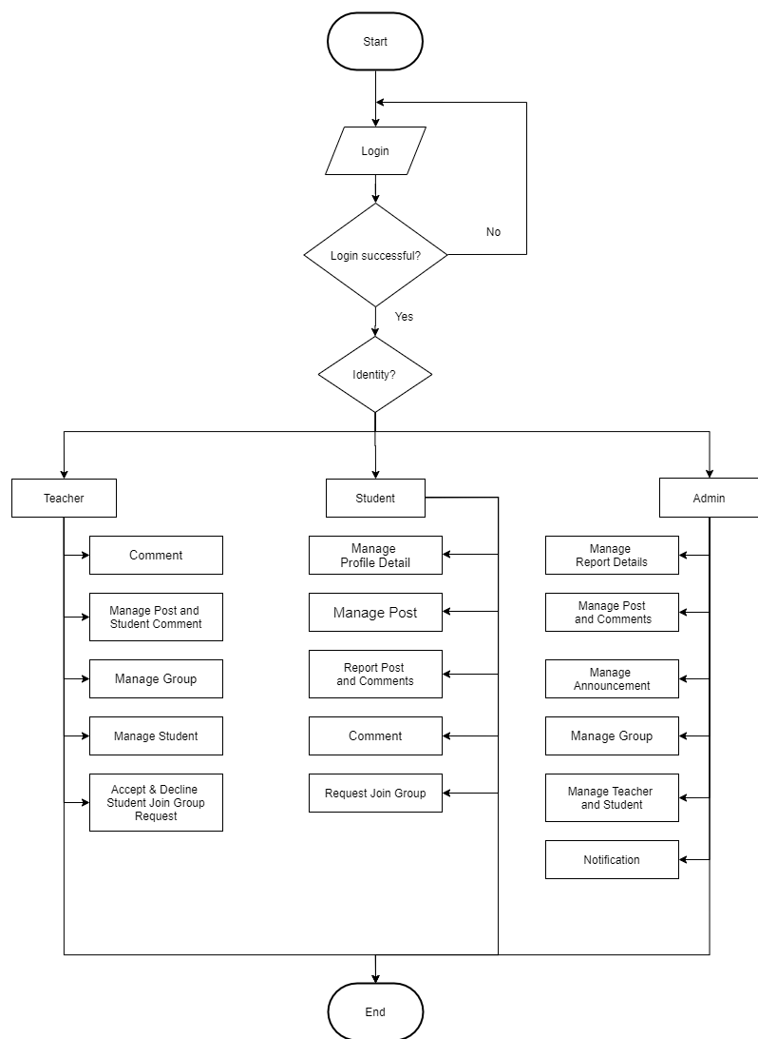

Figures 7

# CHAPTER 6

# GANTT CHART

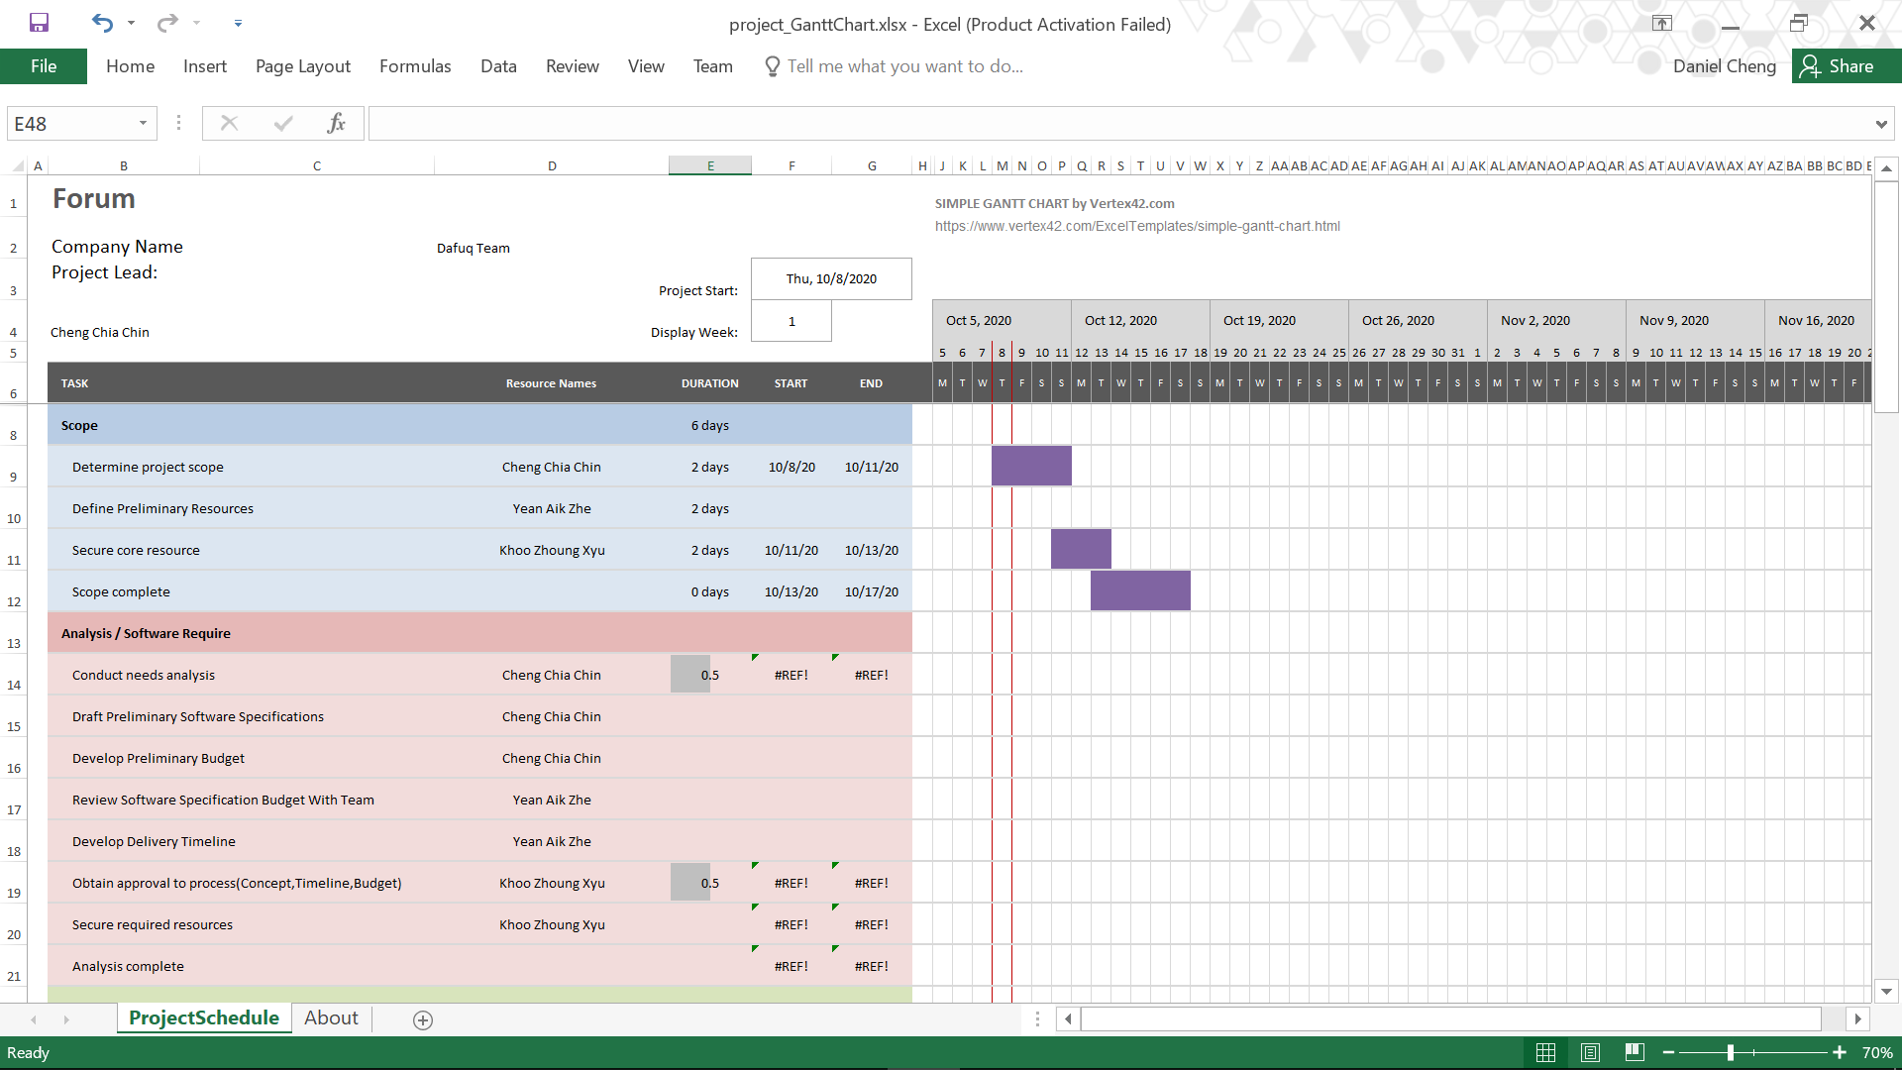 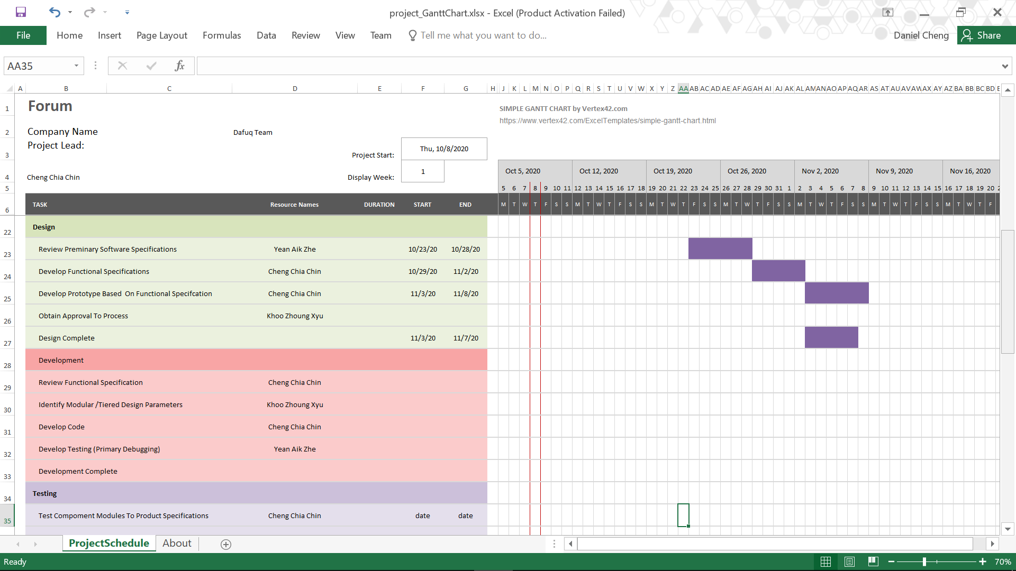

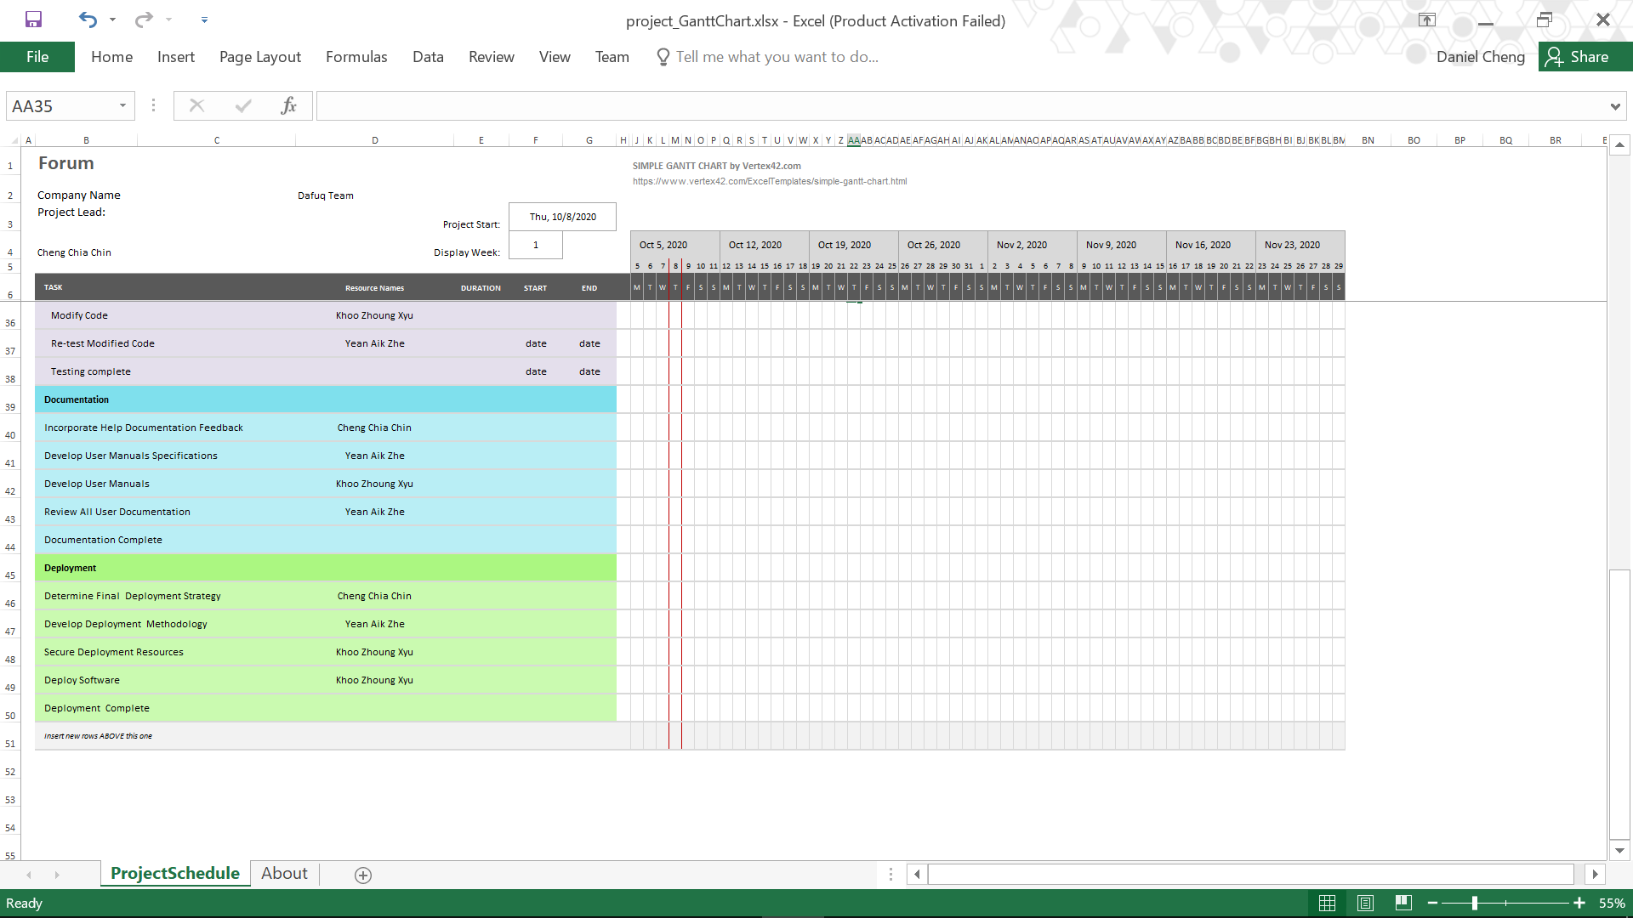

# CHAPTER 7

# CONCLUSION

I wish our project can be easy to use and make everyone flexibility and convenience in life. Student have more time to formulate responses and opinions, they can have the flexibility to reflect on their thoughts and read the responses of others. This project can give us a chance to experience and learns what cannot be gain during lectures or tutorials.

We hope with this project can improved our knowledge and skills. Finally, this project helped understanding wonderful of software and mechanical, and giving us understanding about importance of teamwork. In overall, it was a great experience for us to make this project.

# CHAPTER 8

# REFERENCE

**Website:**

<https://www.google.com/>

<https://www.youtube.com/>

<https://www.wikipedia.org/>

<https://github.com/>

<https://www.w3schools.com/>

<https://developer.mozilla.org/en-US/docs/Web>

<https://stackoverflow.com/>