Unity Essentials

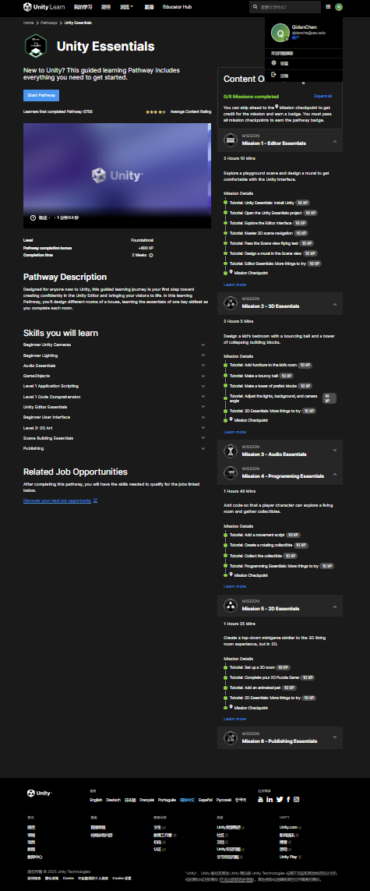

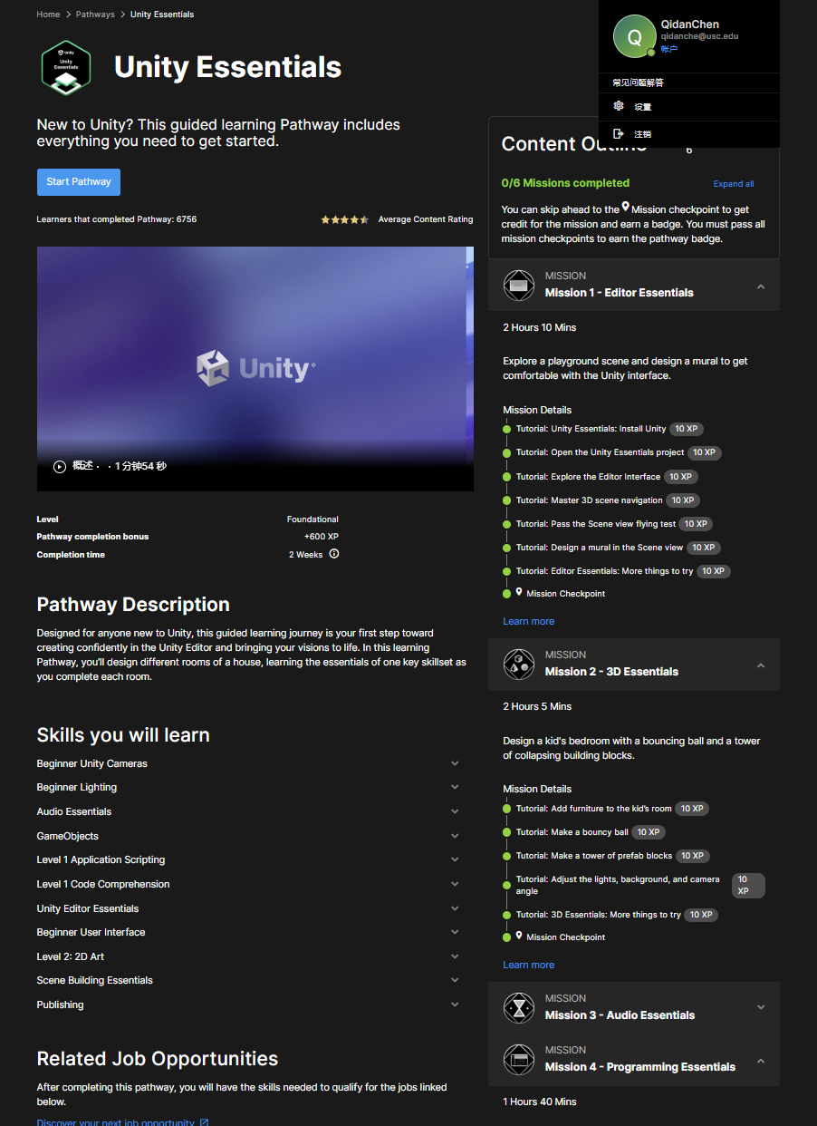

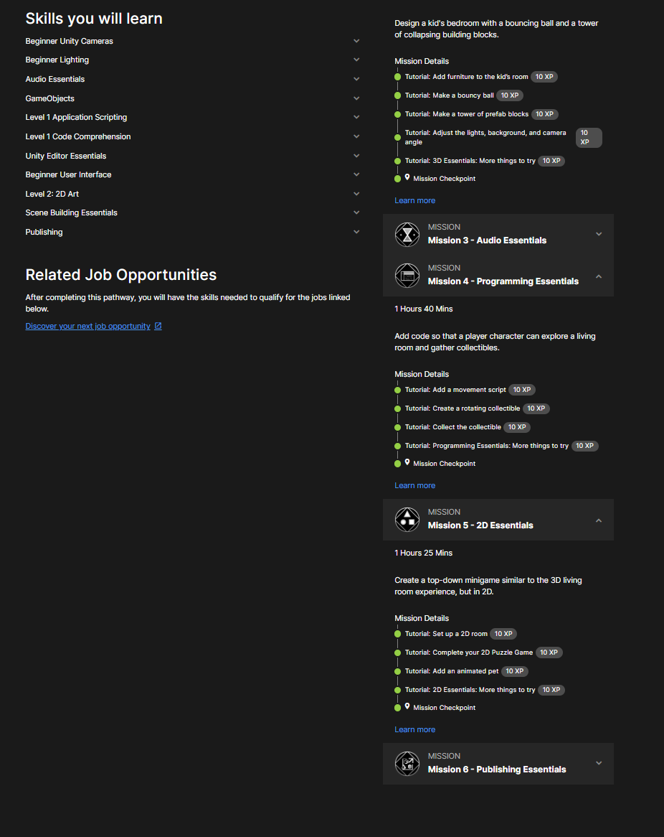

Junior Programmer

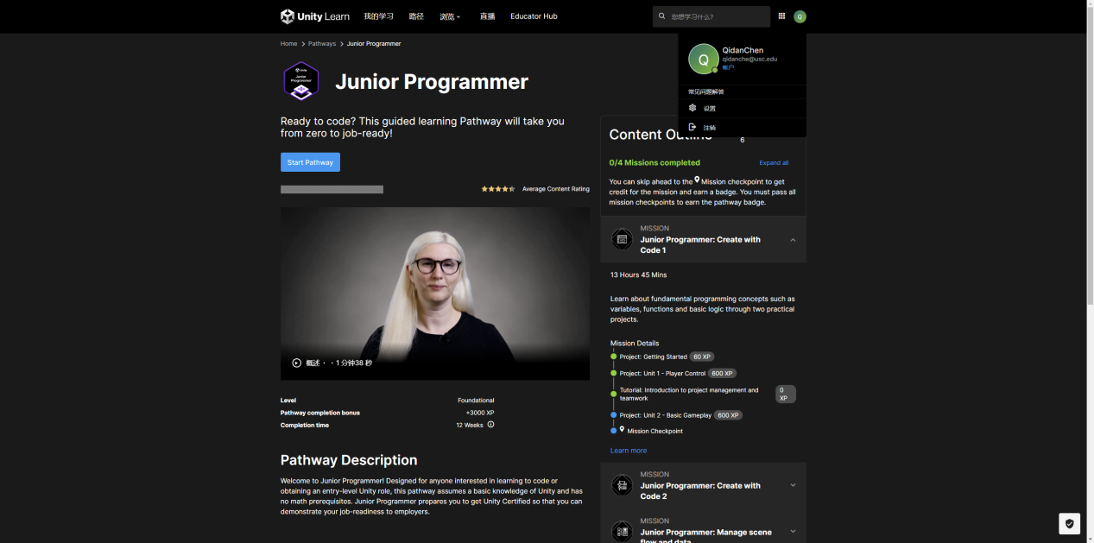

Github url:

<https://github.com/DanielCHEN0422/USC-CSCI526>

Github pages:

<https://danielchen0422.github.io/USC-CSCI526/>

Mission & prototype Links:

<https://danielchen0422.github.io/USC-CSCI526/mission2/mission2-WebGL/index.html>

<https://danielchen0422.github.io/USC-CSCI526/mission4/mission4-WebGL/index.html>

<https://danielchen0422.github.io/USC-CSCI526/mission5/mission5-WebGL/index.html>

<https://danielchen0422.github.io/USC-CSCI526/prototype1/prototype1-WebGL/index.html>

<https://danielchen0422.github.io/USC-CSCI526/prototype2/prototype2-WebGL/index.html>