МОСКОВСКИЙ ГОСУДАРСТВЕННЫЙ ТЕХНИЧЕСКИЙ УНИВЕРСИТЕТ
им. Н.Э. БАУМАНА

Факультет: Информатика и системы управления Кафедра: Информационная безопасность (ИУ8)

ЦИФРОВАЯ ОБРАБОТКА СИГНАЛОВ И ИЗОБРАЖЕНИЙ

Лабораторная работа на тему:

Одномерное (1D) преобразование Хаара
Вариант 12

Преподаватель:

Студент:

Группа:
ИУ8-32М
Цель работы
Найти аналитически коэффициенты разложения и выполнить разложение функции, заданной на интервале $[0, 1]$, вейвлетам Хаара. Выполнить проверку на приближенное выполнение равенства Парсеваля.
Постановка задачи
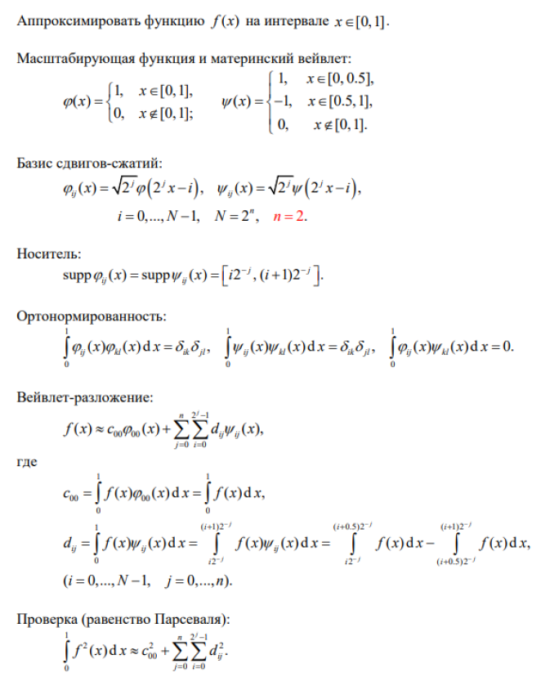
Вариант 12
$$f\left(x\right)=-\frac{1}{x^{2}+1}$$
Ход работы
«Материнский вейвлет»:
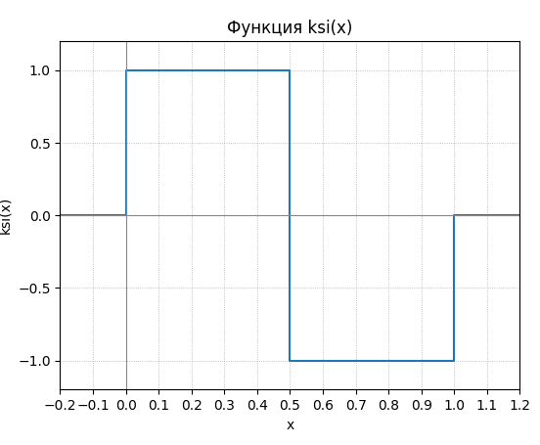
Масштабирующая функция:
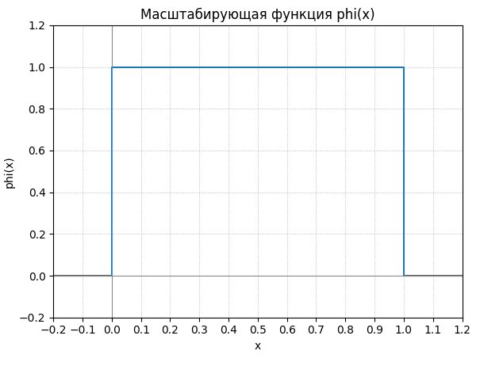
Вейвлет-разложение по базису $V^{2}(N=2^{n}, n=2)$:
$$f\left(x\right)≈c_{00}φ_{00}\left(x\right)+\sum_{j=0}^{2}{\sum_{i=0}^{3}{d_{ij}ψ_{ij}\left(x\right), }}$$
$$c_{00}=\int_{0}^{1}{f\left(x\right)dx}= \int_{0}^{1}{\left(-\frac{1}{x^{2}+1}\right)dx}=-\left(arctg1-arctg0\right)≈-0,7854.$$
$$d_{ij}=\int_{0}^{1}{f\left(x\right)ψ_{ij}(x)dx}=\int_{i2^{-j}}^{\left(i+0,5\right)2^{-j}}{f\left(x\right)dx}-\int_{\left(i+0,5\right)2^{-j}}^{\left(i+1\right)2^{-j}}{f\left(x\right)dx}, \left(i=\overline{0,3};j=\overline{0,2}\right)$$
$$d_{00}=\int_{0}^{0,5}{\left(-\frac{1}{x^{2}+1}\right)dx}-\int_{0,5}^{1}{\left(-\frac{1}{x^{2}+1}\right)dx}≈-0,1419;$$
$$d_{01}=\int_{0}^{0,25}{\left(-\frac{1}{x^{2}+1}\right)dx}-\int_{0,25}^{0,5}{\left(-\frac{1}{x^{2}+1}\right)dx}≈-0,0263;$$
$$d_{11}=\int_{0,5}^{0,75}{\left(-\frac{1}{x^{2}+1}\right)dx}-\int_{0,75}^{1}{\left(-\frac{1}{x^{2}+1}\right)dx}≈-0,0379;$$
$$d_{02}=\int_{0}^{0,125}{\left(-\frac{1}{x^{2}+1}\right)dx}-\int_{0,125}^{0,25}{\left(-\frac{1}{x^{2}+1}\right)dx}≈-0,0037;$$
$$d_{12}=\int_{0,25}^{0,325}{\left(-\frac{1}{x^{2}+1}\right)dx}-\int_{0,325}^{0,5}{\left(-\frac{1}{x^{2}+1}\right)dx}≈-0,0802;$$
$$d_{22}=\int_{0,5}^{0,625}{\left(-\frac{1}{x^{2}+1}\right)dx}-\int_{0,625}^{0,75}{\left(-\frac{1}{x^{2}+1}\right)dx}≈-0,0100;$$
$$d_{32}=\int_{0,75}^{0,875}{\left(-\frac{1}{x^{2}+1}\right)dx}-\int_{0,875}^{1}{\left(-\frac{1}{x^{2}+1}\right)dx}≈-0,0088.$$
Проверка (равенство Парсеваля):
$$\int_{0}^{1}{f^{2}\left(x\right)dx}=\int_{0}^{1}{\frac{1}{(x^{2}+{1)}^{2}}dx}=\left|u=arctg\left(x\right); x=tg\left(u\right)\right|=\frac{arctg(x)}{2}+\frac{x}{2(x^{2}+1)}$$
Подстановка:
$$u=arctg\left(x\right)→x=tg\left(u\right);dx=\frac{1}{\cos^{2}{(u)}}du;x^{2}+1=\frac{1}{\cos^{2}\left(u\right)}.$$
$$\int_{ }^{ }{\frac{1}{(x^{2}+{1)}^{2}}dx}=\int_{ }^{ }{\cos^{2}{u}du}=\left|\cos^{2}\left(u\right)=\frac{1+\cos^{2}\left(2u\right)}{2}\right|=\int_{ }^{ }{\frac{\cos\left(2u\right)+1}{2}du}=$$
$$=\frac{\sin\left(2u\right)}{4}+\frac{u}{2}+C$$
Выполняем обратную замену и производим расчёт:
$$\int_{0}^{1}{\frac{1}{(x^{2}+{1)}^{2}}dx}=\frac{π+2}{8}≈0,6427$$
$$c_{00}^{2}+\sum_{j=0}^{n}{\sum_{i=0}^{2^{j}-1}{d_{ij}^{2}}}≈(-{0,7854)}^{2}+{\left(-1,1419\right)}^{2}+{\left(-0,0263\right)}^{2}+{\left(-0,0379\right)}^{2}+$$
+${\left(-0,0037\right)}^{2}+{\left(-0,0802\right)}^{2}+{\left(-0,0100\right)}^{2}+{\left(-0,0088\right)}^{2}≈0,6457$

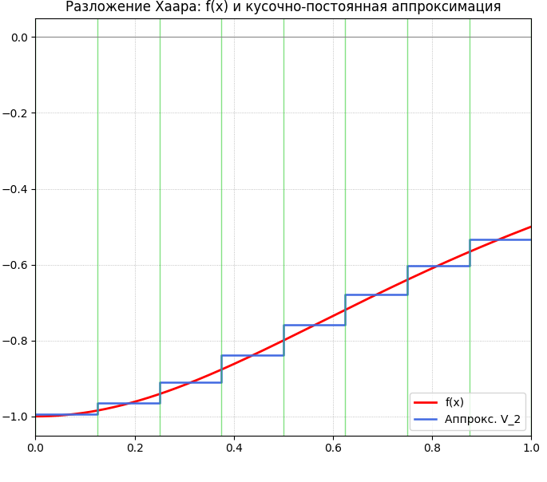

Приложение А
Листинг 1 – Программный код для выполнения задания
import numpy as np
import matplotlib.pyplot as plt
from scipy import integrate

def f(x):
return -1.0 / (x * x + 1.0)

def compute_haar_coefficients(target_function, levels=3, interval=(0.0, 1.0)):

a, b = interval
c00, _ = integrate.quad(target_function, a, b)
detail_coefficients = []
for level_index in range(levels):
level_coeffs = []
num_segments = 2 ** level_index
segment_length = (b - a) / num_segments
for segment_index in range(num_segments):
left_start = a + segment_index * segment_length
middle = left_start + segment_length / 2.0
right_end = left_start + segment_length
left_integral, _ = integrate.quad(target_function, left_start, middle)
right_integral, _ = integrate.quad(target_function, middle, right_end)
d_jk = left_integral - right_integral
level_coeffs.append(d_jk)
detail_coefficients.append(level_coeffs)
return c00, detail_coefficients

def reconstruct_piecewise_average(target_function, level, interval=(0.0, 1.0)):
a, b = interval
num_bins = 2 ** level
bin_length = (b - a) / num_bins
xs = np.arange(a, b + 1e-12, bin_length)
averages = []
for bin_index in range(num_bins):
left = a + bin_index * bin_length
right = left + bin_length
integral_value, _ = integrate.quad(target_function, left, right)
averages.append(integral_value / bin_length)
return xs, np.array(averages)

def check_parseval(target_function, levels=3, interval=(0.0, 1.0)):

a, b = interval
integral_f_squared, _ = integrate.quad(lambda x: target_function(x) ** 2, a, b)
c00, detail_coefficients = compute_haar_coefficients(target_function, levels=levels, interval=interval)
sum_of_squares = c00 * c00
for level_coeffs in detail_coefficients:
for coeff in level_coeffs:
sum_of_squares += coeff * coeff
return integral_f_squared, sum_of_squares

def estimate_energy_error(target_function, levels=3, interval=(0.0, 1.0)):

integral_f_squared, partial_energy = check_parseval(target_function, levels=levels, interval=interval)
return abs(integral_f_squared - partial_energy)

def plot_reconstruction(target_function, level=3, interval=(0.0, 1.0)):

a, b = interval
dense_x = np.linspace(a, b, 2001)
dense_y = target_function(dense_x)
step_x, step_values = reconstruct_piecewise_average(target_function, level, interval)
plt.figure(figsize=(9, 4))
plt.plot(dense_x, dense_y, color="red", linewidth=2.0, label="f(x)")
plt.step(step_x, np.r_[step_values, step_values[-1]], where="post", color="royalblue", linewidth=1.8, label=f"Аппрокс. V_{level-1}")
for k in range(2 ** level + 1):
xk = a + (b - a) * k / (2 ** level)
plt.axvline(xk, color="#32cd32", alpha=0.6, linewidth=1.0)
plt.axhline(0.0, color="#888", linewidth=0.8)
plt.xlim(a, b)
plt.grid(True, linestyle=":", linewidth=0.6)
plt.legend()
plt.tight_layout()
plt.title("Разложение Хаара: f(x) и кусочно-постоянная аппроксимация")
plt.show()

if __name__ == "__main__":

levels = 3
c00, d_coeffs = compute_haar_coefficients(f, levels=levels, interval=(0.0, 1.0))
print(f"c00 = {c00:.6f}")
for j, level in enumerate(d_coeffs):
formatted = ", ".join(f"{c:.6f}" for c in level)
print(f"d[{j}]: [{formatted}]")
int_f2, energy = check_parseval(f, levels=levels, interval=(0.0, 1.0))
print(f"∫ f^2 ≈ {int_f2:.6f}, c00^2 + Σ d^2 ≈ {energy:.6f}")
eps = estimate_energy_error(f, levels=levels, interval=(0.0, 1.0))
print(f"Оценка погрешности ε ≈ {eps:.6f}")
plot_reconstruction(f, level=levels, interval=(0.0, 1.0))

