**CST-235 Java Application Programming Project Status and Design Report**

|  |  |  |
| --- | --- | --- |
| **Topic:** | Milestone 1 | |
| **Date:** | *This should be the date you completed the Report.* | |
| **Revision:** | 1.0 | |
| **Team:** | 1. Daniel Cender | |
| 1. Chance Anderson | |
| 1. Tim James | |
| 1. Marc Teixeira | |
| **Weekly Team Status Summary:** | |  |  |  |  | | --- | --- | --- | --- | | **User Story** | **Team**  **Member** | **Hours**  **Worked** | **Hours Remaining** | | *Designed UI and mockup site pages* | *Tim James* | *3* | *0* | |  |  |  |  | |  |  |  |  | |  |  |  |  | |  |  |  |  | |  |  |  |  | |  |  |  |  | |  |  |  |  | |  |  |  |  | |  |  |  |  | |  |  |  |  | |  |  |  |  | |  |  |  |  | | |
| **GIT URL:** | <https://github.com/DanielCender/CST-235-CLC.git> | |
| **Peer Review:** | *Y/N* | We acknowledge that our team has reviewed this Report and we agree to the approach we are all taking. |

**Planning Documentation**

**Agile Scrum Product Backlog:**

*This needs to contain a URL to the Bitbucket Scrum Product Backlog Artifact.*

**Agile Scrum Sprint Backlog:**

*This needs to contain a URL to the Bitbucket Scrum Sprint Backlog Artifact. This current week's progress should be reflected in the above section of this Design Report.*

**Agile Scrum Burn Down Chart:**

*This needs to contain a URL to the Bitbucket Scrum Burn Down Chart Artifact.*

**Agile Retrospective Results:**

*The following table should be completed after each Retrospective on Things That Went Well (Keep Doing). An alternative to the following table is to use a mind mapping tool such as Coggle; if you use a mind mapping tool, you must include the URL or image file.*

|  |
| --- |
| **What Went Well** |
|  |
|  |
|  |

*The following table should be completed after each Retrospective on Things That Didn’t Go Well (Stop Doing) and What Would Be Done Differently Next Time With an Action Plan to Improve (Try Doing and Continuous Improvement). An alternative to the following table is to use a mind mapping tool such as Coggle; if you use a mind mapping tool, you must include the URL or image file.*

|  |  |  |
| --- | --- | --- |
| **What Did Not Go Well** | **Action Plan** | **Due Date** |
|  |  |  |
|  |  |  |
|  |  |  |

**Design Documentation**

**Install Instructions:**

*Include step-by-step instructions for setting up your database, configuring, and deploying/installing your application. This section should also include detailed instructions for what configuration files are required by your application, what configuration settings need to be adjusted for various runtime (development or production) environments, and where the files need to be deployed to. This section should also contain detailed instructions for how to clone your application source code from Bitbucket and deploy the application to an externally hosted site.*

**General Technical Approach:**

*Describe your approach and design here in your own words. You should also summarize any meeting notes, brainstorming sessions, and so forth that you want to retain throughout the design of your project.*

**Key Technical Design Decisions:**

*Any final technical design decisions, such as framework decisions and so forth, should be documented here. List the technology/framework, its purpose in the design, and why it was chosen.*

**Known Issues:**

*Any anomalies or known issues in the code or functionality should be documented here.*

**Risks:**

*Any risks, unknowns, or general project elements that should be tracked for risk management should be documented here.*

**ER Diagram:**

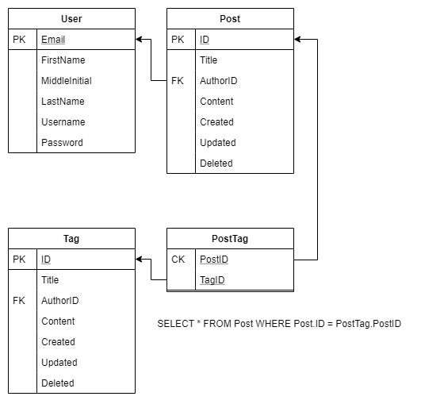

**DDL Scripts:**

*This should contain a link to Bitbucket where the DDL script can be downloaded from.*

**Sitemap Diagram:**

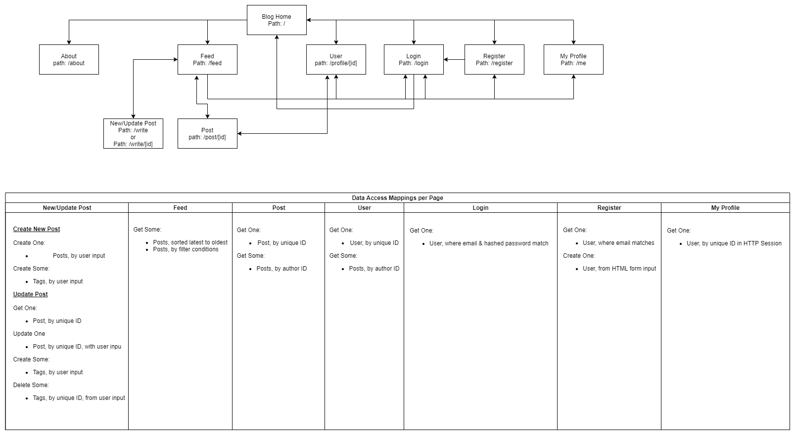

**User Interface Diagrams:**

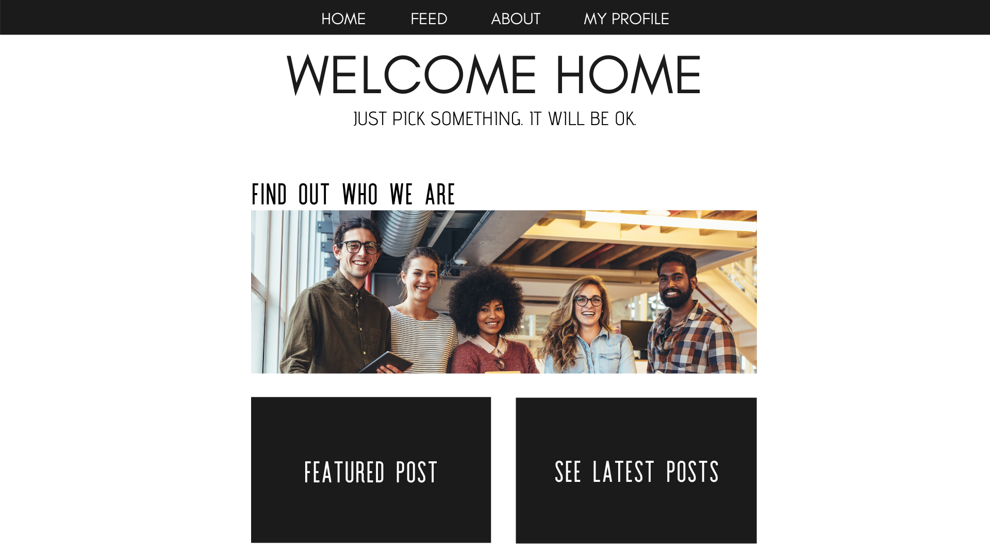

**Class Diagrams:**

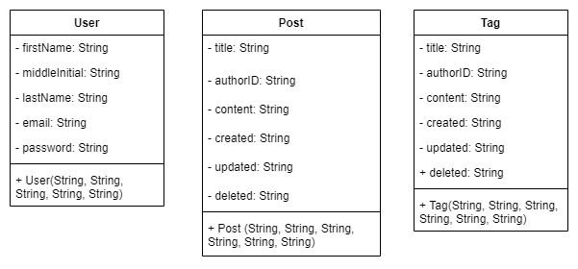

**Service API Design:**

*This section should fully document any Third Party Service Interface APIs being consumed or application specific Service APIs being published, how to access the service, what parameters are required by the API, and the detailed JSON data format specification that could be used by a third party developer to integrate with the service and API.*

**Security Design:**

*This section should outline the design for how authentication and authorization was supported. This section should also contain all of the roles and privileges that are supported by the design.*

**Other Documentation:**

*You should insert any additional drawings, storyboards, white board pictures, project schedules, tasks lists, and so forth that support your approach, design, and project. If you have no supporting documentation, please explain the rationale for why you are leaving this section as N/A.*

