Activity 2

Daniel R. Cender

Grand Canyon University: CST-256-O500

Jan 9, 2021

**Laravel Routes and Controllers**

This section went over the basics of defining routes and controller method mappings with the Laravel framework.

**Screenshots**

1. /whoami (as GET route)

1. /askme (as PHP page and Form Post to the Controller)

1. /askme (as a Form Post to the Controller that prints Form Data)

1. /askme (as a Form Post to the Controller that responses with a View)

**Block-Level Diagram**

**(todo)**

**Laravel N-Layer Application**

**Screenshots**

1. Login Form

1. Login Response for user found

1. Login Response for user not found

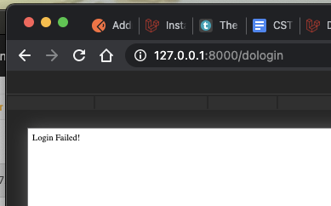

In addition to spacing, APA style includes a special way of citing resource articles. See the APA manual for specifics regarding in-text citations. The APA manual also discusses the desired tone of writing, grammar, punctuation, formatting for numbers, and a variety of other important topics. Although the APA style rules are used in this template, the purpose of the template is only to demonstrate spacing and the general parts of the paper. The student will need to refer to the APA manual for other format directions. GCU has prepared an APA Style Guide available in the Student Writing Center for additional help in correctly formatting according to APA style.

The reference list should appear at the end of a paper (see the next page). It provides the information necessary for a reader to locate and retrieve any source you cite in the body of the paper. Each source you cite in the paper must appear in your reference list; likewise, each entry in the reference list must be cited in your text. A sample reference page is included below; this page includes examples of how to format different reference types (e.g., books, journal articles, information from a website). The examples on the following page include examples taken directly from the APA manual.

References

American Psychological Association. (2010). *Publication manual of the American Psychological Association* (6th ed.). Washington, DC: Author.

Daresh, J. C. (2004). *Beginning the assistant principalship: A practical guide for new school administrators*. Thousand Oaks, CA: Corwin.

Herbst-Damm, K. L., & Kulik, J. A. (2005). Volunteer support, marital status, and the survival times of terminally ill patients. *Health Psychology*, *24*, 225-229. doi:10.1037/0278-6133.24.2.225

U.S. Department of Health and Human Services, National Institutes of Health, National Heart, Lung, and Blood Institute. (2003). *Managing asthma: A guide for schools* (NIH Publication No. 02-2650). Retrieved from http://www.nhlbi.nih.gov/  
health/prof/asthma/asth_sch.pdf