Daniel Cender

CST-227-O500

Activity 1: Car Store Application Guide

Sept 4, 2020

*Note: In the zipped submission, the Car Console App is in the CarClassLibrary solution.*

This application required basic use of OOP paradigms and Windows Forms development to accomplish the required goals. The first part of this assignment required building a console application that behaved as a Car store and shopping cart, with some minor calculation logic.

**Console App**

The functioning console application, when run through with all its options, results in the screenshot below:

There are a couple points of some error handling, namely, where integers or Boolean values are required for user input.

The below picture illustrates what happens when the user inputs a wrong menu selection:

This is the result for inputting a wrong decimal value:

Below shows the output for inputting a wrong Boolean value:

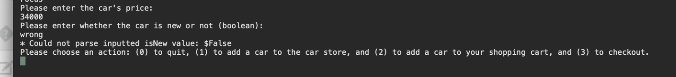

With the addition of this input checking logic, the code has become relatively bulletproof for users who might hammer-fist their way into erroring out the program.

**Windows Forms App**

The windows forms app appears similar to the assignment designs:

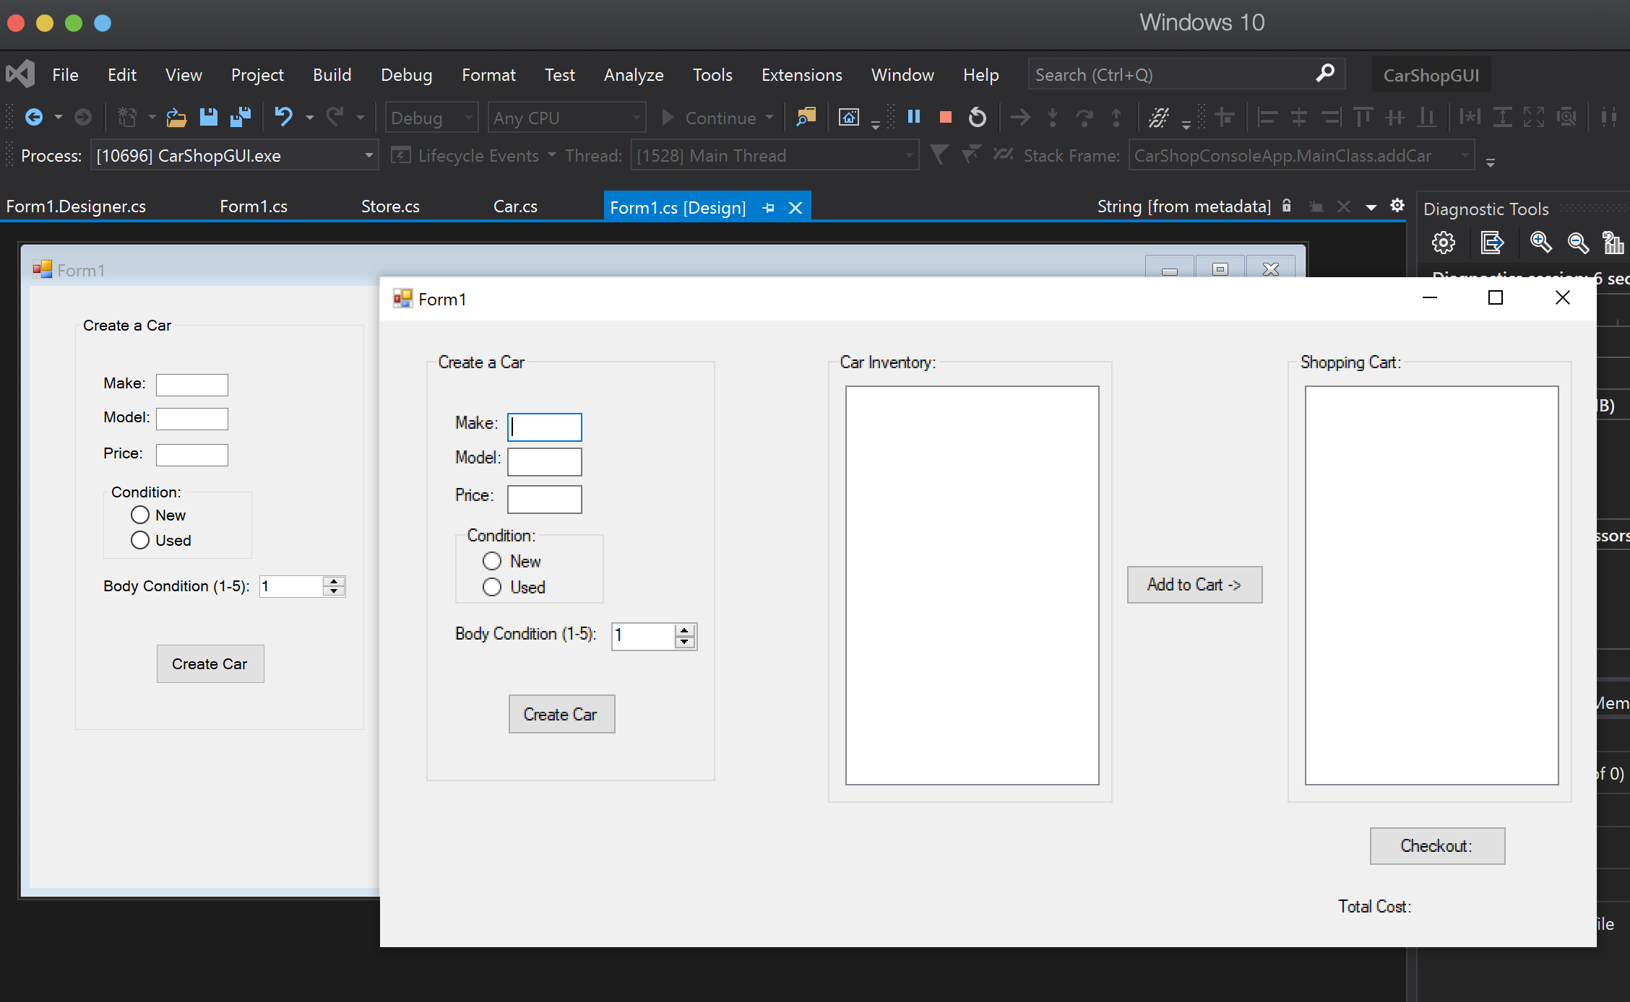

The general function of the WinForms app is to add cars to the CarList, then ShoppingList, of the Store.

The screenshot below shows the result of adding a car to the Store’s CarList.

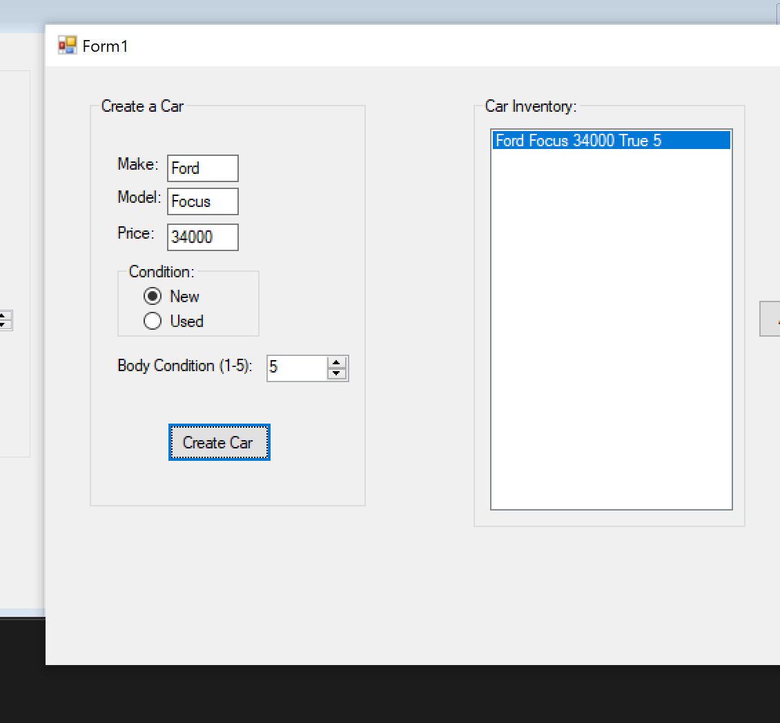

The screenshot below shows the result of adding a car to the ShoppingList and then selecting “Check Out”.

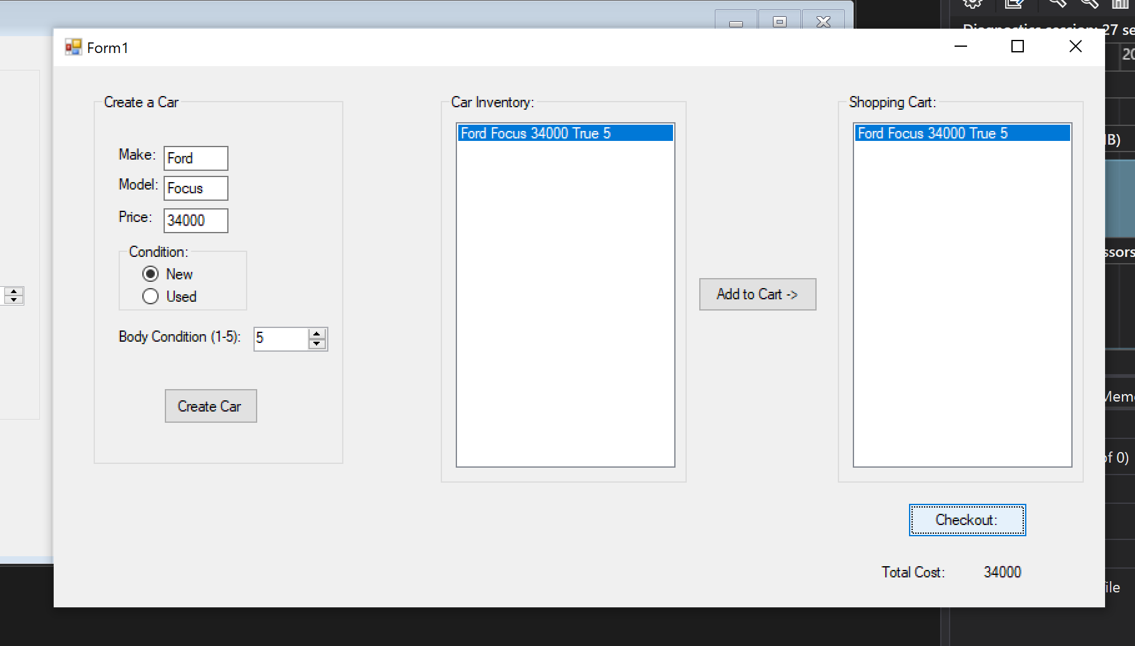

With the UI controls, the only point of possible user input fault is the Price input. That uses an ErrorProvider to send an error response back to the user and prevent adding an invalid Car record to the CarList.

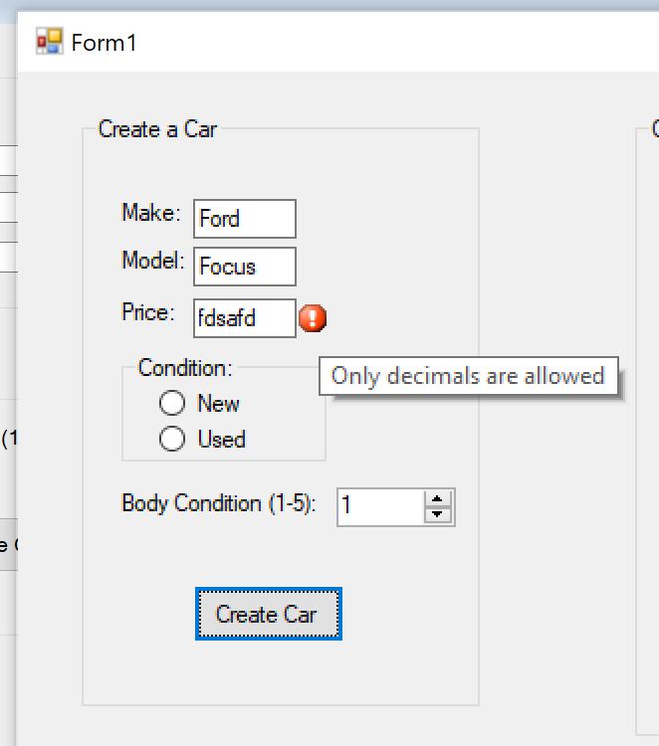

The “Body Condition” UI control is limited to integers between 1 and 5, so that won’t really pose a problem that I can see.