Daniel Cender

CST-227-O500

Milestone 1: Console Application

Sept 5, 2020

This milestone involved the first steps towards building a fully-functional Minesweeper game in C#/.NET. The first piece required building classes for Cell and Board and an initial program to test class methods and board logic.

The result of running my Milestone1 console application is shown below.

*Prompt upon program startup.*

The program prompts a user for a size with which to initialize the square game board.

Once the user responds, the program prints out the board with the initialized Cell instances:

*5x5 Game Grid.*

If the user enters an illegal value for the grid size, the program catches the user error and continues asking for a valid input:

*User input error handling.*

Due to the width of numbers larger than 9, the board will appear “off” if a size larger than 9 is entered.

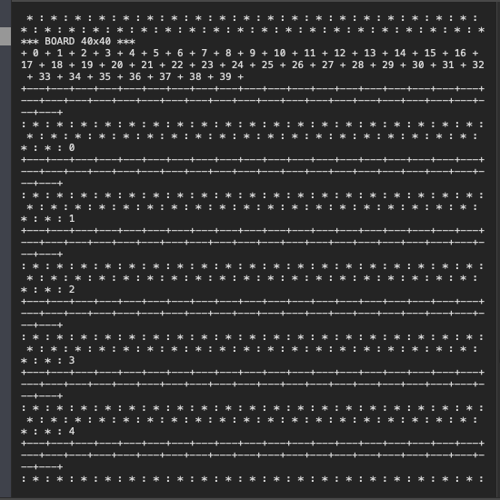

*20x20 Grid.*

However, the grid should scale up to a size of 9x9 just fine for now:

*8x8 Game Grid.*

*9x9 Game Grid.*

*11x11 Game Grid.*

**Documentation**

Here you can see my UML diagram for this simple program.

