CST-227 Activity 5: Stopwatch and Timer Control Guide

Contents

Part 1 – Create a Stopwatch 2

Part 2 – Create a "Wack a Mole" Game 4

Part 3 - Extend the Game 5

# Part 1 – Create a Stopwatch

**Objective:** This lesson will show you how to manage a **Stopwatch** object and a **Timer** control. Both will work together to create a game timer. In the second part of the lesson, you will extend the timer functionality into a game with options that you choose.

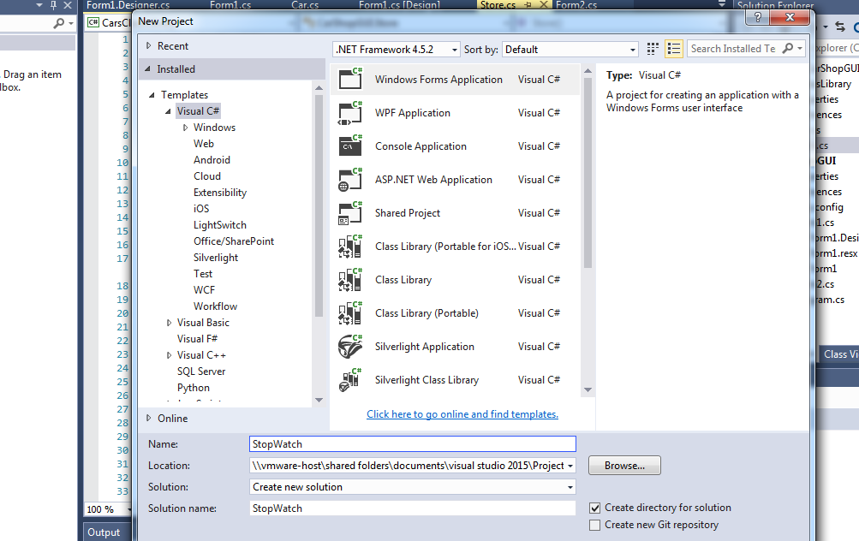

1. Create a new application. Name it StopWatch.
2. One Form1, create three buttons and a label.

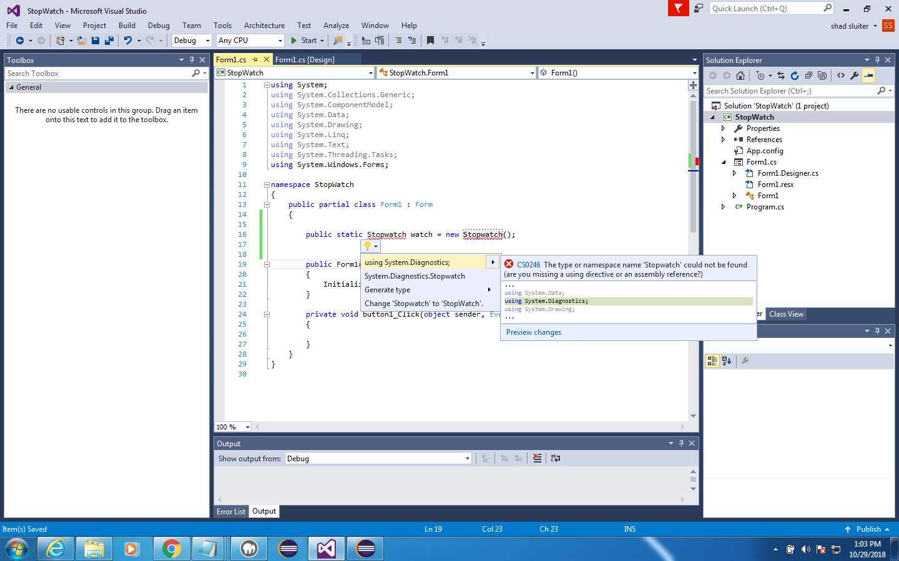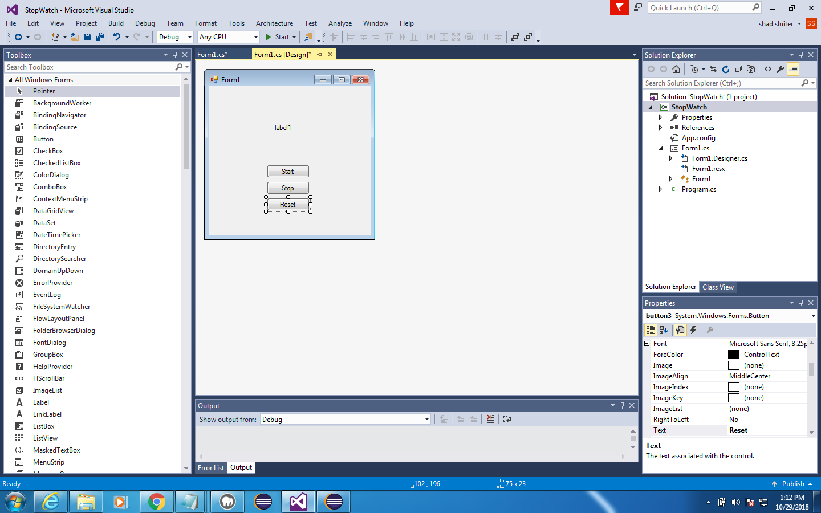

1. Set the text properties to "Start," "Stop," and "Reset."
2. Add a new Stopwatch object to the Form1 code. Notice that we will have to include the line using System.Diagnostics to make Stopwatch recognizable to the project.

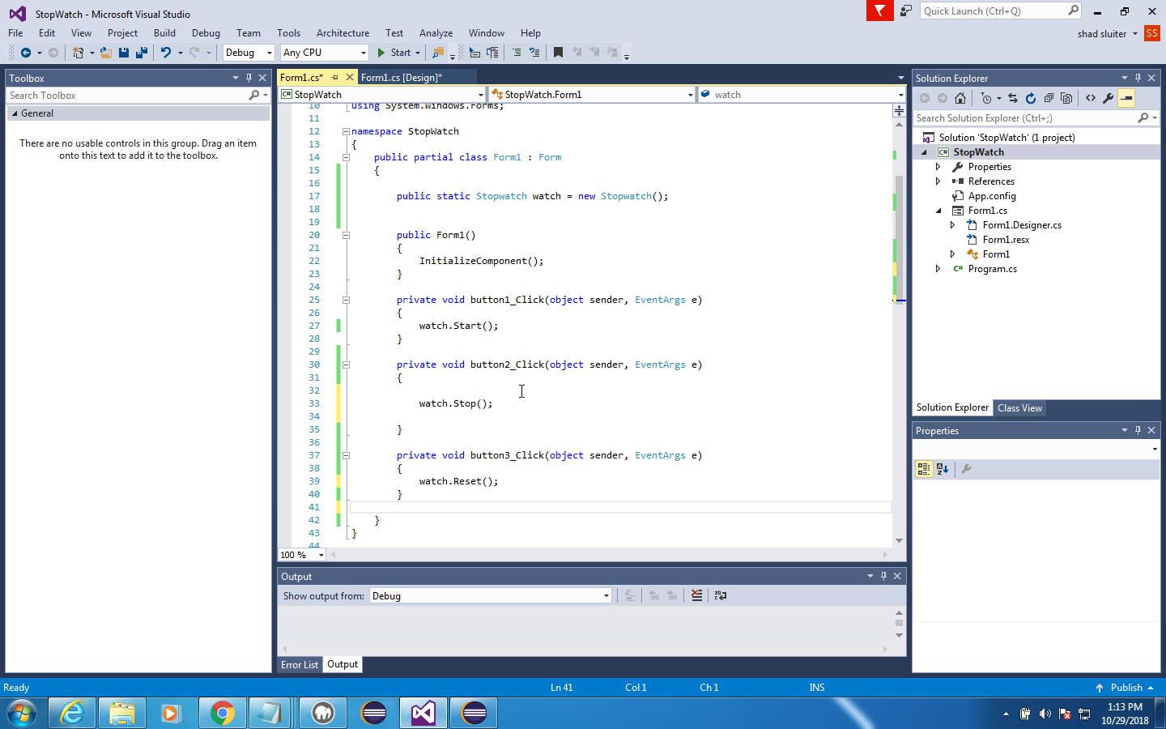

1. Double click each button on the form design screen and add the following events to the program, button1_click, button2_click, button3_click.
2. 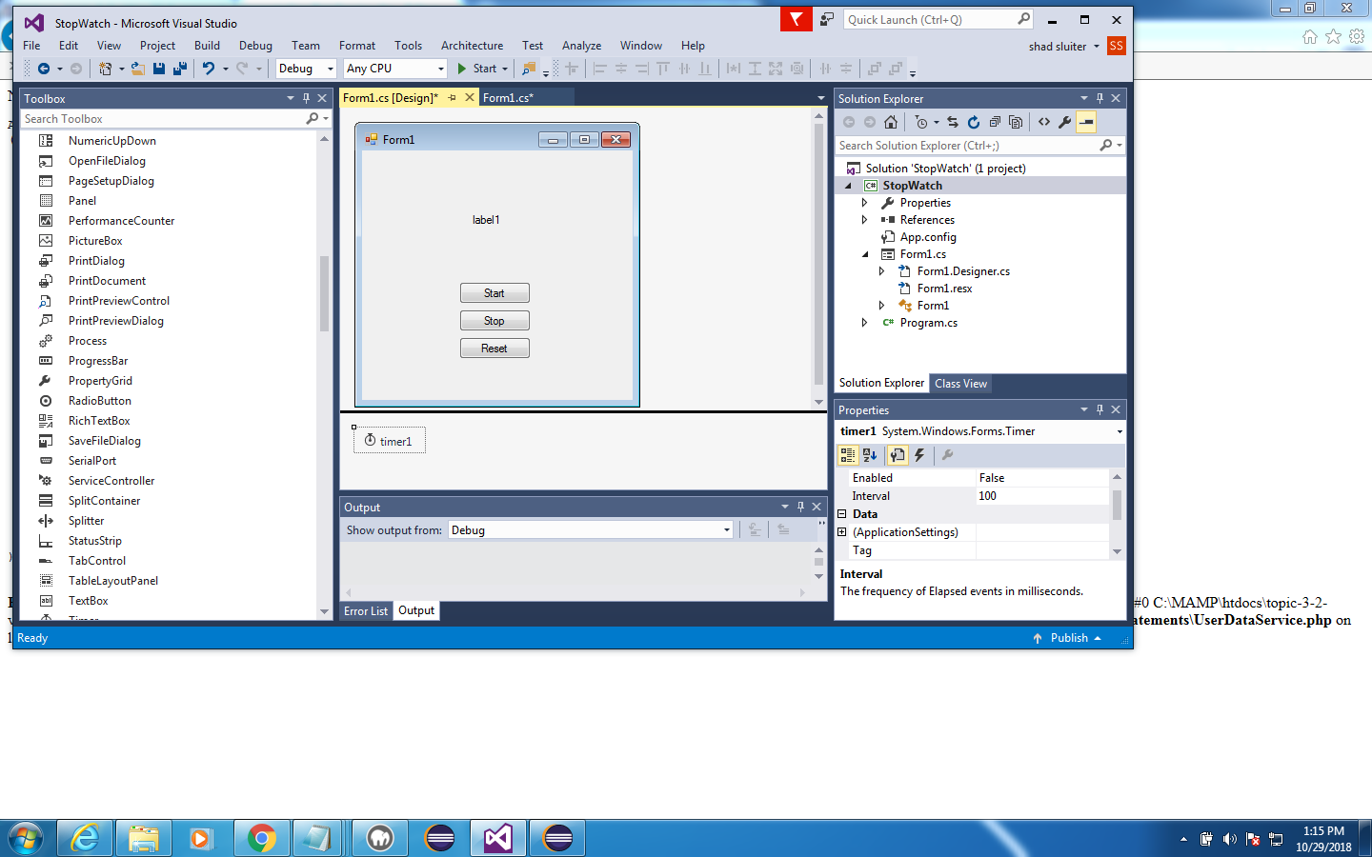Add a timer control to the form. The timer control is not a visible element, but instead shows up as an item in the footnote area of the controls.
3. Set the **enabled** property of the timer to **true**.

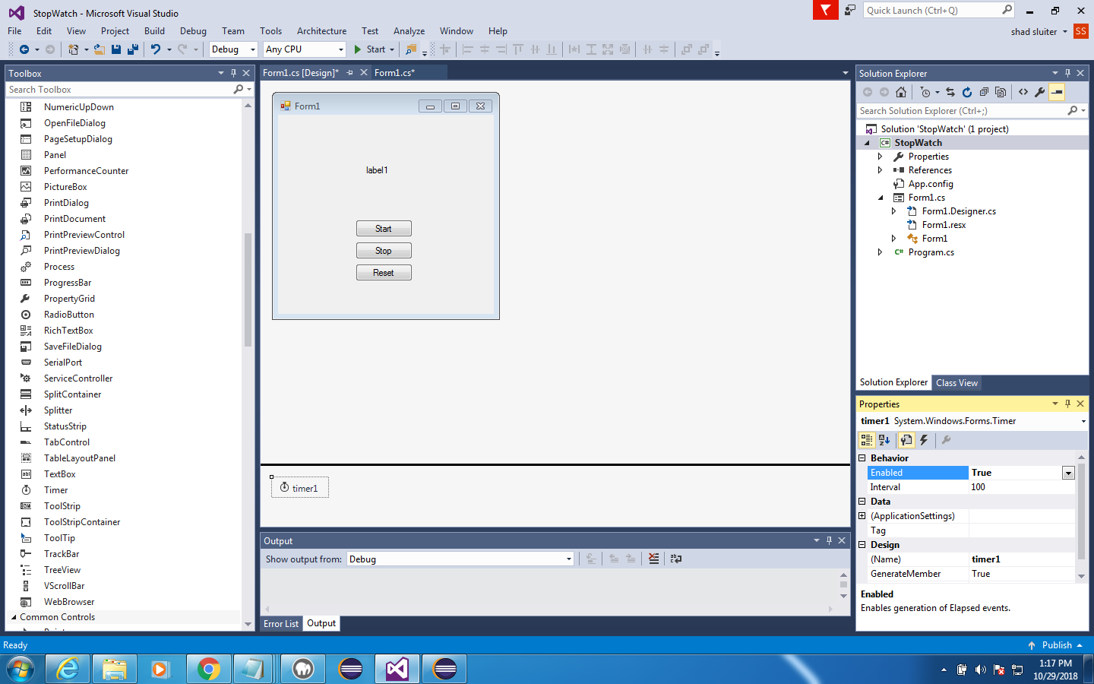

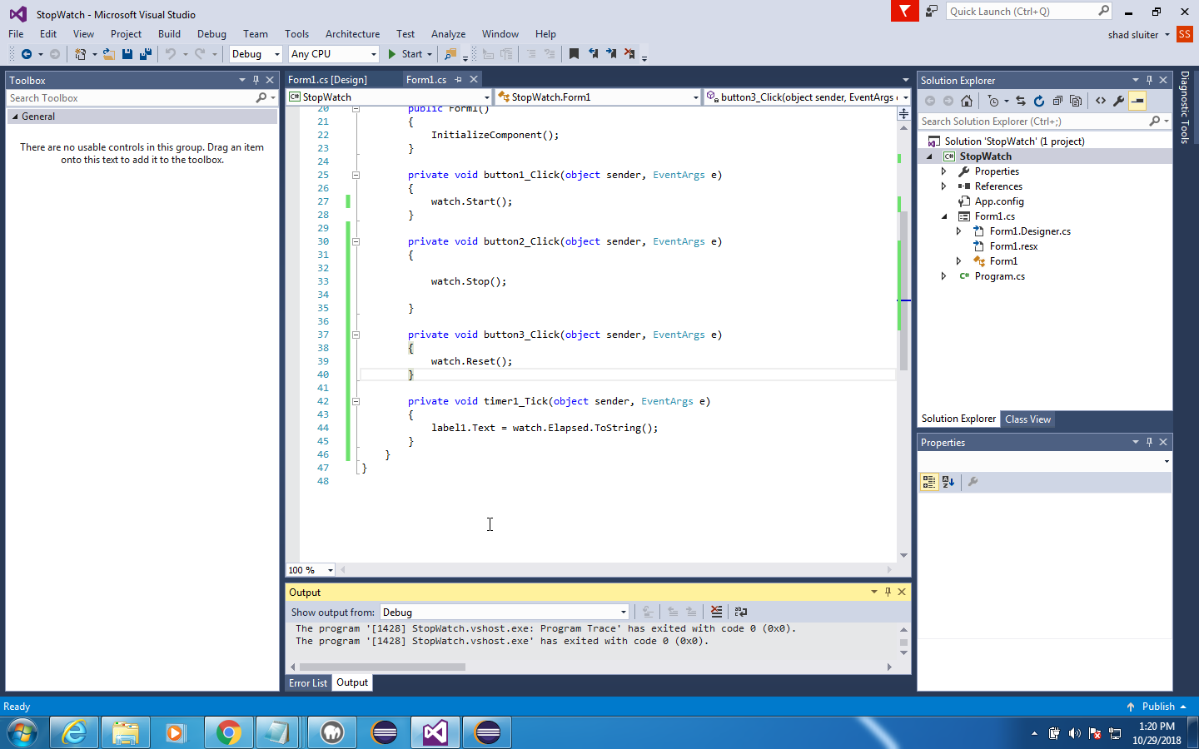

1. Double click the Timer1 control. In the tick method, update the label1 text to show the watch elapsed time property.
2. The timer should run now.

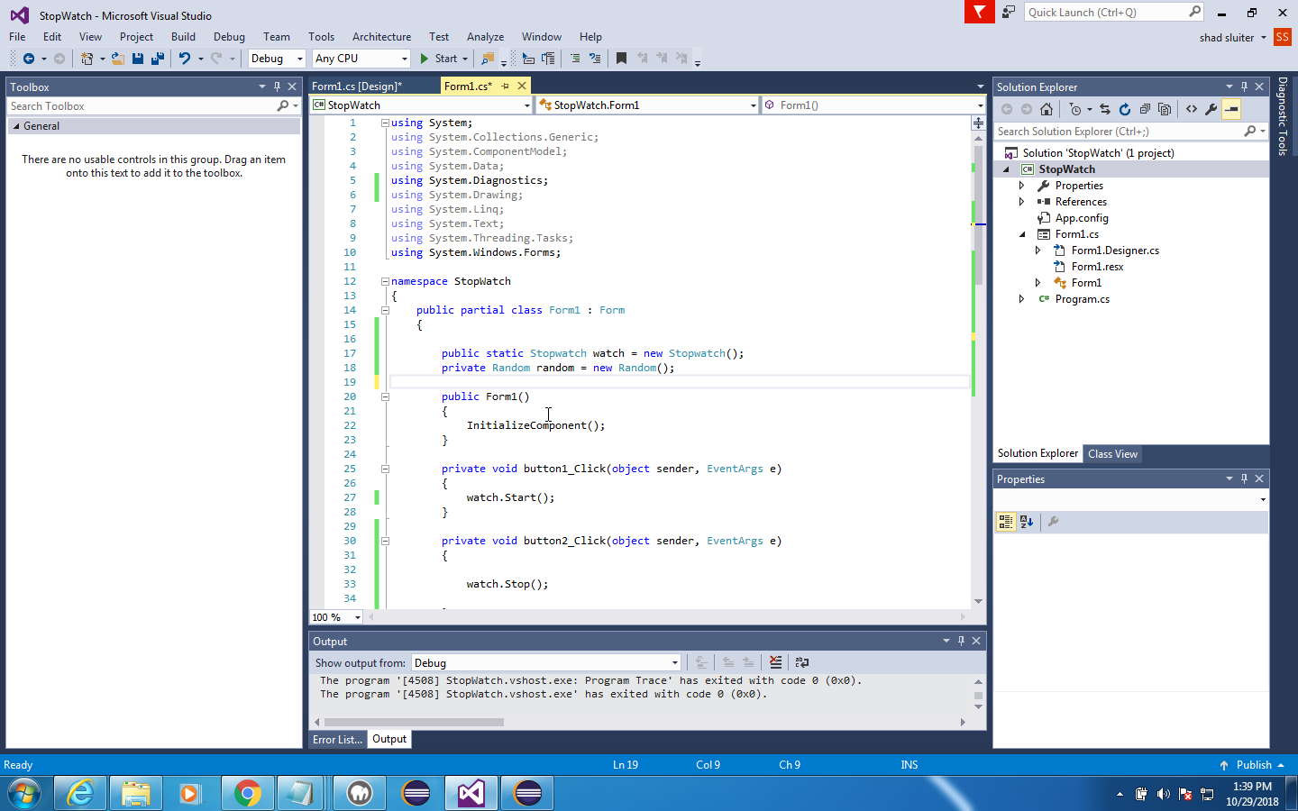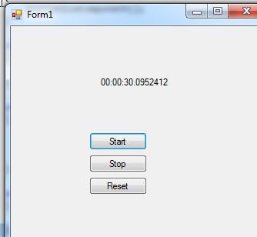

Research ways make the text format more readable.

# Part 2 – Create a "Wack a Mole" Game

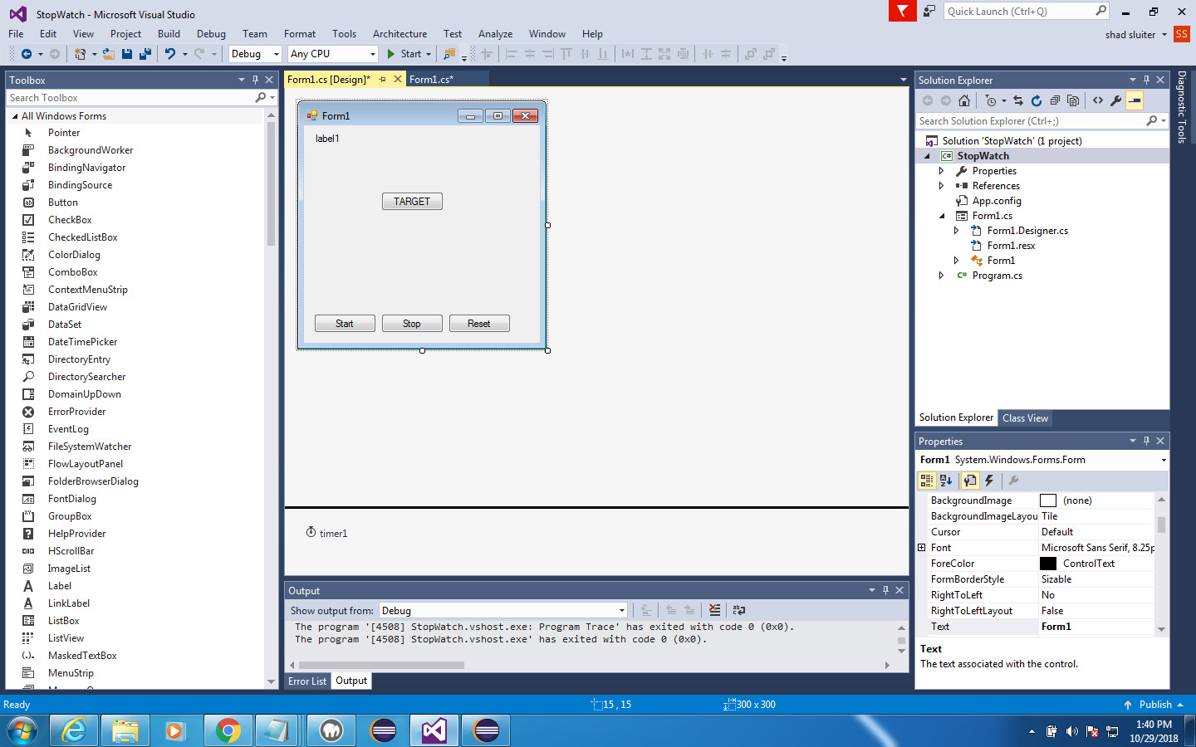

1. Create a new Random() object in the top of the program.
2. Add a new button to the form and move the other buttons to the edge of the window.

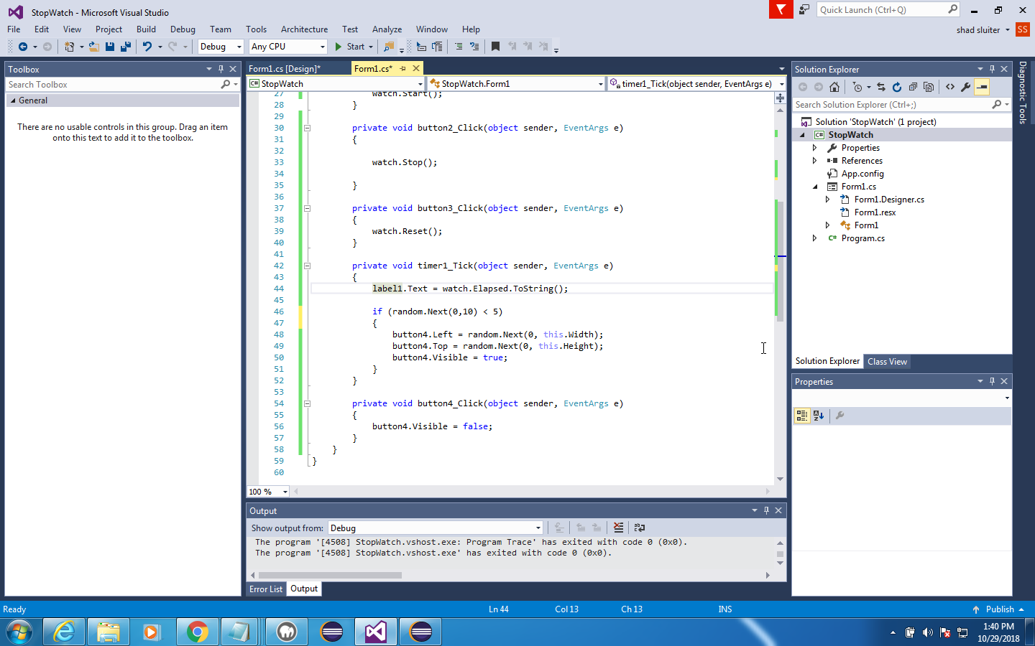

1. Add some code to the **Timer tick** event to move the TARGET button to a random place on the form and set it to visible. Use the button's Top and Left properties to set the button's position. The button will move each time the timer tick interval occurs.
2. Hide the TARGET button when it is clicked. Set its visible property to false.

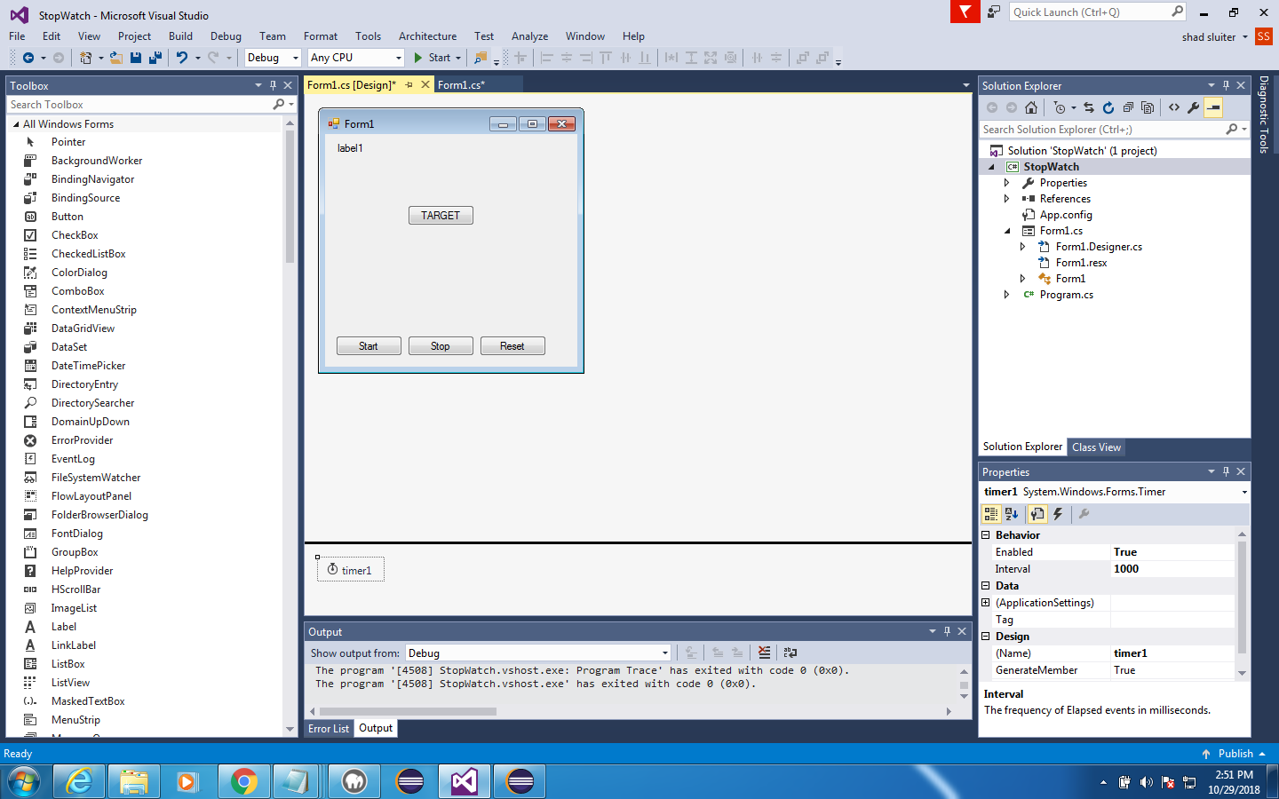

1. I set the interval property of the timer to 1000 so the Timer is triggered once per second.

# Part 3 - Extend the Game

Now that you have created a basic game with a timer control add the following features.

1. Keep score of the number of hits on the target button.
2. Decide what will happen if the player clicks on the form instead of the button (missed click)? Should you end the game? Subtract points? Lose a life? You decide.
3. Modify the appearance of the buttons with colors, fonts and background images. Instead of a TARGET button, you could perform the same effect with a Picture control.
4. Determine how the game will end. Does the game end after 60 seconds? After 50 hits? After 3 misses? You decide.
5. Create a "Play again" button that shows when the game is over. Keep a high score from previous games played.
6. Format the time on Label1 to make it more visually appealing.
7. Create a second button titled "Don't click me!" or "False TARGET". Use it as a decoy or "bomb" that damages the player's game in some way.
8. Increase difficulty. Does the TARGET button get faster or smaller when the score gets higher? Perhaps there are more decoy buttons to avoid.
9. Level features. Multiple levels of difficulty to clear could have background scenery changes. Can a player earn extra lives?

**Deliverables**

1. ZIP file of the project code.
2. Screenshots of the game in action. Paste images into a Word document. Caption each picture with a description of the features you developed.