

Software Engineering Department
Braude College of Engineering
Final Project – Phase A (61998)

ActiveSage : A VR Sport Game
26-1-D-15
Alexandra Belkind
Daniel Chernov

Advisor: Dr.Moshe Sulami

Github-ActiveSaga

Daniel Chernov: Daniel.Chernov@e.braude.ac.il
Alexandra Belkind: Alexandra.Belkind@e.braude.ac.il
Supervisor: Moshe Sulamy: MosheSu@braude.ac.il

Content
1. Abstract ........................................................................................................................................ | 3
2. Introduction .................................................................................................................................. | 3
2.1 Motivation ............................................................................................................................. | 3
2.2 Problem Statement .............................................................................................................. | 3
2.3 Proposed Solution ................................................................................................................ | 3
2.4 Core Objectives and Algorithmic Innovation ........................................................................ | 4
2.5 Progression System and Technology Stack ........................................................................ | 4
3. Background .................................................................................................................................. | 4
3.1 The Global Challenge Of Physical Inactivity ........................................................................ | 4
3.2 Exergaming and Gamification .............................................................................................. | 4
3.3 Virtual Reality (VR) in Fitness .............................................................................................. | 5
3.4 Hardware: Meta Quest 3S ................................................................................................... | 5
3.5 Software Development: Unity Engine .................................................................................. | 6
4. Product ......................................................................................................................................... | 6
4.1 Requirements ....................................................................................................................... | 6
4.1.1 Functional Requirements ............................................................................................ | 7
4.1.2 Non-Functional Requirements .................................................................................... | 7
4.2 Methodology and Development Process ............................................................................. | 7
4.3 Expected Challenges ........................................................................................................... | 8
4.4 Tools and Technologies ....................................................................................................... | 9
4.5 Solution ................................................................................................................................ | 10
4.5.1 Architecture ................................................................................................................. | 10
4.5.2 Use Case .................................................................................................................... | 11
4.5.3 Activity Diagram .......................................................................................................... | 11
4.6 Project Success Metrics ....................................................................................................... | 12
4.7 Verification and Evaluation .................................................................................................. | 12
4.7.1 Verification Plan (Unit & System Testing) ................................................................... | 13
4.7.2 Usability and Safety Testing ....................................................................................... | 14
5. AI Tools Usage ............................................................................................................................ | 14
5.1 List of Tools .......................................................................................................................... | 14
5.2 Representative Prompts ...................................................................................................... | 14
6. References (External Research) .................................................................................................. | 15

1. Abstract:
ACTIVESAGA is an immersive sports-adventure application designed to combat sedentary behavior by integrating high-intensity physical activity with Virtual Reality (VR) gaming. Utilizing the Meta Quest standalone hardware, the project transforms real-world exercise into the core mechanics of a fantasy adventure.
Technologically, the system distinguishes itself through a custom locomotion algorithm that utilizes Head-Mounted Display velocity heuristics and vertical oscillation analysis. This approach allows for the accurate detection and translation of stationary physical movements into virtual traversal and combat actions, without relying on external sensors.
The primary objective of ACTIVESAGA is to enhance user adherence to fitness routines by leveraging gamification and high-immersion narrative to mitigate the monotony of traditional home workouts. By shifting the user's focus from physical effort to gameplay goals, the system aims to reduce the Perceived Rating of Exertion, thereby fostering a sustainable and active lifestyle.
2. Introduction
2.1. Motivation: The Global Inactivity Crisis
In modern society, physical inactivity has become a major health issue, with a significant portion of the global population failing to meet recommended activity levels [1]. This phenomenon is increasingly driven by sedentary lifestyles and the pervasive use of digital screens. However, recent systematic reviews indicate that active VR gaming can effectively counteract these sedentary habits by significantly improving physiological health outcomes [6]. While many individuals recognize the necessity of exercise, maintaining a consistent fitness routine remains a significant challenge.
2.2. Problem Statement: Limitations of Existing Exergames
Current market solutions that attempt to combine fitness with gaming often fail to retain user interest over time. Standard fitness games played on regular 2D screens do not provide a fully immersive experience, leaving the user acutely aware that they are simply "exercising in front of a TV." Research comparing virtual and traditional physical activity programs indicates that full immersion is critical for overcoming the monotony of standard exercise [7]. Additionally, many existing titles lack robust game mechanics—such as character progression, daily rewards, and "Fear Of Missing Out" (FOMO) elements—which are essential for habit formation. As noted in studies on gamification retention, systems that fail to implement deep progression loops struggle to maintain user engagement [3]. Consequently, users often lose interest quickly, viewing the activity as a chore rather than entertainment.
2.3. Proposed Solution: The ACTIVESAGA Approach
"ACTIVESAGA" is our proposed solution: a Virtual Reality (VR) sports-adventure game designed to transform routine physical activity into an engaging gaming experience. By leveraging VR technology, the game creates a psychological distraction that shifts the user's focus from physical effort to gameplay goals. Empirical evidence suggests that this immersive distraction significantly reduces the Perceived Rating of Exertion (RPE), allowing users to exercise longer with less subjective fatigue [2].
2.4. Core Objectives and Algorithmic Innovation
The primary goal of ACTIVESAGA is not to train professional athletes, but to integrate movement into daily life in a fun and sustainable way. It encourages users to maintain a routine of at least five short sessions per week through positive reinforcement. To achieve this without complex external sensors, the system employs a novel walking-in-place method using Head-Mounted Display (HMD) tracking, a technique supported by recent developments in position and orientation algorithms [5]. Furthermore, the game’s design prioritizes eye-hand coordination tasks and natural movement to mitigate cybersickness, ensuring a comfortable experience even during intense activity.
2.5. Progression System and Technology Stack
ACTIVESAGA translates real-world movements into virtual actions through distinct gameplay modes. To maintain long-term engagement, the game features a comprehensive progression system where players earn Experience Points (XP) and currency during each session. As the character becomes stronger, the player faces more difficult challenges, creating a satisfying cycle of improvement. The project is developed using the Unity game engine and C# scripting, utilizing the Meta Quest 3S headset to accurately track user movements and ensure a responsive, health-promoting experience.

3. Background
This chapter outlines the theoretical and technological foundations of the project. It reviews the global health challenges caused by sedentary lifestyles, the concept of "Exergaming," and the specific technologies-Virtual Reality hardware and the Unity game engine-used to develop ACTIVESAGA.
3.1. The Global Challenge Of Physical Inactivity
A significant portion of the global population does not meet the recommended levels of physical activity, as reported by organizations such as the World Health Organization (WHO)[1]. This phenomenon is multifactorial and cannot be attributed to a single cause. Contributing factors include increasingly sedentary work environments, prolonged screen time, limited access to suitable spaces for physical activity, socioeconomic barriers, health-related constraints, and challenges related to motivation and long-term adherence. Home-based workouts, while accessible and convenient, are often perceived as repetitive or monotonous, which may make them harder to sustain over time. The ACTIVESAGA project aims to address these adherence and motivation challenges by leveraging gamification and immersive virtual reality (VR) experiences to reduce psychological barriers and promote sustained engagement in physical activity.
3.2. Exergaming and Gamification
Exergaming-an intersection of physical exercise and interactive gaming refers to digital applications that employ motion-tracking technologies to convert users’ bodily movements into in-game actions. Unlike conventional sedentary games, exergames require sustained physical engagement, and therefore serve as a promising medium for promoting daily activity.
Long-term user engagement in exergaming depends largely on the effective integration of gamification mechanisms that support motivation and consistent participation over time. Commonly used design elements include structured progression systems (such as experience points and levels), a balanced in-game economy, and clear performance feedback. Research by Hamari et al. (2014) indicates that such mechanics, particularly positive reinforcement and "level-up" systems, are highly effective in building sustainable habits and increasing user motivation [3]. ACTIVESAGA implements a layered engagement model in which players earn Experience Points (XP) and virtual currency during play, use these resources to upgrade abilities, and progress through narrative-driven challenges. This approach targets both immediate motivation (daily rewards) and longer-term retention (character progression). Compared to market solutions like Beat Saber or Ring Fit Adventure-which effectively map movement to gameplay but are limited by 2D screens or rhythm-focused mechanics [4] ACTIVESAGA leverages full VR immersion to translate real-world actions into a coherent adventure designed to support sustained behavioral change.
3.3. Virtual Reality (VR) in Fitness
Virtual Reality (VR) technology provides a distinct advantage for fitness applications by enabling a level of immersion that is not achievable through traditional two-dimensional displays. This immersive environment allows users to focus on virtual tasks and goals rather than on the physical sensations associated with exercise, thereby reducing the subjective awareness of effort during activity.
Empirical findings support this effect. Matsangidou et al. (2019) and recent systematic reviews report that users engaging in physical activity within a VR environment experience a significantly lower Perceived Rating of Exertion (RPE) when compared to equivalent exercises performed outside of VR, despite similar physical demands [2, 7]. This reduction in perceived effort can contribute to longer exercise sessions and improved adherence, as users are less affected by the mental fatigue commonly associated with traditional training methods [4].
Within the context of ACTIVESAGA, this property of VR is leveraged to support the project’s broader objective of increasing motivation and long-term engagement by embedding physical activity within immersive, goal-oriented gameplay.
3.4. Hardware: Meta Quest 3S
The project utilizes the Meta Quest platform, specifically chosen for its "Standalone" capabilities, meaning it operates wirelessly without requiring a cable connection to a PC.
The selection of this hardware is driven by two critical factors for fitness applications:
- Wireless Freedom: The lack of cables is critical for a fitness game like ACTIVESAGA, as it allows the user to perform wide movements, jumps, and 360-degree turns safely.
- 6DOF Tracking: The headset and its accompanying controllers support six degrees of freedom (6DOF) tracking, allowing the system to monitor both the orientation and spatial position of the user’s head and hands in real time. This capability enables accurate detection of complex physical movements and supports their reliable translation into corresponding actions within the virtual environment.

3.5 Software Development: Unity Engine
Unity serves as the technological foundation for ACTIVESAGA. As a reliable, cross-platform game engine, it has evolved into the industry standard for Virtual Reality (VR) and Augmented Reality (AR) development.
Unity supports high-fidelity 3D graphics and utilizes C# as its primary scripting language. This offers a significant advantage over other engines by allowing for faster iteration cycles and more accessible logic management.
For a VR fitness project, Unity provides essential built-in capabilities, including advanced 3D rendering, physics simulation, and collision detection, which are required to create an immersive and physically responsive environment. Furthermore, the engine's extensive developer community and the "Asset Store" allow for the integration of high-quality, pre-made assets, enabling the development process to focus on gameplay mechanics and fitness logic rather than modeling every environmental object from scratch.

4. Product
4.1. Requirements
The requirements definition process for ACTIVESAGA was conducted through a combined methodology that included market analysis, academic literature review, and an examination of technological constraints. The objective was to identify gaps in current Exergaming solutions and formulate a specification that addresses both physiological and entertainment needs. The elicitation process consisted of three main phases:
Competitor Analysis: We performed an in-depth analysis of leading fitness games, such as Beat Saber and Ring Fit Adventure. We identified that while popular, these solutions suffer from key weaknesses which became our core requirements: the lack of lower-body tracking on standard hardware and the absence of deep progression systems (RPG elements) to maintain long-term motivation.
Literature Review: Based on the research presented in the Background chapter, we defined requirements aimed at creating a psychological "distraction" from physical effort. This led to the functional requirement for immersive gameplay that shifts the user's focus from the difficulty of the exercise to in-game goals, thereby reducing the Perceived Rating of Exertion (RPE).
Hardware & Safety Constraints: Since the project relies on Standalone hardware (Meta Quest 3S), we derived strict non-functional requirements regarding performance and safety. Specifically, we prioritized high frame rate stability and low latency to prevent "cybersickness", understanding that improper locomotion techniques in VR can cause immediate physical discomfort.
Synthesizing these sources allowed us to define the specific functional and non-functional requirements detailed in the following tables.

4.1.1. Functional Requirements
1 | The system supports integration with compatible VR hardware devices.
2 | The system recognizes specific real-world body movements in real-time.
3 | The system translates detected physical movements into virtual in-game actions.
4 | The system has a mechanism for managing Experience Points.
5 | The system has a mechanism for managing virtual currency.
6 | The system provides two distinct game modes.
7 | The system offers daily challenges with rewards.
8 | The system offers weekly bonus for playing.
9 | The system displays real-time players data.
10 | The system enables players to purchase equipment.
11 | The system enables players to upgrade abilities using virtual currency.
12 | The system stores player progress in a database.

4.1.2. Non-Functional Requirements
1 | Steady framerate to prevent motion sickness.
2 | Low latency response for physical movements.
3 | Intuitive spatial user interface (UI).
4 | Optimized 3D graphics for standalone hardware.
5 | Secure handling of user data.
6 | Physical mechanics suitable for wearable VR equipment.

4.2. Methodology and Development Process
In our development process, we will follow the Agile methodology. This approach allows us to work in sprints, delivering small, incremental features that can be tested and evaluated iteratively. To ensure an efficient process, we have divided the development into several key stages:
- Building the VR Environment: Setting up the Unity project and creating the basic VR scene with player tracking capabilities.
- Developing Core Mechanics: Implementing the movement system that translates physical actions (like running and squatting) into in-game movement.
- Creating Game Logic & UI: Implementing core gameplay states and user interface elements, including menus and a real-time HUD.
- Implementing Progression Systems: Building the in-game shop and the leveling system to reward users for their physical activity.
- Integrating Cloud Services: Connecting the game to a database to manage user login and store progress (XP and currency).
- Integrating Assets: Adding 3D models, environments, and sound effects to create an immersive atmosphere.
- Testing and Optimization: Conducting performance tests on the headset and usability tests to ensure accurate movement detection and smooth gameplay.
By following these stages and continuously improving the game based on feedback, we can ensure a stable and engaging product that successfully combines fitness with gaming.
4.3. Expected Challenges

Developing a motion-based Virtual Reality game on standalone hardware presents several unique engineering and design challenges. We have identified the following key challenges and our strategies to address them:
- Accurate Motion Detection (Locomotion Analysis):
- The Challenge: The Meta Quest 3S tracks only three points: the head and two hands (6DOF). However, our game requires detecting full-body movements such as running in place, squatting, and jumping. Inferring lower-body activity solely from upper-body sensors is algorithmically complex and prone to inaccuracy [5].
- Mitigation Strategy: To address the limitation of lacking lower-body tracking on the Meta Quest 3S, we are developing a custom Locomotion Analyzer within Unity that focuses on detecting sustained running intent. The system relies primarily on Head-Mounted Display (HMD) motion data, analyzing its temporal consistency over short time windows. By identifying periodic motion signatures and specific vertical oscillation patterns, the algorithm distinguishes intentional actions—such as running in place or squatting—from incidental head motion [5, 9]. Noise is reduced through temporal filtering, state-based validation, and confidence thresholds.
- Performance Optimization on Standalone Hardware:
- The Challenge: The Meta Quest 3S utilizes a mobile processor. Rendering a 3D fantasy environment with lighting, particle effects, and physics while maintaining a stable frame rate is difficult. A signifcant drop in frame rate can break immersion and cause immediate user discomfort.
- Mitigation Strategy: We will implement a strict optimization pipeline in Unity, focusing on:
-Culling & LOD: Utilizing "Occlusion Culling" and Level of Detail (LOD) systems to reduce rendering load for distant or obscured objects.
-Lighting: Using Lightmaps (Baked Lighting) for static geometry to minimize expensive real-time shadow calculations.
-Batching: Reducing Draw Calls through Static/Dynamic Batching to alleviate CPU bottlenecks.
-Memory Management: Implementing Object Pooling for particles and physics interactions to prevent performance spikes caused by garbage

- Preventing Motion Sickness (Cybersickness):
- The Challenge: In VR, a disconnect between what the eyes see (movement) and what the inner ear feels (remaining stationary) often causes nausea. Since ACTIVESAGA involves intense physical movement, the risk of motion sickness is high.
- Mitigation Strategy: To minimize cybersickness, the game follows a strict physical-to-virtual movement alignment approach, where in-game motion is directly driven by the player’s physical actions rather than artificial input. Traditional joystick-based locomotion is intentionally avoided. Running and movement are triggered only through sustained physical effort, reducing sensory conflict between visual motion and vestibular feedback. In addition, sudden accelerations, forced camera movements, and non-player-controlled rotations are avoided. High and stable frame rates are prioritized to minimize motion-to-photon latency, and camera behaviour remains fully player-controlled at all times. Together, these design choices aim to preserve immersion while significantly reducing the risk of motion sickness during intense gameplay.

- Safety and User Constraints:
- The Challenge: Players will be jumping and swinging arms while blindfolded by the headset. There is a risk of users hitting furniture or wandering out of the play area.
- Mitigation Strategy: Player safety is ensured by keeping all movements within the Meta Quest Guardian boundaries. The game allows full-body actions and continuously monitors the player’s position relative to the safe zone. If the player approaches the edge, the game automatically pauses and displays a visual warning, preventing collisions with real-world objects while allowing natural movement within the defined play area.

4.4.Tools and Technologies
To implement ACTIVESAGA effectively, we have selected a stack of industry-standard tools and technologies optimized for Virtual Reality development:
1.Game Engine: Unity We utilize Unity as our primary development platform. It was selected for several key capabilities:
- XR & VR Integration: The XR Interaction Toolkit and Meta Quest SDKs allow for seamless integration of head tracking, hand controller input, and spatial awareness.
- Physics & Simulation: Unity’s built-in physics engine enables realistic interactions between the player’s body and the virtual environment, which is crucial for combat impacts.
- Audio System: We utilize Unity's comprehensive audio engine to integrate immersive sound effects and music, providing essential feedback to the user and enhancing the gamified feel of the workout.
- Asset Store: To accelerate the development process, we utilize high-quality reusable assets from the Unity Asset Store, allowing us to focus on gameplay mechanics and fitness logic rather than modeling every object from scratch.
2. Programming Language: C# All game logic is written in C#, an object-oriented language. We leverage C# to manage complex game mechanics, such as the XP progression system, enemy behaviors, and our custom "Locomotion Analyzer" algorithm. Its seamless integration with the Unity Editor allows for rapid debugging and logic iteration.
3. Target Hardware: Meta Quest 3S The project is tailored for the Meta Quest 3S standalone headset. We utilize the headset's 6DOF (Six Degrees of Freedom) sensors to capture the user’s position. The standalone nature of the device is critical for preventing motion sickness and ensuring safety, as it allows users to exercise without being tethered by cables.
4. Backend & Database: MongoDB For data persistence, we integrated MongoDB. We chose MongoDB for its flexible, document-oriented structure (NoSQL), which allows us to store complex player statistics, inventory, and progression data as JSON-like documents. This structure maps naturally to our game objects in Unity and allows for scalable data management.
5. Version Control: Git & GitHub To manage our source code and collaborate effectively, we use Git. Our repository is hosted on GitHub, enabling version control, branch management for different features, and systematic code merging.

4.5. Solution
4.5.1 Architecture
The system architecture implements a hybrid Client-Server model optimized for standalone VR. It prioritizes low-latency local processing for real-time motion detection while ensuring data integrity through a secure cloud synchronization layer.
- VR Hardware (Input Layer): The Meta Quest 3S serves as the physical sensor array. The Head-Mounted Display (HMD) provides crucial telemetry for the Locomotion Analyzer, while the hand controllers handle game interactions and combat mechanics.
- Unity Application (Client): The core execution environment hosting the game logic and the custom Locomotion Analyzer. This component processes HMD vertical oscillation patterns locally to detect running intent, ensuring immediate responsiveness without network dependency.
- Data Manager & Local Store: A dedicated module responsible for data persistence. It utilizes a Local Data Store (JSON/Local Cache) to save player progress immediately on the device, ensuring offline functionality before synchronizing with the cloud.
- Backend Server: An intermediate API layer that secures the connection between the client and the database. It handles validation and prevents direct client access to the database credentials.
- MongoDB Database: The persistent database holding player stats, difficulty settings, and level progression. It is accessed exclusively via the Backend Server to ensure security and scalability.

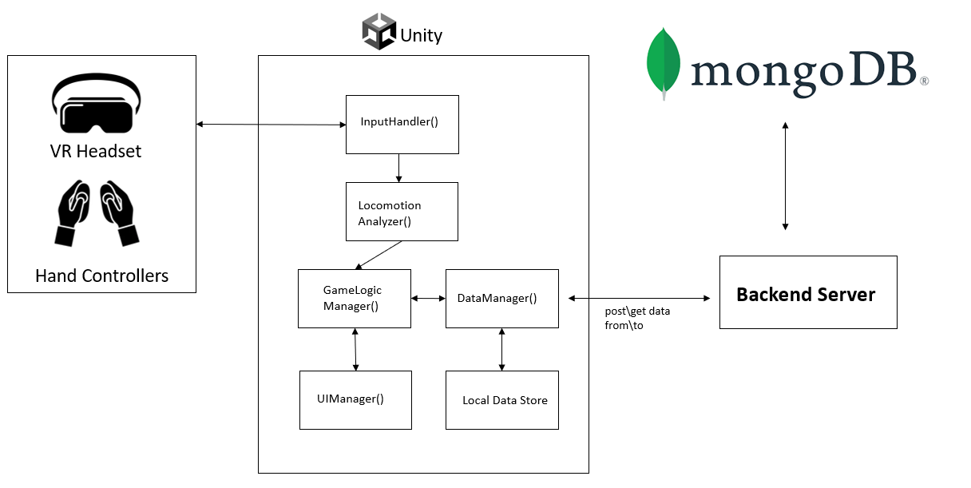

4.5.2 Use Case
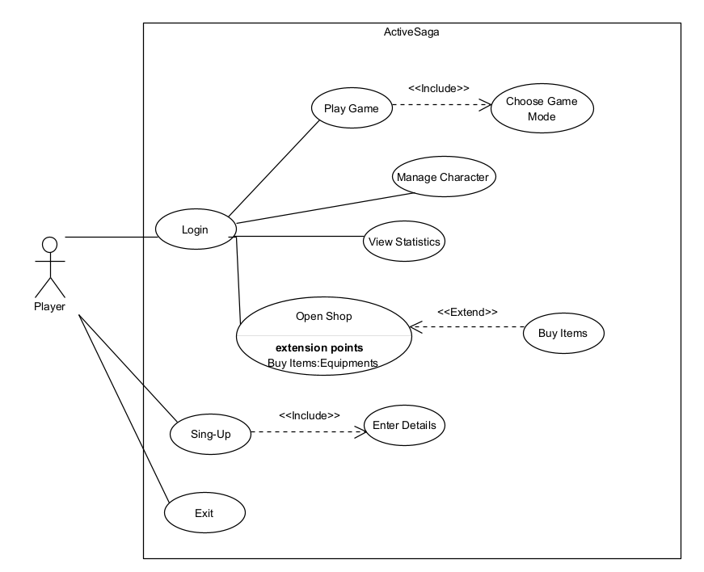

4.5.3 Activity Diagram

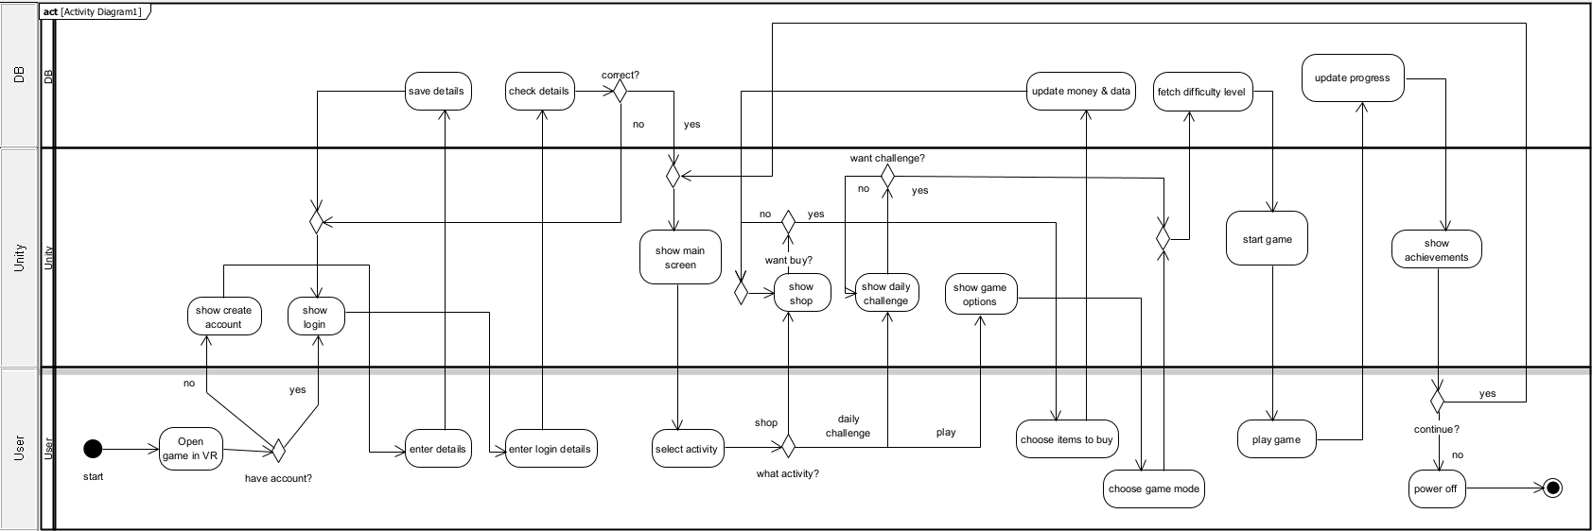

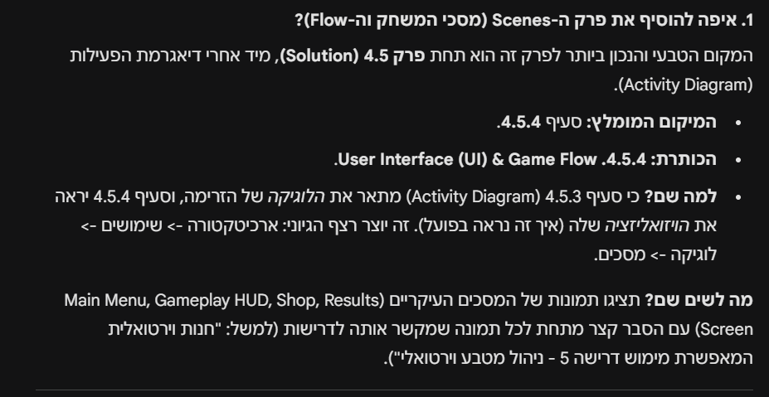
4.6 Project Success Metrics
To objectively evaluate whether ACTIVESAGA has achieved its goals, we have defined the following quantitative metrics. These criteria measure technical stability, the accuracy of our custom movement algorithms, and the effectiveness of the gamification elements in promoting physical activity.
- Locomotion Algorithm Accuracy: Since the core innovation of the project is the "Locomotion Analyzer" which detects lower-body movement using only HMD data, the system must achieve a detection accuracy rate of at least 90% for running-in-place and squatting actions. Success will be measured by comparing the system's input recognition against actual physical movements performed during testing sessions, ensuring distinct separation between intentional exercise and incidental head motion.
- System Performance and Stability: To ensure player safety and prevent "cybersickness" (motion sickness), which is a critical non-functional requirement, the application must maintain a stable frame rate of 72 FPS (Frames Per Second) or higher on the Meta Quest 3 hardware for 99% of the session duration. Additionally, the motion-to-photon latency must remain low to ensure that virtual movements synchronize instantly with physical actions.
- User Retention and Habit Formation: Aligning with the project's objective to establish a fitness routine of five sessions per week , success will be measured by the effectiveness of the "Daily Reward" and progression systems. The quantitative metric is that test users log in and complete a session on at least 3 separate days within a one-week testing window to claim their daily bonuses. This confirms that the gamification mechanics effectively incentivize repeated activity and user adherence.
- Usability and Comfort (SUS Score): To validate the intuitive nature of the spatial UI and the safety of the mechanics, we will administer the System Usability Scale (SUS) questionnaire to testers. The project will be considered successful if it achieves an average score of 70 or above, indicating that the interface is accessible and that the physical constraints (Guardian boundaries) effectively prevented collisions and discomfort during high-intensity play.

4.7 Verification and Evaluation
To ensure the reliability, safety, and effectiveness of ACTIVESAGA, we will implement a comprehensive verification plan. This process is designed to validate the custom locomotion algorithm, the stability of the VR environment on standalone hardware, and the integrity of the data synchronization with the cloud.

4.7.1 Verification Plan (Unit & System Testing)
The following table outlines the specific tests designed to verify each module of the system, ranging from the client-side VR mechanics to the backend database integration.

Test No. | Module | Tested Function | Expected Result
1 | VR Environment | Scene Loading & Initialization | The VR scene should load on the Meta Quest 3S within acceptable time limits without crashing.
2 | VR Environment | Frame Rate Stability | The application must maintain a stable frame rate during gameplay to prevent motion sickness.
3 | VR Environment | Height Calibration | The system should accurately calibrate the player's height at the start to ensure squats are detected relative to their specific body size.
4 | Locomotion Analyzer | Running Detection | The system should correctly interpret "running in place" vertical oscillations as forward movement in the game.
5 | Locomotion Analyzer | Squat Detection | The system should accurately detect when the user physically squats and translate it to a crouching state.
6 | Locomotion Analyzer | Jump Detection | The system should detect sudden vertical impulses (Y-axis) as a "Jump" action and trigger the in-game jump mechanic.
7 | Locomotion Analyzer | Noise Filtering | Random head movements (looking around) should not be falsely interpreted as running or moving.
8 | Game Logic | XP & Progression | Experience Points (XP) earned during a session must be correctly calculated and added to the user's total.
9 | Game Logic | Shop Transaction | Purchasing an item with virtual currency should deduct the correct amount and add the item to the inventory.
10 | Feedback System | Audio & Haptics | Actions like hitting enemies or collecting coins should trigger immediate sound effects and controller vibration (haptics) for feedback.
11 | Safety System | Guardian Boundary Check | The game should pause or display a warning if the user gets too close to the physical play area boundaries.
12 | Backend (MongoDB) | User Authentication | Users should be able to log in securely, and invalid credentials must be rejected.
13 | Backend (MongoDB) | Data Persistence | Player progress (Level, Inventory, Stats) must be saved to the database and retrieved correctly upon the next login.
14 | Backend (MongoDB) | Offline/Online Sync | If the internet connection is lost, data should be stored locally and synchronized with the cloud once the connection is restored.

4.7.2 Usability and Safety Testing
Since ACTIVESAGA requires intense physical activity while "blindfolded" by a VR headset, usability testing focuses heavily on safety and physical comfort. We will invite a group of test users to play the game in a controlled environment. The testing will focus on:
- Cybersickness Monitoring: We will observe users for signs of discomfort or nausea to ensure the locomotion algorithm and frame rate are optimized effectively.
- Intuitive Controls: We will verify that users can understand how to activate the movement (run in place) without needing complex external instructions.
- Physical Safety: We will monitor the users' movements to ensure they stay within the safety zone and that the game provides adequate warnings before potential collisions.

5.AI Tools Usage
This chapter outlines the Artificial Intelligence (AI) tools utilized during the initial research and documentation phase of ACTIVESAGA. These tools served as assistants for linguistic refinement, academic structuring, and literature review.
It is important to note that all content was critically reviewed and verified by the team. The core ideas, architectural design, and final text formulation remain the intellectual property of the students.
5.1. List of Tools
ChatGPT / Gemini | Brainstorming project structure, refining academic English, and searching for relevant literature (sources).
Grammarly | Proofreading, grammar checking, and enhancing sentence clarity.
Consensus / Perplexity | Proofreading, grammar checking, and enhancing sentence clarity.

5.2. Representative Prompts
- Academic Writing: "Rewrite the following introduction paragraph to sound more formal and professional. Focus on the health risks of sedentary behavior."
- Research: "Find academic references from 2024-2025 discussing the benefits of VR exergaming for physical activity. Provide citations in APA format."
- tructuring: "Suggest a logical table of contents for a software engineering final project book, including functional and non-functional requirements."

6.References (External Research)
[1] WHO (2022). "Global status report on physical activity 2022." Discusses the impact of sedentary lifestyles on global health.
[2] Matsangidou, M., et al. (2019). "Is your virtual self as tired as you are? To what extent moving in VR can affect the perception of physical exertion."
[3] Hamari, J., et al. (2014). "Does Gamification Work? - A Literature Review." A study on how XP, points, and progression systems influence user behavior.
[4] VR Health Institute (2024). "Metabolic Ratings of VR Exercise." Provides data on how games like Beat Saber compare to traditional sports in terms of calorie burn.
[5] Park, J., & Lee, G. (2018). "A Walking-in-Place Method for Virtual Reality Using Position and Orientation Tracking Sensors."
[6] Qian, J., McDonough, D. J., & Gao, Z. (2020). "The effectiveness of virtual reality exercise on individual's physiological, psychological and rehabilitative outcomes: A systematic review." International Journal of Environmental Research and Public Health.
[7] Sibilio, F., et al. (2025). "A Systematic Review and Meta-Analysis of Virtual and Traditional Physical Activity Programs." International Journal of Environmental Research and Public Health.
[8] Plouzeau, J., et al. (2025). "To Use or Not to Use Viewpoint Oscillations When Walking in VR? State of the Art and Perspectives." IEEE Transactions on Visualization and Computer Graphics.

