Dyadic Phase Transport in Semiprime Integers

1. Dataset and scope
We analyze a dataset of 500,000 semiprime integers $n=pq$, restricted to the 64-bit regime, where $p$ and $q$ are prime factors, started with this conceptual's representation show bellow.
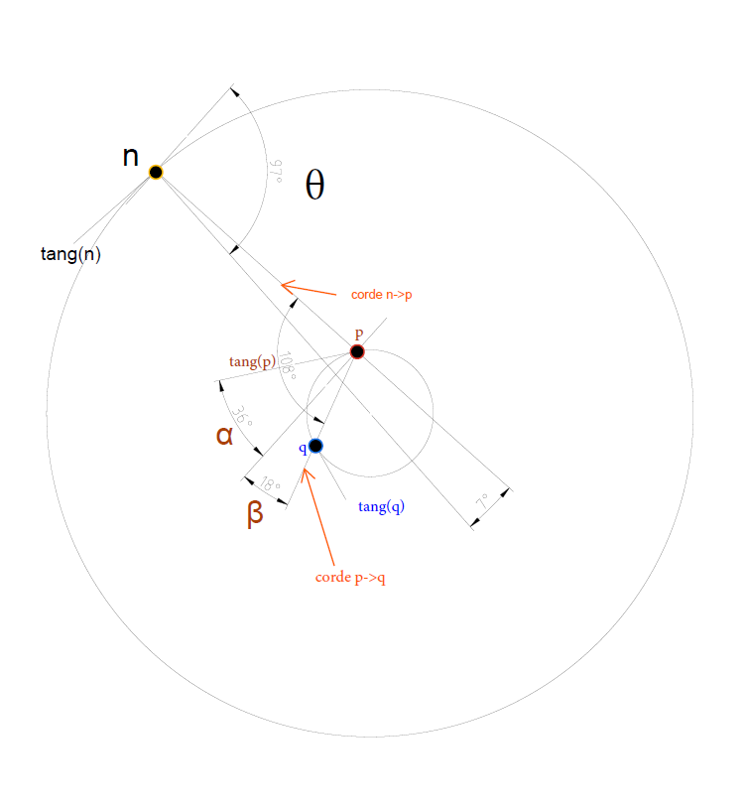
For each triplet $\left(n , p , q\right)$, the dataset contains:
- the dyadic level $k_{x}=⌊{log⁡}_{2}x⌋$,
- angular quantities $θ_{n}$, $θ_{p_{min}}$,
- and a normalized intra-dyadic imbalance flag allowing identification of the smaller and larger factor.
All arithmetic relations were validated:
- $n=pq$holds for 100% of entries,
- both factors are prime,
- dyadic levels match bit-length definitions exactly.
This ensures that all observed effects are structural, not artefacts of corrupted data.

2. Phase composition hypothesis
Let us associate to each integer $x$an angular quantity $\left.θ_{x}∈[0,2π\right)$, interpreted as a phase coordinate on its dyadic circle.
We test the hypothesis that the phase of a semiprime integer is governed by a composition law of the phases of its prime factors:
$$θ_{n}≈{wrap}_{2π}(θ_{p}+θ_{q})$$
This relation is not imposed by construction:
we previously verified that $θ_{n}$is neither the trivial fractional logarithmic phase of $n$, nor a local geometric angle derived from the direct chord $n→p$.

3. Empirical phase alignment
Define the residual phase error:
$$δ={wrap}_{π} \text{⁣}(θ_{n}-(θ_{p}+θ_{q}))$$
Over the full dataset, we observe:
- mean absolute error:
$$⟨∣δ∣⟩≈0.162\text{ rad}$$
- median absolute error:
$$median(∣δ∣)≈0.124\text{ rad}$$
- 90th percentile:
$$P_{90}(∣δ∣)≈0.374\text{ rad}$$
The signed residual is centered near zero:
$$E[δ]≈0.014\text{ rad}$$
This demonstrates a strong phase alignment between $θ_{n}$and the composed phase $θ_{p}+θ_{q}$, with no systematic angular bias.

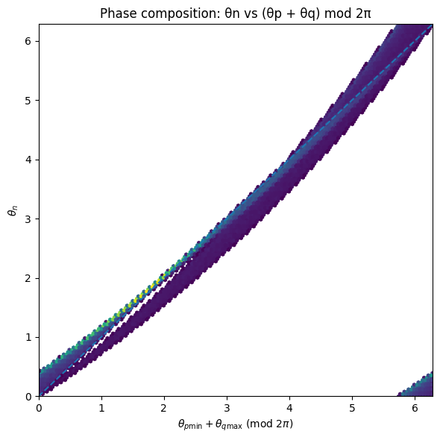
Fig1. Phase of Phase of semiprime integers versus the composed phase of their prime factors. Each point represents a semiprime 𝑛=𝑝𝑞. The horizontal axis shows the composed phase (𝜃𝑝min+𝜃𝑞max)mod 2𝜋, while the vertical axis shows 𝜃𝑛. The clear alignment along the diagonal indicates that the phase of a semiprime is strongly governed by the sum of the phases of its prime factors.

4. Dyadic carry bifurcation
When both prime factors lie in the same dyadic band $k_{p}=k_{q}=k$, the product satisfies:
$${log⁡}_{2}n=2k+(u_{p}+u_{q})$$
leading to two possible dyadic levels:
$$k_{n}∈\{2k, 2k+1\}$$
Segmenting the dataset accordingly yields:
| Dyadic case | median $∣δ∣$| mean $∣δ∣$|
|-----------|------------------|----------------|
| $k_{n}=2k$| ~0.218 rad | ~0.228 rad |
| $k_{n}=2k+1$| ~0.081 rad | ~0.120 rad |
The carry case $k_{n}=2k+1$exhibits a significantly tighter phase locking.
This establishes that dyadic carry is not a passive arithmetic effect, but directly influences angular transport.
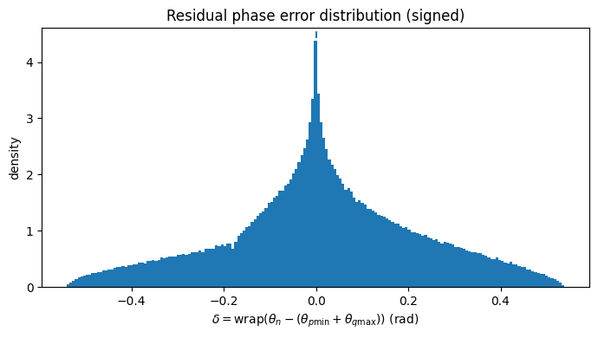
Fig2 Distribution of the signed residual phase error. The histogram shows 𝛿=wrap(𝜃𝑛−(𝜃𝑝min+𝜃𝑞max)). The distribution is centered near zero with finite dispersion, indicating unbiased but non-exact phase transport from the factors to the semiprime.
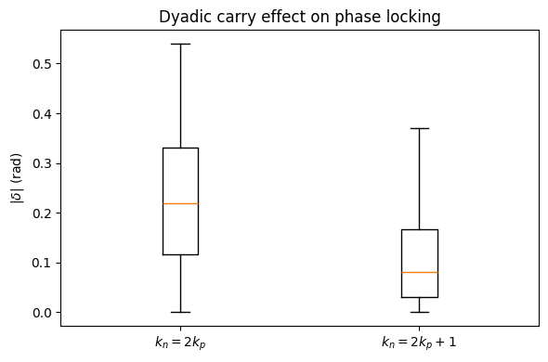
Fig3 Effect of dyadic carry on phase locking. Boxplots of the absolute residual ∣𝛿∣ are shown for two dyadic cases: 𝑘𝑛=2𝑘𝑝 (no carry) and 𝑘𝑛=2𝑘𝑝+1 (carry). The carry case exhibits significantly tighter phase alignment, demonstrating that dyadic sca

5. Dependence on factor imbalance
Define the intra-dyadic imbalance:
$$Δu=∣u_{p}-u_{q}∣\text{with}u_{x}={log⁡}_{2}x-⌊{log⁡}_{2}x⌋$$
We observe a strong monotonic relationship between phase error and imbalance:
- Pearson correlation:
$$corr(∣δ∣,Δu)≈0.374$$
Binned medians show a clear increase:
| $Δu$range | median $∣δ∣$|
|------------------|----------------|
| 0.0 – 0.1 | ~0.12 rad |
| 0.4 – 0.5 | ~0.13 rad |
| 0.6 – 0.7 | ~0.19 rad |
| 0.8 – 0.9 | ~0.37 rad |
| 0.9 – 1.0 | ~0.47 rad |
Thus:
- balanced factors ($u_{p}≈u_{q}$) yield strong phase coherence,
- unbalanced factors lead to progressive phase dispersion.

6. Canonical formulation
The observed behavior is compactly summarized by:
$$\boxed{θ_{n}=θ_{p}+θ_{q} + ε(Δu, carry)}$$
where:
- $ε→0$as $Δu→0$,
- $∣ε∣$increases monotonically with factor imbalance,
- the dyadic carry case $k_{n}=2k+1$minimizes $∣ε∣$.
This defines a dyadic phase transport law for semiprime integers.
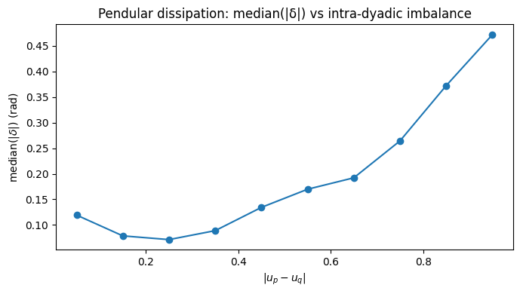
Fig4 Phase dispersion as a function of intra-dyadic factor imbalance. The plot shows the median absolute residual median(∣𝛿∣) as a function of the imbalance ∣𝑢𝑝−𝑢𝑞∣, where 𝑢𝑥=log2(𝑥)−⌊log2(𝑥)⌋. Phase dispersion increases monotonically with factor imbalance, revealing a pendular dissipation law: balanced factors yield strong phase coherence, while unbalanced factors progressively weaken phase locking.

7. Interpretation (kept deliberately minimal)
These results show that:
- multiplication of integers induces a non-local angular structure,
- semiprimes inherit a composed phase from their factors,
- dyadic scaling governs the stability of this transport.
No appeal is made here to analytic continuation, zeta functions, or spectral conjectures.
The phenomenon is empirical, geometric, and reproducible.

