|  |  |  |
| --- | --- | --- |
| **UC-0003** | Access of different types of employees to the different functionalities of the system | |
| Dependencies | * System access security * Different role employees * Real time updates * Maintenance | |
| Description | Quick view of the access to the different functionalities of the system and which functionalities could be access as the different types of employees. | |
| Precondition | The system must implement a log-in system that discriminates access to certain features based on user type. | |
| Role and System functionalities | Dentists | * Can manage all aspects of the patient history system. * Can generate quotes. * Can log-in |
| Assistant | * Can view, modify and create patient history. * Can modify the medical history. |
| Receptionist | * Can access the invoice system. * Can modify the patient history. * Can access the appointment system |
| Postconditions | The access and changes should be life updated. | |

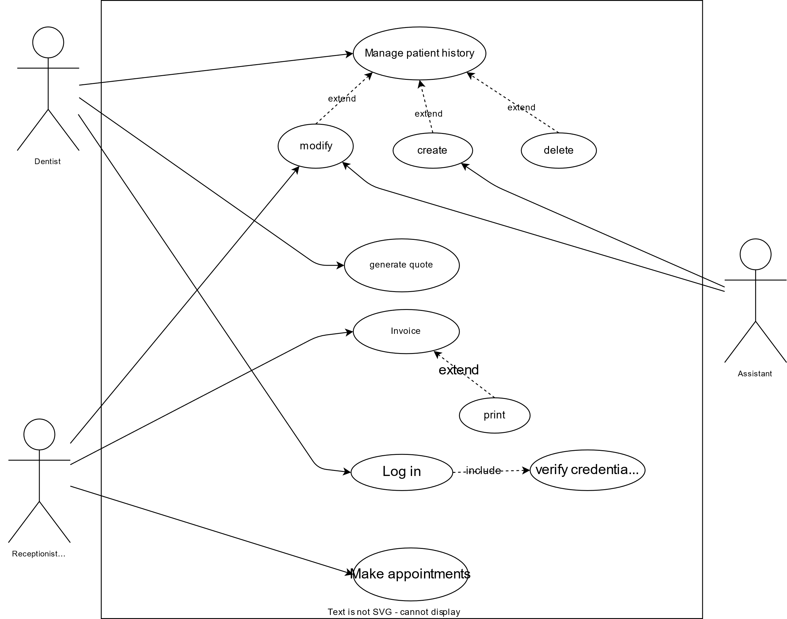VVVVVVVVVVV NOT FINAL VVVVVVVVV NOT FINAL VVVVVVV NOT FINAL