Student ID: 103547416

Name: Daniel Diaz

# Setup Screenshot

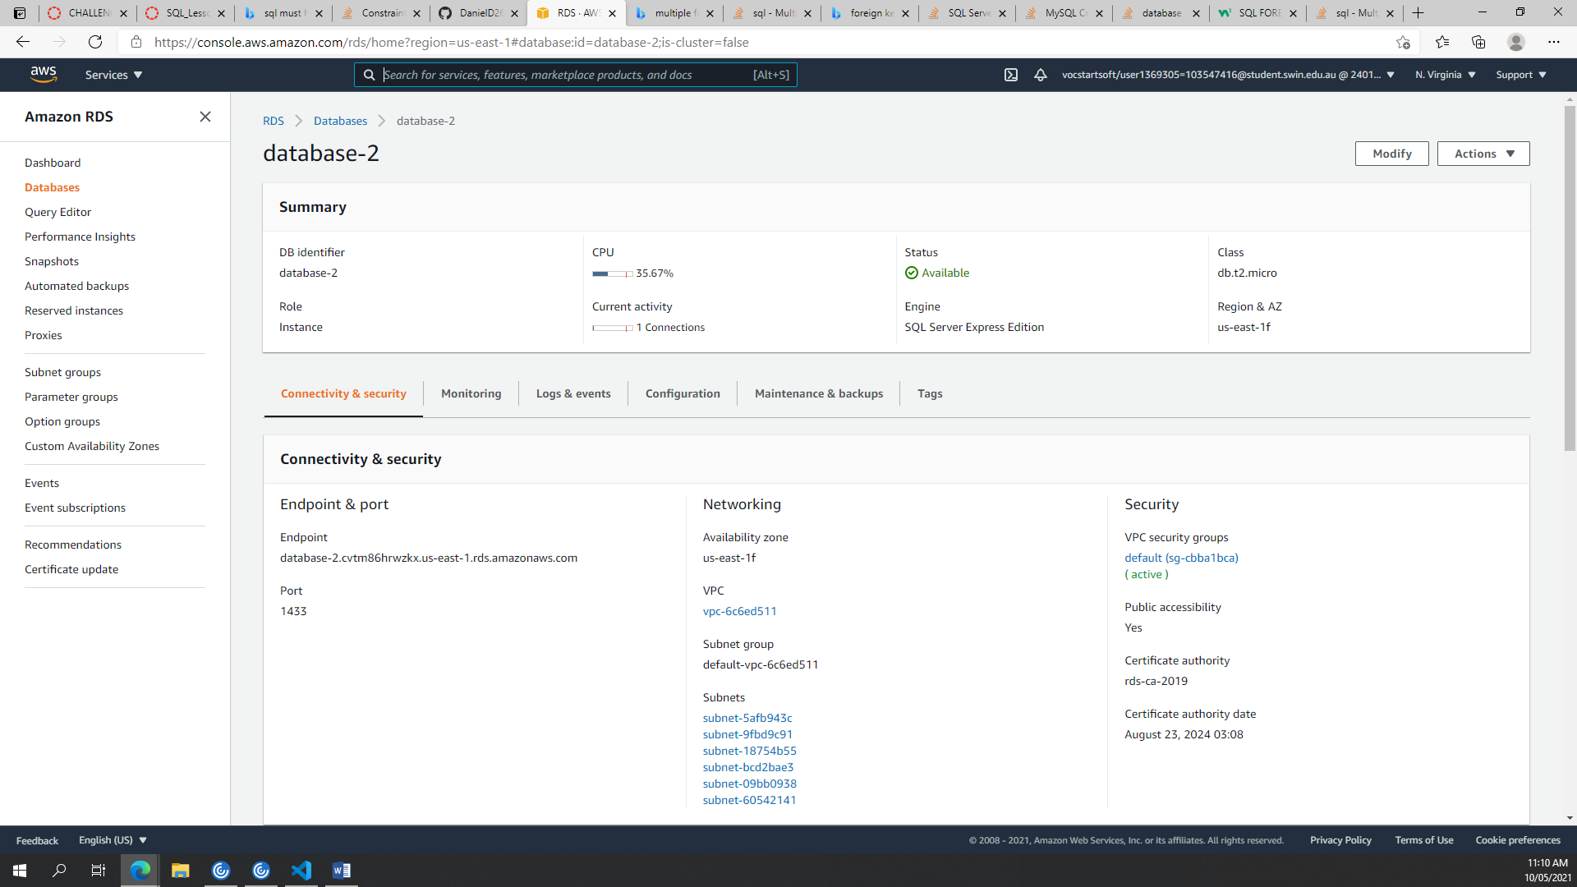

# Task 2 Screenshot

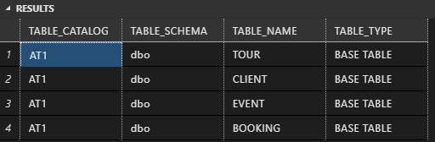



# Task 3 Screenshot

