## 

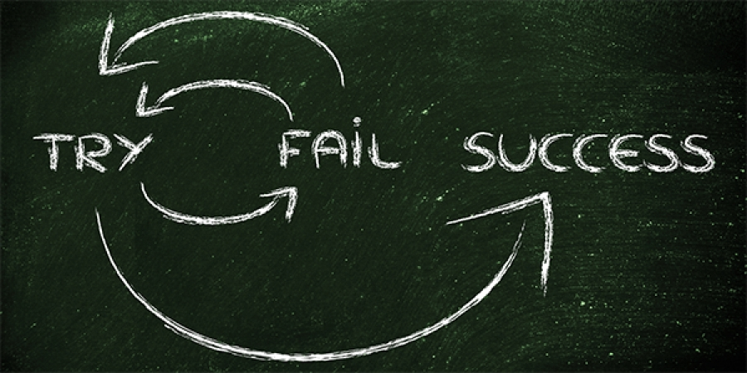

Individual Delivery

22/12/2020 to 13/01/2021

**─**

Daniel del Valle

Data Science

The Bridge

# General Vision

Here is the vision of the project. Write the context of your project.

# Goals

Write here your evaluation goal. If you opt for option B, write B. If you opt for option A+, write all the pluses finished.

# Specifications

In order to do the goals and make the delivery the most, we are going to specify all the necessary to do it possible...

## Software

As it is a software program, we have to specify the minimal software that we need to have to execute the software program. If it is multiplatform, we have to specify the software for each OS.

## Hardware

As it is a software program, we have to specify the minimal hardware that we need to have to execute the software program.

## Requirements

As it is a data science software, we have to specify the minimal data, access apis and others needs that we must have to execute the program.

# Steps

## Research the context

I research the knowledge of my subject and ...

## Get Data

## Data Wrangling

Your text...

## Data Mining / Clean Data

Your text...

## Others...

Your text...