TEACHING EFFECTIVENESS EVALUATION SYSTEM: A WEB-BASED,
ANONYMISED STUDENT-FEEDBACK AND TEACHING-QUALITY
ANALYTICS SYSTEM WITH ROLE-BASED ACCESS

PROJECT REPORT

BY

JOEL, JOSEPH CHUKWUEBUKA
CS/2022/1221

SUBMITTED TO

THE DEPARTMENT OF COMPUTER SCIENCE
FACULTY OF NATURAL SCIENCES
CARITAS UNIVERSITY, AMORJI-NIKE, ENUGU

IN PARTIAL FULFILMENT OF THE REQUIREMENTS FOR THE AWARD OF
BACHELOR OF SCIENCE (B.SC) DEGREE IN COMPUTER SCIENCE

AUGUST, 2026

DECLARATION
I, Joel, Joseph Chukwuebuka, with registration number CS/2022/1221, hereby declare that this project titled “Teaching Effectiveness Evaluation System: A Web-Based, Anonymised Student-Feedback and Teaching-Quality Analytics System with Role-Based Access” is my original research work carried out under the supervision of Prof. Arinze Nwaeze of the Department of Computer Science, Caritas University, Amorji-Nike, Enugu. The work reported herein has not been presented, in whole or in part, to any institution for the award of any other degree or qualification, and all sources consulted have been duly acknowledged.

________________________________ ____________________
Joel, Joseph Chukwuebuka Date
(CS/2022/1221)

APPROVAL
This is to certify that we have read, examined and found this project titled “Teaching Effectiveness Evaluation System: A Web-Based, Anonymised Student-Feedback and Teaching-Quality Analytics System with Role-Based Access”, carried out by Joel, Joseph Chukwuebuka with registration number CS/2022/1221, to be satisfactory and acceptable for the award of a Bachelor of Science (B.Sc) degree in Computer Science of Caritas University, Amorji-Nike, Enugu, and hence we have caused our names and signatures to appear as follows:

________________________________ ____________________
Prof. Arinze Nwaeze Date
(Project Supervisor)
________________________________ ____________________
Ugwu, Ejike Date
(Head of Department)
________________________________ ____________________
Prof. Fergus Onu Date
(External Examiner)

DEDICATION
This project is dedicated to Almighty God, the source of all wisdom and understanding, whose grace sustained me throughout this programme; and to my parents, whose sacrifice, encouragement and unfailing support made this academic journey possible.

ACKNOWLEDGEMENTS
I extend my sincere gratitude to God Almighty for the strength, wisdom and good health that sustained me throughout the duration of this project.
My profound appreciation goes to my Project Supervisor, Prof. Arinze Nwaeze, whose guidance, patience and constructive criticism shaped this work from conception to completion.
I am equally grateful to the Head of the Department of Computer Science, Ugwu, Ejike, for his leadership and support throughout the programme. My sincere thanks go likewise to Dr. Henry Nweke and Dr. Ugochukwu Nwankwo, and to all the other lecturers of the Department of Computer Science, Caritas University, Amorji-Nike, Enugu, for the knowledge they imparted over the course of my study.
Finally, I acknowledge my family, friends and course mates for their moral and financial support, for testing the system and offering feedback on its usability, and for their steadfast encouragement during the development of this work.

ABSTRACT
This work reports on the Teaching Effectiveness Evaluation System, a web-based application developed for Caritas University, Amorji-Nike, Enugu, through which students give structured, anonymised feedback on the quality of teaching and through which lecturers and the directorate of academic quality view the results. The study examined the largely paper-based and infrequent manner in which teaching feedback is presently collected, and used the findings to design an instrument of five teaching-quality dimensions — clarity of delivery, course organisation, assessment fairness, availability and responsiveness, and subject mastery — each measured by two statements on a five-point Likert scale. The system was designed using the Object-Oriented Analysis and Design Methodology and implemented as a self-contained client-side single-page application in HTML, CSS and JavaScript, with its content held in structured in-browser collections. It provides three roles under a single sign-in gate: a student who evaluates assigned courses, a lecturer who views the pooled scores, response distribution and screened anonymous comments for the courses they teach, and an administrator who views teaching quality across staff with raw and rating-style-adjusted scores and data-sufficiency flags, and who controls the evaluation window. A student’s identity is decoupled from their responses so that feedback can be given candidly, and results are suppressed where responses are too few to protect that anonymity. The system was found to deliver a consistent, comparable and confidential channel for evaluating teaching, and the report identifies server-side persistence, authenticated per-user accounts and a statistically computed rating-style adjustment as the principal directions for further work.

TABLE OF CONTENTS
Title Page i
Declaration ii
Approval iii
Dedication iv
Acknowledgements v
Abstract vi
Table of Contents vii
CHAPTER ONE: INTRODUCTION 1
1.1 Background of the Study 1
1.2 Statement of the Problem 1
1.3 Aim and Objectives of the Study 2
1.4 Significance of the Study 2
1.5 Scope of the Study 3
1.6 Limitations of the Study 3
1.7 Definition of Terms 4
CHAPTER TWO: LITERATURE REVIEW 6
2.1 Introduction 6
2.2 Student Evaluation of Teaching in Higher Education 6
2.3 Validity, Bias and the Limits of Student Ratings 6
2.4 Grading Leniency and Rating-Style Adjustment 7
2.5 Anonymity, Candour and Privacy in Feedback 7
2.6 Online Evaluation and Response Rates 8
2.7 Technology Adoption and Information-Systems Success 8
2.8 Web Architecture and Client-Side Implementation 8
2.9 Role-Based Access, Usability and Software Engineering 9
2.10 Review of Related Systems and Research Gap 9
CHAPTER THREE: SYSTEM ANALYSIS AND METHODOLOGY 11
3.1 Data Gathering 11
3.2 Research Methodology and Justification 11
3.3 System Analysis 11
3.3.1 Analysis of the Existing System 11
3.3.2 Analysis of the Proposed System 12
3.4 Justification of the Proposed System 12
CHAPTER FOUR: SYSTEM DESIGN AND IMPLEMENTATION 13
4.1 Design and Specification of the Proposed System 13
4.1.1 Input Design and Specification 13
4.1.2 Output Design and Specification 13
4.1.3 Security and Access Design and Specification 13
4.1.4 Data Design and Specification 14
4.2 System Development Tools and Justification 14
4.3 System Requirements 17
4.3.1 Hardware Requirements 17
4.3.2 Software Requirements 17
4.4 Implementation of the Proposed System 18
CHAPTER FIVE: SUMMARY, CONCLUSION AND RECOMMENDATIONS 19
5.1 Summary 19
5.2 Conclusion 19
5.3 Recommendations 19
REFERENCES 21
APPENDIX A: SOURCE CODE LISTINGS 23
APPENDIX B: SAMPLE OUTPUTS (SCREENSHOTS) 27

CHAPTER ONE

INTRODUCTION

1.1 Background of the Study
The quality of teaching is central to the mission of any university, and the systematic collection of student feedback on teaching has become one of the principal means by which institutions monitor and improve it. Student evaluation of teaching gives learners a structured voice, gives lecturers evidence on which to reflect and develop, and gives academic administrators a comparable basis for quality assurance across courses and departments. For this feedback to be useful, however, it must be gathered on consistent criteria, collected in a way that protects the candour of the respondent, and presented to each audience in a form appropriate to their role.
At Caritas University, Amorji-Nike, Enugu, feedback on teaching has traditionally been gathered, where it is gathered at all, through occasional paper questionnaires administered near the end of a semester. This arrangement has recurring weaknesses. Paper forms are laborious to distribute, collect and tabulate; results arrive too late and in too aggregated a form to guide any timely improvement; students are reasonably unsure that a handwritten form is truly anonymous, which discourages candid answers; and there is no consistent, comparable record of teaching quality across staff that a directorate of academic quality could act upon. The result is that a process meant to improve teaching yields little that is timely, comparable or trusted.
The Teaching Effectiveness Evaluation System is proposed as a web-based response to this situation. It presents each student with the specific courses they are to evaluate and a consistent instrument of five teaching-quality dimensions, each measured by clear statements on a five-point scale. It decouples the student’s identity from their submitted responses, so that feedback may be given without fear of identification. It pools responses into per-dimension and overall scores for each lecturer, alongside a distribution of ratings and screened anonymous comments, and it gives the academic-quality directorate an institution-wide view of teaching quality with adjustments for rating style and safeguards against reporting on too few responses. In doing so it aims to make the evaluation of teaching consistent, timely, confidential and comparable.

1.2 Statement of the Problem
Caritas University lacks a consistent, confidential and timely channel through which students can evaluate the quality of teaching and through which that feedback can reach lecturers and academic administrators in a comparable form. Because feedback is presently gathered through occasional paper questionnaires, the institution cannot assure students that their responses are anonymous, cannot return results quickly enough to inform teaching, and cannot compare teaching quality across staff on a common basis. This single problem — the absence of a consistent, anonymous and analysable channel for evaluating teaching — gives rise to low and guarded participation, feedback that arrives too late to act upon, and an absence of the comparable evidence on which academic quality assurance depends.

1.3 Aim and Objectives of the Study
The aim of this project is to design and implement a web-based system through which students anonymously evaluate teaching on consistent criteria and through which lecturers and the academic-quality directorate view the results under role-based access. The specific objectives, each aimed at mitigating the problem stated in Section 1.2, are:
1. To design a structured evaluation instrument of five teaching-quality dimensions, each measured by statements on a five-point scale, so that teaching is assessed on consistent and comparable criteria.
2. To implement role-based access distinguishing a Student, who evaluates assigned courses, a Lecturer, who views results for courses they teach, and an Administrator, who views results across staff, so that each user sees only the functions and data appropriate to their role.
3. To decouple a student’s identity from their submitted responses through an anonymity mechanism, so that students can give candid feedback without being identified.
4. To aggregate responses into per-dimension and overall scores for each lecturer, with a distribution of ratings and screened comments, and to suppress results where the number of responses is too small to protect anonymity.
5. To provide the academic-quality directorate with an institution-wide view of teaching quality, including raw and rating-style-adjusted scores and data-sufficiency flags, together with control of the evaluation window and the course and staff records.

1.4 Significance of the Study
When completed, this work contributes a practical tool for improving the quality of teaching within the university. By making evaluation consistent, confidential and analysable, the system addresses the weaknesses that presently limit the value of teaching feedback. The following points further underline the importance of the study:
• Candour is protected, because a student’s identity is separated from their responses, encouraging honest feedback that a form known to be traceable would discourage.
• Consistency and comparability are achieved, because every lecturer is evaluated on the same five dimensions measured by the same statements, giving the directorate a common basis for comparison.
• Timeliness and insight are improved, because responses are aggregated automatically into scores, distributions and screened comments rather than tabulated by hand.
• Fairness of interpretation is supported, because results are adjusted for rating style and are suppressed when responses are too few to be reliable or to preserve anonymity.
• The work also serves as a reference for students and developers interested in role-based access, anonymised survey design, and the delivery of an institutional analytics tool as a client-side single-page application.

1.5 Scope of the Study
This project covers the design, implementation and evaluation of a web-based teaching-evaluation system that runs in a standard web browser. Its scope covers a single sign-in gate offering three roles; a student view listing assigned courses, a multi-step evaluation form over five dimensions, and a submission history; a lecturer view presenting per-dimension scores, a response distribution and screened anonymous comments for courses taught, subject to a reporting threshold; and an administrator view presenting an institutional overview, a staff-results table with raw and adjusted scores and data-sufficiency flags, an evaluation-window control, and a course-and-staff management view. The system is intended for use by the students, lecturers and academic-quality directorate of Caritas University.
The study is bounded as follows. It concerns the collection, aggregation and presentation of teaching feedback within a single client-side application, and does not undertake the administration of examinations or the management of student grades. Its content is held in structured collections within the browser to demonstrate every view at realistic scale; connection to a central server, a database and the university’s live enrolment records is identified as further work rather than undertaken here. The anonymity mechanism is demonstrated within the browser; a production deployment would issue anonymity tokens on the server, as Section 4.1.3 explains.

1.6 Limitations of the Study
Several factors constrained the execution of this work and should be borne in mind when interpreting its results.
First, the system is a functional prototype whose content is held in in-browser collections rather than in a server-side store. The seeded courses, results and comments are realistic and stable across a session, but a submitted evaluation is recorded only within the acting user’s session and does not survive a page reload, because no server or database is provisioned in this build. The introduction of a persistence layer is identified in Section 5.3 as the first priority for further work.
Second, sign-in in the present build validates the format of a student’s matriculation number and accepts a password without verifying it against a stored credential; it is intended to exercise the role-based access and anonymity design rather than to secure real accounts. Per-user credentials verified on a server against irreversibly hashed values are identified as further work.
Third, the anonymity token is derived in the browser from the matriculation number for demonstration; as the source code itself notes, a production system must issue tokens server-side from a cryptographically secure generator, held in a table that is never joined back to the student record. Likewise, the rating-style adjustment shown against each lecturer illustrates the correction of leniency and severity and is not, in this build, computed from a statistical model of the full response set.
Fourth, the study was carried out within a single academic session alongside coursework and examinations, which constrained the duration of the evaluation exercise and the number of respondents who could be engaged.

1.7 Definition of Terms
Student Evaluation of Teaching (SET): the systematic collection of students’ judgements about the quality of teaching in a course, usually through a structured questionnaire.
Dimension: one of the five aspects of teaching quality measured by the instrument — clarity of delivery, course organisation, assessment fairness, availability and responsiveness, and subject mastery.
Likert Scale: an ordered response scale on which a respondent indicates level of agreement; here a five-point scale from “strongly disagree” to “strongly agree”.
Anonymity Token: a code that stands in for a respondent so that a submitted evaluation can be counted without being traced to the student who gave it.
Response Rate: the proportion of enrolled students on a course who submitted an evaluation, used to judge whether a result is representative.
Reporting Threshold: a minimum number of responses below which a result is not published, both because it is unreliable and because a very small group could make individual respondents identifiable.
Rating-Style (Leniency) Adjustment: a correction applied to a raw score to account for the tendency of some cohorts to rate systematically higher or lower than others.
Role-Based Access Control (RBAC): an access model in which the functions and data available to a user are determined by the role they hold — here Student, Lecturer or Administrator.
Single-Page Application (SPA): a web application that loads a single document once and updates its views on the client without reloading the page.
Client-Side: executed within the user’s own web browser rather than on a remote server.
CHAPTER TWO

LITERATURE REVIEW

2.1 Introduction
This chapter reviews the literature relevant to the design of a web-based teaching-evaluation system. It examines the long tradition of student evaluation of teaching, the vigorous debate over its validity and biases, the problem of rating style and its adjustment, and the role of anonymity in eliciting candid feedback. It then reviews the evidence on online evaluation and response rates, the theory of technology adoption, and the web, access-control, usability and software-engineering foundations on which the system is built, before reviewing related systems and stating the gap the study addresses. Each body of work is related to the present project, with its contribution and its limitation identified.

2.2 Student Evaluation of Teaching in Higher Education
The systematic use of student ratings to evaluate university teaching has been studied for over half a century. Marsh (1987) provided a comprehensive account of the field and, through the Students’ Evaluation of Educational Quality instrument, established that effective teaching is not a single quantity but a set of distinct dimensions — clarity, organisation, breadth, assessment and rapport among them — a multidimensional view confirmed in the review of Abrami, d’Apollonia and Rosenfield (2007). This directly motivates the present system’s use of five separate dimensions rather than a single overall mark. Marsh and Roche (1997) argued that such ratings are most useful when they are reliable, multidimensional and fed back constructively to support development, and Centra (1993) situated student ratings within a broader programme of reflective faculty evaluation. Reviews by Wachtel (1998), Kulik (2001), Benton and Cashin (2012) and, most comprehensively, Spooren, Brockx and Mortelmans (2013) survey the accumulated evidence, while the classic meta-analysis of multisection validity studies by Cohen (1981) reported a positive association between ratings and student achievement. Richardson (2005) reviews the instruments used to obtain student feedback and the uses to which the results are put. Together these works justify the very enterprise of structured student evaluation and its multidimensional form; their limitation, for a builder, is that they concern the instrument and its interpretation rather than the software through which evaluation is delivered, which the present study supplies.

2.3 Validity, Bias and the Limits of Student Ratings
The use of student ratings is not without serious challenge, and an honest design must acknowledge it. A meta-analysis by Uttl, White and Gonzalez (2017) re-examined the multisection studies and concluded that, once study size is accounted for, ratings are not meaningfully related to learning — a direct challenge to the validity argued from Cohen (1981). Experimental work has exposed bias: MacNell, Driscoll and Hunt (2015) found that an online instructor rated more highly under a male name than a female one for identical teaching, and Boring (2017) found systematic gender bias in a large observational dataset. Stark and Freishtat (2014) criticise the statistical naivety with which ratings are commonly reported and averaged, and Clayson (2009) questions the assumed link between ratings and learning. This literature does not invalidate student evaluation, but it disciplines its use: it argues for reporting distributions rather than bare means, for caution in comparing small samples, and for treating ratings as one source of evidence among several. The present system reflects these lessons in showing the full distribution of ratings alongside the mean, in suppressing results computed on very few responses, and in presenting scores as indicators for reflection rather than definitive verdicts.

2.4 Grading Leniency and Rating-Style Adjustment
A specific and well-documented threat to the fairness of raw ratings is their contamination by grading leniency and differences in rating style. Greenwald and Gillmore (1997) argued that grading leniency is a removable contaminant of student ratings, and Centra (2003) examined whether lecturers can secure higher ratings by grading generously or demanding less work, while McPherson (2006) analysed the determinants of how students evaluate teachers. The practical implication is that a raw mean may reward leniency rather than teaching quality, and that comparisons across staff are fairer when scores are adjusted for such style effects. This literature is the direct justification for the present system distinguishing a raw mean from an adjusted score in the administrator’s staff-results view; the report is explicit, however, that the adjustment demonstrated in this build is illustrative and that a production system would compute it from a statistical model of the response set, as these authors describe.

2.5 Anonymity, Candour and Privacy in Feedback
Whether students respond, and respond honestly, depends heavily on their confidence that they cannot be identified. A body of survey-methodology research establishes the effect: Joinson (1999) found that anonymity reduces social-desirability distortion and raises self-disclosure in questionnaires; Ong and Weiss (2000) showed that anonymity increases willingness to answer sensitive questions truthfully; and Tourangeau and Yan (2007) review at length how the conditions of a survey affect honest answering of sensitive items. Pardo and Siemens (2014) set out the corresponding ethical and privacy principles for the use of student data, including transparency and the protection of the individual. These works are the direct justification for the central design commitment of the present system — that a student’s identity is decoupled from their responses — and for the accompanying safeguard that results are withheld when a group is so small that responses could be attributed to an individual. Their limitation is that they establish the principle without prescribing a concrete browser-based mechanism, which the present design supplies while acknowledging that the mechanism must ultimately be enforced on the server.

2.6 Online Evaluation and Response Rates
The shift from paper to online evaluation, which the present system embodies, has been studied closely, chiefly through its effect on response rates. Layne, DeCristoforo and McGinty (1999), Dommeyer, Baum, Hanna and Chapman (2004), Avery, Bryant, Mathios, Kang and Bell (2006) and Stowell, Addison and Smith (2012) compared online and in-class administration and found online response rates generally lower unless deliberately encouraged, while reporting that the ratings themselves are broadly comparable across modes. Nulty (2008) synthesises this evidence and proposes practical measures for achieving adequate online response rates. The implication for the present system is twofold: that the online medium brings clear gains in speed, consistency and analysability, and that response rate must be measured and displayed and treated as a condition of reporting — which is precisely why the system computes a response rate for each course and applies a reporting threshold to it.

2.7 Technology Adoption and Information-Systems Success
Whether students and staff use the system depends on its acceptance. The Technology Acceptance Model of Davis (1989) holds that adoption is governed chiefly by perceived usefulness and perceived ease of use, and the Unified Theory of Acceptance and Use of Technology of Venkatesh, Morris, Davis and Davis (2003) extends this with performance expectancy, effort expectancy, social influence and facilitating conditions. Read alongside the information-systems success model of DeLone and McLean (2003) and the broader account of institutional information systems by Laudon and Laudon (2020), these theories imply that students will complete evaluations only if the process is quick and evidently confidential, and that lecturers and administrators will rely on the results only if the information is of visible quality. These considerations shaped the system’s short multi-step form, its immediate and legible presentation of scores, and its explicit treatment of response rate and data sufficiency.

2.8 Web Architecture and Client-Side Implementation
The system is built directly on the technologies of the web. From the original account of the World-Wide Web by Berners-Lee, Cailliau, Luotonen, Nielsen and Secret (1994), web applications evolved towards rich client-side interaction, named as the Ajax approach by Garrett (2005) and culminating in the single-page application described by Mikowski and Powell (2013), in which one document is loaded once and its views are switched and re-rendered on the client. The present application is a direct instance of this model: the sign-in gate, the several role-specific views and the multi-step evaluation form are all switched and re-rendered on the client without further page loads. Flanagan (2020) documents the JavaScript language and the Document Object Model through which the interface is constructed, and the HTML5 specification (W3C, 2014) defines the document standards on which it rests. These works describe the general model, which typically assumes a server behind the client; the present system demonstrates the same model with its data seeded in the browser, marking the server connection as the point of extension.

2.9 Role-Based Access, Usability and Software Engineering
Three further foundations complete the review. The mechanism by which the system shows each user only what their role permits derives from Role-Based Access Control, formalised by Sandhu, Coyne, Feinstein and Youman (1996) and standardised by Ferraiolo, Sandhu, Gavrila, Kuhn and Chandramouli (2001), in which permissions attach to roles rather than to individuals; the present system applies this in a three-role form of Student, Lecturer and Administrator. Because the users include students completing a form quickly and staff interpreting results, usability is a genuine concern: the heuristics of Nielsen (1994) — among them visibility of system status, consistency and error prevention — and the design principles of Shneiderman and Plaisant (2010), including the sequence of overview, then detail, informed the progress-tracked evaluation form and the layered presentation of results. The construction of the system followed established software-engineering practice, and it is documented in Chapter Four using object-oriented models. These works ground the access model, the interface and the method of the present study.

2.10 Review of Related Systems and Research Gap
The systems that presently support teaching evaluation fall into a few classes, each with a shortfall the present study addresses. Paper questionnaires, still common at many institutions including the case university, are laborious to process, slow to report and unconvincing in their anonymity. Established rating instruments such as Marsh’s Students’ Evaluation of Educational Quality and the IDEA system reviewed by Benton and Cashin (2012) provide validated, multidimensional measures, but are proprietary instruments and reporting services rather than a system an institution can host and control for itself. The online evaluation modules of learning-management systems automate collection but, as the response-rate literature notes (Nulty, 2008), often achieve poor participation, and they present teaching results within a course-management frame rather than as a dedicated, comparable, institution-wide analytic governed by the information-quality concerns of DeLone and McLean (2003). Against this background two gaps are evident. First, the SET literature is rich on the instrument and its interpretation but offers little guidance on a lightweight, self-hostable, role-based application that delivers anonymised evaluation and presents adjusted, threshold-protected results to distinct audiences. Second, little existing work is set in, or adapted to, the resources and practices of a Nigerian university department. This study addresses both gaps by designing, implementing and evaluating such a system, honestly scoped to what a client-side prototype provides and explicit about the server-side extensions a production deployment would require.
CHAPTER THREE

SYSTEM ANALYSIS AND METHODOLOGY

3.1 Data Gathering
The requirements for the system were established through three complementary means. First, the existing practice of evaluating teaching at the university was observed directly: how paper questionnaires are distributed near the end of a semester, collected, and — where at all — tabulated by hand. Second, a review of the student-evaluation literature and of established instruments, discussed in Chapter Two, was used to identify the dimensions of teaching quality that a sound instrument should measure and the safeguards a credible process should provide. Third, informal discussions with fellow students and with members of staff surfaced the practical concerns that shaped the design — chiefly the students’ doubt that paper forms are truly anonymous, and the staff’s wish for results that are timely, comparable and not distorted by a handful of extreme responses.
These sources converged on a consistent set of requirements: a consistent, multidimensional instrument; genuine and visible anonymity; automatic aggregation into scores, distributions and comments; safeguards against reporting on too few responses; an adjustment for rating style; and a clear separation of what students, lecturers and administrators may each see and do.

3.2 Research Methodology and Justification
The system was developed using the Object-Oriented Analysis and Design Methodology (OOADM). OOADM models a system as a set of collaborating objects, each combining data and the operations upon it, and proceeds through object-oriented analysis of the problem domain to object-oriented design and implementation. It was chosen for three reasons. First, the problem domain is naturally expressed as objects — a course, a dimension, an evaluation response, a lecturer’s pooled result, a staff record — whose relationships map directly onto the design presented in Chapter Four. Second, OOADM’s standard models, the use-case, sequence and class diagrams, communicate the design clearly to a reader. Third, its support for encapsulation and reuse suits an interface assembled from repeated, self-contained view components. The methodology was applied iteratively and incrementally: each view and its behaviour were analysed, designed, implemented and tested in turn, and the whole was integrated into the single application described here.

3.3 System Analysis

3.3.1 Analysis of the Existing System
The existing system is a periodic paper-based questionnaire. Near the end of a semester, printed forms are distributed in class, completed by the students present, collected, and — where resources allow — manually tallied into a summary. Analysis of this arrangement reveals several weaknesses. The process is slow and labour-intensive, so results arrive too late and too aggregated to inform teaching. Anonymity is doubtful, because a handwritten form handed to a departmental officer is not evidently untraceable, which suppresses candid responses. Coverage is partial, because only students physically present on the day respond, and no response rate is recorded. There is no correction for the tendency of some cohorts to rate high or low, so comparisons across staff are unfair. And there is no consistent, comparable institutional record of teaching quality on which a quality-assurance process could act.

3.3.2 Analysis of the Proposed System
The proposed system is a web-based application that addresses each of these weaknesses. It presents a consistent five-dimension instrument to every student for the specific courses they are to evaluate, and it decouples the student’s identity from their responses so that feedback can be candid. It records a response rate for each course and aggregates responses automatically into per-dimension and overall scores, a distribution of ratings and screened comments, which it presents immediately and legibly. It withholds results where the number of responses is too small to be reliable or to protect anonymity, and it distinguishes a raw score from one adjusted for rating style. Through role-based access it offers each user only what is appropriate: a student evaluates and reviews their own submissions, a lecturer sees the pooled results for the courses they teach, and an administrator sees teaching quality across staff and controls the evaluation window and the underlying records.

3.4 Justification of the Proposed System
The proposed system is justified by the weaknesses of the existing one and by the evidence reviewed in Chapter Two. It converts a slow, doubtfully anonymous and non-comparable process into one that is immediate, confidential and consistent. It embodies the multidimensional view of teaching quality that the literature supports, the anonymity that candid feedback requires, and the safeguards — response-rate reporting, minimum-response thresholds and rating-style adjustment — that fair interpretation demands. By delivering all of this as a self-contained client-side application, it also demonstrates that a useful institutional analytic can be built and hosted without heavy server infrastructure, while remaining explicit about the server-side extensions that a full production deployment would require.
CHAPTER FOUR

SYSTEM DESIGN AND IMPLEMENTATION

4.1 Design and Specification of the Proposed System
This section specifies the design of the system: the inputs it accepts, the outputs it produces, the access and anonymity model that governs it, and the structure of the data it holds. The design realises the objectives of Section 1.3 and the requirements of Section 3.1.

4.1.1 Input Design and Specification
The system accepts three principal classes of input. The first is the sign-in input: a role selected from Student, Lecturer or Administrator, an identifier appropriate to that role — a matriculation number for a student, validated against the expected format, or a staff identifier — and a password. The second is the evaluation input: for each of the five dimensions, a student selects one of five ordered responses, from “strongly disagree” to “strongly agree”, for each statement, progressing through the dimensions by way of a step-by-step form with a visible progress indicator and the option to move back. The third is administrative input: the opening and closing of the evaluation window and the maintenance of the course and staff records. All inputs are validated at the point of entry — the matriculation format is checked, a password is required, and a dimension must be answered before the form will advance — so that only well-formed data enters the system.

4.1.2 Output Design and Specification
The outputs are tailored to each role. A student sees the list of courses to be evaluated, with those already completed marked, a confirmation upon submission, and a history of their submissions. A lecturer sees, for each course they teach and subject to the reporting threshold, the overall adjusted score and raw mean, the number of responses and the response rate, a score for each of the five dimensions rendered as a labelled bar, a histogram showing the full distribution of ratings, and a list of screened, anonymised comments presented in randomised order. Where a course has too few responses, a clear notice is shown in place of a score. An administrator sees an institutional overview, and a staff-results table giving, for each lecturer, the number of courses and responses, the response rate, the raw and adjusted scores, and any data-sufficiency or rating-style flag. Every output is presented in a clean, readable layout that adapts to the size of the display.

4.1.3 Security and Access Design and Specification
Access is governed by a three-role model. A Student may evaluate their own assigned courses and view their own submission history; a Lecturer may view the pooled results only for the courses they teach; an Administrator may view results across all staff and manage the evaluation window and records. Each role is shown only the menu and data appropriate to it, realising the role-based access model discussed in Chapter Two.
The defining security property of the system is the anonymity of the respondent. By design, a student’s identity is separated from their submitted responses so that no user — not a lecturer, not an administrator — can trace a rating or comment to the student who gave it. In the present build an anonymity token is derived in the browser to demonstrate this separation; as the source code itself records, a production deployment must issue such tokens on the server from a cryptographically secure random generator, held in a table that is never joined back to the student record. Two further safeguards support anonymity: results are suppressed for any course with fewer responses than the reporting threshold, so that individuals in a small group cannot be identified, and comments are screened for abusive language and identifying details and presented in randomised order so that they cannot be aligned with the rating rows. The report is explicit that password verification and the server-side issuance of tokens are the security extensions required for production, the present build validating identifier format and role rather than authenticating real accounts.

4.1.4 Data Design and Specification
The data of the system is organised as a set of structured collections, each a record type with a fixed set of typed fields. Although these collections are held in the browser in the present build, they are modelled on established database principles so that they could be replaced by server-side tables without altering the behaviour defined upon them. The principal record types are summarised below.
Record type | Principal fields | Purpose
Course | code, title, lecturer, unit, completed | A course a student is to evaluate
Dimension | id, name, items | A teaching-quality dimension and its statements
Evaluation Response | course, answers, token | A student’s anonymised answers for one course
Lecturer Result | code, title, enrolled, responses, scores, distribution, comments | Pooled feedback for a taught course
Staff Row | name, department, courses, responses, rate, raw, adjusted, flag | A lecturer’s institution-level summary
Session State | role, view, token, active course, step, answers | The acting user’s current session

4.2 System Development Tools and Justification
The system was implemented using the core technologies of the web platform, chosen for their universal availability and their fitness for a lightweight, self-contained application.
HTML5 was used to structure the document and its several views, providing the semantic elements and form controls on which the interface is built.
CSS3 was used for presentation, using custom properties for a consistent visual scheme and a responsive layout that adapts to the size of the display.
JavaScript provided all of the application logic — the role gate, the anonymity-token preview, the step-by-step evaluation flow, the aggregation of responses into scores and distributions, the reporting thresholds, and the rendering of every view — operating directly on the Document Object Model without any external framework, which keeps the application small and dependency-free.
A deterministic data generator supplies the seeded courses, results and comments in the browser, standing in for the live enrolment and response data that a production deployment would draw from a server, and allowing every view to be demonstrated at realistic scale.
Netlify was used to deploy the application over an encrypted connection at a public address, and Visual Studio Code with Git served as the development environment and version-control system.
The design was documented using the standard object-oriented models. Figure 4.1 presents the architecture of the system; Figure 4.2, its use cases and actors; Figure 4.3, the sequence of an evaluation; and Figure 4.4, the classes of the domain model.
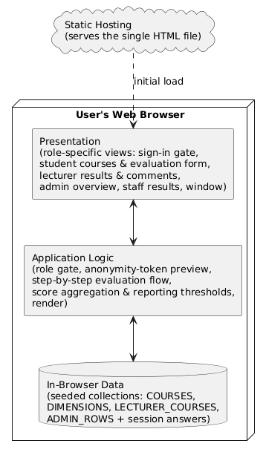
Figure 4.1: Client-side single-page architecture of the Teaching Evaluation System
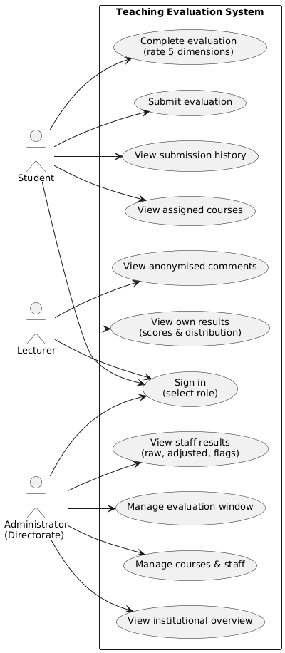
Figure 4.2: Use Case diagram showing the Student, Lecturer and Administrator actors
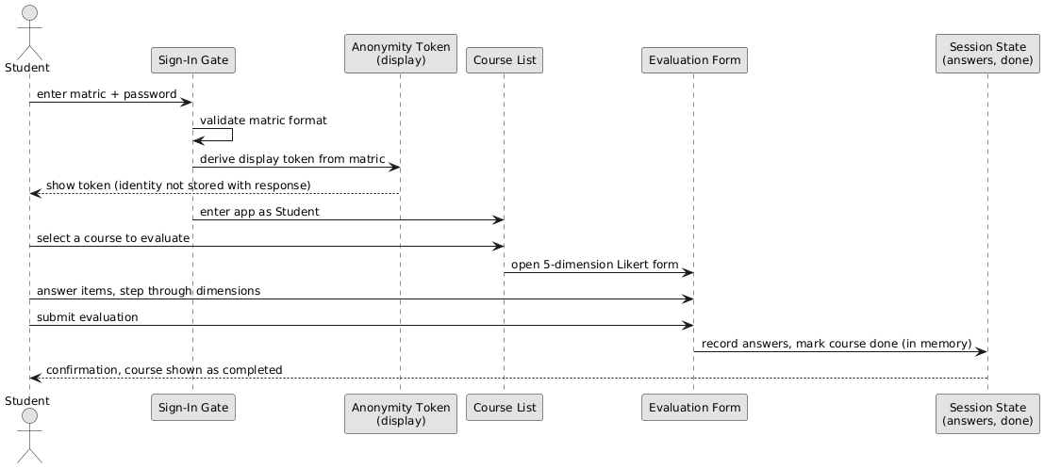
Figure 4.3: Sequence diagram for the anonymous evaluation-and-submission workflow
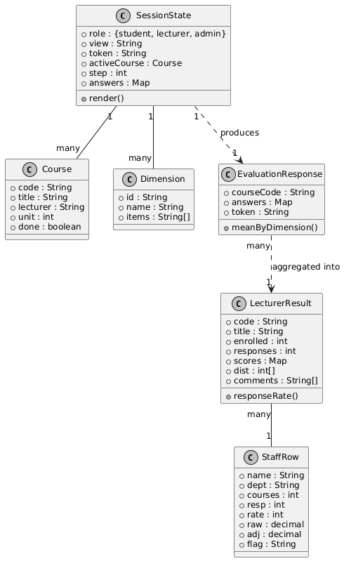
Figure 4.4: Class diagram of the core domain model

4.3 System Requirements
Because the system is a client-side web application, its requirements are modest.

4.3.1 Hardware Requirements
On the user side, any device capable of running a modern web browser is sufficient: a smartphone, tablet, laptop or desktop with at least 1 GB of memory and a working network connection. No specialised hardware is required. For development and deployment, an ordinary personal computer with at least 4 GB of memory was adequate.

4.3.2 Software Requirements
On the user side, the only requirement is a current web browser such as Google Chrome, Mozilla Firefox, Microsoft Edge or Safari, together with an internet connection to load the hosted application. For development, a text editor (Visual Studio Code), a modern web browser with developer tools, the Git version-control system and access to the Netlify hosting platform were used.

4.4 Implementation of the Proposed System
The system was implemented as a single self-contained web document. On loading, it presents the sign-in gate, at which the user selects a role and enters an identifier and password; for a student, the matriculation number is validated against the expected format and an anonymity token is previewed to demonstrate that identity is separated from response. On sign-in the application enters the selected role and renders the corresponding menu and first view.
For a student, the application lists the courses to be evaluated and opens, for a chosen course, the multi-step evaluation form. The form presents one dimension at a time, each with its statements and the five-point scale, tracks progress, and permits movement back and forth before submission; on submission the response is recorded within the session and the course is marked complete. For a lecturer, the application computes and presents, for each taught course meeting the reporting threshold, the dimension scores, the overall raw and adjusted figures, the response count and rate, the distribution histogram and the screened anonymous comments, and it shows a clear notice where responses are too few. For an administrator, the application presents the institutional overview and the staff-results table, computing each lecturer’s response rate and displaying raw and adjusted scores together with data-sufficiency and rating-style flags, alongside the evaluation-window and record-management views. All computation and rendering are performed on the client, and the resulting views are illustrated in Appendix B, with representative source listings given in Appendix A.
CHAPTER FIVE

SUMMARY, CONCLUSION AND RECOMMENDATIONS

5.1 Summary
This project set out to address the absence of a consistent, confidential and analysable channel for evaluating teaching at Caritas University, Amorji-Nike, Enugu. Chapter One established the problem and the objectives; Chapter Two reviewed the literature on student evaluation of teaching, its validity and biases, rating-style adjustment, the role of anonymity, online evaluation and response rates, and the web, access-control and usability foundations of the system; Chapter Three analysed the existing paper-based process and specified the proposed system under the Object-Oriented Analysis and Design Methodology; and Chapter Four presented the design and its implementation as a client-side single-page application. The result is a working system offering three roles — a student who evaluates assigned courses on a five-dimension instrument, a lecturer who views the pooled scores, distribution and screened comments for courses taught, and an administrator who views teaching quality across staff with raw and adjusted scores and data-sufficiency flags — with a student’s identity decoupled from their responses and results suppressed where responses are too few to protect anonymity.

5.2 Conclusion
The work demonstrates that the evaluation of teaching can be made consistent, timely, confidential and comparable through a lightweight web application, and that the safeguards the literature calls for — a multidimensional instrument, protected anonymity, the reporting of distributions and response rates, minimum-response thresholds and an adjustment for rating style — can be embodied directly in its design. Delivered as a self-contained client-side application, the system also shows that a useful institutional analytic can be built and hosted without heavy server infrastructure. Its present limitations — in-browser rather than persistent storage, a demonstration sign-in and anonymity token, and an illustrative rather than statistically computed adjustment — are limitations of a prototype rather than of the design, and each has a clear route to resolution set out below.

5.3 Recommendations
Arising from this work, the following are recommended for further development:
1. That a server and database be introduced so that evaluations are stored persistently, aggregated across all respondents, and retained across sessions and semesters.
2. That anonymity tokens be issued on the server from a cryptographically secure random generator and held in a store that is never joined back to the student record, so that the anonymity demonstrated in this build is genuinely enforced.
3. That per-user authentication be added, verifying credentials on the server against irreversibly hashed values and drawing each student’s courses and each lecturer’s taught courses from the university’s enrolment records.
4. That the rating-style adjustment be computed from a statistical model of the full response set rather than illustrated, so that comparisons across staff are demonstrably fair.
5. That the institution adopt measures known to raise online response rates — timely reminders and a clearly bounded evaluation window — and that the system be evaluated in live use across a full semester with a larger body of respondents.
With these enhancements, the system can move from a functional prototype to a dependable institutional tool for the assurance and improvement of teaching quality.

REFERENCES
Abrami, P. C., d’Apollonia, S., & Rosenfield, S. (2007). The dimensionality of student ratings of instruction. In R. P. Perry & J. C. Smart (Eds.), The scholarship of teaching and learning in higher education (pp. 385–456). Springer.
Avery, R. J., Bryant, W. K., Mathios, A., Kang, H., & Bell, D. (2006). Electronic course evaluations: Does an online delivery system influence student evaluations? The Journal of Economic Education, 37(1), 21–37.
Benton, S. L., & Cashin, W. E. (2012). Student ratings of teaching: A summary of research and literature (IDEA Paper No. 50). The IDEA Center.
Berners-Lee, T., Cailliau, R., Luotonen, A., Nielsen, H. F., & Secret, A. (1994). The World-Wide Web. Communications of the ACM, 37(8), 76–82.
Boring, A. (2017). Gender biases in student evaluations of teaching. Journal of Public Economics, 145, 27–41.
Centra, J. A. (1993). Reflective faculty evaluation: Enhancing teaching and determining faculty effectiveness. Jossey-Bass.
Centra, J. A. (2003). Will teachers receive higher student evaluations by giving higher grades and less course work? Research in Higher Education, 44(5), 495–518.
Clayson, D. E. (2009). Student evaluations of teaching: Are they related to what students learn? A meta-analysis and review of the literature. Journal of Marketing Education, 31(1), 16–30.
Cohen, P. A. (1981). Student ratings of instruction and student achievement: A meta-analysis of multisection validity studies. Review of Educational Research, 51(3), 281–309.
Davis, F. D. (1989). Perceived usefulness, perceived ease of use, and user acceptance of information technology. MIS Quarterly, 13(3), 319–340.
DeLone, W. H., & McLean, E. R. (2003). The DeLone and McLean model of information systems success: A ten-year update. Journal of Management Information Systems, 19(4), 9–30.
Dommeyer, C. J., Baum, P., Hanna, R. W., & Chapman, K. S. (2004). Gathering faculty teaching evaluations by in-class and online surveys: Their effects on response rates and evaluations. Assessment & Evaluation in Higher Education, 29(5), 611–623.
Ferraiolo, D. F., Sandhu, R., Gavrila, S., Kuhn, D. R., & Chandramouli, R. (2001). Proposed NIST standard for role-based access control. ACM Transactions on Information and System Security, 4(3), 224–274.
Flanagan, D. (2020). JavaScript: The definitive guide (7th ed.). O’Reilly Media.
Garrett, J. J. (2005). Ajax: A new approach to web applications. Adaptive Path.
Greenwald, A. G., & Gillmore, G. M. (1997). Grading leniency is a removable contaminant of student ratings. American Psychologist, 52(11), 1209–1217.
Joinson, A. N. (1999). Social desirability, anonymity, and internet-based questionnaires. Behavior Research Methods, Instruments, & Computers, 31(3), 433–438.
Kulik, J. A. (2001). Student ratings: Validity, utility, and controversy. New Directions for Institutional Research, 2001(109), 9–25.
Laudon, K. C., & Laudon, J. P. (2020). Management information systems: Managing the digital firm (16th ed.). Pearson.
Layne, B. H., DeCristoforo, J. R., & McGinty, D. (1999). Electronic versus traditional student ratings of instruction. Research in Higher Education, 40(2), 221–232.
MacNell, L., Driscoll, A., & Hunt, A. N. (2015). What’s in a name: Exposing gender bias in student ratings of teaching. Innovative Higher Education, 40(4), 291–303.
Marsh, H. W. (1987). Students’ evaluations of university teaching: Research findings, methodological issues, and directions for future research. International Journal of Educational Research, 11(3), 253–388.
Marsh, H. W., & Roche, L. A. (1997). Making students’ evaluations of teaching effectiveness effective: The critical issues of validity, bias, and utility. American Psychologist, 52(11), 1187–1197.
McPherson, M. A. (2006). Determinants of how students evaluate teachers. The Journal of Economic Education, 37(1), 3–20.
Mikowski, M. S., & Powell, J. C. (2013). Single page web applications: JavaScript end-to-end. Manning Publications.
Nielsen, J. (1994). Usability engineering. Morgan Kaufmann.
Nulty, D. D. (2008). The adequacy of response rates to online and paper surveys: What can be done? Assessment & Evaluation in Higher Education, 33(3), 301–314.
Ong, A. D., & Weiss, D. J. (2000). The impact of anonymity on responses to sensitive questions. Journal of Applied Social Psychology, 30(8), 1691–1708.
Pardo, A., & Siemens, G. (2014). Ethical and privacy principles for learning analytics. British Journal of Educational Technology, 45(3), 438–450.
Richardson, J. T. E. (2005). Instruments for obtaining student feedback: A review of the literature. Assessment & Evaluation in Higher Education, 30(4), 387–415.
Sandhu, R. S., Coyne, E. J., Feinstein, H. L., & Youman, C. E. (1996). Role-based access control models. Computer, 29(2), 38–47.
Shneiderman, B., & Plaisant, C. (2010). Designing the user interface: Strategies for effective human-computer interaction (5th ed.). Addison-Wesley.
Spooren, P., Brockx, B., & Mortelmans, D. (2013). On the validity of student evaluation of teaching: The state of the art. Review of Educational Research, 83(4), 598–642.
Stark, P. B., & Freishtat, R. (2014). An evaluation of course evaluations. ScienceOpen Research.
Stowell, J. R., Addison, W. E., & Smith, J. L. (2012). Comparison of online and classroom-based student evaluations of instruction. Assessment & Evaluation in Higher Education, 37(4), 465–473.
Tourangeau, R., & Yan, T. (2007). Sensitive questions in surveys. Psychological Bulletin, 133(5), 859–883.
Uttl, B., White, C. A., & Gonzalez, D. W. (2017). Meta-analysis of faculty’s teaching effectiveness: Student evaluation of teaching ratings and student learning are not related. Studies in Educational Evaluation, 54, 22–42.
Venkatesh, V., Morris, M. G., Davis, G. B., & Davis, F. D. (2003). User acceptance of information technology: Toward a unified view. MIS Quarterly, 27(3), 425–478.
W3C. (2014). HTML5: A vocabulary and associated APIs for HTML and XHTML (W3C Recommendation). World Wide Web Consortium.
Wachtel, H. K. (1998). Student evaluation of college teaching effectiveness: A brief review. Assessment & Evaluation in Higher Education, 23(2), 191–212.
APPENDIX A

SOURCE CODE LISTINGS
This appendix presents representative listings from the source code of the system, drawn directly from the implementation. Each is shown with a brief note on its purpose; the complete source is contained in the single application document.

A.1 The evaluation instrument: five dimensions and the response scale
const DIMENSIONS = [
{ id:'clarity', name:'Clarity of delivery', items:[
'The lecturer explains concepts in a way I can follow.',
'Difficult topics are broken down with useful examples.'] },
{ id:'organise', name:'Course organisation', items:[
'Lectures follow the course outline in a logical order.',
'Materials are shared early enough to prepare.'] },
{ id:'fairness', name:'Assessment fairness', items:[
'Tests and assignments reflect what was actually taught.',
'Marking criteria are explained before assessment.'] },
{ id:'support', name:'Availability and responsiveness', items:[
'The lecturer is reachable during stated consultation hours.',
'Questions asked in class are answered properly.'] },
{ id:'mastery', name:'Subject mastery', items:[
'The lecturer shows command of the subject.',
'Course content is linked to current practice in the field.'] }
];
const SCALE = ['Strongly disagree','Disagree','Neutral','Agree','Strongly agree'];
The instrument is defined declaratively. Each of the five dimensions carries an identifier, a display name and the two statements that measure it, and the five ordered points of the Likert scale are held in a single array. Defining the instrument as data in this way means the form, the scoring and the results views are all driven from one source.

A.2 Role menus and session state
const MENUS = {
student: [['courses','▦','My courses'],['history','◷','Submission history'],['help','?','How this works']],
lecturer: [['results','▤','My results'],['comments','❝','Student comments'],['help','?','How scores are computed']],
admin: [['overview','◈','Overview'],['staff','▤','Staff results'],['window','◷','Evaluation window'],['manage','⚙','Courses & staff']]
};
/* ============================================================
STATE
============================================================ */
let ROLE = 'student';
let VIEW = 'courses';
let TOKEN = '';
let activeCourse = null;
let step = 0;
let answers = {};
const $ = id => document.getElementById(id);
const main = $('main');
The menu available to each role is declared as data, so the navigation a user sees follows directly from the role they hold. The session-state variables record the acting role, the current view, the anonymity token and the progress of an evaluation in hand.

A.3 The sign-in gate: validating the matriculation number and entering the app
function attempt(e){
if(e && e.preventDefault) e.preventDefault();
const id=idInput.value.trim(), pw=pwInput.value;
if(!id){say('error','Enter your '+COPY[role].label.toLowerCase()+' to continue.');idInput.focus();return;}
if(role==='student'&&!/^[A-Za-z]{2,4}[\/\-]\d{4}[\/\-]\d{3,4}$/.test(id)){
say('error','That matric number does not match the expected format, e.g. CSC/2021/0417.');idInput.focus();return;}
if(!pw){say('error','Enter your password to continue.');pwInput.focus();return;}
submit.textContent='Checking the register…'; submit.disabled=true;
setTimeout(()=>{
submit.textContent='Sign in'; submit.disabled=false;
TOKEN = role==='student' ? preview(id.toUpperCase()) : '';
enterApp(role, id.toUpperCase());
},800);
}
submit.addEventListener('click', attempt);
On submission the gate requires an identifier, checks a student’s matriculation number against the expected format, and requires a password before proceeding. For a student it derives the anonymity token from the matriculation number and enters the application in the chosen role.

A.4 Deriving the anonymity token (display only)
// Display only. Real tokens must be issued server-side from a CSPRNG,
// into a table that is never joined back to the student table.
function preview(seed){
let a=0x811c9dc5,b=0x1000193;
for(let i=0;i<seed.length;i++){
a=(a^seed.charCodeAt(i))*16777619>>>0;
b=(b+seed.charCodeAt(i)*(i+7))>>>0;
}
const hex=n=>n.toString(16).toUpperCase().padStart(8,'0');
return 'BAL-'+hex(a).slice(0,4)+'-'+hex(b).slice(0,4);
}
function echo(){
const v=idInput.value.trim().toUpperCase();
if(role!=='student'){idEcho.textContent='Not applicable';idEcho.classList.add('pending');tokenEcho.textContent='—';return;}
This routine derives a short token from the student’s identifier so that a response can be shown to travel under a code rather than a name. The comment preserved here records the design intent honestly: in production such tokens must be issued on the server from a cryptographically secure generator and held apart from the student record.

A.5 The step-by-step evaluation form
function viewForm(){
const total=DIMENSIONS.length+1;
const pct=Math.round((step/total)*100);
let body;
if(step<DIMENSIONS.length){
const d=DIMENSIONS[step];
body='<div class="h2">'+d.name+'</div><p class="h2-sub">Answer for '+activeCourse.lecturer+' in '+activeCourse.code+'.</p>'+
d.items.map((q,qi)=>{
const key=d.id+'-'+qi;
return '<div class="qgroup"><p class="q">'+q+'</p><div class="scale">'+
SCALE.map((lab,si)=>
'<button class="sc" aria-pressed="'+(answers[key]===si+1)+'" onclick="pick(\''+key+'\','+(si+1)+')">'+
'<b>'+(si+1)+'</b><span>'+lab+'</span></button>').join('')+
'</div></div>';
}).join('');
} else {
body='<div class="h2">Anything else?</div><p class="h2-sub">Optional. Comments are pooled and screened before your lecturer sees them.</p>'+
'<div class="qgroup"><textarea id="freeText" placeholder="What worked well, and what would you change?">'+(answers.text||'')+'</textarea></div>';
}
const answered = step<DIMENSIONS.length
? DIMENSIONS[step].items.every((_,qi)=>answers[DIMENSIONS[step].id+'-'+qi])
: true;
main.innerHTML=
head(activeCourse.code+' · '+activeCourse.lecturer,'Rate this course','')+
'<div class="prog"><div class="prog-track"><div class="prog-fill" style="width:'+pct+'%"></div></div>'+
'<div class="prog-txt">'+(step+1)+' / '+total+'</div></div>'+
body+
'<div class="steps-nav">'+
'<button class="btn" onclick="back()">'+(step===0?'Cancel':'Back')+'</button>'+
'<button class="btn btn--go" onclick="next()" '+(answered?'':'disabled')+'>'+
(step===total-1?'Submit evaluation':'Continue')+'</button>'+
'</div>';
}
window.pick=function(key,val){ answers[key]=val; viewForm(); };
The form renders one dimension at a time, building the five-point scale for each statement and tracking the answers already given. The Continue control is enabled only when every statement on the current step has been answered, and the final step invites an optional written comment before submission.

A.6 Pooling responses and applying the reporting threshold
function viewResults(){
const c=LECTURER_COURSES[0];
const rate=Math.round(c.responses/c.enrolled*100);
const avg=(Object.values(c.scores).reduce((a,b)=>a+b,0)/5);
const peak=Math.max(...c.dist);
main.innerHTML=head('Lecturer · 2025/2026 second semester','My results',
'Pooled student feedback for courses you taught. Released 21 July, after examination results.')+
'<div class="stats">'+
stat('Adjusted score',avg.toFixed(2)+'<small>/5</small>','Corrected for rating style')+
stat('Raw mean',(avg+0.16).toFixed(2)+'<small>/5</small>','Before correction')+
stat('Responses',c.responses,'of '+c.enrolled+' enrolled')+
stat('Response rate',rate+'<small>%</small>',rate>=40?'Above reporting threshold':'Below threshold')+
'</div>'+
'<div class="split">'+
'<div class="card"><div class="h2">'+c.code+' · '+c.title+'</div>'+
'<p class="h2-sub">Score by dimension. Each is the mean of two items.</p>'+
DIMENSIONS.map(d=>{
const v=c.scores[d.id], pct=v/5*100;
const cls=v<3.5?'low':v<4?'mid':'';
return '<div class="dim"><div class="dim-top"><span>'+d.name+'</span>'+
'<span class="dim-val">'+v.toFixed(1)+'</span></div>'+
'<div class="dim-track"><div class="dim-fill '+cls+'" style="width:'+pct+'%"></div></div></div>';
}).join('')+
'</div>'+
'<div class="card"><div class="h2">Spread of responses</div>'+
'<p class="h2-sub">A mean hides disagreement. This does not.</p>'+
'<div class="hist">'+c.dist.map((n,i)=>
'<div class="hb"><div class="hb-n">'+n+'</div>'+
'<div class="hb-bar'+(n===peak?' peak':'')+'" style="height:'+(n/peak*100)+'%"></div>'+
'<div class="hb-n">'+(i+1)+'</div></div>').join('')+
'</div>'+
'<p style="font-size:12px;color:var(--chalk-faint);margin-top:12px;line-height:1.5">Median 4. Most students agree, but 7 rated at 2 or below — see the comments for why.</p>'+
'</div>'+
'</div>'+
'<div class="card" style="margin-top:14px"><div class="h2">'+LECTURER_COURSES[1].code+' · '+LECTURER_COURSES[1].title+'</div>'+
'<div class="locked"><b>Insufficient data</b>6 of 34 students responded, an 18% response rate. Below 10 responses individual students become identifiable, so no score is published for this course.</div>'+
'</div>';
}
For a lecturer, the results view computes the response rate and the mean of the five dimension scores, presents the dimension bars and the distribution of ratings, and — for a course with too few responses — publishes no score at all, showing instead the notice that protects the anonymity of a small group.
APPENDIX B

SAMPLE OUTPUTS (SCREENSHOTS)
This appendix presents screenshots of the running system, captured from the deployed application, illustrating the sign-in gate and the principal views seen by each of the three roles.
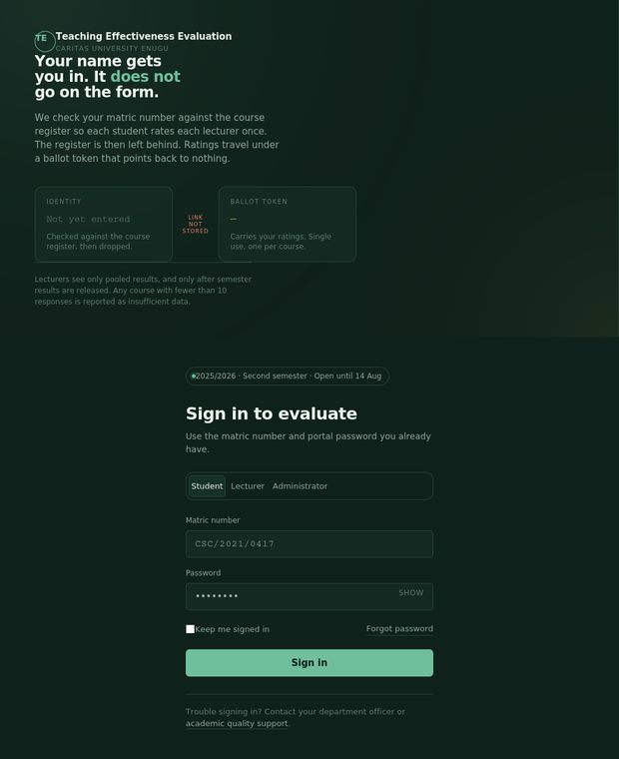
Plate B.1: The sign-in gate, at which a user selects a role and by which a student’s identity is separated from their responses.
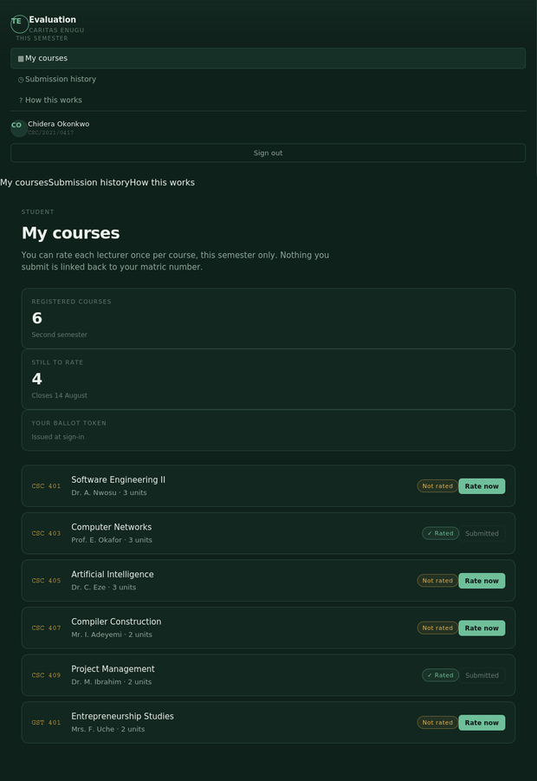
Plate B.2: The student view listing the courses to be evaluated, with completed courses marked.

Plate B.3: The step-by-step evaluation form, showing a dimension and its five-point scale.
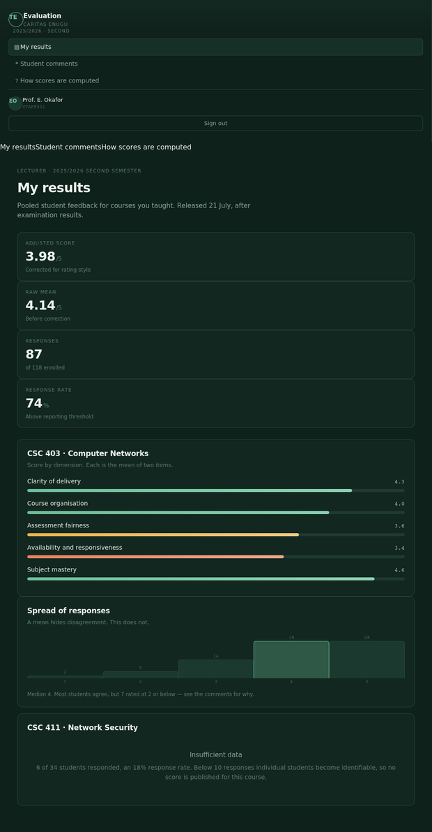
Plate B.4: The lecturer results view, showing dimension scores, the response distribution and the suppression of a course with too few responses.
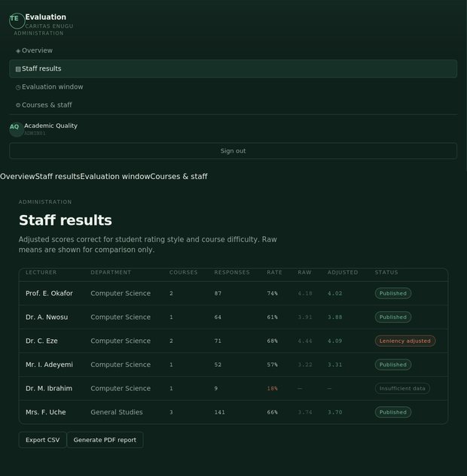
Plate B.5: The administrator staff-results view, showing raw and adjusted scores and data-sufficiency flags.

