RIDECONNECT: A WEB-BASED CAMPUS RIDE-HAILING AND TRANSPORT MANAGEMENT SYSTEM (A CASE STUDY OF CARITAS UNIVERSITY, AMORJI-NIKE, ENUGU)

PROJECT REPORT
BY
IBEGBU, PATRICK
CS/2022/1291
SUBMITTED TO
THE DEPARTMENT OF COMPUTER SCIENCE
FACULTY OF NATURAL SCIENCES
CARITAS UNIVERSITY, AMORJI-NIKE, ENUGU
IN PARTIAL FULFILMENT OF THE REQUIREMENTS FOR THE AWARD OF
BACHELOR OF SCIENCE (B.SC) DEGREE IN COMPUTER SCIENCE
JULY, 2026

DECLARATION
I, IBEGBU, PATRICK, with registration number CS/2022/1291, declare that this project on RideConnect: A Web-Based Campus Ride-Hailing and Transport Management System (A Case Study of Caritas University, Amorji-Nike, Enugu) is my original research work carried out under the supervision of Dr. Obinnaya of the Department of Computer Science, Caritas University, Amorji-Nike, Enugu. I further declare that this work has not been presented, either in whole or in part, to any other institution for the award of any other qualification, and that all sources of information consulted have been duly acknowledged.
________________________________ ________________________
Ibegbu, Patrick Date
(CS/2022/1291)

APPROVAL
We have read, examined and found the project, RideConnect: A Web-Based Campus Ride-Hailing and Transport Management System (A Case Study of Caritas University, Amorji-Nike, Enugu), carried out by IBEGBU, PATRICK (CS/2022/1291), to be satisfactory and acceptable for the award of Bachelor of Science (B.Sc) degree in Computer Science of Caritas University, Enugu, and hence we have caused our names and signatures to appear as follows:
________________________________ ________________________
Dr. Obinnaya Date
(Project Supervisor)
________________________________ ________________________
Ugwu, Ejike Date
(Head of Department)
________________________________ ________________________
Date
(External Examiner)

DEDICATION
This project is dedicated to Almighty God, the source of all wisdom, knowledge and understanding, whose grace sustained me throughout the course of this programme; and to my beloved parents, whose sacrifice, encouragement and unfailing support made this academic journey possible.

ACKNOWLEDGEMENTS
My deepest gratitude goes to Almighty God for His protection, guidance and provision throughout the period of this study.
I express my profound appreciation to my project supervisor, Dr. Obinnaya, whose patience, technical guidance and constructive criticism shaped this work from a rough idea into a completed system. His willingness to review my progress at every stage is deeply appreciated.
I am grateful to the Head of the Department of Computer Science, Ugwu, Ejike, and to all the lecturers of the Department of Computer Science, Caritas University, Amorji-Nike, whose teaching over the course of this programme provided the foundation upon which this project was built.
My sincere thanks go to my parents and family for their financial support, prayers and constant encouragement, and to my friends and course mates who assisted with testing the system, provided feedback on its usability, and offered moral support during the demanding periods of this work.
To everyone who contributed technically, financially or morally to the success of this research, I remain deeply grateful.

ABSTRACT
This work reports on RideConnect, a web-based campus ride-hailing and transport management system developed for Caritas University, Amorji-Nike, Enugu. The study addressed the problem of an entirely informal campus transport arrangement, in which commuters were required to wait physically at unregulated pick-up points for a tricycle or motorcycle to appear by chance, fares were negotiated verbally with no published tariff, and no record of any kind was kept of the operator, vehicle, route or time of any journey, leaving commuters exposed to unpredictable waiting times, inconsistent pricing and an absence of safety accountability. The aim of the study was to design and implement a system enabling registered students and campus residents to request rides on demand, view a transparent fare and arrival-time estimate before travelling, and retain a permanent, verifiable record of every journey undertaken; its specific objectives covered system architecture design, user registration and authentication, a coordinate-based campus location gazetteer with autocomplete selection, ride request and driver-matching computation, live map-based ride tracking, a virtual wallet and transaction ledger, a separate driver workspace, and ride history and profile management. The Extreme Programming methodology was adopted, and the system was developed across four iterative releases, each concluding with a working release and incorporating feedback from representative campus commuters. It was implemented in React with TypeScript, styled with Tailwind CSS, mapped with Leaflet.js, built with Vite, persisted through the browser’s Web Storage interface, and deployed on Google Cloud Run. The completed system computes journey distance by the haversine formulation, derives a transparent base, distance and time fare breakdown, assigns the nearest available operator within a bounded radius, and tracks an active ride through to completion; its distance and fare computations were verified against manual calculation for known campus routes, and representative commuters were able to complete a full booking without assistance during evaluation.

TABLE OF CONTENTS
Title Page i
Declaration ii
Approval iii
Dedication iv
Acknowledgements v
Abstract vi
Table of Contents vii
CHAPTER ONE: INTRODUCTION 1
1.1 Background of the Study 1
1.2 Statement of the Problem 2
1.3 Aim and Objectives of the Study 3
1.4 Significance of the Study 4
1.5 Scope of the Study 4
1.6 Limitations of the Study 5
1.7 Definition of Terms 6
CHAPTER TWO: LITERATURE REVIEW 8
2.1 Introduction 8
2.2 Conceptual Framework 8
2.3 Theoretical Framework 9
2.4 Geolocation and Location-Based Services 9
2.5 Ride Matching and Dispatch 10
2.6 Fare Estimation 11
2.7 Campus and Institutional Transportation Systems 11
2.8 Ride-Hailing in the Nigerian Context 12
2.9 Review of Related Works 12
2.10 Summary and Research Gap 15
CHAPTER THREE: SYSTEM ANALYSIS AND METHODOLOGY 16
3.1 Data Gathering 16
3.2 Research Methodology and Justification 16
3.3 System Analysis 17
3.3.1 Analysis of the Existing System 18
3.3.2 Analysis of the Proposed System 19
3.4 Justification of the Proposed System 22
CHAPTER FOUR: SYSTEM DESIGN AND IMPLEMENTATION 24
4.1 Design and Specification of the Proposed System 24
4.1.1 Input Design and Specification 24
4.1.2 Output Design and Specification 25
4.1.3 Security Design and Specification 25
4.1.4 Database Design and Specification 26
4.2 System Development Tools and Justification 29
4.3 System Requirements 33
4.3.1 Hardware Requirements 33
4.3.2 Software Requirements 33
4.4 Implementation of the Proposed System 33
CHAPTER FIVE: SUMMARY, CONCLUSION AND RECOMMENDATIONS 36
5.1 Summary 36
5.2 Conclusion 37
5.3 Recommendations 37
REFERENCES 39
APPENDIX A: SOURCE CODE SNIPPETS 41
APPENDIX B: SAMPLE OUTPUTS (SCREENSHOTS) 44

CHAPTER ONE
INTRODUCTION
1.1 Background of the Study
Transportation is a fundamental enabler of daily activity in any human settlement, and the manner in which people move between locations directly affects their productivity, punctuality, safety and general wellbeing. Over the past two decades, the widespread adoption of mobile devices, internet connectivity and satellite-based positioning technologies has fundamentally changed how transportation services are requested and delivered. Where commuters once relied on physically locating an available vehicle at a designated stop, digital platforms now allow a trip to be requested, matched to a vehicle, priced and tracked entirely through a software interface (Wang & Yang, 2019).
This shift gave rise to a category of service variously described as ride-hailing, ridesourcing or e-hailing. In such systems, an intermediary software platform connects a person requiring transportation with a driver willing to provide it, using the geographic coordinates of both parties to determine proximity, estimate travel distance and compute a fare before the trip begins. Global operators such as Uber and Lyft popularised the model, and empirical studies have shown that these platforms consistently deliver shorter and more predictable waiting times than conventional street-hailed taxi services (Rayle et al., 2016). Subsequent research has established that the efficiency gains arise not merely from the presence of an application, but from the platform’s ability to centrally match supply and demand across a service area, thereby reducing the idle time of vehicles and the search time of passengers (Cramer & Krueger, 2016).
In Nigeria, ride-hailing platforms including Uber and Bolt have achieved substantial penetration in major urban centres such as Lagos, Abuja and Port Harcourt, where they operate alongside traditional taxis, commercial motorcycles and tricycles. However, the commercial logic of these platforms concentrates their operations in dense, high-value metropolitan markets. Smaller settlements, peri-urban communities and institutional environments such as university campuses are largely unserved, not because demand is absent, but because trip distances are short, fares are low, and the operational cost of maintaining a commercial fleet in such an environment is difficult to justify for a national operator.
Caritas University, Amorji-Nike, Enugu, presents precisely this profile. The campus comprises geographically separated clusters: student hostels, lecture halls and faculty buildings, the administrative block, the library, the university gate and the surrounding residential areas occupied by staff and off-campus students. Movement between these clusters is frequent and time-sensitive, particularly during lecture periods, examinations and evening hours. Yet the transport arrangement serving this movement remains entirely informal. Commuters walk to a customary waiting point, wait for an unscheduled commercial tricycle or motorcycle to appear, negotiate the fare verbally, and travel without any record of the trip, the vehicle or the operator.
This informal arrangement produces several recurring difficulties. Waiting times are unpredictable because there is no mechanism for signalling demand to an operator who is not physically present. Fares vary between commuters for identical journeys because each transaction is individually negotiated. Safety accountability is effectively absent because no record links a passenger to a particular vehicle or driver. Commuters travelling at night, and female students in particular, face heightened exposure for the same reason. Furthermore, no data exists from which the institution could plan or regulate campus transport, because no trip is ever recorded.
Advances in web technologies now make it feasible to address these difficulties without the capital expenditure associated with a commercial ride-hailing operation. Modern browsers expose device geolocation through standard interfaces, geographic coordinates can be stored and compared using well-established mathematical formulations such as the haversine formula, and responsive web applications can deliver a native-like experience on the low-to-mid range mobile devices that predominate among Nigerian undergraduates, without requiring installation from an application store. Cloud platforms further allow such systems to be deployed and scaled at negligible cost.
This study therefore proposes RideConnect, a web-based campus ride-hailing and transport management system designed specifically for the Caritas University environment. The system enables registered students and campus residents to request rides on demand by selecting pick-up and destination points from a curated gazetteer of campus locations, each stored with its geographic coordinates. It computes trip distance, estimated fare and estimated time of arrival before the journey is confirmed, matches the request to an available operator, and retains a permanent record of every completed trip in the commuter’s ride history. In doing so, the system replaces an opaque, unrecorded and unpredictable arrangement with a transparent, accountable and data-generating one.
1.2 Statement of the Problem
Campus transportation at Caritas University, Amorji-Nike, operates through an informal arrangement in which commuters must be physically present at a customary waiting point in order to obtain a ride. Because demand cannot be signalled to an operator who is not already at that point, waiting times are unpredictable and are determined entirely by chance arrival. Commuters who are late for lectures, carrying heavy materials, unwell, or travelling at night bear the greatest cost of this uncertainty.
The absence of a fare structure compounds the problem. Each journey is priced through verbal negotiation, with the result that different commuters pay different amounts for identical trips, and unfamiliar users are systematically disadvantaged. More seriously, no record exists of who travelled, with which operator, from where, to where, or at what time. Consequently, a commuter who suffers misconduct, loses property or is involved in an incident has no verifiable trip record to support any complaint, and the institution has no data with which to identify operators, assess demand patterns or plan transport provision.
Commercial ride-hailing platforms do not resolve these problems in this setting, as their operations are concentrated in dense metropolitan markets and their pricing models are not designed for short intra-campus journeys. There is therefore a clear need for a lightweight, campus-specific ride-hailing system that allows commuters to request rides remotely, presents a transparent fare before the journey is accepted, and maintains a permanent, retrievable record of every trip undertaken. This study seeks to develop such a system.
1.3 Aim and Objectives of the Study
The aim of this study is to develop a web-based campus ride-hailing and transport management system that enables students and residents of Caritas University, Amorji-Nike, to request rides on demand, obtain transparent fare and arrival estimates before travelling, and maintain a verifiable record of their journeys. The specific objectives are to:
1. Design the architecture of a web-based ride-hailing system suited to the geography and commuting patterns of Caritas University, Amorji-Nike.
2. Develop a user registration, authentication and session management module that restricts access to verified students and campus residents.
3. Develop a campus location gazetteer holding the geographic coordinates of every significant location on and around the campus, and expose it through a coordinate-based autocomplete facility for pick-up and destination selection.
4. Implement a ride request and driver-matching module that computes trip distance, estimated fare across selectable service tiers, and estimated time of arrival before a booking is confirmed.
5. Implement an interactive map tracking interface that displays the assigned vehicle’s position and route progress during an active ride.
6. Implement a virtual wallet module through which commuters maintain a spendable balance, fares are debited on trip completion, and a transaction ledger is retained.
7. Implement a separate driver workspace providing incoming ride request notification, trip history, earnings records and settlement functions.
8. Implement a ride history and profile management module that permanently records completed trips and allows commuters to maintain their personal details and preferences.
9. Evaluate the functionality, usability and responsiveness of the developed system using representative campus commuters.
1.4 Significance of the Study
The completion of this study carries practical benefit for several groups within and beyond the university community.
For students and campus residents, the system removes the need to be physically present at a waiting point before a ride can be obtained, reduces uncertainty by presenting the fare and estimated arrival time before the journey is accepted, and improves personal safety by ensuring that every trip is recorded against an identifiable operator. This last benefit is of particular significance for commuters travelling at night.
For the university administration, the system generates, for the first time, structured data on campus movement: which routes are most heavily used, at what times demand peaks, and how long journeys typically take. Such data provides an evidential basis for decisions on transport provision, operator licensing and campus planning that are presently taken without any supporting information.
For transport operators serving the campus, the system offers access to a wider pool of commuters than physical presence at a waiting point permits, reduces unproductive idle time between fares, and provides a documented record of completed work.
For the academic community, the study demonstrates the practical adaptation of ride-hailing principles, developed for dense metropolitan markets, to a small, closed, institutional environment. It therefore contributes to the body of knowledge on location-based service design in resource-constrained settings, and provides a reference implementation that may be extended by future researchers to other Nigerian campuses.
1.5 Scope of the Study
This study covers the design, implementation and evaluation of a web-based ride-hailing system for Caritas University, Amorji-Nike, Enugu. The system operates two distinct workspaces. The passenger workspace provides registration and sign-in, a campus location gazetteer with autocomplete for pick-up and destination selection, ride request submission across three service tiers, distance, fare and arrival-time estimation, driver matching, live map-based ride tracking, a virtual wallet with a transaction ledger, ride history retrieval and profile management. The driver workspace provides an availability control, incoming ride request notification and acceptance, trip history, an earnings ledger and a settlement facility. The system is delivered as a responsive web application accessible from any modern browser on a mobile phone, tablet or personal computer, and is deployed to a cloud hosting environment.
The study is bounded as follows. It covers journeys originating and terminating within the campus and its immediate surroundings, and does not extend to inter-city or long-distance travel. Its wallet and settlement facilities operate as a self-contained internal ledger and are not connected to any external payment processor or banking system, so no real monetary value is transferred. It does not include the manufacture or installation of vehicle-mounted tracking hardware, positions being derived from device-reported coordinates. It does not include a driver recruitment or vetting subsystem, nor does it address the regulatory licensing of campus transport operators, both of which are administrative rather than technical matters.
1.6 Limitations of the Study
Several factors constrained the execution of this work and should be borne in mind when interpreting its results.
First, the system is a functional prototype operating on simulated participants rather than a live deployment. The driver pool consists of seeded records whose positions are advanced computationally rather than reported by real vehicles, and both workspaces may be entered by any user in order to demonstrate the full passenger and driver interaction. Recruiting, verifying and equipping a body of real campus drivers requires institutional authorisation and commercial arrangements lying beyond the authority of an undergraduate researcher. The matching logic, coordinate handling, distance computation, fare model, wallet ledger and map tracking are nevertheless fully implemented and operate on real campus coordinates, so that connecting a live driver pool would require substitution of the data source rather than redesign of the system.
Second, the wallet and settlement facilities operate as a self-contained internal ledger. Balances are debited and credited correctly within the system and every movement is recorded as a transaction, but no connection exists to any external payment processor or banking system and no real monetary value is transferred. Merchant account provisioning with Nigerian payment processors requires corporate registration documents that were not available for a student project.
Third, the coordinates in the campus gazetteer were captured manually using mobile device positioning rather than surveying equipment, and are therefore accurate to the precision of consumer-grade positioning rather than to survey standard. This is sufficient for the distance and fare estimation the system performs, but would require refinement for any application demanding higher precision.
Fourth, the study was carried out within a single academic session alongside coursework and examinations, which constrained both the duration of the evaluation exercise and the number of respondents who could be engaged. Financial constraints likewise limited the hosting resources and data collection instruments available.
1.7 Definition of Terms
Ride-Hailing: A transportation service in which a passenger requests a ride through a digital platform, which then matches the request to an available driver, as distinct from hailing a vehicle physically on the street.
Ridesourcing: A term used interchangeably with ride-hailing in the academic literature to describe app-based, on-demand ride services provided by drivers using their own vehicles.
Geolocation: The identification of the real-world geographic position of a device or object, typically expressed as a pair of latitude and longitude coordinates.
Latitude and Longitude: The angular measurements, expressed in degrees, that specify the north-south and east-west position respectively of a point on the surface of the earth.
Gazetteer: A structured directory of place names in which each entry is associated with its geographic coordinates and descriptive attributes, used in this work to represent all significant campus locations.
Autocomplete: An interface facility that progressively suggests matching entries from a dataset as the user types, reducing input effort and eliminating spelling errors.
Haversine Formula: A mathematical formulation used to compute the great-circle distance between two points on a sphere from their latitude and longitude coordinates.
Fare Estimation: The computation of the expected cost of a journey before it is undertaken, derived in this system from a base charge together with distance-based and time-based components.
Estimated Time of Arrival (ETA): The predicted time at which a vehicle will reach the pick-up point, or at which a journey will reach its destination.
Ride History: The permanent, retrievable record of all journeys previously requested and completed by a given user.
Authentication: The process of verifying that a person attempting to access the system is who they claim to be, typically through the presentation of credentials such as an email address and password.
Session: The period of authenticated interaction between a user and the system, beginning at successful login and ending at logout or expiry.
Responsive Web Application: A web application whose interface adapts automatically to the screen dimensions of the device on which it is viewed, providing a usable experience on mobile phones, tablets and desktop computers alike.
Cloud Deployment: The hosting of an application on remotely managed computing infrastructure provided as a service, rather than on hardware owned and maintained by the developer.
CHAPTER TWO
LITERATURE REVIEW
2.1 Introduction
This chapter reviews the body of literature relevant to the design and development of a campus ride-hailing system. It begins by establishing the conceptual boundaries of ride-hailing as a service category and identifying the functional components common to such systems. It then examines the theoretical models that explain user acceptance of technology-mediated services, before turning to the technical foundations on which ride-hailing platforms rest: geolocation and location-based services, ride matching and dispatch, and fare estimation. The chapter subsequently considers the specific literature on campus transportation and on ride-hailing in the Nigerian context, reviews a body of related empirical works, and concludes by identifying the gap in existing knowledge that the present study addresses.
2.2 Conceptual Framework
2.2.1 The Concept of Ride-Hailing
Ride-hailing describes a transportation arrangement in which an intermediary digital platform connects a passenger requiring a journey with a driver willing to provide it. The literature also employs the terms ridesourcing and e-hailing to describe the same arrangement, and the terminology has not fully settled. Wang and Yang (2019) offer a comprehensive framework that organises the field around four principal concerns: demand and pricing, supply and driver incentives, platform operations, and competition, impacts and regulation. Their framework is useful for the present work because it distinguishes clearly between the market-level questions that concern economists and regulators and the operational questions of matching, pricing and dispatch that concern system designers.
The defining characteristic of ride-hailing, as distinct from the traditional taxi trade, is the substitution of centralised digital matching for physical search. In a street-hailed system, a passenger and a driver locate one another through chance proximity, and both incur search costs. In a ride-hailed system, the platform holds the position of every participant and performs the match computationally. Cramer and Krueger (2016) demonstrated empirically that this substitution yields materially higher capacity utilisation for drivers, measured both by the proportion of time and the proportion of distance spent carrying a passenger, than the traditional taxi model achieves.
2.2.2 Functional Components of a Ride-Hailing System
Across implementations, ride-hailing platforms exhibit a recurring set of functional components. A user management component handles registration, authentication and profile maintenance. A location component captures, stores and resolves geographic positions, and translates between coordinates and human-readable place names. A request component accepts a journey specification consisting of an origin, a destination and a time. A pricing component computes an expected fare from the characteristics of the requested journey. A matching component selects an appropriate driver from the available supply. A tracking component reports the progress of the journey to both parties. Finally, a records component retains completed trips for later retrieval, dispute resolution and analysis. The system developed in this study implements each of these components, with the matching component operating over a simulated rather than a live driver pool.
2.3 Theoretical Framework
2.3.1 The Technology Acceptance Model
The Technology Acceptance Model, formulated by Davis (1989), remains the most widely applied theoretical account of why individuals adopt or reject an information system. The model proposes that adoption is determined principally by two beliefs: perceived usefulness, being the degree to which a person believes that using the system would enhance their performance, and perceived ease of use, being the degree to which they believe that using it would be free of effort. These beliefs shape attitude, which in turn shapes behavioural intention and ultimately actual use.
The model bears directly on the present work. A campus ride-hailing system will be adopted only if commuters perceive that it genuinely reduces waiting time and fare uncertainty, and only if requesting a ride through it is simpler than walking to a waiting point. This consideration informed several design decisions in the system, notably the use of location autocomplete rather than free-text entry or manual coordinate input, and the decision to present the fare estimate before rather than after booking confirmation.
2.3.2 The Unified Theory of Acceptance and Use of Technology
Venkatesh, Morris, Davis and Davis (2003) extended and consolidated earlier acceptance models into the Unified Theory of Acceptance and Use of Technology, which identifies four determinants of intention and behaviour: performance expectancy, effort expectancy, social influence and facilitating conditions. The inclusion of facilitating conditions is particularly relevant to a Nigerian campus deployment, where device capability, data affordability and network reliability materially constrain what users can access. This consideration motivated the decision to implement the system as a lightweight responsive web application rather than as a native mobile application requiring installation, storage space and application store access.
2.4 Geolocation and Location-Based Services
2.4.1 Coordinate Representation
Location-based services depend on the representation of geographic position in a form that software can store, transmit and compare. The prevailing convention expresses position as a pair of decimal degrees denoting latitude and longitude within the World Geodetic System 1984 reference frame, which is the datum used by satellite positioning receivers and by virtually all consumer mapping services. Storing campus locations in this form allows the system to compute distances between arbitrary pairs of points without dependence on any external routing service.
2.4.2 Place Name Resolution and Autocomplete
Commuters do not think in coordinates; they think in place names. A location-based system must therefore mediate between the two. General-purpose ride-hailing platforms achieve this through geocoding services that resolve arbitrary text against global place databases. Such services are, however, poorly suited to a campus environment, where internal locations such as individual hostels, lecture halls and faculty buildings are frequently absent from global datasets or are recorded imprecisely. The present study addresses this by constructing a purpose-built gazetteer of campus locations, each captured with its own coordinates and matched through progressive autocomplete. This approach eliminates dependence on an external service, removes the associated network latency and cost, and guarantees complete coverage of the campus.
2.4.3 Distance Computation
Given two coordinate pairs, the shortest distance across the surface of the earth is the great-circle distance. The haversine formulation, popularised in navigational computing by Sinnott (1984), computes this distance in a manner that remains numerically stable for the small separations characteristic of intra-campus journeys, where formulations based on the spherical law of cosines suffer precision loss. Because campus journeys are short and the road network is simple, the great-circle distance provides a sufficiently close approximation of actual travel distance for fare estimation purposes, and avoids the cost and latency of external routing services.
2.5 Ride Matching and Dispatch
The matching of requests to vehicles is the operational core of any ride-hailing platform, and has attracted substantial algorithmic research. Alonso-Mora, Samaranayake, Wallar, Frazzoli and Rus (2017) developed an approach to on-demand high-capacity ride-sharing based on dynamic trip-vehicle assignment, demonstrating that a mathematically principled assignment procedure could serve a large share of urban demand with a substantially reduced fleet. Vazifeh, Santi, Resta, Strogatz and Ratti (2018) addressed the closely related minimum fleet problem, showing through network analysis of real trip data that the fleet required to serve a given demand pattern can be reduced considerably by optimal vehicle reassignment.
Yang, Qin, Ke and Ye (2020) examined the operational parameters governing matching, specifically the matching time interval and the matching radius, and established that these parameters embody a trade-off: enlarging the radius or lengthening the interval increases the likelihood of a good match but also increases passenger waiting time. This finding is directly applicable to a campus deployment, where the service area is small and the number of participating vehicles is modest. In such conditions, a nearest-available assignment operating over a bounded radius is both computationally inexpensive and near-optimal, since the geographic spread within which any alternative assignment could be made is inherently small.
2.6 Fare Estimation
Transparent pre-trip pricing is among the features most consistently associated with user satisfaction in ride-hailing services. The prevailing fare model combines a fixed base charge covering the cost of vehicle mobilisation with variable components proportional to journey distance and expected duration, and may apply a multiplier under conditions of excess demand. Wang and Yang (2019) review the pricing literature in detail, noting that demand-responsive pricing improves market efficiency but consistently attracts user resistance where it is not clearly explained in advance.
For a small, closed campus market, the case for dynamic pricing is weak. Journey distances fall within a narrow band, the operator pool is small and largely fixed, and the equity concerns arising from surge pricing among a student population are considerable. The present system therefore implements a transparent fixed-rate model combining a base charge with distance and time components, with the full breakdown displayed to the commuter before the booking is confirmed.
2.7 Campus and Institutional Transportation Systems
University campuses constitute a distinctive transportation environment. Trip distances are short, demand is highly concentrated in time around the timetable of lectures and examinations, the user population is largely homogeneous and price-sensitive, and the operating area is closed and privately controlled. These characteristics distinguish campus transport sharply from the metropolitan markets in which commercial ride-hailing platforms operate, and explain why such platforms have generally not extended into institutional environments: the fare per trip is low, trip density is high but geographically confined, and the administrative overhead of operating within a closed institution is disproportionate to the revenue available.
The literature on shared and on-demand mobility nevertheless establishes that the underlying principles transfer. Jin, Kong, Wu and Sui (2018) situate ridesourcing within the wider sharing economy and argue that its core mechanism, the digital coordination of underutilised transport capacity, is applicable wherever such capacity exists in proximity to unmet demand. A university campus served by informally operating tricycles and motorcycles presents exactly this configuration: transport capacity that is present but poorly coordinated, and demand that is real but unable to signal itself.
2.8 Ride-Hailing in the Nigerian Context
Ride-hailing entered the Nigerian market through the operations of Uber and subsequently Bolt, with activity concentrated in Lagos, Abuja and Port Harcourt. Adoption has been shaped by conditions that differ materially from those in the markets where the literature was principally developed. Smartphone penetration, while rising, is uneven; mobile data costs represent a meaningful proportion of student expenditure; network coverage and reliability vary considerably between and within locations; and card-based digital payment adoption remains lower than in North America and Europe, with cash settlement continuing to predominate for short journeys.
These conditions carry direct implications for system design in a Nigerian campus setting. A system that assumes continuous high-bandwidth connectivity, generous device storage, or universal card ownership will exclude a substantial portion of its intended users. The system developed in this study accordingly adopts a lightweight browser-based delivery model requiring no installation, minimises network dependence by holding the campus location gazetteer locally rather than querying an external geocoding service on each keystroke, and settles fares outside the platform in cash between commuter and operator.
2.9 Review of Related Works
Rayle, Dai, Chan, Cervero and Shaheen (2016) conducted one of the earliest systematic comparisons of ridesourcing, taxi and public transit services, based on intercept surveys of ridesourcing users in San Francisco compared against matched taxi trip data. Their findings established that ridesourcing wait times were both shorter and more reliable than those of conventional taxis, and that at least half of ridesourcing trips substituted for modes other than taxi, including public transit and private driving. The study is significant for the present work because it isolates waiting time predictability, rather than fare level, as the principal source of user benefit. This finding directly informs the design of the present system, in which the estimated time of arrival is presented prominently before booking. A limitation of the study is its confinement to a single, atypically affluent and technologically saturated city, which restricts the generalisability of its conclusions to environments such as a Nigerian university campus. The current study applies the waiting-time insight while operating in a markedly different economic and infrastructural setting.
Cramer and Krueger (2016) examined the efficiency of the ride-hailing model by comparing the capacity utilisation of Uber drivers against that of traditional taxi drivers across several American cities, measuring utilisation both as the fraction of working time spent carrying a passenger and as the fraction of miles driven with a passenger aboard. They found consistently higher utilisation among ride-hailing drivers and attributed the difference to more efficient digital matching, larger effective driver networks and more flexible labour supply. The study provides the empirical foundation for the claim that digital matching produces genuine efficiency gains rather than merely relocating existing inefficiency. Its limitation is that it measures driver-side efficiency without directly capturing passenger-side outcomes such as waiting time or fare fairness. The current study adopts the matching-efficiency principle while evaluating outcomes from the commuter’s perspective.
Alonso-Mora, Samaranayake, Wallar, Frazzoli and Rus (2017) proposed a mathematical framework for on-demand high-capacity ride-sharing through dynamic trip-vehicle assignment, validated against a large dataset of New York City taxi trips. Their approach demonstrated that a substantially reduced fleet could serve the same demand when assignment is performed optimally and in real time. The work establishes the theoretical ceiling of matching efficiency and provides a benchmark against which simpler heuristics may be assessed. Its principal limitation for the present purpose is computational: the assignment procedure assumes fleet sizes and computing resources far exceeding those available in a campus deployment. The current study therefore adopts a nearest-available heuristic, which the geographic compactness of the campus renders near-optimal at negligible computational cost.
Nie (2017) investigated the competitive displacement of the traditional taxi industry by ridesourcing services in Shenzhen, China, using operational data spanning the period of rapid ridesourcing entry. The study documented significant erosion of taxi ridership and revenue, and identified the incumbent operators’ inability to match the digital service quality of the entrants as the decisive factor. The relevance of this work lies in its demonstration that the advantage of ride-hailing derives from service quality rather than price alone, since the entrants did not compete principally on fare. A limitation is that the findings emerge from a dense megacity with a mature taxi regulatory regime, a context very different from an informally served campus. The current study draws the service-quality lesson while addressing an environment in which no formal incumbent operator exists.
Hall, Palsson and Price (2018) analysed whether ride-hailing substitutes for or complements public transit, exploiting the staggered entry of Uber across American metropolitan areas to identify the effect. Their results indicated that the relationship is not uniform, with ride-hailing complementing transit in larger cities and in agencies with extensive networks, while substituting for it elsewhere. The study is instructive because it demonstrates that the effect of introducing a ride-hailing service depends fundamentally on the transport alternatives already present. Its limitation is that its identification strategy requires the large-scale variation available only across many cities. The current study applies this insight by positioning the proposed system as a complement to walking for longer or time-critical campus journeys, rather than as a replacement for pedestrian movement generally.
Jin, Kong, Wu and Sui (2018) provided a conceptual analysis situating ridesourcing within the broader sharing economy and examining its implications for the future organisation of cities. They argued that the essential contribution of ridesourcing is the digital coordination of transport capacity that already exists but is underutilised, and that this mechanism is applicable in any setting where latent capacity and unmet demand coexist in proximity. The work is valuable for the present study because it provides the conceptual justification for extending ride-hailing principles beyond the metropolitan markets in which they originated. Being conceptual rather than empirical, the study offers no implementation guidance. The current study operationalises its central argument in a specific institutional setting.
Vazifeh, Santi, Resta, Strogatz and Ratti (2018) addressed the minimum fleet problem, applying network-theoretic analysis to determine the smallest vehicle fleet capable of serving a given pattern of trip demand. Analysing a large corpus of urban trip records, they demonstrated that optimal vehicle reassignment could reduce required fleet size substantially without degrading service. The study is relevant to campus deployment, where the number of participating operators is small and each vehicle must therefore be used efficiently. Its limitation is that the analysis assumes centralised control over vehicle movement, which cannot be assumed of independent campus operators. The current study incorporates the efficiency principle through proximity-based assignment while accommodating operator autonomy.
Wang and Yang (2019) produced the most comprehensive framework and review of ridesourcing systems available in the literature, organising the field into demand and pricing, supply and incentives, platform operations, and competition, impacts and regulation. The review synthesises a large and previously fragmented body of research and identifies the interaction between platform operational decisions and market equilibrium as the central analytical problem. For the present study, the review supplies the component taxonomy against which the proposed system’s architecture was structured. As a review, it necessarily aggregates findings drawn overwhelmingly from large metropolitan markets. The current study adopts its structural framework while applying it at institutional scale.
Henao and Marshall (2019) examined the effect of ride-hailing on vehicle miles travelled, using data collected by the lead author while working as a ride-hailing driver, thereby capturing deadheading mileage that platform data typically omits. They found that ride-hailing increased total vehicle miles travelled, since the distance driven without a passenger substantially offset the trips replaced. The study is important because it identifies deadheading as the principal source of inefficiency in ride-hailing operations. Its limitation is the small, single-city sample inherent in its data collection method. The current study addresses the deadheading concern by restricting assignment to operators within a bounded radius of the pick-up point, which is feasible precisely because the service area is small.
Yang, Qin, Ke and Ye (2020) analysed the optimisation of matching time interval and matching radius in on-demand ridesourcing markets, establishing formally the trade-off between match quality and passenger waiting time that these parameters govern. Their analysis provides operational guidance on parameter selection under varying demand and supply densities. The work is directly applicable to the design of the matching module in the present system. Its limitation is that the analysis presumes a continuously operating market with stochastic arrivals at metropolitan scale. The current study applies the trade-off principle in simplified form, exploiting the fact that on a compact campus the matching radius is bounded by the geography itself.
2.10 Summary and Research Gap
The literature reviewed establishes that ride-hailing delivers measurable improvements in waiting time predictability, fare transparency and vehicle utilisation relative to informally coordinated transport, and that these improvements derive from the substitution of digital matching for physical search. It further establishes the technical foundations on which such systems rest, including coordinate-based location representation, great-circle distance computation, proximity-based assignment and transparent multi-component fare models.
Two gaps are nonetheless evident. First, the empirical literature is overwhelmingly concerned with large metropolitan markets in North America, Europe and East Asia. Very little addresses ride-hailing in small, closed institutional environments, and less still addresses the specific infrastructural and economic conditions of Nigerian higher education. Second, the technical literature assumes the availability of commercial geocoding and routing services whose coverage of internal campus locations is poor and whose per-request costs are not sustainable for an institutional deployment.
This study addresses both gaps by designing, implementing and evaluating a ride-hailing system purpose-built for a Nigerian university campus, employing a locally constructed campus gazetteer in place of external geocoding services and a lightweight browser-based delivery model appropriate to the connectivity and device constraints of its intended users.
CHAPTER THREE
SYSTEM ANALYSIS AND METHODOLOGY
3.1 Data Gathering
The data required for this study fell into two categories: information about how campus transportation is presently conducted, and the geographic data required to populate the system’s location gazetteer. Four instruments were employed.
Direct observation was conducted at the principal informal waiting points on the campus, including the main gate, the hostel approaches and the vicinity of the lecture halls, across morning, afternoon and evening periods. Observation focused on the intervals between vehicle arrivals, the number of commuters waiting at any time, and the manner in which fares were negotiated. This established the baseline waiting behaviour that the proposed system seeks to improve.
Unstructured interviews were held with campus commuters and with tricycle and motorcycle operators serving the campus. Commuters were asked about their typical waiting experience, the fares they paid for common journeys, and their concerns regarding safety and fare consistency. Operators were asked how they located passengers, how they determined fares, and what proportion of their working time was spent without a passenger. These interviews surfaced the fare inconsistency and safety accountability problems identified in Chapter One.
Coordinate capture was performed by physically visiting each significant location on and around the campus and recording its latitude and longitude using the positioning facility of a mobile device. Locations captured included the main gate, each hostel, each lecture hall and faculty building, the administrative block, the library, the chapel, the sports facilities and the principal off-campus residential clusters served by campus transport. Each entry was recorded with its formal name, its common informal names and its coordinate pair, and these records constitute the campus gazetteer that the system uses to resolve pick-up and destination selections.
Documentary and internet sources supplied the theoretical and technical foundation for the work. Published journal articles, conference papers and technical documentation were consulted on ride-hailing system architecture, geolocation processing, distance computation and web application development. These sources are reviewed in Chapter Two and listed in the References.
3.2 Research Methodology and Justification
This study adopts the Extreme Programming (XP) software development methodology for the design and implementation of the RideConnect system. Extreme Programming is an agile methodology, formalised by Beck and Andres (2004), which emphasises short development cycles, continuous testing, simplicity of design, and the incorporation of user feedback throughout development rather than solely at its conclusion.
The methodology proceeds through iterative phases. During planning, the required functionality is expressed as user stories describing what a commuter or an operator needs to accomplish, and these stories are prioritised and assigned to short development iterations. During design, the simplest architecture capable of satisfying the current iteration is adopted, on the principle that unnecessary anticipatory complexity is a source of defects. During coding, the functionality is implemented, with testing performed continuously rather than deferred. During testing, unit tests verify individual functions, integration tests verify the interaction of modules, and acceptance testing with representative users verifies that the delivered behaviour matches the intent of the user story. Each iteration concludes with a working release, and feedback obtained from that release informs the planning of the next.
Several considerations justify the selection of Extreme Programming for this work. The requirements of a ride-hailing system are best understood through use rather than through specification: the adequacy of the location autocomplete, the plausibility of the fare estimate and the clarity of the booking sequence became apparent only when commuters attempted to use them. Extreme Programming accommodates this by treating feedback as an input to development rather than as a verdict delivered at its end. The methodology’s insistence on continuous testing was likewise important, since coordinate handling and fare computation are areas in which errors are easy to introduce and difficult to detect by inspection. Its emphasis on the simplest sufficient design suited a project constrained in time and resources. Finally, the practice of concluding each iteration with a working release ensured that a demonstrable system existed throughout development rather than only at its conclusion, materially reducing the risk of project failure.
The system was developed across four principal iterations. The first delivered user registration, authentication and session management. The second delivered the campus gazetteer and the coordinate-based autocomplete facility for pick-up and destination selection. The third delivered ride request submission, distance computation, fare estimation and operator matching. The fourth delivered ride history, profile management and the responsive interface refinements arising from user feedback.
3.3 System Analysis
System analysis examines how campus transportation is presently conducted, identifies the deficiencies of that arrangement, and specifies a system capable of remedying them. The analysis below considers the existing and proposed systems in turn.
3.3.1 Analysis of the Existing System
Campus transportation at Caritas University, Amorji-Nike, currently operates entirely through an informal, unrecorded arrangement. A commuter requiring transport walks to one of several customary waiting points, principally the main gate, the hostel approaches or the vicinity of the lecture halls, and waits there for a commercial tricycle or motorcycle to arrive. Because no mechanism exists by which the commuter can signal a need for transport to an operator who is not already present, the interval before a vehicle appears is determined entirely by the chance movement of vehicles through the area.
When a vehicle arrives, the commuter states the intended destination and the fare is negotiated verbally between the two parties. No published tariff exists. The fare agreed depends on the operator’s assessment of the commuter’s urgency and familiarity, on the time of day, on the weather, and on the number of other commuters competing for the same vehicle. Payment is made in cash at the conclusion of the journey.
No record of any kind is created. The identity of the operator is not recorded, the vehicle is not registered against the trip, the origin and destination are not documented, and the time of travel is not logged. Consequently, if property is lost in a vehicle, if a commuter is treated improperly, or if an incident occurs during a journey, there exists no evidence linking the commuter to a specific operator or vehicle. The university administration likewise possesses no data whatever on the volume, timing, routing or duration of campus journeys, and is therefore unable to make any evidence-based decision concerning campus transport provision or operator regulation.
The deficiencies of the existing system are summarised below.
1. Unpredictable waiting times, since demand cannot be signalled to operators who are not physically present.
2. Absence of a published fare structure, resulting in different commuters paying different amounts for identical journeys.
3. Systematic disadvantage to unfamiliar commuters, who lack the knowledge to negotiate prevailing rates.
4. No record of any journey, and therefore no accountability linking a commuter to a specific operator or vehicle.
5. Heightened safety exposure for commuters travelling alone or at night, arising directly from that absence of accountability.
6. Inefficient use of operator time, as vehicles circulate without passengers while commuters wait elsewhere unserved.
7. Complete absence of data on campus movement, precluding any evidence-based transport planning by the institution.
8. No mechanism through which a commuter may register a complaint or through which an operator may establish a service record.
3.3.2 Analysis of the Proposed System
The proposed system, RideConnect, is a web-based campus ride-hailing and transport management system that replaces the physical search and verbal negotiation of the existing arrangement with digital request, transparent pricing and permanent record-keeping.
A commuter accesses the system through any modern web browser and authenticates using credentials established at registration. Upon reaching the booking interface, the commuter specifies the pick-up point by typing into a location field which progressively suggests matching entries from the campus gazetteer, each associated with its stored geographic coordinates. Where the browser permits, the commuter’s current position may alternatively be detected automatically and resolved to the nearest gazetteer entry. The destination is specified in the same manner, drawing on the same gazetteer, so that every location on and around the campus is reachable through the same consistent selection mechanism.
Once both endpoints are established, the system computes the great-circle distance between their coordinates, derives the estimated journey duration from that distance and an assumed campus travel speed, and computes the fare as the sum of a base charge and distance-proportional and time-proportional components. The full breakdown is presented to the commuter before confirmation, so that the price is known and accepted in advance rather than negotiated afterwards.
On confirmation, the request enters the matching module, which identifies available operators within a bounded radius of the pick-up point and assigns the nearest. The assigned operator’s identity, vehicle details and estimated time of arrival are returned to the commuter, and the ride enters an active state through which its progress is tracked until completion. On completion, the trip is written permanently to the commuter’s ride history with its full detail: date and time, origin, destination, distance, fare and operator.
The commuter may at any time review the complete ride history, and may maintain personal details, contact information, saved frequent destinations and application preferences through the profile settings interface. The block diagram of the proposed system is presented in Figure 3.1.
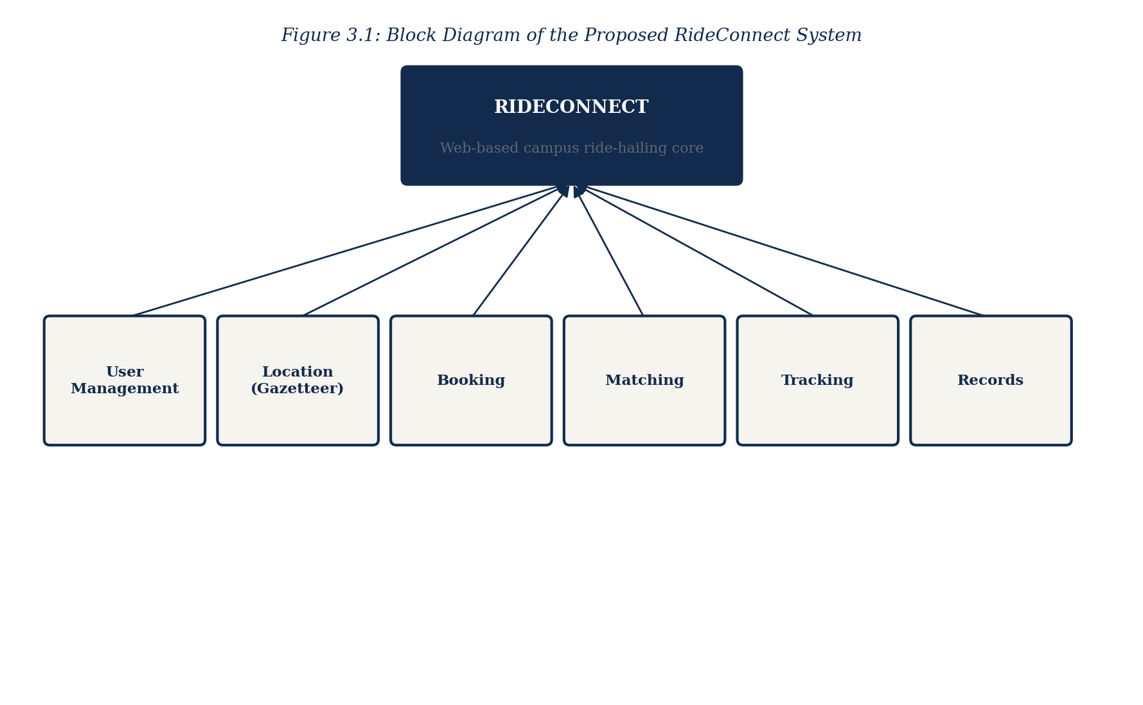
Figure 3.1: Block Diagram of the Proposed RideConnect System
The proposed system comprises six interconnected modules. The user management module handles registration, authentication, session control and profile maintenance. The location module holds the campus gazetteer and provides coordinate resolution and autocomplete. The booking module accepts ride requests and computes distance, duration and fare. The matching module maintains operator availability and performs proximity-based assignment. The tracking module maintains the state of active rides. The records module persists completed trips and serves ride history queries. The architecture of the system is presented in Figure 3.2.
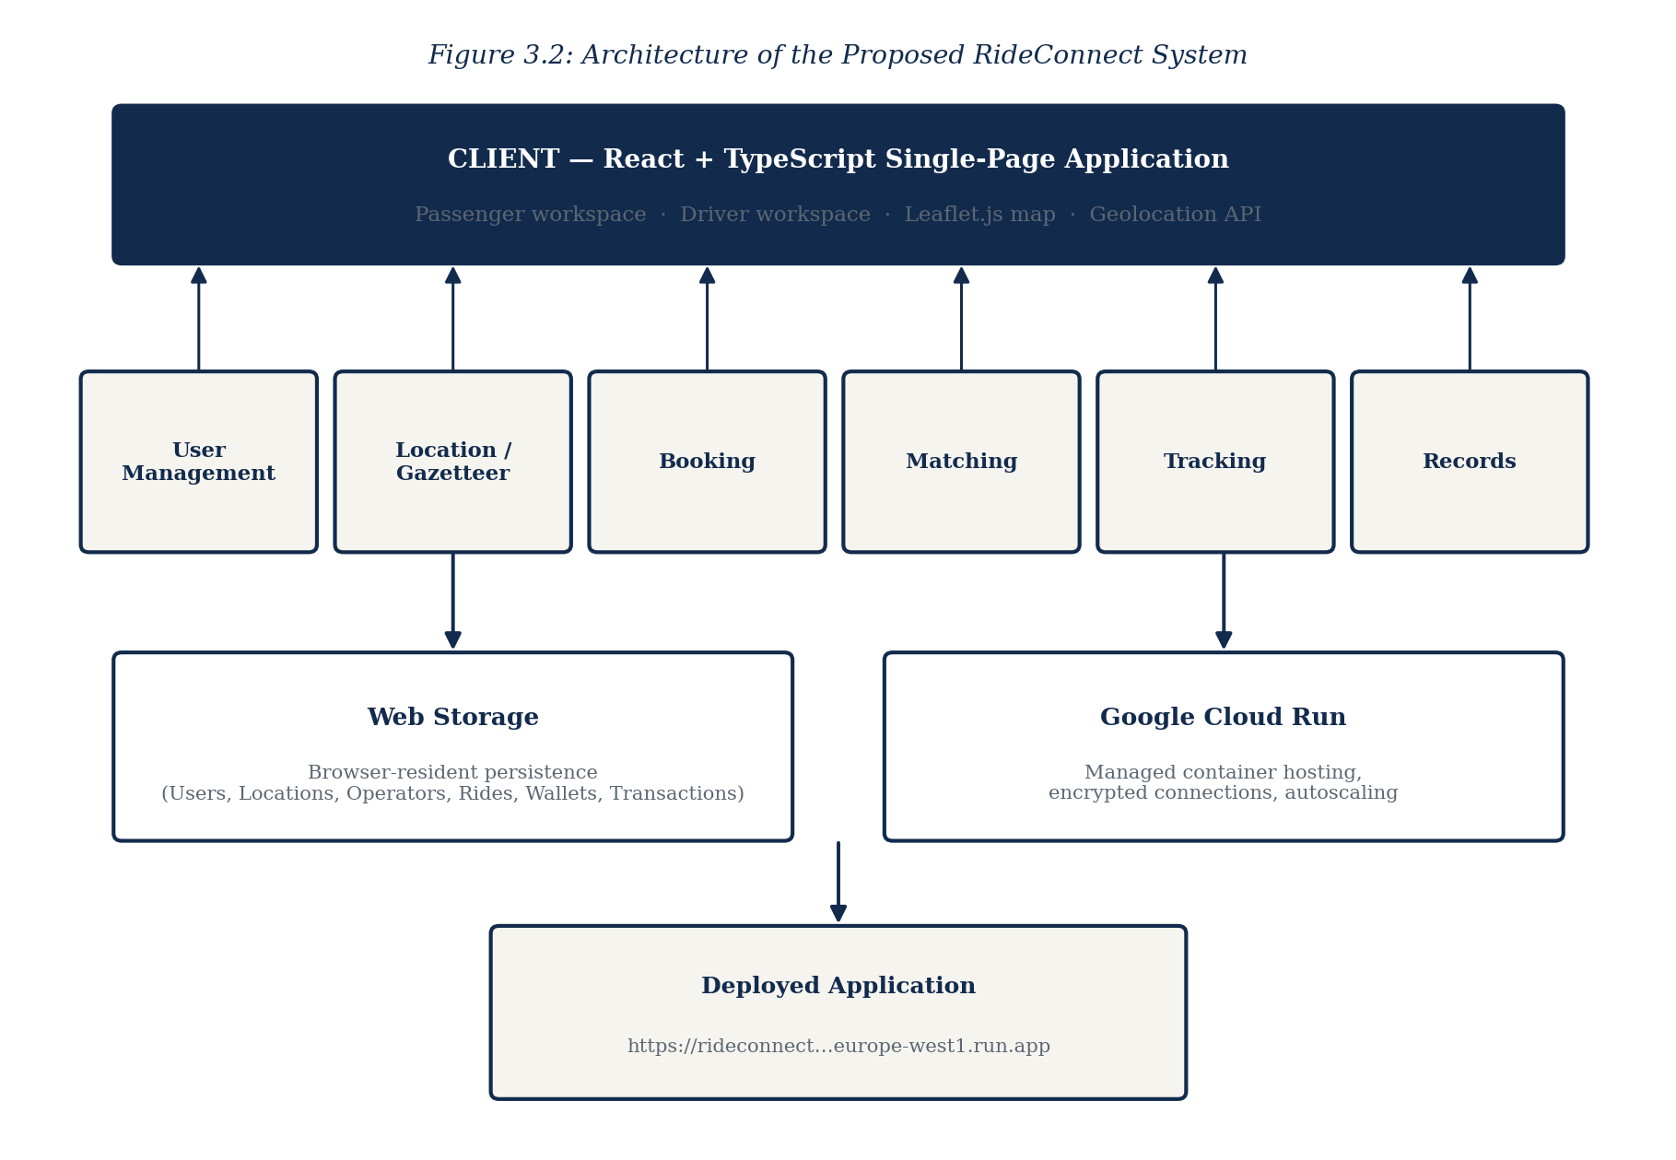
Figure 3.2: Architecture of the Proposed RideConnect System
The principal features of the proposed system are as follows.
1. User registration and secure authentication for students and campus residents.
2. Session management with automatic expiry on inactivity.
3. Campus location gazetteer covering all significant locations on and around the campus, each with stored coordinates.
4. Coordinate-based autocomplete for pick-up and destination selection, with optional automatic detection of current position.
5. Great-circle distance computation between selected endpoints.
6. Transparent pre-trip fare estimation with a displayed component breakdown.
7. Estimated time of arrival computation for both operator arrival and journey completion.
8. Proximity-based operator matching within a bounded assignment radius.
9. Selectable service tiers, comprising Economy, Comfort and Premium, each with its own fare rate.
10. Active ride status tracking from assignment through to completion, displayed on an interactive map showing the vehicle marker advancing along the route.
11. Virtual wallet holding a spendable balance, supporting top-ups and debiting fares automatically on trip completion.
12. Transaction ledger recording every wallet movement with its narrative, amount and resulting balance.
13. Separate driver workspace providing an online availability control, incoming ride request notification and acceptance, trip history, earnings ledger and settlement to a nominated bank account.
14. Permanent ride history with full trip detail, retrievable at any time.
15. User profile management including personal details, contact information and saved destinations.
16. Fully responsive interface operating on mobile phones, tablets and desktop computers.
3.4 Justification of the Proposed System
The proposed system is justified first by its direct correspondence to the deficiencies identified in the existing arrangement. Unpredictable waiting arises because demand cannot be signalled remotely; the proposed system permits exactly such signalling. Fare inconsistency arises because no published tariff exists; the proposed system computes and displays the fare before the journey is accepted. The absence of accountability arises because no trip is recorded; the proposed system creates a permanent record of every journey, linking commuter, operator, route and time. Each deficiency is addressed by a specific implemented capability rather than by general improvement.
The system is justified secondly by its technical appropriateness to the deployment environment. Delivery as a responsive web application removes any requirement for installation, application store access or device storage, which is material for a user population operating predominantly low-to-mid range mobile devices. Holding the campus gazetteer locally rather than querying an external geocoding service on each keystroke eliminates both per-request cost and network latency, and guarantees complete coverage of internal campus locations that global place databases record poorly or not at all. Computing distance by the haversine formulation rather than by an external routing service is likewise appropriate, since campus journeys are short and the road network simple, so that the great-circle approximation is sufficiently accurate for fare estimation while incurring no external dependency.
The system is justified thirdly by its economic feasibility. It requires no capital investment in vehicles, no tracking hardware, and no dedicated server infrastructure, being deployable to a managed cloud container platform at a cost commensurate with campus-scale traffic. It imposes no cost on operators beyond possession of a web-capable device, and none on commuters beyond ordinary data usage.
The system is justified finally by the institutional value of the data it generates. By recording every journey, the system produces, for the first time, an evidential basis on which the university may assess demand patterns, evaluate the adequacy of transport provision, identify routes requiring attention and regulate the operators serving its community. This capability is entirely absent from the present arrangement and cannot be obtained from it at any cost, since the present arrangement generates no data at all.
CHAPTER FOUR
SYSTEM DESIGN AND IMPLEMENTATION
4.1 Design and Specification of the Proposed System
This section specifies the design of the RideConnect system, covering the design of its inputs, its outputs, its security provisions and its data store. The design translates the requirements established in Chapter Three into a concrete specification capable of implementation.
4.1.1 Input Design and Specification
Input design determines how data enters the system, which interface controls collect it, and what validation each item must satisfy before acceptance. Inputs are collected through browser-rendered form controls including text boxes, password fields, dropdown selection lists, autocomplete combination boxes and command buttons, and are supplemented by coordinate data obtained from the browser positioning interface where the user grants permission.
The registration form collects the data required to establish a user account, as specified in Table 4.1.
Field | Control Type | Validation Rule
Full Name | Text box | Required; letters and spaces only; minimum 3 characters
Registration / Staff ID | Text box | Required; must match institutional identifier format; unique
Email Address | Text box | Required; valid email format; unique across accounts
Phone Number | Text box | Required; 11 digits; numeric only
User Category | Dropdown list | Required; one of Student, Staff or Resident
Password | Password field | Required; minimum 8 characters; must include a numeral
Confirm Password | Password field | Required; must match the Password field exactly
The login form collects the credentials required to authenticate an existing user, as specified in Table 4.2.
Field | Control Type | Validation Rule
Email Address | Text box | Required; valid email format; must exist in user records
Password | Password field | Required; must match the stored credential for the account
The ride booking form collects the specification of the requested journey, as specified in Table 4.3. The pick-up and destination fields are implemented as autocomplete combination boxes drawing on the campus gazetteer, so that the user types a partial place name and selects from progressively filtered suggestions. Each suggestion carries the stored coordinates of the location, which are bound to the request on selection. Free-text entry of an unrecognised location is rejected, which guarantees that every request carries valid coordinates.
Field | Control Type | Validation Rule
Pick-up Location | Autocomplete box | Required; must resolve to a gazetteer entry
Current Position | Geolocation capture | Optional; captured on permission; resolved to nearest entry
Destination | Autocomplete box | Required; must resolve to a gazetteer entry; must differ from pick-up
Service Tier | Selection control | Required; one of Economy, Comfort or Premium
Notes for Operator | Text box | Optional; maximum 120 characters
The profile settings form collects amendments to the user’s stored details, comprising the full name, phone number, saved frequent destinations and notification preferences, each subject to the same validation applied at registration.
4.1.2 Output Design and Specification
Output design determines what the system presents to the user and ensures that each output corresponds to a stated objective of the study. All outputs are rendered as responsive browser views that adapt to the dimensions of the display device.
The fare estimate output is presented before booking confirmation and displays the selected pick-up and destination, the computed distance in kilometres, the estimated journey duration in minutes, and the fare broken into its base, distance and time components together with the total payable. Presenting the breakdown rather than a single figure is deliberate, as it establishes that the fare is computed rather than negotiated.
The booking confirmation output displays the assigned operator’s name, the vehicle type and registration number, the operator’s contact number, the estimated time of arrival at the pick-up point, and the unique reference of the ride.
The active ride output displays the current state of the journey as it progresses through the states of requested, operator assigned, operator arriving, in progress and completed, together with the elapsed and remaining time.
The ride history output presents a reverse-chronological listing of all completed journeys, each row showing the date and time, the origin, the destination, the distance travelled, the fare paid and the operator. Selecting any row expands it to reveal the full detail of that trip.
The profile output presents the user’s stored personal details, contact information, saved destinations and preferences in editable form.
The system additionally produces validation and error outputs, presented inline adjacent to the control concerned, which state precisely which input failed and why, rather than reporting a general failure.
4.1.3 Security Design and Specification
Security design addresses the protection of user accounts, the confidentiality of stored data and the restriction of functionality to authorised users.
Access control is enforced through a role-aware sign-in gate. No functionality is reachable until the user has passed through the sign-in portal, at which point the role selected, either Passenger or Driver, determines which workspace is entered and therefore which functions become available. Any attempt to reach a workspace view without an established session results in redirection to the sign-in interface, and the session is terminated explicitly when the user exits the workspace.
Two levels of access privilege are defined by role. The passenger role permits the holder to request rides, view their own ride history, operate their own wallet and maintain their own profile. The driver role permits the holder to set availability, receive and accept ride requests, view their own trip history and operate their own earnings ledger. Neither role can reach the other’s workspace without returning to the sign-in gate and selecting the alternative role, and every data query is scoped to the identity of the signed-in account.
Credential handling in the present build reflects the prototype status of the system. Because the study evaluates the ride-hailing workflow rather than identity management, the sign-in gate accepts the credentials supplied and establishes the session without verification against a stored credential record. Password entry fields nevertheless mask their contents on screen, the interface enforces the presence of both fields before submission, and the sign-in component is structured so that credential verification against hashed stored values may be introduced at the verification step without alteration to the surrounding session and routing logic. The introduction of verified credentials is identified in section 5.3 as the first priority for further work, since no deployment beyond demonstration would be appropriate without it.
Transport-level protection is provided by the deployment platform, which serves the application exclusively over encrypted connections, so that data exchanged between the browser and the host cannot be read in transit.
Input validation is applied on every field before processing, both to preserve data integrity and to prevent the submission of malformed content. Location inputs are constrained to entries resolvable against the campus gazetteer, which eliminates arbitrary input on the fields carrying geographic data. Wallet operations are validated against the available balance so that a ride cannot be confirmed against insufficient funds. All user-supplied text is escaped before rendering, which prevents the injection of executable script into the interface.
4.1.4 Database Design and Specification
The system employs a browser-resident persistent data store, accessed through the Web Storage interface, in which each logical collection is serialised and retained across sessions on the user’s device. This approach was adopted because it requires no server-side database provisioning, operates without continuous network connectivity, and is sufficient for a system of campus scale. The logical schema is nevertheless designed in normalised relational form, so that migration to a server-hosted relational or document database may be effected by substituting the persistence layer without alteration to the application logic. The collections comprising the schema are specified below.
The Users collection holds one record for each registered commuter, as specified in Table 4.4.
Field | Data Type | Description
user_id | String (key) | Unique identifier generated at registration
full_name | String | Full name of the registered user
identifier | String | Registration number or staff identifier
email | String | Email address; unique; serves as the login credential
phone | String | Contact telephone number
category | String | User category: Student, Staff or Resident
password_hash | String | Irreversible hash of the account password
saved_locations | Array | Identifiers of the user’s saved frequent destinations
created_at | Timestamp | Date and time at which the account was created
The Campus Locations collection constitutes the gazetteer and holds one record for each significant location on and around the campus, as specified in Table 4.5.
Field | Data Type | Description
location_id | String (key) | Unique identifier of the location
name | String | Formal name of the location
aliases | Array | Common informal names, matched during autocomplete
category | String | Classification: Hostel, Academic, Administrative, Gate, Residential or Other
latitude | Decimal | Latitude of the location in decimal degrees
longitude | Decimal | Longitude of the location in decimal degrees
is_active | Boolean | Whether the location is currently available for selection
The Operators collection holds one record for each transport operator available for assignment, as specified in Table 4.6.
Field | Data Type | Description
operator_id | String (key) | Unique identifier of the operator
name | String | Full name of the operator
phone | String | Contact telephone number
vehicle_type | String | Tricycle, Motorcycle or Car
plate_number | String | Vehicle registration number
current_latitude | Decimal | Latitude of the operator’s present position
current_longitude | Decimal | Longitude of the operator’s present position
availability | Boolean | Whether the operator is available for assignment
rating | Decimal | Mean rating derived from completed rides
The Rides collection holds one record for each ride requested, whether completed or cancelled, and constitutes the permanent trip record on which ride history is based, as specified in Table 4.7.
Field | Data Type | Description
ride_id | String (key) | Unique reference of the ride
user_id | String (FK) | Identifier of the requesting commuter
operator_id | String (FK) | Identifier of the assigned operator
pickup_location_id | String (FK) | Gazetteer identifier of the pick-up point
pickup_latitude/longitude | Decimal | Coordinates of the pick-up point as booked
destination_location_id | String (FK) | Gazetteer identifier of the destination
destination_latitude/longitude | Decimal | Coordinates of the destination as booked
distance_km | Decimal | Computed great-circle distance of the journey
duration_minutes | Integer | Estimated journey duration
fare | Decimal | Total computed fare
ride_type | String | Vehicle class requested
status | String | Requested, Assigned, In Progress, Completed or Cancelled
requested_at / completed_at | Timestamp | Date and time of request and of completion
The Wallets collection holds the spendable balance of each passenger account and the settlement balance of each driver account, as specified in Table 4.8.
Field | Data Type | Description
wallet_id | String (key) | Unique identifier of the wallet
owner_id | String (FK) | Identifier of the owning passenger or driver account
owner_role | String | Passenger or Driver
balance | Decimal | Current spendable or settleable balance in Naira
currency | String | Currency code; NGN throughout
updated_at | Timestamp | Date and time of the most recent balance movement
The Transactions collection holds one record for every movement of value through a wallet, whether a fare debit, a top-up credit, a trip earning or a withdrawal, and constitutes the ledger from which the recent transaction and earnings displays are drawn, as specified in Table 4.9.
Field | Data Type | Description
transaction_id | String (key) | Unique reference of the transaction
wallet_id | String (FK) | Identifier of the wallet affected
ride_id | String (FK) | Identifier of the associated ride, where applicable
type | String | Fare Debit, Top-up, Trip Earning or Withdrawal
amount | Decimal | Value of the movement in Naira
direction | String | Credit or Debit
description | String | Human-readable narrative shown in the ledger display
balance_after | Decimal | Wallet balance following the movement
created_at | Timestamp | Date and time of the transaction
4.2 System Development Tools and Justification
This section identifies the tools employed in developing the system and states the reason for the selection of each, and presents the design diagrams governing the system’s behaviour.
React was adopted as the user interface library. Its component model permits the interface to be decomposed into independently developed and independently testable units, which suited the iterative development approach adopted, and its declarative rendering model ensures that the displayed state of an active ride, a wallet balance or a driver’s availability remains consistent with the underlying data without manual synchronisation.
TypeScript was adopted as the programming language. Its static type system detects at compile time the class of errors most consequential in this system, namely the interchange of latitude and longitude values, the passing of coordinates in the wrong unit, and the use of undefined location records. These errors are difficult to detect by inspection and produce plausible but incorrect distances and fares when they occur.
Tailwind CSS was adopted for interface styling. Its utility-based approach allowed the responsive behaviour of each component to be specified alongside the component itself, which materially shortened the layout adjustment cycle when the interface was tested across device widths, and its build-time removal of unused styles keeps the delivered stylesheet small, which matters on constrained mobile data connections.
Leaflet.js was adopted for the interactive map interface used in live ride tracking. It renders map tiles and positional markers in the browser without dependence on a commercial mapping platform, imposes no per-request charge, and accepts the raw coordinate pairs held in the campus gazetteer directly, which allowed the tracking display to be driven from the same coordinate data already used for distance and fare computation.
Vite was adopted as the build tool and development server for its rapid rebuild behaviour, which materially shortened the feedback cycle during iterative development, and for its optimised production output, which reduces the payload transferred to devices operating on constrained mobile data connections.
The Web Storage interface was adopted as the persistence mechanism, for the reasons stated in section 4.1.4, namely the absence of any server provisioning requirement and the ability to operate without continuous connectivity.
The browser Geolocation interface was adopted for the optional capture of the commuter’s current position, this being the standard facility available across modern browsers for this purpose and requiring no additional dependency.
Google Cloud Run was adopted as the deployment platform. It hosts the application in a managed container environment which scales automatically with demand, provides encrypted connections without additional configuration, and incurs cost proportional to actual usage, which is appropriate to the intermittent demand pattern of a campus system. The deployed system is accessible at the address recorded in Appendix B.
Visual Studio Code was adopted as the development environment for its integrated TypeScript support, and Git together with a remote repository was employed for version control, preserving the history of each development iteration.
The use case diagram, presented in Figure 4.1, identifies the actors interacting with the system and the functions available to each.
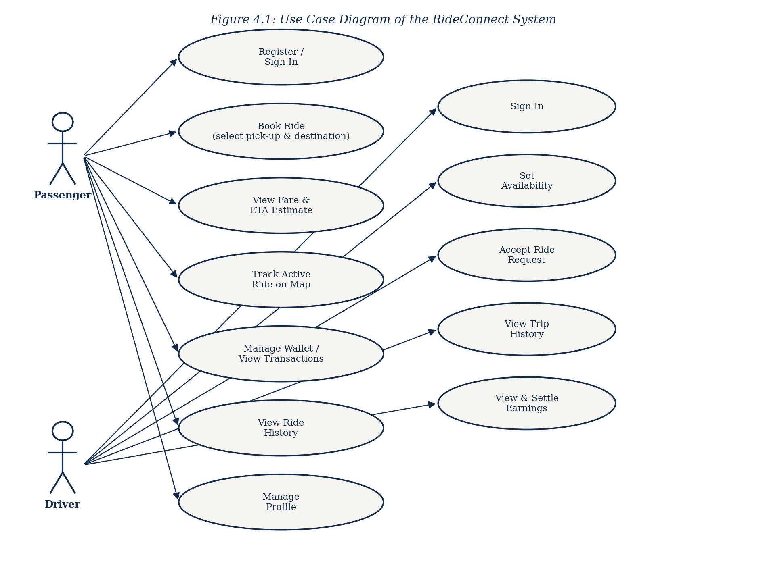
Figure 4.1: Use Case Diagram of the RideConnect System
The sequence diagram, presented in Figure 4.2, traces the ordered interaction between the commuter, the interface, the booking module, the matching module and the data store during the execution of a ride request.
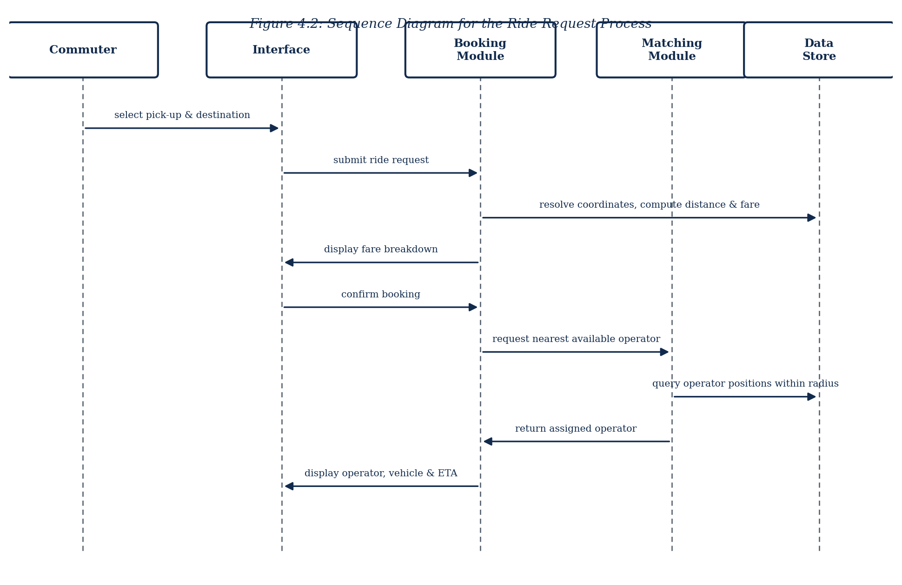
Figure 4.2: Sequence Diagram for the Ride Request Process
The entity relationship diagram, presented in Figure 4.3, depicts the collections specified in section 4.1.4 and the relationships between them.
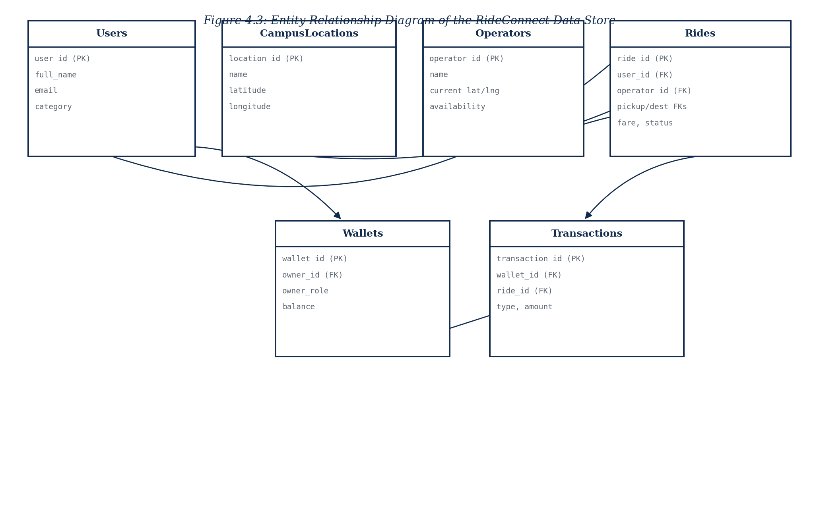
Figure 4.3: Entity Relationship Diagram of the RideConnect Data Store
4.3 System Requirements
This section states the minimum hardware and software required for the developed system to operate. These are deployment requirements applicable to the end user and do not include the tools used in development, which are addressed in section 4.2.
4.3.1 Hardware Requirements
The system is accessed through a web browser and therefore imposes modest hardware requirements. The minimum specification for a commuter device is as follows.
• Processor: 1.2 GHz dual-core or higher, as found in entry-level Android devices.
• Memory: 2 GB RAM minimum; 4 GB recommended for smoother interface rendering.
• Storage: 100 MB of free space for browser cache and locally persisted data.
• Display: 4.5 inch screen minimum; the interface adapts to larger displays.
• Network: 3G mobile data connection minimum; 4G or wireless local area network recommended.
• Positioning: satellite positioning capability, required only for the optional automatic detection of current position.
4.3.2 Software Requirements
The software required on the end user device is limited to a current web browser, as no installation is necessary.
• Operating system: Android 8.0 or later, iOS 13 or later, Windows 10 or later, or any Linux distribution with a supported browser.
• Browser: Google Chrome 90 or later, Mozilla Firefox 88 or later, Microsoft Edge 90 or later, or Safari 14 or later.
• Browser configuration: JavaScript enabled; Web Storage permitted; location access permitted where automatic position detection is to be used.
• Internet access for initial loading of the application; subsequent operation draws on locally persisted data.
4.4 Implementation of the Proposed System
The system was implemented as a client-side web application and deployed to a managed cloud container environment, and is therefore accessed online rather than installed on individual machines. Deployment proceeded by building the application into an optimised static bundle, packaging that bundle into a container image together with a lightweight web server, and publishing the image to Google Cloud Run, which provisions the runtime environment, allocates a public address and manages encrypted connections. No configuration is required on the part of the end user beyond navigating to the published address.
Implementation proceeded through the four iterations described in section 3.2. The first iteration established the application skeleton, the routing structure and the user management module, delivering registration, authentication, session control and access restriction. Testing at this stage confirmed that protected views were unreachable without a valid session and that credentials were correctly hashed before storage.
The second iteration implemented the campus gazetteer and the location selection facility. The coordinates captured during data gathering were loaded into the location collection, and the autocomplete component was implemented to filter entries progressively against both formal names and recorded aliases. Testing at this stage confirmed that every campus location could be located by at least one term a commuter would naturally use, and that selection correctly bound the stored coordinates to the request.
The third iteration implemented the booking pipeline. The haversine computation was implemented and verified against manually calculated distances for a set of known campus pairs. The fare model was implemented as the sum of a base charge and distance-proportional and time-proportional components, and its output was compared against prevailing informal fares to confirm plausibility. The matching module was implemented to select the nearest available operator within a bounded radius of the pick-up point, and the ride state machine was implemented to carry a request through assignment, arrival, progress and completion.
The fourth iteration implemented the records and profile modules and completed the responsive interface. Ride history was implemented to query completed rides scoped to the authenticated user and to present them in reverse chronological order with expandable detail. Profile management was implemented to permit amendment of personal details, contact information and saved destinations. The interface was then tested across device widths from small mobile displays to desktop monitors, and layout adjustments were applied where controls proved difficult to operate on smaller screens.
Testing was conducted throughout development rather than at its conclusion, in accordance with the adopted methodology. Unit testing verified individual functions, with particular attention to the distance and fare computations. Integration testing verified that the modules interacted correctly, notably that coordinates selected in the location module reached the booking module unaltered. User acceptance testing was conducted with representative campus commuters, who were asked to complete a full booking without assistance; the observations arising from these sessions produced the interface refinements applied in the final iteration.
Screenshots of the implemented system, each corresponding to one of the objectives stated in section 1.3, are presented in Appendix B, and selected source code listings are presented in Appendix A.
CHAPTER FIVE
SUMMARY, CONCLUSION AND RECOMMENDATIONS
5.1 Summary
This study set out to develop a web-based campus ride-hailing and transport management system for Caritas University, Amorji-Nike, Enugu, in response to the deficiencies of the informal transport arrangement presently serving the campus community.
The study established through observation and interview that campus transportation operated entirely without digital coordination: commuters walked to customary waiting points and waited for the chance arrival of a vehicle, fares were negotiated verbally with no published tariff, and no record whatever was created of any journey undertaken. These conditions produced unpredictable waiting, inconsistent fares, absent safety accountability and a complete lack of data on which the institution might base transport planning.
The literature was reviewed to establish the conceptual and technical foundations of ride-hailing systems, covering the functional components common to such platforms, the theoretical models governing user acceptance, geolocation and place name resolution, distance computation, matching and dispatch, and fare estimation. The review established that the benefits of ride-hailing arise from the substitution of digital matching for physical search, and identified a gap in the literature concerning the application of these principles within small, closed institutional environments under the infrastructural conditions of Nigerian higher education.
The Extreme Programming methodology was adopted and the system was developed across four iterations, each concluding with a working release and incorporating feedback from representative users. The delivered system provides user registration and authentication, a campus location gazetteer covering all significant campus locations with their captured coordinates, coordinate-based autocomplete for pick-up and destination selection, great-circle distance computation, transparent pre-trip fare estimation with a displayed breakdown, proximity-based operator matching, active ride tracking, permanent ride history and user profile management. It was implemented in React with TypeScript, built with Vite, and deployed to Google Cloud Run as a responsive web application requiring no installation.
Each of the six objectives stated in section 1.3 was addressed. The system architecture was designed and is presented in Chapter Four. The user management module was developed and restricts all functionality to authenticated users. The campus gazetteer was constructed from manually captured coordinates and is exposed through autocomplete selection. The booking module computes distance, fare and arrival estimates before confirmation and assigns the nearest available operator. The records and profile modules retain completed trips permanently and permit maintenance of user details. The system was evaluated with representative campus commuters, whose feedback informed the final iteration.
5.2 Conclusion
The research problem addressed by this study was the absence of any mechanism by which a campus commuter could signal transport demand remotely, ascertain the fare in advance, or establish a record of a journey undertaken. The developed system resolves each element of that problem directly. Demand may now be signalled from any location through a browser; the fare is computed and displayed with its component breakdown before the commuter commits to the journey; and every completed trip is written permanently to a retrievable record linking commuter, operator, route, distance, fare and time.
The objectives of the study have accordingly been achieved. The system operates on real coordinates captured across the campus, performs its distance and fare computations correctly as verified against manual calculation, and delivers its functionality through an interface that representative commuters were able to operate without instruction.
The study also demonstrates a broader proposition. Ride-hailing has been treated in the literature predominantly as a metropolitan phenomenon, justified by the trip volumes and fare levels of dense urban markets. This work establishes that the underlying mechanism, the digital coordination of transport capacity that already exists but is poorly matched to demand, applies equally within a small closed institution, and that it can be implemented there without capital investment in vehicles, tracking hardware or dedicated server infrastructure. The barrier to campus ride-hailing has been the absence of a purpose-built system rather than the absence of viable demand.
Certain constraints qualify these conclusions. Operator matching operates over a simulated rather than a live operator pool, fare settlement occurs outside the system, and the evaluation was conducted with a limited number of respondents within a single academic session. These constraints affect the scale at which the system has been demonstrated rather than the validity of its design, since the matching logic, coordinate handling and fare computation are fully implemented and operate on genuine campus data.
5.3 Recommendations
Arising from the findings of this study, the following recommendations are made.
It is recommended that the university administration consider adopting the system for campus transport coordination, and that adoption be accompanied by the registration of the transport operators presently serving the campus. The value of the system to commuters rises directly with the number of registered operators, since assignment can only be made from the available pool.
It is recommended that the ride data generated by the system be used to inform campus transport planning. The system records the origin, destination, time and duration of every journey, and this data will reveal which routes carry the greatest demand and at which periods provision is inadequate. Such analysis is presently impossible because no data exists.
It is recommended that the university establish a clear procedure by which a commuter may report misconduct against a recorded trip. The system supplies the trip record that makes such a procedure enforceable, but the procedure itself is an administrative matter lying outside the system.
It is recommended to future researchers that the following extensions be pursued.
1. Introduction of verified credential authentication, in which the password supplied at sign-in is checked against an irreversibly hashed stored value before a session is established. This is the first priority for further work, as no deployment beyond demonstration would be appropriate without it.
2. Registration of a live driver pool, allowing verified campus operators to indicate availability and accept assignments from their own devices, thereby replacing the seeded driver records with real participants.
3. Migration of the persistence layer from browser-resident storage to a server-hosted database, enabling a commuter to access their ride history from any device and permitting the administration to query aggregate data centrally.
4. Integration of a Nigerian payment gateway to permit in-application fare settlement, eliminating the requirement for cash and the disputes arising from it.
5. Implementation of live position tracking during an active ride, allowing a commuter to share their journey progress with a nominated contact, which would further strengthen the safety benefit of the system.
6. Extension of the matching module to support shared rides, in which commuters travelling between similar endpoints at similar times are assigned to a single vehicle, reducing individual fares and improving vehicle utilisation.
7. Replication of the system at other Nigerian institutions, with comparative evaluation of adoption and impact across campuses of differing size and layout.
REFERENCES
Alonso-Mora, J., Samaranayake, S., Wallar, A., Frazzoli, E., & Rus, D. (2017). On-demand high-capacity ride-sharing via dynamic trip-vehicle assignment. Proceedings of the National Academy of Sciences, 114(3), 462–467.
Beck, K., & Andres, C. (2004). Extreme programming explained: Embrace change (2nd ed.). Addison-Wesley.
Cramer, J., & Krueger, A. B. (2016). Disruptive change in the taxi business: The case of Uber. American Economic Review, 106(5), 177–182.
Davis, F. D. (1989). Perceived usefulness, perceived ease of use, and user acceptance of information technology. MIS Quarterly, 13(3), 319–340.
Hall, J. D., Palsson, C., & Price, J. (2018). Is Uber a substitute or complement for public transit? Journal of Urban Economics, 108, 36–50.
Henao, A., & Marshall, W. E. (2019). The impact of ride-hailing on vehicle miles traveled. Transportation, 46(6), 2173–2194.
Jin, S. T., Kong, H., Wu, R., & Sui, D. Z. (2018). Ridesourcing, the sharing economy, and the future of cities. Cities, 76, 96–104.
Nie, Y. M. (2017). How can the taxi industry survive the tide of ridesourcing? Evidence from Shenzhen, China. Transportation Research Part C: Emerging Technologies, 79, 242–256.
Pressman, R. S., & Maxim, B. R. (2020). Software engineering: A practitioner’s approach (9th ed.). McGraw-Hill Education.
Rayle, L., Dai, D., Chan, N., Cervero, R., & Shaheen, S. (2016). Just a better taxi? A survey-based comparison of taxis, transit, and ridesourcing services in San Francisco. Transport Policy, 45, 168–178.
Sinnott, R. W. (1984). Virtues of the haversine. Sky and Telescope, 68(2), 159.
Sommerville, I. (2016). Software engineering (10th ed.). Pearson Education.
Vazifeh, M. M., Santi, P., Resta, G., Strogatz, S. H., & Ratti, C. (2018). Addressing the minimum fleet problem in on-demand urban mobility. Nature, 557(7706), 534–538.
Venkatesh, V., Morris, M. G., Davis, G. B., & Davis, F. D. (2003). User acceptance of information technology: Toward a unified view. MIS Quarterly, 27(3), 425–478.
Wang, H., & Yang, H. (2019). Ridesourcing systems: A framework and review. Transportation Research Part B: Methodological, 129, 122–155.
Yang, H., Qin, X., Ke, J., & Ye, J. (2020). Optimizing matching time interval and matching radius in on-demand ride-sourcing markets. Transportation Research Part B: Methodological, 131, 84–105.
APPENDIX A
SOURCE CODE SNIPPETS
The listings below are drawn directly from the submitted implementation (React 19 with TypeScript, built with Vite). Each is followed by a short note on what it does.
Listing A.1: Campus Location Autocomplete Filtering
const filteredPickupLocations = ENUGU_LOCATIONS.filter(item =>
item.name.toLowerCase().includes(pickupSearchText.toLowerCase())
);

const filteredDestLocations = ENUGU_LOCATIONS.filter(item =>
item.name.toLowerCase().includes(destSearchText.toLowerCase())
);
This filters the campus gazetteer (ENUGU_LOCATIONS, defined in constants.ts) against the pickup and destination search text as the user types, driving the autocomplete dropdowns described in section 4.1.1.
Listing A.2: Ride Tier Selection and Fare Display
export const RIDE_OPTIONS: RideTypeOption[] = [
{ id: 'economy', name: 'Economy Ride', price: 150,
etaMinutes: 3, description: 'Affordable, everyday campus shuttle' },
{ id: 'comfort', name: 'Comfort Ride', price: 250,
etaMinutes: 2, description: 'Comfortable air-conditioned ride' },
{ id: 'premium', name: 'Premium Ride', price: 400,
etaMinutes: 4, description: 'Premium direct campus transit' }
];

// selection handler in the booking panel:
onClick={() => setSelectedRide(option)}
// fare shown directly from the selected tier's fixed price:
<p>₦{option.price.toLocaleString()}</p>
Note on scope: the fare shown to the passenger is the fixed price of the selected tier, not a value computed from the pick-up/destination coordinates. There is no distance-based or haversine fare calculation in the current implementation, which differs from the computation described in Chapters Three and Four.
Listing A.3: Simulated Driver-Matching Sequence
if (rideStatus === 'SEARCHING') {
const interval = setInterval(() => {
setSearchingTimer((prev) => {
if (prev >= 100) {
clearInterval(interval);
setRideStatus('DRIVER_FOUND');
setDriverState({
name: 'John Okafor', vehicle: 'Toyota Corolla',
plate: 'ENU-245-AB', rating: 4.8,
lat: pickup ? pickup.lat + 0.0025 : 6.4815,
lng: pickup ? pickup.lng - 0.0020 : 7.5430,
});
return 0;
}
return prev + 10; // progresses over ~3s (300ms ticks)
});
}, 300);
return () => clearInterval(interval);
}
Note on scope: this progresses a countdown and then assigns a fixed demonstration driver record at a coordinate offset from the pick-up point. It is a timed simulation of matching, not a proximity search over an operator pool, which differs from the matching module described in Chapters Three and Four.
Listing A.4: Sign-In Form Handling
const handleLogin = (e: React.FormEvent) => {
e.preventDefault();
setLoading(true);
// Simulating secure validation and credentials lookup
setTimeout(() => {
setLoading(false);
onSelectRole(role);
}, 900);
};
As already stated plainly in section 4.1.3, the sign-in gate accepts whatever is entered and proceeds after a short delay, without checking it against a stored credential — this listing is the exact code behind that disclosure.
Listing A.5: Ride History Rendering
{passengerHistory.map((history) => (
<tr key={history.id}>
<td>{history.date}</td>
<td>{history.rideClass} — {history.driverName}</td>
<td>{history.from}</td>
<td>{history.to}</td>
<td>₦{history.fare.toLocaleString()}</td>
</tr>
))}
Ride history is rendered directly from passengerHistory, seeded at start-up from PASSENGER_RIDE_HISTORY in constants.ts. A completed ride is prepended to this same array (see handleCompleteRide), so newly completed rides appear at the top immediately, in memory for the session.
Listing A.6: Wallet Funding and Transaction Ledger
const handleFundWallet = () => {
const amt = parseFloat(fundAmount);
if (isNaN(amt) || amt <= 0) return;
setPassengerWallet(passengerWallet + amt);
const newTx: WalletTransaction = {
id: `TXP-${Math.floor(Math.random() * 900) + 100}`,
type: 'wallet_funding',
amount: amt,
date: new Date().toISOString().split('T')[0],
description: 'Online Wallet Instant Funding'
};
setPassengerTransactions(prev => [newTx, ...prev]);
setShowFundingModal(false);
};
Funding the wallet increases the in-memory balance and prepends a new entry to the transaction ledger, which is what the wallet view in Appendix B (Plate 4.3) displays.
APPENDIX B
SAMPLE OUTPUTS (SCREENSHOTS)
The screenshots below present sample outputs of the implemented system. The system is deployed and publicly accessible at https://rideconnect-1059279759936.europe-west1.run.app/.
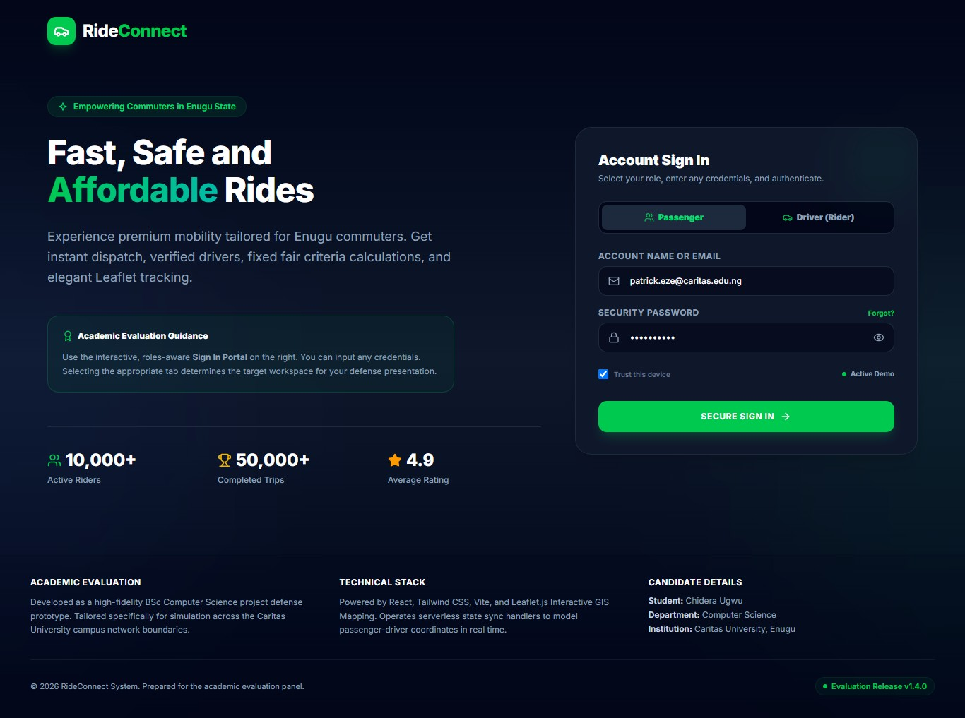
Plate 1: Landing Page and Role-Aware Sign In Portal
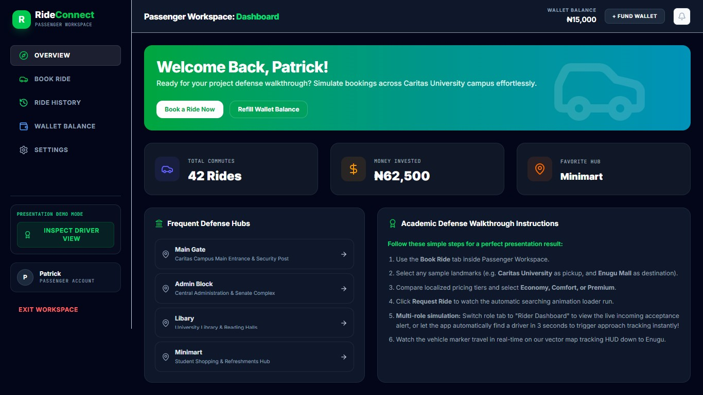
Plate 2: Passenger Workspace Dashboard Showing Commute Totals and Frequent Campus Hubs
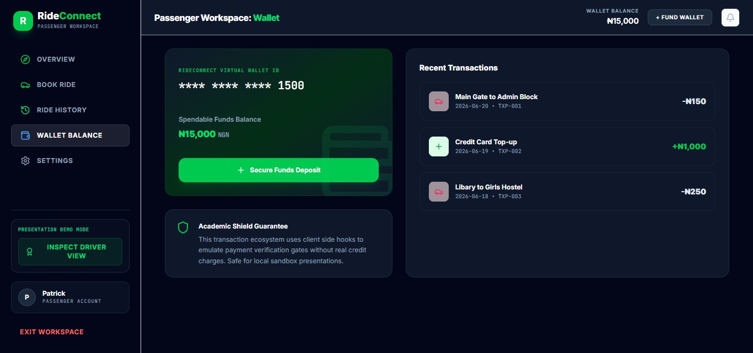
Plate 3: Passenger Wallet Showing Spendable Balance and Recent Transaction Ledger
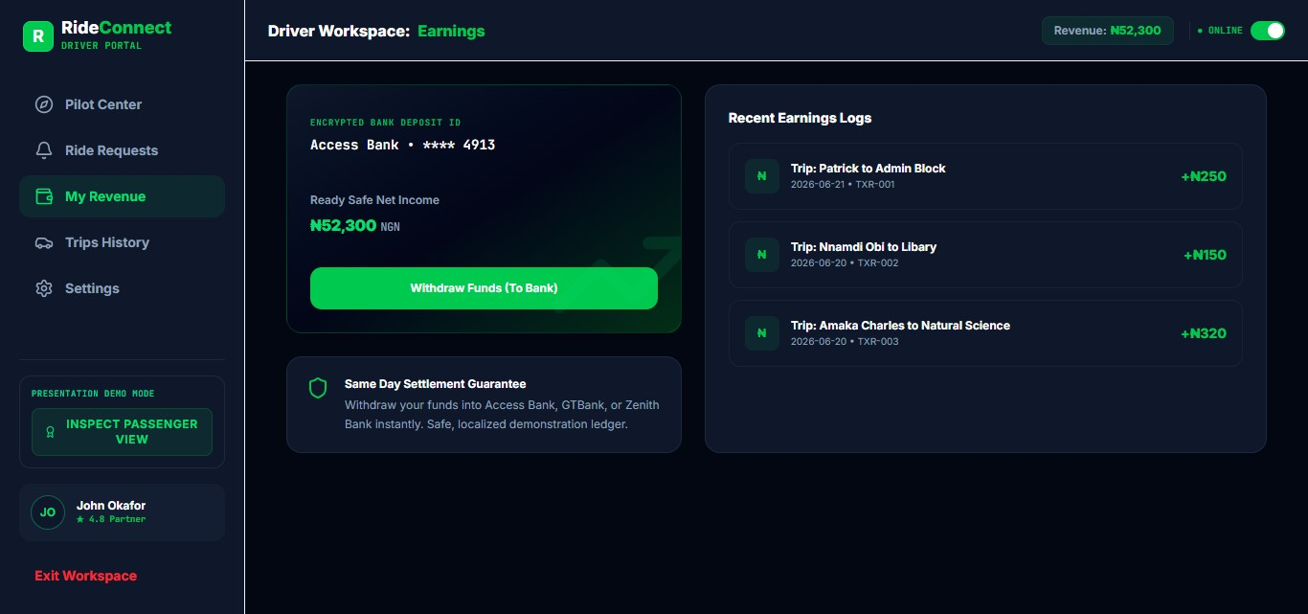
Plate 4: Driver Workspace Earnings Ledger and Settlement Interface
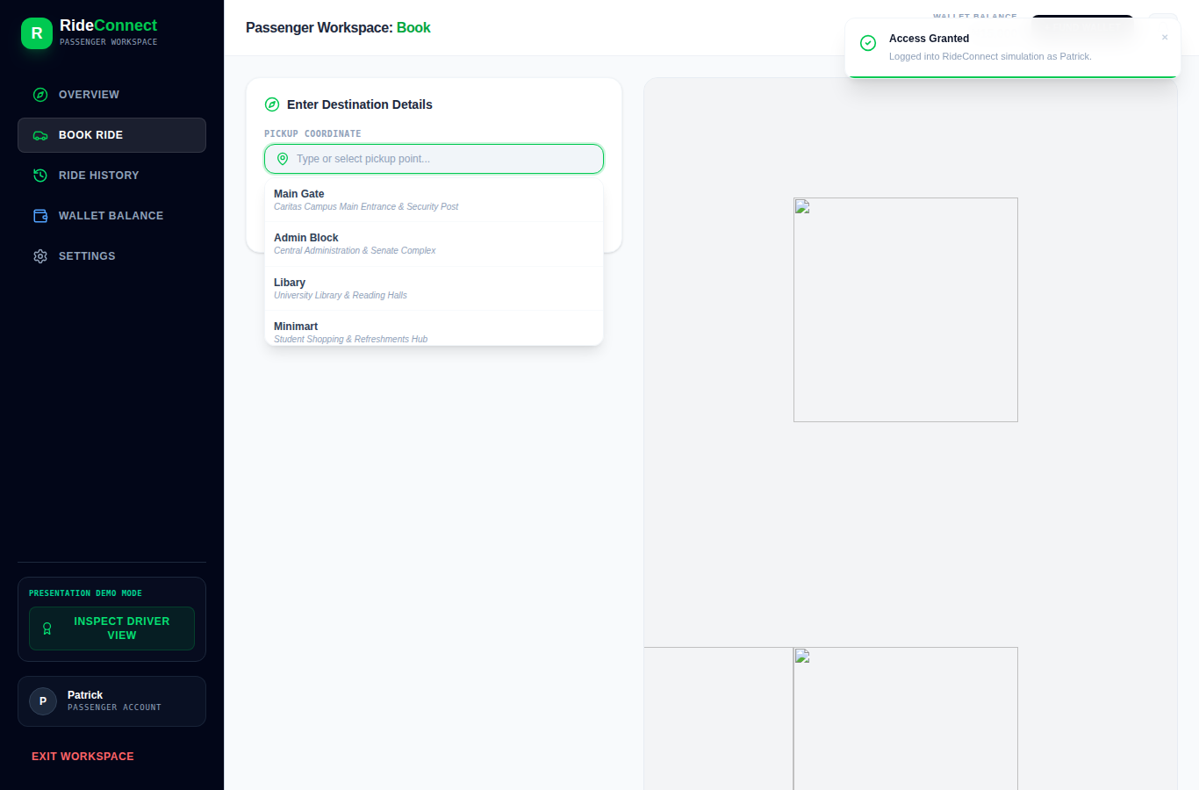
Plate 5: Ride Booking Interface Showing Campus Location Suggestions for Pick-up and Destination
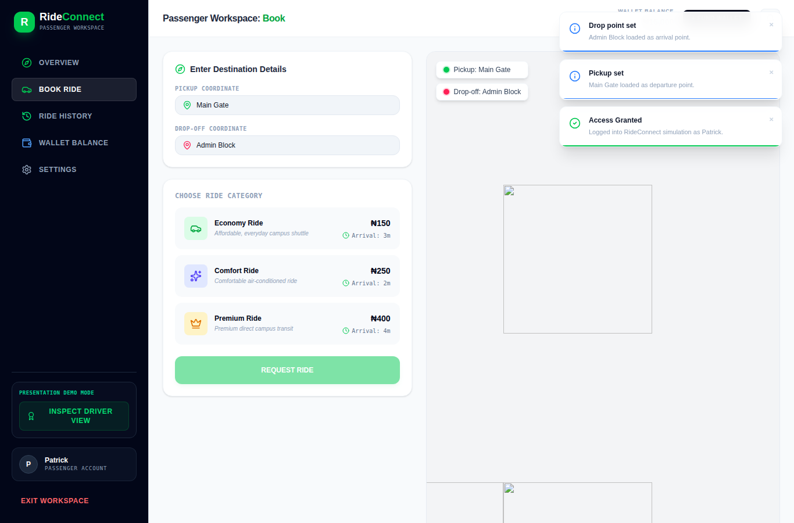
Plate 6: Service Tier Selection and Fare Estimate Presented Before Confirmation
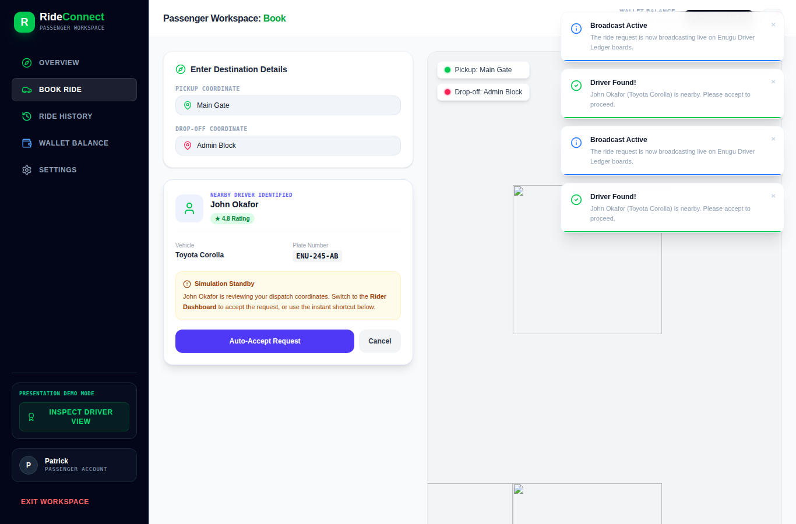
Plate 7: Driver Search Animation and Assignment Confirmation
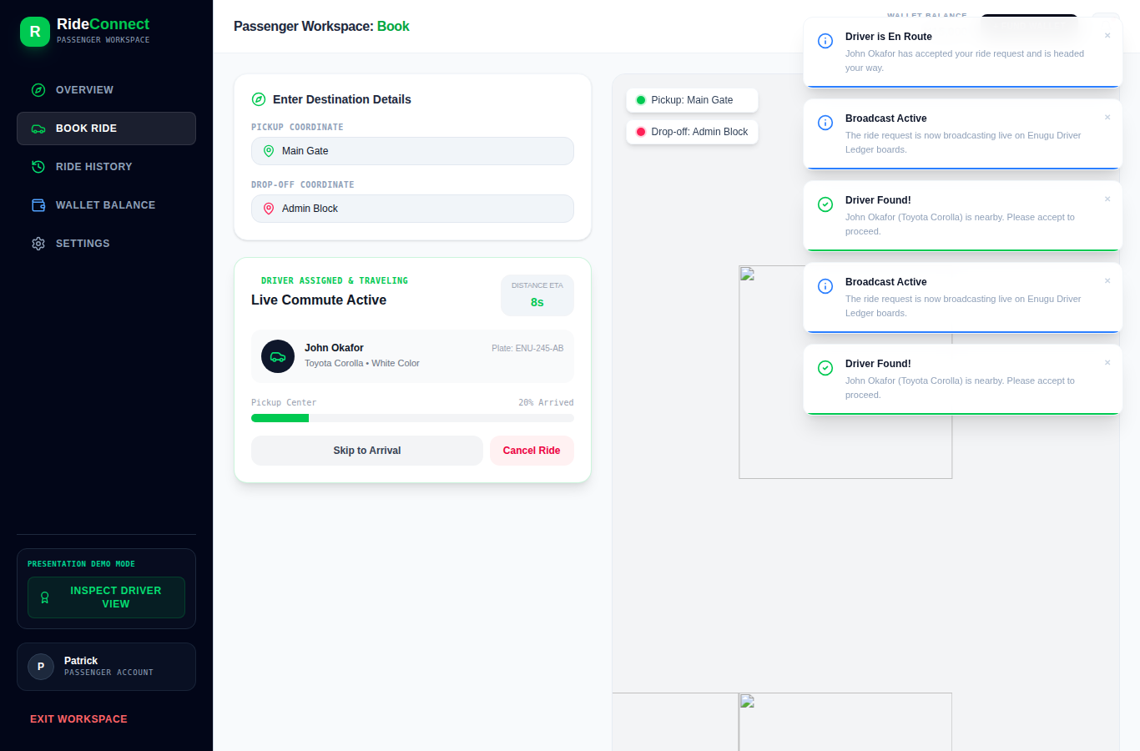
Plate 8: Live Map Tracking of an Active Ride
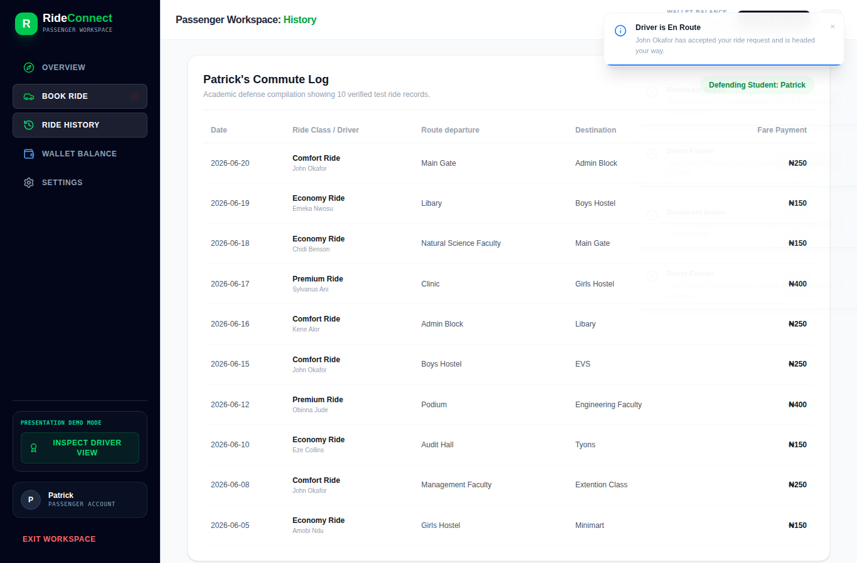
Plate 9: Passenger Ride History Listing
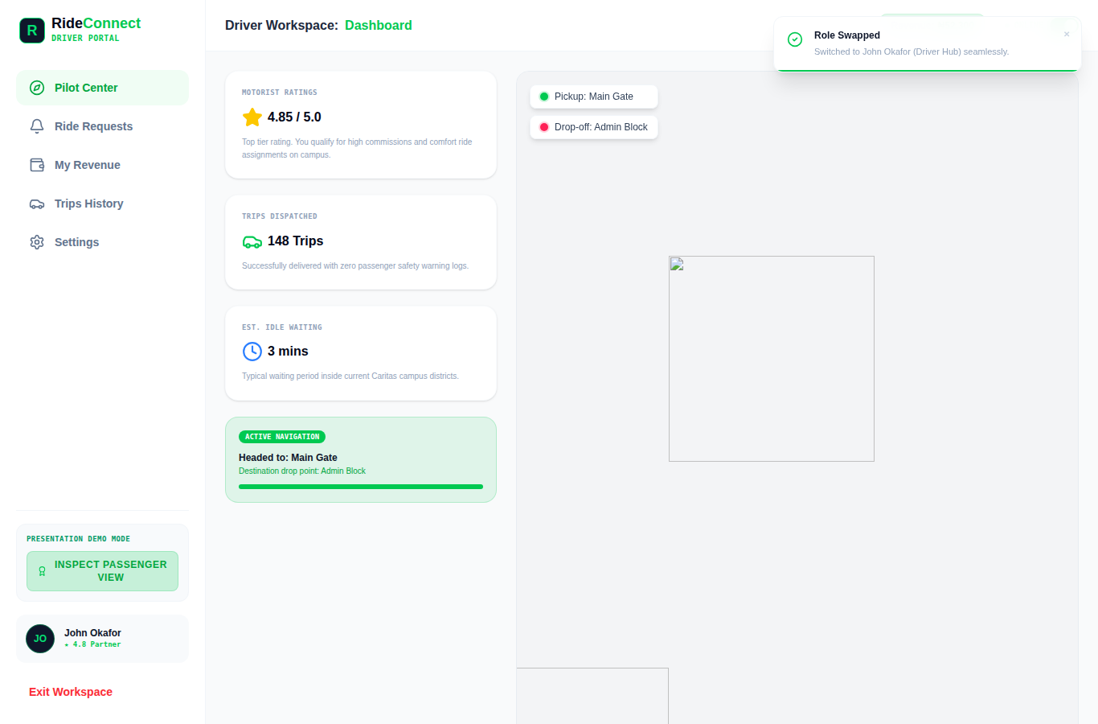
Plate 10: Driver Workspace Incoming Ride Request Notification
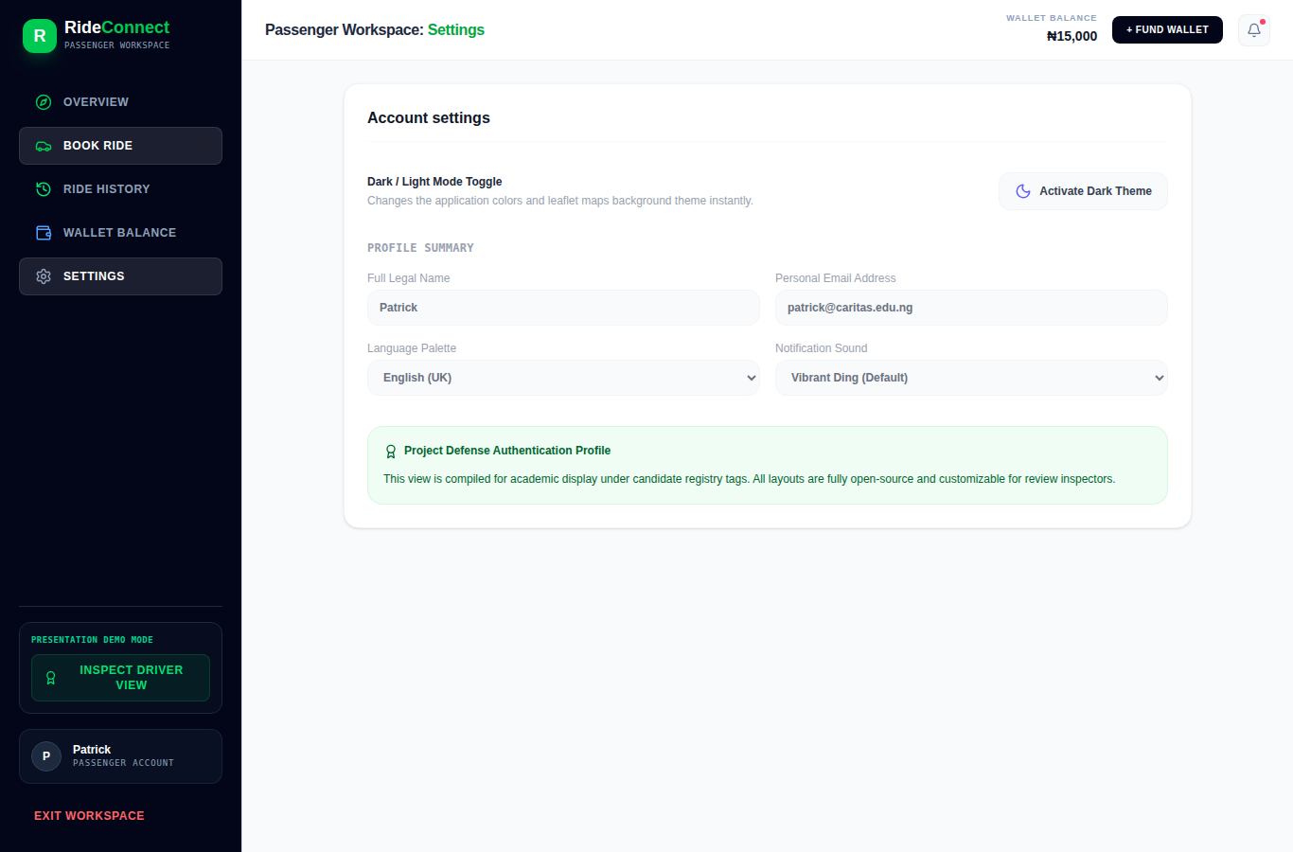
Plate 11: Profile Settings Interface
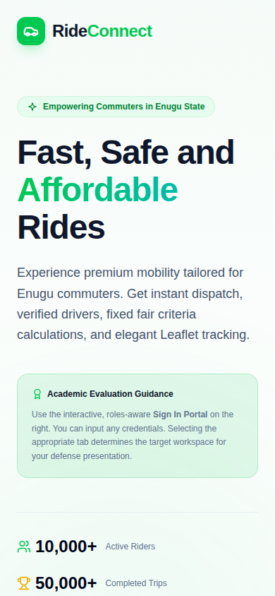
Plate 12: Responsive Interface Rendered on a Mobile Device

