DESIGN AND IMPLEMENTATION OF AN EXPERT SYSTEM FOR STUDENT USE IN THE SCHOOL OF NURSING, CARITAS UNIVERSITY
PROJECT REPORT
BY
OKAM, SOMTO CHINAGOROM
CS/2022/1324
SUBMITTED TO
THE DEPARTMENT OF COMPUTER SCIENCE
FACULTY OF NATURAL SCIENCES
CARITAS UNIVERSITY, AMORJI-NIKE, ENUGU
IN PARTIAL FULFILMENT OF THE REQUIREMENTS FOR THE AWARD OF
BACHELOR OF SCIENCE (B.SC) DEGREE IN COMPUTER SCIENCE
AUGUST, 2026

DECLARATION
I, OKAM, SOMTO CHINAGOROM, with registration number CS/2022/1324, hereby declare that this project titled "Design and Implementation of an Expert System for Student Use in the School of Nursing, Caritas University" is my original research work carried out under the supervision of Dr. Ugo Nwachukwu of the Department of Computer Science, Caritas University, Amorji-Nike, Enugu. The work reported herein has not been presented, in whole or in part, to any institution for the award of any other degree or qualification, and all sources consulted have been duly acknowledged.
________________________________ ________________________

Okam, Somto Chinagorom Date
(CS/2022/1324)

APPROVAL
This is to certify that we have read, examined and found this project titled "Design and Implementation of an Expert System for Student Use in the School of Nursing, Caritas University", carried out by OKAM, SOMTO CHINAGOROM with registration number CS/2022/1324, to be satisfactory and acceptable for the award of a Bachelor of Science (B.Sc) degree in Computer Science of Caritas University, Amorji-Nike, Enugu, and hence we have caused our names and signatures to appear as follows:
________________________________ ________________________

Dr. Ugo Nwachukwu Date
(Project Supervisor)
________________________________ ________________________

Ugwu, Ejike Date
(Head of Department)
________________________________ ________________________

Prof. Fergus Onu Date
(External Examiner)

DEDICATION
This project is dedicated to Almighty God, the giver of wisdom and understanding, for His grace and guidance throughout the course of this programme, and to my family, whose patience, encouragement and unfailing support made this academic journey possible.

ACKNOWLEDGEMENTS
I extend my sincere gratitude to God Almighty for the strength, wisdom and good health that sustained me throughout the duration of this project.
My profound appreciation goes to my Project Supervisor, Dr. Ugo Nwachukwu, whose guidance, patience and constructive criticism shaped this work from conception to completion.
I am equally grateful to the Head of the Department of Computer Science, Ugwu, Ejike, for his leadership and support throughout the programme. My sincere thanks go likewise to Prof. Arinze Nwaeze, Dr. Henry Nweke and Dr. Ugochukwu Nwankwo, and to all the other lecturers of the Department of Computer Science, Caritas University, for the knowledge imparted to me over the course of my studies.
Finally, I thank my family and friends for their encouragement, understanding and support throughout the period of this project.

ABSTRACT
This work reports on the Nursing Student Academic Advisory Expert System, a rule-based expert system developed for the School of Nursing, Caritas University, Amorji-Nike, Enugu. It analysed the manual and periodic manner in which nursing students’ academic standing, specialization fit, clinical-placement eligibility and graduation pathway are presently reviewed, and used the findings to design a knowledge base of explicit advisory rules reasoned over by a forward-chaining inference engine with certainty-factor scoring and an explanation facility. The system was designed using the Expert System Development Life Cycle and implemented as a self-contained client-side single-page application in HTML, CSS and JavaScript, with a student-facing dashboard and an administrative view for browsing individual student records.

TABLE OF CONTENTS
Title Page i
Declaration ii
Approval iii
Dedication iv
Acknowledgements v
Abstract vi
Table of Contents vii
CHAPTER ONE: INTRODUCTION 1
1.1 Background of the Study 1
1.2 Statement of the Problem 1
1.3 Aim and Objectives of the Study 2
1.4 Significance of the Study 2
1.5 Scope of the Study 3
1.6 Limitations of the Study 3
CHAPTER TWO: LITERATURE REVIEW 5
2.1 Introduction 5
2.2 Expert Systems and Rule-Based Reasoning 5
2.3 Certainty Factors and Reasoning Under Uncertainty 5
2.4 Expert System Development Methodology 6
2.5 Learning Analytics and Academic Early-Warning Systems 6
2.6 Role-Based Access Control 7
2.7 Client-Side Web Implementation 7
2.8 Usable Interface Design 7
2.9 Summary and Research Gap 8
CHAPTER THREE: SYSTEM ANALYSIS AND METHODOLOGY 9
3.1 Data Gathering 9
3.2 Research Methodology and Justification 9
3.3 System Analysis 9
3.3.1 Analysis of the Existing System 9
3.3.2 Analysis of the Proposed System 10
3.4 Justification of the Proposed System 10
CHAPTER FOUR: SYSTEM DESIGN AND IMPLEMENTATION 12
4.1 Design and Specification of the Proposed System 12
4.1.1 Input Design and Specification 12
4.1.2 Output Design and Specification 13
4.1.3 Security Design and Specification 13
4.1.4 Data Design and Specification 13
4.2 System Development Tools and Justification 14
4.3 System Requirements 16
4.3.1 Hardware Requirements 17
4.3.2 Software Requirements 17
4.4 Implementation of the Proposed System 17
CHAPTER FIVE: SUMMARY, CONCLUSION AND RECOMMENDATIONS 19
5.1 Summary 19
5.2 Conclusion 19
5.3 Recommendations 20
REFERENCES 21
APPENDIX A: SOURCE CODE SNIPPETS 22
APPENDIX B: SAMPLE OUTPUTS (SCREENSHOTS) 24

CHAPTER ONE
INTRODUCTION
1.1 Background of the Study
Nursing education places unusually compounded demands on a student. Beyond the coursework common to any degree, a nursing student must clear a sequence of foundational science courses before advancing to specialty clinical courses, must meet a minimum grade point average and prerequisite requirement before being permitted into clinical practicum placement, and must accumulate credit units at a pace that keeps a five-level programme on schedule for on-time graduation. At the School of Nursing, Caritas University, Amorji-Nike, Enugu, a student’s standing against these requirements is presently established through periodic review by academic advisers and departmental staff, cross-checking a student’s transcript against the curriculum requirements by hand.
This arrangement places the burden of noticing a problem on a review that happens only periodically, rather than on a system the student can consult at will. A student who has fallen behind on credit units, who has failed a prerequisite that now blocks a clinical placement, or whose grades cluster strongly enough in one area to suggest a particular specialization, has no way to discover this for themselves between advising sessions. It was this gap — the absence of an always-available, rule-based means by which a nursing student could check their own academic standing and receive specific, reasoned advisory guidance — that prompted the system reported in this project.
The Nursing Student Academic Advisory Expert System is proposed as a response to this gap. Rather than replacing the academic adviser, it gives a student immediate, rule-based feedback on four fronts — academic standing, specialization fit, clinical-placement readiness and graduation pathway — each recommendation traceable to an explicit rule and accompanied by an explanation of why it was given and how strongly the record supports it. A parallel administrative view allows departmental staff to open the same dashboard for any individual student, so that the tool serves both the student checking their own progress and the staff member reviewing a caseload.
1.2 Statement of the Problem
The School of Nursing, Caritas University, lacks a rule-based, always-available means by which a student can check their own academic standing, specialization fit, clinical-placement eligibility and graduation pathway. Because this review is presently conducted periodically and by hand, a student who has fallen behind on required credit units, failed a prerequisite that blocks a clinical placement, or drifted below the CGPA required for good standing, has no way of discovering this for themselves between advising sessions. This single problem — the absence of an immediate, explainable, rule-based advisory check — gives rise to delayed detection of at-risk academic standing, uncertainty among students about their eligibility for clinical placement, and the loss of an opportunity to catch a problem early enough to act on it.
1.3 Aim and Objectives of the Study
The aim of this project is to design and implement a rule-based expert system that reasons over a nursing student’s academic record and provides advisory guidance on academic standing, specialization, clinical-placement readiness and graduation pathway. The specific objectives, each aimed at mitigating the problem stated in Section 1.2, are:
1. To design a knowledge base of explicit, IF/THEN advisory rules across four categories — Academic Standing, Specialization Guidance, Clinical Readiness and Graduation Pathway — so that every piece of advice the system gives traces back to a specific, readable rule.
2. To implement a forward-chaining inference engine that derives structured facts from a student’s raw grade record and tests them against the knowledge base, together with a certainty-factor model that expresses how strongly the record supports each fired rule without ever claiming absolute certainty.
3. To provide an explanation facility so that a student or adviser can see, for any piece of advice, exactly which fact triggered which rule, rather than receiving an unexplained recommendation.
4. To implement a graduation-readiness score and a degree-audit view that summarise, from the same underlying facts, how on-track a student is and which courses remain outstanding.
5. To provide an administrative view, gated behind a sign-in, through which departmental staff may browse a roster of students and open any individual student’s advisory dashboard on a read-only basis.
1.4 Significance of the Study
When completed, this work contributes a practical, immediately usable advisory tool for nursing students and the department that supports them. By moving the first check of academic and clinical-placement standing from a periodic, manual review to an always-available, rule-based system, it narrows the window in which a student’s difficulty could go unnoticed. The following points further underline the importance of the study:
• Timeliness is improved, because a student can check their standing at any time rather than waiting for the next advising session.
• Transparency is strengthened, because every recommendation is accompanied by an explanation naming the exact rule and fact behind it, rather than being presented as an unexplained verdict.
• Staff oversight is supported, because the administrative roster view lets departmental staff review any individual student’s standing without reconstructing it from a transcript by hand.
• The work also serves as a reference for students and developers interested in rule-based expert systems, certainty-factor reasoning, and the delivery of an explainable advisory tool without heavy server infrastructure.
1.5 Scope of the Study
This project covers the design, implementation and evaluation of a rule-based expert system that runs in a standard web browser. Its scope covers a representative nursing curriculum spanning five academic levels; a knowledge base of fourteen advisory rules across the four categories named in Section 1.3; a forward-chaining inference engine with certainty-factor scoring and an explanation facility; a graduation-readiness score and degree-audit view; a printable advisory report; and an administrative area, gated behind a demonstration sign-in, for browsing a roster of students and viewing any one student’s dashboard on a read-only basis. The system is intended for use by the students and academic staff of the School of Nursing, Caritas University.
The study is bounded as follows. It concerns the reasoning over, and presentation of, a student’s academic record within a single client-side application, and does not undertake clinical diagnosis, patient-facing decision support, or the formal administration of examinations and results. The curriculum against which it reasons is a representative sample built to demonstrate the system rather than a live export of the department’s official course catalogue; connection to the university’s actual student-records system is identified in Section 5.3 as further work rather than undertaken here.
1.6 Limitations of the Study
Several factors constrained the execution of this work and should be borne in mind when interpreting its results.
First, the system holds its curriculum and student records in structured in-browser collections rather than in a server-side database. This lets every view be demonstrated at realistic scale, but a change made in one session — a grade entered or edited — is not written to a persistent store and does not survive a page reload, because no server or database is provisioned in this build. The introduction of a persistence layer is identified in Section 5.3 as the first priority for further work.
Second, administrative sign-in in the present build is performed within the browser against a single shared demonstration password, intended to exercise the student/administrator access distinction rather than to secure real staff accounts. Per-staff credentials verified on a server are likewise identified as further work.
Third, the student roster available to the administrative view is a small set of representative demonstration records, built to exercise the rule base across different scenarios, rather than the department’s actual student population.
Fourth, the study was carried out within a single academic session alongside coursework and examinations, which constrained the duration of the evaluation exercise.
CHAPTER TWO
LITERATURE REVIEW
2.1 Introduction
This chapter reviews the body of literature relevant to the design of a rule-based academic advisory expert system. It begins with the theory of expert systems and rule-based reasoning, on which the present system’s core architecture rests, and with the treatment of uncertainty through certainty factors. It then turns to expert system development methodology, to the related field of learning analytics and academic early-warning systems, and finally to the technical foundations of the implementation: role-based access, client-side web development and usable interface design. Each body of work is related to the present project, with its contribution and its limitation identified, and the chapter concludes by stating the gap that the study addresses.
2.2 Expert Systems and Rule-Based Reasoning
An expert system is a computer program that emulates the decision-making of a human expert within a narrow domain by reasoning over a base of explicitly represented knowledge rather than by following a fixed procedural script. Buchanan and Shortliffe (1984), reporting on MYCIN — among the earliest and most influential rule-based expert systems, built to recommend antimicrobial therapy — establish the now-standard architecture of a knowledge base of IF/THEN rules, an inference engine that matches facts against those rules, and an explanation facility that can state why a given conclusion was reached. This architecture is directly adopted in the present system: Chapter Four documents an equivalent separation between the knowledge base of fourteen advisory rules, the forward-chaining inference engine that matches a student’s derived facts against them, and an explanation facility that states, for every fired rule, the specific fact that triggered it. Giarratano and Riley (2005) reinforce this architecture and add that a defining strength of the rule-based approach, relative to an opaque statistical or learned model, is that its reasoning is inspectable: every conclusion can be traced back to the exact rule that produced it. This traceability is precisely what the present system’s explanation facility is designed to expose to a student rather than to keep hidden inside the system.
2.3 Certainty Factors and Reasoning Under Uncertainty
A rule firing on a real, sometimes borderline, record does not always warrant the same degree of confidence, and treating every fired rule as equally certain risks overstating what the data supports. Buchanan and Shortliffe (1984) address this directly in MYCIN through the certainty-factor model, in which each conclusion carries a numeric measure of confidence derived from how strongly the evidence supports it, rather than being reported as a flat true/false verdict. Negnevitsky (2005) situates certainty factors within the broader treatment of reasoning under uncertainty in rule-based systems, and observes that a well-designed certainty measure should never assert total confidence from a single, possibly incomplete, source of evidence. The present system applies this principle directly: every fired rule is assigned a certainty factor computed from how far the student’s data sits past the rule’s threshold, bounded between fifty-five and ninety-seven per cent, so that a borderline CGPA produces a lower confidence figure than a CGPA clearly below the probation threshold, and no recommendation is ever presented as absolutely certain.
2.4 Expert System Development Methodology
Jackson (1998) and Turban, Aronson and Liang (2005) set out the life cycle by which an expert system is customarily built: problem identification, to bound the domain the system will reason about; knowledge acquisition, to gather the rules an expert would apply; knowledge representation, to encode those rules in a form the system can execute; inference-engine design, to determine how the represented rules will be matched against facts; implementation; and testing and validation against known cases. This life cycle, generally referred to as the Expert System Development Life Cycle, is the methodology adopted for the present work and is detailed, with justification, in Section 3.2. It is distinguished from a general-purpose methodology such as the Object-Oriented Analysis and Design Methodology by its explicit separation of the knowledge base — the rules an expert would state — from the mechanism that reasons over it, a separation that maps directly onto the present system’s division between its rule base and its inference engine.
2.5 Learning Analytics and Academic Early-Warning Systems
The broader field of learning analytics concerns the use of a student’s data to identify academic risk and to guide intervention before it is too late to act. Arnold and Pistilli (2012), reporting on Purdue University’s Course Signals system, describe an early-warning tool that combines a student’s grades, effort and demographic data into a risk indicator surfaced to the student and their instructor, and report a measurable association between its use and improved student retention. Siemens and Long (2011) situate such systems within the wider promise of learning analytics: that data already held by an institution can be turned into timely, actionable guidance rather than left to inform only a retrospective review. These works establish that the underlying idea — turning a student’s academic data into a timely, actionable signal — is well founded and has been shown to help. Their limitation, for the present project, is architectural rather than conceptual: systems of this kind are typically large, statistically modelled tools integrated into an institution’s learning-management system, and their risk indicator is generally opaque to the student, in contrast to a rule-based system whose every recommendation can be explained. The present system pursues the same goal of timely, actionable academic guidance, but through an explicitly rule-based, explainable and independently deployable design that a single undergraduate project can realistically build and defend.
2.6 Role-Based Access Control
The mechanism by which the present system distinguishes an ordinary student session from an administrative one derives from the model of Role-Based Access Control formalised by Sandhu, Coyne, Feinstein and Youman (1996), in which permissions are assigned to roles rather than to individual users. The present project applies the principle in a deliberately minimal form: a student session may view and edit only its own record, while an administrative session, reached through a separate sign-in, may view — but not edit — the dashboard of any student in the roster. The honest limitation, relative to the full model, is that the present build enforces this distinction in client-side code against a shared demonstration credential rather than through server-side, per-account authorisation; extending it to real staff accounts with server-side enforcement is identified in Section 5.3 as further work.
2.7 Client-Side Web Implementation
The system is implemented without a front-end framework, directly against the browser’s document model. Flanagan (2020) describes JavaScript as the language of the web platform and the Document Object Model as the interface through which a script reads and modifies the structure and content of a page. The present system uses exactly this approach: plain JavaScript derives a student’s facts, matches them against the rule base, and constructs each vitals card, advisory card and roster row directly, without an intermediate library. The merit of this framework-free approach, at the present scale, is a small, dependency-free artefact that deploys as a static site with no build step; its limitation, which the literature also notes, is that hand-written DOM manipulation becomes harder to maintain as an application grows, which is why a framework is usually adopted at a larger scale than the present system occupies.
2.8 Usable Interface Design
Because the system is intended to be read and understood quickly by a student checking their own standing, the usability of its interface is a genuine design concern. Nielsen (1994) sets out heuristics for user-interface design — among them visibility of system status and the recognition of information rather than its recall — which informed the design of the vitals strip and the readiness score, both of which surface a student’s standing at a glance rather than requiring it to be inferred from the raw record. Shneiderman and Plaisant (2010) add the influential principle of overview first, then detail on demand, which maps directly onto the present interface: the readiness score and vitals give an overview, and each advisory card expands, through its explanation toggle, to the specific reasoning behind it only when the student asks for it.
2.9 Summary and Research Gap
The literature reviewed establishes that a rule-based expert system rests on a knowledge base, an inference engine and an explanation facility (Buchanan & Shortliffe, 1984; Giarratano & Riley, 2005); that a well-designed system should express its confidence rather than overclaim it (Negnevitsky, 2005); that such a system is properly built through a life cycle of problem identification, knowledge acquisition, representation, inference-engine design, implementation and validation (Jackson, 1998; Turban et al., 2005); that turning academic data into a timely signal is a well-founded goal (Arnold & Pistilli, 2012; Siemens & Long, 2011); that sensitive views should be gated by role (Sandhu et al., 1996); and that the interface should be built against established usability heuristics (Nielsen, 1994; Shneiderman & Plaisant, 2010) using the tools the browser natively provides (Flanagan, 2020).
Two gaps are nonetheless evident. First, the expert-systems literature is written largely around domains such as medical diagnosis and offers comparatively little worked guidance for academic advising specifically, while the learning-analytics literature that does address academic advising is generally realised as large, statistically modelled, institution-integrated software rather than as a transparent, rule-based system a student can inspect rule by rule. Second, little existing work combines explicit rule-based reasoning, certainty-factor scoring and a genuine explanation facility in a single lightweight tool addressed specifically to nursing academic advising — covering standing, specialization, clinical readiness and graduation pathway together — built without server infrastructure by a single undergraduate. This study addresses both gaps by designing, implementing and evaluating such a system, honestly scoped to what a client-side rule-based prototype provides and clear about the server-side extensions a production deployment would require.
CHAPTER THREE
SYSTEM ANALYSIS AND METHODOLOGY
3.1 Data Gathering
The data used to inform the design of this system were gathered through direct observation, informal interview and the study of documentation. Observation of how a nursing student’s academic standing is presently reviewed at the School of Nursing revealed the day-to-day practice the system seeks to improve: periodic, manual checking of a student’s transcript against curriculum requirements by academic advisers and departmental staff, with no tool a student could consult independently between such reviews. This observation was supplemented by informal conversation about the requirements nursing students are expected to meet — the credit-unit pace expected of each level, the CGPA and prerequisite conditions attached to clinical placement, and the broad specialty tracks a student might be guided toward — and by a review of published literature on expert systems, certainty-factor reasoning and learning analytics, as set out in Chapter Two. Together, these sources established both the problem to be solved and the accepted principles for solving it.
3.2 Research Methodology and Justification
The methodology adopted for this work is the Expert System Development Life Cycle (ESDLC). Under this methodology, the problem domain is treated as a set of expert-stated rules to be captured, represented and reasoned over by an inference engine, rather than as a set of collaborating objects or a strictly sequential set of processing stages. ESDLC was chosen for three reasons. First, the problem domain is naturally rule-shaped: an academic adviser’s guidance to a nursing student — concerning probation risk, specialization fit, clinical eligibility and graduation pace — is most faithfully captured as a set of explicit IF/THEN statements, which is exactly the representation ESDLC is built around. Second, ESDLC’s explicit separation of knowledge acquisition and representation from inference-engine design maps directly onto the structure of the built system, in which the rule base is a distinct, independently readable module from the engine that reasons over it — a separation neither the Waterfall model nor the Object-Oriented Analysis and Design Methodology insists upon. Third, ESDLC’s final stage of testing and validation against known cases suited the way the system was actually built and verified: each rule was tested against representative student records before being wired to the interface, as described in Section 4.4. In accordance with this methodology, the system architecture, the ESDLC stages as applied to this project, and the inference process are documented as diagrams in Chapter Four under Section 4.2.
3.3 System Analysis
3.3.1 Analysis of the Existing System
The existing system is manual and periodic in character. A nursing student’s academic standing, specialization fit, clinical-placement eligibility and graduation pathway are reviewed by academic advisers and departmental staff at scheduled intervals, by checking a student’s transcript against the curriculum’s requirements by hand. Between these reviews, a student has no tool through which to check their own standing. This manner of operation gives rise to a number of drawbacks:
• Delayed detection, since a decline in standing — a falling CGPA, a failed prerequisite — is caught only at the next scheduled review rather than as soon as it occurs.
• No self-service check, since a student cannot verify their own eligibility for clinical placement or their progress toward graduation without approaching an adviser.
• Unexplained guidance, since informal advice given in a review is rarely accompanied by a stated, traceable reason the student can revisit later.
• Uneven staff attention, since a manual review of an entire cohort’s transcripts against curriculum requirements is time-consuming and cannot be repeated as often as a change in standing might warrant.
3.3.2 Analysis of the Proposed System
The proposed system, the Nursing Student Academic Advisory Expert System, replaces this periodic manual review with an always-available, rule-based advisory tool. A student’s grade record is matched, on demand, against a knowledge base of fourteen explicit rules across four categories — Academic Standing, Specialization Guidance, Clinical Readiness and Graduation Pathway — and every recommendation the system gives is accompanied by a certainty factor and an explanation naming the exact rule and fact behind it. A graduation-readiness score and a degree-audit view summarise the same underlying facts at a glance, and an administrative view, gated behind a sign-in, lets departmental staff open the same dashboard for any student in the roster. The major features of the proposed system are therefore its rule-based knowledge base, its forward-chaining inference engine with certainty-factor scoring, its explanation facility, its readiness score and degree audit, and its administrative roster view. The chief benefits are immediacy of feedback, transparency of reasoning, and the consolidation of four distinct advisory concerns into one dashboard.
3.4 Justification of the Proposed System
The proposed system is justified as the appropriate solution to the problem because it addresses each of the identified drawbacks directly. Delayed detection is reduced because a student’s standing can be checked, and re-checked, at any time rather than only at a scheduled review. The absence of a self-service check is remedied because the system is available to the student directly, without requiring an adviser’s involvement to obtain a first read of their standing. Unexplained guidance is addressed because every recommendation is accompanied by a certainty factor and a rule-level explanation that can be revisited at any time, not only recalled from a conversation. Uneven staff attention is met because the administrative roster view lets a staff member open any individual student’s dashboard directly, rather than reconstructing their standing from a transcript by hand. Because every drawback of the existing arrangement is met by a corresponding feature of the proposed system, the proposed system is the well-founded solution to the stated problem. Its delivery as a rule-based, self-contained client-side application further suits an undergraduate project and a resource-constrained deployment, while leaving a clear path — a server, a database and live integration with the department’s actual student records — for a production extension.
CHAPTER FOUR
SYSTEM DESIGN AND IMPLEMENTATION
4.1 Design and Specification of the Proposed System
This section describes the principal design processes of the system: the design of its inputs, its outputs, its security and its data. In architectural terms the system is a single-page client-side application built around four cooperating components — a working memory of facts derived from the student record, a knowledge base of explicit rules, a forward-chaining inference engine, and a user interface that renders the student and administrative views — together with an explanation facility and a certainty module that annotate each conclusion the inference engine reaches. This arrangement is illustrated in Figure 4.1.
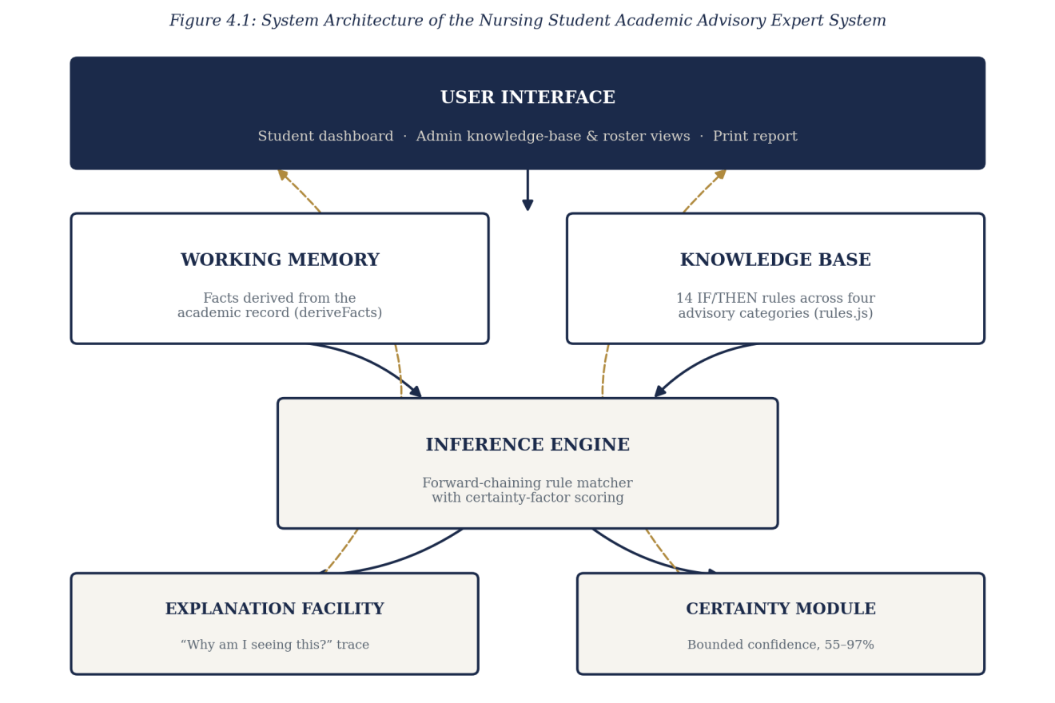
Figure 4.1: System Architecture of the Nursing Student Academic Advisory Expert System
4.1.1 Input Design and Specification
The inputs to the system are collected through interface controls presented to the user. The principal input is the academic record table, through which a student supplies a letter grade (A–F) for each course in the curriculum via a drop-down control, and a level selector through which the student’s current academic level is set. A second input is the administrative sign-in form, which collects a demonstration password. The input fields of the academic record table are summarised in Table 4.1.
Input Field | Control Type | Data Collected
Course grade | Drop-down list | Letter grade (A, B, C, D, E, F) for one curriculum course
Academic level | Drop-down list | Student’s current level (100–500)
Administrative password | Password box | Demonstration credential gating the administrative area
4.1.2 Output Design and Specification
The outputs of the system are the views it renders in response to the derived facts and the fired rules, designed to be consistent with the objectives stated in Chapter One. The principal output is the advisory results panel, in which each fired rule is presented as a card bearing its category, severity, certainty factor and advisory text, together with an explanation toggle that reveals the specific fact behind it. A second output is the vitals strip, presenting CGPA, credit units completed, outstanding core courses and clinical-placement blocks at a glance. A third is the graduation-readiness score, a single percentage with a four-part breakdown, and the accompanying degree-audit view listing outstanding and completed courses. A fourth is the printable advisory report, a formatted, standalone document generated from the same results for the student to save or present. The administrative roster view renders a fifth output, a summary row per student showing CGPA and readiness at a glance, from which the same dashboard views can be opened read-only for any individual student. Representative outputs are shown in Appendix B.
4.1.3 Security Design and Specification
The security of the system rests on its two-area access model. By default, a user of the system operates in the student area and may view and edit only their own record. To reach the administrative area, a user must supply the demonstration password; only after this is satisfied are the knowledge-base and student-roster views reached, and the roster’s individual student dashboards are rendered strictly read-only, with no grade-editing control presented. This restriction is enforced at the level of the interface, which renders the administrative routes only after the password check succeeds and withholds the editable grade controls from the read-only roster view.
The prototype status of this build is reflected honestly in one respect, identified in Section 5.3 as a priority for further work: the administrative password is a single shared demonstration credential checked in client-side code, sufficient to exercise the access distinction but not to secure real staff accounts. A production deployment would require per-staff credentials verified on a server against irreversibly hashed values, together with server-side enforcement of the student/administrator distinction.
4.1.4 Data Design and Specification
The present build does not provision a server-side database. To demonstrate every view at realistic scale, the curriculum and the working student records are held in structured collections within the browser, loaded when the application starts. The logical model is nevertheless designed as a set of well-defined record types, so that migration to a server-hosted store may be effected by substituting the data source without altering the rules or the inference engine defined upon it. The curriculum record, which is the reference structure the inference engine reasons against, is specified in Table 4.2.
Field | Type | Description
code | String | Unique course code, e.g. NUR301
title | String | Course title
level | Number | Academic level at which the course is taken (100–500)
semester | Number | Semester within the level (1 or 2)
units | Number | Credit units carried by the course
category | String (enumerated) | Subject category used by specialization-guidance rules
core | Boolean | Whether the course is a required core course
clinical | Boolean | Whether the course is a clinical-practicum prerequisite
A rule record, held in the knowledge base, is specified in Table 4.3. Each rule pairs a machine-checkable condition with the advisory text, explanation and certainty computation to be produced when it fires.
Field | Type | Description
id | String | Unique rule identifier, e.g. AS-01
category | String (enumerated) | One of the four advisory categories
severity | String (enumerated) | critical, warning, positive or info
test | Function(facts) | Boolean condition evaluated against derived facts
advice | Function(facts) | Advisory text produced when the rule fires
explain | Function(facts) | Explanation naming the fact that satisfied the condition
cf | Function(facts) | Certainty factor computed from how far the fact sits past its threshold
A student record is a small structure holding a name, registration number, current level and a list of [course code, grade] pairs, from which the inference engine derives CGPA, credit-unit progress, category averages, outstanding core courses and clinical-placement blocks at the point the record is examined.
4.2 System Development Tools and Justification
The system was developed as a self-contained client-side web application, using the core technologies of the web platform without a front-end framework or a build step. The reasons for each choice are given below.
HTML5 provides the document structure of the application. Delivering the entire system as a small set of static files requires no installation and deploys directly to a static hosting platform.
CSS3 provides the presentation, using custom properties for a consistent visual identity and media queries for a responsive layout that adapts from desktop to mobile, including a table-to-card transformation of the academic record on small screens.
JavaScript (ES6) is the programming language, used without any external library or framework. Following the ESDLC methodology adopted in Chapter Three, the knowledge base is held as a distinct array of rule records, the inference engine is a small set of pure functions that derive facts and forward-chain them against the rule base, and the interface is built by plain functions that construct and insert each vitals card, advisory card and roster row into the page. Avoiding a framework keeps the system within a small, readable set of files and removes a large dependency (Flanagan, 2020).
Google Fonts supplies the typefaces used throughout, loaded directly by the browser. The application is deployed as a static site on Vercel, built from a GitHub repository, which serves it over an encrypted connection at no cost and requires no server administration. Visual Studio Code and the GitHub web interface were used for development, and Git for version control.
In keeping with the ESDLC methodology adopted in Chapter Three, the stages by which the system was developed, and the process by which it reasons, are documented below through the ESDLC stage diagram and the inference-flow diagram.
Figure 4.2 sets out the six stages of the Expert System Development Life Cycle as applied to this project: problem identification, in which the advisory domain was bounded to the four categories named in Chapter One; knowledge acquisition, in which the curriculum structure and the grading and eligibility rules a student is subject to were gathered; knowledge representation, in which those rules were encoded as the fourteen IF/THEN records of the knowledge base; inference-engine design, in which the forward-chaining matcher and certainty-factor computation were designed; implementation, in which the system was built feature by feature as described in Section 4.4; and testing and validation, in which every rule was run against representative student records before being wired to the interface.
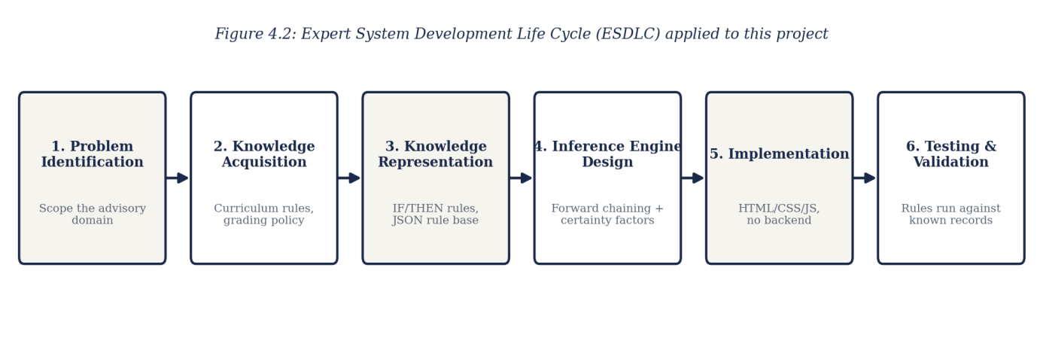
Figure 4.2: Expert System Development Life Cycle (ESDLC) applied to this project
Figure 4.3 documents the central process of the system: the forward-chaining inference cycle by which a student’s raw grade record becomes a set of explained, certainty-scored advisories. The record is first reduced to structured facts by deriveFacts — CGPA, credit-unit progress, category averages and blocked courses among them. Each of the fourteen rules in the knowledge base is then tested against those facts; a rule whose condition is false is skipped, while a rule whose condition is true fires, at which point its certainty factor and explanation are computed and the resulting advisory is added to the set shown to the student, grouped by category.
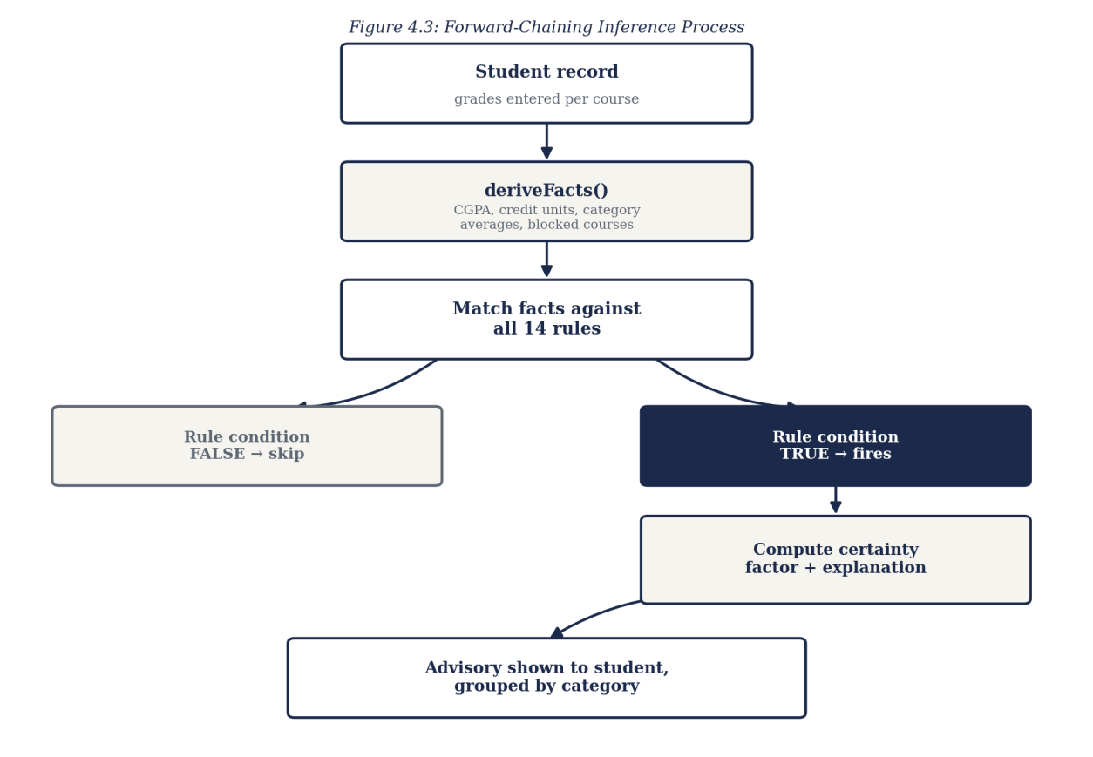
Figure 4.3: Forward-Chaining Inference Process
4.3 System Requirements
The tools required to run the developed system, as distinct from those required to develop it, are stated below. Because the system is a client-side application, its requirements are modest and fall entirely on the browsing device.
4.3.1 Hardware Requirements
• A processor of 1.2 GHz dual-core or higher, as found in entry-level devices.
• A minimum of 2 GB of RAM.
• At least 50 MB of free space for the browser cache.
• A network connection for the initial loading of the application.
4.3.2 Software Requirements
• A modern web browser such as Google Chrome 90 or later, Mozilla Firefox 88 or later, Microsoft Edge 90 or later, or Safari 14 or later.
• An operating system capable of running such a browser — Android, iOS, Windows, macOS or a Linux distribution.
• JavaScript enabled in the browser. No server runtime or installation is required.
4.4 Implementation of the Proposed System
The system is implemented as a static client-side web application, deployed on Vercel from a GitHub repository and accessed through a web browser at the address recorded in Appendix B. On loading, the application renders the landing page, from which a user proceeds to the student area or, after a password check, to the administrative area.
Implementation proceeded in the order set out by the adopted methodology. The knowledge base was written first — the fourteen rules across the four advisory categories, each expressed as an explicit IF/THEN condition — followed by the inference engine, comprising the fact-derivation function and the forward-chaining matcher. Each rule was verified at this stage by running the engine directly against representative student records and inspecting which rules fired and why, before any interface was built on top of it. The student dashboard — the editable record table, the vitals strip and the advisory results panel with its explanation toggles — was implemented next. Certainty-factor scoring was then added to every rule, again verified by inspecting the computed confidence values against known records before being wired to the display. The graduation-readiness score, the degree-audit view and the printable report followed, each derived from the same facts already computed by the inference engine rather than introducing a new source of truth. Finally, the administrative area was implemented — the password gate, the knowledge-base viewer, and the student-roster list from which any individual student’s dashboard can be opened read-only — reusing the same rendering functions built for the student dashboard rather than duplicating them.
Testing was conducted throughout rather than at the end. Each rule’s condition, advisory text and certainty computation were checked against representative student records built to exercise different scenarios — a strong performer, a student with a failed core course, a student blocked from clinical placement, and a final-year student with an outstanding course — confirming in each case that the intended rules, and only the intended rules, fired. The responsive layout was tested across device widths from small mobile displays to desktop monitors, with the academic record table specifically verified to collapse into a stacked-card layout below mobile breakpoints. Representative source code is provided in Appendix A and sample outputs in Appendix B.
CHAPTER FIVE
SUMMARY, CONCLUSION AND RECOMMENDATIONS
5.1 Summary
This project set out to solve a single, clearly identified problem: the absence, at the School of Nursing, Caritas University, of a rule-based, always-available means by which a student could check their own academic standing, specialization fit, clinical-placement eligibility and graduation pathway. Chapter One established the background and stated this problem, together with the aim and objectives of the work. Chapter Two reviewed the literature on expert systems and rule-based reasoning, certainty-factor models, expert-system development methodology, learning analytics, role-based access, client-side implementation and interface usability. Chapter Three analysed the existing periodic, manual review process, set out the proposed system and justified it, and explained the Expert System Development Life Cycle adopted as the project’s methodology. Chapter Four presented the design of the system’s inputs, outputs, security and data, documented that design through architecture, methodology-stage and inference-flow diagrams, and described the implementation. The result is the Nursing Student Academic Advisory Expert System, a working rule-based expert system providing a knowledge base of fourteen advisory rules, a forward-chaining inference engine with certainty-factor scoring, an explanation facility, a graduation-readiness score and degree audit, a printable advisory report, and an administrative view for browsing a roster of students.
5.2 Conclusion
The objectives of the study have been achieved. A knowledge base of fourteen explicit rules was designed and implemented across the four advisory categories of Academic Standing, Specialization Guidance, Clinical Readiness and Graduation Pathway, so that every piece of advice the system gives traces back to a specific, readable rule. A forward-chaining inference engine was implemented, together with a certainty-factor model that expresses confidence within a bounded range rather than ever asserting absolute certainty. An explanation facility was implemented, so that a student or adviser can see the exact fact behind any recommendation. A graduation-readiness score and degree-audit view were implemented from the same underlying facts. An administrative view, gated behind a sign-in, was implemented, letting departmental staff browse a roster and open any individual student’s dashboard on a read-only basis. Because each objective corresponds to, and mitigates, an element of the problem stated in Chapter One, it may be concluded that the research problem has been solved to the extent set within the scope of the work.
Certain constraints qualify this conclusion. The system holds its curriculum and student records in the browser rather than in a server-side store, so a grade entered or edited in a session does not persist across a reload; administrative sign-in is performed on the client against a shared demonstration credential; and the student roster available to the administrative view is a small set of representative records rather than the department’s actual student population. These constraints affect the scale and the security at which the system has been demonstrated rather than the validity of its design, since the knowledge base, the inference engine, the certainty-factor computation and the explanation facility are fully implemented and behave on the demonstration data exactly as they would on live records.
5.3 Recommendations
On the strength of the outcome of this study, it is recommended that the School of Nursing consider adopting a rule-based advisory tool of the kind developed here to complement, rather than replace, the periodic review presently conducted by academic advisers, so as to give students an immediate first check between such reviews. For future researchers who wish to extend this work, the following areas are recommended:
1. Provision of a server and a persistent database, so that a grade entered or edited is stored durably and survives across sessions and devices, and so that the curriculum and student roster reflect the department’s actual records rather than a representative sample. This is the first priority, as the present build reasons correctly but does not retain.
2. Replacement of the shared demonstration password with per-staff credentials verified on a server against irreversibly hashed values, together with server-side enforcement of the student/administrator access distinction.
3. Live integration with the university’s actual student-records system, in place of the representative demonstration curriculum and roster used in this build.
4. Expansion of the knowledge base with additional rules — covering, for example, elective-course guidance or year-on-year performance trends — verified individually against known records in the manner described in Section 4.4 before being added.
5. Addition of notification delivery, so that a student is alerted when a newly entered grade causes a new rule to fire, rather than needing to re-run the analysis manually.
REFERENCES
Arnold, K. E., & Pistilli, M. D. (2012). Course signals at Purdue: Using learning analytics to increase student success. Proceedings of the 2nd International Conference on Learning Analytics and Knowledge, 267–270.
Buchanan, B. G., & Shortliffe, E. H. (1984). Rule-based expert systems: The MYCIN experiments of the Stanford Heuristic Programming Project. Addison-Wesley.
Flanagan, D. (2020). JavaScript: The definitive guide (7th ed.). O’Reilly Media.
Giarratano, J., & Riley, G. (2005). Expert systems: Principles and programming (4th ed.). Course Technology.
Jackson, P. (1998). Introduction to expert systems (3rd ed.). Addison-Wesley.
Negnevitsky, M. (2005). Artificial intelligence: A guide to intelligent systems (2nd ed.). Addison-Wesley.
Nielsen, J. (1994). Usability engineering. Morgan Kaufmann.
Sandhu, R. S., Coyne, E. J., Feinstein, H. L., & Youman, C. E. (1996). Role-based access control models. Computer, 29(2), 38–47.
Shneiderman, B., & Plaisant, C. (2010). Designing the user interface: Strategies for effective human-computer interaction (5th ed.). Addison-Wesley.
Siemens, G., & Long, P. (2011). Penetrating the fog: Analytics in learning and education. EDUCAUSE Review, 46(5), 30–32.
Turban, E., Aronson, J. E., & Liang, T. P. (2005). Decision support systems and intelligent systems (7th ed.). Pearson Prentice Hall.
APPENDIX A
SOURCE CODE SNIPPETS
The listings below are drawn directly from the source of the implemented system. Each is followed by a brief explanation of what it does.
Listing A.1 — A knowledge base rule (Academic Standing)
{
id: 'AS-01',
category: RULE_CATEGORY.STANDING,
severity: 'critical',
description: 'IF CGPA < 2.00 THEN flag academic-probation risk.',
test: f => f.cgpa < 2.00,
advice: () => 'Academic probation risk. Prioritize retaking
failed core courses before your next registration.',
explain: f => `Your CGPA is ${f.cgpa.toFixed(2)}, below the
2.00 good-standing threshold.`,
cf: f => certainty((2.00 - f.cgpa) * 4)
}
Each rule pairs a boolean condition (test) with the text produced when it fires (advice), the reasoning shown in the explanation facility (explain), and the certainty-factor computation (cf). This rule flags academic-probation risk whenever a student’s CGPA falls below 2.00, with its certainty rising the further below the threshold the CGPA sits.
Listing A.2 — The certainty-factor helper
function certainty(margin, sensitivity = 1) {
const raw = 1 / (1 + Math.exp(-sensitivity * margin));
return Math.min(0.97, Math.max(0.55, 0.55 + raw * 0.42));
}
This function converts how far past its threshold a fact sits (margin) into a bounded confidence score. The bound of 0.55–0.97 is deliberate: a fired rule is never reported as barely confident, since it did fire, and never reported as absolutely certain, since no rule-based system should overclaim from a single academic record — the principle discussed in Section 2.3.
Listing A.3 — Deriving facts from a raw grade record
function deriveFacts(student) {
const byCode = Object.fromEntries(
CURRICULUM.map(c => [c.code, c]));
const taken = student.records
.map(([code, grade]) => (
{ ...byCode[code], grade, point: GRADE_POINTS[grade] }))
.filter(r => r.code);

const totalUnits = taken.reduce((s, r) => s + r.units, 0);
const totalPoints = taken.reduce(
(s, r) => s + r.point * r.units, 0);
const cgpa = totalUnits > 0 ? totalPoints / totalUnits : 0;
/* … category averages, blocked clinical courses, outstanding
core courses and the graduation-readiness score are derived
in the same function … */
}
deriveFacts is the working-memory stage of the inference cycle shown in Figure 4.3: it turns a student’s raw [course code, grade] pairs into the structured facts — CGPA among them — that every rule in the knowledge base reasons over.
Listing A.4 — The forward-chaining inference engine
function runInference(facts, rules = RULES) {
return rules
.filter(rule => rule.test(facts))
.map(rule => ({
id: rule.id,
category: rule.category,
severity: rule.severity,
advice: rule.advice(facts),
explanation: rule.explain(facts),
certainty: Math.round(rule.cf(facts) * 100)
}));
}
This is the inference engine proper: every rule in the knowledge base is tested against the derived facts, and each rule whose condition is true contributes its advisory text, its explanation and its certainty percentage to the result shown to the student.
Listing A.5 — Route access to the administrative area
function render(){
const route = location.hash.replace('#','') || 'landing';
if (route === 'student') return renderStudentView();
if (route === 'admin') return renderAdminGate();
if (route === 'admin-hub') return renderAdminHub();
if (route === 'admin-kb') return renderAdminKB();
if (route === 'admin-students') return renderAdminStudentList();
if (route.startsWith('admin-student-'))
return renderAdminStudentDashboard(
Number(route.split('-')[2]));
return renderLanding();
}
The router directs an ordinary visitor to the student area by default and requires the administrative routes to be reached through the password-gated admin route, which is the interface-level enforcement of the two-area access model described in Section 4.1.3.
APPENDIX B
SAMPLE OUTPUTS (SCREENSHOTS)
The screenshots below present sample outputs of the implemented system, captured from the running application.

Figure B.1: The landing page, from which a user proceeds to the Student or Admin area
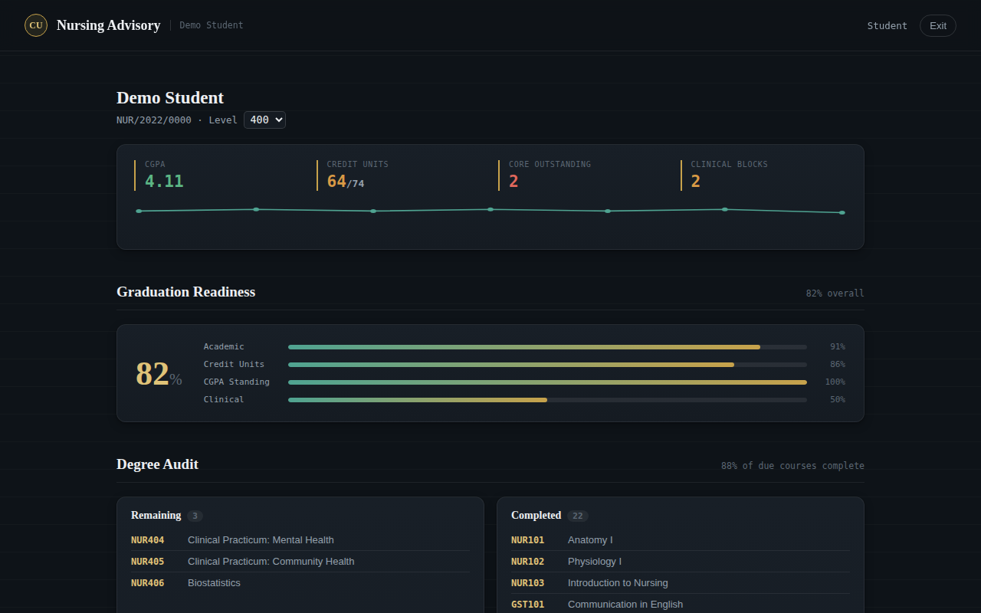
Figure B.2: The student dashboard — CGPA, credit units, outstanding core courses and clinical blocks at a glance
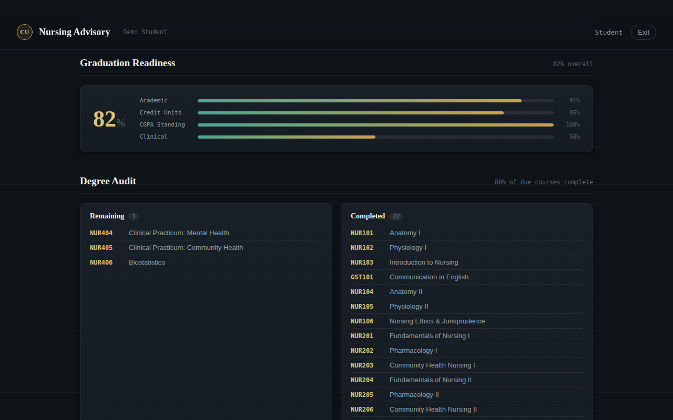
Figure B.3: The Graduation Readiness score and Degree Audit view
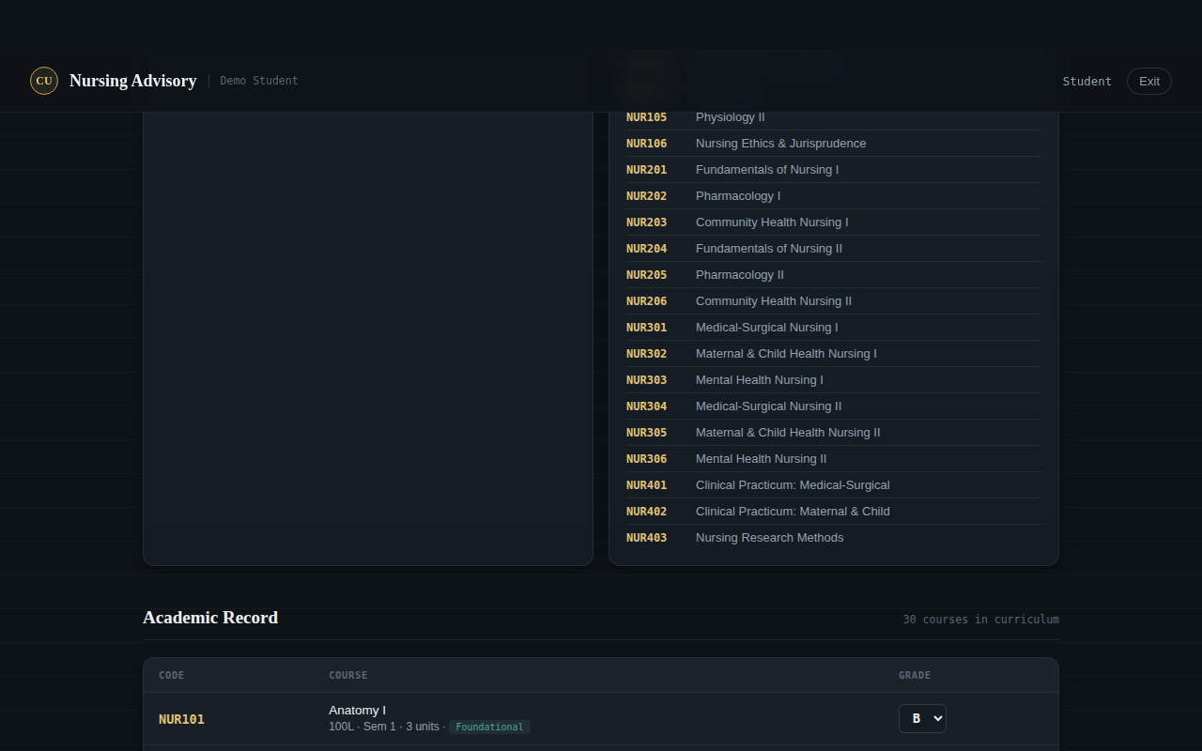
Figure B.4: The editable academic record table
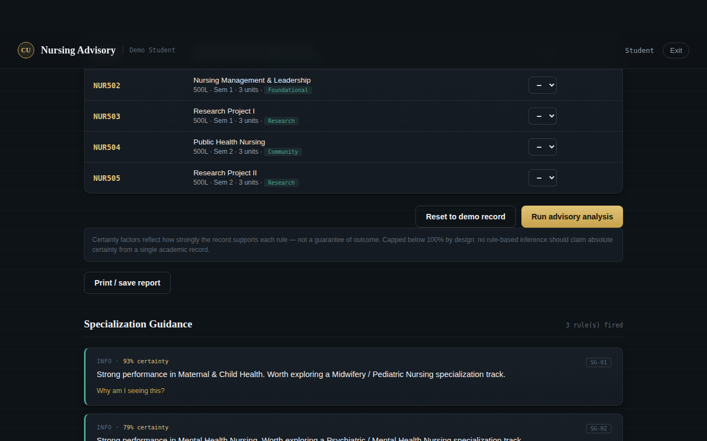
Figure B.5: Advisory results grouped by category, each with its certainty factor
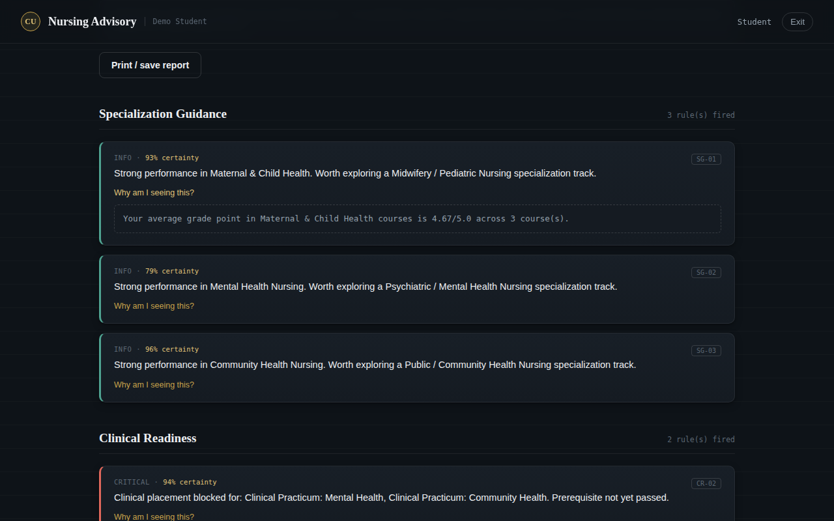
Figure B.6: An expanded explanation trace showing the fact behind a fired rule
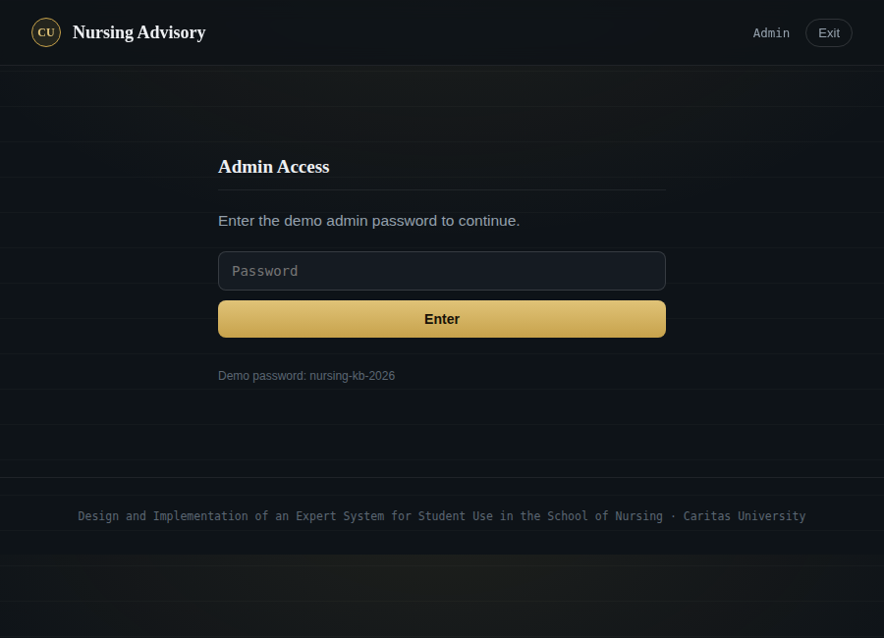
Figure B.7: The administrative sign-in gate
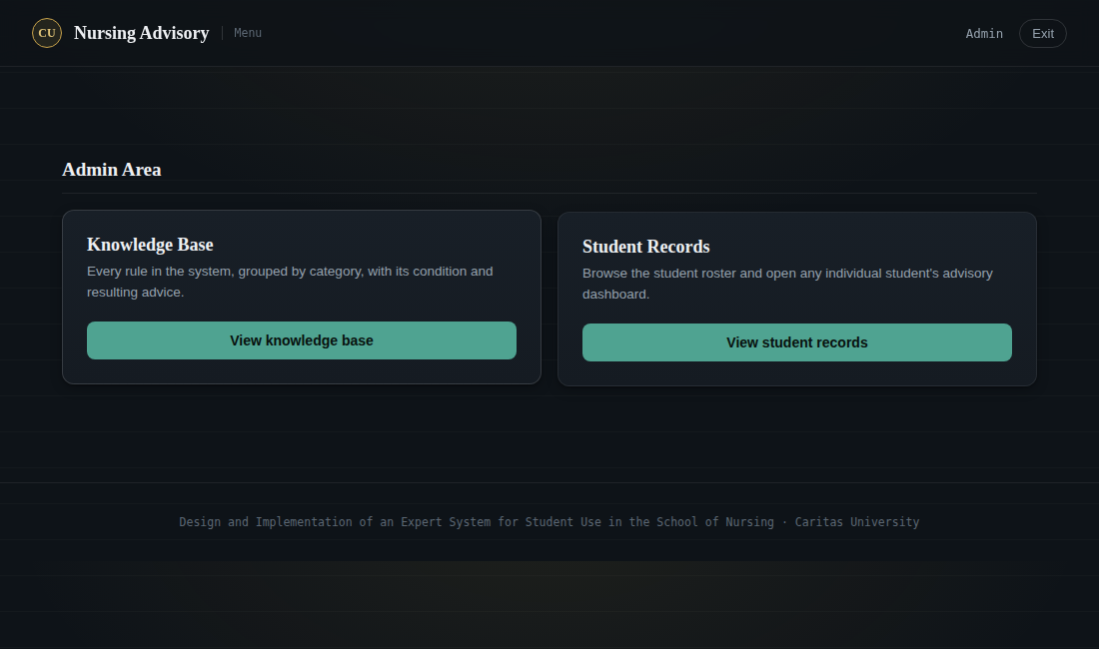
Figure B.8: The administrative menu — Knowledge Base and Student Records
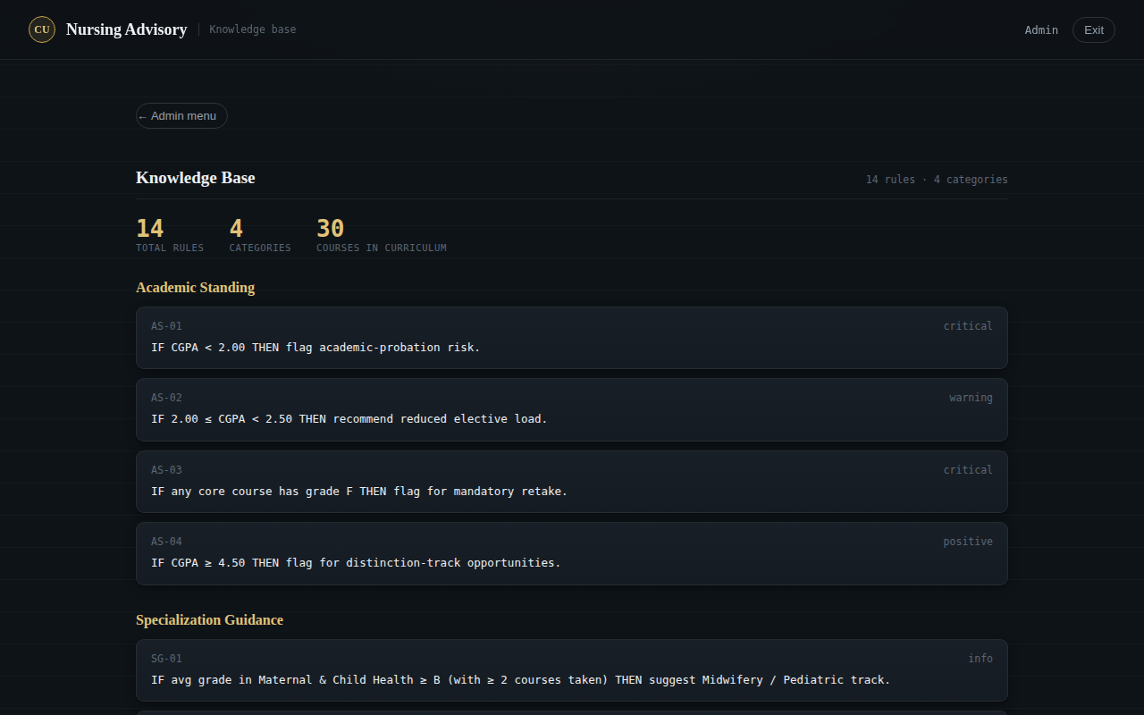
Figure B.9: The Knowledge Base viewer, listing every rule by category
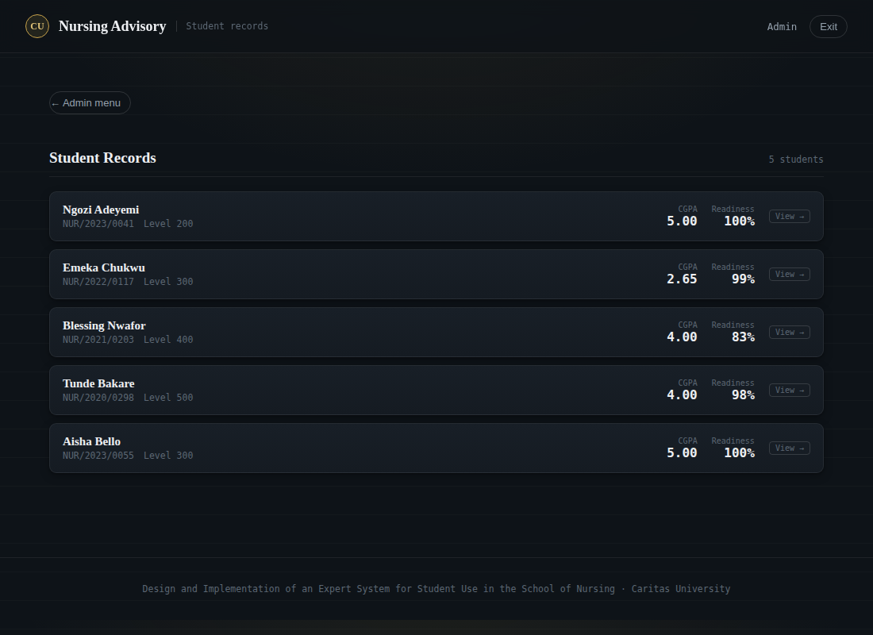
Figure B.10: The student roster, from which any student’s dashboard can be opened
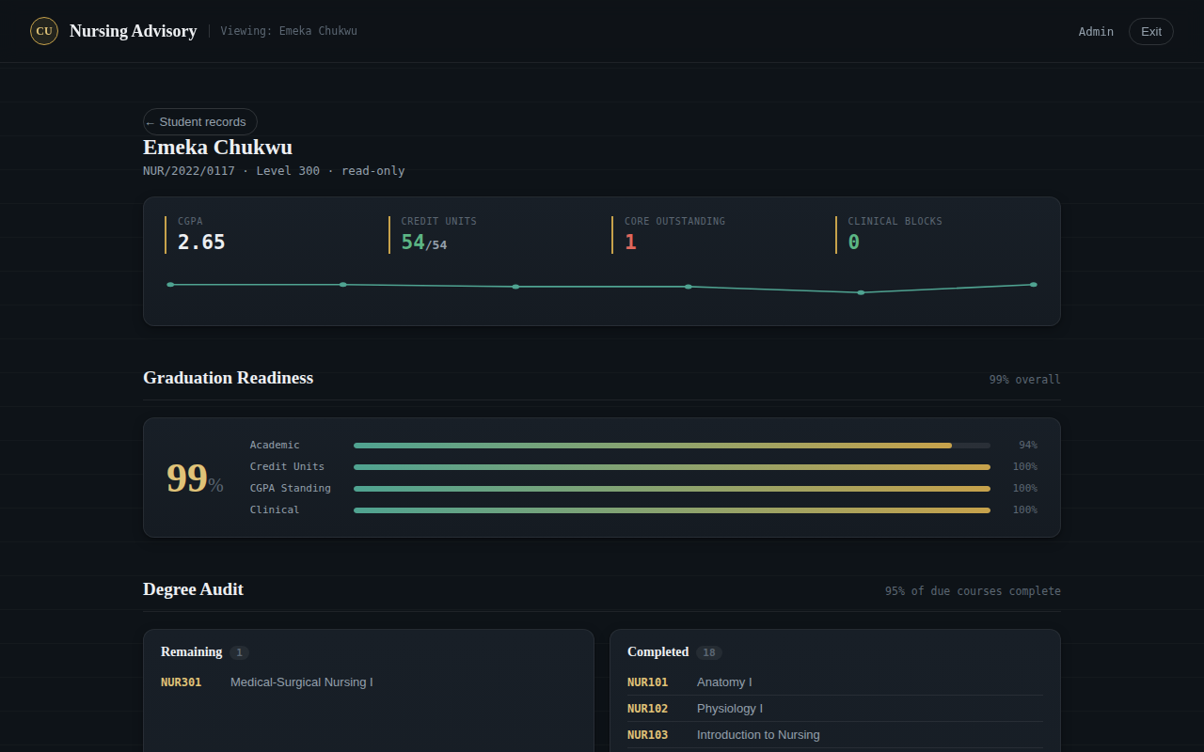
Figure B.11: An individual student’s dashboard opened from the roster (read-only)

Figure B.12: The same student’s advisory results, viewed read-only by an administrator

