ACADEMIC STANDING: STUDENT ATTENDANCE DASHBOARD SYSTEM
WITH ROLE-BASED ACCESS

(A CASE STUDY OF THE DEPARTMENT OF COMPUTER SCIENCE,
CARITAS UNIVERSITY, AMORJI-NIKE, ENUGU)

PROJECT REPORT

BY

UGWU, KENNETH
CS/2022/1218

SUBMITTED TO

THE DEPARTMENT OF COMPUTER SCIENCE
FACULTY OF NATURAL SCIENCES
CARITAS UNIVERSITY, AMORJI-NIKE, ENUGU

IN PARTIAL FULFILMENT OF THE REQUIREMENTS FOR THE AWARD OF
BACHELOR OF SCIENCE (B.SC) DEGREE IN COMPUTER SCIENCE

AUGUST, 2026

DECLARATION
I, Ugwu, Kenneth, with registration number CS/2022/1218, hereby declare that this project titled “Academic Standing: A Web-Based Student Performance Monitoring System with Role-Based Access” is my original research work carried out under the supervision of Prof. Arinze Nwaeze of the Department of Computer Science, Caritas University, Amorji-Nike, Enugu. The work reported herein has not been presented, in whole or in part, to any institution for the award of any other degree or qualification, and all sources consulted have been duly acknowledged.

________________________________ ____________________
Ugwu, Kenneth Date
(CS/2022/1218)

APPROVAL
This is to certify that we have read, examined and found this project titled “Academic Standing: A Web-Based Student Performance Monitoring System with Role-Based Access”, carried out by Ugwu, Kenneth with registration number CS/2022/1218, to be satisfactory and acceptable for the award of a Bachelor of Science (B.Sc) degree in Computer Science of Caritas University, Amorji-Nike, Enugu, and hence we have caused our names and signatures to appear as follows:

________________________________ ____________________
Prof. Arinze Nwaeze Date
(Project Supervisor)
________________________________ ____________________
Ugwu, Ejike Date
(Head of Department)
________________________________ ____________________
Prof. Fergus Onu Date
(External Examiner)

DEDICATION
This project is dedicated to Almighty God, the source of all wisdom and understanding, whose grace sustained me throughout this programme; and to my parents, whose sacrifice, encouragement and unfailing support made this academic journey possible.

ACKNOWLEDGEMENTS
I extend my sincere gratitude to God Almighty for the strength, wisdom and good health that sustained me throughout the duration of this project.
My profound appreciation goes to my Project Supervisor, Prof. Arinze Nwaeze, whose guidance, patience and constructive criticism shaped this work from conception to completion.
I am equally grateful to the Head of the Department of Computer Science, Ugwu, Ejike, for his leadership and support throughout the programme. My sincere thanks go likewise to Dr. Henry Nweke and Dr. Ugochukwu Nwankwo, and to all the other lecturers of the Department of Computer Science, Caritas University, Amorji-Nike, Enugu, for the knowledge they imparted over the course of my study.
Finally, I acknowledge my family, friends and course mates for their moral and financial support, for testing the system and offering feedback on its usability, and for their steadfast encouragement during the development of this work.

ABSTRACT
This project presents Academic Standing, a web-based system for monitoring student performance and academic standing in the Department of Computer Science, Caritas University, Amorji-Nike, Enugu. The study first looked at how student standing was determined before now. That method was manual and only became available after results were released. Findings from this were then used to design a role-based alternative that serves the head of department, the lecturers and the students. The system computes semester and cumulative grade point averages, together with the degree classification, on the five-point scale. It also ranks students who are at risk using a rule-based scoring engine, measures how attendance relates to performance, and works out the grades a student would need to reach a target classification. The Object-Oriented Analysis and Design Methodology was used for the design, and the system was implemented in HTML, CSS and JavaScript.

TABLE OF CONTENTS
Title Page i
Declaration ii
Approval iii
Dedication iv
Acknowledgements v
Abstract vi
Table of Contents vii
CHAPTER ONE: INTRODUCTION 1
1.1 Background of the Study 1
1.2 Statement of the Problem 2
1.3 Aim and Objectives of the Study 2
1.4 Significance of the Study 3
1.5 Scope of the Study 3
1.6 Limitations of the Study 4
1.7 Definition of Terms 5
CHAPTER TWO: LITERATURE REVIEW 6
2.1 Introduction 6
2.2 Conceptual Framework 6
2.2.1 Learning Analytics and Educational Data Mining 6
2.2.2 Academic Standing and Degree Classification 6
2.2.3 Academic Early-Warning Systems 7
2.3 Theoretical Framework 7
2.3.1 Tinto’s Model of Student Attrition 7
2.3.2 The Technology Acceptance Model and UTAUT 7
2.4 Factors Influencing Academic Performance 7
2.5 Predicting and Identifying At-Risk Students 8
2.6 Attendance and Academic Achievement 8
2.7 Learning Analytics Dashboards and Presentation 8
2.8 Ethics and Privacy in Learning Analytics 9
2.9 Review of Related Works 9
2.10 Summary and Research Gap 10
CHAPTER THREE: SYSTEM ANALYSIS AND METHODOLOGY 11
3.1 Data Gathering 11
3.2 Research Methodology and Justification 11
3.3 System Analysis 12
3.3.1 Analysis of the Existing System 12
3.3.2 Analysis of the Proposed System 13
3.4 Justification of the Proposed System 14
CHAPTER FOUR: SYSTEM DESIGN AND IMPLEMENTATION 16
4.1 Design and Specification of the Proposed System 16
4.1.1 Input Design and Specification 16
4.1.2 Output Design and Specification 17
4.1.3 Security Design and Specification 17
4.1.4 Database Design and Specification 18
4.2 System Development Tools and Justification 20
4.3 System Requirements 24
4.3.1 Hardware Requirements 24
4.3.2 Software Requirements 25
4.4 Implementation of the Proposed System 25
CHAPTER FIVE: SUMMARY, CONCLUSION AND RECOMMENDATIONS 27
5.1 Summary 27
5.2 Conclusion 28
5.3 Recommendations 28
REFERENCES 30
APPENDIX A: SOURCE CODE SNIPPETS 33
APPENDIX B: SAMPLE OUTPUTS (SCREENSHOTS) 35

CHAPTER ONE

INTRODUCTION

1.1 Background of the Study
The academic standing of a student is arguably the most important record a university keeps about that student. It is expressed as a cumulative grade point average (CGPA) on the five-point scale that Nigerian universities use. This single value decides whether a student can move to the next level, whether they fall into probation or withdrawal, and in the end the class of degree they graduate with. Standing matters to the institution as well, not only to the individual student. When the standing of a whole department is looked at together, it shows how many students are on track to graduate in good standing and how many are slipping towards failure. It also shows the points in the curriculum where students struggle the most.
Yet for all this importance, academic standing has always been something a student only sees after the fact. In the usual arrangement, a student learns their position only when results come out at the end of the semester. By then that semester is already gone, and nothing can be done to change the result it produced. The computation itself is done by hand or in spreadsheets by departmental staff. What reaches the student is one figure and nothing more, not a picture they can actually interpret. And nobody gets any early sign that a particular student is falling behind while there is still time to help.
Improvements in web technology now make it possible to close this gap, and to do so cheaply. None of the calculations involved are difficult. A grade point average is just a weighted average of scores and credit units. A degree classification is a lookup against fixed bands. The link between attendance and performance is an ordinary correlation, and working out the average a student needs to reach a target class is simple algebra. All of this can run inside the browser and be shown the moment a score is entered, straight to the person who needs it: the lecturer entering the score, the student it affects, and the head of department in charge of the class.
This study therefore proposes a system called Academic Standing, built for the Department of Computer Science, Caritas University, Amorji-Nike. It gives each type of user a workspace suited to their role. The head of department sees an overview of the whole department, with the mean standing, a register of at-risk students, and how attendance relates to performance. The lecturer sees only the courses they teach. Here a score sheet works out totals, grades and grade points as the scores are typed in, and shows how the class is spread. The student sees their own standing and degree classification, their trend over the semesters, the subject areas they are strong in, and a projection of what is left to reach the class of degree they are aiming for. In short, the system replaces the old arrangement (one figure, released late, seen too far after the fact) with one that runs continuously, can be interpreted, and shows each user only what their role allows.

1.2 Statement of the Problem
At the Department of Computer Science, Caritas University, Amorji-Nike, a student's academic standing is worked out by hand or in spreadsheets, and it only becomes known after the end-of-semester results are released. The figure therefore arrives after the semester that produced it has already ended. This means neither the student nor the department can act on it in time to change the outcome it reports.
This arrangement creates a number of related problems. A student receives their CGPA as a plain number. It carries no indication of the class of degree it falls under, the direction it is heading, or the effort needed to improve it. The department, for its part, has no way of knowing ahead of results which students are drifting towards failure, so support comes late or does not come at all. No regular analysis links attendance to performance, even though the two are known to be connected. And there is no per-course view to show which courses are failing the most students. The result is that decisions about intervention, support and the curriculum are made without the evidence needed to guide them. There is a clear need for a system that computes standing as the semester goes on and presents it, in a form each party can read and act on. This study builds that system.

1.3 Aim and Objectives of the Study
The aim of this study is to develop a web-based student performance and academic standing monitoring system. The system should give the department, its lecturers and its students a clear view of academic standing early, before results are formally released, with each user seeing what suits their role. The specific objectives are to:
1. Design the architecture and role model of a web-based academic standing system serving three actors: the head of department, the lecturer and the student.
2. Develop a role-based access mechanism that scopes every actor to the data appropriate to their role — department-wide for the head of department, own-courses for the lecturer, and self for the student.
3. Implement the automatic computation of semester grade point average, cumulative grade point average and degree classification on the Nigerian five-point scale.
4. Implement a lecturer score sheet that computes each student’s total, letter grade and grade point as continuous-assessment and examination scores are entered.
5. Implement a rule-based at-risk scoring engine that ranks students by a transparent composite of CGPA shortfall, semester GPA decline, attendance shortfall and outstanding carryovers.
6. Implement a degree-class projection facility that computes the grade point average a student must achieve across their remaining units to reach a chosen classification.
7. Implement department-level analytics, including the correlation of attendance with CGPA and a course difficulty index reporting mean score, spread and failure rate per course.
8. Evaluate the functionality, usability and responsiveness of the developed system using representative departmental users.

1.4 Significance of the Study
The completion of this study carries practical benefit for several groups within the university community.
For students, the system turns a single backward-looking figure into something they can read and use going forward. It shows the current CGPA, but also the class of degree that CGPA falls under, the way it built up semester by semester, and the subject areas where the student is strong or weak. Most useful of all, it shows the grade point average the student still needs across their remaining courses to reach a target class. A student can therefore act on their standing while there is still time to change it.
For lecturers, the system takes the arithmetic out of grading. Totals, letter grades and grade points appear as the scores are entered, and the spread of the class is shown next to them. A lecturer can see at once how the cohort has done and how many students have failed.
For the head of department, the system provides, for the first time, a view of the whole department that updates continuously. This includes the mean standing of the cohort, the share of students in good standing, a ranked register of the students most at risk, the correlation between attendance and performance, and an index of the courses that fail the most students. Decisions on intervention, support and curriculum that used to be taken blind can now be guided by real figures.
For the wider academic community, the study shows how an academic early-warning and analytics system can be built to fit the data and infrastructure of a Nigerian university department. It also provides a working reference implementation that other researchers can extend.

1.5 Scope of the Study
This study covers the design, implementation and evaluation of a web-based academic standing monitoring system for the Department of Computer Science, Caritas University, Amorji-Nike. The system gives three workspaces, one for each role. The head-of-department workspace shows a department overview, a filterable at-risk register, a course difficulty index and a searchable student record. The lecturer workspace shows the courses the lecturer teaches, a score sheet that computes totals, grades and grade points live, and a grade distribution. The student workspace shows personal standing, degree classification, a trend of semester GPA against CGPA, strengths by subject area, a degree-class projection and an attendance view. Every value is recomputed for whichever academic session is selected, so the session control acts as a real filter and not merely a label.
The study is bounded in a few ways. It deals with computing, monitoring and presenting academic standing. It does not extend to running examinations or issuing results, which remain the job of the university's examination system. It works on a self-contained departmental dataset generated inside the application, so that every view can be shown at a realistic scale; connecting to the university's live result database is left as further work rather than done here. And it does not cover the recruitment, timetabling or payroll functions of a full departmental information system, since those are administrative matters rather than matters of academic standing.

1.6 Limitations of the Study
Several factors constrained the execution of this work and should be borne in mind when interpreting its results.
First, the system is a working prototype that runs on a generated departmental dataset rather than on live institutional records. The one hundred and forty-eight student records, along with their results across every semester, their attendance and their carryovers, are produced inside the application by a deterministic generator. This keeps the figures realistic and stable across reloads, but they are not the figures of real students. The computation of GPA, CGPA, classification, risk score, correlation and projection is still fully implemented, and it runs on this dataset exactly as it would on real records. Connecting the university result database would therefore mean swapping the data source, not redesigning the system.
Second, the prototype does not yet save changes. When a lecturer edits a score on the score sheet, the total, grade and grade point are recomputed at once, but the change is not written to any store and does not survive a reload, because this build has no server-side database. Adding a persistence layer is listed in section 5.3 as a priority for further work.
Third, sign-in in the current build is handled inside the browser against a small set of demonstration accounts. It is meant to exercise the role-based access design, not to secure real accounts. Verifying credentials on a server against irreversibly hashed values is also left as further work.
Fourth, the study was done within a single academic session, alongside coursework and examinations. This limited how long the evaluation could run and how many respondents could be involved.

1.7 Definition of Terms
Academic Standing: the overall academic position of a student at a given point in their programme, expressed principally through the cumulative grade point average and the degree classification it falls within.
Grade Point Average (GPA): the credit-weighted average of the grade points earned by a student in the courses of a single semester.
Cumulative Grade Point Average (CGPA): the credit-weighted average of the grade points earned across all semesters completed to date.
Grade Point: the numeric value assigned to a letter grade on the five-point scale, ranging from five for an A to zero for an F.
Degree Classification: the class of degree corresponding to a band of CGPA, namely First Class, Second Class Upper, Second Class Lower, Third Class, Pass or Below Pass.
Carryover: a course previously failed that a student must repeat, which continues to affect the cumulative average until passed.
At-Risk Student: a student whose composite risk score, derived from academic standing, recent trend, attendance and carryovers, indicates a material likelihood of academic difficulty.
Risk Score: a rule-based composite measure, expressed from zero to one hundred, that ranks students by their exposure to academic difficulty.
Role-Based Access: a design in which the data and functions available to a user are determined by their assigned role, so that each user sees only what their role permits.
Course Difficulty Index: a per-course summary of mean score, spread and failure rate, used to identify the courses in which students most often fail.
Correlation: a statistical measure, here the Pearson coefficient, of the strength and direction of the relationship between two quantities, such as attendance and CGPA.
Responsive Web Application: a web application whose interface adapts automatically to the screen dimensions of the device on which it is viewed.
CHAPTER TWO

LITERATURE REVIEW

2.1 Introduction
This chapter reviews the literature relevant to the design of a web-based student performance and academic standing monitoring system. It establishes the conceptual field of learning analytics and educational data mining, the meaning of academic standing and the theory of student attrition and technology adoption, before surveying the empirical work on the factors that influence performance, the prediction and early identification of at-risk students, the role of attendance, the presentation of analytics through dashboards, and the ethics of using student data. It then reviews a body of closely related works, each with its contribution and its limitation, and concludes by stating the gap that the present study addresses.

2.2 Conceptual Framework

2.2.1 Learning Analytics and Educational Data Mining
The use of student data to understand and improve learning is organised under two closely related headings. Siemens and Long (2011) define learning analytics as the measurement, collection, analysis and reporting of data about learners for the purpose of understanding and optimising learning, while educational data mining, surveyed by Romero and Ventura (2010, 2020) and by Baker and Yacef (2009), applies data-mining methods to discover patterns in that data. Baker and Inventado (2014) and Siemens and Baker (2012) characterise the two fields as complementary, the former emphasising reporting to human decision-makers and the latter automated discovery, while Peña-Ayala (2014) provides a broad survey of the methods used across both. The present system sits on the learning-analytics side of this distinction, since its purpose is to report standing and risk to the department, its lecturers and its students in a form on which they can act.

2.2.2 Academic Standing and Degree Classification
Academic standing, expressed as the cumulative grade point average and the class of degree it falls within, is the principal summary a university produces about a student, and its determinants have long been studied. Kuh, Kinzie, Buckley, Bridges and Hayek (2006) synthesise the institutional and behavioural conditions associated with student success, and Adekitan and Salau (2019), in a Nigerian setting close to that of the present study, show that standing in the early years strongly conditions the final class of degree. These works establish standing not as a terminal verdict but as a trajectory that is observable, and therefore actionable, before it is finalised.

2.2.3 Academic Early-Warning Systems
An academic early-warning system identifies students at risk of failure in time for intervention. Arnold and Pistilli (2012) describe Course Signals at Purdue University, which surfaced a risk indicator to students and instructors and reported improved grades and retention; Jayaprakash, Moody, Lauría, Regan and Baron (2014) report a comparable open early-alert initiative, and Hu, Lo and Shih (2014) develop warning models for online performance. Together these establish the central proposition of the present study — that surfacing risk early and interpretably changes outcomes — while the present system deliberately adopts a transparent, rule-based indicator in place of the opaque predictors these systems often use.

2.3 Theoretical Framework

2.3.1 Tinto’s Model of Student Attrition
Tinto (1975) advanced the most influential account of why students leave higher education before completing, arguing that departure is the outcome of a longitudinal process in which academic and social integration determine commitment to completion, a position he later extended to the role of the classroom (Tinto, 1997). The model establishes that academic difficulty develops over an observable trajectory rather than appearing suddenly, which is precisely what a semester-by-semester standing trend makes visible, and motivates the system’s emphasis on presenting standing continuously rather than only at graduation.

2.3.2 The Technology Acceptance Model and UTAUT
Whether the system is used depends on its acceptance. The Technology Acceptance Model of Davis (1989) holds that adoption is governed chiefly by perceived usefulness and perceived ease of use, and the Unified Theory of Acceptance and Use of Technology of Venkatesh, Morris, Davis and Davis (2003) extends this with performance expectancy, effort expectancy, social influence and facilitating conditions. These accounts informed several design decisions — the live computation of grades, the interpretation of every average into a degree class, and the projection facility — each intended to raise the perceived usefulness and ease of use on which adoption by heads of department, lecturers and students depends.

2.4 Factors Influencing Academic Performance
A large body of work has tried to isolate the factors that shape academic achievement. Superby, Vandamme and Meskens (2006) combined academic, behavioural and background variables to sort first-year students by their likely outcome, and found that a small number of readable factors carried most of the signal. Huang and Fang (2013) reported that prior academic performance was the strongest single predictor in an engineering course, while Kuh et al. (2006) stressed the role of engagement. Zimmerman (2002) pointed to another factor, self-regulation, meaning the way a learner monitors their own progress. That is exactly the capability a standing dashboard is meant to support. The present system takes the factors that the evidence supports most consistently, namely prior standing, recent trend, attendance and outstanding carryovers, and uses them as the inputs to its risk measure.

2.5 Predicting and Identifying At-Risk Students
Predicting student performance from earlier and current data is one of the busiest areas in educational data mining. Several comparative studies have tested classifiers such as decision trees, naïve Bayes and neural networks for this purpose, among them Kotsiantis, Pierrakeas and Pintelas (2003), Nghe, Janecek and Haddawy (2007), Yadav, Bharadwaj and Pal (2012), Kabakchieva (2013) and Bydžovská (2016). Romero, Ventura, Espejo and Hervás (2008) and Márquez-Vera, Cano, Romero and Ventura (2013) took a different route, using rule-based and genetic-programming approaches that produce models a human can read. In their review, Shahiri, Husain and Rashid (2015) report that CGPA and internal assessment are the attributes that predict most consistently. Other studies show that failure can be predicted early across very different settings; these include Dekker, Pechenizkiy and Vleeshouwers (2009), Costa, Fonseca, Santana, de Araújo and Rego (2017), Asif, Merceron, Ali and Haider (2017) and Oyelade, Oladipupo and Obagbuwa (2010). More recent work has drawn on online and virtual-learning data and on deep-learning methods, including Yukselturk, Ozekes and Türel (2014), Hussain, Zhu, Zhang and Abidi (2018), Waheed, Hassan, Aljohani and colleagues (2020) and Bravo-Agapito, Romero and Pamplona (2021). All of this supports the attributes the present system combines. Where the system parts ways with this literature is in method: it uses a transparent rule-based composite instead of a trained classifier. That choice suits a setting where the score has to be explained to the student, and where there is as yet no validated training corpus to learn from.

2.6 Attendance and Academic Achievement
The link between class attendance and achievement is one of the most firmly settled findings in the education literature. In a meta-analysis covering many studies, Credé, Roch and Kieszczynka (2010) found that attendance predicted grades and grade point average better than most other known predictors. This gives a solid basis for the way the present system treats attendance as a first-class indicator. Attendance feeds into the risk score, and it is also the subject of a correlation shown to the department and to each student. The system reports the coefficient but does not claim that attendance causes the result.

2.7 Learning Analytics Dashboards and Presentation
An analytic figure is only worth anything when it reaches the people who can act on it. Sclater, Peasgood and Mullan (2016) reviewed how institutions use learning analytics and stressed the need for indicators that are actionable and well presented. Chalaris, Gritzalis, Maragoudakis, Sgouropoulou and Tsolakidis (2014) applied data mining to improve educational processes and reported the results back to decision-makers. Marbouti, Diefes-Dux and Madhavan (2016) showed that a model is only useful when its output gets to the instructor early enough to act on. These lessons shaped several choices in the present system: every average is placed on a labelled classification scale, each one is paired with a trend and a projection, and the audience for each figure is fixed by role.

2.8 Ethics and Privacy in Learning Analytics
Because the system handles student data and produces risk labels, its design has to reckon with the ethics of learning analytics. Pardo and Siemens (2014) set out principles for using such data responsibly: transparency, student agency, privacy and accountability. The present system reflects these in three ways. Its risk score is transparent and can be explained. Each user is confined to the data their role allows. And risk is shown as a prompt for support, not as a fixed verdict on the student.

2.9 Review of Related Works
Arnold and Pistilli (2012) showed, on a large scale, that an early-warning indicator shown to students and staff improved grades and retention. For the present purpose, though, it had a drawback: the indicator behind it was proprietary and not open to the students it classified. The present study answers this with a risk score that is rule-based and fully explainable.
Kotsiantis, Pierrakeas and Pintelas (2003) established that academic difficulty can be predicted early using machine-learning classifiers. Their method, however, leaned on a trained model whose behaviour is hard to explain and whose accuracy depends on having a labelled corpus. The present study keeps the early-identification idea but delivers it through an explainable rule instead.
Superby, Vandamme and Meskens (2006) found that a handful of readable factors classify students well. Their analysis was backward-looking, though, and was never built into a tool that students could use during the year. The present study puts similar factors inside a live interface that is scoped to each role.
Asif, Merceron, Ali and Haider (2017) showed that early-year performance is a strong sign of final standing, which supports intervening early. What they reported was an analysis rather than a monitoring tool. The present study supplies the trend and projection that turn early standing into something a student can act on.
Marbouti, Diefes-Dux and Madhavan (2016) confirmed that predictive models only help when their output reaches instructors early. The present study honours this by recomputing and showing standing and risk continuously, rather than waiting until the end of term.
Adekitan and Salau (2019) showed the predictive value of early standing in a Nigerian five-point-scale setting very close to this one. Their focus, however, was on predictive modelling rather than on delivering an interface. The present study shares that context and adds the role-scoped interface through which standing is actually monitored.

2.10 Summary and Research Gap
Taken together, the literature makes several things clear. Surfacing academic risk early, and in a form people can read, improves outcomes. A small number of transparent attributes (standing, trend, attendance and carryovers) carries most of the signal that is needed. Attendance on its own is a strong predictor. And an analytic is only useful when it reaches the person who can act on it in a form they can understand, and when its use respects the student's privacy and agency.
Two gaps still stand out. First, the empirical literature is dominated by predictive modelling that yields classifiers whose output cannot be explained to the very students they concern, and by backward-looking analyses that were never built into a tool usable during the period they describe. Fairly little of it deals with delivering standing and risk through a transparent interface, scoped to the role of a head of department, a lecturer or a student. Second, not much of this work is set in, or adapted to, the data and infrastructure of a Nigerian university department. This study addresses both gaps by designing, implementing and evaluating a transparent, rule-based academic standing monitoring system, scoped by role, and built for a Nigerian departmental setting.
CHAPTER THREE

SYSTEM ANALYSIS AND METHODOLOGY

3.1 Data Gathering
The data this study needed fell into two groups. The first was information on how academic standing is currently worked out and passed on within the department. The second was the structural information needed to model results, grading and classification correctly. Three instruments were used to gather it.
Interviews were held with the departmental staff who compile results and with students. Staff were asked how CGPA is currently computed, at what point in the semester results become available, and what analysis, if any, is done on how standing is spread across a cohort. Students were asked how they get to know their standing, how they read the figure they are given, and whether they can tell from it what a target class of degree would demand of them. These interviews brought out the backward-looking, single-figure nature of the present arrangement, which is described in section 3.3.1.
A study of the university's grading regulations supplied the rules the system had to encode exactly. These are the mapping of scores to letter grades and grade points on the five-point scale, the credit-weighting of grade points into a grade point average, and the CGPA bands that define each class of degree. These rules are not design choices but institutional facts, and they are reproduced faithfully in the grading and classification logic of the system.
Documentary and internet sources supplied the theoretical and technical background for the work. These were published journal articles and conference papers on learning analytics, academic early-warning systems, performance prediction, and the relationship between attendance and achievement. They are reviewed in Chapter Two and listed in the References.

3.2 Research Methodology and Justification
This study adopts the Object-Oriented Analysis and Design Methodology (OOADM) for the analysis and design of the Academic Standing system. OOADM treats a system as a set of interacting objects, where each object holds both its own state and the behaviour that acts on that state. It moves from identifying the actors and their goals, through modelling the objects and how they interact, and on to implementation.
The methodology runs through a few clear phases. In object-oriented analysis, the actors are identified, that is the head of department, the lecturer and the student, together with the use cases each one pursues. The domain is then modelled as a set of classes such as Student, Semester, Course Result and Risk Profile. In object-oriented design, the responsibility of each class is fixed, the interactions between them are written out as sequences, and the rules that decide which actor may reach which objects are specified. In implementation, the design is turned into code, with each class matching a self-contained unit of the program.
A few reasons justify choosing OOADM for this work. The domain falls naturally into objects. A student has semesters, a semester has course results, a course result gives a grade and a grade point, and a risk profile is computed from all of it. Modelling these as classes with clear responsibilities keeps the computation of standing, risk and projection tidy and easy to test on its own. The way OOADM deals openly with actors and use cases also fitted a system whose whole point is that three different actors see three different, scoped views of the same underlying objects. The access rules then come out naturally as limits on which objects each actor may reach. The object model also makes the migration that is listed as further work easier, since swapping in a live data source for the generated one changes how the objects are built but not the behaviour defined on them.
In line with the departmental guidelines for object-oriented projects, the use case diagram, the sequence diagram and the class diagram for the system are presented in Chapter Four, section 4.2, together with the tools used to build the design.

3.3 System Analysis
System analysis examines how academic standing is presently determined within the department, identifies the deficiencies of that arrangement, and specifies a system capable of remedying them.

3.3.1 Analysis of the Existing System
Academic standing at the Department of Computer Science, Caritas University, Amorji-Nike, is currently worked out through a manual, release-bound process. During a semester, lecturers record continuous-assessment and examination scores for their courses on paper or in their own spreadsheets. At the end of the semester the scores are combined, grades and grade points are computed, and each student's grade point average and cumulative average are produced. Only then, after the semester is already over, does a student learn their standing, and even then only as a single number.
This arrangement has several weaknesses. Since standing is only known after the fact, neither the student nor the department can act within the semester that produced it. Since it comes as a bare figure, a student cannot easily see the class of degree it maps to, the direction it is heading, or the effort needed to lift it. And since no analysis is done across the cohort, the department cannot spot, ahead of results, which students are drifting towards failure. It also cannot see the relationship between attendance and performance, and cannot tell which courses fail the most students. The weaknesses of the existing arrangement are summarised below.
1. Academic standing becomes known only after results are released, too late for corrective action within the semester it reports.
2. Standing is presented to the student as a single figure, without its degree classification, its trend, or the target required to improve it.
3. No early-warning mechanism exists, so students drifting toward failure are identified late or not at all.
4. No routine analysis links attendance to performance, although the two are known to be related.
5. No per-course view reveals which courses fail the greatest number of students.
6. The grading arithmetic is performed manually or in isolated spreadsheets, which is laborious and error-prone.
7. Decisions on intervention, support and curriculum are consequently taken without the evidence needed to direct them.

3.3.2 Analysis of the Proposed System
The proposed system, Academic Standing, is a web-based system for monitoring student performance and academic standing. It replaces the old backward-looking, single-figure arrangement with three things: continuous computation, presentation that can be interpreted, and access that is scoped to each role.
A user reaches the system through any modern web browser and signs in. The role attached to the account, whether head of department, lecturer or student, then decides which workspace they enter and what data they can reach inside it. Every read of student data goes through a single access-control point, so no role can widen its own scope from the interface. A student reaches only their own record. A lecturer reaches only the students taking the courses they teach. The head of department reaches the whole department.
In the head-of-department workspace, the system shows the department's enrolment, its mean CGPA and mean attendance, the share of students in good standing, a ranked at-risk register, the correlation of attendance with CGPA shown as a scatter with a fitted line, the spread of the cohort across degree classes, and a course difficulty index that ranks courses by failure rate. In the lecturer workspace, the system shows the courses the lecturer teaches. For each one there is a score sheet where entering a continuous-assessment score and an examination score immediately gives the total, the letter grade and the grade point, alongside the mean, spread and failure rate of the class and a distribution of its scores. In the student workspace, the system shows the student's CGPA and its degree classification on a labelled scale, the last semester's GPA and how it changed, the units earned and those remaining, any carryovers, the trend of GPA against cumulative CGPA over the semesters, the student's strengths by subject area, an attendance view against the cohort, and a projection facility that computes the average needed across remaining units to reach a chosen class. Every figure throughout is recomputed for the academic session that is selected.
The principal features of the proposed system are as follows.
• Role-based sign-in that scopes each actor — head of department, lecturer or student — to the data appropriate to their role through a single access-control point.
• Automatic computation of semester GPA, cumulative CGPA and degree classification on the Nigerian five-point scale.
• A lecturer score sheet computing total, letter grade and grade point as continuous-assessment and examination scores are entered.
• A grade distribution and class summary — mean, spread and failure rate — for each course a lecturer teaches.
• A rule-based at-risk scoring engine combining CGPA shortfall, semester GPA decline, attendance shortfall and outstanding carryovers into a transparent composite.
• A filterable, searchable at-risk register ranking students by composite risk score.
• A degree-class projection facility computing the GPA required across remaining units to reach a chosen classification.
• Department analytics: the correlation of attendance with CGPA and the distribution of the cohort across degree classes.
• A course difficulty index reporting mean score, spread and failure rate per course, ranked by failure rate.
• Recomputation of every figure as at a selected academic session.
• A fully responsive interface operating on mobile phones, tablets and desktop computers.

3.4 Justification of the Proposed System
The proposed system is justified first by how directly it answers the weaknesses of the existing arrangement. Backward-looking standing is met by computation that runs the moment a score is known. The single-figure problem is met by placing every CGPA on a labelled classification scale and pairing it with a trend and a projection. The lack of early warning is met by a ranked risk register. The missing attendance analysis is met by an explicit correlation, and the missing per-course view is met by a course difficulty index. Each weakness is answered by a specific capability that has actually been built.
The system is justified secondly by how transparent its risk model is. Instead of a trained classifier whose output cannot be explained to the student it concerns, it uses a rule-based composite in which every contributing factor and its weight are stated openly. Any risk score can therefore be justified to the person it describes. In a setting where a risk score might trigger an intervention, being able to explain it is a real advantage over a more opaque predictor.
The system is justified thirdly by how well it fits the environment it will run in. It is a responsive web application that needs no installation and holds its logic and data in the browser. It therefore runs on the low-to-mid range devices common among the intended users, and in its present form costs nothing to serve. The object model also means that connecting the university's live result database, listed as further work, would need the data source to be swapped rather than the system to be redesigned.
CHAPTER FOUR

SYSTEM DESIGN AND IMPLEMENTATION

4.1 Design and Specification of the Proposed System
This section sets out the design of the Academic Standing system. It covers the design of the inputs, the outputs, the security provisions and the data model. The design takes the requirements settled in Chapter Three and turns them into a concrete specification that can be implemented.

4.1.1 Input Design and Specification
Input design decides how data gets into the system, which interface controls collect it, and what validation each item has to pass. Inputs are collected through browser controls, including text boxes, password fields, search boxes, selection controls and numeric score fields.
The sign-in form collects the credentials required to establish a session, as specified in Table 4.1.
Field | Control Type | Validation Rule
Email or matriculation number | Text box | Required; must match a known account identifier
Password | Password field | Required; masked on entry; matched against the account

The lecturer score sheet collects the two component scores for each student, as specified in Table 4.2. Entry of either score triggers immediate recomputation of the total, grade and grade point.
Field | Control Type | Validation Rule
Continuous assessment | Numeric field | Required; integer; constrained to the range 0 – 30
Examination | Numeric field | Required; integer; constrained to the range 0 – 70

The register and student-record views take a free-text search term and a choice of risk band, and the projection facility takes the target degree classification as a choice. The academic session is set through a selection control that appears throughout the interface. All of these inputs are optional, and they constrain data rather than create it. A search term is matched against the student's name and matriculation number, a band choice filters the register, and a target choice re-runs the projection.

4.1.2 Output Design and Specification
Output design decides what the system shows, and makes sure each output answers a stated objective. All outputs are rendered as responsive browser views that adapt to the display device.
The department overview output shows the enrolment, mean CGPA, count of flagged students and mean attendance as headline figures. Below these it shows a scatter of attendance against CGPA with its fitted line and correlation coefficient, the spread of the cohort across degree classes, and a ranked list of the students most at risk.
The at-risk register output shows a ranked, filterable table of students. Each row gives the level, CGPA, the change since the previous semester, attendance, carryovers, a composite risk score and the reasons behind it, along with a note of how the score is built.
The course difficulty index output presents a table of courses ranked by failure rate, each showing subject area, credit units, number of students sat, mean score, spread and failure rate.
The lecturer score-sheet output shows, for a selected course, the class summary (students sat, mean, spread, failure rate and credit units), a distribution of scores by grade band, and the editable score sheet itself, where each row's total, grade and grade point update as the scores are entered.
The student standing output shows the CGPA and its classification, the last semester's GPA and how it changed, units earned and remaining, and any carryovers. It places the CGPA on a classification scale and names the gap to the next class. It also shows a trend of GPA against cumulative CGPA over the semesters, a projection of the average needed to reach a chosen class, and the student's average grade point by subject area. The results output lists every semester's courses, scores, grades and points. The attendance output shows the student's attendance against the cohort and the correlation within it.
The system additionally produces validation and error outputs, presented adjacent to the control concerned, which state precisely which input failed and why.

4.1.3 Security Design and Specification
Security design addresses the restriction of functionality to authorised users, the scoping of data to the acting role, and the integrity of input.
Access is governed by one explicit access policy. Each role, that is head of department (administrator), lecturer and student, is tied to a defined scope over students, courses and scores. Every read of student data goes through a single access-control function that checks this policy. A student's scope resolves to their own record only. A lecturer's scope resolves to the students taking the courses they teach. The head of department's scope resolves to the whole department. Because every view gets its data through this one point, a role cannot widen its own scope from the interface. There is no path by which a student view can ask for another student's record, or a lecturer view for a course they do not teach.
The build is honest about its prototype status in two respects, and both are listed in section 5.3 as priorities for further work. First, sign-in is done inside the browser against a small set of demonstration accounts, so that the role-based scoping described above can be exercised. In a production deployment, credentials would need to be checked on a server against irreversibly hashed values, rather than compared in the browser. Second, because the access policy is currently enforced in client-side code, its guarantees hold for the demonstration but would, in production, have to be enforced again on the server that supplies the data, so that scope cannot be got around outside the interface. The scoping design itself, the single access-control point and the per-role policy, is written so that this server-side enforcement can be added later without changing the views that depend on it.
Input integrity is kept by validating every field before it is used. Score fields are held to their permitted numeric ranges, so a total can never go past its maximum. All text supplied by the user is escaped before it is rendered, which stops executable content from being injected into the interface.

4.1.4 Database Design and Specification
The present build does not provide a server-side database. To show every view at a realistic scale without touching live student records, the departmental dataset (the students, their results across every semester, their attendance and carryovers) is generated inside the application by a deterministic procedure, so the figures stay stable across reloads. The logical data model is still designed in a normalised, object-oriented form, as a set of classes with clear relationships. This means moving to a server-hosted relational or document database would only mean swapping the data source, without changing the behaviour defined on the model. The main classes of the model are specified below.
The Account class holds one record for each user permitted to sign in, as specified in Table 4.3.
Attribute | Type | Description
identifier | String (key) | Staff email or student matriculation number
role | Enumeration | One of administrator, lecturer or student
name | String | Display name of the account holder
title | String | Role title shown in the interface
staffId | String | For a lecturer, links the account to taught courses

The Student class holds one record for each enrolled student, as specified in Table 4.4.
Attribute | Type | Description
id | String (key) | Unique identifier of the student
matric | String | Matriculation number
name | String | Full name of the student
level | Integer | Current level: 200, 300, 400 or 500
programme | String | Programme of study
attendance | Integer | Attendance percentage across registered courses
cgpa | Decimal | Cumulative grade point average
semesters | Collection | The student’s Semester records
carryovers | Collection | Failed courses awaiting a repeat

The Semester class holds one record for each semester a student has completed, and the Course Result class holds one record for each course within a semester, as specified in Tables 4.5 and 4.6.
Attribute | Type | Description
label | String | Level and semester, e.g. 300L First
session | String | Academic session of the semester
gpa | Decimal | Grade point average of the semester
cgpa | Decimal | Cumulative average as at that semester
units | Integer | Credit units carried in the semester
rows | Collection | The Course Result records of the semester

Attribute | Type | Description
code | String | Course code, e.g. CSC 301
title | String | Course title
unit | Integer | Credit units of the course
area | String | Subject area, e.g. Programming, Systems
ca | Integer | Continuous-assessment score, out of 30
exam | Integer | Examination score, out of 70
total | Integer | Sum of the two scores, out of 100
letter | String | Letter grade derived from the total
point | Integer | Grade point derived from the total

The Risk Profile class holds a student's computed exposure, as specified in Table 4.7. It is derived from the student's standing, trend, attendance and carryovers, and is recomputed for the selected session.
Attribute | Type | Description
riskScore | Integer | Composite score from 0 to 100
riskBand | Enumeration | high, watch or clear
riskReasons | Collection | The factors that produced the score
gpaDelta | Decimal | Change in GPA since the previous semester

The grading and classification rules the model encodes are institutional facts, not design choices. Scores map to grades and grade points as shown in Table 4.8, and cumulative averages map to degree classes as shown in Table 4.9.
Score Range | Letter Grade | Grade Point
70 – 100 | A | 5
60 – 69 | B | 4
50 – 59 | C | 3
45 – 49 | D | 2
40 – 44 | E | 1
0 – 39 | F | 0

CGPA Range | Degree Classification
4.50 – 5.00 | First Class
3.50 – 4.49 | Second Class Upper
2.40 – 3.49 | Second Class Lower
1.50 – 2.39 | Third Class
1.00 – 1.49 | Pass
0.00 – 0.99 | Below Pass

4.2 System Development Tools and Justification
This section identifies the tools employed in developing the system, states the reason for each selection, and presents the object-oriented design diagrams governing the system’s behaviour.
HTML5 was chosen for the document structure of the application. Delivering the system as a single self-contained web document means it needs no installation and runs on any modern browser. That suits a user population working mostly on low-to-mid range devices.
CSS3 was chosen for presentation. It uses custom properties to keep a consistent visual system and media queries for responsive layout. Because it needs no build step, the delivered application stays small and loads at once even on slow mobile connections, and the responsive rules let the same interface serve phones, tablets and desktops.
JavaScript (ES6) was chosen as the programming language, with no external framework. The domain (students, semesters, results, risk profiles) is expressed directly as objects and the functions defined on them. This realises the object-oriented design faithfully and keeps the computation of standing, risk and projection tidy and easy to test on its own. Leaving out a framework removes a large dependency, cuts load time, and keeps the codebase small enough for one person to read through.
Inline SVG was chosen for every chart: the attendance-versus-CGPA scatter with its fitted line, the semester trend, the grade distribution and the classification scale. These are drawn by the application itself, with no charting library. This removes another dependency and its per-request cost, and lets each chart be driven from the same objects already used for the computation.
A deterministic data generator was chosen to produce the departmental dataset in the browser, standing in for the live data source that a production deployment would provide. Because it is seeded, it produces the same realistic figures on every load, which makes the system stable to demonstrate and to test.
Netlify was chosen as the deployment platform. It serves the application over encrypted connections at no cost, gives it a public address, and needs no server administration, which suits a client-side application of this kind. Visual Studio Code was used as the development environment, and Git for version control.
The use case diagram in Figure 4.1 identifies the three actors and the use cases open to each. The student views standing, results, attendance and projection. The lecturer enters scores and views class performance. The head of department views the department overview, the at-risk register, the course index and the student records.
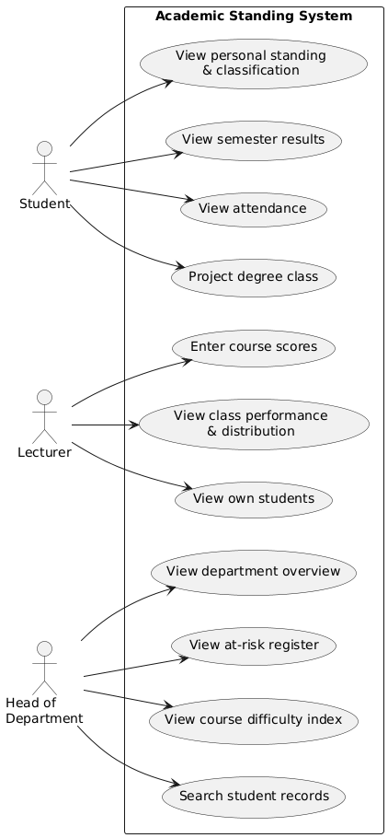
Figure 4.1: Use Case Diagram of the Academic Standing System
The sequence diagram in Figure 4.2 traces the order of events after a lecturer enters a score. The interface passes the changed score to the grading logic. That logic computes the total, checks the grade bands for the letter and point, and returns them to be shown at once. The same objects also feed the recomputation of the class summary and distribution.
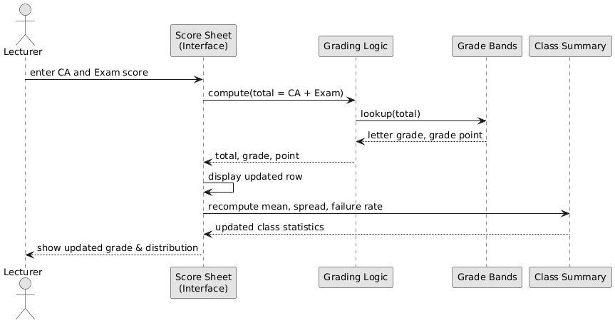
Figure 4.2: Sequence Diagram for the Score-Entry and Grading Process
The class diagram in Figure 4.3 shows the main classes of the domain, namely Account, Student, Semester, Course Result, Course, Risk Profile and Degree Class, and how they relate. Among these relationships are the composition of Semesters and Course Results within a Student, and the derivation of a Risk Profile from a Student's standing, attendance and carryovers.
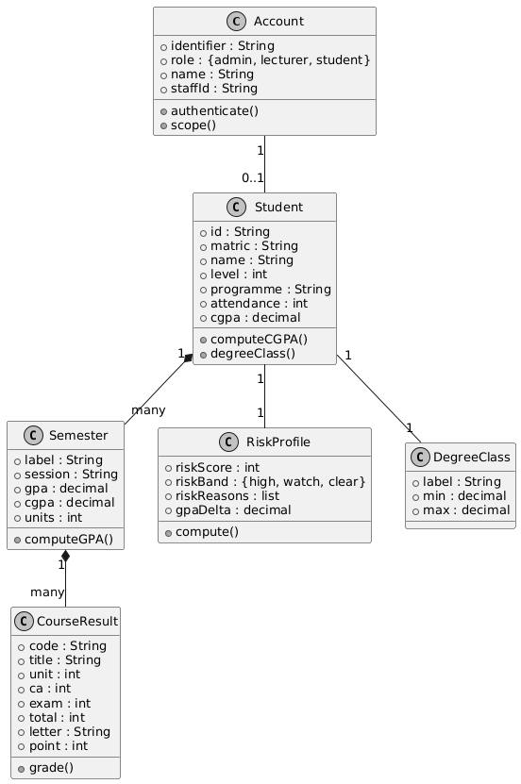
Figure 4.3: Class Diagram of the Academic Standing Domain Model

4.3 System Requirements
This section states the least hardware and software the developed system needs in order to run. These are deployment requirements that apply to the end user. They do not include the tools used during development, which are covered in section 4.2.

4.3.1 Hardware Requirements
The system is accessed through a web browser and therefore imposes modest hardware requirements. The minimum specification for an end-user device is as follows.
• Processor: 1.2 GHz dual-core or higher, as found in entry-level Android devices.
• Memory: 2 GB RAM minimum; 4 GB recommended for smoother rendering of the charts.
• Storage: 100 MB of free space for the browser cache.
• Display: 4.5-inch screen minimum; the interface adapts to larger displays.
• Network: 3G mobile data connection minimum; 4G or wireless local area network recommended.

4.3.2 Software Requirements
The software required on the end-user device is limited to a current web browser, as no installation is necessary.
• Operating system: Android 8.0 or later, iOS 13 or later, Windows 10 or later, or any Linux distribution with a supported browser.
• Browser: Google Chrome 90 or later, Mozilla Firefox 88 or later, Microsoft Edge 90 or later, or Safari 14 or later.
• Browser configuration: JavaScript enabled.
• Internet access for the initial loading of the application.

4.4 Implementation of the Proposed System
The system was implemented as a client-side web application and deployed to a managed hosting platform, so it is reached online rather than installed on individual machines. It is publicly available at the address given in Appendix B. The end user needs no setup beyond going to that address and signing in.
Implementation went object by object, following the chosen methodology. The grading and classification logic was built first and checked against manual computation. For a set of known score combinations, the letter grade and grade point returned by the system were compared with the grading regulations. For a set of known result sets, the semester GPA, cumulative CGPA and degree class were compared with hand calculation. This logic sits under every other view, so it had to be correct before anything else was built.
The account and access-control objects came next. These set up the three roles and the single access-control point through which all student data is read. Testing at this stage confirmed that each role reached exactly its permitted scope: a student session resolved to a single record, a lecturer session resolved only to the students taking that lecturer's courses, and the administrator session resolved to the whole department.
The analytics objects were built after that. These are the rule-based risk engine, which combines CGPA shortfall, GPA decline, attendance shortfall and carryovers into a composite score and band; the correlation of attendance with CGPA; the spread of the cohort across degree classes; and the course difficulty index. Each one was checked against values computed independently on the generated dataset.
The role workspaces and their views were built last, together with the projection facility and the session filter. The responsive interface was then tested across device widths, from small mobile screens to desktop monitors, and layout adjustments were made where controls turned out to be hard to use on smaller screens. Testing ran throughout the work rather than only at the end. Unit checks verified the grading, risk, correlation and projection functions in isolation, and acceptance testing with representative departmental users confirmed that each role could reach and read its intended views without being coached. Screenshots of the implemented system appear in Appendix B, and selected source-code listings in Appendix A.
CHAPTER FIVE

SUMMARY, CONCLUSION AND RECOMMENDATIONS

5.1 Summary
This study set out to develop a web-based student performance and academic standing monitoring system for the Department of Computer Science, Caritas University, Amorji-Nike. It was a response to the weaknesses of the manual, release-bound arrangement by which academic standing used to be determined.
Through interview and documentary study, the work established a few things about that arrangement. Standing was computed by hand or in spreadsheets and only became known after end-of-semester results were released. It was given to students as a single figure, with no classification, trend or target attached. And no early warning, attendance analysis or per-course difficulty view existed for the department. Between them, these conditions left students unable to act on their standing in time, and left the department unable to direct intervention with any evidence.
The literature was reviewed to set the conceptual and technical ground for academic analytics and early-warning systems. This covered learning analytics and educational data mining, the theory of student attrition and of technology acceptance, performance prediction and risk identification, the link between attendance and achievement, and the presentation of academic analytics. The review established that surfacing risk early and readably improves outcomes, and that a small number of transparent attributes carries most of the signal needed. It also pointed to a gap around delivering standing and risk through a transparent, role-scoped interface in a Nigerian departmental setting.
The Object-Oriented Analysis and Design Methodology was adopted, and the system was designed as a set of interacting classes and implemented in HTML, CSS and JavaScript. The delivered system provides role-based sign-in that scopes each actor to its permitted data; automatic computation of GPA, CGPA and degree classification; a lecturer score sheet with live grading; a rule-based at-risk register; department analytics, including the attendance-CGPA correlation and the degree-class distribution; a course difficulty index; and a degree-class projection facility. All of these are recomputed for a selected session and delivered through a responsive interface deployed to a public web address.
Each of the objectives stated in section 1.3 was met. The architecture and role model were designed and are presented in Chapter Four. The role-based access mechanism was built and scopes every actor through a single access-control point. GPA, CGPA and classification are computed on the five-point scale. The lecturer score sheet computes total, grade and point as scores are entered. The rule-based risk engine ranks students by a transparent composite. The projection facility computes the average needed to reach a chosen class. The department analytics and course difficulty index were built, and the system was evaluated with representative departmental users.

5.2 Conclusion
The problem this study set out to solve was that academic standing could not be known, interpreted or acted upon before results were formally released. The developed system resolves each part of that problem. Standing is computed continuously rather than after the fact. It is shown not as a bare figure but on a labelled classification scale, with its trend and the target needed to improve it. Students drifting towards failure are surfaced through a ranked, transparent risk register. The relationship between attendance and performance is made plain. And the courses failing the most students are identified. The objectives of the study have therefore been achieved.
The study also makes a wider point. Academic early-warning systems have mostly been treated in the literature as predictive-modelling exercises, producing classifiers whose output cannot easily be explained to the students they concern, or as backward-looking analyses never built into a tool available during the period they describe. This work shows that the real value of early warning, which is acting on academic difficulty while there is still time, can be delivered through a transparent, rule-based interface scoped by role. It also shows that such a system can be built for a Nigerian departmental setting without spending on infrastructure.
A few constraints qualify these conclusions. The system runs on a generated departmental dataset rather than on live records. It does not yet save changes. And sign-in and access enforcement are currently done in the browser rather than on a server. These constraints affect the scale and the security at which the system has been shown, not the soundness of its design, since the grading, risk, correlation and projection logic is fully built and runs on realistic data exactly as it would on real records.

5.3 Recommendations
Arising from the findings of this study, the following recommendations are made.
It is recommended that the department consider adopting the system for the continuous monitoring of academic standing, and that its at-risk register be used to steer support towards the students it identifies, while intervention can still affect the semester in question.
It is recommended that the analytics the system produces, namely the attendance-CGPA correlation, the degree-class distribution and the course difficulty index, be used to inform decisions on academic support and curriculum that are currently taken without such evidence.
It is recommended to future researchers that the following extensions be pursued.
1. Provision of a server-hosted database and a persistence layer, so that scores entered and amendments made are stored durably and survive across sessions and devices. This is the first priority for further work, as the present build recomputes but does not retain.
2. Introduction of server-side authentication, verifying credentials against irreversibly hashed values, together with server-side enforcement of the access policy, so that the role scoping holds beyond the interface.
3. Integration with the university’s live result and registration systems as the data source, replacing the generated dataset with real records while retaining the computation and presentation unchanged.
4. Extension of the risk engine, once a body of real historical outcomes has accumulated, to calibrate its weights empirically and, if warranted, to complement the transparent rule-based score with a validated predictive model whose reasons remain explainable.
5. Addition of an export facility, so that the at-risk register and course difficulty index can be issued as documents for departmental meetings and record-keeping.
6. Extension of the system to further departments and faculties, with comparative evaluation of standing and risk across units of differing size and curriculum.

REFERENCES
Adekitan, A. I., & Salau, O. (2019). The impact of engineering students’ performance in the first three years on their graduation result using educational data mining. Heliyon, 5(2), e01250.
Arnold, K. E., & Pistilli, M. D. (2012). Course Signals at Purdue: Using learning analytics to increase student success. Proceedings of the 2nd International Conference on Learning Analytics and Knowledge, 267–270.
Asif, R., Merceron, A., Ali, S. A., & Haider, N. G. (2017). Analyzing undergraduate students’ performance using educational data mining. Computers & Education, 113, 177–194.
Baker, R. S., & Inventado, P. S. (2014). Educational data mining and learning analytics. In J. A. Larusson & B. White (Eds.), Learning analytics: From research to practice (pp. 61–75). Springer.
Baker, R. S. J. d., & Yacef, K. (2009). The state of educational data mining in 2009: A review and future visions. Journal of Educational Data Mining, 1(1), 3–17.
Bravo-Agapito, J., Romero, S. J., & Pamplona, S. (2021). Early prediction of undergraduate student’s academic performance in completely online learning. Computers in Human Behavior, 115, 106595.
Bydžovská, H. (2016). A comparative analysis of techniques for predicting student performance. Proceedings of the 9th International Conference on Educational Data Mining, 306–311.
Chalaris, M., Gritzalis, S., Maragoudakis, M., Sgouropoulou, C., & Tsolakidis, A. (2014). Improving quality of educational processes providing new knowledge using data mining techniques. Procedia - Social and Behavioral Sciences, 147, 390–397.
Costa, E. B., Fonseca, B., Santana, M. A., de Araújo, F. F., & Rego, J. (2017). Evaluating the effectiveness of educational data mining techniques for early prediction of students’ academic failure in introductory programming courses. Computers in Human Behavior, 73, 247–256.
Credé, M., Roch, S. G., & Kieszczynka, U. M. (2010). Class attendance in college: A meta-analytic review of the relationship of class attendance with grades and student characteristics. Review of Educational Research, 80(2), 272–295.
Davis, F. D. (1989). Perceived usefulness, perceived ease of use, and user acceptance of information technology. MIS Quarterly, 13(3), 319–340.
Dekker, G. W., Pechenizkiy, M., & Vleeshouwers, J. M. (2009). Predicting students drop out: A case study. Proceedings of the 2nd International Conference on Educational Data Mining, 41–50.
Hu, Y. H., Lo, C. L., & Shih, S. P. (2014). Developing early warning systems to predict students’ online learning performance. Computers in Human Behavior, 36, 469–478.
Huang, S., & Fang, N. (2013). Predicting student academic performance in an engineering dynamics course: A comparison of four types of predictive mathematical models. Computers & Education, 61, 133–145.
Hussain, M., Zhu, W., Zhang, W., & Abidi, S. M. R. (2018). Student engagement predictions in an e-learning system and their impact on student course assessment scores. Computational Intelligence and Neuroscience, 2018, 6347186.
Jayaprakash, S. M., Moody, E. W., Lauría, E. J. M., Regan, J. R., & Baron, J. D. (2014). Early alert of academically at-risk students: An open source analytics initiative. Journal of Learning Analytics, 1(1), 6–47.
Kabakchieva, D. (2013). Predicting student performance by using data mining methods for classification. Cybernetics and Information Technologies, 13(1), 61–72.
Kotsiantis, S. B., Pierrakeas, C. J., & Pintelas, P. E. (2003). Preventing student dropout in distance learning using machine learning techniques. Proceedings of the 7th International Conference on Knowledge-Based Intelligent Information and Engineering Systems, 267–274.
Kuh, G. D., Kinzie, J., Buckley, J. A., Bridges, B. K., & Hayek, J. C. (2006). What matters to student success: A review of the literature. National Postsecondary Education Cooperative.
Marbouti, F., Diefes-Dux, H. A., & Madhavan, K. (2016). Models for early prediction of at-risk students in a course using standards-based grading. Computers & Education, 103, 1–15.
Márquez-Vera, C., Cano, A., Romero, C., & Ventura, S. (2013). Predicting student failure at school using genetic programming and different data mining approaches with high-dimensional and imbalanced data. Applied Intelligence, 38(3), 315–330.
Nghe, N. T., Janecek, P., & Haddawy, P. (2007). A comparative analysis of techniques for predicting academic performance. Proceedings of the 37th ASEE/IEEE Frontiers in Education Conference, T2G-7–T2G-12.
Oyelade, O. J., Oladipupo, O. O., & Obagbuwa, I. C. (2010). Application of k-means clustering algorithm for prediction of students’ academic performance. International Journal of Computer Science and Information Security, 7(1), 292–295.
Pardo, A., & Siemens, G. (2014). Ethical and privacy principles for learning analytics. British Journal of Educational Technology, 45(3), 438–450.
Peña-Ayala, A. (2014). Educational data mining: A survey and a data mining-based analysis of recent works. Expert Systems with Applications, 41(4), 1432–1462.
Romero, C., & Ventura, S. (2010). Educational data mining: A review of the state of the art. IEEE Transactions on Systems, Man, and Cybernetics, Part C, 40(6), 601–618.
Romero, C., & Ventura, S. (2020). Educational data mining and learning analytics: An updated survey. WIREs Data Mining and Knowledge Discovery, 10(3), e1355.
Romero, C., Ventura, S., Espejo, P. G., & Hervás, C. (2008). Data mining algorithms to classify students. Proceedings of the 1st International Conference on Educational Data Mining, 8–17.
Sclater, N., Peasgood, A., & Mullan, J. (2016). Learning analytics in higher education: A review of UK and international practice. Jisc.
Shahiri, A. M., Husain, W., & Rashid, N. A. (2015). A review on predicting student’s performance using data mining techniques. Procedia Computer Science, 72, 414–422.
Siemens, G., & Baker, R. S. J. d. (2012). Learning analytics and educational data mining: Towards communication and collaboration. Proceedings of the 2nd International Conference on Learning Analytics and Knowledge, 252–254.
Siemens, G., & Long, P. (2011). Penetrating the fog: Analytics in learning and education. EDUCAUSE Review, 46(5), 30–40.
Superby, J. F., Vandamme, J. P., & Meskens, N. (2006). Determination of factors influencing the achievement of the first-year university students using data mining methods. Proceedings of the Workshop on Educational Data Mining at ITS 2006, 37–44.
Tinto, V. (1975). Dropout from higher education: A theoretical synthesis of recent research. Review of Educational Research, 45(1), 89–125.
Tinto, V. (1997). Classrooms as communities: Exploring the educational character of student persistence. The Journal of Higher Education, 68(6), 599–623.
Venkatesh, V., Morris, M. G., Davis, G. B., & Davis, F. D. (2003). User acceptance of information technology: Toward a unified view. MIS Quarterly, 27(3), 425–478.
Waheed, H., Hassan, S. U., Aljohani, N. R., Hardman, J., Alelyani, S., & Nawaz, R. (2020). Predicting academic performance of students from VLE big data using deep learning models. Computers in Human Behavior, 104, 106189.
Yadav, S. K., Bharadwaj, B., & Pal, S. (2012). Data mining applications: A comparative study for predicting student’s performance. International Journal of Innovative Technology and Creative Engineering, 1(12), 13–19.
Yukselturk, E., Ozekes, S., & Türel, Y. K. (2014). Predicting dropout student: An application of data mining methods in an online education program. European Journal of Open, Distance and E-Learning, 17(1), 118–133.
Zimmerman, B. J. (2002). Becoming a self-regulated learner: An overview. Theory Into Practice, 41(2), 64–70.

APPENDIX A
SOURCE CODE SNIPPETS

The listings below present selected portions of the source code of the implemented system.

Listing A.1: Grade and Grade-Point Derivation (Five-Point Scale)
const GRADE_BANDS = [
{ min: 70, letter: 'A', point: 5 },
{ min: 60, letter: 'B', point: 4 },
{ min: 50, letter: 'C', point: 3 },
{ min: 45, letter: 'D', point: 2 },
{ min: 40, letter: 'E', point: 1 },
{ min: 0, letter: 'F', point: 0 },
];
function gradeOf(score) {
return GRADE_BANDS.find((b) => score >= b.min);
}

Listing A.2: Degree Classification from CGPA
const DEGREE_CLASSES = [
{ key: 'first', label: 'First Class', min: 4.50 },
{ key: 'second_upper', label: 'Second Class Upper', min: 3.50 },
{ key: 'second_lower', label: 'Second Class Lower', min: 2.40 },
{ key: 'third', label: 'Third Class', min: 1.50 },
{ key: 'pass', label: 'Pass', min: 1.00 },
{ key: 'fail', label: 'Below Pass', min: 0.00 },
];
function degreeClass(cgpa) {
return DEGREE_CLASSES.find((c) => cgpa >= c.min);
}

Listing A.3: Rule-Based At-Risk Scoring Engine
// Composite of standing, trend, attendance and carryovers.
let score = 0; const why = [];
const gap = Math.max(0, Math.min(1, (3.5 - cgpa) / 3.5));
score += gap * 40; // CGPA shortfall
if (delta <= -0.5) { score += 20; } // semester GPA drop
else if (delta <= -0.25) { score += 10; }
const att = Math.max(0, Math.min(1, (70 - attendance) / 70));
score += att * 25; // attendance shortfall
score += (Math.min(carry, 4) / 4) * 15; // outstanding carryovers
const risk = Math.round(Math.max(0, Math.min(100, score)));
const band = risk >= 60 ? 'high' : risk >= 35 ? 'watch' : 'clear';

Listing A.4: Role-Based Access Scoping
const POLICY = {
admin: { students: 'all' },
lecturer: { students: 'my-classes' },
student: { students: 'self' },
};
function roster() {
const rule = POLICY[SESSION.role].students;
if (rule === 'self') return [SESSION.subject];
if (rule === 'my-classes') return studentsTaking(myCourses());
return ALL_STUDENTS; // admin
}

Listing A.5: Degree-Class Projection
// GPA required across remaining units to reach a target class.
const total = unitsEarned + remainingUnits;
const required = (target.min * total - cgpa * unitsEarned) / remainingUnits;
const alreadySecured = required <= 0;
const outOfReach = required > 5;

Listing A.6: Pearson Correlation of Attendance with CGPA
function pearson(xs, ys) {
const n = xs.length;
const mx = xs.reduce((a, b) => a + b, 0) / n;
const my = ys.reduce((a, b) => a + b, 0) / n;
let num = 0, dx = 0, dy = 0;
for (let i = 0; i < n; i++) {
num += (xs[i] - mx) * (ys[i] - my);
dx += (xs[i] - mx) ** 2;
dy += (ys[i] - my) ** 2;
}
return num / Math.sqrt(dx * dy);
}

APPENDIX B
SAMPLE OUTPUTS (SCREENSHOTS)

The screenshots below present sample outputs of the implemented system. The system is deployed and publicly accessible at https://student-performance-dashboard-system.netlify.app/.

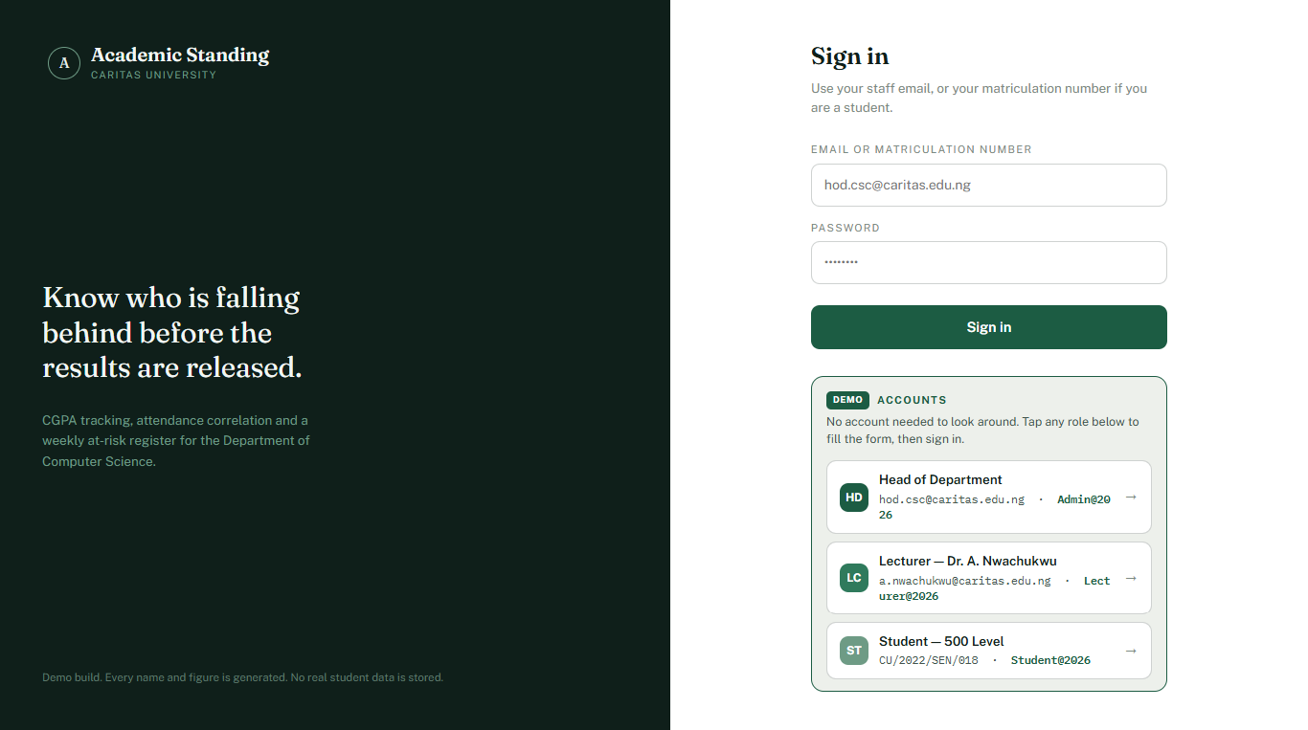
Plate 4.1: Role-Aware Sign-In Portal
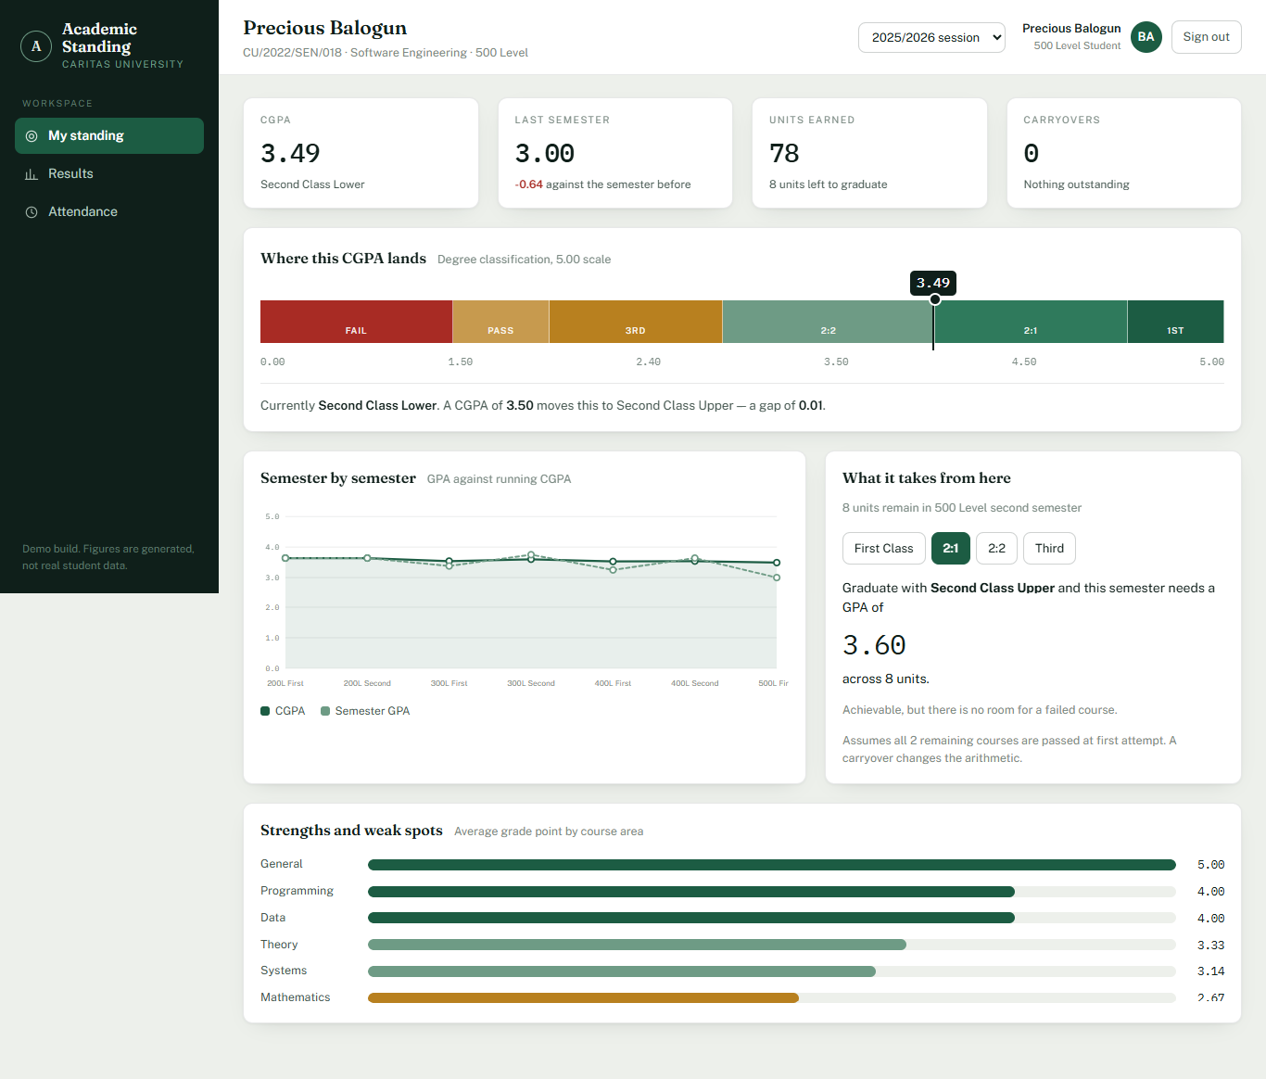
Plate 4.2: Head-of-Department Overview — Mean Standing, Attendance-CGPA Correlation and At-Risk Register
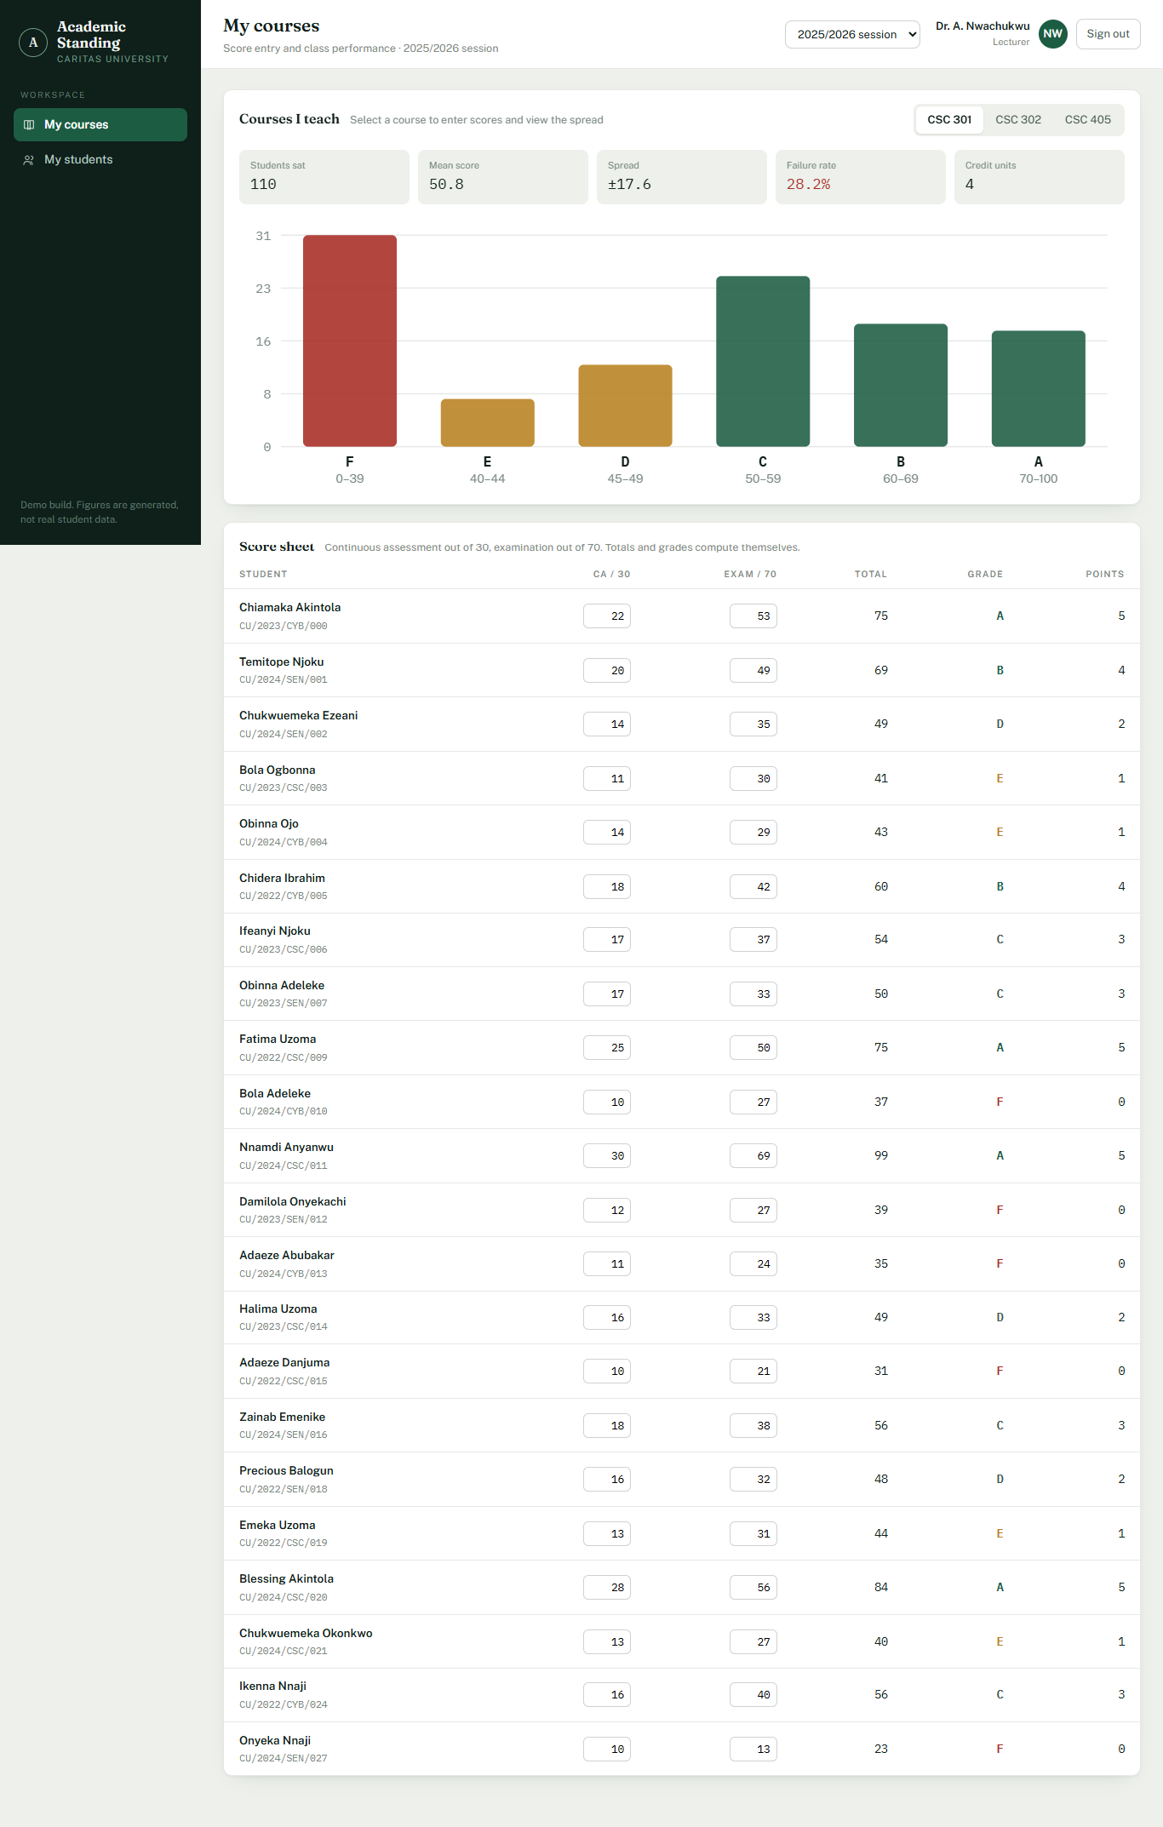
Plate 4.3: Lecturer Score Sheet with Live Grading and Grade Distribution
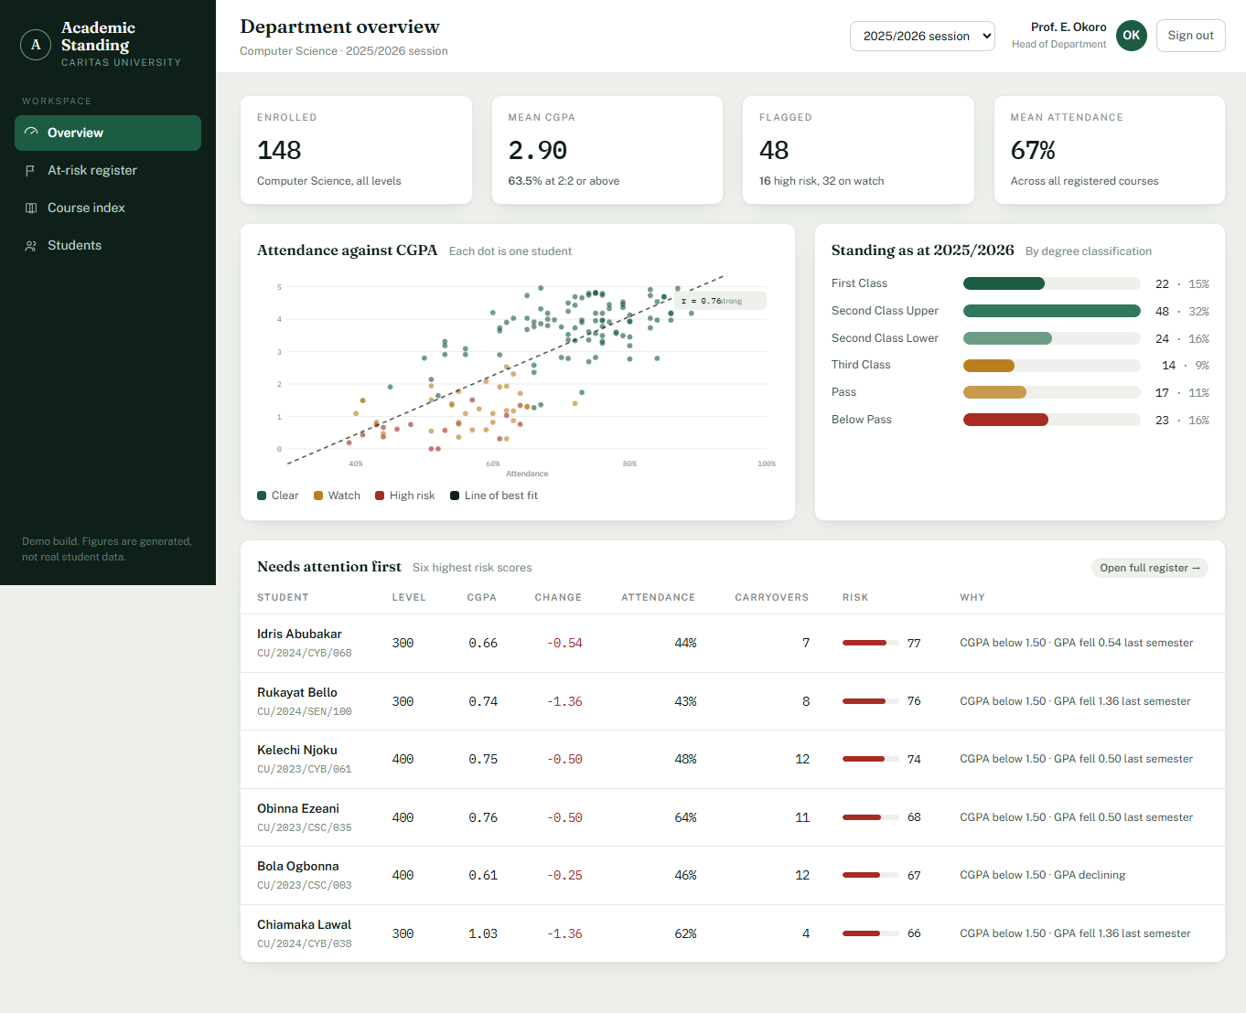
Plate 4.4: Student Standing — Degree Classification, Semester Trend and Projection

