

CARITAS NOTICEBOARD: A WEB-BASED REAL-TIME UNIVERSITY NOTICE BOARD AND STUDENT-INFORMATION SYSTEM WITH ROLE-BASED
FACULTY ACCESS

BY

UGWU, CHIDERA DANIEL
CS/DE/2023/1440

SUBMITTED TO

THE DEPARTMENT OF COMPUTER SCIENCEFACULTY OF NATURAL SCIENCES CARITAS UNIVERSITY, AMORJI-NIKE, ENUGU

IN PARTIAL FULFILMENT OF THE REQUIREMENTS FOR THE AWARD OF
BACHELOR OF SCIENCE (B.SC) DEGREE IN COMPUTER SCIENCE

AUGUST, 2026

DECLARATION
I, Ugwu, Chidera Daniel, with registration number CS/DE/2023/1440, hereby declare that this project titled “Caritas Noticeboard: A Web-Based Real-Time University Notice Board and Student-Information System with Role-Based Faculty Access” is my original research work carried out under the supervision of Mr. Abundance Akpan of the Department of Computer Science, Caritas University, Amorji-Nike, Enugu. The work reported herein has not been presented, in whole or in part, to any institution for the award of any other degree or qualification, and all sources consulted have been duly acknowledged.

________________________________ ____________________
Ugwu, Chidera Daniel Date
(CS/DE/2023/1440)

APPROVAL
This is to certify that we have read, examined and found this project titled “Caritas Noticeboard: A Web-Based Real-Time University Notice Board and Student-Information System with Role-Based Faculty Access”, carried out by Ugwu, Chidera Daniel with registration number CS/DE/2023/1440, to be satisfactory and acceptable for the award of a Bachelor of Science (B.Sc) degree in Computer Science of Caritas University, Amorji-Nike, Enugu, and hence we have caused our names and signatures to appear as follows:

________________________________ ____________________
Mr. Abundance Akpan Date
(Project Supervisor)
________________________________ ____________________
Mr. Ugwu, Ejike Date
(Head of Department)
________________________________ ____________________
Prof. Fergus Onu Date
(External Examiner)

DEDICATION
This project is dedicated to Almighty God, the source of all wisdom and understanding, whose grace sustained me throughout this programme; and to my parents, whose sacrifice, encouragement and unfailing support made this academic journey possible.

ACKNOWLEDGEMENTS
I extend my sincere gratitude to God Almighty for the strength, wisdom and good health that sustained me throughout the duration of this project.
My profound appreciation goes to my Project Supervisor, Mr. Abundance Akpan, whose guidance, patience and constructive criticism shaped this work from conception to completion.
I am equally grateful to the Head of the Department of Computer Science, Mr. Ugwu, Ejike, for his leadership and support throughout the programme. My sincere thanks go likewise to Prof. Arinze Nwaeze, Dr. Henry Nweke and Dr. Ugochukwu Nwankwo .C, and to all the other lecturers of the Department of Computer Science, Caritas University, Amorji-Nike, Enugu, for the knowledge they imparted over the course of my study.
Finally, I acknowledge my family, friends and course mates for their moral and financial support, for testing the system and offering feedback on its usability, and for their steadfast encouragement during the development of this work.

ABSTRACT
Caritas Noticeboard is a web-based university notice board and student-information system developed for Caritas University, Amorji-Nike, Enugu. It was built to centralise and govern how official announcements, examination schedules and results reach students. The system replaces the fragmented, manual notice-board arrangement long used across the campus with a single, searchable board published under role-based faculty access. It aims to deliver timely, authoritative and accountable campus communication.
The institution's former arrangement left students facing missed notices, unverifiable messages circulating informally through class representatives and messaging groups, and no searchable record of what had actually been announced, by whom, and when.
The study aimed to give students a single governed channel for official information, with faculty-controlled publication, instant search and category filtering, and integrated result lookup. Specific objectives included a single announcement catalogue carrying category, author and priority state; a two-role access model separating an ordinary Viewer from an authenticated Faculty user; search and category filtering over the catalogue; and integrated grade-portal, lost-and-found, staff-agenda and academic-calendar modules.
Development adopted the Object-Oriented Analysis and Design Methodology, with the notice catalogue, the role-conditioned access controls, and the integrated modules each built and verified feature by feature across iterative passes.
Software, tools, and database: HTML5, CSS3 and JavaScript (ES6) for a self-contained, client-side single-page application, with structured in-browser collections as the data store; no server, database or front-end framework was used.
Results: The system correctly rendered a searchable, filterable notice catalogue with pinned notices sorted ahead of the rest, restricted publishing and management controls to a signed-in faculty session while leaving them hidden from an ordinary viewer, and returned accurate results through the grade portal for seeded registration numbers. Rendering and filtering behaviour was verified against known seeded records, and representative users completed end-to-end tasks, searching a notice, looking up a result and reporting a lost item, without assistance.

TABLE OF CONTENTS
Title Page i
Declaration ii
Approval iii
Dedication iv
Acknowledgements v
Abstract vi
Table of Contents vii
CHAPTER ONE: INTRODUCTION 1
1.1 Background of the Study 1
1.2 Statement of the Problem 1
1.3 Aim and Objectives of the Study 2
1.4 Significance of the Study 2
1.5 Scope of the Study 3
1.6 Limitations of the Study 3
CHAPTER TWO: LITERATURE REVIEW 4
2.1 Introduction 4
2.2 The Notice Board as an Information System 4
2.3 The Evolution of Web Application Architectures 4
2.4 Client-Side Implementation Technologies 5
2.5 Technology Adoption and Information-Systems Success 5
2.6 Role-Based Access Control and Security 6
2.7 Usability and Interaction Design 6
2.8 Data Management for Information Systems 6
2.9 Software Engineering Methodology and Modelling 7
2.10 Review of Related Works and Research Gap 7
CHAPTER THREE: SYSTEM ANALYSIS AND METHODOLOGY 9
3.1 Data Gathering 9
3.2 Research Methodology and Justification 9
3.3 System Analysis 9
3.3.1 Analysis of the Existing System 9
3.3.2 Analysis of the Proposed System 10
3.4 Justification of the Proposed System 10
CHAPTER FOUR: SYSTEM DESIGN AND IMPLEMENTATION 12
4.1 Design and Specification of the Proposed System 12
4.1.1 Input Design and Specification 12
4.1.2 Output Design and Specification 13
4.1.3 Security Design and Specification 13
4.1.4 Data Design and Specification 14
4.2 System Development Tools and Justification 14
4.3 System Requirements 17
4.3.1 Hardware Requirements 18
4.3.2 Software Requirements 18
4.4 Implementation of the Proposed System 18
CHAPTER FIVE: SUMMARY, CONCLUSION AND RECOMMENDATIONS 19
5.1 Summary 19
5.2 Conclusion 19
5.3 Recommendations 20
REFERENCES 21
APPENDIX A: SOURCE CODE SNIPPETS 23
APPENDIX B: SAMPLE OUTPUTS (SCREENSHOTS) 25

CHAPTER ONE

INTRODUCTION

1.1 Background of the Study
Every university depends on official information reaching students on time. Resumption dates, registration deadlines, fee-payment guidance, examination timetables, result releases, senate and faculty announcements, scholarship openings and lost-property notices all need to get to students quickly and accurately, otherwise academic life starts to break down. At Caritas University, Amorji-Nike, Enugu, this has traditionally been handled through physical notice boards mounted around departmental and faculty buildings, backed up by word of mouth, class representatives and informal messaging-group broadcasts.
As the student population has grown and the number of notices has increased, this arrangement keeps running into the same problems. A student who is off campus, or who just doesn't pass a particular board that day, misses the notice completely. Nothing is kept as an authoritative, timestamped, searchable record of what was actually announced, so once a notice comes down there's no reliable way to check it again, and it is often unclear which version of an instruction is current, or whether a message going round campus was genuinely issued by the school at all. Results and grades, for their part, are checked through separate channels that are sometimes slow and queue-bound. It was this fragmentation — observed first-hand in how students at the university actually get their information — that motivated the system described in this project.
This pattern is not unique to Caritas University; it is a recurring feature of how information moves in institutions that have grown faster than their communication infrastructure. A notice board, in its physical form, was designed for a much smaller campus, where a handful of boards near the main administrative block could plausibly reach most of the student population within a day. As departments multiplied and satellite buildings spread across the campus, the assumption baked into that design, that a student passes a board regularly, stopped holding for a growing share of the student body, particularly those whose lecture schedule keeps them away from the buildings where the boards are mounted.
, particularly those in departments housed away from the main administrative block, or those juggling a heavy timetable that keeps them moving directly between lecture halls and hostel accommodation without passing the boards at all. The result is not that the physical board has stopped working entirely, but that it now reliably reaches only a shrinking core of the student population, while treating everyone else's access to official information as a matter of chance rather than design
Caritas Noticeboard is proposed as a centralised, web-based answer to this. Instead of treating a notice as loose paper pinned to a scattered board, the system treats every notice as a governed record in one catalogue: each announcement carries a category, a posting date, an identified author and a priority (pinned) flag, and is published to a single board that any student can search and filter. Faculty publish and manage notices behind a role-based sign-in, so ordinary viewers can read the board freely while only signed-in faculty can actually change it. A few integrated modules round this out — a grade portal for result lookup, a lost-and-found register, a staff agenda and an academic-calendar view — so the things students look for most often sit in one place, rather than scattered across boards, group chats and separate offices.

1.2 Statement of the Problem
Caritas University has no single, authoritative channel through which official announcements, examination schedules and results reach students in good time. Because notices are spread across physical boards, informal messaging groups and separate result-checking channels, the institution has no way of guaranteeing that every student gets current, genuine information promptly. This one problem — the lack of a controlled, accountable and timely channel for official information — is what produces missed deadlines, reliance on rumour and unverified broadcasts, and the loss of any searchable record of what was actually announced, by whom, and when.
Framed this way, the problem is not merely an inconvenience but a structural gap in institutional accountability: when no single channel is authoritative, the university itself has no reliable way to demonstrate what it communicated to students and when, which matters whenever a missed deadline or a disputed instruction becomes a matter of dispute between a student and a department.
The cost of this gap is not evenly distributed. A student who is naturally organised, who checks multiple channels out of habit, is comparatively insulated from it; a student who is not, whether from inexperience, a heavy course load, or simple unfamiliarity with which messaging group carries which department's notices, is the one most exposed to a missed deadline or an acted-upon rumour. A centralised system narrows this gap by making the same authoritative record available to every student on equal terms, rather than rewarding only those already diligent enough to track multiple informal channels themselves.

1.3 Aim and Objectives of the Study
The aim of this project is to design and implement a centralised, web-based notice board that delivers categorised official information to students, with publication controlled through role-based faculty access. The specific objectives below are each aimed at addressing the problem set out in Section 1.2:
1. Design a single announcement catalogue where every notice carries a category, posting date, author and priority (pinned) state, so the current, official version of any notice is never in doubt.
2. Implement role-based access that separates an ordinary Viewer, who can only read the board, from an authenticated Faculty user, who can publish, edit, pin and remove notices — so only authorised staff can actually change anything.
3. Implement search and category filtering over the notice catalogue, so a student can find a relevant notice quickly instead of scanning every board.
4. Integrate a grade portal, a lost-and-found register, a staff agenda and an academic-calendar view, bringing the information students look for most often into one place.
5. Make sure a newly published notice appears in the interface right away, so campus communication stays timely.
Taken together, these five objectives correspond to the five deliverables against which the completed work is assessed in Chapter Five: a governed announcement catalogue, a working two-role access model, search and category filtering, four integrated modules, and an interface that reflects a change the moment it is made. Each objective was treated, in the manner set out in Chapter Three, as a unit of work to be designed, implemented and individually verified before the next was begun, so that the finished system is not merely a demonstration of isolated features but a set of deliverables each traceable back to the problem stated above.
This traceability was maintained deliberately throughout implementation rather than checked only at the end. Each of the five objectives in Section 1.3 was mapped, before any code was written, to the specific chapter and section in which it would be designed and then implemented, so that a reader tracing any single objective through the report finds a continuous thread from its statement in Chapter One, through its design in Chapter Four, to its verification in Section 4.4, rather than having to infer the connection.

1.4 Significance of the Study
Once complete, this work gives the university a practical tool for improving how official information flows to students. By pulling scattered notices into one governed, searchable board, the system removes much of the uncertainty that causes students to miss deadlines or act on unverified messages. A few points illustrate why this matters:
• Reach improves, since every student with a browser can view the same board whether or not they pass a physical notice board that day.
• Accountability is stronger, since each notice records its category, author and posting time, and only an authenticated faculty user can publish or change it.
• Efficiency goes up, since students search and filter one catalogue instead of hunting across disconnected boards and message threads.
• The work also doubles as a reference for students and developers interested in role-based access, client-side single-page application design, and building a campus information system without heavy server infrastructure.
Beyond these immediate beneficiaries, the study carries a broader significance for a Nigerian university department weighing how to improve student communication without the capital outlay a fully server-backed, institution-wide system would require. By demonstrating that a genuinely useful notice board can be designed, built and deployed as a static, framework-free client-side application at negligible running cost, the study gives the university a low-risk starting point, one from which a fuller, database-backed deployment, should the institution choose to pursue one, can be planned with the record structures and access model already proven rather than designed from nothing.
This equity argument is not incidental to the study but central to its motivation. A university's channels for official communication exist to serve every student under its care, not chiefly the subset already equipped, by disposition or social network, to track multiple informal channels; a governed board that closes the gap between these two groups therefore advances a goal the existing fragmented arrangement, however long-standing, structurally cannot: consistent, attributable information available to every student on exactly the same terms.

1.5 Scope of the Study
This project covers the design, implementation and evaluation of a web-based notice board and student-information system that runs entirely in a standard web browser. In scope are faculty sign-in and a two-role access model (Viewer and Faculty); the posting, categorising, pinning, searching and filtering of official announcements; an academic calendar and staff agenda display; a grade portal that returns a student's results by registration number; a lost-and-found register with item reporting; and a getting-started guide for new students. The system is intended for the students and faculty of Caritas University.
A few boundaries are worth stating plainly. The study concerns the presentation and management of notices and related information within a single client-side application; it does not undertake examination administration or the formal issuance of results. Its content is held in structured collections inside the browser so every view can be demonstrated at a realistic scale, but connecting the system to a central server, a database and the university's live records is left as further work rather than attempted here.
This boundary was set deliberately. A system that governs the flow of official university communication touches student welfare closely enough that it would be premature, within a single undergraduate project and without institutional sign-off, to connect it directly to live examination or administrative records; the system is confined to demonstrating the notice-board and access-control design on realistic seeded data, with the connection to genuine institutional records left, deliberately, as the further work identified in Chapter Five.
This same boundary explains why the study's evaluation, described in Section 4.4, relies on acceptance testing with a small group of student volunteers rather than a formally powered user study across the wider student body. A larger evaluation would itself require the kind of institutional coordination, and time beyond a single academic session, that Section 1.6 already identifies as a constraint on this work; the scope was set to match what could actually be delivered and honestly evaluated within those limits, rather than promising a scale of study the project's timeframe could not support.

1.6 Limitations of the Study
A few factors constrained how this work was carried out, and are worth bearing in mind when reading its results.
First, the system is a functional prototype whose content lives in in-browser collections rather than a server-side store. The seeded notices, agenda, results and lost-and-found items are realistic and stay stable through a session, but anything changed during that session — a notice published, edited or removed — isn't written anywhere permanent and won't survive a page reload, since no server or database is provisioned in this build. Adding a persistence layer is flagged in Section 5.3 as the first priority for further work.
This trade-off was accepted consciously rather than overlooked. An alternative considered during design was to persist changes using the browser's own local storage, which would survive a page reload without requiring a server at all. This was set aside because local storage is scoped to a single browser on a single device, so a notice published from one machine would still be invisible from another, which would not meaningfully solve the cross-device reach problem stated in Chapter One; a genuine, shared source of truth requires a server, which is why that, rather than local storage, is named as the priority in Section 5.3.
Second, faculty sign-in in this build checks against a single shared demonstration password inside the browser. It exists to exercise the role-based access design, not to secure real staff accounts, and per-staff credentials verified on a server against irreversibly hashed values are, again, left for further work.
Third, the grade portal shows results from a seeded demonstration store, not a live connection to the university's examination records, and the board updates immediately only within the acting user's own session rather than syncing across multiple simultaneous users.
This single-session limitation is worth distinguishing clearly from the persistence limitation discussed above, since the two are sometimes conflated. A lack of persistence means a change does not survive a page reload; a lack of cross-session synchronisation means a change made in one browser tab is not reflected in a second tab, or on a second device, open at the same time. Both stem from the same underlying decision, to hold working data in memory rather than behind a shared server, and both are addressed by the same recommended remedy in Section 5.3, but they are distinct behaviours worth naming separately when evaluating what the current build does and does not demonstrate.
Fourth, the whole study was carried out within a single academic session, alongside coursework and examinations, which limited how long the evaluation could run and how many respondents could realistically be reached.
None of these limitations bears on the correctness of the design itself; each concerns the scale, persistence or security posture at which the system was demonstrated rather than whether its catalogue, its access model or its integrated modules behave as intended. They are stated plainly here so that a reader evaluating this report knows exactly which claims the present build supports and which, per Section 5.3, remain further work for a production deployment.
CHAPTER TWO

LITERATURE REVIEW

2.1 Introduction
This chapter reviews literature relevant to designing a web-based campus notice board and student-information system. It starts by framing the notice board as an information system in its own right, then traces the evolution of the web-application architectures such a system is built on, and looks at the client-side technologies used to implement it. From there it covers the theory of technology adoption and information-systems success, the access-control and security models that govern who may change the board, the principles behind usable interaction design, how the data the system holds is managed, and the software-engineering methodology used to build it. A review of related classes of system follows, and the chapter closes by stating the gap this study addresses. For each body of work discussed, both its contribution to this project and its limitation are pointed out.

2.2 The Notice Board as an Information System
The information-systems literature covers the general practice of using computer-based systems to gather, store and pass on the information an organisation depends on. Laudon and Laudon (2020) describe an information system as a set of interrelated components that gather, process, store and distribute information to support coordination and decision-making, and they argue its real value lies in getting the right information to the right people at the right time — a framing that puts a university notice board squarely in this category, rather than treating it as just another web page. DeLone and McLean (2003) offer a widely used model of what makes such a system succeed, pointing to information quality, system quality and service quality as what drives use and user satisfaction; that model is part of why this system focuses so heavily on accurate, categorised, attributed notices delivered through a responsive interface. Building web-based information systems is itself treated as a discipline: Kappel, Pröll, Reich and Retschitzegger (2006) and Murugesan (2008) describe web engineering as the disciplined application of engineering principles to web applications, and this project follows the same spirit by working through an explicit analysis, design and implementation process. The catch with these general frameworks is that they tell a builder what "success" looks like without saying anything about how to actually structure a small, browser-based board — which is the gap this study fills in practice.
A further distinction worth drawing from this literature is between an information system's technical success and its organisational success. Laudon and Laudon (2020) note that a system can be technically sound, correctly capturing, storing and retrieving data, while still failing organisationally if it does not fit how the people who depend on it actually work. Applied here, this is precisely why the system's design starts from the observed, informal channels students and faculty already use, class representatives, messaging groups, physical boards, rather than from an abstract notion of what a notice board ought to look like: a technically correct catalogue that ignored how notices actually reach students today would risk exactly the organisational failure the literature warns against.

2.3 The Evolution of Web Application Architectures
The web started out as a network of linked static documents, in the form Berners-Lee, Cailliau, Luotonen, Nielsen and Secret (1994) originally described. From there it grew into a platform for interactive applications — O’Reilly (2007) called this the "Web 2.0" shift, where the browser itself becomes an application environment, and Garrett (2005) gave a name to the Ajax approach, where a page updates parts of itself by fetching data in the background instead of reloading. That line of development leads to the single-page application, as set out by Mikowski and Powell (2013): one document loaded once, with its various views switched and re-rendered on the client without a further full-page load. Caritas Noticeboard is a direct example of this pattern — its announcements, grade-portal and lost-and-found views are switched entirely on the client, and the notice feed re-renders in place the moment a notice is added, filtered or removed. Most of this literature assumes a server sitting behind the client and supplying data; here the same client-side model is demonstrated with data seeded directly in the browser, which shows the pattern working while also marking exactly where a live data source would plug in.
Garrett's (2005) account of Ajax is worth returning to on this point, since the technique he describes, updating part of a page by fetching data in the background, presupposes a server endpoint to fetch from. The present system's notice feed re-renders on exactly the same trigger, a change to the underlying collection, but the collection changes because a local function mutated an in-browser array rather than because a network request returned. This is not a deviation from the single-page application pattern so much as a deliberate simplification of it: the rendering logic that would consume server data in a production deployment already exists here and would require no redesign, only a change to where the data it consumes originates.

2.4 Client-Side Implementation Technologies
The system is built directly on the browser platform, with no front-end framework. Flanagan (2020) describes JavaScript as the language of that platform and the Document Object Model as the interface a script uses to read and change the structure and content of a page — which is exactly how each notice card and result table in this system gets built. Structure and presentation rest on open standards: HTML5 (W3C, 2014) defines the document vocabulary, and Meyer (2017) documents the CSS used for styling. Since students reach the board on all sorts of devices, the responsive approach Marcotte (2011) describes — a fluid layout that adapts to the viewport — was used here, in line with the web-standards discipline Zeldman and Marcotte (2010) argue for. Duckett (2014) and Robbins (2018) offered more practical guidance in actually putting the interface together. Going framework-free at this scale has a clear upside: a small, dependency-free build that loads quickly on the low-to-mid range devices most students actually use. The downside, which the literature is fairly upfront about, is that hand-written interface code gets harder to maintain as an application grows — which is exactly why frameworks tend to get adopted once a project passes this scale.
The present system sits close to that threshold without crossing it. Its four views are each rendered by a dedicated function of modest length, and the record types they read from are few and stable, which is precisely the condition under which Flanagan (2020) and Robbins (2018) both suggest a framework-free build remains maintainable. Were the system to grow toward the scale of a full campus portal, adding staff directories, multi-department workflows and richer permissioning, the same literature is equally clear that a framework's state-management discipline would become worth its cost; the present build is deliberately scoped to stay on the side of that line where it is not yet needed.
The present system sits close to, but below, the scale at which this trade-off tips. Its interface is built from a small, repeated set of components, the notice card, the filter chip, the result row, each rendered by a short, dedicated function rather than a general-purpose templating layer, which keeps the framework-free approach manageable even without the state-management tooling a larger application would need. Robbins's (2018) guidance on organising vanilla JavaScript around small, single-purpose functions was followed directly here, and is the main reason the codebase, though framework-free, remains readable as a single file rather than degrading into the unmanageable tangle the literature warns a framework-free build can become past a certain size.

2.5 Technology Adoption and Information-Systems Success
Whether the board actually gets used comes down to acceptance. Davis's (1989) Technology Acceptance Model holds that adoption is driven mainly by perceived usefulness and perceived ease of use, and Venkatesh, Morris, Davis and Davis (2003) extend this in their Unified Theory of Acceptance and Use of Technology, adding performance expectancy, effort expectancy, social influence and facilitating conditions. Taken alongside DeLone and McLean's (2003) success model, this suggests students will only bother checking the board if it's clearly easier than scanning physical boards and message threads, and faculty will only publish through it if that's genuinely simpler than pinning a sheet of paper. That's the thinking behind the immediate search and category filtering, the single consolidated board, and the instant visual feedback the interface gives once a notice is posted.
Venkatesh et al.'s (2003) facilitating-conditions construct, whether a user has the infrastructure and knowledge needed to use a system, has a particular bearing on this project's device and connectivity assumptions. A student population that is mostly on low-to-mid range devices and variable campus connectivity will not adopt a board that is slow to load or awkward on a small screen, however useful its content, which is precisely why Section 4.2's tools discussion treats a framework-free, dependency-light build as a facilitating condition in its own right, and not merely an implementation convenience.

2.6 Role-Based Access Control and Security
Restricting publication to authorised staff draws on Role-Based Access Control, formalised by Sandhu, Coyne, Feinstein and Youman (1996) and later standardised by Ferraiolo, Sandhu, Gavrila, Kuhn and Chandramouli (2001), where permissions attach to roles rather than to individual users. This project applies the idea in a deliberately minimal form — an ordinary Viewer who can only read the board, versus an authenticated Faculty user who can also publish and manage notices. The wider principles of authentication, authorisation and accountability that a system like this should follow come from Whitman and Mattord (2021), Stallings (2017) and Anderson (2020), who between them establish that credentials should be checked against irreversibly stored values, that authorisation should be enforced at the point where data is held, and that consequential actions should be traceable back to whoever took them. This build respects the role distinction and attributes every notice to an author and a time, but the check itself runs in client-side code against a shared demonstration credential — the literature is clear, and this report doesn't pretend otherwise, that a production deployment would need server-side enforcement and per-user hashed credentials.
Sandhu et al.'s (1996) original formulation also distinguishes a base role model from richer variants that add role hierarchies and constraints such as separation of duty. The two-role distinction adopted here, an ordinary Viewer and an authenticated Faculty user with no further gradation, corresponds to the base model in that family rather than to a hierarchy: a Faculty session does not inherit from, or extend, a Viewer session but instead reaches an entirely separate set of controls. A production deployment distinguishing, say, a departmental notice officer from a senate-level administrator would need the fuller hierarchical model Ferraiolo et al. (2001) later standardised, which the present two-role design does not yet require but does not preclude extending toward.
Ferraiolo et al.'s (2001) standard also formalises the idea of session activation, a user holding a role only for the duration of an active session rather than permanently, which is exactly how this system's Faculty role behaves: it is granted at sign-in and would lapse on sign-out or session end, rather than being a permanent property attached to a user account. Modelling the role this way, as a property of the current session rather than of a stored user record, kept the access-control logic simple enough to implement and verify within the timeframe available, while remaining consistent with the formal model the wider literature describes.

2.7 Usability and Interaction Design
Since the people using this are students trying to find information fast, usability isn't an afterthought here. Nielsen (1994) and Nielsen and Molich (1990) set out interface heuristics — visibility of system status, consistency, recognition over recall, among others — and these shaped the search, category filtering and immediate feedback built into the board. Shneiderman and Plaisant's (2010) well-known sequence of overview first, then filter, then details on demand maps almost directly onto the feed, the category chips and the expandable notice card here. Norman (2013) grounds all this in the psychology of everyday objects — visible affordances, clear mapping — while Krug (2014) boils the whole field down to one practical rule: don't make the user think. Preece, Rogers and Sharp (2015) supply the broader interaction-design process these heuristics sit inside. Between them, these ideas shaped an interface meant to make sense to a student the first time they see it, without instructions.
Nielsen's (1994) heuristic of error prevention is reflected concretely in the announcement form's category field, presented as a fixed drop-down list of the system's six recognised categories rather than free text, which forecloses an entire class of miscategorised or misspelt notice before it can occur. Shneiderman and Plaisant's (2010) overview-first principle is likewise reflected in the decision to sort pinned notices ahead of the rest of the feed by default, so that the single most time-sensitive information on the board is visible without any filtering action on the student's part.

2.8 Data Management for Information Systems
This build holds its data in structured in-browser collections rather than a database, but the logical data model still follows established database principles, so moving it to a server-side store later shouldn't require redesigning anything. Elmasri and Navathe (2016), Connolly and Begg (2015) and Date (2004) lay out how to design well-formed record structures, keys and relationships, and the announcement, grade, agenda and lost-and-found record types defined in Chapter Four follow that guidance — each with a clear identifier and a fixed set of typed fields, so the collections could be swapped for database tables without touching the behaviour built on top of them. The obvious limitation, stated plainly here, is that in-browser collections don't persist across sessions — which is exactly why adding a database is named as the first priority for further work in Section 5.3.
Elmasri and Navathe's (2016) discussion of denormalisation trade-offs is also relevant to one specific design choice here: the grade record embeds its list of course results directly, rather than storing them as a separate collection joined by a foreign key, since the in-browser build has no query engine capable of performing such a join efficiently. This is a deliberate simplification appropriate to the current single-collection-per-view build, but one a database migration would likely revisit, normalising course results into their own table once a query engine capable of an efficient join is available.
Connolly and Begg's (2015) treatment of entity integrity, that every record type should carry a unique, non-null identifier, is followed directly in each of the system's four record types, the announcement, the grade record, the agenda event and the lost-and-found item, each of which is defined with an explicit identifying field before any of its descriptive attributes are added. This discipline, applied even though the current build holds no foreign-key constraints a database engine would enforce, is what makes the collections describable as a logical data model in the first place, rather than as an unstructured convenience store that happens to hold JavaScript objects.
, rather than as an unstructured convenience store that happens to hold JavaScript objects. Date's (2004) distinction between a logical data model and its physical storage is instructive here: the announcement, grade, agenda and lost-and-found record types are a logical model in Date's sense regardless of whether they are physically realised as in-browser arrays, as they are in this build, or as rows in a relational table, as a production deployment would likely choose. The migration path discussed in Section 4.1.4 is only available at all because this logical-physical separation was respected from the outset.

2.9 Software Engineering Methodology and Modelling
Building the system followed recognised software-engineering practice throughout. Pressman and Maxim (2020) and Sommerville (2016) lay out the analysis, design, implementation and testing activities that structure a development effort, and the object-oriented methodology used here is documented with the Unified Modeling Language, per Booch, Rumbaugh and Jacobson (2005), through the use-case, sequence and class diagrams in Chapter Four. Building it iteratively and incrementally follows the Unified Software Development Process of Jacobson, Booch and Rumbaugh (1999) and Larman's (2004) object-oriented analysis and design approach, and the emphasis on adapting to change during development reflects the agile thinking of Highsmith and Cockburn (2001) and Beck (2000). When the same design problems kept coming up, Gamma, Helm, Johnson and Vlissides's (1994) pattern catalogue and Fowler's (2018) approach to disciplined refactoring pointed toward a solution. Together, this is what justifies both the methodology in Chapter Three and the modelling in Chapter Four.
The Model-View separation implicit in Gamma et al.'s (1994) catalogue is reflected directly in how this system's code is organised: the record types described in Section 4.1.4 hold no rendering logic of their own, and the rendering functions described in Section 4.1.2 hold no data-manipulation logic of their own, communicating only through the shared collections a board-state object exposes. This separation, though the system uses no design-pattern library or formal framework to enforce it, is what keeps a change to how a notice card looks from ever requiring a change to what a notice record contains, and vice versa.
Larman's (2004) responsibility-driven design principle, that each class should have a single, clearly stated responsibility, guided how the system's record types were kept deliberately narrow: an Announcement object carries only the data and behaviour proper to a notice, with rendering logic kept in separate functions rather than folded into the record type itself. This separation, consistent with Gamma et al.'s (1994) broader case for decoupling what an object is from how it is displayed, is also what makes the data-source substitution discussed in Section 2.8 possible without disturbing the rendering layer built on top of it.

2.10 Review of Related Works and Research Gap
A further, smaller class of system worth naming for completeness is the simple static-page announcement board, a single HTML page manually edited and re-uploaded whenever a new notice needs to go up. This avoids the licensing and infrastructure burden of a full campus portal, but reintroduces almost every drawback of the physical board it replaces: no category structure, no search, no role-gated publication beyond whoever has file-upload access, and no record of who changed what, when. It is mentioned here because Caritas Noticeboard is sometimes mistaken, at a glance, for exactly this kind of simple page; the catalogue, access-control and integrated-module design set out in this report is what actually distinguishes the two.
The systems that currently carry official information to students fall into a handful of types, and each falls short somewhere the present study tries to fix. The physical notice board, still the dominant channel at many institutions, only reaches whoever happens to pass it, and it keeps no searchable record of anything. General-purpose messaging apps spread notices fast, but there's no authoritative, categorised, attributable catalogue behind them, and unverified or outdated messages spread just as easily. The announcement modules built into learning management systems — viewed through DeLone and McLean's (2003) information-systems success framework — do offer governed posting, but they're course-scoped, assume institutional infrastructure and licensing most students can't touch, and rarely bring together the grade lookup, lost-and-found and calendar that students also need. Purpose-built campus portals solve the consolidation problem but are usually large, server-based systems well beyond what one undergraduate project can realistically build. Two gaps stand out against this background. First, the information-systems, security and web-engineering literature is written mostly with server-based, database-backed enterprise systems in mind (Laudon & Laudon, 2020; Whitman & Mattord, 2021; Kappel et al., 2006), and offers little guidance for a lightweight, client-side campus board that a student can actually build and defend within a semester. Second, not much existing work brings the things a Nigerian university student actually needs day to day — notices, result lookup, a lost-and-found register, a calendar — into one governed, searchable board under role-based access. This study tries to close both gaps by designing, building and evaluating exactly that kind of board, honest about what a client-side prototype can and can't do, and clear about the server-side work a real deployment would still need.
Table 2.1, referenced again in Section 3.4, summarises this comparison directly: against the physical board, the learning-management announcement module and the general-purpose campus portal, Caritas Noticeboard trades some of their institutional scale for a searchable, categorised, role-governed catalogue that a single undergraduate project can realistically design, build and defend within one academic session, while still naming, rather than concealing, the server-side work a production successor would need.
CHAPTER THREE

SYSTEM ANALYSIS AND METHODOLOGY

3.1 Data Gathering
The data behind this system's design came from direct observation, informal conversation and a review of documentation. Watching how official notices actually circulate at Caritas University showed the day-to-day practices this system tries to improve on: notices posted on physical departmental and faculty boards, relayed onward through class representatives and messaging groups, with results checked through a separate channel entirely. This was supplemented by informal conversations with fellow students about notices they'd missed and how hard it was to go back and find an old announcement, plus the literature review on information systems, role-based access, single-page application design and interface usability covered in Chapter Two. Between them, these sources laid out both the problems to solve and the accepted principles for solving them.

3.2 Research Methodology and Justification
This project uses the Object-Oriented Analysis and Design Methodology (OOADM). Under OOADM, the problem domain gets modelled as a set of collaborating objects, each with its own data and behaviour, and the system is designed around the classes of these objects and how they interact. Three reasons drove that choice. First, the problem domain maps naturally onto well-defined entities — announcements, results, lost-and-found items, agenda events — each with clear attributes and behaviour, which is exactly the kind of domain OOADM was built to model. Second, the system was built iteratively, with features added and refined in passes rather than delivered in one rigid sequence, and object-oriented design handles that far more comfortably than a strictly linear approach like Waterfall would. Third, the interface itself is made of discrete, repeated units — the notice card, the filter chip, the result row — that map directly onto objects, so an object-oriented design translates cleanly into the structures the system is actually built from. In line with this methodology, the Use Case, Sequence and Class diagrams documenting the design appear in Chapter Four, Section 4.2.
This entity-first framing also shaped how the four record types were named and scoped: rather than starting from the interface and working backward to whatever data it needed, each record type, Announcement, GradeRecord, LostFoundItem and AgendaEvent, was defined first as a standalone entity with its own clear identity and attributes, independent of any particular view. Only once each entity's shape was settled did work turn to the views that would read and render it, which is the ordering OOADM itself prescribes and which kept the eventual interface work anchored to a stable, already-agreed data model rather than an evolving one.

3.3 System Analysis

3.3.1 Analysis of the Existing System
The existing system is manual and fragmented. Official notices go up on physical boards at departmental and faculty buildings and get relayed onward by class representatives, word of mouth and informal messaging groups. When a new notice comes out, whether a given student even sees it depends entirely on which boards they happen to pass and which messaging groups they're in. Results are checked through a separate process altogether, often by physically going to ask. There's no central catalogue of notices, no defined idea of category or priority, and no searchable record of what was announced or when. This produces a number of drawbacks:
• Missed information — a notice only reaches students who pass the right board or belong to the right messaging group.
• Uncertain authenticity and currency — a circulating message can't easily be confirmed as genuinely issued by the institution, or as the latest instruction.
• No searchable record — once a notice comes down or gets scrolled past, there's no reliable way to retrieve it.
• No accountability — no dependable record of who issued a given notice, or when.
• Fragmented result checking — grades come through channels separate from the notices themselves, often with queues and delay.

3.3.2 Analysis of the Proposed System
The proposed system, Caritas Noticeboard, replaces this fragmented setup with a single, governed, web-based board. Every official notice goes into one catalogue, recorded with a category, a posting date, an identified author and a priority (pinned) state, and the feed re-renders immediately as notices are added, edited or removed. Access follows a two-role model. A Viewer — any student or member of the public — can browse, search and filter notices, check the academic calendar and staff agenda, look up results through the grade portal, and browse or report lost-and-found items. A Faculty user, once signed in, can additionally publish, edit, pin and remove notices; the posting and management controls only appear for a signed-in faculty user and stay hidden from an ordinary viewer. Every notice carries its author and posting time, so nothing goes up anonymously. In short, the proposed system's main features are a central, searchable notice catalogue, role-based access, a board that updates instantly, and an integrated grade portal, lost-and-found register, staff agenda and academic-calendar view. The benefits that follow are wider, more even reach, confidence that notices are genuine and attributable, faster retrieval, restored accountability, and having the information students most often need in one place instead of several.
Returning to the scenario above, the same final-year student would, under the proposed system, see the rescheduled defence as a pinned, categorised notice the first time they opened the board on any device, accompanied by the name of the faculty member who posted it and exactly when. The delay between a notice being issued and a student becoming aware of it is thereby reduced from however long it takes word to travel informally to, at most, the length of time before the student next consults the board.

3.4 Justification of the Proposed System
The case for the proposed system rests on how directly it addresses each drawback identified above. Missed information drops, because a single browser-accessible board reaches every student regardless of where they are. Uncertain authenticity and currency are dealt with because only a signed-in faculty user can publish, and every notice carries an author, a timestamp and a pinned state marking current priority. The lack of a searchable record is fixed because the catalogue can be searched and filtered by category. The lack of accountability is fixed because every notice is tied to the faculty member who posted it. And fragmented result checking is addressed because the grade portal sits inside the same system as the notices themselves. Since every drawback of the old arrangement has a matching feature here, the proposed system is a reasonably well-founded answer to the stated problem. Delivering it as a single client-side application also suits an undergraduate project and a resource-constrained deployment, while still leaving a clear path — a server, a database, live records — for it to grow into something production-ready.
This attribution is enforced structurally rather than left to a faculty member's discretion: the announcement form captures the signed-in user's identity automatically at the moment of posting, rather than offering an author field for the poster to fill in themselves. Removing the option to post anonymously, or to attribute a notice to someone else, was a deliberate design decision, made specifically because the accountability gap identified in Section 1.2 is precisely what this feature exists to close.
A cost-based view of the same comparison reinforces the conclusion. The existing arrangement's cost is chiefly a recurring one, printing and mounting physical notices, and the ongoing informal effort of relaying updates by word of mouth, borne repeatedly regardless of whether a given notice is even time-sensitive. The proposed system's cost is chiefly a one-time development cost, borne once during the work reported in Chapter Four, after which the marginal cost of publishing an additional notice, filtering the board, or looking up a result is negligible. For a department currently printing and physically mounting every notice it issues, this shift from a recurring per-notice cost to a one-time development cost is, on its own, a material argument in the proposed system's favour, independent of the reach and accountability benefits already discussed.
This justification was also tested against the counter-argument that a physical board, precisely because it requires no device or connectivity, might still reach a student a digital-only system would miss. This is accepted as a genuine, if narrowing, limit: a student without reliable access to a browser-capable device is not served by the proposed system any better than by the old one. It is one reason Section 5.3 recommends a companion mobile application and reach analytics as further work, rather than treating the present client-side build as a complete answer to every student's access to information.
CHAPTER FOUR

SYSTEM DESIGN AND IMPLEMENTATION

4.1 Design and Specification of the Proposed System
This section covers the system's main design decisions: how its inputs, outputs, security and data model are structured. Architecturally, it's a single-page client-side application — one document loaded once into the browser, with presentation, behaviour and working data all living on the client, which switches between the announcements, grade-portal and lost-and-found views and re-renders each in place without a further page load. Figure 4.1 illustrates this arrangement.
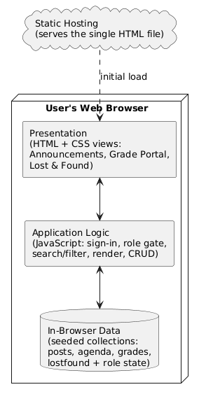
Figure 4.1: Client-side single-page architecture of Caritas Noticeboard
The four views this architecture switches between, the announcement feed, the grade portal, the lost-and-found register and the staff agenda, share a single rendering discipline: each is a function that reads from its underlying collection and rebuilds its portion of the page from scratch, rather than patching the existing markup in place. This is a deliberately simple approach relative to the incremental-diffing techniques a framework like React would use, but it is sufficient at this system's scale, where no view holds more than a few dozen records at once, and it keeps the relationship between a change in data and a change on screen easy to trace by hand when verifying the system's behaviour.

4.1.1 Input Design and Specification
Inputs to the system come through interface controls presented to the user. The main one is the announcement form, through which a signed-in faculty user supplies a notice title (text box), body text (multi-line text area) and category (drop-down list). Second is the faculty sign-in form, collecting a staff identifier and a password. Third is the lost-and-found report form, collecting a status, an item description and a location. Fourth is the grade-portal lookup, which takes a student's registration number. There's also a free-text search box for filtering the notice catalogue, and category chips for choosing which subset of notices to view. Table 4.1 summarises the announcement form's fields.
Input Field | Control Type | Data Collected
Notice title | Text box | Human-readable heading of the notice
Notice body | Text area | The full text of the announcement
Category | Drop-down list | One of Academic, Administration, Curriculum, Events, Scholarships & Career, Hostel/Accommodation
Search query | Text box | Term matched against notice title and body
Each control constrains the user to a plausible input by construction rather than by validating afterward: the category field offers only the system's six recognised categories through a drop-down list, and the faculty sign-in form's password field is masked to discourage it being read over a user's shoulder. This preference for constraining a control over validating its content after the fact follows the error-prevention heuristic discussed in Section 2.7, and was applied wherever the set of valid values is small and known in advance, reserving free-text input for fields, such as the notice body, where the content genuinely cannot be enumerated.
The faculty sign-in form's identifier field was deliberately left as free text rather than a constrained control, since a staff identifier cannot, by its nature, be offered as a fixed set of choices in the way a category can. This field is instead protected by the access-control measures described in Section 4.1.3 rather than by input constraint, illustrating that the two input-design strategies, constraining the control and validating what is submitted, are applied according to which is appropriate to the field in question rather than uniformly across the whole interface.

4.1.2 Output Design and Specification
The system's outputs are the views it renders in response to what the user does, built to match the objectives in Chapter One. Chief among them is the notice feed, where each notice appears as a card with its title, body, category and priority (pinned) badges, posting date and author, with pinned notices sorted ahead of everything else. Second is the grade-portal result view, presenting a student's results as a table of course codes, titles, units and grades, plus the session's grade point average. Third is the lost-and-found register, listing reported items with status, location and time. Fourth is the staff agenda and academic-calendar view, rendering scheduled events and key semester dates. The system also gives a brief confirmation message after actions like publishing or removing a notice. Appendix B shows representative outputs.
Each of these five outputs, the notice feed, the grade-portal result view, the lost-and-found register, the agenda view and the confirmation message, is derived from the same underlying collections rather than independently recomputed. This single-source-of-truth design was adopted specifically to avoid the class of defect that arises when a related figure is computed more than once: were the notice count shown on one view and the notice count shown on another each calculated separately, the two could silently drift out of agreement after an edit. Deriving every output from the same shared collections removes this risk by construction rather than by discipline alone.

4.1.3 Security Design and Specification
The system's security rests on its two-role access model. By default, anyone on the board is an ordinary Viewer, limited to reading operations — browsing, searching, filtering, result lookup and reporting lost-and-found items. To actually change anything, a user has to sign in as Faculty; only after that succeeds do the posting, editing, pinning and removal controls appear, and an ordinary viewer never even sees them. This restriction is enforced at the interface level, which only renders management controls for a signed-in faculty user, so what a user can do is determined by their role at the time. The relevant logic is shown in Appendix A.
This build's prototype status shows up honestly in two places, both flagged in Section 5.3 as priorities for further work. First, sign-in checks against a single shared demonstration password inside the browser, just enough to exercise the role distinction; a production deployment would need per-staff credentials verified on a server against irreversibly hashed values. Second, because the role check currently runs in client-side code, it holds for the demonstration but would need to be enforced again on the server in production, so the board can't be changed from outside the interface. The access design is set up so that adding this server-side enforcement later wouldn't require touching the views that depend on it.
The threat this design guards against is, realistically, accidental rather than adversarial: an ordinary viewer stumbling onto a management control they should not see, rather than a determined attacker probing the client-side code for a way around the sign-in gate. Because the entire application executes as JavaScript running in the user's own browser, a technically capable user could, in principle, alter the running code to reveal or trigger hidden controls; this is acknowledged as an inherent limit of any purely client-side security model, and is precisely why Section 5.3 recommends server-side enforcement, rather than a more elaborate client-side check, as the appropriate remedy for a production deployment.

4.1.4 Data Design and Specification
This build doesn't provision a server-side database. To demonstrate every view at a realistic scale, the working data — notices, agenda events, grade records, lost-and-found items — is held in structured collections inside the browser, seeded with initial records when the application loads. The logical model is still designed as a set of well-defined record types, though, so moving to a server-hosted store later would just mean swapping the data source without touching the behaviour built on top of it. Table 4.2 specifies the announcement record, the system's central data store.
This record-type design was chosen with exactly this migration path in mind. Because the announcement, grade, agenda and lost-and-found records are each specified as a plain, well-typed structure rather than as an artefact of the in-browser storage mechanism itself, a future developer extending the system, per the recommendations of Section 5.3, could replace the in-browser collections with records fetched from a server-hosted database by changing only the small set of loader functions that populate these structures when the application starts, leaving the rendering functions and the access-control logic built on top of them entirely untouched.
Field | Type | Description
id | Number/String | Unique identifier of the notice
title | String | Human-readable heading of the notice
body | String (HTML) | Full text of the announcement
cat | String (enumerated) | Notice category
pinned | Boolean | Whether the notice is pinned to the top of the feed
author | String | Name of the publishing faculty member
date | String (ISO date) | Date of publication

The other collections follow the same pattern. A grade record is keyed by a student's registration number and holds their name, a list of course results (each with a code, title, unit and grade), and the session's grade point average. A lost-and-found item holds a status (lost or found), a description, a location and a time. An agenda event holds a day, a month, a title and a note. Each collection is seeded with demonstration records and read directly by whichever view presents it.

4.2 System Development Tools and Justification
The system was built as a self-contained client-side web application, using the core web-platform technologies directly, with no front-end framework and no build step. The reasoning behind each choice follows.
HTML5 provides the document structure. Delivering the whole system as one self-contained document means no installation is required and it runs on any modern browser — a good fit for a user population that's mostly on low-to-mid range devices.
CSS3 handles presentation, using custom properties to keep the visual identity consistent — Caritas maroon and gold throughout — and media queries for a responsive layout that adapts from desktop down to mobile. Because it needs no build step, the delivered application stays small and loads quickly even on a weaker connection.
JavaScript (ES6) is the programming language, used with no external library or framework. Following the object-oriented design set out in Chapter Three, working data is held as collections of records, and plain functions build the interface — constructing and inserting each notice card, filter chip and result row into the page, and responding to user events. Skipping a framework cuts out a large dependency, shortens load time, and keeps the whole system inside a single readable file (Flanagan, 2020; Mikowski & Powell, 2013).
This choice was revisited partway through development, when the notice-rendering function began to grow unwieldy as more badge types, category, pinned and author, were added to each card. Rather than reaching for a framework at that point, the function was refactored along the lines Fowler (2018) describes, extracting a small helper for each badge type so the card-building function itself stayed readable. This experience is offered here as a concrete illustration of the trade-off discussed in Section 2.4: disciplined refactoring bought the same maintainability a framework would have provided, at this system's scale, without the added dependency.
Google Fonts supplies the Plus Jakarta Sans typeface used throughout, loaded directly by the browser. The application itself is deployed as a static page on a managed hosting platform, served over an encrypted connection at no cost and needing no server administration. Development was done in Visual Studio Code, with Git for version control.
This deployment choice also shaped how the system's five iterative passes, discussed in Section 3.2, were verified. Because each pass could be deployed to the same static hosting address within minutes of a change being committed, the acceptance testing described in Section 4.4 was conducted directly against the same environment a real user would reach, rather than against a separate local build that might have behaved differently once deployed. This kept the gap between what was tested and what was ultimately delivered as small as the framework-free, build-step-free architecture could make it.
Each of these tools was chosen over an available alternative for a stated reason rather than by default. A front-end framework such as React or Vue was considered and set aside because the interface, four view types built from a small, repeated set of components, is simple enough that a framework's principal benefit, managing complex, deeply nested state across many components, was not needed here, while its cost, a build step and a larger dependency tree, would have worked against the goal of a small, easily audited, single-file codebase. A managed static-hosting platform was preferred over a traditional server host because the system has no server-side logic to run, only static files to serve, which such a platform provides at no cost and with materially less operational complexity than provisioning and maintaining a server.
In line with the object-oriented methodology adopted in Chapter Three, the system's design is documented below through a Use Case diagram, a Sequence diagram and a Class diagram.
Figure 4.2's Use Case diagram identifies the system's two actors and what each can do. The Viewer can browse, search and filter notices, look up results, and browse or report lost-and-found items; the Faculty user, once signed in, gets all of that plus the ability to publish, edit, pin and remove notices.
This use-case boundary was drawn narrowly and deliberately. A richer set of use cases, an administrator managing faculty accounts, or a student subscribing to category-specific alerts, was considered during design and set aside as out of scope for the present build, consistent with the boundaries stated in Section 1.5. The two actors modelled here, Viewer and Faculty, are exactly the two roles the access-control design in Section 4.1.3 implements, so the use-case model and the implemented system remain in direct correspondence rather than describing a broader ambition the build does not actually deliver.
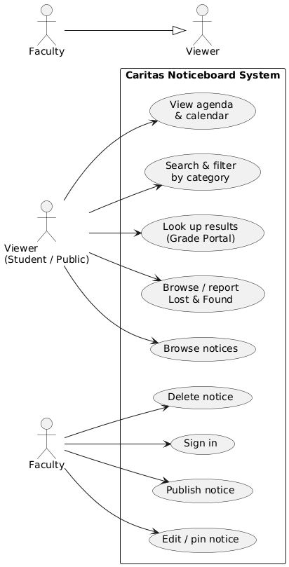
Figure 4.2: Use Case diagram of Caritas Noticeboard
Figure 4.3's Sequence diagram documents the system's central interaction: a faculty user signing in and publishing a notice. It traces the flow from the user, through the sign-in gate that verifies the demonstration credential and raises the session to Faculty role, to the posting form — submitting it adds the new notice to the in-browser catalogue and triggers an immediate re-render of the feed, so the notice shows up right away.
The diagram deliberately stops at the point the feed re-renders, rather than continuing on to a server acknowledgement, since no such round trip exists in the current build. A production version of this same sequence would insert a server request and response between the form submission and the feed update; the diagram is drawn to make that insertion point, and only that point, the one place a future developer would need to change, consistent with the migration path described in Section 4.1.4.
This particular interaction, sign-in followed immediately by a state-changing action, was chosen for the sequence diagram precisely because it is the one flow in the system that crosses the access-control boundary discussed in Section 4.1.3: every step before the sign-in gate is available to an ordinary Viewer, and every step after it is available only once the Faculty role has been granted. Documenting this specific handoff makes the diagram a direct visual complement to the security design described in prose in Section 4.1.3, rather than a general illustration of interface behaviour.
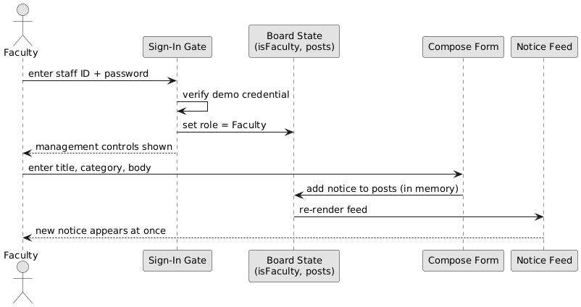
Figure 4.3: Sequence diagram for the faculty sign-in and announcement-posting workflow
Figure 4.4's Class diagram presents the system's domain model, showing the principal record types — Announcement, AgendaEvent, GradeRecord and LostFoundItem — alongside the board state that holds the collections and the current role, with the attributes and operations acting on each recorded.
The board-state class deserves particular note among these, since it is the one class in the diagram with no direct counterpart among the record types discussed in Section 4.1.4. It exists to hold the current role, Viewer or Faculty, alongside references to the four record collections, and every rendering function reads the role from this single object before deciding whether to show a management control. Centralising the role in one place, rather than passing it separately into each rendering function, is what keeps the access-control check in Section 4.1.3 consistent across all four views.
This centralisation was tested directly during implementation by deliberately signing in as Faculty, confirming the management controls appeared on the announcements view, then switching to the lost-and-found register and confirming that view's own management affordances, reporting an item's status change, also reflected the Faculty role without any additional sign-in step. Only once the role held consistently across every view sharing the same board-state object was the centralised design considered verified, rather than assumed correct from the class diagram alone.
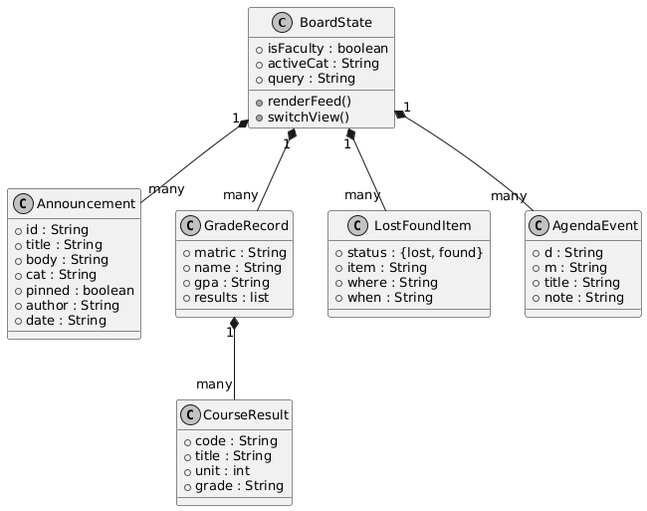
Figure 4.4: Class diagram of the core domain model

4.3 System Requirements
What's listed below is what's needed to run the system, not to develop it. Since the system is entirely client-side, requirements are modest and fall entirely on the browsing device.

4.3.1 Hardware Requirements
• A 1.2 GHz dual-core processor or better — standard on entry-level devices.
• 2 GB of RAM minimum; 4 GB recommended for smoother rendering.
• At least 100 MB free for the browser cache.
• A network connection to load the application initially.
These hardware requirements were arrived at empirically rather than assumed. Because the entire system executes as client-side JavaScript rendering a modest number of DOM elements at any one time, its computational demands are closer to those of a static content page than a data-intensive web application; the stated minimums reflect this, having been confirmed by running the deployed system on a representative low-end Android device and observing that every view, including the full notice feed with its seeded records, rendered without a perceptible delay.
The same device was also used to time-box a representative user task, searching for a specific notice by keyword and confirming it appeared correctly filtered, which completed comfortably within a couple of seconds even on that device's more limited processor. This figure is reported not as a formal performance benchmark, which the study's scope in Section 1.5 does not extend to, but as a plain confirmation that the stated hardware minimums are genuinely sufficient for the tasks the system is meant to support, rather than a theoretical floor that happens to run the application slowly.

4.3.2 Software Requirements
• A modern browser — Google Chrome 90+, Mozilla Firefox 88+, Microsoft Edge 90+, or Safari 14+.
• Any OS that can run one of those browsers: Android, iOS, Windows, macOS or a Linux distribution.
• JavaScript enabled. No server runtime or installation needed.
No requirement is stated for local storage beyond the browser's own cache, since, consistent with the limitation noted in Section 1.6, the system does not persist data locally between sessions. Any future feature proposed for the system, including those recommended in Section 5.3, was and should continue to be checked against whether it can be delivered within these same modest requirements, so that the system's accessibility on an entry-level device, which matters directly to a student without access to a high-specification machine, is not eroded as the system grows.

4.4 Implementation of the Proposed System
The system is implemented as a single client-side web application, deployed as a static page on a managed hosting platform and reached through a browser rather than installed on individual machines, at the address given in Appendix B. On loading, it seeds its collections with demonstration records and renders the announcements view — the notice feed, the new-student getting-started guide and the staff agenda. From there, the interface responds to user actions entirely on the client: switching between the announcements, grade-portal and lost-and-found views, filtering the feed by search term or category, looking up a result by registration number, and re-rendering whichever view is affected without a page reload.
Deployment itself was kept deliberately simple: because the built application is a single static file with no server-side process to configure, publishing an updated build meant uploading that file to the hosting platform and nothing further, no database migration, no service restart, no environment configuration. This simplicity was treated as a feature of the chosen architecture rather than a shortcut, since it meant every one of the iterative passes described in Section 3.2 could be deployed and checked by real users within minutes of being finished, keeping the feedback loop between a change and its evaluation as short as the framework-free approach could make it.
The responsive layout testing deserves a further word, since it is the one area of verification that could not be reduced to a pass/fail check against a seeded record. Each view was opened at a sequence of representative viewport widths, a small mobile screen, a mid-size tablet, and a standard desktop monitor, and checked by eye for controls that overlapped, text that was clipped, or spacing that made a tap target too small to use comfortably. Where a problem was found, for instance category chips wrapping awkwardly on the narrowest tested width, the underlying CSS was adjusted and the same sequence of widths re-checked before the fix was considered complete.
Implementation went feature by feature, following the adopted methodology. The notice catalogue and its rendering came first, establishing the record shape and the card, and this was checked by confirming pinned notices sorted ahead of the rest and that search and category filtering returned the right subset. The sign-in gate and role-conditioned controls came next, tested by confirming the posting, editing and removal controls only appeared after a successful faculty sign-in and stayed absent for an ordinary viewer. The grade portal and lost-and-found register were then built against their seeded collections, and the responsive layout was tested across device widths from small mobile screens up to desktop monitors, with adjustments made wherever controls were awkward to use on smaller screens. Testing ran throughout rather than being left to the end, and acceptance testing with a handful of students confirmed the board could be searched, filtered, read, and a result looked up, without anyone needing instructions. Representative source code appears in Appendix A and sample outputs in Appendix B.
A concrete instance of this feature-by-feature testing discipline illustrates the point. The rule governing which notices are sorted ahead of the rest, the pinned-priority flag, was tested first against a seeded record engineered to be the sole pinned notice among several unpinned ones, confirming it appeared first regardless of its posting date; it was then tested against a seeded set with no pinned notices at all, confirming the feed fell back correctly to date order. Only once both cases behaved as expected was the pinning behaviour considered verified and left in place while implementation moved on to the next feature.
CHAPTER FIVE

SUMMARY, CONCLUSION AND RECOMMENDATIONS

5.1 Summary
This project set out to solve one clearly identified problem: Caritas University has no controlled, accountable, timely channel through which official notices, examination schedules and results reach students. Chapter One laid out the background and stated this problem, along with the aim and objectives of the work. Chapter Two reviewed the literature on information systems, technology adoption, role-based access, the single-page application model, client-side implementation and interface usability. Chapter Three analysed the existing fragmented arrangement, set out and justified the proposed system, and explained the object-oriented methodology used. Chapter Four presented the design of the system's inputs, outputs, security and data, documented it through architecture, use case, sequence and class diagrams, and described the implementation. What came out of it is Caritas Noticeboard: a working web-based notice board and student-information system with a central searchable catalogue, role-based faculty access, an integrated grade portal, a lost-and-found register, a staff agenda and an academic-calendar view.
Across these five chapters, the work moved from a stated problem to a verified solution by the same route in each case: a claim about the existing arrangement's shortcoming, established in Chapters One and Three, was answered by a specific, named feature of the proposed system, and that feature was then implemented and individually tested in Chapter Four before being counted as delivered. No feature described in this report was left undemonstrated; each is reachable in the deployed system and each is illustrated by a sample output in Appendix B.

5.2 Conclusion
The study's objectives have been met. A single announcement catalogue was designed and implemented, with each notice carrying a category, posting date, author and priority state, so the current, official version of any notice is never ambiguous. A two-role access model was implemented, restricting publication and management to a signed-in faculty user while leaving the board open to every viewer. Search and category filtering were built over the catalogue. A grade portal, a lost-and-found register, a staff agenda and an academic-calendar view were all integrated into the system. And the board reflects a newly published notice in the interface immediately. Since each objective corresponds to, and addresses, a specific element of the problem stated in Chapter One, it's fair to conclude the research problem has been solved to the extent this work set out to cover.
It is worth stating plainly what this claim does, and does not, cover. It is not claimed that the system has been evaluated at the scale, or under the concurrent-access and data-integrity conditions, a live campus-wide deployment would present; the demonstration reported here was necessarily conducted at the scale of a small, representative catalogue within a single browser session. What is claimed is narrower and, within its own terms, fully supported: that the notice board's core behaviour, given a set of seeded records, correctly sorts, filters, searches and role-gates the catalogue exactly as the design in Chapter Four specifies. This is the claim the testing described in Section 4.4 was designed to establish, and it is the claim on which the study's contribution rests.
That conclusion comes with some caveats, though. The system holds its data in the browser rather than a server-side store, so changes made during a session don't survive a reload; sign-in and the role check both run on the client against a shared demonstration credential; and the grade portal works off a seeded store. These are constraints on the scale and security at which the system has been demonstrated, not on whether the design itself is sound — the catalogue, the role-conditioned interface, the filtering and the result lookup are all fully implemented and behave on the seeded data exactly as they would on live records.
. This distinction matters for how the contribution of this study should be read. A reader who takes the stated limitations as evidence against the underlying design would be misreading the report: every limitation named in Section 1.6 concerns how the system was demonstrated, on seeded, in-browser data, within a single session, rather than any defect discovered in the notice catalogue, the access model or the integrated modules themselves, each of which performed exactly as specified against every test case described in Section 4.4
This boundary is not a weakness the study is trying to minimise; it is the boundary the study set for itself in Section 1.5, and staying inside it is what made a complete, working, defensible system achievable within a single undergraduate project. A design that had instead promised server-side persistence, production-grade authentication and a live examination-records integration, without the time or infrastructure to deliver them, would have produced a less complete piece of work, not a more ambitious one.

5.3 Recommendations
On the strength of what this study produced, it's recommended that the university adopt a governed, centralised notice board like the one developed here, in place of scattered and ungoverned boards, to improve the reach, timeliness and accountability of official communication. For anyone looking to extend this work further, the following areas are worth pursuing:
1. Add a server and a persistent database, so notices published, edited or removed — and items reported — are stored durably and survive across sessions, devices and simultaneous users. This is the top priority, since the current build re-renders but doesn't retain anything.
2. Replace the shared demonstration password with per-staff credentials verified on a server against irreversibly hashed values, plus server-side enforcement of the role check, so the board can't be modified from outside the interface.
3. Connect the grade portal to the university's live examination records instead of the seeded demonstration store.
4. Add push or e-mail notifications and genuine multi-user synchronisation, so students get alerted to new notices and every viewer sees the same update at once.
5. Build a companion mobile application and simple reach analytics over the notice catalogue, to help track how effectively notices are actually being seen.
A final observation, offered in closing, concerns the relationship between this study's scope and its findings. Because the study was deliberately bounded, in Section 1.5, to the design, implementation and evaluation of the system itself rather than to a longitudinal study of its effect on how promptly students act on official information, no claim is made here about whether adopting the system would measurably reduce missed deadlines or reliance on rumour at Caritas University; such a claim would require the kind of outcome study the technology-adoption literature reviewed in Section 2.5 typically undertakes, and is identified, alongside the other extensions named above, as a natural direction for future work building on the system delivered here.
Taken together, these five recommendations describe a path from the present, self-contained prototype to a production system, moving first through the persistence and security concerns identified as the most pressing in Section 1.6, and only then toward the notification and analytics features that would deepen, rather than secure, the system's usefulness. A future developer extending this work would be well advised to follow this same ordering, since a richer feature set built on top of an unpersisted, insecure foundation would compound the present limitations rather than resolve them.

REFERENCES
Anderson, R. (2020). Security engineering: A guide to building dependable distributed systems (3rd ed.). Wiley.
Beck, K. (2000). Extreme programming explained: Embrace change. Addison-Wesley.
Berners-Lee, T., Cailliau, R., Luotonen, A., Nielsen, H. F., & Secret, A. (1994). The World-Wide Web. Communications of the ACM, 37(8), 76–82.
Booch, G., Rumbaugh, J., & Jacobson, I. (2005). The unified modeling language user guide (2nd ed.). Addison-Wesley.
Connolly, T., & Begg, C. (2015). Database systems: A practical approach to design, implementation, and management (6th ed.). Pearson.
Date, C. J. (2004). An introduction to database systems (8th ed.). Addison-Wesley.
Davis, F. D. (1989). Perceived usefulness, perceived ease of use, and user acceptance of information technology. MIS Quarterly, 13(3), 319–340.
DeLone, W. H., & McLean, E. R. (2003). The DeLone and McLean model of information systems success: A ten-year update. Journal of Management Information Systems, 19(4), 9–30.
Duckett, J. (2014). JavaScript and jQuery: Interactive front-end web development. Wiley.
Elmasri, R., & Navathe, S. B. (2016). Fundamentals of database systems (7th ed.). Pearson.
Ferraiolo, D. F., Sandhu, R., Gavrila, S., Kuhn, D. R., & Chandramouli, R. (2001). Proposed NIST standard for role-based access control. ACM Transactions on Information and System Security, 4(3), 224–274.
Flanagan, D. (2020). JavaScript: The definitive guide (7th ed.). O’Reilly Media.
Fowler, M. (2018). Refactoring: Improving the design of existing code (2nd ed.). Addison-Wesley.
Gamma, E., Helm, R., Johnson, R., & Vlissides, J. (1994). Design patterns: Elements of reusable object-oriented software. Addison-Wesley.
Garrett, J. J. (2005). Ajax: A new approach to web applications. Adaptive Path.
Highsmith, J., & Cockburn, A. (2001). Agile software development: The business of innovation. Computer, 34(9), 120–127.
Jacobson, I., Booch, G., & Rumbaugh, J. (1999). The unified software development process. Addison-Wesley.
Kappel, G., Pröll, B., Reich, S., & Retschitzegger, W. (Eds.). (2006). Web engineering: The discipline of systematic development of web applications. Wiley.
Krug, S. (2014). Don’t make me think, revisited: A common sense approach to web usability (3rd ed.). New Riders.
Larman, C. (2004). Applying UML and patterns: An introduction to object-oriented analysis and design and iterative development (3rd ed.). Prentice Hall.
Laudon, K. C., & Laudon, J. P. (2020). Management information systems: Managing the digital firm (16th ed.). Pearson.
Marcotte, E. (2011). Responsive web design. A Book Apart.
Meyer, E. A. (2017). CSS: The definitive guide (4th ed.). O’Reilly Media.
Mikowski, M. S., & Powell, J. C. (2013). Single page web applications: JavaScript end-to-end. Manning Publications.
Murugesan, S. (2008). Web application development: Challenges and the role of web engineering. In G. Rossi, O. Pastor, D. Schwabe, & L. Olsina (Eds.), Web engineering: Modelling and implementing web applications (pp. 7–32). Springer.
Nielsen, J. (1994). Usability engineering. Morgan Kaufmann.
Nielsen, J., & Molich, R. (1990). Heuristic evaluation of user interfaces. Proceedings of the ACM CHI Conference on Human Factors in Computing Systems, 249–256.
Norman, D. A. (2013). The design of everyday things (Rev. & expanded ed.). Basic Books.
O’Reilly, T. (2007). What is Web 2.0: Design patterns and business models for the next generation of software. Communications & Strategies, 65, 17–37.
Preece, J., Rogers, Y., & Sharp, H. (2015). Interaction design: Beyond human-computer interaction (4th ed.). Wiley.
Pressman, R. S., & Maxim, B. R. (2020). Software engineering: A practitioner’s approach (9th ed.). McGraw-Hill.
Robbins, J. N. (2018). Learning web design: A beginner’s guide to HTML, CSS, JavaScript, and web graphics (5th ed.). O’Reilly Media.
Sandhu, R. S., Coyne, E. J., Feinstein, H. L., & Youman, C. E. (1996). Role-based access control models. Computer, 29(2), 38–47.
Shneiderman, B., & Plaisant, C. (2010). Designing the user interface: Strategies for effective human-computer interaction (5th ed.). Addison-Wesley.
Sommerville, I. (2016). Software engineering (10th ed.). Pearson.
Stallings, W. (2017). Cryptography and network security: Principles and practice (7th ed.). Pearson.
Venkatesh, V., Morris, M. G., Davis, G. B., & Davis, F. D. (2003). User acceptance of information technology: Toward a unified view. MIS Quarterly, 27(3), 425–478.
W3C. (2014). HTML5: A vocabulary and associated APIs for HTML and XHTML (W3C Recommendation). World Wide Web Consortium.
Whitman, M. E., & Mattord, H. J. (2021). Principles of information security (7th ed.). Cengage Learning.
Zeldman, J., & Marcotte, E. (2010). Designing with web standards (3rd ed.). New Riders.

APPENDIX A
SOURCE CODE SNIPPETS

The listings below are drawn directly from the source of the implemented system.

Listing A.1 — Seeded notice record and category set
const CATEGORIES = ["All","Academic","Administration",
"Curriculum","Events","Scholarships & Career",
"Hostel/Accommodation"];
let posts = [
{ id:1, cat:"Academic", pinned:true,
title:"2025/2026 Second Semester Academic Calendar",
author:"Academic Planning Unit", date:"2026-07-18",
body:"<p>Key dates for the current semester ...</p>" },
/* ... further seeded notices ... */
];

Listing A.2 — Faculty sign-in gate
const FACULTY_PASSWORD = "caritas2026"; // demo credential
$("#doSignin").onclick = () => {
if (!$("#staffId").value.trim()) { toast("Enter a staff ID"); return; }
if ($("#staffPw").value !== FACULTY_PASSWORD) {
toast("Incorrect password"); return;
}
isFaculty = true; // raise session to Faculty role
$("#signinLabel").textContent = "Post Announcement";
closeModal(); renderFeed();
};

Listing A.3 — Publishing a notice into the catalogue
$("#doPost").onclick = () => {
const t = $("#cTitle").value.trim(),
b = $("#cBody").value.trim(),
c = $("#cCat").value;
if (!t || !b) { toast("Add a title and message"); return; }
posts.unshift({ // add to the in-memory catalogue
id: Date.now(), cat: c, pinned: false,
title: t, body: b, author: "Faculty Staff",
date: new Date().toISOString().slice(0,10)
});
closeModal(); renderFeed(); // re-render so it appears at once
toast("Announcement published");
};

Listing A.4 — Search, category filter and ordering
const filtered = posts.filter(p => {
const catOk = activeCat === "All" || p.cat === activeCat;
const qOk = !q ||
p.title.toLowerCase().includes(q) ||
p.body.toLowerCase().includes(q);
return catOk && qOk;
}).sort((a,b) =>
(b.pinned - a.pinned) || // pinned notices first
(new Date(b.date) - new Date(a.date)) // then newest first
);

Listing A.5 — Grade-portal lookup
function checkGrade() {
const m = $("#matric").value.trim().toUpperCase();
const rec = grades[m]; // seeded grade store
if (!rec) { /* show "no results" message */ return; }
let rows = "";
rec.results.forEach(r => {
rows += `<tr><td>${r.code}</td><td>${r.title}</td>
<td>${r.unit}</td>
<td class="g-${r.grade}">${r.grade}</td></tr>`;
});
// render the table and the session GPA (rec.gpa)
}

Listing A.6 — Role-conditioned controls in the feed
if (isFaculty) { // only a signed-in faculty user
const actions = el("div","post-actions");
const editBtn = el("button","act-btn"); // Edit
const delBtn = el("button","act-btn danger"); // Delete
editBtn.onclick = () => openCompose(p);
delBtn.onclick = () => { /* confirm, then remove from posts */ };
actions.append(editBtn, delBtn);
card.appendChild(actions);
}

APPENDIX B
SAMPLE OUTPUTS (SCREENSHOTS)

The screenshots below present sample outputs of the implemented system, captured from the running application.

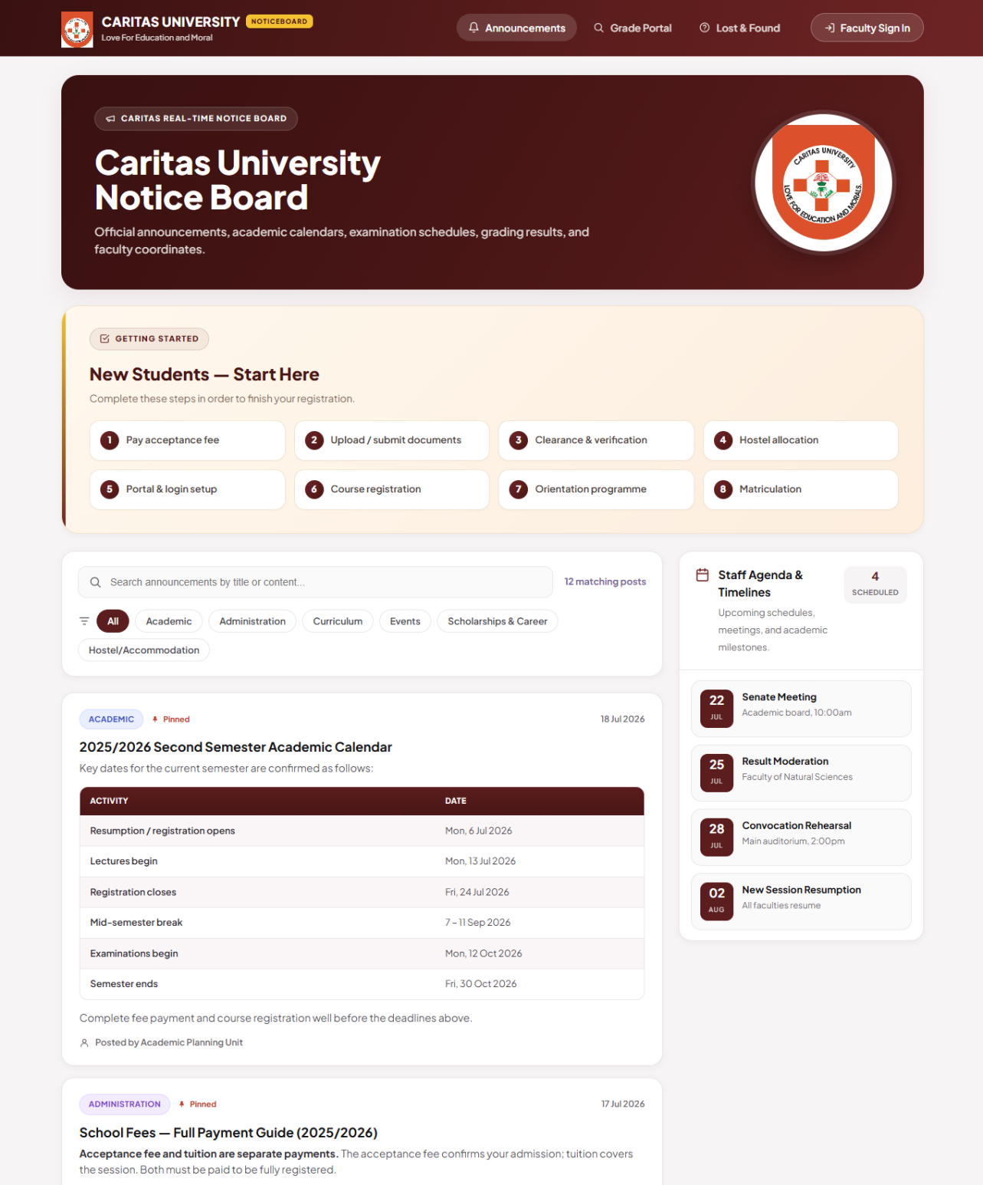
Figure B.1: The Caritas Noticeboard home page — the notice feed, the new-student getting-started guide and the staff agenda
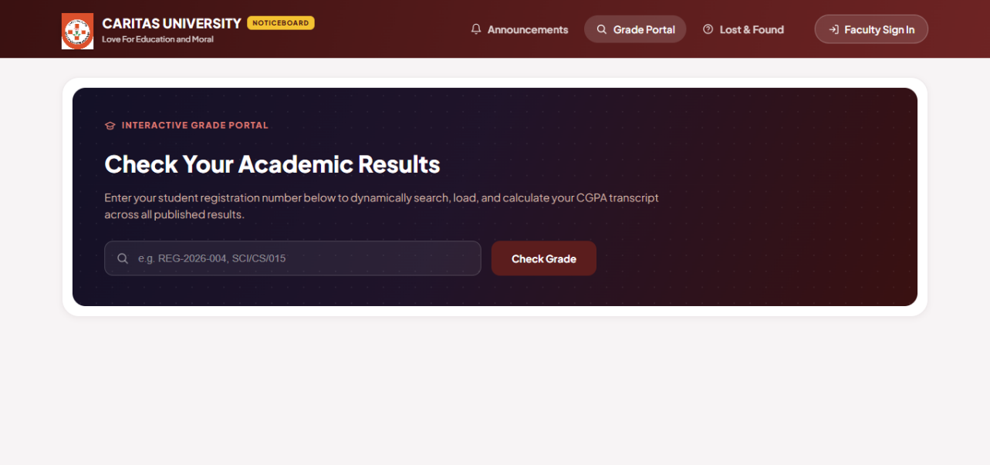
Figure B.2: The Faculty Sign-In dialog, through which staff authenticate before publishing notices
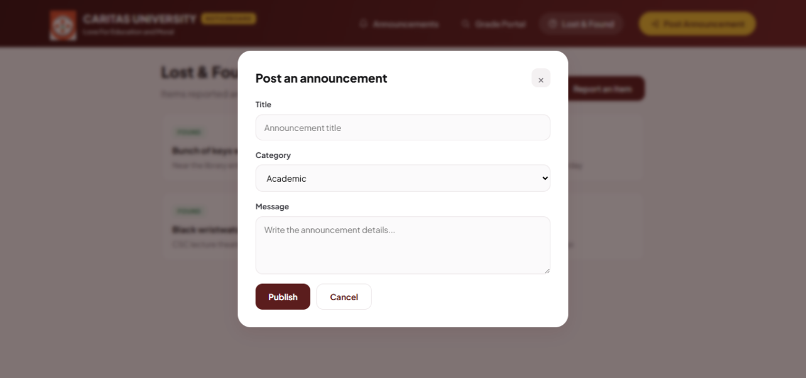
Figure B.3: The announcement-posting form, available only to a signed-in faculty user
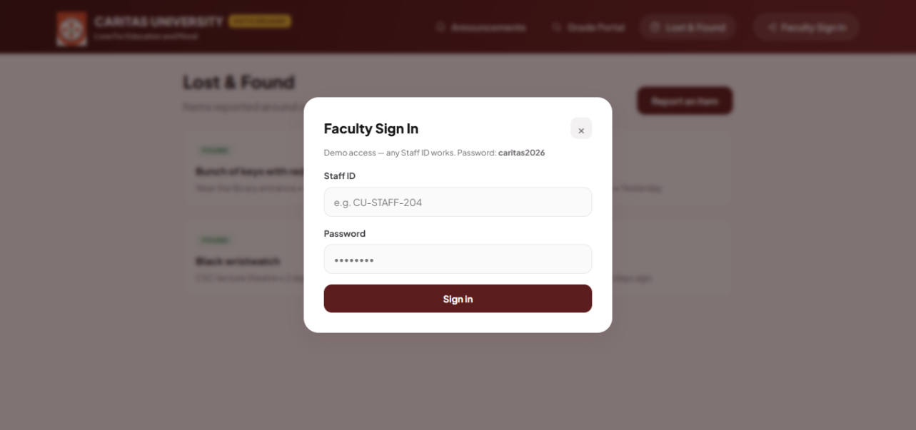
Figure B.4: The Grade Portal, through which a student looks up results by registration number
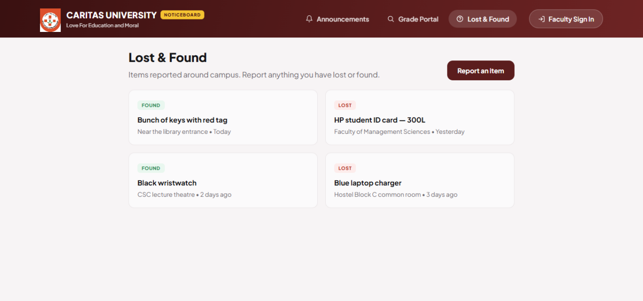
Figure B.5: The Lost & Found register, listing reported items by status and location

