BrandVault: A Web-Based Brand Identity and Digital Asset Management System with Role-Based Governance
(A Case Study of Aurelia Brands Limited)
Project Report
By
Ohagbara, Pascal
CS/DE/2023/1446
Submitted To
The Department of Computer Science,
Faculty of Natural Sciences,
Caritas University, Amorji-Nike, Enugu
In Partial Fulfilment of the Requirements for the Award of a Bachelor of Science (B.Sc) Degree in Computer Science
July, 2026

Declaration
I, Ohagbara, Pascal, with registration number CS/DE/2023/1446, hereby declare that this project titled "BrandVault: A Web-Based Brand Identity and Digital Asset Management System with Role-Based Governance" is my original research work carried out under the supervision of Mr. Abundance Akpan of the Department of Computer Science, Caritas University, Amorji-Nike, Enugu. I further declare that this work has not been presented, either in whole or in part, to any other institution for the award of any other qualification, and that all sources of information consulted have been duly acknowledged.
........................................................ .....................................
Ohagbara, Pascal Date
(CS/DE/2023/1446)

Approval
We have read, examined and found this project titled "BrandVault: A Web-Based Brand Identity and Digital Asset Management System with Role-Based Governance" (A Case Study of Aurelia Brands Limited), carried out by Ohagbara, Pascal with registration number CS/DE/2023/1446, to be satisfactory and acceptable for the award of a Bachelor of Science (B.Sc) degree in Computer Science of Caritas University, Amorji-Nike, Enugu, and hence we have caused our names and signatures to appear as follows:
........................................................ .....................................
Mr. Abundance Akpan Date
(Project Supervisor)
........................................................ .....................................
Mr. Ugwu, Ejike Date
(Head of Department)
........................................................ .....................................
Date
(External Examiner)

Dedication
This project is dedicated to God Almighty, the source of all wisdom, knowledge and understanding, whose grace sustained me throughout the course of this programme; and to my family, whose sacrifice, encouragement and unfailing support made this academic journey possible.

Acknowledgements
I extend my sincere gratitude to God Almighty for the strength, wisdom and good health that sustained me throughout the duration of this project.
My profound appreciation goes to my Project Supervisor, Mr. Abundance Akpan, whose guidance, patience and constructive criticism shaped this work from its conception to its completion. His willingness to review my progress at every stage of the work is deeply appreciated.
I am grateful to the Head of the Department of Computer Science, Mr. Ugwu, Ejike, for his leadership and support. My appreciation likewise goes to Prof. Arinze Nwaeze, Dr. Henry Nweke and Dr. Ugochukwu Nwankwo, and to all the other lecturers of the Department of Computer Science, Caritas University, Amorji-Nike, Enugu, whose teaching over the course of this programme provided the foundation upon which this project was built.
Finally, I acknowledge my family, friends and colleagues for their moral and financial support, and for their steadfast encouragement during the development of this system. To everyone who contributed technically, financially or morally to the success of this work, I remain deeply grateful.

Abstract
This work reported on BrandVault, a web-based brand identity and digital asset management system developed by Ohagbara Pascal for organisations maintaining an in-house creative team. It analysed the fragmented storage of brand assets across scattered folders and messaging tools, and used the findings to design a centralised repository enforcing role-based access, an approval workflow and an activity audit trail. The system was designed using the Object-Oriented Analysis and Design Methodology and was implemented in React with TypeScript on a Node.js and Express server, with persistence through structured JSON storage.

Table of Contents
Title Page i
Declaration ii
Approval iii
Dedication iv
Acknowledgements v
Abstract vi
Table of Contents vii
CHAPTER ONE: INTRODUCTION 1
1.1 Background of the Study 1
1.2 Statement of the Problem 1
1.3 Aim and Objectives of the Study 1
1.4 Significance of the Study 2
1.5 Scope of the Study 2
1.6 Limitations of the Study 3
CHAPTER TWO: LITERATURE REVIEW 4
CHAPTER THREE: SYSTEM ANALYSIS AND METHODOLOGY 6
3.1 Data Gathering 6
3.2 Research Methodology and Justification 6
3.3 System Analysis 6
3.3.1 Analysis of the Existing System 6
3.3.2 Analysis of the Proposed System 7
3.4 Justification of the Proposed System 7
CHAPTER FOUR: SYSTEM DESIGN AND IMPLEMENTATION 9
4.1 Design and Specification of the Proposed System 9
4.1.1 Input Design and Specification 9
4.1.2 Output Design and Specification 9
4.1.3 Security Design and Specification 10
4.1.4 Database Design and Specification 10
4.2 System Development Tools and Justification 11
4.3 System Requirements 12
4.3.1 Hardware Requirements 12
4.3.2 Software Requirements 12
4.4 Implementation of the Proposed System 12
CHAPTER FIVE: SUMMARY, CONCLUSION AND RECOMMENDATIONS 13
5.1 Summary 13
5.2 Conclusion 13
5.3 Recommendations 13
References 15
Appendix A - Source Code Snippets 16
Appendix B - Sample Outputs (Screenshots) 18

Chapter One
Introduction

1.1 Background of the Study
A brand is the visual and communicative identity through which an organisation is recognised by its customers, partners and the public. This identity is carried by a large and steadily growing collection of digital assets: logos and icons, colour and typography specifications, campaign photography, corporate documents, and website and graphic templates. For any organisation that markets itself actively, these assets are valuable property that must be produced, approved, distributed and reused consistently across every channel.
In many organisations that operate an in-house creative team, these brand assets are not kept in any single, governed place. They accumulate instead across personal computers, shared drive folders, email attachments and instant-messaging conversations. As the volume of assets grows and the number of people who touch them increases, this scattered arrangement produces recurring problems: staff are unsure which version of a logo is current, unapproved or outdated material finds its way into public use, and there is no reliable record of who uploaded, changed or approved a given file. It was the prevailing circumstance of this fragmentation, observed in the day-to-day operations of a mid-sized brand-driven company, that prompted the development of the system reported in this project.
BrandVault is proposed as a centralised, web-based response to this situation. Rather than treating brand files as loose documents in a shared folder, it treats them as governed records in a single repository where every asset carries a category, a set of descriptive tags, an approval status and a full history of the actions performed upon it. In doing so, the system aims to bring order, accountability and consistency to the management of an organisation's brand identity.

1.2 Statement of the Problem
Organisations with an in-house creative team lack a single, controlled repository for their brand assets. Because files are stored across scattered and ungoverned locations, the organisation cannot reliably guarantee that only approved, current brand material is distributed and used. This single problem - the absence of controlled, accountable storage and approval for brand assets - gives rise to version confusion, the circulation of off-brand material, and the loss of any audit trail of who did what to each asset.

1.3 Aim and Objectives of the Study
The aim of this project is to design and implement a centralised, web-based brand identity and digital asset management system that stores brand assets in one governed repository and controls their distribution through role-based access and an approval workflow. The specific objectives, each aimed at mitigating the problem stated in Section 1.2, are:
- To design a single repository in which every brand asset is catalogued with a category, descriptive tags, file metadata and an approval status, so that the current, approved version of any asset can be identified without ambiguity.
- To implement a role-based access control scheme distinguishing Administrator, Editor and Viewer users, so that the ability to upload, approve and delete assets is restricted to appropriately authorised staff.
- To implement an approval workflow in which assets contributed by Editors remain in a pending state until an Administrator approves or archives them, so that only vetted material becomes generally available.
- To implement an activity audit trail that records every upload, approval, archival, deletion, role change and download, so that accountability for each action is preserved.
- To provide a dashboard that summarises the state of the repository, so that the organisation can monitor its brand assets at a glance.

1.4 Significance of the Study
When completed, this work contributes a practical tool for preserving the integrity of an organisation's brand. By consolidating scattered files into one governed repository, the system removes the ambiguity that leads staff to distribute outdated or incorrect assets. The following points further underline the importance of the study:
- Brand consistency is strengthened, because every distributed asset passes through an approval step before it becomes generally visible.
- Accountability is improved, because the activity log provides a continuous record of who uploaded, approved, archived, deleted or downloaded each asset.
- Operational efficiency is increased, because staff can search and filter a single catalogue rather than hunting through disconnected folders and message threads.
- The work also serves as a reference for students and developers interested in role-based governance, file handling and audit logging in modern web applications.

1.5 Scope of the Study
This project is targeted at developing a functionally effective, web-based brand asset management system that runs in a standard web browser. Its scope covers user authentication by profile selection, three-tier role-based access control, the upload and cataloguing of brand assets across defined categories, an approval and archival workflow, asset search and filtering, file download, a live activity audit trail, an analytics dashboard, and the presentation of static brand references for colour and typography. The system is intended for use by an organisation's internal creative and marketing team.

1.6 Limitations of the Study
The following factors constrained the scope of the work. Authentication is implemented through profile selection rather than full password-based credential verification, which was deemed sufficient for the controlled internal setting the system targets. Persistence is handled through structured JSON files on the server rather than a relational database management system, which places practical limits on concurrent write performance at very large scale. Finally, the study was constrained by the time available within the approval period of study, which focused development on the core governance features described above rather than on peripheral capabilities.

Chapter Two
Literature Review
This chapter reviews previously published work relevant to the management of digital brand assets, the control of access to shared information systems, and the auditing of user actions. It relates the main ideas of these works to one another and to the present project, on whose groundwork the current system is based.
The management of an organisation's reusable creative files is commonly discussed under the heading of Digital Asset Management (DAM). Rosenblatt (2019) describes digital asset management as the practice of organising, storing and retrieving rich media files together with the metadata that describes them, and argues that the value of such a system lies less in raw storage than in the structured metadata and controlled access that surround each file. This position is directly relevant to the present work, whose catalogue records a category, tags and status for every asset rather than storing files as anonymous documents.
The specific concern with keeping an organisation's identity consistent across channels is addressed in the branding literature. Wheeler (2018) contends that a brand is sustained not by its logo alone but by the disciplined and repeated application of an agreed set of visual standards, and that inconsistency erodes recognition and trust. The implication for a software system is that merely storing assets is insufficient; the system must also govern which assets are sanctioned for use. The approval workflow implemented in the present project follows directly from this idea.
The mechanism by which the present system restricts sensitive operations to authorised users is Role-Based Access Control (RBAC). In the model formalised by Sandhu, Coyne, Feinstein and Youman (1996), permissions are assigned to roles rather than to individual users, and users acquire permissions by being assigned to roles. This indirection simplifies administration and makes the security posture of a system easier to reason about. The present project applies this principle through its Administrator, Editor and Viewer roles, each of which carries a distinct and fixed set of permissions.
The value of recording user actions is emphasised in the literature on system accountability. Whitman and Mattord (2021) observe that an audit trail - a chronological record of the activities performed within a system - is a foundational control for accountability, enabling an organisation to establish who performed a given action and when. The activity log maintained by the present system, which records every consequential action against an asset or user, is a practical realisation of this control.
On the technical side, the present system is built as a single-page application. Banks and Porcello (2020) describe the component-based model of the React library, in which user interfaces are decomposed into self-contained components whose rendered output is a function of their current data, or state. This model underlies the structure of the present system's interface, whose panels are implemented as independent components driven by shared application state. The server that supports these components is built with the Express framework, which Brown (2019) presents as a minimal and flexible foundation for defining the routes of a web application programming interface.
Taken together, these works establish that an effective brand asset system must combine structured storage (Rosenblatt, 2019), enforced brand discipline (Wheeler, 2018), role-based restriction of sensitive actions (Sandhu et al., 1996) and a dependable audit trail (Whitman & Mattord, 2021), realised on a modern component-based web stack (Banks & Porcello, 2020; Brown, 2019). The present project draws these threads together into a single implemented system, which the following chapters analyse, design and describe.

Chapter Three
System Analysis and Methodology

3.1 Data Gathering
The data used to inform the design of this system were gathered through direct observation and through the study of documentation. Observation of how brand files are handled within a mid-sized brand-driven organisation revealed the day-to-day practices that the system seeks to improve: the storing of assets in personal folders and shared drives, the exchange of files by email and messaging, and the informal, verbal manner in which approvals were sought and granted. This observation was supplemented by a review of published documentation on digital asset management, role-based access control and audit logging, as set out in Chapter Two. Together, these sources established both the problems to be solved and the accepted principles for solving them.

3.2 Research Methodology and Justification
The methodology adopted for this work is the Object-Oriented Analysis and Design Methodology (OOADM). Under this methodology the problem domain is modelled as a set of collaborating objects, each with its own data and behaviour, and the system is designed in terms of the classes of these objects and the interactions between them. OOADM was chosen for three reasons. First, the problem domain maps naturally onto well-defined entities - assets, users and activities - each with clear attributes and operations, which is precisely the kind of domain OOADM was devised to model. Second, the system was built iteratively, adding and refining features in successive passes rather than in one rigid sequence, and the object-oriented approach accommodates such iterative refinement more comfortably than a strictly linear methodology such as the Waterfall model. Third, the chosen implementation technologies are themselves object- and component-oriented, so that an object-oriented design translates directly into the structures of the built system. In accordance with this methodology, the Use Case, Sequence and Class diagrams that document the design are presented in Chapter Four under Section 4.2.

3.3 System Analysis

3.3.1 Analysis of the Existing System
The existing system is manual and fragmented in character. Brand assets are stored across a combination of personal computers, shared cloud folders, email attachments and instant-messaging conversations. When a member of the creative team produces or revises an asset, the file is placed wherever is locally convenient and circulated to colleagues on request. Approval of an asset, where it occurs at all, is sought informally and is not recorded. There is no central catalogue, no defined notion of an asset's approval status, and no log of the actions performed upon any file.
This manner of operation gives rise to a number of drawbacks:
- Version confusion, since several copies of an asset may exist in different locations with no authoritative indication of which is current.
- Circulation of off-brand material, since there is no enforced step at which an asset is vetted before it becomes available for use.
- Absence of accountability, since no record is kept of who uploaded, altered, approved or removed a file.
- Inefficient retrieval, since locating a particular asset requires searching through disconnected folders and message histories.
- Uncontrolled access, since any person with access to a shared folder may add, change or delete its contents without restriction.

3.3.2 Analysis of the Proposed System
The proposed system, BrandVault, replaces this fragmented arrangement with a single, governed, web-based repository. Every brand asset is uploaded into one catalogue and recorded with a category, a set of descriptive tags, its file metadata and an explicit approval status. Access to the system is governed by three roles. A Viewer may browse, search and download approved assets and view the dashboard and brand references. An Editor may additionally upload new assets, which enter the system in a pending state. An Administrator holds full authority: to approve or archive pending assets, to delete assets, and to create users and change their roles. Every consequential action is written to an activity log, producing a continuous audit trail. A dashboard presents the current composition of the repository and its most recent activity. The major features of the proposed system are therefore its central catalogue, its role-based access control, its approval workflow, its audit trail and its analytics dashboard. The chief benefits are the elimination of version confusion, the prevention of off-brand distribution, the restoration of accountability, and markedly more efficient retrieval of assets.

3.4 Justification of the Proposed System
The proposed system is justified as the appropriate solution to the problem because it addresses each of the identified drawbacks directly and at their root. Version confusion is removed because a single catalogue holds one authoritative record per asset, carrying an unambiguous status. Off-brand distribution is prevented because the approval workflow interposes a mandatory vetting step between contribution and general availability. Accountability is restored because the audit trail records every action and the user who performed it. Retrieval is made efficient because a single searchable, filterable catalogue replaces the scattered stores of the existing arrangement. Uncontrolled access is eliminated because role-based access control confines each sensitive operation to users who are authorised to perform it. Because every drawback of the existing system is met by a corresponding feature of the proposed system, the proposed system is the well-founded solution to the stated problem.

Chapter Four
System Design and Implementation

4.1 Design and Specification of the Proposed System
This section describes the principal design processes of the system: the design of its inputs, its outputs, its security and its data store. The overall structure of the system follows a three-tier arrangement in which a browser-based presentation tier communicates with an application tier that, in turn, reads from and writes to a data tier. This arrangement is illustrated in Figure 4.1.
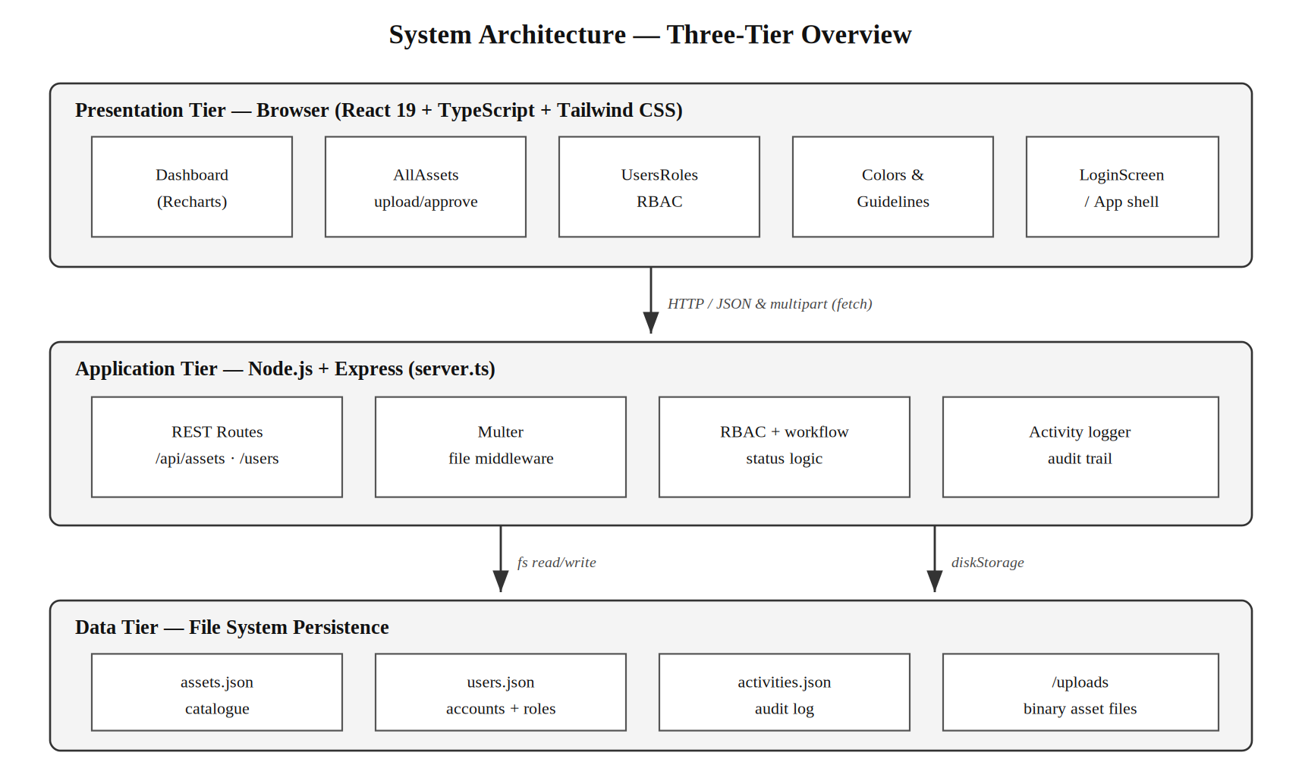
Figure 4.1: Three-tier system architecture of BrandVault

4.1.1 Input Design and Specification
The inputs to the system are collected through interface controls presented to the user. The principal input is the asset upload form, which combines a drag-and-drop file selection area with text fields and selection controls. Through this form the system collects the asset file itself, a display name (text box), a system category (drop-down list), and a set of descriptive tags (tag-entry field). A second input form collects the details of a new user: full name (text box), email address (text box) and access role (drop-down list). A search box accepts free text used to filter the catalogue, and status tabs accept the user's choice of which subset of assets to view. The devices required for input are a standard keyboard, a pointing device and, for file selection, access to the user's local file system. The input fields of the asset upload form are summarised in Table 4.1.
Table 4.1: Input fields of the asset upload form
Input Field | Control Type | Data Collected
Asset file | Drag-and-drop / file browser | The binary brand asset to be stored
Asset display name | Text box | Human-readable name of the asset
System category | Drop-down list | Logo, image, document, website- or graphic-template
Asset tags | Tag-entry field | Descriptive keywords for search
Search query | Text box | Term matched against name, tags, extension, uploader

4.1.2 Output Design and Specification
The outputs of the system are the views it renders in response to user actions, designed to be consistent with the objectives stated in Chapter One. The principal output is the asset repository view, in which each asset is presented as a card bearing its preview or file-type icon, its name, size and uploader, its category and status badges, and its descriptive tags. A second output is the dashboard, which presents summary statistics - the total number of assets and the counts of approved, pending and downloaded assets - together with a chart of asset distribution by category and a feed of recent activity. A third output is the users-and-roles table, which lists each team member with their role and join date. A fourth is the activity feed itself, which renders the audit trail as a chronological list of actions. The dashboard output is shown in Appendix B.

4.1.3 Security Design and Specification
The security of the system rests principally on role-based access control. Each user is assigned exactly one of three roles - Administrator, Editor or Viewer - and the operations available to a user are determined by that role. Viewers are confined to reading operations: browsing, searching, viewing and downloading. Editors are additionally permitted to upload assets, but any asset they contribute is created with a pending status and does not become generally visible until an Administrator approves it. Administrators alone may approve or archive assets, delete assets, and create users or alter their roles. These restrictions are enforced at the level of the interface, which presents each user only with the controls appropriate to their role, and are reflected in the design of the application tier, which sets an uploaded asset's initial status according to the uploader's role. The relevant server logic is shown in Appendix A.

4.1.4 Database Design and Specification
The system persists its data in three structured JSON collections held on the server, each functioning as a table of records: an assets collection, a users collection and an activities collection. Uploaded binary files are stored separately in a dedicated uploads directory, with each asset record holding a reference to its stored file. The fields of the assets collection, which is the central store of the system, are specified in Table 4.2.
Table 4.2: Specification of the assets collection
Field | Type | Description
id | String | Unique identifier of the asset record
name | String | Human-readable display name
category | String (enumerated) | Asset category
tags | String array | Descriptive keywords for search
size | Number | File size in bytes
extension | String | File extension
uploadedBy | String | Name of the contributing user
uploadedAt | String (ISO date) | Timestamp of upload
status | String (enumerated) | Approved, Pending or Archived
url | String | Reference to the stored file

4.2 System Development Tools and Justification
The system was developed using a modern JavaScript and TypeScript technology stack. The presentation tier was built with the React library, using the TypeScript language for type safety and the Tailwind CSS framework for styling; the Recharts library was used to render the dashboard's charts, and the application was assembled and served in development by the Vite build tool. The application tier was built with the Node.js runtime and the Express framework, with the Multer middleware handling file uploads. Persistence was implemented through structured JSON files managed with Node's file-system module. React and TypeScript were chosen because their component model and static typing suit the construction of a structured, multi-panel interface; Express and Multer were chosen for their directness in defining a web interface and handling file uploads; and JSON-file persistence was chosen for its simplicity and transparency at the scale the system targets. In keeping with the object-oriented methodology adopted in Chapter Three, the design of the system is documented below through a Use Case diagram, a Sequence diagram and a Class diagram.
The Use Case diagram in Figure 4.2 identifies the actors of the system and the operations available to each. It shows how the Viewer, Editor and Administrator roles form an increasing hierarchy of capability, with the Editor inheriting the Viewer's operations and the Administrator inheriting the Editor's.
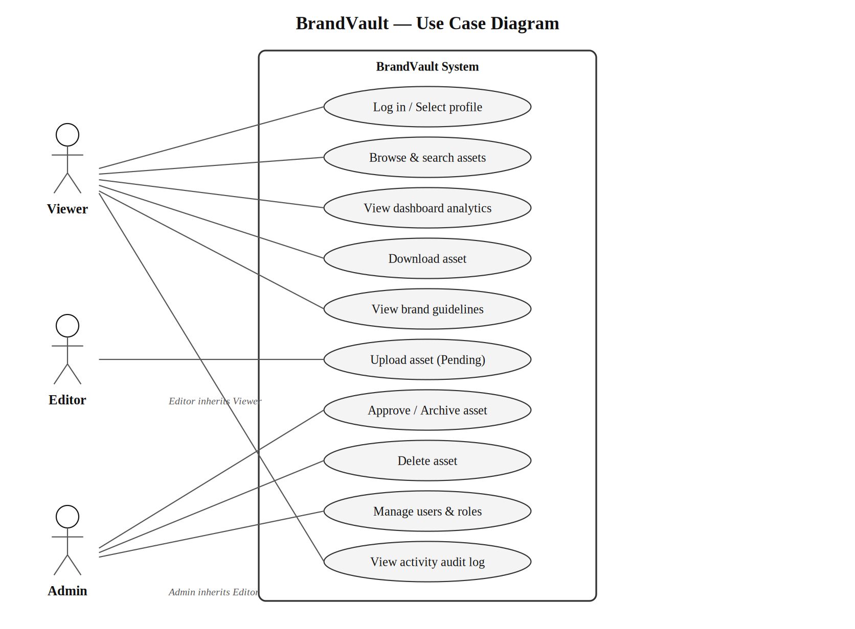
Figure 4.2: Use Case diagram of BrandVault
The Sequence diagram in Figure 4.3 documents the central interaction of the system: the upload of an asset and its subsequent approval. It traces the flow of messages from the user through the React client and the Express interface to the file-storage middleware and the JSON store, showing how an asset's status is set according to the uploader's role and how each step is written to the audit trail.
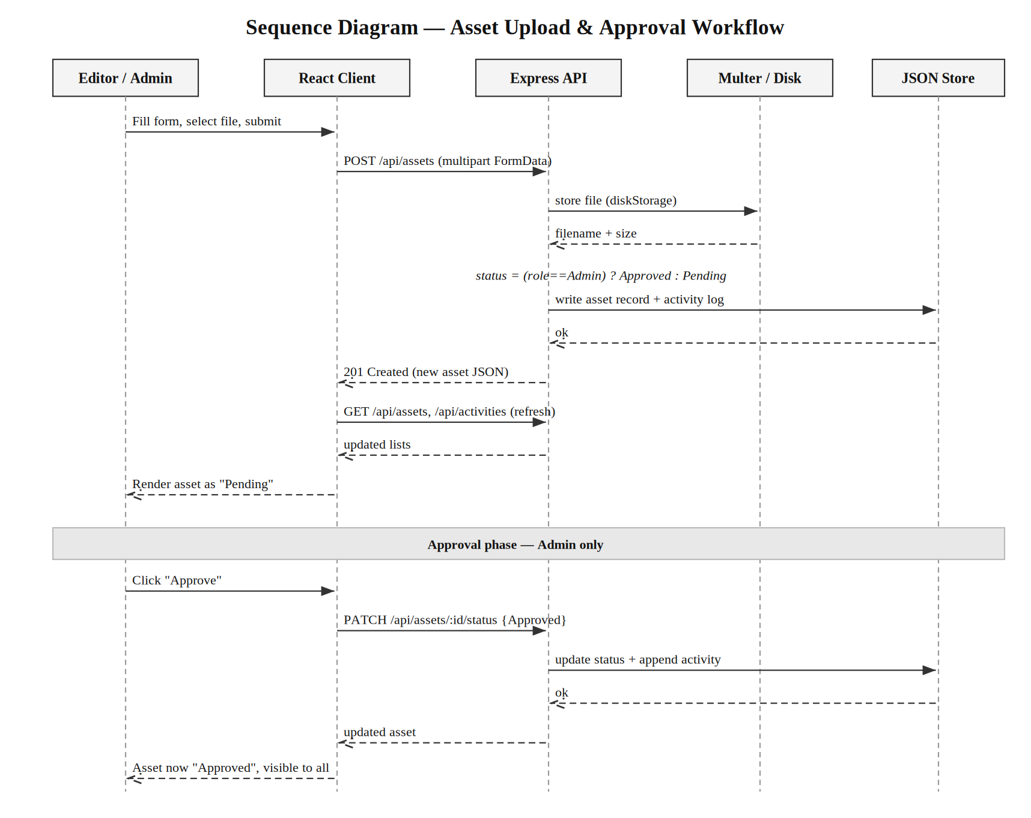
Figure 4.3: Sequence diagram for the asset upload and approval workflow
The Class diagram in Figure 4.4 presents the domain model of the system. It shows the principal classes - User, Asset and Activity - together with the supporting ColorValue and TypographyStyle classes and the BrandRepository that aggregates the collections, and it records the attributes and operations of each.
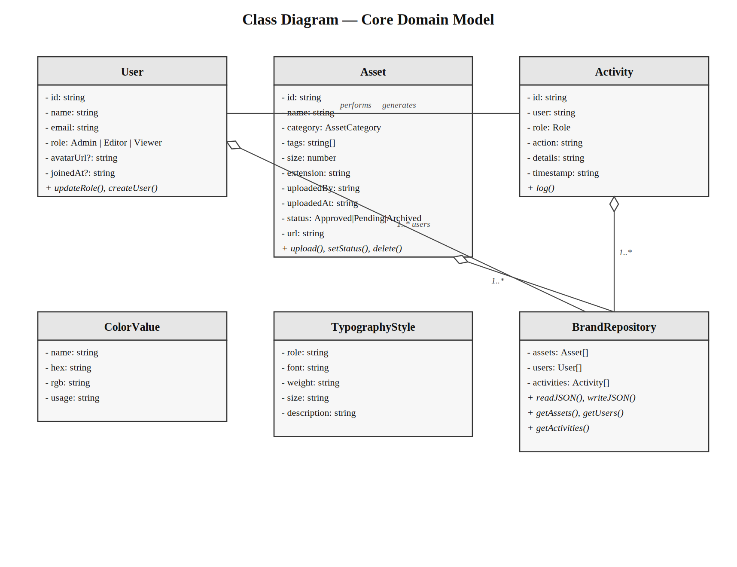
Figure 4.4: Class diagram of the core domain model

4.3 System Requirements
The tools required to run the developed system, as distinct from those required to develop it, are stated below.

4.3.1 Hardware Requirements
- A processor of 1.6 GHz or higher.
- A minimum of 4 GB of RAM (8 GB recommended for the server host).
- At least 1 GB of free disk space for the application and stored assets, with additional space in proportion to the volume of assets held.
- A network connection linking client machines to the server host.

4.3.2 Software Requirements
- The Node.js runtime installed on the server host.
- A modern web browser (such as Google Chrome, Mozilla Firefox or Microsoft Edge) on each client machine.
- An operating system capable of running Node.js, such as Windows, macOS or a Linux distribution.

4.4 Implementation of the Proposed System
The proposed system is implemented as a web application that runs online, served by a Node.js and Express process on a host machine and accessed by users through a web browser. On start-up the server ensures that its data and upload directories exist, loads its three JSON collections into memory (seeding them with initial demonstration records where none exist), and exposes a set of interface routes for retrieving and modifying assets, users and activities. The React client, delivered to the browser, loads these collections when it starts and thereafter issues requests to the interface as the user acts upon the system, re-fetching the affected collections after each change so that the displayed state remains current. Uploaded files are written to the server's uploads directory by the Multer middleware and served back to clients on request. Installation consists of deploying the application to the host, installing its dependencies, building the client, and starting the server process, after which the system is reached at the host's address. Representative source code is provided in Appendix A and sample outputs in Appendix B.

Chapter Five
Summary, Conclusion and Recommendations

5.1 Summary
This project set out to solve a single, clearly identified problem: the absence, in organisations with an in-house creative team, of a controlled and accountable place to store and approve brand assets. Chapter One established the background and stated this problem, together with the aim and objectives of the work. Chapter Two reviewed the published literature on digital asset management, brand consistency, role-based access control and audit logging. Chapter Three analysed the existing fragmented arrangement, set out the proposed system and justified it, and explained the object-oriented methodology adopted. Chapter Four presented the design of the system's inputs, outputs, security and data store, documented that design through architecture, use case, sequence and class diagrams, and described the system's implementation. The result is BrandVault, a working web-based brand identity and digital asset management system providing a central catalogue, role-based access control, an approval workflow, an activity audit trail and an analytics dashboard.

5.2 Conclusion
The objectives of the study have been achieved. A single governed repository was designed and implemented, in which each asset is catalogued with a category, tags, metadata and an approval status, so that the current approved version of any asset can be identified without ambiguity. A three-role access control scheme was implemented, restricting sensitive operations to authorised users. An approval workflow was implemented, holding contributed assets in a pending state until they are vetted. An audit trail was implemented, recording every consequential action. A dashboard was provided to summarise the state of the repository. Because each objective corresponds to, and mitigates, an element of the problem stated in Chapter One, it may be concluded that the research problem of the study has been solved to the extent set within the scope of the work.

5.3 Recommendations
On the strength of the outcome of this study, it is recommended that organisations which maintain brand assets adopt a governed, centralised repository of the kind developed here in place of scattered and ungoverned storage, in order to preserve the integrity and consistency of their brand. For future researchers who wish to extend this work, the following areas are recommended:
- Migration of the persistence layer from JSON files to a relational or document database, such as PostgreSQL or MongoDB, to improve concurrent-write performance and scalability.
- Replacement of profile-selection authentication with full password-based credentials and session management, together with encryption of stored credentials.
- Extension of the catalogue with automatic tag suggestion and content-based search, to further improve retrieval.
- Addition of version history for individual assets, so that superseded versions are retained and recoverable.
- Provision of reporting and export facilities over the activity audit trail, to support periodic governance review.

References
Banks, A., & Porcello, E. (2020). Learning React: Modern patterns for developing React apps (2nd ed.). O'Reilly Media.
Brown, E. (2019). Web development with Node and Express: Leveraging the JavaScript stack (2nd ed.). O'Reilly Media.
Rosenblatt, B. (2019). Digital asset management: Content architectures and workflows. Routledge.
Sandhu, R. S., Coyne, E. J., Feinstein, H. L., & Youman, C. E. (1996). Role-based access control models. Computer, 29(2), 38-47.
Wheeler, A. (2018). Designing brand identity: An essential guide for the whole branding team (5th ed.). John Wiley & Sons.
Whitman, M. E., & Mattord, H. J. (2021). Principles of information security (7th ed.). Cengage Learning.

Appendix A
Source Code Snippets
The following representative excerpts are drawn from the source code of the system.
Listing A.1 - Core domain model (types.ts).
export interface Asset {
id: string;
name: string;
category: 'logo' | 'image' | 'document' | 'typography'
| 'website-template' | 'graphic-template';
tags: string[];
size: number;
extension: string;
uploadedBy: string;
uploadedAt: string;
status: 'Approved' | 'Pending' | 'Archived';
url: string;
}

export interface User {
id: string; name: string; email: string;
role: 'Admin' | 'Editor' | 'Viewer';
}

Listing A.2 - Role-driven approval status on asset upload (server.ts).
// server.ts - role-driven approval status on upload
app.post("/api/assets", upload.single("file"), (req, res) => {
const { name, category, tags, uploadedBy, role } = req.body;
const newAsset = {
id: "asset-" + Date.now(),
name: name || req.file.originalname,
category: category || "image",
size: req.file.size,
extension: fileExt,
uploadedBy: uploadedBy || "Demo User",
uploadedAt: new Date().toISOString(),
status: (role === "Admin" ? "Approved" : "Pending"),
url: `/uploads/${req.file.filename}`,
isDemo: false
};
assets.unshift(newAsset);
writeJSON(ASSETS_FILE, assets);
// append to audit trail ...
});

Listing A.3 - Approve or archive an asset with audit logging (server.ts).
// server.ts - approve / archive with audit logging
app.patch("/api/assets/:id/status", (req, res) => {
const { id } = req.params;
const { status, updaterName, updaterRole } = req.body;
const i = assets.findIndex(a => a.id === id);
if (i === -1) return res.status(404).json({ error: "Asset not found." });
assets[i].status = status;
writeJSON(ASSETS_FILE, assets);
activities.unshift({
id: "act-" + Date.now(),
user: updaterName, role: updaterRole,
action: status === "Approved" ? "Approved" : "Archived",
details: assets[i].name,
timestamp: new Date().toISOString()
});
writeJSON(ACTIVITIES_FILE, activities);
res.json(assets[i]);
});

Listing A.4 - Role-based access control enforced in the interface (AllAssets.tsx).
// AllAssets.tsx - access control enforced in the interface
{(currentUser.role === "Admin" ||
(currentUser.role === "Editor" && asset.status === "Pending")) && (
<div className="action-rail">
{currentUser.role === "Admin" && asset.status === "Pending" && (
<>
<button onClick={() => onUpdateStatus(asset.id, "Approved")}>Approve</button>
<button onClick={() => onUpdateStatus(asset.id, "Archived")}>Archive</button>
</>
)}
</div>
)}

Appendix B
Sample Outputs (Screenshots)
The following screenshots present selected outputs of the running system.
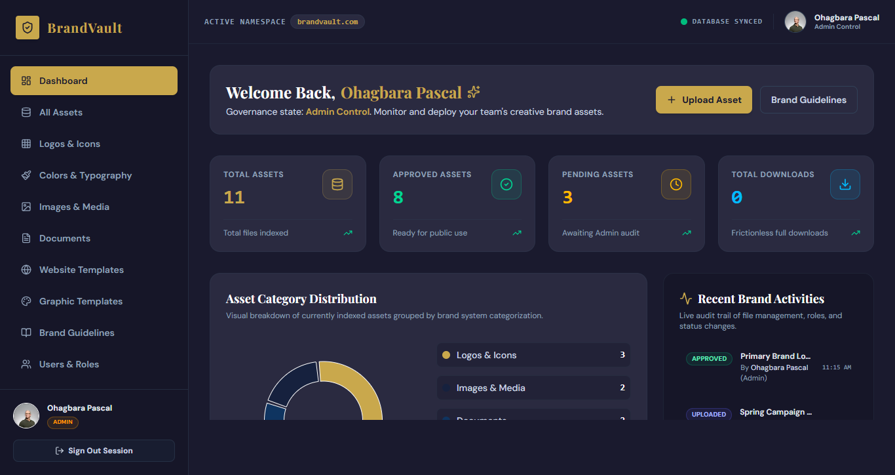
Plate B.1: The BrandVault dashboard, showing summary statistics, category distribution and recent activity
Insert the remaining screenshots here - the asset repository view (Plate B.2), the upload form (Plate B.3) and the users-and-roles table (Plate B.4) - each with its numbered caption.

