DESIGN AND IMPLEMENTATION OF A FITNESS TRACKER
APPLICATION FOR PEOPLE WITH DISABILITIES
(MOMENTUM: AN ADAPTIVE FITNESS TRACKER FOR WHEELCHAIR AND LIMITED-MOBILITY USERS)
PROJECT REPORT

BY
OGBONNA, EMMANUEL
CS/2022/1321
SUBMITTED TO
THE DEPARTMENT OF COMPUTER SCIENCE
FACULTY OF NATURAL SCIENCES
CARITAS UNIVERSITY, AMORJI-NIKE, ENUGU
IN PARTIAL FULFILMENT OF THE REQUIREMENTS FOR THE AWARD OF
BACHELOR OF SCIENCE (B.SC) DEGREE IN COMPUTER SCIENCE
AUGUST, 2026

DECLARATION
I, OGBONNA, EMMANUEL, with registration number CS/2022/1321, hereby declare that this project titled “Design and Implementation of a Fitness Tracker Application for People with Disabilities (Momentum)” is my original research work carried out under the supervision of Dr. Ugo Nwachukwu of the Department of Computer Science, Caritas University, Amorji-Nike, Enugu. The work reported herein has not been presented, in whole or in part, to any institution for the award of any other degree or qualification, and all sources consulted have been duly acknowledged.
………………………………………… …………………………………
OGBONNA, EMMANUEL Date
(CS/2022/1321)

APPROVAL
This is to certify that we have read, examined and found this project titled “Design and Implementation of a Fitness Tracker Application for People with Disabilities (Momentum)”, carried out by OGBONNA, EMMANUEL with registration number CS/2022/1321, to be satisfactory and acceptable for the award of a Bachelor of Science (B.Sc) degree in Computer Science of Caritas University, Amorji-Nike, Enugu, and hence we have caused our names and signatures to appear as follows:
………………………………………… …………………………………
Dr. Ugo Nwachukwu Date
(Project Supervisor)
………………………………………… …………………………………
Mr. Ugwu, Ejike Date
(Head of Department)
………………………………………… …………………………………
Prof. Fergus Onu Date
(External Examiner)

DEDICATION
This project is dedicated to Almighty God, the source of all wisdom and understanding, whose grace sustained me throughout this programme; and to my parents, whose sacrifice, encouragement and unfailing support made this academic journey possible.

ACKNOWLEDGEMENTS
I extend my sincere gratitude to God Almighty for the strength, wisdom and good health that sustained me throughout the duration of this project.
My profound appreciation goes to my Project Supervisor, Dr. Ugo Nwachukwu, whose guidance, patience and constructive criticism shaped this work from conception to completion.
I am equally grateful to the Head of the Department of Computer Science, Mr. Ugwu, Ejike, for his leadership and support throughout the programme. My sincere thanks go likewise to Prof. Arinze Nwaeze, Dr. Henry Nweke and Dr. Ugochukwu Nwankwo, and to all the other lecturers of the Department of Computer Science, Caritas University, Amorji-Nike, Enugu, for the knowledge they imparted over the course of my study.
Finally, I acknowledge my family, friends and course mates for their moral and financial support, for testing the system and offering feedback on its usability and accessibility, and for their steadfast encouragement during the development of this work.

ABSTRACT
This work reports on Momentum, an accessible web-based fitness tracker developed for people with disabilities, with particular attention to wheelchair users and people with limited mobility. It analysed the way mainstream fitness applications assume an able body — counting steps and standing movement — and used the findings to design a tracker built instead around adapted metrics of rolling distance, active minutes and adapted sessions, supported by an accessible interface offering a high-contrast mode and adjustable text. The system was designed using the Object-Oriented Analysis and Design Methodology and implemented as a client-side single-page application in React and TypeScript, with its working data held in structured in-browser storage. The result is a working tracker that logs adapted activity, sets and reports weekly goals, guides an adapted exercise library and presents progress and achievements accessibly.

TABLE OF CONTENTS
Title Page i
Declaration ii
Approval iii
Dedication iv
Acknowledgements v
Abstract vi
Table of Contents vii

CHAPTER ONE: INTRODUCTION 1
1.1 Background of the Study 1
1.2 Statement of the Problem 2
1.3 Aim and Objectives of the Study 2
1.4 Significance of the Study 3
1.5 Scope of the Study 3
1.6 Limitations of the Study 4
CHAPTER TWO: LITERATURE REVIEW 5
2.1 Introduction 5
2.2 Physical Activity and Disability 5
2.3 The Exclusion of Disabled Users in Fitness Technology 6
2.4 Accessibility and Inclusive Design 6
2.5 Self-Tracking, Behaviour Change and Gamification 7
2.6 The Single-Page Application Model 8
2.7 Client-Side Implementation Technologies 8
2.8 Software Engineering Methodology and Modelling 9
2.9 Review of Related Works and Research Gap 9
CHAPTER THREE: SYSTEM ANALYSIS AND METHODOLOGY 11
3.1 Data Gathering 11
3.2 Research Methodology and Justification 11
3.3 System Analysis 12
3.4 Justification of the Proposed System 13
CHAPTER FOUR: SYSTEM DESIGN AND IMPLEMENTATION 14
4.1 Design and Specification of the Proposed System 14
4.2 System Development Tools and Justification 17
4.3 System Requirements 19
4.4 Implementation of the Proposed System 20
CHAPTER FIVE: SUMMARY, CONCLUSION AND RECOMMENDATIONS 21
5.1 Summary 21
5.2 Conclusion 21
5.3 Recommendations 22
REFERENCES 23
APPENDIX A: SOURCE CODE SNIPPETS 26
APPENDIX B: SAMPLE OUTPUTS (SCREENSHOTS) 28

CHAPTER ONE
INTRODUCTION

1.1 Background of the Study
Regular physical activity is one of the most reliable contributors to long-term health, and its benefits are, if anything, greater for people with disabilities, for whom active living guards against the secondary conditions — loss of shoulder function, cardiovascular decline, pressure injuries and weight gain — that a sedentary life can bring. Yet the digital tools that now mediate everyday fitness were not built with these users in mind. The dominant fitness trackers and smartphone applications are organised around the step: they count paces, estimate distance from a walking stride, and reward a daily step target. For a wheelchair user, a person with an amputation or anyone whose movement does not take the form of walking, this design is not merely unhelpful but discouraging, because it renders their genuine effort invisible and reports a day of hard training as zero activity.
It was this mismatch, observed in the everyday experience of people who exercise without walking, that prompted the development of the system reported in this project. A wheelchair user who pushes several kilometres, an athlete who completes a seated upper-body circuit and a person recovering shoulder function through prescribed physiotherapy are all being active, but a step-based application has no vocabulary for what they have done. What is required is not a cosmetic setting bolted onto a walking app, but a tracker whose very metrics, exercises and encouragements are built around adapted movement.
Momentum is proposed as that tracker. It replaces the step with metrics that describe adapted activity honestly — rolling distance, active minutes and adapted sessions — and organises the whole application around them. A user records wheeling, seated strength, physiotherapy, adaptive swimming or handcycling; sets weekly goals in these terms; follows an exercise library curated for upper-body conditioning, rotator-cuff care and wheelchair push efficiency; and watches progress accumulate through charts, streaks and achievement badges. Because the application is built for users who may have visual or motor constraints, accessibility is treated as a core feature rather than an afterthought, with a high-contrast mode, adjustable text sizes, keyboard-navigable controls and readable text summaries placed beside every chart.

1.2 Statement of the Problem
Mainstream fitness-tracking applications are designed around able-bodied, step-based movement and therefore fail to record, measure or encourage the physical activity of people with disabilities. Because the metrics, exercises and goals of these applications assume walking and standing, a wheelchair user or a person with limited mobility cannot see their genuine effort reflected in the tools available to them, and the interfaces of these applications are frequently inaccessible to users with visual or motor impairments. This single problem — the absence of a fitness tracker whose metrics and interface are built for adapted movement and accessible use — leaves a large group of users without a usable means of monitoring and sustaining their physical activity.

1.3 Aim and Objectives of the Study
The aim of this project is to design and implement an accessible, web-based fitness tracker whose metrics, exercises and goals are built for the adapted movement of people with disabilities. The specific objectives, each aimed at mitigating the problem stated in Section 1.2, are:
- To design an activity-logging model based on adapted metrics — rolling distance, active minutes and adapted sessions across wheeling, seated strength, physiotherapy, adaptive swimming and handcycling — so that the genuine effort of a non-ambulatory user is recorded and made visible.
- To implement a personal profile and weekly goal-setting facility expressed in these adapted metrics, so that a user can set and pursue targets appropriate to their own mobility.
- To provide an exercise library curated for adapted movement — upper-body conditioning, rotator-cuff care, seated cardio and trunk mobility — so that users have safe, relevant routines to follow.
- To implement a progress view that presents adapted activity over time through charts, streaks and achievement badges, each accompanied by a readable text summary, so that progress is both motivating and accessible.
- To build the entire interface to an accessibility standard — offering a high-contrast mode, adjustable text sizes, visible keyboard focus and labelled controls — so that users with visual or motor impairments can operate the application.

1.4 Significance of the Study
When completed, this work contributes a practical tool that makes physical activity trackable and encouraging for a group of users the mainstream tools overlook. By measuring adapted movement honestly and presenting it accessibly, the system removes the discouragement that follows from effort going unrecorded. The following points further underline the importance of the study:
- Inclusion is advanced, because a wheelchair user or a person with limited mobility can, for the first time in many everyday tools, see their real activity recorded and rewarded rather than reported as zero.
- Health is supported, because adapted goal-setting, an exercise library emphasising shoulder care, and motivating feedback together encourage the sustained activity that protects against secondary health conditions.
- Accessibility is demonstrated, because the application is itself operable by users with visual and motor impairments, standing as a worked example of inclusive interface design rather than a claim about it.
- The work also serves as a reference for students and developers interested in accessible interface design, adapted-metric self-tracking, and the delivery of a health application as a client-side single-page application.

1.5 Scope of the Study
This project covers the design, implementation and evaluation of an accessible web-based fitness tracker that runs in a standard web browser. Its scope covers a guided onboarding that captures a user’s preferred name, mobility profile and weekly goals; the logging of adapted activities with their distance, duration, intensity, terrain and perceived effort; a dashboard summarising the day and the week; a curated exercise library; a progress view presenting trends, streaks and achievement badges; and an accessibility-and-settings facility offering theme, contrast, text-size and unit controls. The system supports four mobility profiles — manual wheelchair, powered wheelchair, limited mobility and physiotherapy recovery — with its primary emphasis on wheelchair and limited-mobility users.
The study is bounded as follows. It concerns the recording, presentation and encouragement of adapted activity within a single client-side application, and does not undertake clinical measurement, medical diagnosis or the automatic capture of movement from body-worn sensors; activity is entered by the user rather than measured by hardware. The application’s data is held in structured in-browser storage on the user’s device; connection to a central server, to wearable devices and to a shared multi-user database is identified as further work rather than undertaken here.

1.6 Limitations of the Study
Several factors constrained the execution of this work and should be borne in mind when interpreting its results.
First, the system records activity through manual entry rather than automatic sensor capture. A web application running in a browser cannot reliably read movement sensors in the background, so the user logs each session themselves. The figures the system reports are therefore as accurate as the user’s entries, and the application is presented as an activity logger and goal tracker rather than an instrument of clinical measurement. Integration with wearable devices is identified in Section 5.3 as a priority for further work.
Second, the working data is held in the browser’s local storage on a single device rather than in a server-side database. A user’s logged activity persists across visits on the same device and browser, but does not synchronise across devices or between users. The application is seeded with a realistic starting dataset so that every view can be demonstrated at scale; the introduction of a server and shared database is likewise identified as further work.
Third, the accessibility provisions of the system — the high-contrast mode, the adjustable text and the labelled, keyboard-navigable controls — were designed and tested against recognised inclusive-design guidance, but a full, formal conformance audit against the Web Content Accessibility Guidelines by an independent assessor was beyond the resources of an undergraduate project.
Fourth, the study was carried out within a single academic session alongside coursework and examinations, which constrained the duration of the evaluation exercise and the number of respondents who could be engaged.

CHAPTER TWO
LITERATURE REVIEW

2.1 Introduction
This chapter reviews the literature relevant to the design of an accessible fitness tracker for people with disabilities. It establishes the importance of physical activity for disabled people, examines the documented exclusion of these users from mainstream fitness technology, and reviews the principles of accessibility and inclusive design on which the present system rests. It then considers the theory of self-tracking, behaviour change and gamification that informs its motivational features, before turning to the single-page application model and the client-side technologies used to implement it, and the software-engineering methodology used to build it. A review of related classes of system follows, and the chapter concludes by stating the gap the study addresses. Each body of work is related to the present project, with its contribution and its limitation identified.

2.2 Physical Activity and Disability
The health value of regular physical activity is well established, and the World Health Organization (2020) sets out global recommendations that include, for the first time in a dedicated form, guidance for adults living with disability, affirming that the benefits of activity outweigh the risks and that disabled adults should be as active as their condition allows. Rimmer, Riley, Wang, Rauworth and Jurkowski (2004) document the physical, structural and programmatic barriers that keep disabled people from being active, while Martin Ginis, Ma, Latimer-Cheung and Rimmer (2016) synthesise the evidence that participation in physical activity improves the health and well-being of people with physical disabilities. For wheelchair users specifically, the shoulder bears the double load of propulsion and daily transfers, and Mulroy, Thompson, Kemp et al. (2011) show that a targeted exercise and movement-optimisation programme reduces shoulder pain in manual wheelchair users — evidence that directly motivates the shoulder-care emphasis of the present system’s exercise library. The limitation of this literature, for a builder, is that it establishes why adapted activity matters without prescribing the design of a tool to support it, which the present study supplies.

2.3 The Exclusion of Disabled Users in Fitness Technology
A growing body of work documents how self-tracking technology, organised around the step, fails disabled users. Consolvo, McDonald and Landay (2009), in foundational work on activity-tracking design, frame the step count and the daily goal as the organising devices of the genre — devices that, by construction, do not represent wheeling or seated exercise. More recent research examines the consequence for disabled users directly: Malu and Findlater and colleagues, in studies of wearable use by people with mobility impairments, report that step-based devices misrepresent or ignore wheelchair activity and that users desire metrics matched to their movement. Carrington, Hosmer, Yeh, Hurst and Kane (2015), in their work on wheelchair-based interaction, argue for technology conceived from the wheelchair user’s perspective rather than adapted from an ambulatory default. Commercial acknowledgement has followed research: platform vendors have added wheelchair-specific modes that count pushes rather than steps, confirming the need but leaving a gap for an application whose entire design, and not one mode, is built around adapted movement. This body of work directly justifies the central design decision of the present project.

2.4 Accessibility and Inclusive Design
Because the application is intended for users who may have visual or motor impairments, its own accessibility is a primary design concern rather than a compliance afterthought. The Web Content Accessibility Guidelines (W3C, 2018) provide the recognised standard, organising accessible design under the principles that content be perceivable, operable, understandable and robust, and prescribing testable criteria for contrast, keyboard operability, text resizing and non-reliance on colour alone — criteria that shaped the present system’s high-contrast mode, adjustable text, visible focus states and the pairing of every status with an icon and a word. The broader philosophy is supplied by the inclusive- and universal-design traditions: Story, Mueller and Mace (1998) set out the principles of universal design, and Persson, Åhman, Yngling and Gulliksen (2015) relate universal design, inclusive design and accessibility as a coherent stance that designing for the margins improves the experience for all. Nielsen’s (1994) usability heuristics, among them visibility of system status and recognition rather than recall, complement these accessibility principles in shaping an interface meant to be operable and self-evident. The limitation of the guidelines, acknowledged in this report, is that conformance is ultimately established by audit; the present work applies the criteria in design and testing but does not undertake a formal independent assessment.

2.5 Self-Tracking, Behaviour Change and Gamification
The motivational features of the system — goals, streaks and achievement badges — rest on established theory. Li, Dey and Forlizzi (2010) describe the stages people pass through in personal-informatics systems, from collection to reflection, and locate the value of self-tracking in the reflection that logged data enables, which informs the present system’s progress view and its readable summaries. The practice of applying game elements to non-game contexts is defined by Deterding, Dixon, Khaled and Nacke (2011), and Hamari, Koivisto and Sarsa (2014), in a systematic review, find that gamification can produce positive motivational effects while cautioning that outcomes depend on context and user. Fogg (2009) supplies a behaviour model in which behaviour follows from the convergence of motivation, ability and a trigger, which frames the system’s reminders and one-tap logging presets as triggers that lower the effort of acting. These works justify the streak and badge mechanisms while cautioning, as the present report acknowledges, that such features must serve genuine encouragement rather than mere engagement.

2.6 The Single-Page Application Model
The application is built as a single-page application, a model in which one document is loaded once and its several views are switched and re-rendered on the client without further full-page loads (Mikowski & Powell, 2013). This model descends from the shift towards the browser as an application environment described by O’Reilly (2007) and the background-exchange approach named by Garrett (2005). Momentum is a direct instance of the model: its dashboard, logging, exercise-library, progress, profile and settings views are switched entirely on the client, and the dashboard re-renders in place whenever an activity is logged. The model in its general form assumes a server supplying data behind the client; the present system demonstrates the same client-side model with its data held in the browser, which both realises the model and marks the point — a server-side data source — at which it would be extended.

2.7 Client-Side Implementation Technologies
The system is implemented in React, a component-based library for building user interfaces in which the interface is expressed as a composition of reusable components whose rendered output is a function of their state (React, 2024). TypeScript adds static typing to JavaScript, catching a class of errors before run time and documenting the shape of the data the application manipulates (Microsoft, 2024) — used here to define the activity, profile, goal and exercise record types. The application is built and bundled with Vite, and its layout and theming rest on the utility-first approach of Tailwind CSS, with charts rendered by the Recharts library and animation by an accompanying motion library. Persistence between visits is provided by the browser’s Web Storage (localStorage) facility, standardised by the W3C (2016), which stores the user’s logged activity, profile and settings on the device. The merit of this stack is a fast, dependency-light application that deploys as static files and requires no server; its limitation, acknowledged in this report, is that browser storage is device-local and does not by itself provide cross-device or multi-user persistence.

2.8 Software Engineering Methodology and Modelling
The construction of the system followed recognised software-engineering practice. Pressman and Maxim (2020) and Sommerville (2016) set out the analysis, design, implementation and testing activities that structure a development effort, and the object-oriented methodology adopted here is documented using the Unified Modeling Language of Booch, Rumbaugh and Jacobson (2005) through the use-case, sequence and class diagrams presented in Chapter Four. The component model of React aligns naturally with object-oriented design, each component encapsulating its own state and behaviour, and the iterative manner in which the system was built — adding and refining one feature at a time — reflects the object-oriented analysis and design approach of Larman (2004). These works collectively justify the methodology of Chapter Three and the modelling of Chapter Four.

2.9 Review of Related Works and Research Gap
The tools presently available for tracking physical activity fall into a few classes, each with a shortfall the present study addresses. Mainstream step-based applications and wearables reach a large audience but, as reviewed above, misrepresent or ignore adapted movement and are frequently inaccessible to users with visual or motor impairments. Platform wheelchair modes acknowledge the problem but treat adapted tracking as one setting within an application whose defaults, exercises and encouragements remain ambulatory. Clinical and rehabilitation systems measure adapted movement rigorously but are specialised instruments, tied to equipment and supervision, rather than everyday self-tracking tools. General accessibility literature (W3C, 2018; Story et al., 1998) prescribes how an interface should be built but not how a fitness tracker’s metrics should be reconceived for adapted movement. Against this background the gap is clear: there is little existing work that reconceives the whole of a consumer fitness tracker — its metrics, its exercises, its goals and its interface — around adapted movement and delivers it as an accessible application that a person with a disability can realistically use day to day. This study addresses that gap by designing, implementing and evaluating such an application, honestly scoped to what a client-side prototype provides and clear about the extensions a production deployment would require.

CHAPTER THREE
SYSTEM ANALYSIS AND METHODOLOGY

3.1 Data Gathering
The data used to inform the design of this system were gathered through observation, informal interview and the study of documentation and literature. Observation of how disabled people engage with mainstream fitness applications revealed the central difficulty the system addresses: that step-based tools record a day of genuine adapted training as little or no activity. This observation was supplemented by informal conversations with wheelchair users and people undergoing physiotherapy about the activities they wished to track — wheeling distance, seated strength, shoulder-care routines — and by a review of the published literature on physical activity and disability, accessible and inclusive design, self-tracking and the single-page application model, as set out in Chapter Two. Together, these sources established both the problem to be solved and the accepted principles for solving it.

3.2 Research Methodology and Justification
The methodology adopted for this work is the Object-Oriented Analysis and Design Methodology (OOADM). Under this methodology the problem domain is modelled as a set of collaborating objects, each with its own data and behaviour, and the system is designed in terms of the classes of these objects and the interactions between them. OOADM was chosen for three reasons. First, the problem domain maps naturally onto well-defined entities — the activity log, the user profile, the weekly goal, the exercise and the achievement badge — each with clear attributes and behaviour, which is precisely the kind of domain OOADM was devised to model. Second, the system was built iteratively, adding and refining features in successive passes rather than in one rigid sequence, which the object-oriented approach accommodates more comfortably than a strictly linear methodology such as the Waterfall model. Third, the interface is implemented in React as a composition of components — the summary card, the activity row, the goal ring, the exercise card — that correspond directly to objects, so that an object-oriented design translates directly into the structures of the built system. In accordance with this methodology, the Use Case, Sequence and Class diagrams that document the design are presented in Chapter Four under Section 4.2.

3.3 System Analysis

3.3.1 Analysis of the Existing System
The existing means by which disabled people track physical activity is, in the general case, a mainstream step-based fitness application or wearable device adapted for a purpose it was not designed to serve. Such an application counts steps, estimates distance from a walking stride and rewards a daily step target. When a wheelchair user pushes several kilometres or completes a seated workout, the application either records nothing or misattributes the effort, and its exercise suggestions and daily encouragements assume standing movement. Where a wheelchair mode exists, it is a single setting within an otherwise ambulatory application. The interfaces of these applications, moreover, are frequently inaccessible to users with visual or motor impairments. This manner of operation gives rise to a number of drawbacks:
- Invisible effort, since adapted activity such as wheeling, seated strength or physiotherapy is not counted, so that a day of genuine training is reported as little or no activity.
- Irrelevant metrics and goals, since steps and a step target do not describe or motivate the movement a disabled user actually performs.
- Unsuitable guidance, since the exercises and encouragements assume standing and walking rather than upper-body, seated or shoulder-care routines.
- Inaccessible interfaces, since low contrast, small controls and colour-only cues exclude users with visual or motor impairments.
- Discouragement, since effort that goes unrecorded and unrewarded undermines the motivation the tool is meant to build.

3.3.2 Analysis of the Proposed System
The proposed system, Momentum, replaces this ill-fitting arrangement with a fitness tracker built from the outset around adapted movement and accessible use. On first use, a guided onboarding captures the user’s preferred name, their mobility profile and their weekly goals. Thereafter the user logs adapted activities — wheeling, seated strength, physiotherapy, adaptive swimming or handcycling — each recorded with its distance where relevant, its duration, its intensity, its terrain and the user’s perceived effort. A dashboard summarises the day and reports weekly goals for rolling distance, active minutes and sessions, each shown as a progress ring. An exercise library, curated for upper-body conditioning, rotator-cuff care, seated cardio and trunk mobility, offers routines the user may follow or log. A progress view presents rolling-distance and active-minute trends, an activity streak and a shelf of achievement badges, each chart accompanied by a readable text summary. Throughout, the interface offers a high-contrast mode, three text sizes, visible keyboard focus and labelled controls. The major features of the proposed system are therefore its adapted-metric activity log, its adapted goal-setting, its curated exercise library, its accessible progress and achievement view, and its built-in accessibility controls. The chief benefits are the honest recording of adapted effort, relevant and motivating goals, safe and suitable exercise guidance, and an interface operable by users with visual or motor impairments.

3.4 Justification of the Proposed System
The proposed system is justified as the appropriate solution to the problem because it addresses each of the identified drawbacks directly. Invisible effort is remedied because the system logs adapted activity in its own metrics of rolling distance, active minutes and sessions, so that a day of wheeling or seated training is recorded and made visible. Irrelevant metrics and goals are addressed because goal-setting is expressed in these same adapted terms. Unsuitable guidance is met because the exercise library is curated specifically for adapted, seated and shoulder-protective movement. Inaccessible interfaces are addressed because the application is built to recognised accessibility guidance, with a high-contrast mode, adjustable text, keyboard operability and non-reliance on colour alone. Discouragement is countered because streaks, badges and immediate feedback reward the effort the system now records. Because every drawback of the existing arrangement is met by a corresponding feature of the proposed system, the proposed system is the well-founded solution to the stated problem. Its delivery as a client-side single-page application further suits an undergraduate project and a resource-constrained deployment, while leaving a clear path — a server, a shared database and wearable-device integration — for a production extension.

CHAPTER FOUR
SYSTEM DESIGN AND IMPLEMENTATION

4.1 Design and Specification of the Proposed System
This section describes the principal design processes of the system: the design of its inputs, its outputs, its security and its data model. In architectural terms the system is a client-side single-page application organised in three layers on the browsing device: a presentation layer of React components, an application-logic layer that holds the working state and computes derived statistics, and a local data store in the browser that persists that state between visits. This arrangement is illustrated in Figure 4.1.
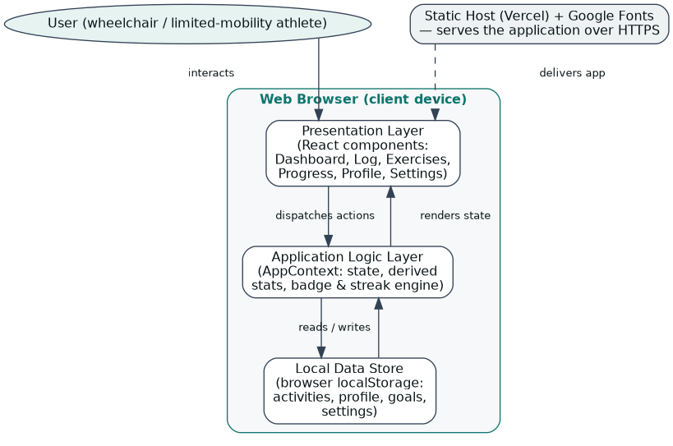
Figure 4.1: Three-layer client-side architecture of Momentum

4.1.1 Input Design and Specification
The inputs to the system are collected through interface controls presented to the user. The principal input is the activity-logging form, through which a user selects an activity type, names the session and supplies its distance and duration — assisted by one-tap preset values — together with a push intensity, a terrain and a perceived-effort rating. A second input is the onboarding and profile facility, which collects a preferred name (text box), a mobility profile (selectable cards), optional equipment details and weekly goal values. A third input is the settings facility, through which the user selects a theme, toggles high contrast, chooses a text size and selects a distance unit. The input fields of the activity-logging form are summarised in Table 4.1.
Input Field | Control Type | Data Collected
Activity type | Selectable cards | Wheeling, seated strength, physiotherapy, adaptive swim or handcycling
Session name | Text box | A human-readable name for the session
Distance | Number box + presets | Rolling or swimming distance in kilometres
Duration | Number box + presets | Length of the session in minutes
Intensity | Selectable options | Light, moderate or vigorous effort
Terrain | Selectable chips | Paved, track, indoor, incline or water
Perceived effort | Selectable chips | Energised, relaxed, strong or challenged
Table 4.1: Input fields of the activity-logging form

4.1.2 Output Design and Specification
The outputs of the system are the views it renders in response to user actions, designed to be consistent with the objectives stated in Chapter One. The principal output is the dashboard, which presents the day’s rolling distance, active minutes, sessions and current streak as summary cards, the week’s goals as progress rings, and the day’s activity as a feed. A second output is the progress view, which presents rolling-distance and active-minute trends as charts, each with a readable text summary, together with an achievement-badge shelf. A third output is the exercise library, which presents each curated routine as a card bearing its category, duration, target muscles and equipment. The system also gives brief confirmation feedback — a toast message and a celebratory animation — after an activity is logged. Representative outputs are shown in Appendix B.

4.1.3 Security Design and Specification
As an accessible personal tracker whose data is held privately on the user’s own device, the system deliberately does not impose an account-and-password barrier, since such a barrier would add an accessibility burden without protecting data that never leaves the device. In place of remote accounts, the design relies on the isolation the browser already provides: the working data is stored in the browser’s local storage, which is confined to the user’s own device and origin and is not transmitted to any server. Onboarding therefore captures only a preferred name and mobility preferences, holding no sensitive credentials. Where the system is extended to synchronise across devices, as identified in Section 5.3, authenticated per-user accounts with credentials verified on a server against irreversibly hashed values, and server-side authorisation, would be introduced at that stage. The present design keeps the data model independent of the storage mechanism so that this extension may be made without altering the views that depend on it.

4.1.4 Data Design and Specification
The present build does not provision a server-side database. To demonstrate every view at realistic scale and to persist a user’s own entries between visits, the working data — activities, profile, goals, settings and badges — is held in structured storage within the browser, seeded with initial records on first load. The logical model is nevertheless designed as a set of well-defined record types so that migration to a server-hosted store may be effected by substituting the data source without altering the behaviour defined upon the model. The activity record, which is the central store of the system, is specified in Table 4.2.
Field | Type | Description
id | String | Unique identifier of the activity
type | Enumerated | Wheeling, strength, physio, swimming, handcycling or mobility
title | String | Human-readable name of the session
distanceKm | Number | Distance in kilometres (0 for non-distance activities)
durationMinutes | Number | Length of the session in minutes
pushIntensity | Enumerated | Light, moderate or vigorous
terrain | Enumerated | Paved, track, indoor, incline, water or trail
feelRating | Enumerated | Energised, relaxed, strong or challenged
timestamp | ISO date-time | When the activity was performed
Table 4.2: Specification of the activity record
The remaining record types follow the same pattern. The user profile holds a preferred name, a mobility profile type, optional equipment details and mobility notes. The weekly goals hold target values for rolling distance, active minutes and sessions. The settings hold the theme, high-contrast, text-size, distance-unit and audio-cue preferences. Each exercise holds a title, a category, a list of target muscles, a duration and the mobility profiles it suits, and each badge holds a title, a category, an unlocked state and a progress percentage. Each collection is seeded with demonstration records and is read and re-rendered directly by the views that present it.

4.2 System Development Tools and Justification
The system was developed as a client-side single-page application using the React ecosystem. The reasons for each choice are given below.
React and TypeScript provide the application framework and language. React expresses the interface as a composition of reusable components whose output follows from their state, which suits an interface built from repeated units such as summary cards, activity rows and goal rings; TypeScript adds static typing that documents the activity, profile, goal and exercise record types and catches a class of errors before run time.
Vite provides the build tooling and development server, producing an optimised set of static files for deployment. Tailwind CSS provides the styling, its utility-first classes supporting a consistent visual identity and, importantly, the disciplined control of colour and contrast on which the accessibility of the interface depends.
Recharts renders the rolling-distance and active-minute trend charts of the progress view, and an accompanying motion library provides the subtle animation and the celebratory feedback shown when an activity is logged. The browser’s local storage persists the user’s data between visits, and the application is deployed as a set of static files on a managed hosting platform that serves it over an encrypted connection at no cost and requires no server administration. Visual Studio Code was used as the development environment and Git for version control.
In keeping with the object-oriented methodology adopted in Chapter Three, the design of the system is documented below through a Use Case diagram, a Sequence diagram and a Class diagram.
The Use Case diagram in Figure 4.2 identifies the actor of the system — the athlete using the tracker — and the operations available: completing onboarding, logging an activity, viewing the dashboard, browsing the exercise library, viewing progress and achievements, and adjusting accessibility and settings.
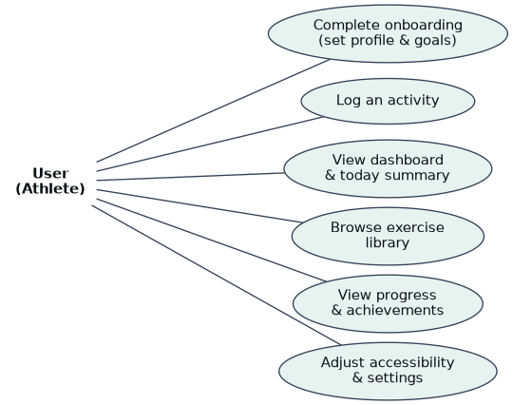
Figure 4.2: Use Case diagram of Momentum
The Sequence diagram in Figure 4.3 documents the central interaction of the system: the logging of an activity. It traces the flow from the user, who opens the form and enters the session, through the application logic, which validates the entry, assigns an identifier and timestamp and re-computes the derived statistics, streak and badges, to the local store, which persists the updated activities, and back to the interface, which confirms with a toast and celebratory animation and reflects the new activity on the dashboard.
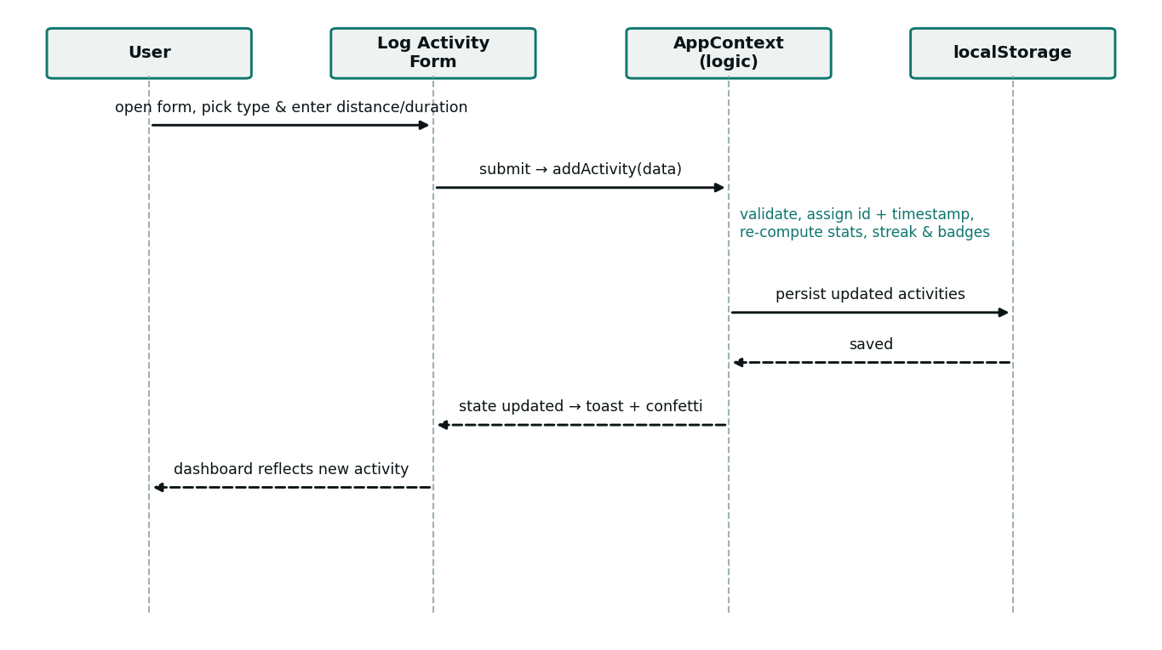
Figure 4.3: Sequence diagram for the activity-logging workflow
The Class diagram in Figure 4.4 presents the domain model of the system. It shows the application state that holds the collections and the operations upon them, together with the principal record types — ActivityLog, UserProfile, WeeklyGoals, AppSettings, Badge and Exercise — and their attributes.
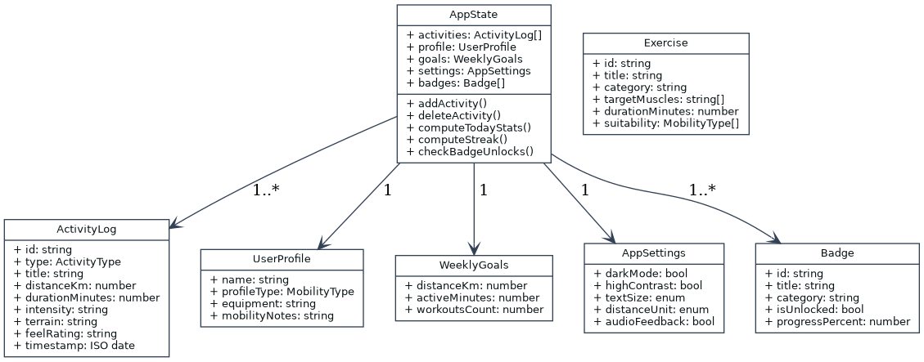
Figure 4.4: Class diagram of the core domain model

4.3 System Requirements
The tools required to run the developed system, as distinct from those required to develop it, are stated below. Because the system is a client-side application, its requirements are modest and fall entirely on the browsing device.

4.3.1 Hardware Requirements
- A processor of 1.2 GHz dual-core or higher, as found in entry-level devices.
- A minimum of 2 GB of RAM; 4 GB recommended for smoother rendering of charts and animation.
- At least 100 MB of free space for the browser cache and stored data.
- A network connection for the initial loading of the application.

4.3.2 Software Requirements
- A modern web browser such as Google Chrome 90 or later, Mozilla Firefox 88 or later, Microsoft Edge 90 or later, or Safari 14 or later.
- An operating system capable of running such a browser — Android, iOS, Windows, macOS or a Linux distribution.
- JavaScript and browser local storage enabled. No server runtime or installation is required.

4.4 Implementation of the Proposed System
The system is implemented as a client-side single-page application, built with Vite and deployed as a set of static files on a managed hosting platform, and accessed through a web browser; it is therefore reached online rather than installed on individual machines, at the address recorded in Appendix B. On first load, the application seeds its collections with a realistic starting dataset and, for a new user, presents the guided onboarding that captures a preferred name, a mobility profile and weekly goals. Thereafter the interface responds to user action entirely on the client — switching between the dashboard, logging, exercise-library, progress, profile and settings views, and re-rendering the affected view in place without a page reload — while the user’s entries are written to the browser’s local storage so that they persist across visits.
Implementation proceeded feature by feature, in keeping with the adopted methodology. The activity record and the logging form were built first, establishing the adapted-metric model and verified by confirming that a logged session updated the dashboard’s daily totals and weekly rings. The derived statistics — the daily and weekly aggregates, the activity streak and the badge-unlock checks — were implemented next and tested against the seeded data. The exercise library and the progress view with its trend charts and readable summaries followed. The accessibility provisions were then implemented and tested: the high-contrast mode, the three text sizes, the visible keyboard focus and the labelled controls were each verified, and the layout was tested across device widths from small mobile displays to desktop monitors. Testing was conducted throughout rather than at the end, and informal acceptance testing with representative users confirmed that an activity could be logged and progress read without instruction. Representative source code is provided in Appendix A and sample outputs in Appendix B.

CHAPTER FIVE
SUMMARY, CONCLUSION AND RECOMMENDATIONS

5.1 Summary
This project set out to solve a single, clearly identified problem: the absence of a fitness tracker whose metrics and interface are built for the adapted movement and accessible use of people with disabilities. Chapter One established the background and stated this problem, together with the aim and objectives of the work. Chapter Two reviewed the literature on physical activity and disability, the exclusion of disabled users from fitness technology, accessibility and inclusive design, self-tracking and gamification, the single-page application model, and the client-side technologies and methodology used. Chapter Three analysed the ill-fitting existing arrangement, set out the proposed system and justified it, and explained the object-oriented methodology adopted. Chapter Four presented the design of the system’s inputs, outputs, security and data, documented that design through architecture, use-case, sequence and class diagrams, and described the implementation. The result is Momentum, a working accessible fitness tracker that logs adapted activity, sets and reports weekly goals in adapted metrics, offers a curated exercise library, presents progress and achievements accessibly, and provides built-in accessibility controls.

5.2 Conclusion
The objectives of the study have been achieved. An activity-logging model based on adapted metrics was designed and implemented, so that the effort of a non-ambulatory user is recorded and made visible. A profile and weekly goal-setting facility expressed in these adapted metrics was implemented. An exercise library curated for adapted movement was provided. A progress view presenting trends, streaks and achievement badges, each with a readable text summary, was implemented. The interface was built to recognised accessibility guidance, offering a high-contrast mode, adjustable text, visible keyboard focus and labelled controls. Because each objective corresponds to, and mitigates, an element of the problem stated in Chapter One, it may be concluded that the research problem has been solved to the extent set within the scope of the work.
Certain constraints qualify this conclusion. Activity is entered by the user rather than captured automatically from wearable sensors; the working data is held in the browser on a single device rather than in a shared server-side database; and the accessibility provisions, while designed and tested against recognised guidance, were not subjected to a formal independent conformance audit. These constraints affect the scale and the manner in which the system has been demonstrated rather than the validity of its design, since the adapted-metric log, the goal-setting, the exercise library, the accessible progress view and the accessibility controls are fully implemented and behave on the user’s own entries exactly as they would at larger scale.

5.3 Recommendations
On the strength of the outcome of this study, it is recommended that accessible, adapted-metric fitness tracking of the kind developed here be adopted in place of the ill-fitting step-based tools that disabled users are presently obliged to use, in order to make their physical activity visible, measurable and encouraging. For future researchers who wish to extend this work, the following areas are recommended:
- Integration with wearable devices — wheelchair-mounted odometers, smart-watch push counters and heart-rate monitors — so that adapted activity may be captured automatically rather than entered by hand. This is the first priority, as it addresses the principal limitation of the present build.
- Provision of a server and a shared database with authenticated per-user accounts, so that a user’s data synchronises across their devices and is preserved independently of any single browser.
- A formal, independent accessibility audit against the Web Content Accessibility Guidelines, together with testing involving assistive technologies such as screen readers, to certify and further improve the accessibility the system was designed to provide.
- Expansion of the exercise library with professionally reviewed, video-guided routines for each mobility profile, developed in consultation with physiotherapists.
- Addition of a companion native mobile application and of optional sharing features, so that users may, if they wish, train alongside a community of other adaptive athletes.

REFERENCES
Booch, G., Rumbaugh, J., & Jacobson, I. (2005). The unified modeling language user guide (2nd ed.). Addison-Wesley.
Carrington, P., Hosmer, K., Yeh, T., Hurst, A., & Kane, S. K. (2015). “Big or small, hold em or throw em”: Designing mobile interactions for power wheelchair users. In Proceedings of the ACM SIGACCESS Conference on Computers and Accessibility. ACM.
Consolvo, S., McDonald, D. W., & Landay, J. A. (2009). Theory-driven design strategies for technologies that support behavior change in everyday life. In Proceedings of the SIGCHI Conference on Human Factors in Computing Systems (pp. 405–414). ACM.
Deterding, S., Dixon, D., Khaled, R., & Nacke, L. (2011). From game design elements to gamefulness: Defining gamification. In Proceedings of the 15th International Academic MindTrek Conference (pp. 9–15). ACM.
Fogg, B. J. (2009). A behavior model for persuasive design. In Proceedings of the 4th International Conference on Persuasive Technology. ACM.
Garrett, J. J. (2005). Ajax: A new approach to web applications. Adaptive Path.
Hamari, J., Koivisto, J., & Sarsa, H. (2014). Does gamification work? A literature review of empirical studies on gamification. In Proceedings of the 47th Hawaii International Conference on System Sciences (pp. 3025–3034). IEEE.
Larman, C. (2004). Applying UML and patterns: An introduction to object-oriented analysis and design and iterative development (3rd ed.). Prentice Hall.
Li, I., Dey, A. K., & Forlizzi, J. (2010). A stage-based model of personal informatics systems. In Proceedings of the SIGCHI Conference on Human Factors in Computing Systems (pp. 557–566). ACM.
Martin Ginis, K. A., Ma, J. K., Latimer-Cheung, A. E., & Rimmer, J. H. (2016). A systematic review of review articles addressing factors related to physical activity participation among children and adults with physical disabilities. Health Psychology Review, 10(4), 478–494.
Microsoft. (2024). TypeScript documentation. Microsoft. https://www.typescriptlang.org/docs/
Mikowski, M. S., & Powell, J. C. (2013). Single page web applications: JavaScript end-to-end. Manning Publications.
Mulroy, S. J., Thompson, L., Kemp, B., Hatchett, P. P., Newsam, C. J., Lupold, D. G., … Requejo, P. (2011). Strengthening and optimal movements for painful shoulders (STOMPS) in chronic spinal cord injury: A randomized controlled trial. Physical Therapy, 91(3), 305–324.
Nielsen, J. (1994). Usability engineering. Morgan Kaufmann.
O’Reilly, T. (2007). What is Web 2.0: Design patterns and business models for the next generation of software. Communications & Strategies, 65, 17–37.
Persson, H., Åhman, H., Yngling, A. A., & Gulliksen, J. (2015). Universal design, inclusive design, accessible design, design for all: Different concepts — one goal? Universal Access in the Information Society, 14(4), 505–526.
Pressman, R. S., & Maxim, B. R. (2020). Software engineering: A practitioner’s approach (9th ed.). McGraw-Hill.
React. (2024). React documentation. Meta Open Source. https://react.dev/
Rimmer, J. H., Riley, B., Wang, E., Rauworth, A., & Jurkowski, J. (2004). Physical activity participation among persons with disabilities: Barriers and facilitators. American Journal of Preventive Medicine, 26(5), 419–425.
Sommerville, I. (2016). Software engineering (10th ed.). Pearson.
Story, M. F., Mueller, J. L., & Mace, R. L. (1998). The universal design file: Designing for people of all ages and abilities. Center for Universal Design, North Carolina State University.
World Health Organization. (2020). WHO guidelines on physical activity and sedentary behaviour. World Health Organization.
World Wide Web Consortium. (2016). Web storage (Second edition). W3C Recommendation. https://www.w3.org/TR/webstorage/
World Wide Web Consortium. (2018). Web Content Accessibility Guidelines (WCAG) 2.1. W3C Recommendation. https://www.w3.org/TR/WCAG21/

APPENDIX A
SOURCE CODE SNIPPETS
Listing A.1: Core domain types (types.ts)
export type ActivityType =
| 'wheeling' | 'strength' | 'physio'
| 'swimming' | 'handcycling' | 'mobility';

export interface ActivityLog {
id: string;
type: ActivityType;
title: string;
distanceKm: number; // 0 for non-distance activities
durationMinutes: number;
timestamp: string; // ISO string
pushIntensity?: 'light' | 'moderate' | 'vigorous';
terrain?: 'paved' | 'track' | 'indoor' | 'incline' | 'water';
feelRating?: 'energized' | 'relaxed' | 'strong' | 'challenged';
}

export type MobilityProfileType =
| 'manual_wheelchair' | 'powered_wheelchair'
| 'limited_mobility' | 'physio_recovery';
Listing A.2: Activity logging and the streak engine (AppContext.tsx)
// Adding a logged activity and re-computing derived state
const addActivity = (newAct) => {
const created = {
...newAct,
id: `act-${Date.now()}`,
timestamp: newAct.timestamp || new Date().toISOString(),
};
setActivities(prev => [created, ...prev]);
showToast(`Logged "${created.title}" successfully!`);
triggerConfetti();
checkBadgeUnlocks([created, ...activities]);
};

// Consecutive-day activity streak, counted honestly from today
const streakDays = useMemo(() => {
const days = new Set(activities.map(a =>
new Date(a.timestamp).toISOString().split('T')[0]));
let streak = 0; const d = new Date();
if (days.has(d.toISOString().split('T')[0])) {
streak++; d.setDate(d.getDate() - 1);
}
while (days.has(d.toISOString().split('T')[0])) {
streak++; d.setDate(d.getDate() - 1);
}
return streak;
}, [activities]);
Listing A.3: Accessibility settings applied to the document root (AppContext.tsx)
// Applying accessibility settings to the document root
useEffect(() => {
const root = document.documentElement;
root.classList.toggle('dark', settings.darkMode);
root.classList.toggle('high-contrast', settings.highContrast);
root.classList.remove('text-scale-normal',
'text-scale-large', 'text-scale-xlarge');
root.classList.add(`text-scale-${settings.textSize}`);
}, [settings]);

APPENDIX B
SAMPLE OUTPUTS (SCREENSHOTS)
The application is deployed and accessible online. The screenshots below present its principal views.
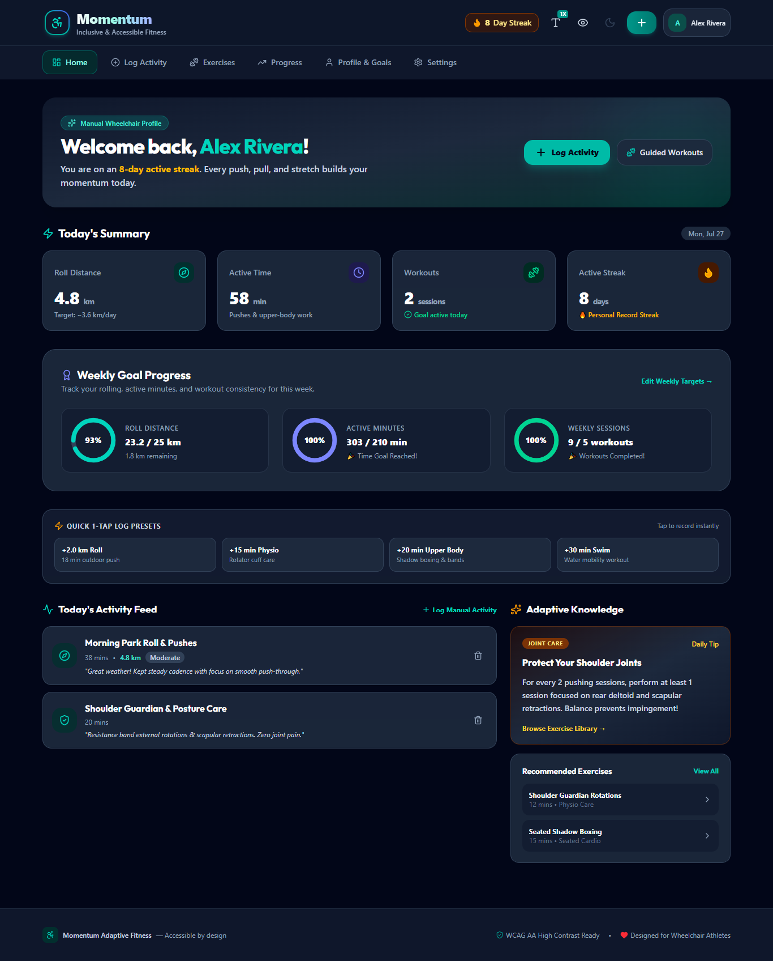
Figure B.1: The dashboard — today’s adapted-metric summary, weekly goal rings, quick-log presets and activity feed.
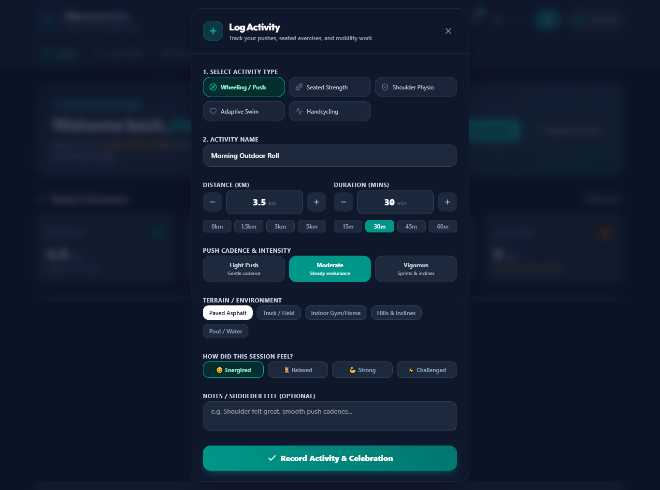
Figure B.2: The activity-logging form — adapted activity types, distance and duration with one-tap presets, intensity, terrain and perceived effort.
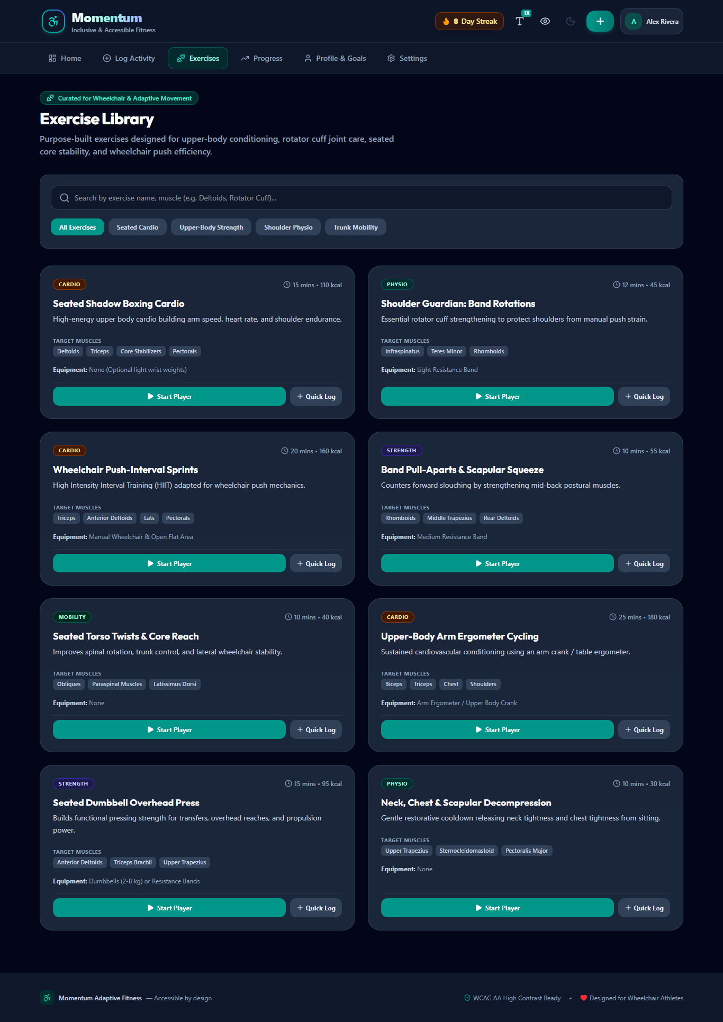
Figure B.3: The exercise library — routines curated for seated cardio, upper-body strength, shoulder physio and trunk mobility.
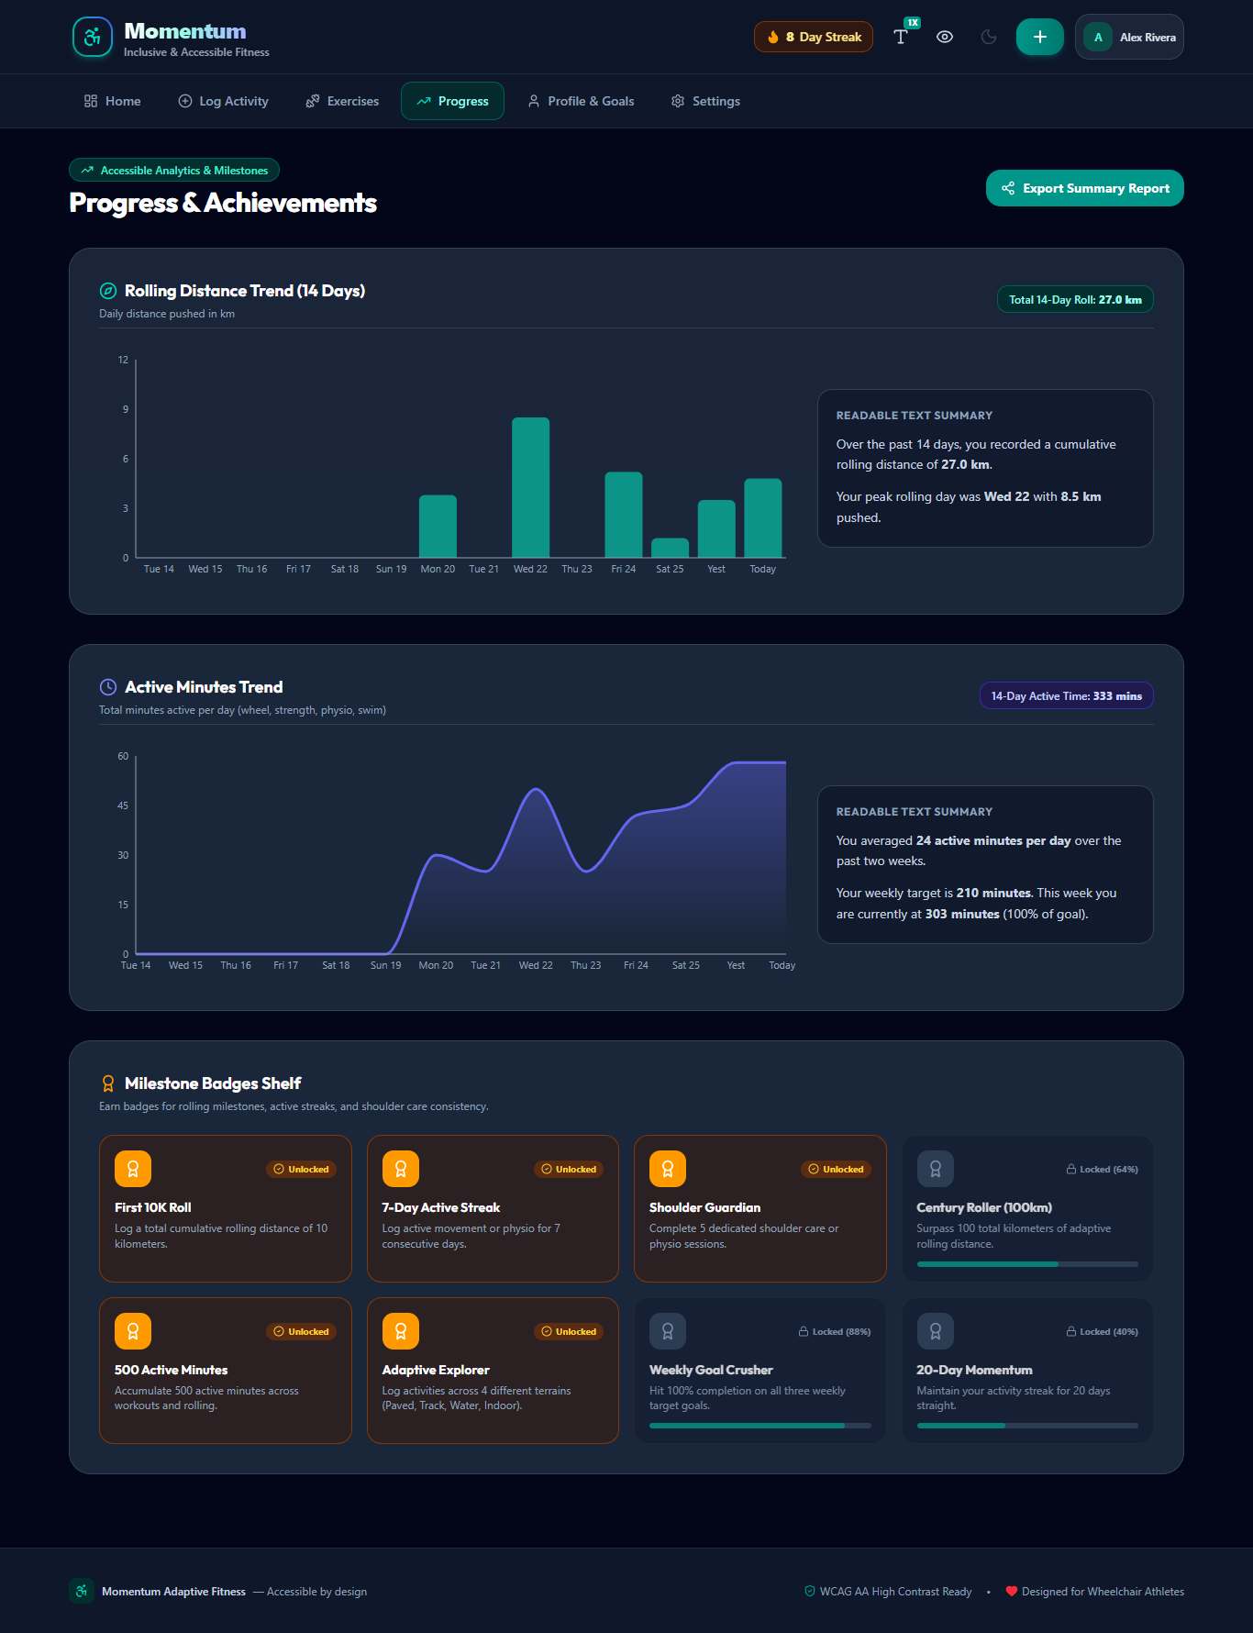
Figure B.4: The progress and achievements view — rolling-distance and active-minute trends, each with a readable text summary, and a milestone-badge shelf.
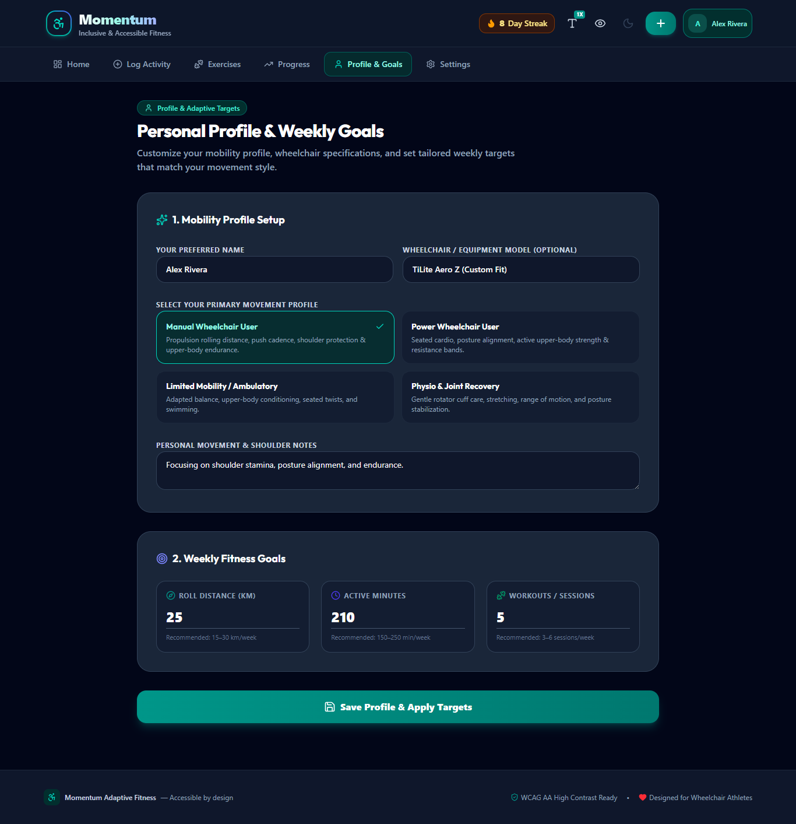
Figure B.5: The profile and weekly-goals view — mobility profile selection and adapted weekly targets.
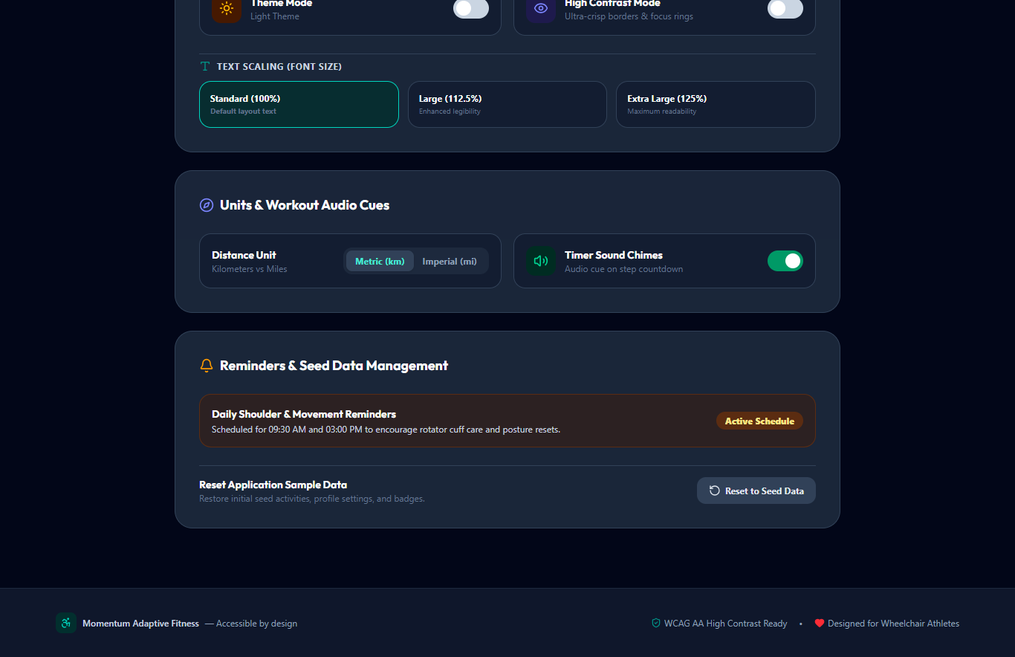
Figure B.6: The settings and accessibility view — theme, high-contrast mode, text scaling and unit controls.

